**GCP-Cloud-Price-Estimator**

This custom build Estimator allows you to calculate and estimates price of google cloud storage for selected region.

Google [github repo](https://github.com/GoogleCloudPlatform/professional-services/tree/main/tools/gcs-bucket-mover#bucket-locking) has GCS bucket movement tool which gives various option to end user to create bucket movement job from source to target source however it does not include any storage and operation cost comparison with target project. Custom build GCP-Cloud-Price-Estimator utility helps end user to use this utility to calculate operation and storage cost for new bucket location and compare with existing bucket cost. This utility can be used to compare cost differences from source and multiple target locations/regions.

# Prerequisite instructions:

* System configuration: Ubuntu 18.x and above
* Google Account, Project, Bucket and service account should be created for source bucket
* GS Util should be setup for user bucket on Ubuntu system (Script provided)
* Download binaries from Git hub project repo[**link**](https://github.com/audaxlabs/gcp-cloud-storage-cost-estimator)
* Use provided readme file to build and create runnable jar manually.

## Instructions to setup and execute

* **Step#1**: Download executable binaries and script bundle from Git hub project repo[**link**](https://github.com/audaxlabs/gcp-cloud-storage-cost-estimator)
* **Step#2:** Create folder (**googlePOC**) at root directory
* **Step#3**: Copy **Cloud-Estimator.jar** inside **googlePOC** folder
* **Step#4**: **Edit** and update GCP source bucket information in “**gcp-souce-configuration.cfg**” file.
* **Step#5: Edit** “google-source-data.sh” file and update source Bucket information.
* **Step#6:** Setup GS Util using provided script.
* **Step#7:** Execute script “**executor.sh**” to start utility.

### Step#4: GCP source bucket

Configure source bucket information in provided gcp-souce-configuration.cfg file

### Step#5: Update Bucket information

Configure **Edit** and update GCP source bucket information in

### Step#6: Setup GS Util

Execute sh gsUtilSetup.sh to start the utility

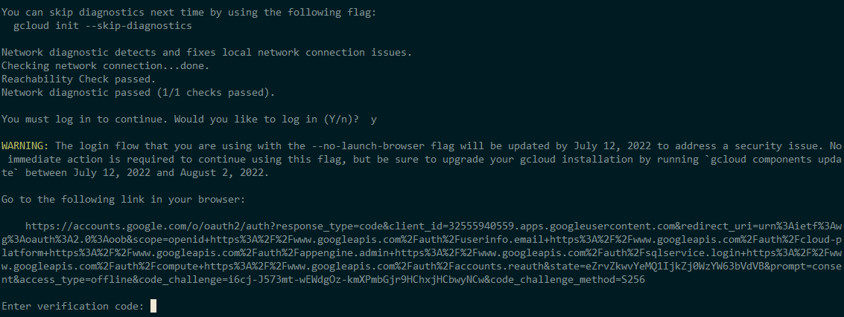

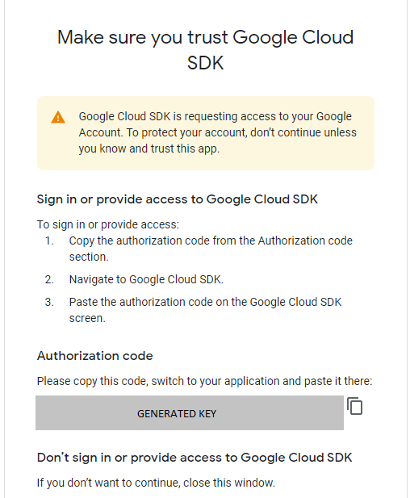

**Copy the auth key and provide in console > Press CNTRL+C to come out once setup is complete.**

### Step#7: Execute and run

**Run** the executor.sh file

**PRESS 0 TO START ESTIMATION FOR TARGET BUCKET LOCATION**

**INPUT#1:** SELECT STORAGE TYPE

**INPUT#2:** SELECT CONTINENT FOR TARGET BUCKET

**INPUT#3:** SELECT REGION FOR TARGET BUCKET

**INPUT#4:** SELECT OPERATION TYPE AND SIZE FOR TARGET BUCKET

**OUTPUT:** UTILITY WILL PRINT ESTIMATE FOR PROVIDED TARGET BUCKET.

**PRESS#0** TO CALCUTE ESTIMATES AGAIN FOR ANOTHER TARGET LOCATON OR **PRESS#1** TO EXIT UTILITY

# Contact Details:

**Tech Support <techsupport@audaxlabs.com>**