**SYSTEM REQUIREMENTS SPECIFICATION**

CareerFind

Web Application

CEN3031Onlne Team6

Caplin, Hicks, Snow Last Revision: 04/26/2020

Contents

2 Introduction 4

2.1 Purpose 4

2.2 Business Context 4

2.3 Scope 4

2.4 User Characteristics 4

3 General System Description 5

3.1 System Context 5

3.2 Major System Capabilities 5

3.3 Assumptions 5

3.4 Operational Scenarios 6

4 System Capabilities, Conditions, and Constraints 7

4.1 Business Requirements 7

4.2 Functional Requirements 7

4.3 Logical Data Requirements 15

4.4 User Requirements 16

4.5 Systems Requirements 18

4.6 Policy and Regulation Requirements 19

4.7 System Life Cycle Sustainment Requirements 19

5 Wireframes/ User Interface Design 20

5.1 User Login Page 20

5.2 Student Pages 21

5.3 Admin Pages 24

6 Requirements Traceability Matrix 28

7 References 30

8 CareerFind Content Management 30

8.1 Log into CareerFind 30

8.2 Manage Users 31

8.3 Manage Career Clusters 32

8.4 Manage Careers 33

8.5 Edit Career Details 35

9 CareerFind Deployment 37

9.1 Cloud-Based Deployment with Heroku 37

9.2 Deployment on Client Owned Hardware 40

# Introduction

## Purpose

This document defines what the CareerFind web application (the *site*) is intended to do and how it should accomplish that. It is intended to serve as a design and product reference for developers, users, and other stakeholders of the site.

## Business Context

The site was requested by a local middle school (the *client*) as a supplement to the traditional career counseling services offered to students.

## Scope

The site is a web-based career counseling application that schools can use to deliver career information over the Internet or a Local/ Wide Area Network.

## User Characteristics

### Student

Students will have read-only access to content on the site. There could potentially be thousands of students using the site. Access to the site would occur via a web browser running on a conventional Personal Computer or embedded device (tablet, smartphone).

### Admin

Teachers and other school staff will have read-write access to content on the site. There could potentially be dozens of teachers using the site. Access to the site would occur via a web browser running on a conventional Personal Computer or embedded device (tablet, smartphone).

# General System Description

## System Context

### System Context Model

### System Context Description

CareerFind provides a web-based interface that allows Students and Admins to view and interact with the data stored within a MongoDB instance. Students are only able to read career data stored in the database. Admins can create, read, update, and delete career and user data stored in the database.

## Major System Capabilities

There are two major capabilities provided by the site to meet the client’s highest priority requests:

* A database provides content management capabilities: create, read, update, and delete on career data.
* A user authentication page and session tracking restrict content management capabilities to Admins.

## Assumptions

It was assumed during development that CareerFind would be deployed by a single middle school and used by a portion of the students and staff associated with the school. We assumed that that all Admins within the system could be trusted with the ability to alter all career and user data within the system.

While we suspect this arrangement will suffice for anticipated deployment options it may prove to be a challenge to scalable deployment. If the site were deployed by a county or state with several schools using the same instance of the site it may be difficult to manage if all teachers were still given Admin accounts.

## Operational Scenarios

Possible deployment and usage scenarios for the site:

* A single CareerFind and MongoDB instance is deployed to a desktop PC residing in an office at a middle school. A school IT resource or other staff maintains the installation. The machine serves the site to personnel associated with the school via a Local Area Network or the Internet. Potentially Dozens of Admin users and hundreds of Students access the site throughout a typical school year.
* Several CareerFind and MongoDB instances are deployed to virtual machines hosted by a virtual machine hypervisor such as vmware ESXi located in a county IT department. The CareerFind instances are served to local middle schools via a Wide Area Network or the Internet. Potentially Dozens of Admin users and hundreds of Students access each instance of the site in a typical school year.
* A single CareerFind and MongoDB instance is deployed to Heroku and hosted in the cloud by a state IT department. The CareerFind instance is shared by all middle schools in the state via the Internet. Potentially tens of thousands of Admin users and hundreds of thousands of Students access the instance in a typical school year.

# System Capabilities, Conditions, and Constraints

An initial meeting was held with the client to gather requirements. The focus of this interview was primarily on functional requirements. Additional requirements and modifications were supplied by the client during development.

## Business Requirements

* Schedule – initial development must complete within 8 weeks of project start with final delivery by April 26, 2020.
* Budget – no budget limitations were placed on the project at the time of development.

## Functional Requirements

### Requirements Gathering and User Story Creation

User Requirements (*Section 4.5*) were derived from notes taken during the initial client interview. These were in turn used to create User Stories.

### User Stories

#### Base System – Read Career Data, Manage Career Data

|  |  |
| --- | --- |
| **Epic: Content Management** | **Epic: Primary View** |
|  |  |
| *Theme: Manage content.* | *Theme: View content.* |
| As an Admin I want to manage (CRUD) the career clusters ( name, icon, keyword associations) displayed on the site. | As a User I want to see a list of career clusters (name, icon) after logging into the site so that I can drill down into associated careers for each cluster. |
| As an Admin I want to manage (CRUD) the keywords (name, type: subject, interest) associated with career clusters. | As a User after clicking on a career name I want to see base career data (name, salary, subject keywords, description) and associated DITL/ Celebrity links presented on a page. |
| As an Admin I want to manage (CRUD) careers (name, salary, description) displayed on the site. | As a User after clicking on a DITL link from an associated career page I would like to see that career's DITL article presented on a page. |
| As an Admin I want to manage (CRUD) Day-In-the-Life articles that are associated with careers. | As a User after clicking on a celebrity link from an associated career page I would like to see that career's celebrity profile (name, photo, article) presented on a page. |
| As an Admin I want to manage (CRUD) the celebrity profiles (name, photo, article) associated with careers. |  |

#### Multi-User System – Manage User Data, Authentication and Session Tracking

|  |  |
| --- | --- |
| **Epic: Multi-User Accounts** |  |
|  |  |
| *Theme: User Management* | *Theme: User Login Page* |
| As an Admin I would like to manage (CRUD) all user types (student, admin) from a listing of all users in the system. | As a User I should be able to access the site with valid credentials (username/ password or e-mail/ password) from a login page. |
| As an Admin I should be able to reset the password of any listed user in the system. |  |
| As an Admin I want to manage (CRUD) classes (name, associated users) in the system. |  |
| As an Admin I want to be able to filter listed users by class. |  |

#### Chat Counselor – Chat Bot makes Career Recommendations for Students

|  |  |
| --- | --- |
| **Epic: Content Management** | **Epic: Chat Career Counselor** |
|  |  |
| *Theme: Manage content.* | *Theme: Career Recommendations* |
| As an Admin I want to manage (CRUD) prompts that will be presented to students when they log into the site. | As a Student I want to answer a chat prompt after logging into the site and receive a career cluster recommendation based on parsed keywords in my response. |
| As an Admin I want to manage (CRUD) an icon/ profile picture that will be used by the site's chat counselor. | As a Student I want my response to be logged if it does not contain any known keywords so that my Admin can improve the system. |
| As an Admin I want to be able to view and delete (RD) anonymized student response logs that did not contain any keywords present in the system. | As a Student I want recommended career clusters to be placed in a queue so that I can remember to visit them. |
|  | As a Student I want keywords parsed from my responses to be stored so that future recommendations take them into account. |
|  | As a Student I should be able to bookmark careers I am interested in. |

#### Reward System – Engage Students and Encourage Repeat Visits

|  |  |
| --- | --- |
| **Epic: Multi-User Accounts** | **Epic: Point-Based Progress Tracker** |
|  |  |
| *Theme: User Management* | *Theme: Progress Tracker* |
| As an Admin I can view point totals of students and classes containing students. | As a Student I earn 1 point each time I visit a new career and all associated content. |
| As an Admin I can reset point totals of individual students and all students within a particular class. | As a Student my viewed content should be tracked in my account. |
|  | As a Student I should be able to view my current point total. |
|  | As a Student I can view the point total of any groups I belong to. |

### Use Cases

#### Create, Update, Delete Career Cluster

*Requirements Traceability*: CF01

*Actor*: Admin

*Priority*: High

*Create*: From the Main page Admin clicks 'Edit Clusters'. Clicks the add button (plus sign) in the upper right of the 'Edit' modal window. Types in the 'name' of the new cluster and a path to its associated 'image'. Under 'Actions' clicks the check mark to save changes or the X to cancel. Clicks outside of the 'Edit' modal window to dismiss it.

*Update*: From the Main page Admin clicks 'Edit Clusters'. Types desired cluster in the search field or manually locates it in the list. Clicks the pencil under 'Actions' to edit the cluster's 'name' and 'image'. Under 'Actions' clicks the check mark to save changes or the X to cancel. Clicks outside the 'Edit' modal window to dismiss it.

*Delete*: From the Main page Admin clicks 'Edit Clusters'. Types desired cluster in the search field or manually locates it in the list. Clicks the trash-can under 'Actions' to delete the associated cluster. When prompted for confirmation clicks the check mark to confirm or the X to cancel. Clicks outside the 'Edit' modal window to dismiss it.

#### Create, Update, Delete Career Cluster Keywords

*Requirements Traceability*: CF02

*Actor*: Admin

*Priority*: High

*Create*: From the Cluster detail page Admin clicks 'Edit Keywords'. Clicks the add button (plus sign) in the upper right of the 'Edit' modal window. Types in the 'name' of the new cluster and selects its 'type': 'subject' or 'interest'. Under 'Actions' clicks the check mark to save changes or the X to cancel. Clicks outside the 'Edit' modal window to dismiss it.

*Update*: From the Cluster detail page Admin clicks 'Edit Keywords'. Types the desired keyword in the search field or manually locates it in the list. Clicks the pencil under 'Actions' to edit the keyword's 'type'. Under 'Actions' clicks the check mark to save changes or the X to cancel. Clicks outside the 'Edit' modal window to dismiss it.

*Delete*: From the Cluster detail page Admin clicks 'Edit Keywords'. Types desired keyword in the search field or manually locates it in the list. Clicks the trash-can under 'Actions' to delete the associated keyword. When prompted for confirmation clicks the check mark to confirm or the X to cancel. Clicks outside the 'Edit' modal window to dismiss it.

#### Create, Update, Delete Career

*Requirements Traceability*: CF03

*Actor*: Admin

*Priority*: High

*Create*: From the Cluster Detail page Admin clicks 'Edit Careers'. Clicks the add button (plus sign) in the upper right of the 'Edit' modal window. Types in the 'name' of the new career and its annual 'salary'. Under 'Actions' clicks the check mark to save changes or the X to cancel. Clicks outside of the 'Edit' modal window to dismiss it.

*Update*: From the Cluster Detail page Admin clicks 'Edit Careers'. Types desired career in the search field or manually locates it in the list. Clicks the pencil under 'Actions' to edit the career's 'name' and 'salary'. Under 'Actions' clicks the check mark to save changes or the X to cancel. Clicks outside the 'Edit' modal window to dismiss it.

*Delete*: From the Cluster Detail page Admin clicks 'Edit Careers'. Types desired career in the search field or manually locates it in the list. Clicks the trash-can under 'Actions' to delete the associated career. When prompted for confirmation clicks the check mark to confirm or the X to cancel. Clicks outside the 'Edit' modal window to dismiss it.

#### Update Career Description

*Requirements Traceability*: CF03

*Actor*: Admin

*Priority*: High

*Update*: From the Career Detail page Admin clicks 'Edit Description'. Edits description text in the 'Edit' modal window. Under 'Actions' clicks the check mark to save changes or the X to cancel. Clicks outside of the 'Edit' modal window to dismiss it.

#### Update Career Day-in-the-Life (DITL)

*Requirements Traceability*: CF04

*Actor*: Admin

*Priority*: High

*Update*: From the Career Detail page Admin clicks 'A Day in the Life' link. From the DITL page Admin clicks 'Edit DITL'. Edits DITL article text in the 'Edit' modal window. Under 'Actions' clicks the check mark to save changes or the X to cancel. Clicks outside of the 'Edit' modal window to dismiss it.

#### Create, Update, Delete Career Celebrity Profile

*Requirements Traceability*: CF05

*Actor*: Admin

*Priority*: High

*Create*: From the Career Detail page Admin clicks 'Edit Celebrity Profile'. Types in the 'name' of the new profile and a path to its associated 'image'. Under 'Actions' clicks the check mark to save changes or the X to cancel. Clicks outside of the 'Edit' modal window to dismiss it.

*Update*: From the Career Detail page Admin clicks 'Edit Celebrity Profile'. Clicks the pencil under 'Actions' to edit the profile's 'name' and 'image'. Under 'Actions' clicks the check mark to save changes or the X to cancel. Clicks outside the 'Edit' modal window to dismiss it.

*Delete*: From the Career Detail page Admin clicks 'Edit Celebrity Profile'. Clicks the trash-can under 'Actions' to delete the associated profile. When prompted for confirmation clicks the check mark to confirm or the X to cancel. Clicks outside the 'Edit' modal window to dismiss it.

#### Update Celebrity Profile Article

*Requirements Traceability*: CF05

*Actor*: Admin

*Priority*: High

*Update*: From the Career Detail page Admin clicks the celebrity profile link (the celebrity profile 'name'). From the Celebrity Profile page Admin clicks 'Edit Article'. Edits article text in the 'Edit' modal window. Under 'Actions' clicks the check mark to save changes or the X to cancel. Clicks outside of the 'Edit' modal window to dismiss it.

#### Read CareerFind Content

*Requirements Traceability*: CF06, CF07, CF08, CF09

*Actor*: Student

*Priority*: High

*Read*: From the Main page Student clicks one of Career Cluster links to navigate to the Cluster Detail page. Student clicks one of the Career links to navigate to the Career Detail page and view the career's name, salary, associated keywords of type subject, and description. Student clicks 'A Day in the Life' link to read the article on the 'A Day in the Life' page. Student navigates back to the Career Detail page using breadcrumbs. Student clicks celebrity profile link to view associated celebrity name, image, and article on the Celebrity Profile page. Student uses breadcrumbs to navigate back to the Career Detail, Cluster Detail, or Main page.

#### Create, Update, Delete Users

*Requirements Traceability*: CF10, CF11, CF12, CF13, CF23, CF24

*Actor*: Admin

*Priority*: High

*Create*: Admin clicks 'Manage Users' from the admin dashboard. Clicks the add button (plus sign) in the upper right of the modal window. Types in the 'username', 'first name', 'last name', 'class', 'points', and selects a role (S: Student or A: Admin) via dropdown. Under 'Actions' clicks the check mark to save changes or the X to cancel. Navigates back to ‘Main’ via breadcrumbs.

*Update*: Admin clicks 'Manage Users' from the admin dashboard. Admin can manually locate the desired user in the list or use the available tools (filter on 'class', filter on 'role', type 'username', 'first name', or 'last name' into search field). Clicks the pencil under 'Actions' to edit the user's 'first name', 'last name', 'class', 'points', or 'role'. Under 'Actions' clicks the check mark to save changes or the X to cancel. Navigates back to ‘Main’ via breadcrumbs.

*Delete*: Admin clicks 'Manage Users' from the admin dashboard. Admin can manually locate the desired user in the list or use the available tools (filter on 'class', filter on 'role', type 'username', 'first name', or 'last name' into search field). Clicks the trash-can under 'Actions' to delete the associated user. When prompted for confirmation clicks the check mark to confirm or the X to cancel. Navigates back to ‘Main’ via breadcrumbs.

#### Access CareerFind

*Requirements Traceability*: CF14

*Actor*: Admin, Student

*Priority*: High

*Admin*: Admin is taken to the 'CareerFind' login page when attempting to access a CareerFind url without an active session. Types credentials in the 'username' and 'password' fields and clicks 'SIGN IN'. A warning message is displayed if invalid credentials are entered. If valid credentials are entered the Admin page associated with the target url is displayed.

*Student*: Student is taken to the 'CareerFind' login page when attempting to access a CareerFind url without an active session. Types credentials in the 'username' and 'password' fields and clicks 'SIGN IN'. A warning message is displayed if invalid credentials are entered. If valid credentials are entered the Student page associated with the target url is displayed.

#### Create, Update, Delete Chat Counselor Image and Prompts

*Requirements Traceability*: CF15, CF 16

*Actor*: Admin

*Priority*: Medium

*Create*: Admin clicks 'Manage Counselor' from the admin dashboard. Clicks the add button (plus sign) in the upper right of the modal window. Types in the 'prompt'. Under 'Actions' clicks the check mark to save changes or the X to cancel. Navigates back to 'Main' via breadcrumbs.

*Update*: Admin clicks 'Manage Counselor' from the admin dashboard. Types in a path to the Counselor's associated 'image' in the upper left of the modal window. Admin locates the desired prompt in the list and clicks the pencil under 'Actions' to edit it. Under 'Actions' clicks the check mark to save changes or the X to cancel. Navigates back to 'Main' via breadcrumbs.

*Delete*: Admin clicks 'Manage Counselor' from the admin dashboard. Locates the desired prompt in the list and clicks the trash-can under 'Actions' to delete it. When prompted for confirmation clicks the check mark to confirm or X to cancel. Navigates back to 'Main' via breadcrumbs.

#### Toggle, Read, Delete, Delete All, Counselor Logs

*Requirements Traceability*: CF17, CF19

*Actor*: Admin

*Priority*: Low

*Toggle*: Admin clicks 'Manage Counselor' from the admin dashboard. Clicks the 'Enable Logging' check box at the top of the modal window to toggle whether Student responses to Counselor prompts are logged when no keyword matches are found in the response. Navigates back to 'Main' via breadcrumbs.

*Read*: Admin clicks 'Manage Counselor' from the admin dashboard. Clicks the 'Logs' button to open the 'Logs' modal window. If logging is enabled Student responses to Counselor prompts that did not contain a keyword match are listed. Admin clicks outside the 'Logs' modal window to dismiss it.

*Delete*: Admin clicks 'Manage Counselor' from the admin dashboard. Clicks the 'Logs' button to open the 'Logs' modal window. Locates the desired response in the list and clicks the trash-can under 'Actions' to remove it. When prompted for confirmation clicks the check mark to confirm or X to cancel. Admin clicks outside the 'Logs' modal window to dismiss it.

*Delete All*: Admin clicks 'Manage Counselor' from the admin dashboard. Clicks the 'Logs' button to open the 'Logs' modal Window. Clicks 'Delete All'. When prompted for confirmation clicks the check mark to confirm or X to cancel. Clicks outside the 'Logs' modal window to dismiss it.

#### Receive Chat Counselor Career Cluster Recommendations

*Requirements Traceability*: CF18, CF21

*Actor*: Student

*Priority*: Medium

*Receive*: Student logs into site and the Chat Counselor image with a random prompt is displayed in the chat box at the bottom right of the page. Student types and submits a response from the 'Enter Text' field. The system parses the response for keyword hits and associates them with the Student. The system recommends the Career Cluster that has the most keywords in common with the Student. In the event of a tie, the first of the tied Career Clusters will be returned.

#### Bookmark Career

*Requirements Traceability*: CF22

*Actor*: Student

*Priority*: Low

*Bookmark*: Student navigates to a 'Career Detail' page. Clicks the 'Bookmark' button at the top of the page to add the Career to the 'Bookmarks' dropdown on the Student dashboard. The Student can now navigate to the bookmarked career by selecting it from the 'Bookmarks' dropdown on the Student dashboard.

#### Use Cluster Recommendation Queue

*Requirements Traceability*: CF20

*Actor*: Student

*Priority*: Low

*Use*: When the Chat Counselor makes a Career Cluster recommendation it is displayed in a recommendation 'Queue' on the Student dashboard. Clicking on the recommendation will take the Student to the appropriate 'Cluster Detail' page. Navigating to a queued 'Cluster Detail' page either by clicking the link on the 'Main' page or by clicking on the recommendation in the queue will remove the recommendation from the queue.

#### Track Student Progress and Rewards

*Requirements Traceability*: CF25, CF26

*Actor*: Student

*Priority*: Low

*Track*: Student views all content associated with a Career ('Career Detail' page, 'DITL' page, 'Celebrity Profile' page) and receives 1 'point'. Career pages viewed by the Student are associated with the Student.

#### Display Progress on Scoreboard

*Requirements Traceability*: CF27, CF28

*Actor*: Student

*Priority*: Low

*Scoreboard*: The Student's 'point' total and the 'point' total of the Student's class is displayed on a 'Scoreboard' located on the Student dashboard.

## Logical Data Requirements

The site stores career and user data in a database. User data is stored within a single model. Career data includes data shared by broad career groupings (Clusters) and data specific to individual careers (Careers).

### User Model

* **user**: *String*, a username
* **password**: *String*, an encrypted password
* **fname**: *String*, a user’s first name
* **lname**: *String*, a user’s last name
* **role**: *Enumerated String*, ‘admin’ or ‘student’
* **group**: *String*, the user’s class at school

### Cluster Model

* **name**: *String*, a cluster’s name
* **image**: *String*, a path to an image file

### Career Model

* **name**: *String*, a career’s name
* **shortDescription**: *String*, a career’s short description
* **description**: *String*, a career’s description
* **salary**: *String*, a career’s annual salary
* **image**: *String*, a path to an image file
* **ditl**: *String*, a career’s day-in-the-life article
* **ditlImage**: *String*, a path to an image file
* **cluster**: *String*, a career’s parent cluster
* **celebrity**: *Object*
  + **name**: *String*, a celebrity’s name
  + **photo**: *String*, a path to an image file
  + **article**: *String*, a celebrity profile

## User Requirements

### Base System

#### A main page with 16 career clusters allowing users to drill down into additional career information.

#### A content management system allowing admins to create, read, update, and delete career information.

* Career clusters (name and image)
* Keywords
* Career names, descriptions, salaries, Day in the Life, career-keyword associations
* Celebrity names, articles, images
* Chat counselor scripts

#### A database capable of storing career information.

#### An appealing and simple interface suitable for middle school students.

* Uses color template provided by client (navy blue and neon green)
* Presents information in digestible chunks.
* Presents information in ways that stand out and are engaging, like support for pictures, vibrant colors, large print text, fun fonts.
* Minimalistic design so interface is quick and easy to use.

### Multi-User System

#### A user login page that accepts and validates appropriate credentials (username/ password).

#### Assignment of users to disjoint roles (student, admin).

#### Assignment of users to disjoint groups (classes).

#### An interface allowing admins to create, read, update, and delete user accounts.

* Admins should be able to reset the passwords of other users.

### Reward System

#### A point based system to support progress tracking and reporting for individual students and classes of students.

#### An interface for admins to manage the reward system (enable/ disable, reset accumulated points).

#### Information radiators so that students can easily see progress.

#### Student accounts should track what information has and has not been viewed in the system.

### Chat Counselor

#### A content management system allowing admins to create, read, update, and delete chat counselor content (prompts, avatar, response logs).

#### An interface allowing students to respond to prompts from the chat counselor and to receive appropriate career cluster recommendations.

#### Recommendations should be made based on keywords identified in student responses and associated with student accounts.

#### Student accounts should provide an associated queue of career recommendations made by the chat counselor.

#### Students should be able to return to careers they are interested in for further review.

## System Requirements and Technology Stack

CareerFind can be deployed to Heroku for cloud-based hosting. This requires a Heroku account and provisioning of a MongoDB instance from Heroku. Billing is based on database usage and requires a credit card.

CareerFind can also be deployed on your own hardware. This requires a desktop PC or server capable of:

* installing and running MongoDB 3.6.12
* installing and running Node.js 13.6.0
* responding to the anticipated user request volume.

Installation of a version of MongoDB Compass compatible with the MongoDB instance is also recommended in case backend access to the database is necessary.

Please see CareerFind Deployment (*Section 9*) for deployment instructions.

### Technology Stack

CareerFind relies on Node.js for server-side logic, Express for routing, and Mongoose to connect to a MongoDB instance that may exist on the web server or a separate database server. The front-end is a React app that relies on the Material-UI and Material-Table component libraries. Crypto is a Node library that runs in the browser to encrypt user passwords before they are sent to the server. The browser’s localStorage API is utilized for session tracking. Axios is used to communicate with the CareerFind API via HTTP requests and responses.

## Policy and Regulation Requirements

No policy or regulation requirements have been provided by the client at this time. Potential areas of concern:

* **Personally Identifying Information** (**PII**) – Storage of the PII of students and school staff. User passwords are only stored in the database after they have been encrypted. The only other PII that might be stored in the database through normal use are the first and last names of users. While this information is not encrypted it is not necessary for normal functioning of the site.
* **Section 508 Compliancy** – A 1998 amendment to the Rehabilitation Act requires Federal agencies to ensure that any electronic systems they use are accessible to people with handicaps or impaired senses. 1 If a school receives federal funding; directly or indirectly, they may be required to meet these requirements. There may be similar state or local requirements a school must adhere to. CareerFind has not be tested for Section 508 compliancy. Section 508 testing guidelines are available on Section508.gov should such testing be needed.2

## System Life Cycle Sustainment Requirements

CareerFind should not require any special provisions or maintenance under normal operating circumstances. It may be prudent to assign administrative/ support duties to ensure smooth operation of the site in the case that troubleshooting is required. This individual should be comfortable with:

* managing and working with the selected deployment platform.
* accessing the database directly.

# Wireframes/ User Interface Design

Wireframes were created as part of the design process for the User Interface. They are presented here with notes to document the site’s original design. For instructions please see CareerFind Content Management Instructions (*Section 10.1*).

## User Login Page

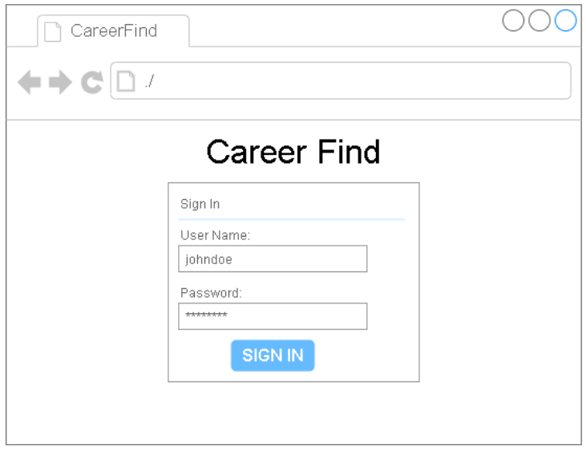Users of ‘Student’ and ‘Admin’ types can access the site with a valid username and password.

## Student Pages

### Main Page

After a logging into the site a Student is currently taken to the Home page displaying the ‘Career Clusters’ loaded in the system. The Student is currently able to log out of the system. The scoreboard, recommendation queue, and chat bot functionalities have not been delivered yet.

### Career Cluster Detail Page

Clicking on a ‘Career Cluster’ from Home takes a Student to the ‘Cluster Detail Page’ which lists associated careers. Note that the ‘Scoreboard’ and ‘Queue’ have not been delivered.

### Career Detail Page

Clicking on a ‘Career’ from the ‘Cluster Detail Page’ takes a Student to that career’s ‘Career Detail Page’. In the current version of the site the day-in-the-life and celebrity articles are displayed on this page as well as opposed to separate pages. Note that the ‘Scoreboard’ and ‘Queue’ are not present on this page as the associated functionality has not been delivered.

## Admin Pages

### Main Page

After a logging into the site an Admin is currently taken to the Home page displaying the ‘Career Clusters’ loaded in the system. A button opening an ‘Edit’ modal for the career clusters is displayed on this page. The career counselor and its management interface has not been delivered yet.

#### Career Cluster Edit Modal

‘Career Clusters’ can be edited by clicking the ‘Edit Clusters’ button that is displayed on this page. The modal is similar in functionality to the table on the ‘Manage Users’ page. Note that this modal window was not part of the original design.

### Career Cluster Detail Page

Clicking on a ‘Career Cluster’ from Home takes an Admin to the ‘Cluster Detail Page’ which lists associated careers. Careers associated with the cluster can be managed via the ‘Edit Cluster Careers’ button displayed on this page. Note that ‘keyword’ functionality has not been delivered and that the keyword management interface does not currently appear on this page.

#### Career Edit Modal

A cluster’s associated careers can be edited via a modal opened by clicking the ‘Edit Cluster Careers’ button that is displayed on this page. The modal is similar in functionality to the table on the ‘Manage Users’ page is displayed. Note that this modal window was not part of the original design

### Career Detail Page

Clicking on a ‘Career’ from the ‘Cluster Detail Page’ takes an Admin to that career’s ‘Career Detail Page’. In the current version of the site the day-in-the-life and celebrity articles are displayed on this page as well as opposed to separate pages. Note that the keyword functionality and associated management interface has not been delivered.

#### Career Detail Edit Modal

The ‘Edit Career’ button on this page opens the ‘Edit’ modal window which allows all information on the page to be edited. The modal is similar to the ‘Manage Users’ table and does not have an associated wireframe as it was not part of the original design.

### Manage Users Page

After logging into the site an Admin can access the ‘Manage Users’ page where ‘Student’ and ‘Admin’ accounts can be created, updated, and deleted. A single search field at the upper right of the table allows filtering of users based on all columns excepting ‘password’. Note that the ‘Reward System’ has not been delivered and so no option to enable it or points appear on this page currently.

# Requirements Traceability Matrix

| User Requirement | User Story | Test Case | Priority | Status | User Story Description |
| --- | --- | --- | --- | --- | --- |
| 4.4.1.1, 4.4.1.2 | CF01 | CF01_USTC | HIGH | DELIVERED | As an Admin I want to manage (CRUD) the career clusters ( name, icon, keyword associations) displayed on the site. |
| 4.4.1.2 | CF02 | CF02_USTC | HIGH | UNDELIVERED | As an Admin I want to manage (CRUD) the keywords (name, type: subject, interest) associated with career clusters. |
| 4.4.1.2 | CF03 | CF03_USTC | HIGH | DELIVERED | As an Admin I want to manage (CRUD) careers (name, salary, description) displayed on the site. |
| 4.4.1.2 | CF04 | CF04_USTC | HIGH | DELIVERED | As an Admin I want to manage (CRUD) Day-In-the-Life articles that are associated with careers. |
| 4.4.1.2 | CF05 | CF05_USTC | HIGH | DELIVERED | As an Admin I want to manage (CRUD) the celebrity profiles (name, photo, article) associated with careers. |
| 4.4.1.1 | CF06 | CF06_USTC | HIGH | DELIVERED | As a User I want to see a list of career clusters (name, icon) after logging into the site so that I can drill down into associated careers for each cluster. |
| 4.4.1.1 | CF07 | CF07_USTC | HIGH | DELIVERED | As a User after clicking on a career name I want to see base career data (name, salary, subject keywords, description) and associated DITL/ Celebrity links presented on a page. |
| 4.4.1.1 | CF08 | CF08_USTC | HIGH | DELIVERED | As a User after clicking on a DITL link from an associated career page I would like to see that career's DITL article presented on a page. |
| 4.4.1.1 | CF09 | CF09_USTC | HIGH | DELIVERED | As a User after clicking on a celebrity link from an associated career page I would like to see that career's celebrity profile (name, photo, article) presented on a page. |
| 4.4.2.2, 4.4.2.4 | CF10 | CF10_USTC | HIGH | DELIVERED | As an Admin I would like to manage (CRUD) all user types (student, admin) from a listing of all users in the system. |
| 4.4.2.4 | CF11 | CF10_USTC | HIGH | DELIVERED | As an Admin I should be able to reset the password of any listed user in the system. |
| 4.4.2.3 | CF12 | CF10_USTC | HIGH | DELIVERED | As an Admin I want to manage (CRUD) classes (name, associated users) in the system. |
| 4.4.2.3, 4.4.2.4 | CF13 | CF10_USTC | HIGH | DELIVERED | As an Admin I want to be able to filter listed users by class. |
| 4.4.2.1 | CF14 | CF10_USTC | HIGH | DELIVERED | As a User I should be able to access the site with valid credentials (username/ password or e-mail/ password) from a login page. |
| 4.4.4.1 | CF15 | N/A | LOW | UNDELIVERED | As a Admin I want to manage (CRUD) prompts that will be presented to students when they log into the site. |
| 4.4.4.1 | CF16 | N/A | LOW | UNDELIVERED | As a Admin I want to manage (CRUD) an icon/ profile picture that will be used by the site's chat counselor. |
| 4.4.4.1 | CF17 | N/A | LOW | UNDELIVERED | As a Admin I want to be able to view and delete (RD) anonymized student response logs that did not contain any keywords present in the system. |
| 4.4.4.2, 4.4.4.3 | CF18 | N/A | LOW | UNDELIVERED | As a Student I want to answer a chat prompt after logging into the site and receive a career cluster recommendation based on parsed keywords in my response. |
| 4.4.4.1 | CF19 | N/A | LOW | UNDELIVERED | As a Student I want my response to be logged if it does not contain any known keywords so that my Admin can improve the system. |
| 4.4.4.4 | CF20 | N/A | LOW | UNDELIVERED | As a Student I want recommended career clusters to be placed in a queue so that I can remember to visit them. |
| 4.4.4.3 | CF21 | N/A | LOW | UNDELIVERED | As a Student I want keywords parsed from my responses to be stored so that future recommendations take them into account. |
| 4.4.4.5 | CF22 | N/A | LOW | UNDELIVERED | As a Student I should be able to bookmark careers I am interested in. |
| 4.4.3.2 | CF23 | N/A | LOW | UNDELIVERED | As an Admin I can view point totals of students and classes containing students. |
| 4.4.3.2 | CF24 | N/A | LOW | UNDELIVERED | As an Admin I can reset point totals of individual students and all students within a particular class. |
| 4.4.3.1 | CF25 | N/A | LOW | UNDELIVERED | As a Student I earn 1 point each time I visit a new career and all associated content. |
| 4.4.3.1, 4.4.3.4 | CF26 | N/A | LOW | UNDELIVERED | As a Student my viewed content should be tracked in my account. |
| 4.4.3.3 | CF27 | N/A | LOW | UNDELIVERED | As a Student I should be able to view my current point total. |
| 4.4.3.3 | CF28 | N/A | LOW | UNDELIVERED | As a Student I can view the point total of any groups I belong to. |

# References

1. [*Section 508 Amendment to the Rehabilitation Act of 1973*](https://en.wikipedia.org/wiki/Section_508_Amendment_to_the_Rehabilitation_Act_of_1973). Wikipedia. Accessed 04/25/2020.
2. [Test for Accessibility](https://www.section508.gov/test). Section508.gov. Accessed 04/25/2020.

# CareerFind Content Management

## Log into CareerFind

You will have to log in to access the CareerFind site if you do not have an active session open. After entering your ‘username’ and ‘password’ click ‘SIGN IN’ to access the site. You can sign out of the site at any time by clicking the user dashboard button at the upper right of the page and selecting ‘LOGOUT’.

If the system does not recognize your account credentials you will receive an error message and must enter valid credentials before you can access the site.

***Note:*** *If you are working with a new CareerFind installation you can use the default username: ‘admin’ and the default password: ‘admin’. If the default credentials have already been changed check with your system administrator.*

## Manage Users

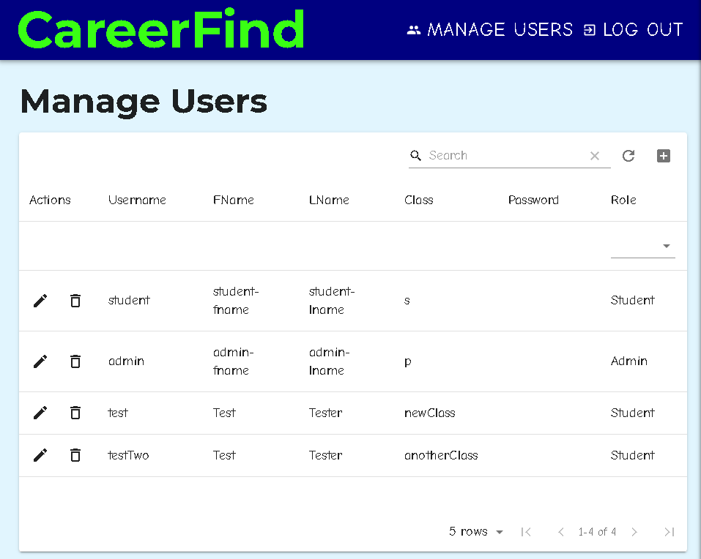After logging into CareerFind with admin credentials you can manage users. Click ‘MANAGE USERS’ on the admin dashboard in the top right corner of the page. You can return to the ‘Home’ page at any time by clicking ‘CareerFind’.

### Add a New User

1. Click the plus sign (+) at the upper right corner of the ‘Manage Users’ modal window.
2. A new user record will be added to the list. All users must have a ‘username’, ‘password’, and ‘role’ in order to save the new user. An ‘FName’, ‘LName’, and ‘Class’ can optionally be specified.
3. After completing the necessary changes under the ‘Actions’ column click the check mark to save changes or click the X to cancel.

***Note:*** *Valid roles include ’Admin’ and ‘Student’. Students have read access to the site while Admins are able to manage users and content. Users can be associated with a ‘Class’ so that it is easier to manage users associated with a specific classroom.*

### Edit an Existing User

1. To filter the list of users by any column except ‘Password’ simply type into the ‘Search’ field at the upper right of the ‘Manage Users’ modal window. You can also filter users by ‘Role’ via the dropdown in that column.
2. Locate the user you wish to edit and click the pencil under the ‘Actions’ column next to that user in the list. You will be able to edit all fields. You can only enter a new password if you wish to change a user’s password.
3. After completing the necessary changes under the ‘Actions’ column click the check mark to save changes or click the X to cancel.

### Delete an Existing User

1. To filter the list of users by any column except ‘Password’ simply type into the ‘Search’ field at the upper right of the ‘Manage Users’ modal window. You can also filter users by ‘Role’ via the dropdown in that column.
2. Locate the user you wish to delete and click the trashcan under the ‘Actions’ column next to that user in the list.
3. When prompted for confirmation under the ‘Actions’ column click the check mark to delete the user or click the X to cancel.

## Manage Career Clusters

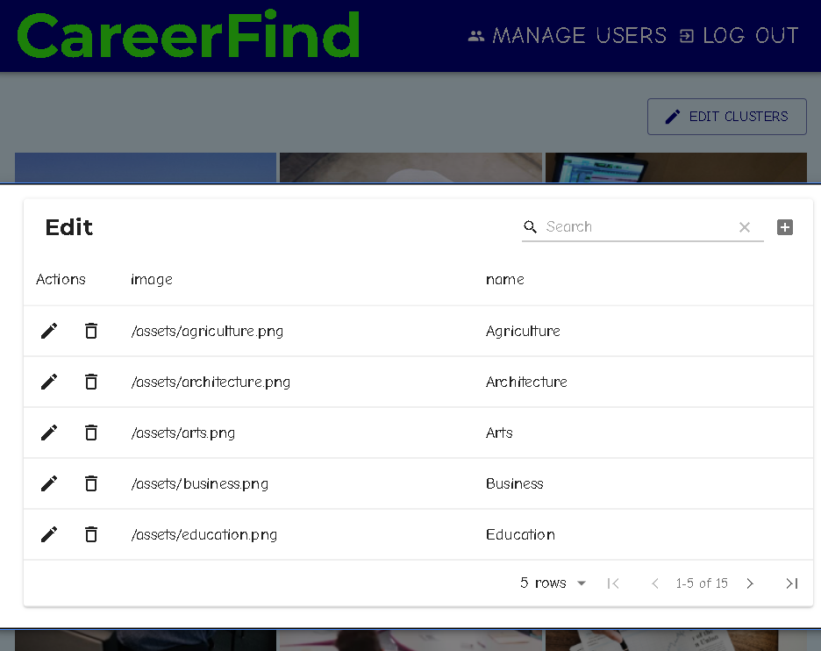After logging into CareerFind with admin credentials you can manage career clusters. Click ‘Edit Clusters’ on the CareerFind ‘Home’ page to open the ‘Edit’ modal window. You can close the ‘Edit’ modal window by clicking outside of it.

### Add a Career Cluster

1. Click the plus sign (+) at the upper right corner of the ‘Edit’ modal window.
2. A new record will be added to the list. All career clusters must have a ‘name’. A path to an ‘image’ that will displayed on ‘Main’ can also be entered.
3. After completing the necessary changes under the ‘Actions’ column click the check mark to save changes or click the X to cancel.

***Note:*** *Images are stored on the CareerFind webserver under ‘/app/client/public’ and valid image paths are relative to this location. To use the ‘/app/client/public/assets/information_technology.png’ image for example you would specify the ‘image’ path ‘/assets/information_technology.png’.*

### Edit a Career Cluster

1. Locate the career cluster you wish to edit and click the pencil under the ‘Actions’ column next to that career cluster in the list. You will be able to edit the ‘name’ and ‘image’ path of the career cluster.
2. After completing the necessary changes under the ‘Actions’ column click the check mark to save changes or click the X to cancel.

### Delete a Career Cluster

1. Locate the career cluster you wish to delete and click the trash-can under the ‘Actions’ column next to that career cluster in the list.
2. When prompted for confirmation under the ‘Actions’ column click the check mark to delete the career cluster or click the X to cancel. The career cluster and all associated content will be removed from the system.

## Manage Careers

After logging into CareerFind with admin credentials you can manage careers. Click on a Career Cluster from the CareerFind ‘Home’ page to open that Career Cluster’s detail page. From the Career Cluster detail page click ‘Edit Cluster Careers’ to open the ‘Edit’ modal window. You can close the ‘Edit’ modal window by clicking outside of it.

### Add a Career

1. Click the plus sign (+) at the upper right corner of the ‘Edit’ modal window.
2. A new career record will be added to the list. All careers must have a ‘name’. You can also specify a ‘shortDescription’, ‘image’, and ‘salary’.
3. 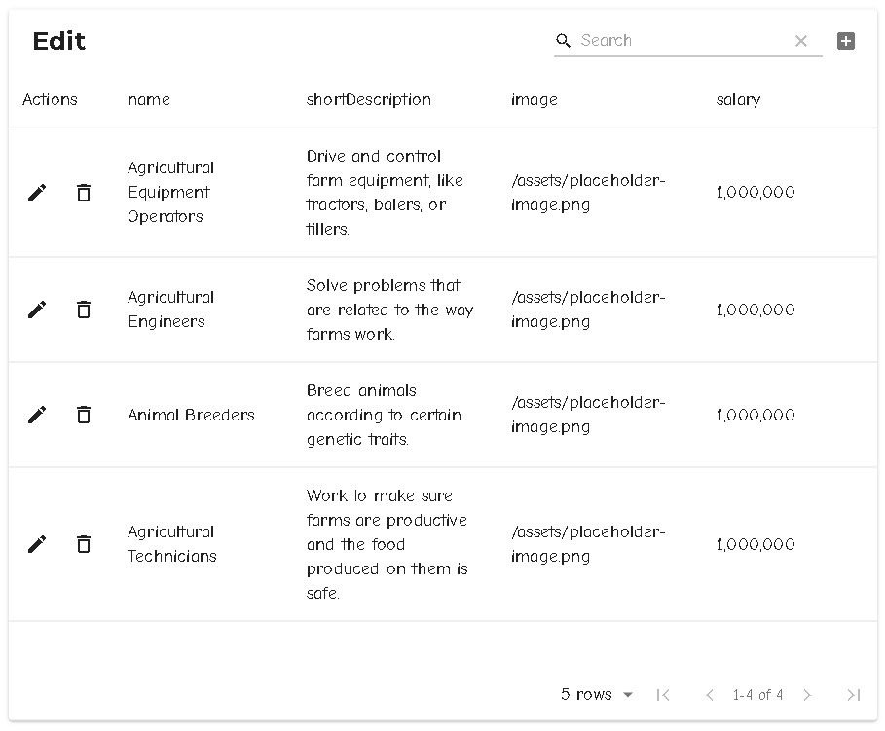After completing the necessary changes under the ‘Actions’ column click the check mark to save changes or click the X to cancel.

### Edit a Career

1. To filter the list of careers by any column simply type into the ‘Search’ field at the upper right of the ‘Edit’ modal window.
2. Locate the career you wish to edit and click the pencil under the ‘Actions’ column next to that career in the list. You will be able to edit any of the career’s fields.
3. After completing the necessary changes under the ‘Actions’ column click the check mark to save changes or click the X to cancel.

### Delete a Career

1. To filter the list of careers by any column simply type into the ‘Search’ field at the upper right of the ‘Edit’ modal window.
2. Locate the career you wish to delete and click the trash-can under the ‘Actions’ column next to that career in the list.
3. When prompted for confirmation under the ‘Actions’ column click the check mark to delete the career and all associated content or click the X to cancel.

## Edit Career Details

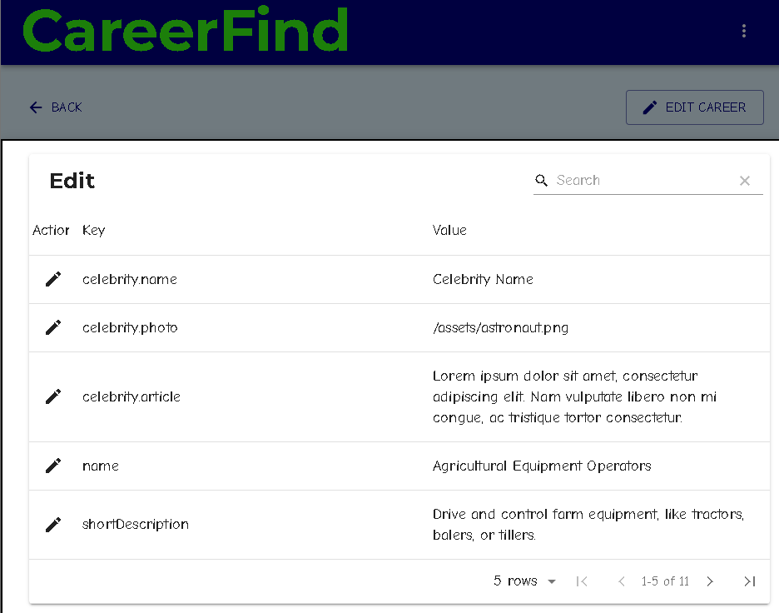After logging into CareerFind with admin credentials you can update career details. Click on a Career Cluster from the CareerFind ‘Home’ page to open that Career Cluster’s detail page. From the Career Cluster detail page click on a Career to open that Career’s detail page. From the Career detail page click ‘Edit Career’ to open the ‘Edit’ modal window. You can close the ‘Edit’ modal window by clicking outside of it.

### Edit Career Details

1. You will be able to edit the career’s details:
   * ‘name’ – the career’s name.
   * ‘shortDescription’ – a short description of the career.
   * ‘cluster’ – the cluster ID the career is associated with.
   * ‘image’ – a path to the career’s image.
   * ‘description’ – a description of the career.
   * ‘salary’ – the career’s salary.
   * ‘ditl’ – the career’s day-in-the-life article.
   * ‘ditlImage’ – the career’s day-in-the-life image.
   * ‘celebrity.name’ – the name of the career’s associated celebrity.
   * ‘celebrity.photo’ – a path to the career’s celebrity photo.
   * ‘celbrity.article’ – the career’s celebrity article.
2. After making the necessary changes to any value click the check mark to save changes or click the X to cancel.

***Note:*** *You can use the left and right arrows at the bottom of the modal window to shift from one page of values to the next.*

# CareerFind Deployment

***Note:*** *These instructions are intended for information technology professionals or others with similar experience*.

## Cloud-Based Deployment with Heroku

CareerFind can be deployed directly from its Git repository to Heroku for cloud-based deployment. Please note that this option requires provisioning of a MongoDB instance from Heroku and a credit card that will be billed based on usage.

***Note:*** *Instructions for deployment on client owned hardware are available in Section 10.2.2*.

### Installing the Git client

Please download a version of the Git client that is compatible with your web server’s operating system from <https://git-scm.com/downloads> . Detailed installation instructions are available at <https://git-scm.com/book/en/v2/Getting-Started-Installing-Git> .

### Cloning the CareerFind Git Repository

Open a command prompt and navigate to a location were you would like to create a copy of CareerFind for deployment. Type the following commands to clone the repository and navigate to the project directory:

git clone https://github.com/audiblePi/career-finder

cd career-finder

### Installing Node.js

Please download a version of Node that is compatible with your web server’s operating system from <https://nodejs.org/en/download/releases/> . The currently supported version of Node is Node.js 13.6.0. Refer to the official documentation for more details regarding installation: <https://nodejs.dev/how-to-install-nodejs> .

### Installing supporting software

Navigate to the career-finder/app directory from the command line and type the following:

npm install

npm run-script install-all

### Installing the Heroku Command Line Interpreter (CLI)

Please install the Heroku 7.38.2 CLI compatible with the operating system you will be using to deploy the site. Downloads and instructions are available at <https://devcenter.heroku.com/articles/getting-started-with-nodejs#set-up> .

### Creating a New Heroku App and Git Remote

After installing the Heroku CLI please log into your Heroku account by typing the following command:

heroku login

The command will open your default web browser to the Heroku login page where you can create a Heroku account if you do not already have one. Note that you must be logged into Heroku for the following Heroku CLI commands to work properly.

From the career-finder project directory type the following to create an empty Heroku app and add an associated local remote to your repository:

heroku create

You can verify that the remote has been created by typing the following:

git remote -v

For more advanced deployment options with git refer to: <https://devcenter.heroku.com/articles/git> .

### Provisioning a Database

You can provision an mLab MongoDB instance using the Heroku CLI by typing the following:

heroku addons:create mongolab:sandbox

***Note:*** *While mLab’s sandbox option is free you will still need to provide a credit card number to provision the database. If you need to scale your MongoDB instance up later you can modify your plan by logging into your account at Heroku.*

For more information on mLab and pricing refer to: <https://elements.heroku.com/addons/mongolab> .

### Setting Environment Variables

After provisioning a database check its connection string by typing the following:

heroku config

The environment variable MONGODB_URI should already be set to use the appropriate connection string for the database you provisioned. For more information regarding your mLab MongoDB instance please refer to the official documentation by typing:

heroku addons:docs mongolab

### Deploying from Master to Heroku

After configuring a new Heroku app and cloning the CareerFind Git repository you can now deploy the site to the cloud. Open a command prompt and navigate to the career-finder project directory. Deploy the site by typing the following:

git subtree push --prefix app heroku master

### Loading Initial Data into the Database

To load base user and career data into CareerFind navigate to career-finder/app via command line and type the following:

npm run-script test-restart

You can now access CareerFind using the default admin credentials:

* username: admin
* password: admin

***Note:*** *After logging into the site for the first time as admin please remember to click ‘Manage Users’ and then click the pencil icon next to the ‘admin’ user to edit that user. Change the default password by typing a new password in the ‘password’ field and then click the check icon to save changes.*

***Note:*** *If the data in CareerFind ever needs to be reset you can always run the data script as noted here. Please keep in mind that any new data that has been added to the system since installation will be overwritten by the base data when doing this*.

### Connecting to the Production Database

We recommend installing MongoDB compass which will allow you to connect directly to the CareerFind database should the need ever arise. Please refer to the ‘download’ and ‘documentation’ links at the bottom of the following page to get started:

<https://www.mongodb.com/products/compass>

You can find your mLab MongoDB connection string from your Heroku dashboard. After logging in and selecting your Heroku app click the ‘mLab MongoDB’ link listed under your app’s ‘Installed add-ons’. You can use the ‘Standard MongoDB URI’ displayed at the top of your mLab account within Compass.

***Note:*** *Do not forget to specify the <dbuser> and <dbpassword> in the connection string. You may want to create a new database user specifically for use with Compass. From your mLab account click the ‘Users’ tab and then ‘Add database user’ to do this*.

## Deployment on Client Owned Hardware

CareerFind can be deployed on client owned hardware such as a desktop PC or rack mount server. See System Requirements (*Section 4.5*) for details regarding appropriate hardware.

### Installing the Git client

Please download a version of the Git client that is compatible with your web server’s operating system from <https://git-scm.com/downloads> . Detailed installation instructions are available at <https://git-scm.com/book/en/v2/Getting-Started-Installing-Git> .

### Cloning the CareerFind Git Repository

Open a command prompt and navigate to a location were you would like to create a copy of CareerFind for deployment. Type the following commands to clone the repository and navigate to the project directory:

git clone https://github.com/audiblePi/career-finder

cd career-finder

### Installing Node.js

Please download a version of Node that is compatible with your web server’s operating system from <https://nodejs.org/en/download/releases/> . The currently supported version of Node is Node.js 13.6.0. Refer to the official documentation for more details regarding installation: <https://nodejs.dev/how-to-install-nodejs> .

### Installing Supporting Libraries

Navigate to the career-finder/app directory from the command line and type the following:

npm install

npm run-script install-all

### Installing MongoDB and creating a Database instance

Please refer to the installation documentation at <https://docs.mongodb.com/v3.6/administration/install-community/> to download and install a build of MongoDB 3.6.12 compatible with your web server’s operating system.

Follow the instructions under ‘The mongo shell’ to start the mongo shell on your database server. You should see that your database instance is being hosted at the default port locally:  


Make a note of the ip address and port being used in the connection string if they are different from the defaults: 127.0.0.1 and 27017 .

***Note:*** *By default MongoDB is configured to ‘bind localhost’. This means that the database instance will not accept connections from remote machines. If you want to connect to the database instance remotely or if you want to run CareerFind on a separate machine from MongoDB please follow the steps at* <https://docs.mongodb.com/manual/administration/security-checklist/> *to enable appropriate security measures before doing so*.

### Setting Environment Variables

You will need to add an environment variable called ‘MONGODB_URI’ to your web server. Consult your operating system’s documentation on how to do this. After adding the environment variable set it equal to your MongoDB instance’s connection string. If you are using the local database instance with default configuration the connection string should be:

mongodb://127.0.0.1:27017/CareerFind

CareerFind will use the above connection string to connect to the MongoDB instance running at port 27017 on the local machine and will use the ‘CareerFind’ database.

### Loading Initial Data into the Database

To load base user and career data into CareerFind navigate to career-finder/app via command line and type the following:

npm run-script test-restart

You can now access CareerFind using the default admin credentials:

* username: admin
* password: admin

***Note:*** *After logging into the site for the first time as admin please remember to click ‘Manage Users’ and then click the pencil icon next to the ‘admin’ user to edit that user. Change the default password by typing a new password in the ‘password’ field and then click the check icon to save changes.*

***Note:*** *If the data in CareerFind ever needs to be reset you can always run the data script as noted here. Please keep in mind that any new data that has been added to the system since installation will be overwritten by the base data when doing this*.

### Build and Host CareerFind

Navigate to ./career-finder/app/client and type the following from command line:

npm run build

This will build an optimized version of the site under ./career-finder/app/client. To host this directory install and run the serve node package:

npm install -g serve

npm serve -s build

You should now be able to access CareerFind at port 5000 of your web server. For more information on serve please refer to <https://create-react-app.dev/docs/deployment> and <https://github.com/zeit/serve/blob/master/README.md> .

### Connecting to the Production Database

We recommend installing MongoDB compass which will allow you to connect directly to the CareerFind database should the need ever arise. Please refer to the ‘download’ and ‘documentation’ links at the bottom of the following page to get started:

<https://www.mongodb.com/products/compass>

You can use the connection string you assigned to MONGODB_URI earlier in Compass. To connect to the default local MongoDB instance use mongodb://127.0.0.1:27017.