Simple Linear Regression
Rafiq Islam
2024-08-29
Table of contents

Simple Linear Regression
A simple linear regression in multiple predictors/input variables/features/independent variables/ explanatory variables/regressors/ covariates (many names) often takes the form
$$y=f\left(x\right)+ϵ=βx+ϵ$$
where $β∈R^{d}$ are regression parameters or constant values that we aim to estimate and $ϵ∼N\left(0,1\right)$ is a normally distributed error term independent of $x$ or also called the white noise.
In this case, the model:
$$y=f\left(x\right)+ϵ=β_{0}+β_{1}x+ϵ$$
Therefore, in our model we need to estimate the parameters $β_{0},β_{1}$. The true relationship between the explanatory variables and the dependent variable is $y=f\left(x\right)$. But our model is $y=f\left(x\right)+ϵ$. Here, this $f\left(x\right)$ is the working model with the data. In other words, $\hat{y}=f\left(x\right)={\hat{β}}_{0}+{\hat{β}}_{1}x$. Therefore, there should be some error in the model prediction which we are calling $ϵ=∥y−\hat{y}∥$ where $y$ is the true value and $\hat{y}$ is the predicted value. This error term is normally distributed with mean 0 and variance 1. To get the best estimate of the parameters $β_{0},β_{1}$ we can minimize the error term as much as possible. So, we define the residual sum of squares (RSS) as:

Using multivariate calculus we see

Setting the partial derivatives to zero we solve for $\hat{β_{0}},\hat{β_{1}}$ as follows

and,

Therefore, we have the following

Simple Linear Regression slr is applicable for a single feature data set with contineous response variable.
import numpy as np
import matplotlib.pyplot as plt
from sklearn.linear_model import LinearRegression

Assumptions of Linear Regressions
- Linearity: The relationship between the feature set and the target variable has to be linear.
- Homoscedasticity: The variance of the residuals has to be constant.
- Independence: All the observations are independent of each other.
- Normality: The distribution of the dependent variable $y$ has to be normal.

Synthetic Data
To implement the algorithm, we need some synthetic data. To generate the synthetic data we use the linear equation $y\left(x\right)=2x+\frac{1}{2}+ξ$ where $ξ∼N\left(0,1\right)$
X=np.random.random(100)
y=2*X+0.5+np.random.randn(100)
Note that we used two random number generators, np.random.random(n) and np.random.randn(n). The first one generates $n$ random numbers of values from the range (0,1) and the second one generates values from the standard normal distribution with mean 0 and variance or standard deviation 1.
plt.figure(figsize=(9,6))
plt.scatter(X,y)
plt.xlabel('$X$')
plt.ylabel('y')
plt.gca().set_facecolor('#f4f4f4')
plt.gcf().patch.set_facecolor('#f4f4f4')
plt.show()
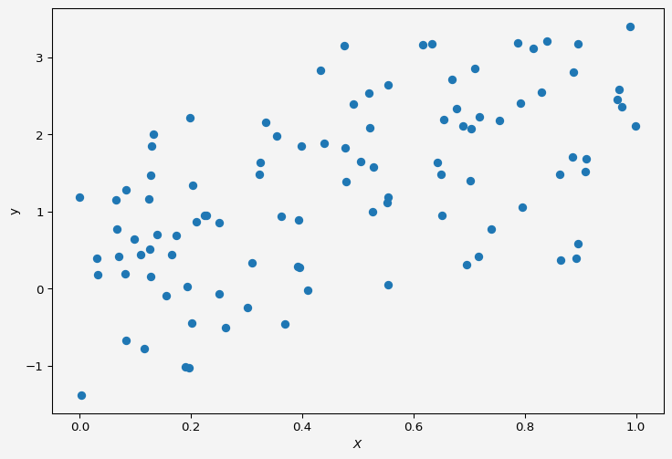

Model
We want to fit a simple linear regression to the above data.
slr=LinearRegression()
Now to fit our data $X$ and $y$ we need to reshape the input variable. Because if we look at $X$,
X
array([9.89469872e-01, 4.76078458e-01, 3.23974018e-01, 9.09779393e-01,
8.95129256e-01, 7.95287821e-01, 7.87903871e-01, 6.49688028e-01,
8.64559658e-01, 6.47034370e-02, 2.01573829e-01, 4.78057404e-01,
3.34960902e-01, 5.28424783e-01, 4.09968303e-01, 3.10044110e-01,
2.23752472e-01, 3.95586563e-01, 1.27938282e-01, 7.92643357e-01,
9.08484024e-01, 4.32249599e-01, 1.97941222e-01, 1.16101487e-01,
1.65533020e-01, 8.31217915e-02, 8.30751418e-01, 8.40450631e-01,
6.64136179e-02, 7.00165203e-02, 1.92471652e-01, 1.54869061e-01,
1.96757131e-01, 2.50097884e-01, 3.68276924e-01, 5.05005204e-01,
7.02555783e-01, 7.16339093e-01, 3.01486225e-01, 4.91990749e-01,
6.50864812e-01, 3.99087563e-01, 2.70438827e-03, 5.21204904e-01,
5.52737645e-01, 8.87355527e-01, 8.18953140e-02, 6.77126297e-01,
2.27160923e-01, 1.08853839e-01, 2.03342102e-01, 3.61629622e-01,
8.15849848e-01, 3.90943607e-01, 6.95686880e-01, 1.24406021e-01,
5.53520274e-01, 5.26672469e-01, 8.34864785e-02, 9.66227396e-01,
6.89071380e-01, 6.69830198e-01, 5.53640210e-01, 7.53981474e-01,
8.92471213e-01, 8.95827674e-01, 8.62880030e-01, 7.03415454e-01,
9.77622696e-02, 9.99264165e-01, 4.39198720e-01, 8.85622764e-01,
6.33181055e-01, 1.89602440e-01, 1.26096665e-01, 1.39320165e-01,
7.38969198e-01, 3.23488340e-01, 2.09079718e-01, 3.23509361e-02,
1.73693500e-01, 9.69689673e-01, 5.54532627e-01, 3.07281534e-02,
3.53616478e-01, 4.76525489e-01, 5.20063065e-01, 9.74096569e-01,
1.33148566e-01, 7.10244252e-01, 6.43083639e-01, 2.61639572e-01,
2.79183280e-04, 2.50270843e-01, 6.54359706e-01, 3.93050540e-01,
7.17748169e-01, 1.28315642e-01, 1.28833793e-01, 6.16857111e-01])
It is a one-dimensional array/vector but the slr object accepts input variable as matrix or two-dimensional format.
X=X.reshape(-1,1)
X[:10]
array([[0.98946987],
[0.47607846],
[0.32397402],
[0.90977939],
[0.89512926],
[0.79528782],
[0.78790387],
[0.64968803],
[0.86455966],
[0.06470344]])
Now we fit the data to our model
slr.fit(X,y)
slr.predict([[2],[3]])
array([4.66204414, 6.85428871])
We have our $X=2,3$ and the corresponding $y$ values are from the above cell output, which are pretty close to the model $y=2x+\frac{1}{2}$.
intercept = round(slr.intercept_,4)
slope = slr.coef_
Now our model parameters are: intercept $β_{0}=$ 0.2776 and slope $β_{1}=$ array([2.19224458]).
plt.figure(figsize=(9,6))
plt.scatter(X,y, alpha=0.7,label="Sample Data")
plt.plot(np.linspace(0,1,100),
slr.predict(np.linspace(0,1,100).reshape(-1,1)),
'k',
label='Model $\hat{f}$'
)
plt.plot(np.linspace(0,1,100),
2*np.linspace(0,1,100)+0.5,
'r--',
label='$f$'
)
plt.xlabel('$X$')
plt.ylabel('y')
plt.legend(fontsize=10)
plt.gca().set_facecolor('#f4f4f4')
plt.gcf().patch.set_facecolor('#f4f4f4')
plt.show()
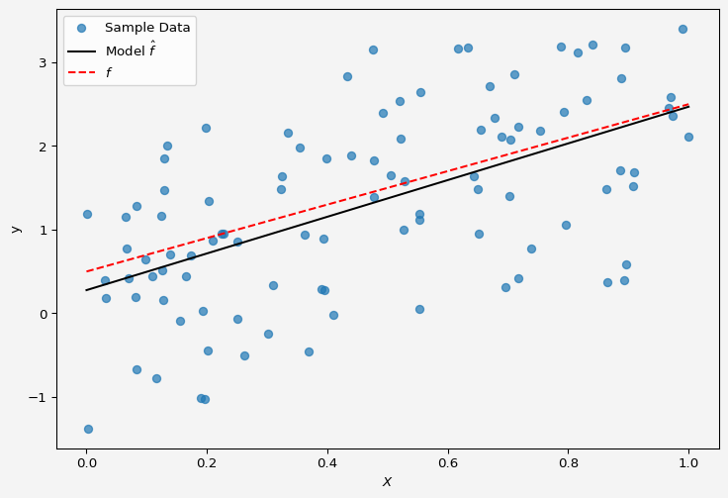
So the model fits the data almost perfectly.
Up next multiple linear regression.
Share on

You may also like

