Simple Linear Regression
Rafiq Islam
2024-08-29
Table of contents

Simple Linear Regression
A simple linear regression in multiple predictors/input variables/features/independent variables/ explanatory variables/regressors/ covariates (many names) often takes the form
$$y=f\left(x\right)+ϵ=βx+ϵ$$
where $β∈R^{d}$ are regression parameters or constant values that we aim to estimate and $ϵ∼N\left(0,1\right)$ is a normally distributed error term independent of $x$ or also called the white noise.
In this case, the model:
$$y=f\left(x\right)+ϵ=β_{0}+β_{1}x+ϵ$$
Therefore, in our model we need to estimate the parameters $β_{0},β_{1}$. The true relationship between the explanatory variables and the dependent variable is $y=f\left(x\right)$. But our model is $y=f\left(x\right)+ϵ$. Here, this $f\left(x\right)$ is the working model with the data. In other words, $\hat{y}=f\left(x\right)={\hat{β}}_{0}+{\hat{β}}_{1}x$. Therefore, there should be some error in the model prediction which we are calling $ϵ=∥y−\hat{y}∥$ where $y$ is the true value and $\hat{y}$ is the predicted value. This error term is normally distributed with mean 0 and variance 1. To get the best estimate of the parameters $β_{0},β_{1}$ we can minimize the error term as much as possible. So, we define the residual sum of squares (RSS) as:

Using multivariate calculus we see

Setting the partial derivatives to zero we solve for $\hat{β_{0}},\hat{β_{1}}$ as follows

and,

Therefore, we have the following

Simple Linear Regression slr is applicable for a single feature data set with contineous response variable.
import numpy as np
import matplotlib.pyplot as plt
from sklearn.linear_model import LinearRegression

Assumptions of Linear Regressions
- Linearity: The relationship between the feature set and the target variable has to be linear.
- Homoscedasticity: The variance of the residuals has to be constant.
- Independence: All the observations are independent of each other.
- Normality: The distribution of the dependent variable $y$ has to be normal.

Synthetic Data
To implement the algorithm, we need some synthetic data. To generate the synthetic data we use the linear equation $y\left(x\right)=2x+\frac{1}{2}+ξ$ where $ξ∼N\left(0,1\right)$
X=np.random.random(100)
y=2*X+0.5+np.random.randn(100)
Note that we used two random number generators, np.random.random(n) and np.random.randn(n). The first one generates $n$ random numbers of values from the range (0,1) and the second one generates values from the standard normal distribution with mean 0 and variance or standard deviation 1.
plt.figure(figsize=(9,6))
plt.scatter(X,y)
plt.xlabel('$X$')
plt.ylabel('y')
plt.gca().set_facecolor('#f4f4f4')
plt.gcf().patch.set_facecolor('#f4f4f4')
plt.show()
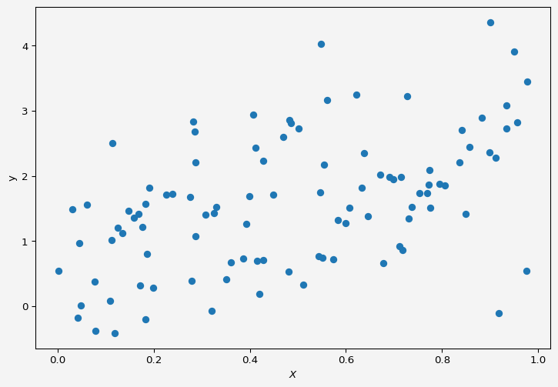

Model
We want to fit a simple linear regression to the above data.
slr=LinearRegression()
Now to fit our data $X$ and $y$ we need to reshape the input variable. Because if we look at $X$,
X
array([0.54350566, 0.19179981, 0.1102937 , 0.13564765, 0.64640552,
0.85645264, 0.06083284, 0.69803311, 0.17714354, 0.48544618,
0.11397627, 0.67115417, 0.58301306, 0.19946267, 0.77566724,
0.91088589, 0.71197402, 0.54641311, 0.35048027, 0.3611599 ,
0.42024893, 0.97531215, 0.17162959, 0.76896285, 0.11947208,
0.84169145, 0.69035912, 0.44932591, 0.60756644, 0.1123327 ,
0.41258668, 0.63692466, 0.59969503, 0.04543999, 0.16826581,
0.83674603, 0.55120366, 0.4069427 , 0.71843246, 0.84868148,
0.39212281, 0.63223466, 0.42816056, 0.57368907, 0.54875927,
0.77436935, 0.0767215 , 0.73031715, 0.94998161, 0.14748762,
0.03039946, 0.88262806, 0.28302511, 0.51176534, 0.22580015,
0.7521296 , 0.04285458, 0.28720558, 0.3258712 , 0.28615193,
0.79508589, 0.27958539, 0.7275184 , 0.80553828, 0.30743879,
0.48021834, 0.77276695, 0.27564745, 0.89961142, 0.1862892 ,
0.62128266, 0.04819337, 0.33025148, 0.18331117, 0.7144743 ,
0.32118972, 0.15895914, 0.23837682, 0.97704621, 0.8985455 ,
0.12590815, 0.39858141, 0.41457466, 0.73754826, 0.93396919,
0.93339582, 0.00278918, 0.56009263, 0.28712059, 0.0787017 ,
0.18303066, 0.55444799, 0.42857703, 0.6768916 , 0.48316807,
0.91773056, 0.95600724, 0.3865401 , 0.46964271, 0.50227746])
It is a one-dimensional array/vector but the slr object accepts input variable as matrix or two-dimensional format.
X=X.reshape(-1,1)
X[:10]
array([[0.54350566],
[0.19179981],
[0.1102937 ],
[0.13564765],
[0.64640552],
[0.85645264],
[0.06083284],
[0.69803311],
[0.17714354],
[0.48544618]])
Now we fit the data to our model
slr.fit(X,y)
slr.predict([[2],[3]])
array([4.27136204, 6.04310232])
We have our $X=2,3$ and the corresponding $y$ values are from the above cell output, which are pretty close to the model $y=2x+\frac{1}{2}$.
intercept = round(slr.intercept_,4)
slope = slr.coef_
Now our model parameters are: intercept $β_{0}=$ 0.7279 and slope $β_{1}=$ array([1.77174027]).
plt.figure(figsize=(9,6))
plt.scatter(X,y, alpha=0.7,label="Sample Data")
plt.plot(np.linspace(0,1,100),
slr.predict(np.linspace(0,1,100).reshape(-1,1)),
'k',
label='Model $\hat{f}$'
)
plt.plot(np.linspace(0,1,100),
2*np.linspace(0,1,100)+0.5,
'r--',
label='$f$'
)
plt.xlabel('$X$')
plt.ylabel('y')
plt.legend(fontsize=10)
plt.gca().set_facecolor('#f4f4f4')
plt.gcf().patch.set_facecolor('#f4f4f4')
plt.show()
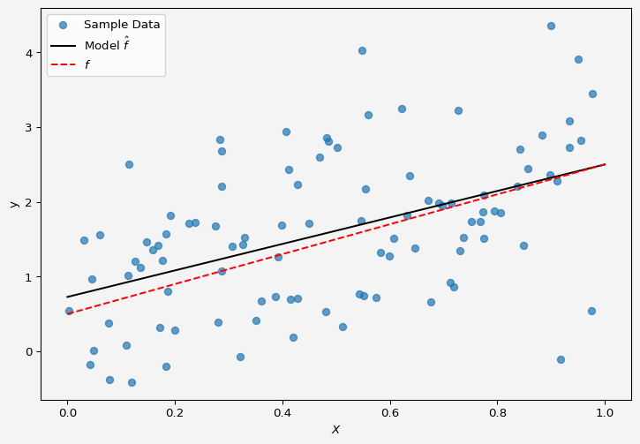
So the model fits the data almost perfectly.
Up next multiple linear regression.
Share on

You may also like

