Fragmental Manual

v1.00

Contents

- Introduction

- Effects
  - Routing
  - Delay
  - Granulator
  - Spectral Transposer
  - Spectral Exaggerator
  - Spectral Accumulator
  - Reverse

- Modulation
  - Basics
  - LFO
  - Envelope Follower
  - The Knob

- Credits

1. Introduction
Fragmental is a multi-fx VST plugin which is a bit different to most multi-fx plugins. Incorporating a stereo delay, granulator and reverse effect, it also has three phase vocoder effects: a spectral transposer, spectral exaggerator, and a spectral accumulator. These effects may be combined in any order, in serial or parallel configurations, and there are three modulation sources, each of which may be either an LFO, an envelope follower on the input audio, or a special physically-modeled knob.

Some things to note about Fragmental:
- Although it was designed for real-time performance, Fragmental has a constant delay of 7680 samples, due to the presence of the three phase vocoder effects. So that the host will be able to compensate for this, this delay will remain even if the phase vocoder effects are not active (to the best of my knowledge, dynamic plugin delay compensation is not implemented in any current VST host).
- The Host Sync button below the Output section will sync any active LFOs to the nearest bar playing in the host, and the following parameters will have their values quantised to note values:
  - Delay: L. Time and R. Time (unless Short Times is activated). Note that the delay has a maximum delay time of 2 seconds, so longer measures may not work correctly.
  - LFO: Freq.
- All Level controls (including the output level) have a range of -∞->+6dB, with the centre position representing 0dB.
- OpenGL is used to draw the routing section (this is slightly gratuitous, but I find it easier to code procedural stuff like this in OpenGL than VSTGUI).
- The code for the phase vocoder effects is all taken from the PVOC plugins – as this code is released under the LGPL, it is not directly compatible with Steinberg's VST licensing terms, and must be included in a separate .dll (NiallsPVOCLib.dll). See the readme for installation details.
- Fragmental is open source, released under the MIT/expat license (apart from the PVOC code, obviously). You should be able to obtain the source code from: http://www.niallmoody.com/ndcplugs/fragmental.htm

2. Effects

i. Routing
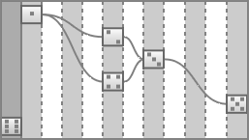
In line with the original intention for Fragmental to be used in real-time performance, the routing section was designed to allow for quick configuration changes. So, with a single mouse movement you can add, remove or change the position of any effect within the chain.
The routing section is divided into a number of vertical strips. The pale grey strips represent potential positions for the effects to occupy, while the dark grey strip on the far left is used to disable effects and remove them from the processing chain. Bezier curves are drawn to show how the effects are connected to each other, with the signal path always travelling left to right. To save space, the various effects are denoted by domino-style symbols, to match the ones next to the effects' names in the main effects section.

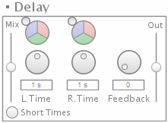
ii. Delay
The delay is a fairly standard stereo delay, with a couple of quirks. The Short Times button switches between a long (0->2 seconds) and short (0->0.02 seconds) time range for the two time parameters. This allows for chorus and flanger-type effects when paired with an LFO, but can also provide ringing feedback-style effects in combination with a high value on the Feedback parameter. The delay is also immune to the zipper noise that plagues many digital delays – instead of clicks when the delay times are changed, the delay will actually scrub through the audio, resulting in a raising or lowering of the delayed signal's pitch. The other quirk is that the feedback control can provide greater than 100% feedback, resulting in the signal continually reinforcing itself (there is a distortion unit in the feedback loop which will prevent the signal ever going outside the -1/+1 VST audio range however).

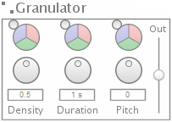
iii. Granulator
The granulator is a standard delayline granulator. Like all the effects (except the delay, with its separate left and right delay times), it is a stereo effect with the parameters applying to both channels. Density controls the number of currently active grains (with a maximum of 32), and Duration controls the length of the grains, with a maximum of 88200 samples (2 seconds when running at a 44100Hz samplerate). Pitch controls the pitch of the grains, and is set when the grain is initially activated, making it possible for grains with different pitches to be active at the same time.

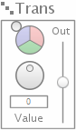
iv. Spectral Transposer
The spectral transposer is a phase vocoder effect that can alter the pitch of its input audio. The range for this effect is -24->+24 semitones.

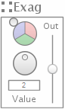
v. Spectral Exaggerator
The Spectral Exaggerator is another phase vocoder effect, which emphasizes the spectral peaks of the input audio. If you were to feed it an instrumental sound with a strong fundamental, the exaggerator would exaggerate the fundamental, while attenuating the other frequencies in the signal. The range for this effect is 0->4, with 1 representing no exaggeration, 4 meaning maximum exaggeration, and 0 meaning the spectral peaks are actually attenuated, leaving just the other frequencies present.

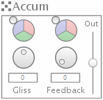
vi. Spectral Accumulator
The spectral accumulator essentially stores (accumulates) the previous spectral information from its input signal. The two controls specify whether this information is transposed (Gliss), and how long it takes to decay (Feedback).

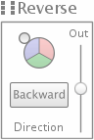
vii. Reverse
This is a simple effect based on the previous ndc Plugs Reversinator plugin. It provides a simple pseudo-realtime reverse effect.

3. Modulation

i. Basics

As with Fragmental's approach to routing, modulation is handled in a manner that is intended to reduce the number of mouse actions needed to reconfigure or adjust the current setup. As such, any parameter that may be modulated has a pie chart-style control (pictured) associated with it. This control represents the three modulation sources in the plugin, and how their respective levels are applied to the associated parameter. The smaller circle can be dragged – when it is entirely within the blue section, the associated parameter will be entirely modulated by the blue mod source. When it is partly outside the large circle, the associated parameter will be modulated to a lesser degree by the blue mod source. When it is partly over the blue section, and partly over the red section, the associated parameter will be modulated by a combination of the blue and red mod sources. The following pictures hopefully explain this a bit better:
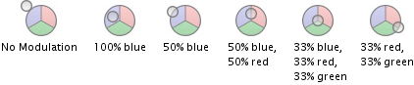
Compared to a 'normal' modulation scheme in a synth etc. this single control therefore acts as both the modulation amount control and the modulation source control.
The other thing to note is that each mod source has the same options – each one can be either an LFO, an envelope follower, or a special physically-modelled knob control.

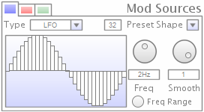
ii. LFO
The LFO is made up of a number of steps, and could be considered a kind of step sequencer. The LFO's shape (or the step values) can be set by drawing in the main step panel. The number of steps can be set with the small control above the panel – the available choices are 32, 16, 12, 8, 6, 4, 3, and 2. There are four preset shapes available: sine, saw, square and ramp, set via the preset shape control. The Freq knob sets the frequency at which the LFO runs, but this is also determined by the Freq Range toggle button – if this is toggled, the LFO actually acts as an audio-rate oscillator, with a range of 0.1->22000Hz, while if it is off, the range is 0.0001->1Hz. The smooth parameter can be used to smooth the output of the LFO – if set to 0, the output is as seen in the steps panel, while if it is set to 100%, a b-spline interpolator is applied to produce a smooth output.

iii. Envelope Follower
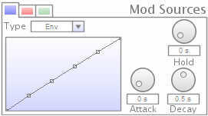
The envelope follower is slightly different to other envelope followers, in that its output is passed through a waveshaper. The attack, hold and decay controls function as you would expect, and they all have a range of 0->1 seconds. The waveshaper is controlled by the main panel with 6 draggable points on it. On this panel, the x-axis corresponds to the input amplitude, while the y-axis corresponds to the output. Moving the points away from the straight line seen above therefore alters the envelope follower's output. The following diagram hopefully explains this a bit better:
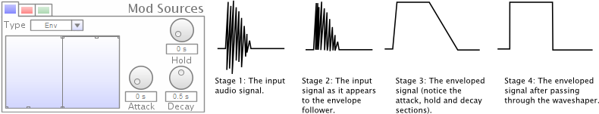
One use for the waveshaper is to connect it to the output level control, and then use it to create noise gate or simplistic compression effects. Here are some examples:
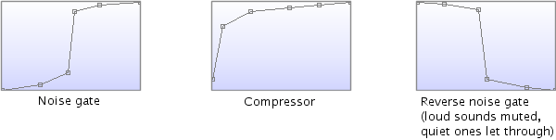
The waveshaper has 4 standard shapes which can be selected by right-clicking on it (keep clicking to cycle through them).

iv. The Knob
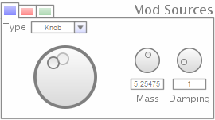
The knob is a simple GUI widget which has certain physical properties, based on a mass-spring-damper model. What this means is that when you drag it, the knob's value will not instantly travel to its new position, like a normal knob widget. Instead, it will move as if it were attached to that position via a spring. This motion is dependent on the Mass and Damping controls: a low Mass will mean it moves fast, and is more likely to oscillate, while a high Mass will slow it down. Similarly, a low Damping value will make it more likely to oscillate, while a high Damping value will reduce any overshoot. You can see the actual position of the knob in the transparent circle on the knob widget, the darker circle is the position you've moved it to.

4. Credits
- Coding and GUI: Niall Moody.
- Concept and Consultation: Steve Hamann.
- PVOC effects routines: Trevor Wishart, Richard Dobson, Composer's Desktop Project.
- Phase Vocoder class: Mark Dolson, Richard Dobson, Composer's Desktop Project.
- MXFFT FFT routines: Trevor Wishart and Keith Henderson.

The original PVOC effects, from which the Spectral Transpose, Exaggerate and Accumulator effects are taken, can be found here: http://people.bath.ac.uk/masrwd/pvplugs.html

