Toolset User Document

*Covers Toolset-HD and Toolset-Apps. Applications found [Here](../../Toolset).

# Introduction

## Background

Toolset is a revision to a helpful tool called The Panel developed by Cole Tirpak. The Panel was loosely based on a previous concept made by Cole called the Restart Tool. The Panel was a more robust tool created to simplify mundane tasks frequently performed by the Help Desk. Toolset reworked The Panel’s appearance and file structure as well as implemented new features.

* * *

## What’s New

Toolset includes a few new features and appearances. Here’s a list of what you’ll find different:

* **Completely resizable. Resize, maximize, and snap to screen edges**
* **Tabs.** Manage multiple computers on one panel
* **Scroll bar.** View all tools on one screen at any size
* **Theme panel.** Stays hidden until needed
* **More tools.** More quick tasks than ever
* **New themes.** Redesigned themes add a sleek, vivid look
* **New file structure.** Organized loose files and separated code into external files
* **Two versions.** A full version for Help Desk and a stripped down one for Apps
* **Feedback.** Submit suggestions or feedback
* **Saved workspace.** Size and theme now saved to user profile
* **Automatic updates.** App refreshes at 11pm to stay current with any changes

* * *

# How to use

### Standard Use

1. Enter a hostname into the input bar. (Figure 1)
2. Click the add(+) button. (Figure 1) Note: The hostname will be added to the tab list as active.
3. Select the computer to run tasks on by clicking its tab in the tab list. (Figure 1)
4. Click on a task from the panel below the tab list. (Figure 1)
5. Follow prompts from the task.

### Independent tasks

1. Hover over and click on the tab labeled **Themes** on the left side of the window. (Figure 2)
2. The theme panel will appear over the normal panel. Select a theme from the list. (Figure 3)
3. To exit, move the mouse off of the list to hide the theme panel again.

### Choosing a Theme

1. Hover over and click on the tab labeled **Themes** on the left side of the window. (Figure 4)
2. The theme panel will appear over the normal panel. Select a theme from the list. (Figure 5)
3. To exit, move the mouse off of the list to hide the theme panel again.

### Submitting Feedback

1. Click on the **feedback** link at the bottom of the window.
2. Type your feedback/suggestion into the white text box.
3. Click submit. (Figure 6) Note: Clicking the red X in the upper left corner will close the feedback overlay, but won’t clear the text box so you can return to it later.

* * *

# Things To Do

## Possible Future Features

Toolset will be constantly evolving as more work, more ideas, and more functions are put into it. Not all features will make it to “production”, but here’s a list of what will be tried:

* Zim
* Custom themes or colors
* Install locally
* Task prompt timeout

* * *

## Files with specific paths

Developer Note: The scripts below still refer to the full file path and need to be updated if file structure changes.

* *Batch\ActionsRemote.cmd*
* *Batch\DeleteCache.cmd*
* *Batch\DeleteUpdates.cmd*
* *Batch\UnloadTrendRemote.cmd*
* *Powershell\Tasks.ps1*

* * *

# Screenshots

Figure 1 (top)

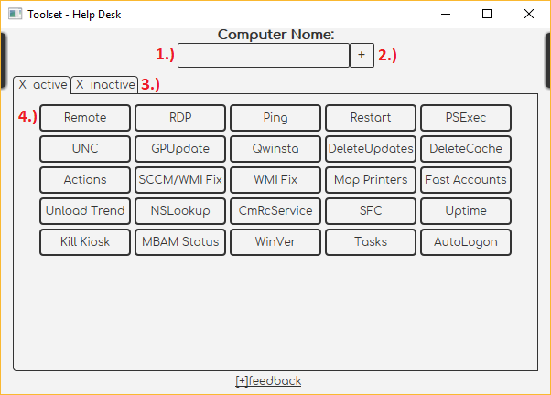

## Screenshots (Continued…)

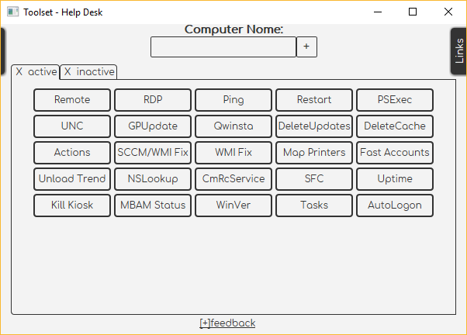 Figure 2 (top) 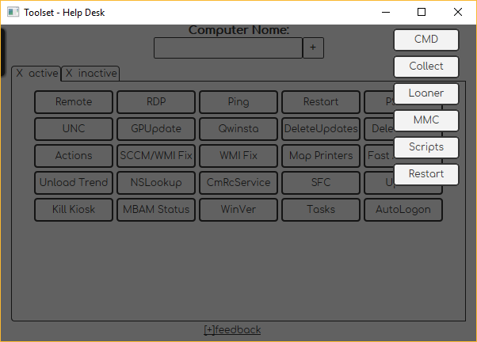 Figure 3 (top)

## Screenshots (Continued…)

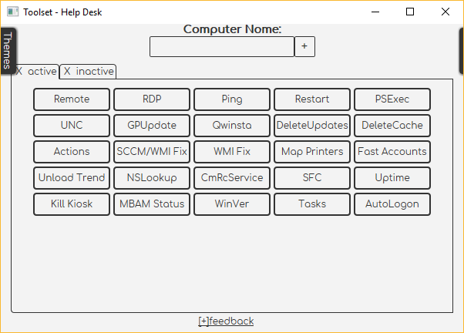 Figure 4 (top) 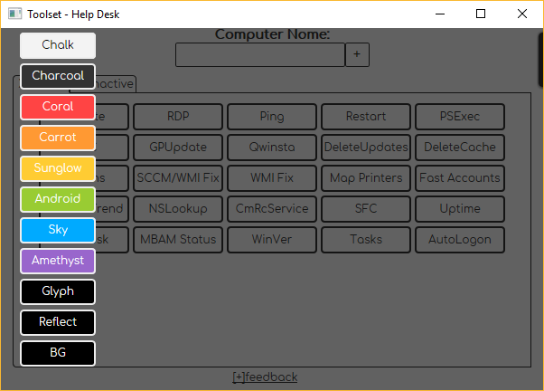 Figure 5 (top)

## Screenshots (Continued…)

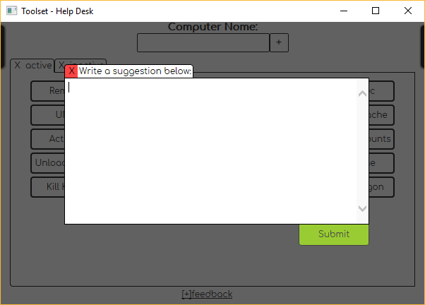

Figure 6 (top)

* * *