RemoteKbM
An 87 key keyboard and relative touchpad
for the Savant True Control UI.

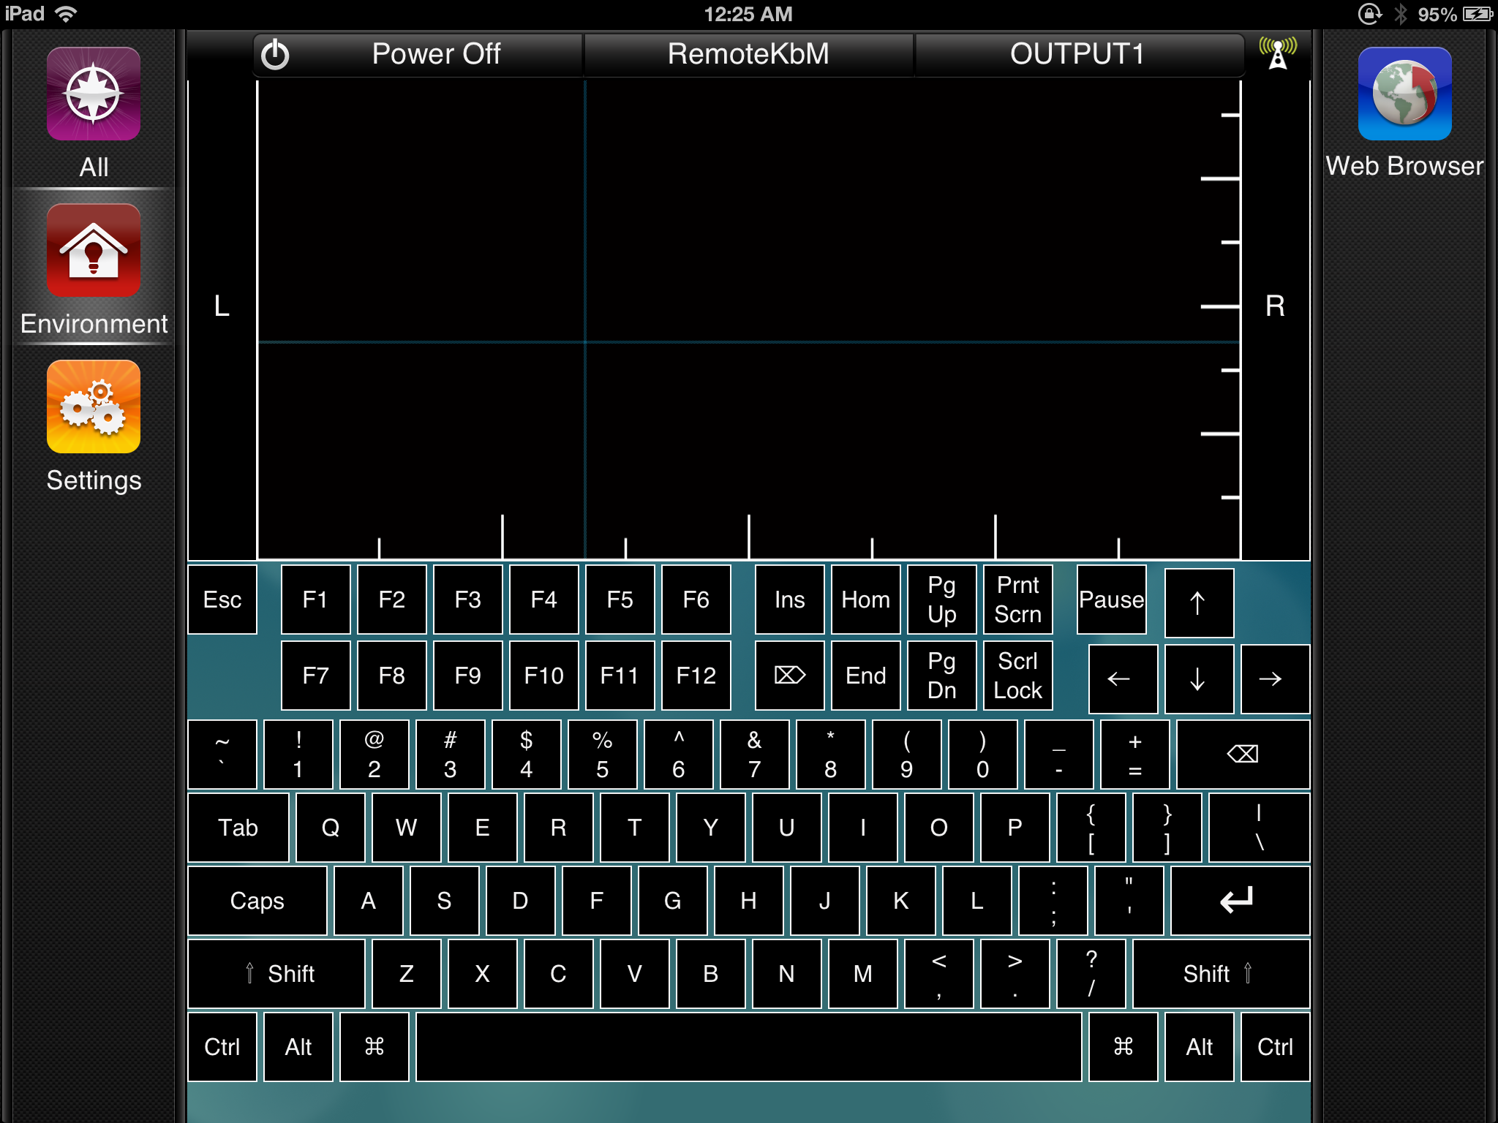

Introduction

Savant produce one of the best control and automation systems available, anywhere in the world. Yet, despite this fact, in some ways the user interface is quite lacking. One of the things that has always particularly frustrated me, is the complete lack of a relative touchpad, to send mouse movements to a remote computer, or a keyboard with which to send key strokes. This frustration was particularly evident when I tried to use the TrueCommand interface for web browsing. I always found that the 'joystick' style control employed in this part of the UI was clumsy, awkward and very very slow to use. In addition, this interface made no provision, whatsoever, for sending key strokes. So while I could use the mouse to navigate to the Google search page, I couldn't actually type in a search. While we can invoke the built in iOS keyboard in a Savant UI, it can't be used to send keystrokes to a remote machine, and it also lacks special keys like CMD, Option, Esc...... etcetera....

When I requested these features from Savant, their reply was “that's not possible to do in our interface”. Perhaps stupidly, I refused to accept this answer. Many people also said that a BT keyboard and mouse was the way to go, but again I didn't feel that was an adequate solution. I kept asking, why should I have to keep a BT keyboard/trackpad beside my couch, just to search YouTube or Google, when I already have an iPad in my hands? It seemed inefficient and illogical to have two pieces equipment, cluttering up my already crowded lounge room, when I felt it should be possible to consolidated them both into one.

Having already grown increasingly annoyed with this situation, when I was challenged by a workmate (a Savant programmer of considerable skill, who also believed that this couldn't be done) to make it work, I accepted.

In the following pages, I will describe the interface, how it works and how to install the components required (many of which I wrote myself) to build this interface into a Savant control system, and augment the existing control methods already employed for devices like:

Plex Media Server
Windows Media Center
MythTV
SageTV
XBMC

The Problem

In finding a solution to this problem, I had to work though the following issues.

1> I had to determine if it was in fact possible to build a relative trackpad using the Savant UI components.

In my minds eye, to create a relative touchpad interface, we would need to capture positional information regarding the touch event on the iPad screen. The most logical way to do this is to try and capture an X,Y co-oridinate from the touch. The keyboard was a no-brainer, I already knew it would be possible to do, just time consuming in it's functional details.

By playing around at the plist level within the themes files, I discovered that with the techniques known to me, it wasn't possible to land a touch event on two graphical elements simultaneously. I have heard rumours to the contrary, but I haven't been able to find any example code to determine how this might be achieved.

This made it very difficult to build a UI that would perform the way we wanted it to and give us continual X,Y co-ordinate data as the user swiped their finger across iPads the touch screen. I did however find a way.

I came to the realisation that, while multi-touch events might have been beyond my knowledge, it was possible to initiate touch events on multiple GUI elements sequentially and without lifting your finger off the screen. I was also aware at that time, that it is quite easy to create a button that is hidden when touched.

This lead me to the theory that I could stack a number of buttons in a layered row and column arrangement. When the user touched the top column button, it would disappear and reveal the row button underneath, which after another four pixel movement of the finger, would also register a touch event and disappear.

2> I had to design the UI and test it.

The shear number of buttons required for a screen 1536x1536 in resolution, made design of the UI cumbersome and time consuming in a Photoshop .psd. So I wrote a Bash shell scrip that generated the plist file directly, placing the row and column buttons according to algorithmic formula. This script went though quite a development phase of it's own, just trying to get this right, without becoming massive in itself.

3> I had to write a device profile to support the UI.

Deciding on the most appropriate service to use was quite a challenge, as there is no standard service category in Savant that really fits the bill. None of the existing services had standard action names that actually fit the requirements for a relative touchpad or a PC104 keyboard, nor did any existing service even have enough standard actions to fill the requirement of 87 individual keyboard keys (a PC104 keyboard minus the numeric keypad).

That left me with quite a problem because it also turns out that we can't dynamically assign custom workflows to a screen.plist element (at least not by any method that I know of), they have to be statically referenced in the screen.plist. That meant that writing all the required actions into the device profile as custom actions, would limit us to only one instance of the RemoteKbM device per RacePoint layout.

I briefly considered assigning the RemoteKbM device to the General Programmable Service Requests service, but that would have meant manually embedding a huge script to into the 'RunCLI' workflow for each instance of the RemoteKbM device as well as having to repeat this action on every Racepoint layout. This on top of the requirement to install the daemon script and it's dependencies on the target machine. I felt that while technically this would have worked, it was a huge additional burden on the integrator that needed to be avoided.

In the end, I used the Concierge service for several reasons.
1> It has no standard screen of it's own, so I could assign my own without conflicts.
2> It provided me with a single standard action that I could use for every ui event.

4> I had to write a daemon program to run on the target devices.

The daemon process was probably the most difficult of all. It not only needed to be fast and capable of passing key strokes and mouse movements to the underlying operating system, it also needed to be cross platform to reduce the development and support burden.

I chose Python to write the daemon process for several reasons
1> Python is a truly cross platform interpreted language that is almost as fast as C
2> Python is a massively extensible language with great features already built in
3> Python is easy to work with
4> I had already found several candidate Python modules for sending keystrokes and mouse movements to the operating system, that are also cross platform

The Method

The are 4 elements to discuss here. The touchpad UI element(s), the keyboard UI element(s), the device profile and the daemon process.

The touchpad:

The touchpad works by virtue of the way the column and row buttons are layered, and the actions that are fired on the “Press” and “Release” events.
In total there are currently 69 row buttons and 133 column buttons.

The column buttons are 16px wide and 698px high. They are logically divided into two groups. The “Upper” column group and the “Lower” column group. The column buttons in the upper group are arranged at 20px spacing, so they don't actually butt together. This leaves a small, 4px gap between each column in this group. The columns in the lower group are spaced in the same manner, but their positions are offset by 10px with respect to the upper group. This means that when viewed from above, each column in the lower group is overlapped by 6px on the left and right edges, by buttons in the upper group.

The row buttons are divided, grouped and layered in the same manner as the columns, but their spacing and offset values are vertically arranged instead of horizontally.

It's at this point important to remember that the Savant UI allows only 1 GUI element per layer. Collectively the rows and buttons are arranged in a kind of cross-hatching pattern, with a column occupying the upper most layer and a row button occupying the next, then another column button and so on.....

In the following screen shot, “top” columns and “top” rows are depicted in black. The “bottom” columns are depicted in pink whilst the “bottom” rows are green.

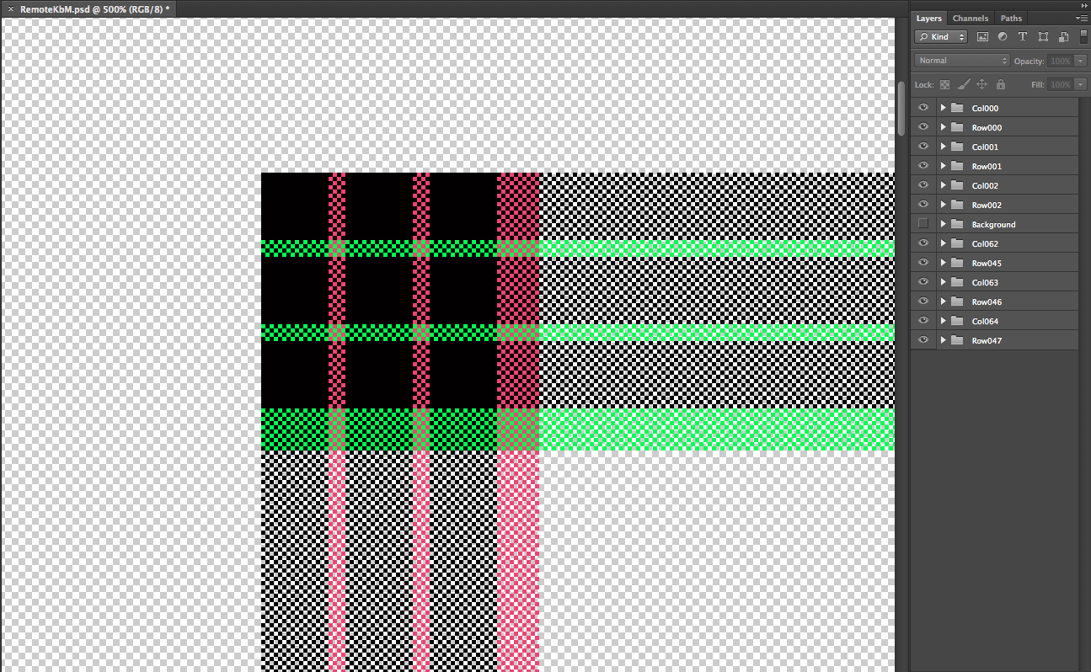
I settled on this layering scheme as a result of extensive testing. When using simpler layering schemes, I found that high speed finger movements, particularly on the iPad3, didn't trigger every column/row. This is mostly due to a lack of processor power on the iPad3. The iPad3 has a very high resolution screen and a low powered processor, making it's touch sensitivity very poor under these circumstances. As a result, when a high speed finger movement occurred, we would only trigger every 20th or 30th column/row, making the touchpad resolution very poor and resulting in very jerky and unpredictable mouse movements. Using this layering scheme, each column/row button has an increased area that is touchable. Each button in the top column group exposes an area 16px wide. When that button is hidden on a touch event, an area 12px wide is exposed on the corresponding button in the lower column group. In addition, an area 4px wide in the bottom column group, is always exposed to a “first touch”. Rows are arranged in the same manner. This greatly increases the chances of landing a touch event on successive columns/row, given that the elements are much larger than they would be in other arrangements. Using this scheme I was also able to better balance the UI element count to screen area ratio. It still doesn't trigger EVERY column/row when a fast movement occurs, but we at least land a touch on every 5th to 10th column/row which greatly improves the touch resolution over other layer schemes and helps to smooth out the mouse movement.

Early implementations of the touchpad actually consisted of an array of square buttons, each of which had a row/column address. Whilst this scheme performed very well in terms of touch sensitivity it had two major problems:
1> It had a very high ui element count to screen area ratio. The end result of this was a very small touch area with over 800 buttons in it. This made the screen.plist file unreasonable large and the iPad3 took nearly 6 seconds to load the page.
2> Any increase in the size of the touch area exponentially increased the number of UI elements, exacerbating the load times an screen.plist size problems.

In functional terms, there's very little to know about the touchpad. It doesn't support muti-touch, so no gestures :-( (hopefully this will change....)
However, it DOES support scrolling horizontally and vertically, by simply dragging a finger across the bottom of the touch area or up/down the right hand side.

Touching and immediately releasing the” L” or “R” buttons on either side of the touch area will send a click event to the daemon process. To perform a click and drag action, one must hold the button in question for approximately 2 seconds to “click latch”. This will emulate a mouse button hold on either the “L” or the “R” buttons. Simply touch and release to “un-latch” the mouse button.

The keyboard:

The way the keyboard works is pretty straight forward. For the most part, it's just a collection of 87 carefully placed toggle buttons, 96px square. We set the text on these button from state centre, so it will in the future be possible to build in language support. It you have a client who wants the keyboard to display Kanji, or simplified Chinese, or Cyrillic or Hebrew characters... it will be possible... soon...

To work around the lack of a double touch capability, for key combinations I have used the toggle UI buttons. When one wants to send, say, a Cmd+Z combo (undo), they simply toggle on the CMD button, then press the Z key, and toggle the CMD button off again. The key codes are not sent to the daemon script until the CMD button toggle is released. The CTRL and Option buttons work the same way.

The Shift buttons differ slightly, they are also toggle buttons, but unless they are being used as part of another key combo, pressing an alpha numeric button after setting the shift toggle on, will toggle the shift button off again. This produces a “one shot” effect similar to the native iOS keyboard.

The device profile:

Every button on the screen fires the “PowerOn” action in the device profile, either as the “Press” action or the “Release” or “ToggleRelease” action. The exact nature of this assign changes depending on the button in question and it's function.

State variables, that are not local to the iPad, are set as part of the status messages system are are only set when the appropriate messages are received from the daemon process. The “PowerOn” action does not set state variables. What that means is that toggle buttons will not toggle on unless the daemon is active on the target machine and communications between the Savant system host and the target, have been established.

#### RemoteKbM ####

1> Start RacePoint Blueprint
2> Open Savant Themes Manager
3> Select theme
4> Add a new screen using the blank template screen “RemoteKbM.psd”. Ensure that the name “RemoteKbM” is correctly referenced and bind this screen to the Concierge Service.
5> Commit your changes.
6> Close RBP
7> Open Finder
8> Navigate to your custom theme
9> “Right Click” and select “Show Package Contents”
10> Descend to Screens
11> Delete the directory RemoteKbM.psd.cache

