KINGDOMS AMID KATACLYSM

Dominion Authority - Tier 5 Abilities
Absolute Dominion Design Summary
Voice of God | Divine Schism
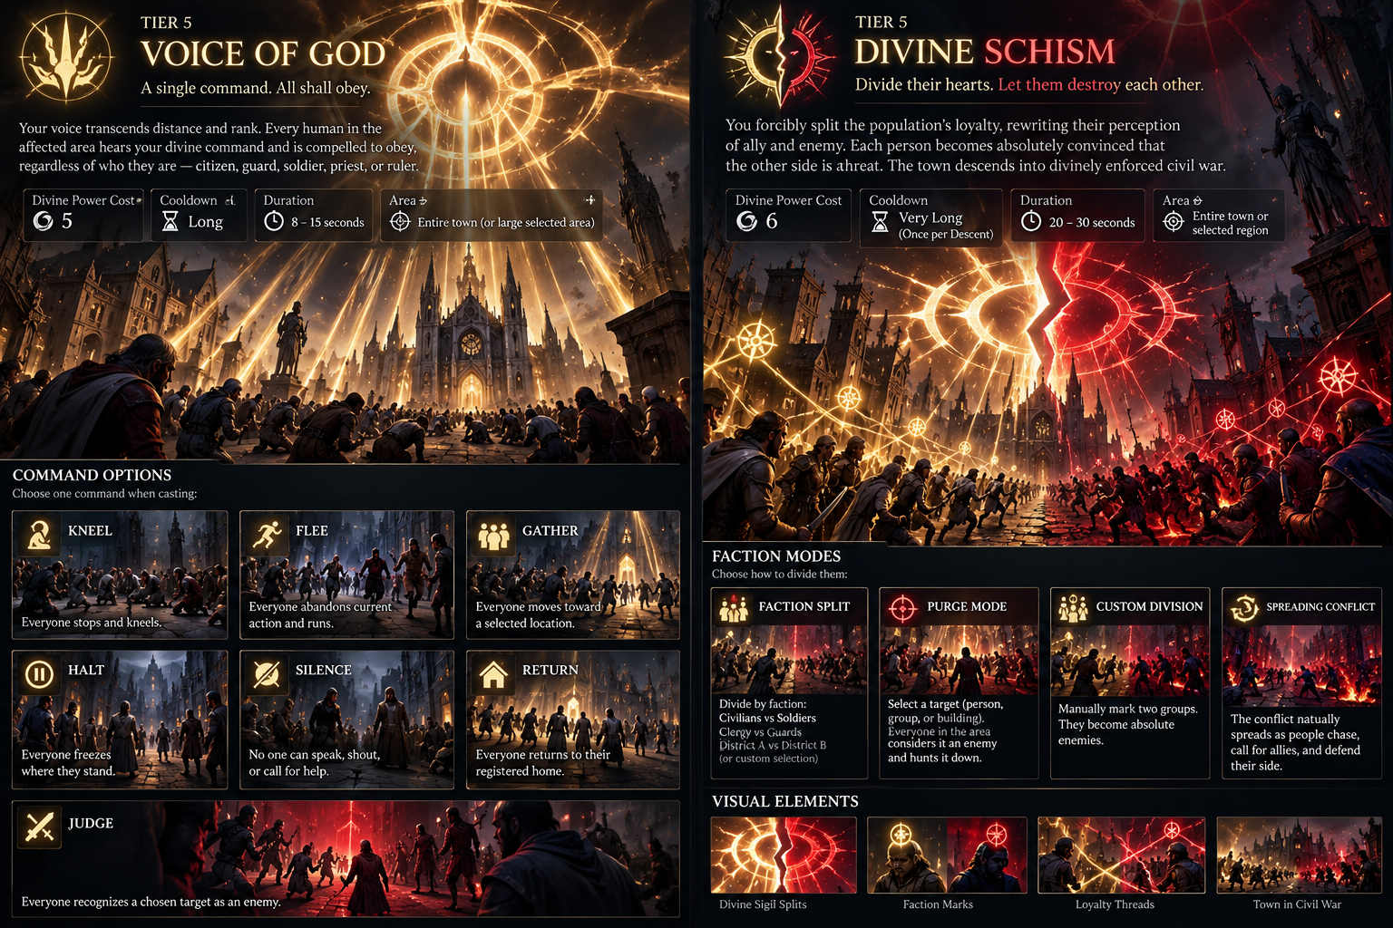
Tier 5 Dominion does not merely move larger crowds. It temporarily overrides human autonomy at the highest level: one ability enforces absolute obedience; the other rewrites loyalty and turns civilization against itself.

1. Tier 5 Dominion at a Glance
Ability | Loadout | Cast | Duration | Scope | Primary Role
Voice of God | 5 DP | Command | 8-15 s | Town | Immediate absolute obedience; emergency control.
Divine Schism | 6 DP | Loyalty rewrite | 20-30 s | Town / large region | Organized internal conflict; aggressive Dominion.
Design rule: Tier 5 is broader and more absolute, but it must not replace low-tier precision. Mind Whisper, Possession, Oathbound, and other lower-tier powers remain cheaper, quieter, and better for surgical objectives.

2. Voice of God
CORE FANTASY
A single divine command. All shall obey. Every human in the affected settlement hears and understands the command regardless of role - citizen, guard, soldier, priest, engineer, commander, merchant, worker, or responder. Rank does not grant mental resistance; only explicit anti-divine protection can block the effect.
GAMEPLAY FUNCTION
- Voice of God is broad, immediate, short, and expensive.
- Temporarily overrides the current human Intent with a Divine Command.
- After the command ends, NPCs reevaluate the current situation rather than blindly returning to an obsolete state.
- Recommended as a very long cooldown or once-per-descent ability.
COMMAND MODES
- KNEEL: Everyone stops and kneels. Work, combat, evacuation, rituals, repairs, firefighting, and communication stop for the duration.
- HALT: Everyone freezes current movement and action. Best for interrupting an emergency response or setting up another power.
- FLEE: Everyone abandons current intent and enters extreme flight behavior away from the chosen origin or threat point.
- GATHER: Requires a destination. Everyone attempts to converge on a selected building, plaza, landmark, or valid ground position.
- RETURN: Everyone attempts to return to their registered home or fallback residence anchor.
- SILENCE: Humans cannot shout, spread social awareness, ring alarms, issue human commands, or call for help.
- JUDGE: Requires a target. Every affected human temporarily recognizes the chosen person, group, faction, or entity as an enemy.
VISUAL LANGUAGE
- A gigantic white-gold Dominion sigil appears above the town.
- A luminous authority wave sweeps across the settlement.
- Thin golden threads briefly connect the divine sigil to affected humans.
- Each human receives a small command-specific icon; the large VFX quickly fades to preserve readability.
RECOMMENDED BALANCE
- Divine Power loadout cost: 5 DP.
- Duration: about 8-15 seconds depending on command.
- Manifestation Strain: approximately 10-20 seconds.
- Alarm: major increase; civilization immediately recognizes direct divine intervention.

3. Divine Schism
CORE FANTASY
Divide their hearts. Let them destroy each other. The god rewrites loyalty itself. Humans do not become insane; they become absolutely convinced that their assigned side is righteous and the opposing side is the enemy.
GAMEPLAY FUNCTION
- Creates organized, purposeful internal conflict rather than random frenzy.
- Affected humans keep their normal capabilities: soldiers fight like soldiers, guards like guards, while civilians use simple melee, tools, pushing, or flee if incapable.
- Temporary Dominion factions override normal faction relationships while active; real consequences such as deaths, injuries, blocked routes, and destruction remain afterward.
- Recommended as once per descent because of its strategic impact and simulation cost.
SCHISM MODES
- FACTION SPLIT: Divide humans by category or affiliation, such as civilians vs soldiers, clergy vs guards, responders vs military, or District A vs District B.
- PURGE: Choose one person, group, faction, building occupants, or tagged category. Everyone affected considers that target an enemy and hunts or opposes it.
- CUSTOM DIVISION: Manually designate two groups or regions and make them absolute enemies.
- SPREADING CONFLICT: Begin with hostile groups and allow nearby humans to choose sides based on proximity, allies, leaders, social grouping, and location.
VISUAL LANGUAGE
- A gigantic golden Dominion sigil forms above the town and violently splits in two.
- One half remains white-gold; the other becomes crimson-gold.
- Affected humans receive small faction marks; allies may briefly show thin loyalty threads.
- For Purge, the condemned target receives a bright crimson judgment sigil and nearby affected humans turn toward it together.
RECOMMENDED BALANCE
- Divine Power loadout cost: 6 DP.
- Duration: about 20-30 seconds.
- Manifestation Strain: approximately 15-30 seconds.
- Alarm: extremely high once conflict begins; town coordination becomes severely disrupted.

4. Why the Two Abilities Are Different
Design Axis | Voice of God | Divine Schism
Core control | One universal command | Rewrites loyalty and hostility
Behavior | Immediate and direct | Autonomous and emergent
Duration | Short | Longer
Aggression | Optional through JUDGE | Primary identity
Best use | Emergency control / perfect setup | Civil war / sabotage civilization response
Player fantasy | Everyone obeys me now | I decide who humanity considers its enemy

5. Cross-Tier Design Rule
Higher Tier does not mean a lower-tier ability becomes obsolete. Tier 5 gives absolute scope and conceptual control; Tier 1-4 remain more efficient, precise, quiet, persistent, or specialized.
- Use Mind Whisper to move one mission-critical priest instead of spending Voice of God.
- Use Possession when the objective requires operating a gate, relic, ritual device, or restricted interaction.
- Use Divine Congregation when the goal is sustained population concentration rather than a brief universal command.
- Use Mark the Heretic, Turncoat, Mob Verdict, or Manufactured Hatred when the player needs targeted aggression without committing the entire town to Divine Schism.

6. Implementation Principles
- All human roles use a shared Dominion-compatible interface or HumanActor/DominionTarget layer.
- Do not permanently overwrite NPC faction or AI data. Apply temporary Intent, loyalty, hostility, or command override layers.
- Recommended override priority: Divine Dominion Override -> Mission Override -> Emergency Intent -> Normal Role/Faction.
- After the effect ends, remove only the temporary Dominion layer and force AI reevaluation.
- For Divine Schism, use spatially limited enemy queries and low-frequency target reevaluation instead of every NPC scanning the full town every frame.

7. Final Tier 5 Dominion Identity
Voice of God represents absolute obedience: one command that the entire settlement must follow for a brief moment.
Divine Schism represents absolute control over allegiance: the god decides who humans love, defend, condemn, and fight.
Together they define Tier 5 Dominion as control over human autonomy itself - not simply a larger crowd-control radius.

