Lab 7 : A Timed Speed Boost with Sound, Particles and a HUD

Lab Overview:
In this lab you will add a Speed Boost power-up to the game. Power-ups float in the level. When the player touches one, it disappears, plays a sound and a particle burst, and makes the player run faster for a limited time. A HUD icon with a countdown stays on screen for as long as the boost is active. A few seconds after being collected, the power-up reappears so it can be collected again.
By the end of the lab you should be able to explain how a timer counts down with Time.deltaTime, how Invoke runs a method a few seconds later, how to build and spawn a particle effect prefab, how to play a sound with an AudioSource, why each script in a feature should have one job, and how to show and hide a HUD element from code.
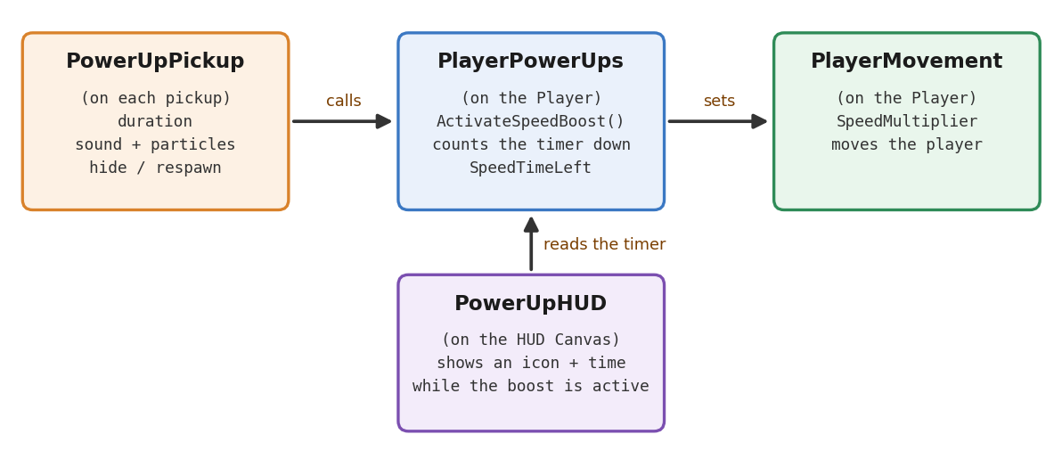
Figure 1: The four scripts in this lab and how they talk to each other

Before You Start:
- Get the starter project:
- Open the GitHub Classroom assignment (or the repo) and clone it:
https://github.com/amcnabbbaltar/450_541_Lab7_2026
- Open the project in Unity 6, then open Assets/Scenes/SampleScene.
- Look at what you are starting with:
- The Lab 7 starter contains the finished project from the previous labs. Before adding anything, find these:
- Assets/Scripts: PlayerMovement, PlayerAnimatorController, RollBehaviour, ScoreManager and ScorePickup. Put every new script you create in this folder.
- From Lab 6: the Flip double jump, the StartMenu and EndScene scenes, and the HUD Canvas with the score.
- Assets/Prefab/Pickup: the spinning coin from Lab 4. Our power-up is built the same way: an empty parent with the trigger and scripts, and an animated Visuals child.
- The Player in the scene is tagged Player and has a Rigidbody, a Capsule Collider, Player Movement and Player Animator Controller.
- Check that the project runs:
- Select the Player and look at its Animator component. Avatar must be X BotAvatar. If it shows None or Missing, click the circle next to the field and choose X BotAvatar.
- Press Play: the character should walk, run, jump and roll, and coins should print the score in the Console.
Good to know: The Player in the scene is an instance of a prefab. Components and values you add to it in this lab show up in bold with a blue line in the Inspector. These are called overrides and they are fine.

Step-by-Step Solution:

Task 1: Give PlayerMovement a Speed Multiplier
A power-up needs something to change. We give PlayerMovement one simple setting, a speed multiplier, that other scripts are allowed to change. PlayerMovement doesn't know anything about power-ups, pickups or timers: it just moves at whatever multiplier it is given.
- Add the multiplier property:
- Open PlayerMovement (in Assets/Scripts). Add this property below the public bool IsGrounded => isGrounded; line:
// Multiplies the normal speed. 1 = normal, 1.5 = 50% faster.
// Other scripts (like PlayerPowerUps) are allowed to change it.
public float SpeedMultiplier { get; set; } = 1f;
- Unlike IsGrounded, this property has a public set, because we want another script to change it.
- = 1f gives it a starting value: by default the player moves normally.
- Use the multiplier:
- In MovePlayer(), multiply the speed:
Vector3 targetVelocity = moveDirection * moveSpeed
* SpeedMultiplier;
- Save and press Play. Nothing should have changed: the multiplier is 1.
- Quick test: temporarily change = 1f to = 2f, save, and press Play. The player should run twice as fast. Put it back to 1f afterwards.
One job per script: We could put the power-up timer straight into PlayerMovement, but then it would grow every time we add a new power-up. Instead, PlayerMovement only exposes a setting, and a new PlayerPowerUps script (Task 2) decides when and for how long that setting changes. Each script has one job, which makes both easier to read, test and reuse.
- Check your understanding:
- Why does SpeedMultiplier have a public set, while IsGrounded only has a getter?
SpeedMultiplier has a public set so the power-up script can change the speed. IsGrounded only needs to be read by other scripts.

Task 2: Create the PlayerPowerUps Script
PlayerPowerUps lives on the Player. When it receives a speed boost, it starts a timer, changes the speed multiplier in PlayerMovement, and puts it back to normal when the timer runs out.
- Create the script:
- Select the Player, click Add Component, create a new script called PlayerPowerUps, move it into Assets/Scripts, and replace its contents with:
using UnityEngine;

// Gives the player a speed boost for a limited time.
public class PlayerPowerUps : MonoBehaviour
{
[SerializeField] private float boostMultiplier = 1.5f; // 50% faster

// Seconds of boost left. The HUD reads it; only this script changes it.
public float SpeedTimeLeft { get; private set; }

private PlayerMovement movement;

private void Start()
{
movement = GetComponent<PlayerMovement>();
}

// Called by the pickup. Collecting another boost restarts the timer.
public void ActivateSpeedBoost(float duration)
{
SpeedTimeLeft = duration;
movement.SpeedMultiplier = boostMultiplier;
}

private void Update()
{
if (SpeedTimeLeft <= 0f) return; // no boost running

SpeedTimeLeft -= Time.deltaTime;

if (SpeedTimeLeft <= 0f)
{
movement.SpeedMultiplier = 1f; // back to normal speed
}
}
}
- Understand the important lines:
- SpeedTimeLeft is the timer. Above 0 means the boost is running.
- { get; private set; } means any script can read it, but only PlayerPowerUps can change it, like Score in ScoreManager.
- Time.deltaTime is the number of seconds since the last frame (about 0.016 at 60 FPS). Subtracting it every frame makes the timer count real seconds, whatever the frame rate.
- When the timer crosses 0, the multiplier goes back to 1 and the player runs at normal speed again.

- Check your understanding:
- What would happen if Update() subtracted 1 from SpeedTimeLeft every frame instead of Time.deltaTime?
The boost would end after 10 frames instead of 10 seconds. It would be much too fast and would depend on the frame rate.

- Update() checks SpeedTimeLeft <= 0f twice. What is each check for?
The first check stops the code if there is no boost. The second check puts the speed back to normal when the timer ends.

Task 3: Build the Power-Up Object
The power-up uses the same structure as the coin from Lab 4: an empty parent that holds the trigger and the scripts, and a Visuals child that we animate and hide. The parent stays active the whole time, which is what lets it play a sound and come back after it is "gone".
- Create the parent and the child:
- Right-click the Hierarchy > Create Empty, rename it SpeedBoostPickup, and place it somewhere the player can reach, with Position Y at 0.6.
- Right-click SpeedBoostPickup > 3D Object > Cube and rename it Visuals. Set Rotation to 45, 0, 45 and Scale to 0.4, 0.4, 0.4 so it looks like a diamond.
- Remove the Box Collider from Visuals (right-click the component header > Remove Component). The parent will have the collider.
- In Assets/Material, create a material (Create > Material) called SpeedBoostMaterial, make it bright yellow, and drag it onto Visuals.
- Make the parent a trigger:
- Select SpeedBoostPickup and add a Sphere Collider. Check Is Trigger and set Radius to 0.6.
Trigger reminder: A trigger is not solid. The player walks through it, and Unity calls OnTriggerEnter on our script the moment the player enters it. Triggers only fire if one of the two objects has a Rigidbody, and our Player does.
- Add an Audio Source to the parent:
- With SpeedBoostPickup selected, click Add Component > Audio > Audio Source.
- Uncheck Play On Awake. Leave Audio Resource empty: the script will choose the sound.
- Leave Spatial Blend at 0 (2D) so the sound has the same volume wherever the camera is.
- Check that the Camera object in the scene has an Audio Listener component: it is the "ears" of the scene.

- Animate the Visuals:
- Select SpeedBoostPickup and open Window > Animation > Animation. Click Create and save the clip as PowerUpFloat in Assets/CoinAnimation.
- Click Add Property > Visuals > Transform and add Position and Rotation.
- Turn on Record. At 0:30 set Visuals Position Y to 0.3. At 1:00 set Visuals Rotation Y to 360. Turn Record off.
- Select PowerUpFloat in the Project window and make sure Loop Time is checked.
- Check the property names read Visuals : Position and Visuals : Rotation, not SpeedBoostPickup. We animate the child so every copy floats around its own spot.

Task 4: Get a Pickup Sound
The repo has no sounds yet, so you will find one yourself, the way you would for your own game.
- Find a sound online:
- Go to kenney.nl/assets and look at the free audio packs (for example the interface, digital or impact sound packs). Kenney's assets are CC0: free to use with no conditions.
- freesound.org has many more sounds, but each one has its own licence. Read it before you download.
- Pick a short, bright sound that says "power-up!" (a chime, a rising blip, a sparkle). Under one second is best. Download it as .wav or .ogg.
Check the licence: Sounds found through a normal web search are usually not free to use. CC0 means you can use the file with no conditions. CC BY means you can use it if you credit the author. Write your sound's details in the answer box below.
- Which sound did you choose? Give its file name, author, website and licence.
I used coinCollect.wav and renamed it PowerUpSound.wav. It is from Mixkit: https://mixkit.co/free-sound-effects/coin/. The licence is the Mixkit Sound Effects Free License. I could not find the individual creator name.

- Import it:
- In the Project window, create a folder Assets/Audio.
- Drag the sound file from your computer into Assets/Audio and rename it PowerUpSound.
- Select it and click the play button in the Inspector preview to hear it.
AudioClip vs. AudioSource: The sound file is an AudioClip: just the data. An AudioSource is the speaker that plays clips. In Task 6, our script will ask the pickup's AudioSource to play this clip once.

Task 5: Create a Particle Burst Effect
A Particle System spawns lots of tiny images (particles) and moves them according to the settings you choose: sparks, smoke, rain, magic. We will make a short burst of sparkles, save it as a prefab, and spawn a copy every time a power-up is collected.
- Create the Particle System:
- In the Hierarchy, right-click > Effects > Particle System. Rename it PowerUpBurst.
- By default it shoots a constant stream of white particles upward. You will now turn that into a one-shot burst.
- Main module (the top section of the Particle System component):
- Duration: 0.5. Looping: unchecked. The effect plays once and stops.
- Start Lifetime: 0.6. Each particle lives 0.6 seconds.
- Start Speed: 4. Start Size: 0.15.
- Start Color: yellow (match your pickup).
- Gravity Modifier: 0.5, so the sparkles fall a little.
- Simulation Space: World. Play On Awake: checked, so it plays as soon as it is spawned.
- Stop Action: Destroy. When the effect is finished, Unity deletes the object for us.
- Emission and Shape:
- Open the Emission module. Set Rate over Time to 0, then click + under Bursts to add one burst: Time 0, Count 40.
- Open the Shape module. Set Shape to Sphere and Radius to 0.2, so particles fly out in every direction.
- Make the particles fade and shrink:
- Tick Color over Lifetime, click the gradient bar and set the top-right key (alpha) to 0. Particles now fade out.
- Tick Size over Lifetime and choose a curve that goes down from 1 to 0. Particles now shrink as they fade.
- Click Restart in the small Particle Effect panel in the Scene view to preview the burst. Tweak the values until you like it.
- Save it as a prefab:
- Create a folder Assets/Prefab/Effects and drag PowerUpBurst from the Hierarchy into it.
- Delete PowerUpBurst from the Hierarchy. From now on, the script will create copies of the prefab when they are needed.
Why Stop Action: Destroy? Every pickup creates a new effect object. Without Stop Action: Destroy, those finished effects would stay in the scene forever, invisible but still using memory. You can watch them appear and disappear in the Hierarchy while playing.

Task 6: Write the PowerUpPickup Script
Now we connect everything. When the player touches the pickup, the script gives the player the power-up, plays the sound and the particle burst, hides the pickup, waits, and shows it again.
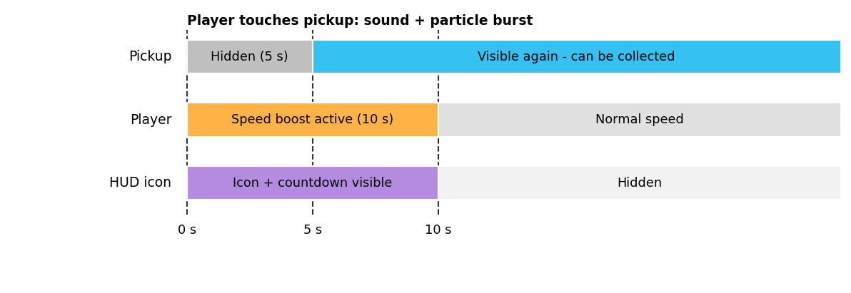
Figure 2: What happens after the player touches a pickup (default values)
- Create the script:
- Select SpeedBoostPickup (the parent), click Add Component, create a script called PowerUpPickup, move it into Assets/Scripts, and replace its contents with:
using UnityEngine;

// A speed boost pickup. When the player touches it, it gives the boost,
// plays a sound and particles, hides, and comes back a few seconds later.
public class PowerUpPickup : MonoBehaviour
{
[SerializeField] private float duration = 10f; // boost length
[SerializeField] private float respawnDelay = 5f; // time hidden
[SerializeField] private GameObject visuals; // child to hide
[SerializeField] private AudioClip pickupSound;
[SerializeField] private GameObject pickupEffect; // particle prefab

private void OnTriggerEnter(Collider other)
{
// Only the player has a PlayerPowerUps component
PlayerPowerUps powerUps = other.GetComponent<PlayerPowerUps>();
if (powerUps == null) return;

powerUps.ActivateSpeedBoost(duration);

// Sound and particles
GetComponent<AudioSource>().PlayOneShot(pickupSound);
Instantiate(pickupEffect, transform.position, Quaternion.identity);

// Disappear, and call Reappear() after respawnDelay seconds
visuals.SetActive(false);
GetComponent<Collider>().enabled = false;
Invoke(nameof(Reappear), respawnDelay);
}

private void Reappear()
{
visuals.SetActive(true);
GetComponent<Collider>().enabled = true;
}
}
- Fill in the Inspector:
- Duration: 10. Respawn Delay: 5.
- Visuals: drag the Visuals child in.
- Pickup Sound: drag PowerUpSound from Assets/Audio.
- Pickup Effect: drag the PowerUpBurst prefab from Assets/Prefab/Effects.
- Understand the important lines:
- other.GetComponent<PlayerPowerUps>() looks for PlayerPowerUps on whatever touched the trigger. Only the Player has one, so coins, walls and the floor are ignored.
- PlayOneShot(pickupSound) plays the clip once on the pickup's Audio Source.
- Instantiate(prefab, position, rotation) creates a new copy of a prefab in the scene. Here it puts the particle burst exactly where the pickup is.
- Invoke(nameof(Reappear), respawnDelay) asks Unity to call Reappear() in 5 seconds. Meanwhile the game keeps running normally. nameof turns the method name into text, and gives a compile error if you mistype it.
Why hide the child instead of the whole pickup? Destroy(gameObject) (what the coin does) removes the pickup for good, so it could never come back. Turning off the whole pickup would also turn off its Audio Source, cutting the sound. Hiding only the Visuals child and disabling the collider makes the pickup look gone and stop working, while the parent stays active to play the sound and bring it back.
- Test the Speed Boost:
- Press Play and run through the pickup. You should hear the sound, see the burst, and the pickup should vanish.
- The player now runs faster for 10 seconds, then goes back to normal speed.
- After 5 seconds the pickup reappears and can be collected again. Collecting it again while the boost is active restarts the 10 seconds.
Nothing happens? Check that the Sphere Collider has Is Trigger ticked and that the Player has the PlayerPowerUps component.
Burst but no sound? Check Pickup Sound is filled, the Audio Source volume isn't 0, and the Game view's Mute Audio button is off.
Sound but no burst? Check Pickup Effect is filled with the prefab from the Project window, not an object from the Hierarchy, and that the prefab has Play On Awake checked.
Error: MissingComponentException (AudioSource)? The pickup has no Audio Source. Go back to Task 3 and add one.
The pickup never comes back? The Visuals slot probably points at the parent instead of the child.
- Make it a prefab and place a few:
- Drag SpeedBoostPickup from the Hierarchy into Assets/Prefab to make it a prefab.
- Place two or three copies around the level, for example at the start of a long straight path where the extra speed is useful.

- Check your understanding:
- Why is the boost timer counted down in PlayerPowerUps instead of in the pickup? (Hint: what would happen to the boost if the pickup respawned, or was destroyed?)
The boost is on the player, so its timer should be there too. This lets the boost keep working even if the pickup respawns or gets destroyed.

- The pickup creates a new PowerUpBurst every time it is collected. Why don't the finished effects pile up in the Hierarchy?
Stop Action is set to Destroy. This deletes the effect when the particles are finished.

Task 7: Show the Speed Boost on the HUD
The player needs to know the boost is active and how long it will last. We will add a small icon with a countdown in the top-left corner of the screen. It is visible for the entire time the boost is active, and hidden the rest of the time.
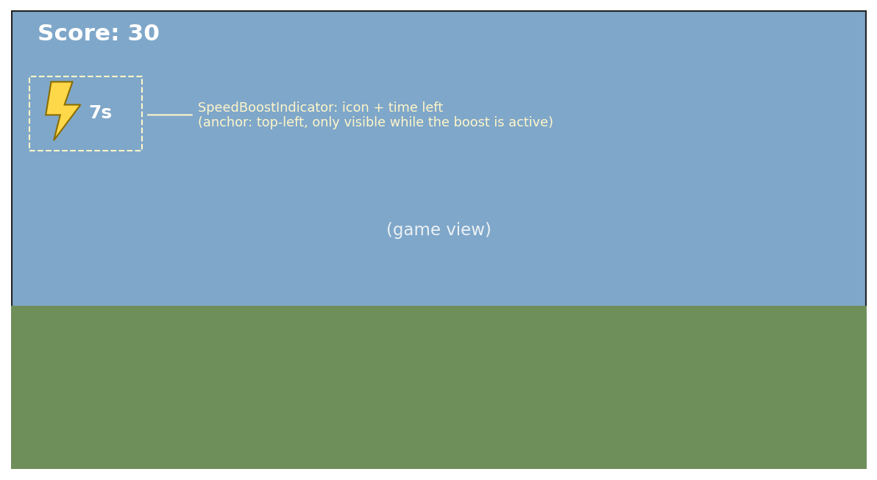
Figure 3: HUD layout while the Speed Boost is active
- Find an icon online:
- Open game-icons.net (simple icons, CC BY 3.0 licence) or kenney.nl/assets (UI and icon packs, CC0 licence).
- Find an icon that says speed: a lightning bolt, a running shoe, wind lines...
- Download it as a PNG with a transparent background, in white if the site lets you choose colours. 256 x 256 is plenty. Avoid SVG files: Unity can't use them as UI images without an extra package.
- Which icon did you choose? Give its name, author, website and licence.
I used Bolt spell cast by Delapouite from game-icons.net. The licence is CC BY 3.0. Link: https://game-icons.net/1x1/delapouite/bolt-spell-cast.html.

- Import the icon as a sprite:
- Create a folder Assets/UI, drag the PNG into it and rename it SpeedIcon.
- Select it. In the Inspector set Texture Type to Sprite (2D and UI), keep Sprite Mode on Single, make sure Alpha Is Transparency is checked, and click Apply.

Texture vs. sprite: A texture is just the grid of pixels in the image file. A sprite is a 2D graphic Unity makes from a texture. UI Images can only draw sprites, so every picture you want on a Canvas has to be imported as a sprite first.
- Find the HUD Canvas:
- Use the HUD Canvas you made in Lab 6, with the ScoreText in the top-left corner. The new icon goes just below the score.
- If your scene has no HUD, create one: right-click the Hierarchy > UI > Canvas, rename it HUD, and in the Canvas Scaler set UI Scale Mode to Scale With Screen Size, Reference Resolution to 1920 x 1080, and Match to 0.5.
Why Scale With Screen Size? With the default Constant Pixel Size, an icon that looks fine at 1920 x 1080 looks tiny on a 4K screen. Scale With Screen Size designs the UI for one reference resolution and scales it for every other screen.
- Build the Speed Boost indicator:
- Right-click HUD > Create Empty, rename it SpeedBoostIndicator. Anchor preset: hold Alt + Shift and click top-left. Pos X 40, Pos Y -130, Width 160, Height 64. That puts it just under the score.
- Right-click SpeedBoostIndicator > UI > Image, rename it Icon. Anchor preset Alt + Shift + middle-left, Width 56, Height 56. Drag your SpeedIcon sprite into Source Image, tick Preserve Aspect, and set Color to yellow.
- Right-click SpeedBoostIndicator > UI > Text - TextMeshPro, rename it TimeText. If Unity asks, click Import TMP Essentials. Anchor preset Alt + Shift + middle-left, Pos X 70, Width 90, Height 64. Text 10s, Font Size 36, Bold, vertical alignment middle.
- If your icon isn't white, leave the Image Color white so it keeps its own colours.

Anchors in one sentence: The anchor is the point of the screen an element is attached to. An indicator anchored to the top-left keeps the same distance from that corner, whatever the size of the window.
- Create the PowerUpHUD script:
- Select HUD, click Add Component, create a script called PowerUpHUD, move it into Assets/Scripts, and replace its contents with:
using UnityEngine;
using TMPro; // TMP_Text

// Shows the speed boost icon and seconds left while the boost is on.
public class PowerUpHUD : MonoBehaviour
{
[SerializeField] private PlayerPowerUps powerUps;
[SerializeField] private GameObject speedIndicator; // icon + time
[SerializeField] private TMP_Text speedTimeText;

private void Update()
{
float timeLeft = powerUps.SpeedTimeLeft;

// Visible for the whole boost, hidden the rest of the time
speedIndicator.SetActive(timeLeft > 0f);

// CeilToInt rounds 6.2 up to 7, so we never show 0s too early
speedTimeText.text = Mathf.CeilToInt(timeLeft) + "s";
}
}
- Fill in the three slots: Power Ups (drag the Player, Unity picks its PlayerPowerUps component), Speed Indicator (SpeedBoostIndicator) and Speed Time Text (its TimeText child).
- The HUD only reads the timer. PlayerPowerUps owns it, so the icon and the boost always start and end at the same moment.
- The indicator is hidden with SetActive. That is safe here because PowerUpHUD is on the HUD object, not on the indicator, so its Update() keeps running while the indicator is hidden.

- Test the HUD:
- Press Play. The icon is not visible.
- Collect a Speed Boost: the icon appears and counts down from 10s. It disappears exactly when the player slows down again.
- Collect another boost while the first is active: the countdown jumps back to 10s.
NullReferenceException in PowerUpHUD? One of the three slots is empty. The error message gives the line number: check which variable that line uses.
The icon is a white square? Its Source Image is empty, or the PNG has no transparent background.
Can't drag the PNG into Source Image? Its Texture Type is still Default. Set it to Sprite (2D and UI) and click Apply.
- Check your understanding:
- The icon must stay visible for the entire time the boost is active. Which value decides that, and which script owns it?
The icon shows while SpeedTimeLeft is above 0. This value is controlled by PlayerPowerUps.

- Why is it a good idea for the HUD to only read SpeedTimeLeft instead of keeping its own timer?
This keeps the HUD and the boost on the same timer. The icon will disappear when the boost ends.

Optional Challenges:
- Warning blink: make the icon blink during the last 3 seconds of the boost.
- Clock icon: put a dark copy of the icon on top of it, set its Image Type to Filled with Fill Method Radial 360, and set its fillAmount from code so the icon drains like a clock.
- Respawn effect: play a smaller particle burst and a different sound when the pickup reappears.
- Speed trail: add a Trail Renderer to the Player and only enable it while the boost is active.
- Faster animation: the character slides a little at 1.5x speed because the Running clip plays at normal speed. Add a Float parameter to the Animator and use it as the Idle Walk Run state's Speed Multiplier.

Final Steps:
- Test Your Project:
- Press Play. Collect a Speed Boost and check: the sound plays, the burst appears, and the pickup vanishes and comes back 5 seconds later.
- The player runs faster for 10 seconds, then returns to normal speed.
- The HUD icon is visible for the whole 10 seconds and hides when the boost ends.
- Collect a boost while one is active: the timer restarts at 10 seconds.
- Check that everything from the starter project still works: walking, running, jumping, falling, rolling and coins.
- Submission:
- Save your fork of the repo.
- Submit your Assets folder zipped with this filled in and saved document in the assets folder.

