COMFY COZY CAFÉ
User Manual
Vanier College
Computer Science Department
Application Development (Desktop) Final Project
Kiara Bartuccio, Audreane Deschenes, Jia-Yu Joy Ho
Course: 420-331-VA (Sec-02)
Teacher: Syed Naseem Afzal
Table of Contents
Introduction 1
What does this Application provide? 1
System Requirements 1
Understanding the Multilingual System 2
How to switch languages 2
Database Overview 2
Starting the Application 3
The Start Screen 3
Main Menu 4
Hot Drink Menu 4
Cold Drink Menu 7
Pastry Menu 8
Shortcut 9
Cart System 9
Checkout Screen (Pickup and delivery) 10
Troubleshooting 11
Frequently asked questions (FAQ) 12
Who do you contact for help? 12

Introduction
Welcome to our Comfy Cozy Café, ordering system! This is a C# desktop application that is designed to help you choose your drinks and pastries quickly and efficiently. Allowing you to add your items to the virtual cart and choose whether you would prefer to have it delivered or to pick them up yourself. This guide will help you navigate our application and explain what you need to know to be able to work this system, even if you have never used a program like ours before!

This application is also offered in 3 languages:
- English (default)
- French
- Spanish

This allows our Comfy Cozy Café to target a larger audience!

What does this Application provide?
This system lets you:

- Browse Hot Drinks, Cold Drinks, Pastries, and prices
- Select sizes, quantity, and custom additions
- Review, edit, and remove items in the Cart
- Provide customer information for pickup and delivery
- A database
- Change the language of the entire application
- Provides confirmation messages

System Requirements
- Windows 10 or 11
- .NET Desktop Runtime
- Database files
- At least 300 MB of free space

Understanding the Multilingual System
This whole application supports English, as the default language, French, and Spanish.
Meaning that all:
- Buttons
- Labels
- Menus
- Messages
- Instructions
Can instantly switch between the 3 languages with the click of a button.
You DO NOT need to restart the application yourself.

How to switch languages
At the start menu, you will be presented with a “Start Order” button, however, if you look at the top of the form, you can see a drop-down menu titled “Language:” that allows you to select either:
- English (default)
- Français
- Espanol

Once you have selected the language of your choice, the entire application updates instantly, this includes menus, buttons, and instructions.

Database Overview
This application uses a database.
A database is a simple and safe storage place for information.
Ours keeps permanent records of the items:

- Name
- Price
- Quantity
- Size
- Add Ons
You do not need to know any programming or SQL.

Let’s take a walk through the application!

Starting the Application
- Download the Comfy Cozy Café ZIP file containing the .sln file
- Extract all that is in your ZIP folder
- Open the .sln file in Visual Studio 2022
- Click the run button to run the entire application

The Start Screen
Once you ran the application, you are then presented with the start screen. The start screen includes:
- Our logo for the café
Language selector
- A “Start Order” button in the middle of the screen
- A language selector at the very top of the screen
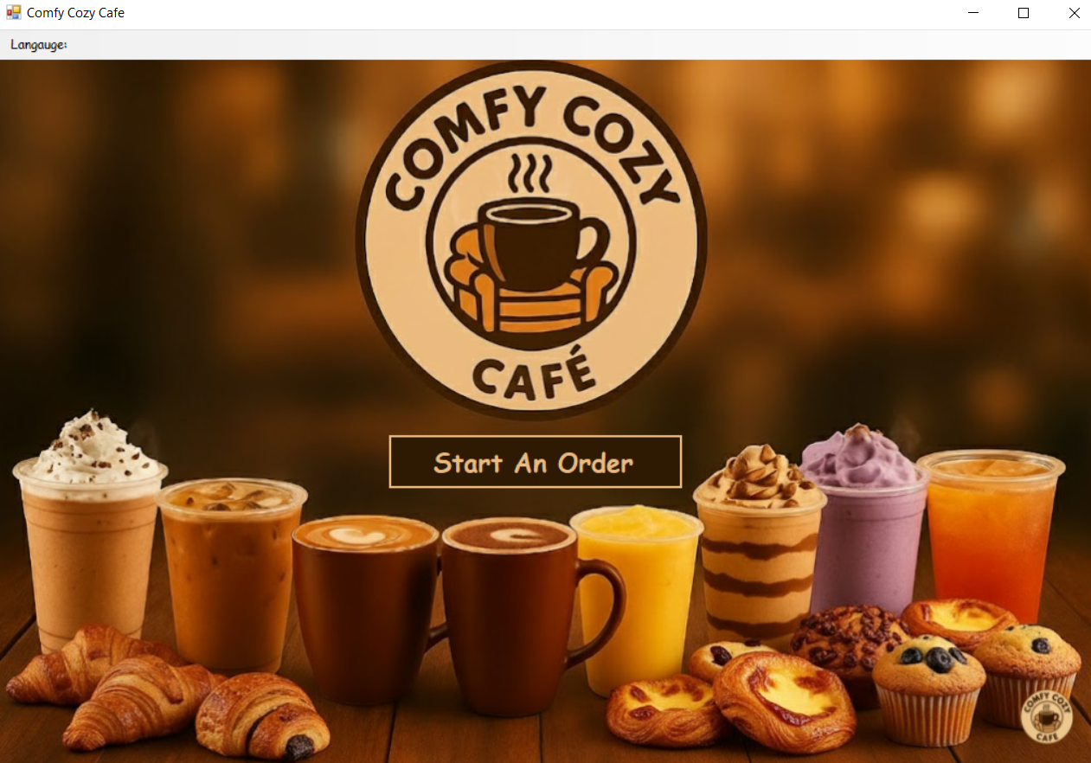
What to press when you want to start ordering

Main Menu
After selecting the “Start Order” button, you are then presented with 3 choices:
- Hot Drinks
- Cold Drinks
- Pastries
It is your decision to pick which items to select.

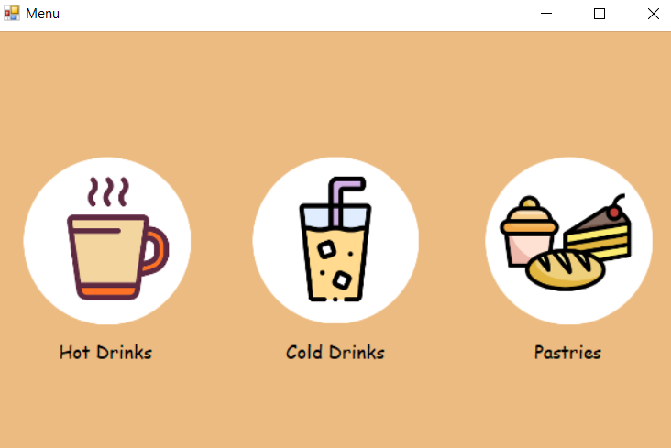
Click on 1 of 3 circles to select either Hot Drinks, Cold Drinks, or Pastries

Hot Drink Menu
Here you are presented with:
- Images of different types of hot drinks
- Names
- Size options (S(small) / M(medium) / L(large)
- Quantity
- Add-Ons
- Add to Cart button
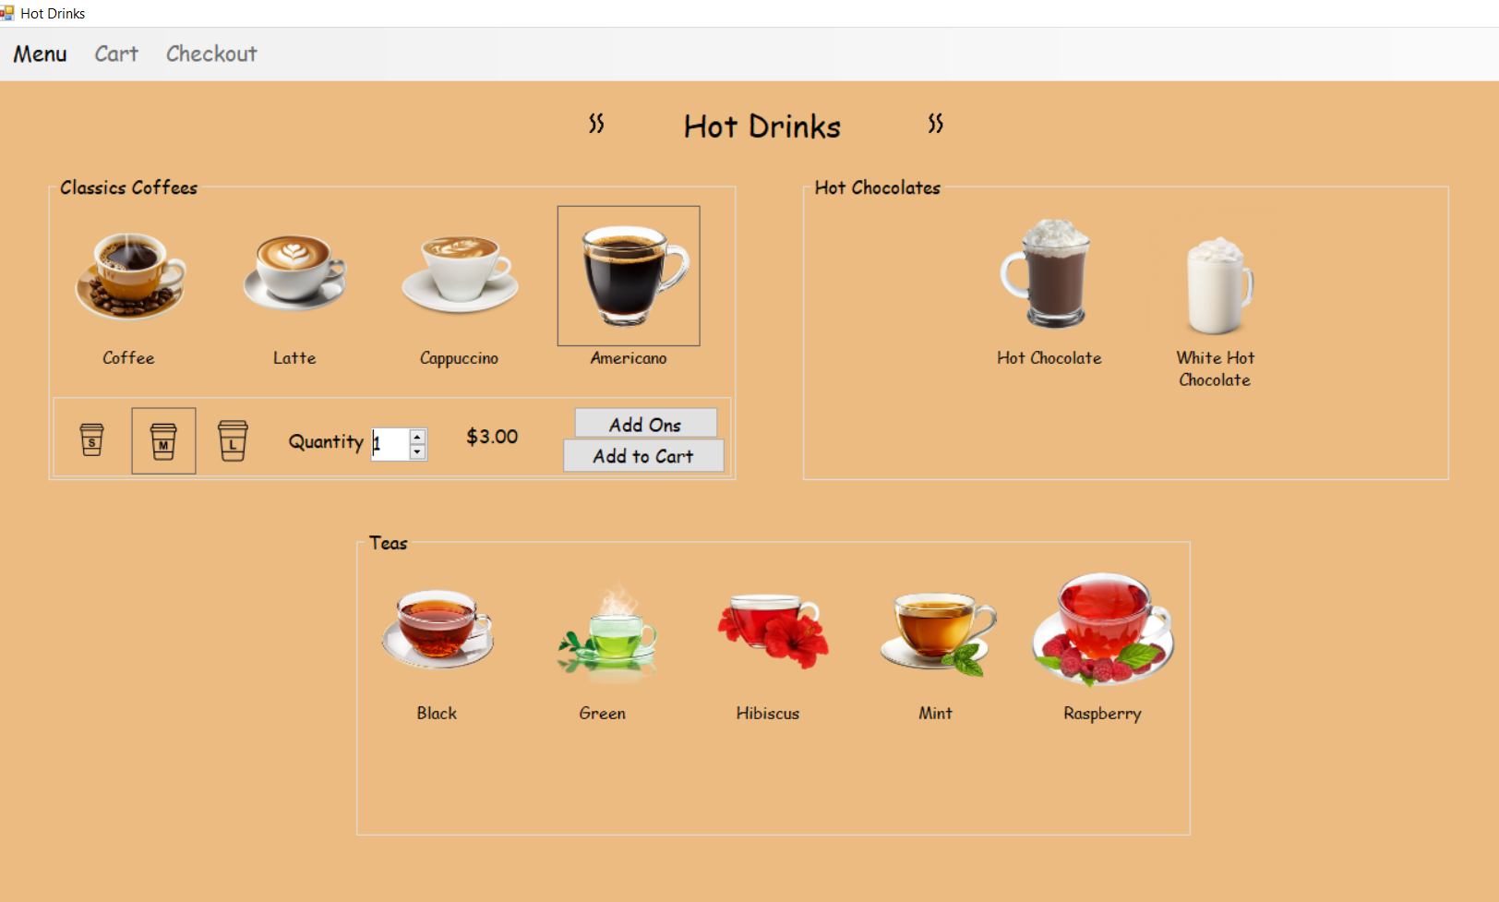
In this picture (with grey box around selected item):
- Americano is selected
- Quantity = 1
- Size = M
- Price = $3.00
Then you are faced with the decision of including an Add-On or go to checkout, but will not face able to move on without selecting a size first, the options of size, quantity, price, and buttons only appear after you have selected an items picture:

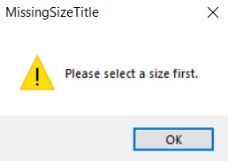

If your decision was to include Add-Ons, this is what you will be faced with:
Can adjust the quantity of Americanos
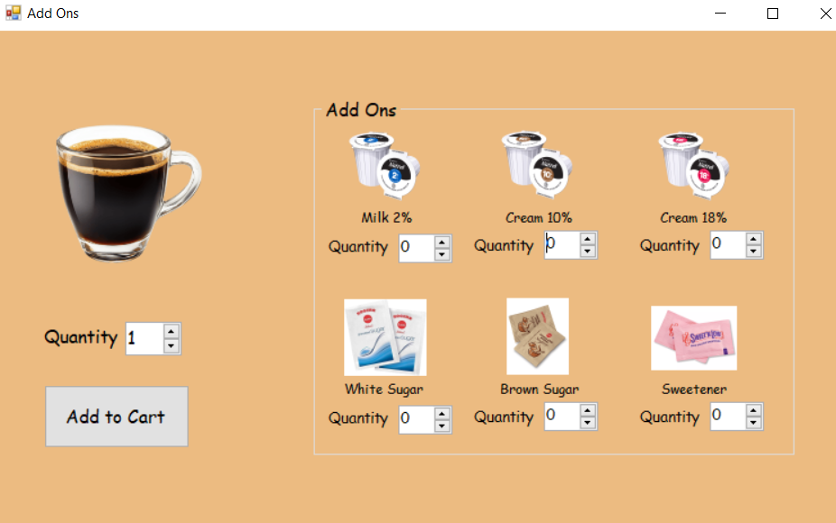
Add to cart button
Add the number of Add-Ons you would like

Once added you will get this message:
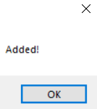

Cold Drink Menu
The Cold Drink menu is very similar to the Hot Drink menu. However, in this menu, you do not have the option of Add-Ons.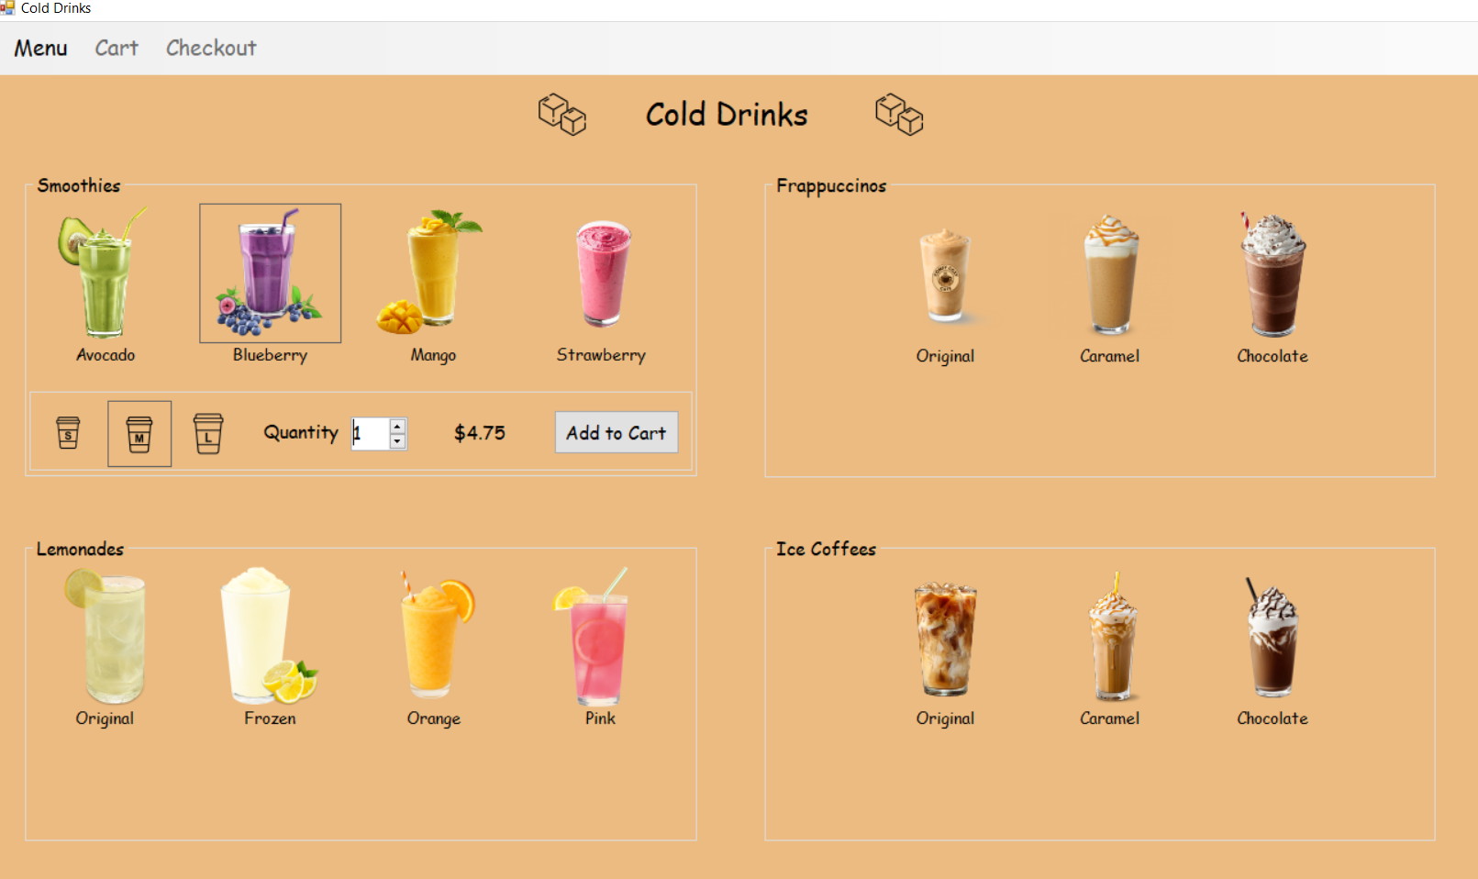
In this picture (what is selected is contoured in a grey box):
- The blueberry smoothie is selected
- Size = M
- Quantity = 1
- Price = $4.75
Also in this menu, you will be unable to add the item to the cart unless you have selected the size you want. The options of size, quantity, price, and buttons only appear after you have selected an items picture, once added you will have a message “Added”, like the Hot Drink Menu:
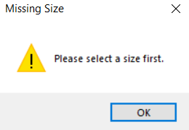

Pastry Menu

Also, for the Pastry Menu, it is very similar steps as to the Hot and Cold Drink menu, however, the Pastry Menu does not have Add-Ons, nor does it have a size selection.
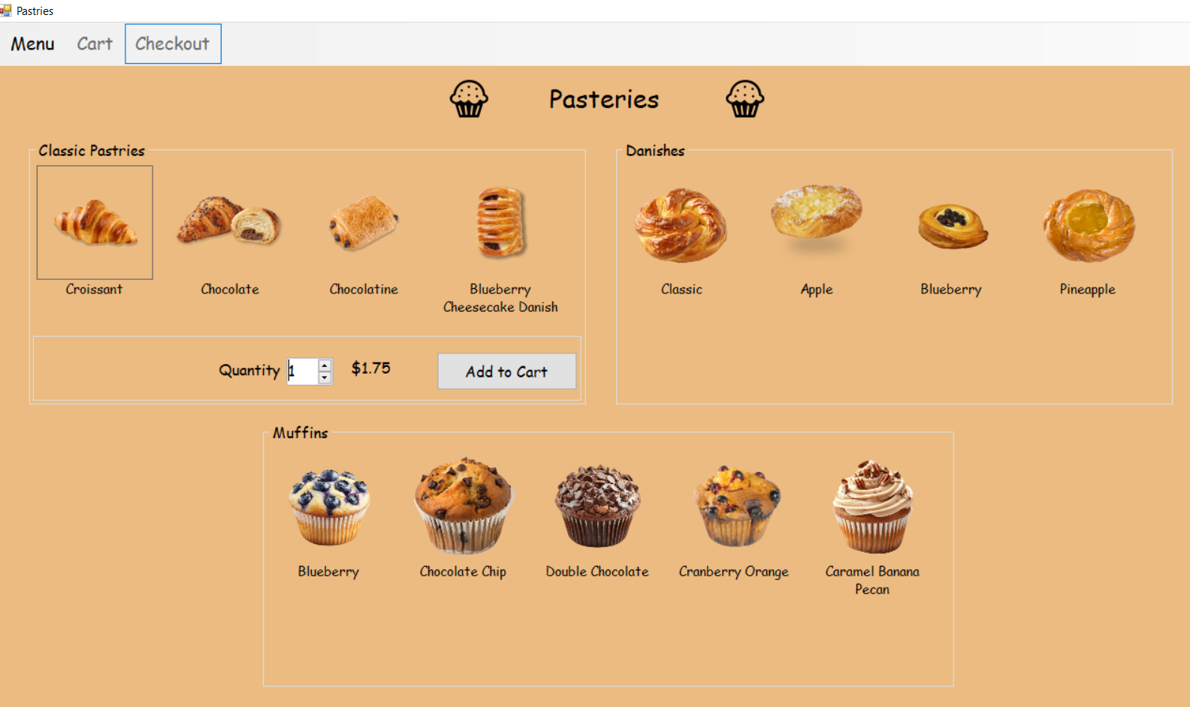
In this picture (what is selected is contoured in a grey box):
- Croissant
- Quantity = 1
- Price = $1.75

Then you are presented with a “Add to Cart” button and once the item is added, you will see this message:
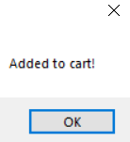

Shortcut
What you see here is the top bar menu that is present on every menu page.
When you press the Menu button you are shown a drop-down menu of all 3 menus:
- Hot Drinks
- Cold Drinks
- Pastries
This makes it easier and quicker to change between all 3 menus instead of having to close and reopen the program all over again.
Once you have added an item to cart, the Cart and Checkout button will change from light grey(unclickable) to black(clickable), which will bring you to the screen that you selected.

Cart System
This is where al the items you added to cart get put into a list
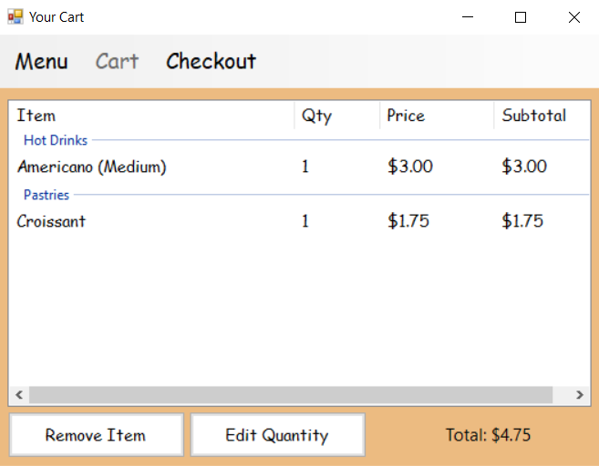
Total of all items
Where the list of items goes
Remove Item button
Edit Quantity buttons

The Remove Item button and Edit Quantity button:
To remove an item or edit the quantity of an item, you need to select the item first then click what button you choose.
Once something is added to cart the menu resets.

Checkout Screen (Pickup and delivery)
You will be presented with a form to fill out and at the end decided whether you would like to pickup your items or have then delivered.
The form includes:
- Name
- Last Name
- Email
- Address
- Credit or debit card
On the right side is a summary of the items
A pay button at the bottom left
The total amount of your order on the bottom right.

ADD SCREEN SHOT OF CART HERE!!!!!!!!!!!!!!!!

If you picked delivery, you will be charged extra to the total amount.
Once you have completed the process you will receive an order confirmation number and the cart resets.

Troubleshooting
Some solutions to some common problems you might have
PROBLEM:
Nothing happens when adding to cart
SOLUTION:
Select both size and drink

PROBLEM:
Cart is empty
SOLUTION:
You must add at least 1 item to it

PROBLEM:
Cannot checkout
SOLUTION:
Some fields are missing

PROBLEM:
Language did not change
SOLUTION:
Click change language button

PROBLEM:
Application will not open
SOLUTION:
Ensure you are using Windows 10 or 11

Frequently asked questions (FAQ)
“Where does my order go?”
- Into the cafes cart

“Can I undo a mistake?”
- Yes, edit or remove items in the Cart

“Does changing the language delete my order?”
- Yes

“Do I need internet?”
- No, everything runs locally

Who do you contact for help?
If anything is confusing or not working how it was intended to be:
- Contact 1 of the 3 system administrators
- Restart the application
- Refer back to this guide

