UBarbershop
Deliverable 2
Section 2
Used for booking appointments for the clients and internal use for the admin to add employees, services, days closed or employee vacations and look at all the booked appointments.
Victor Fortin (6385988), Audréane Deschênes (2072658), Section 1: Jonathan Morin (6240678)

Table of Contents
Team Journal 1
Web Application Design 1
Task Breakdown 7
Tools & Technologies 8

Team Journal
Audréane Deschênes gave the general idea on what the project will be on, and Jonathan Morin and Victor Fortin gave ideas for features that might be needed. Everyone collectively worked on the ERD to make sure there aren’t anything missing for any of the planned features or if an entity lacks a foreign key or an attribute.
The team meetings are done primarily by messaging as we are from different sections, otherwise we have in-person meetings during theory class which is once a week. With the added meetings by messaging, we plan to have meetings around 3 to 4 times a week.
Audréane Deschênes front-end and database expert is leading the first deliverable.
Victor Fortin back-end, deployment and testing expert is leading the second deliverable
Jonathan Morin back-end, front-end is presenting the third deliverable.

Web Application Design
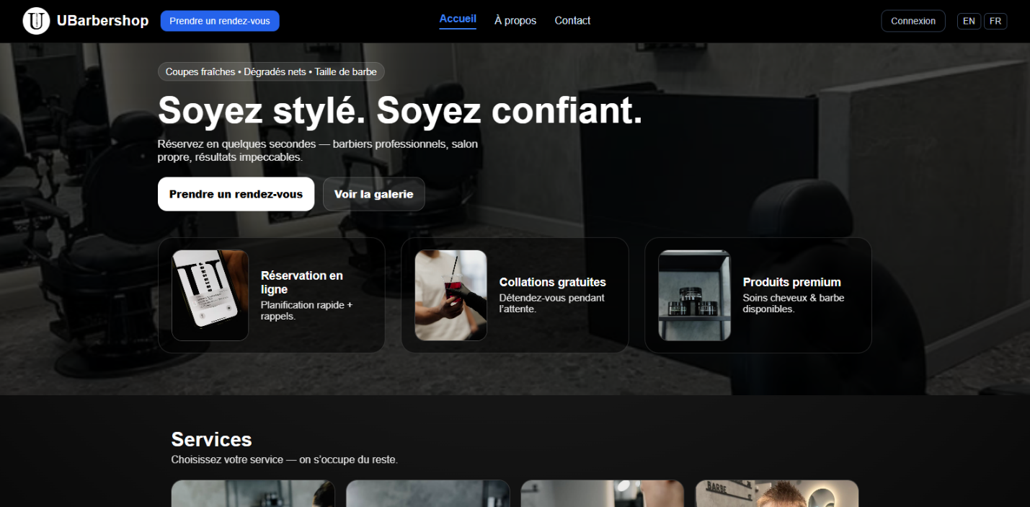
Regular client view:

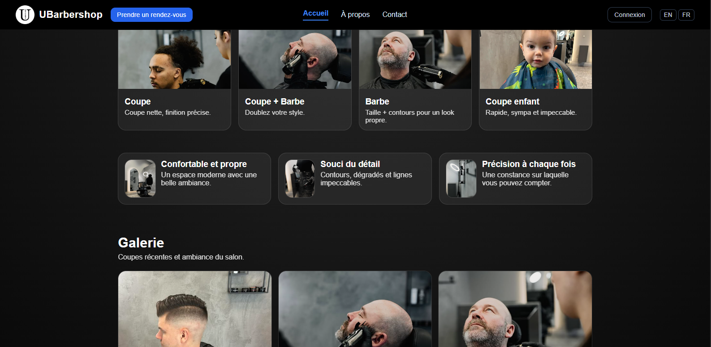

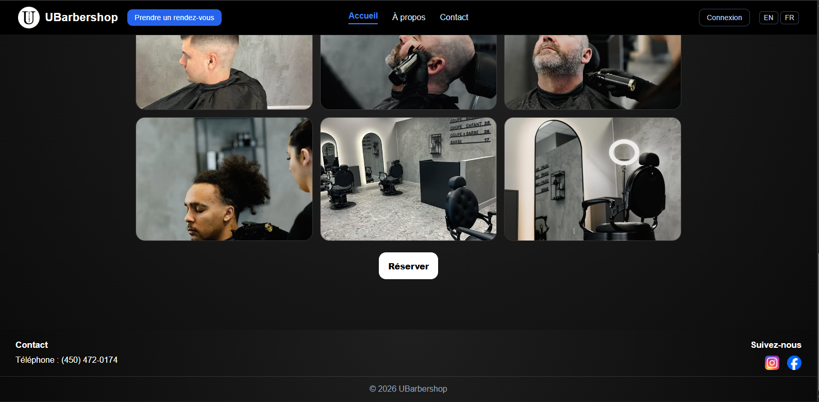

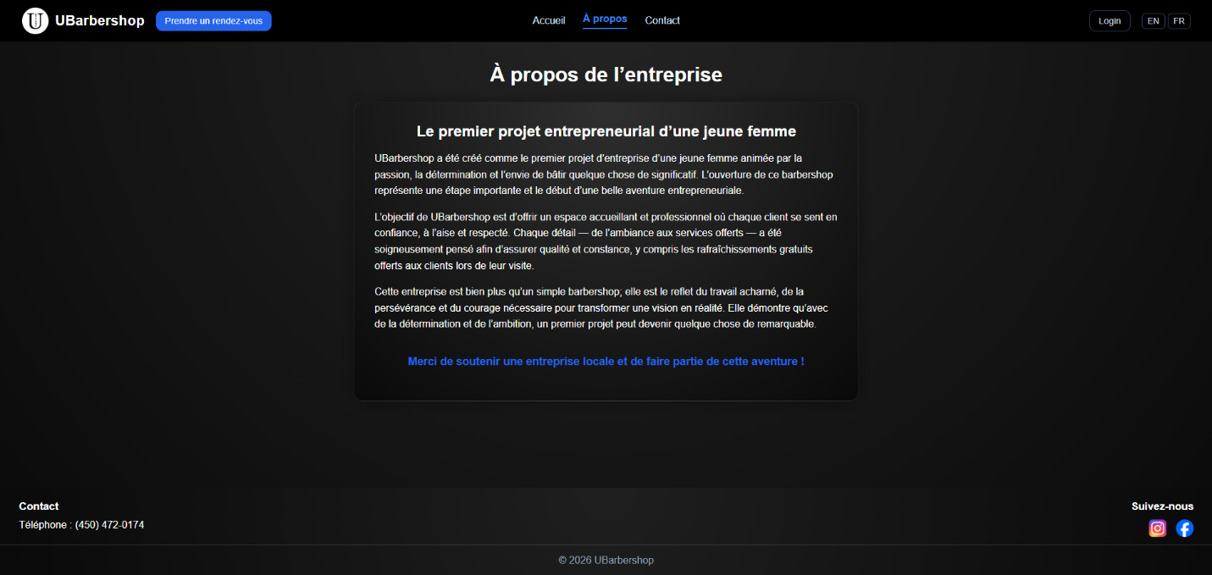

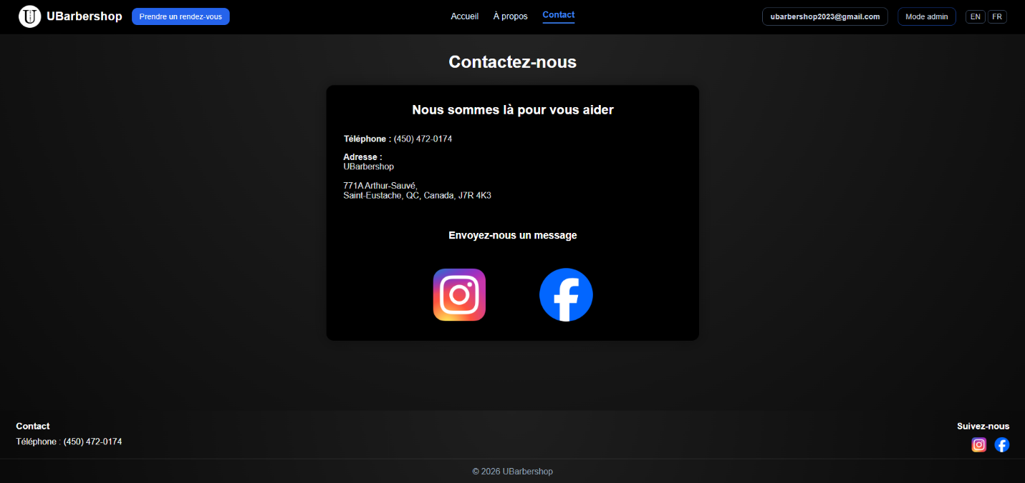

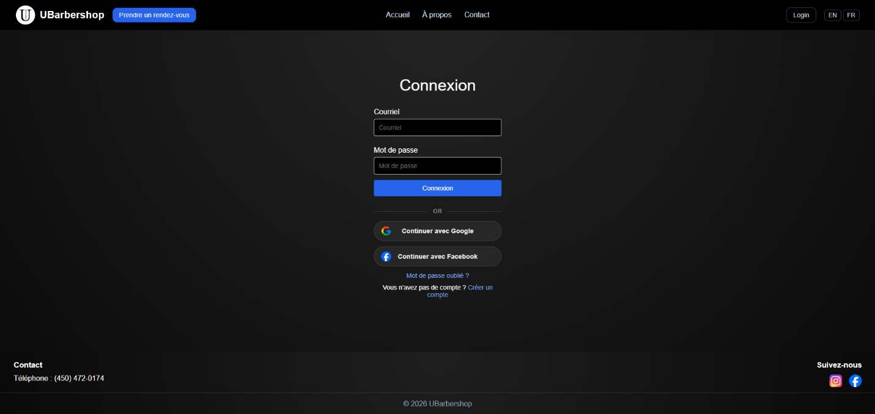

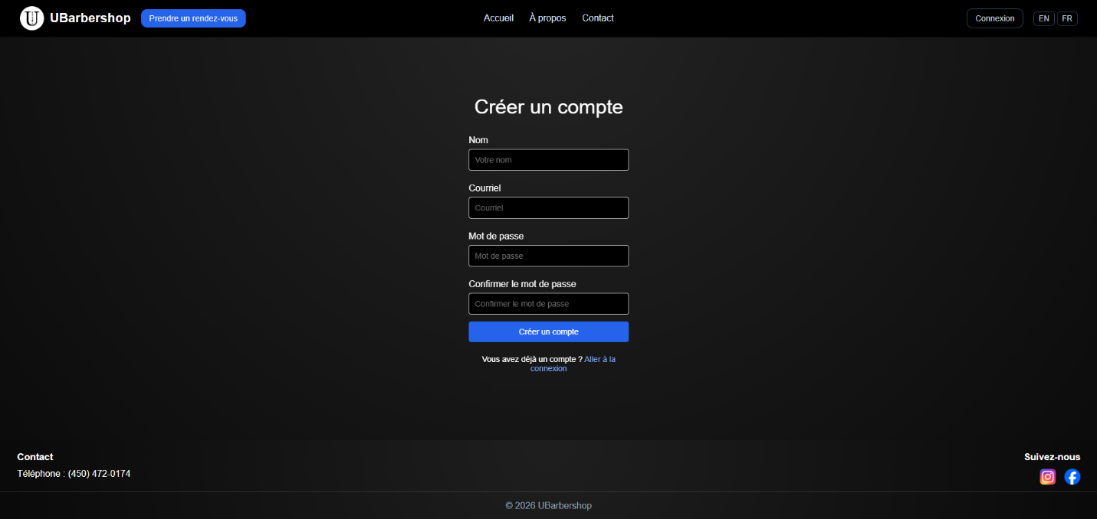

When logged in as the admin:
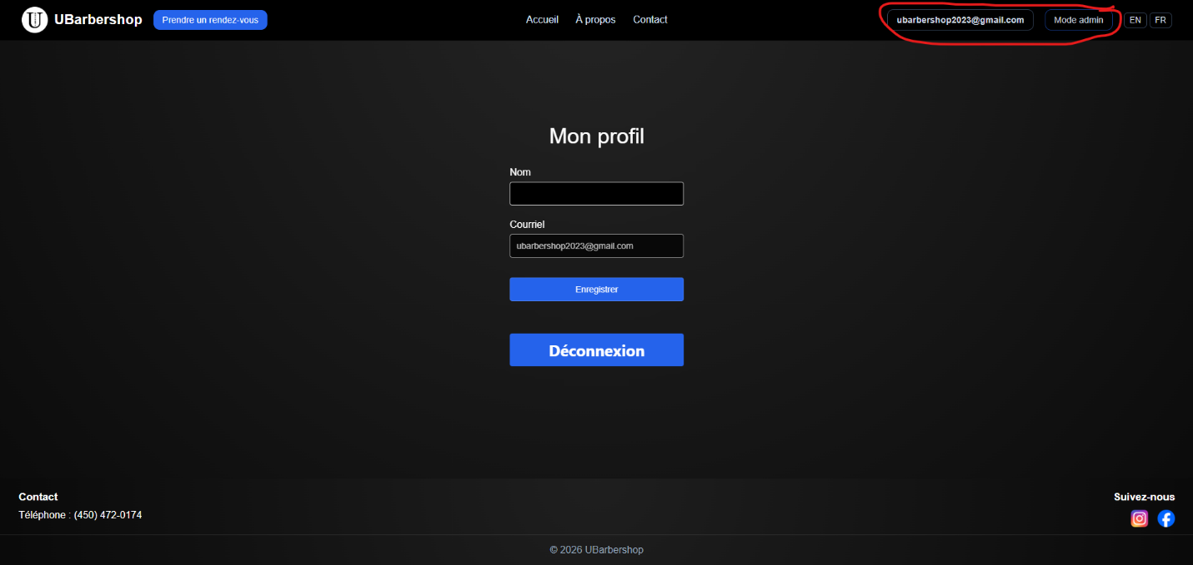
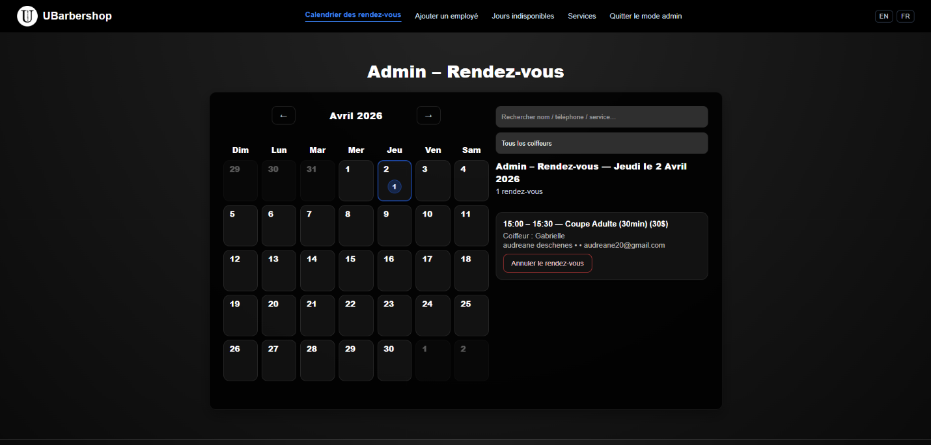

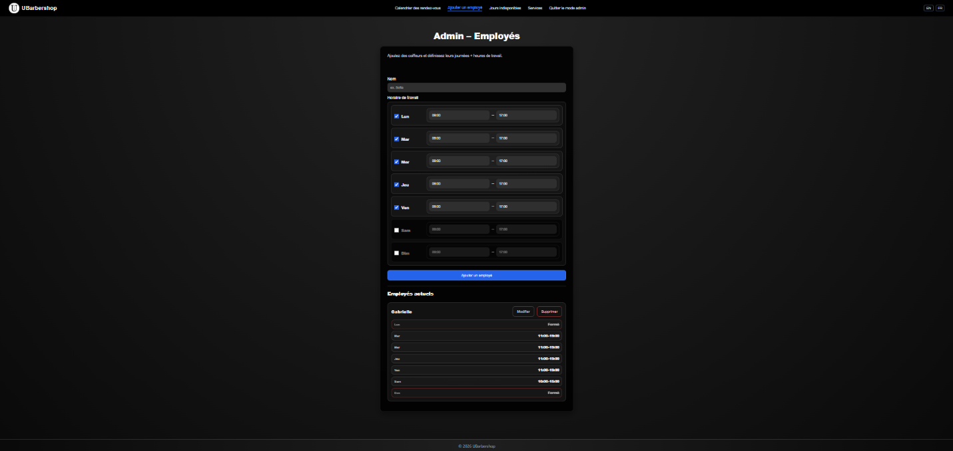

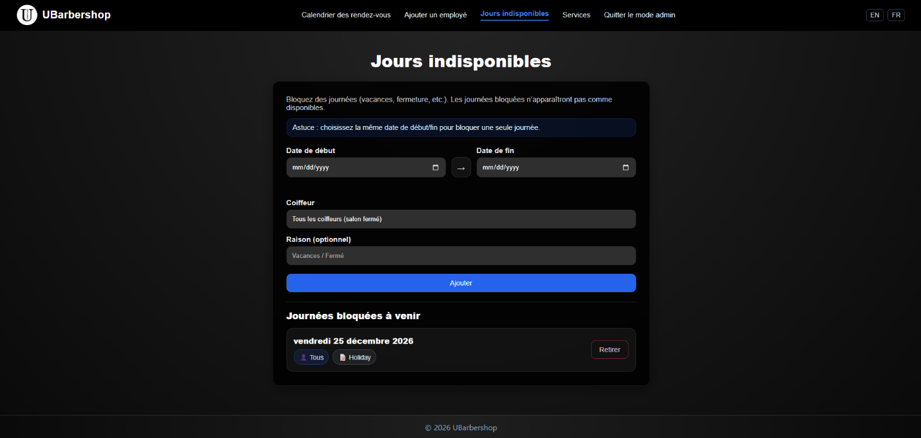

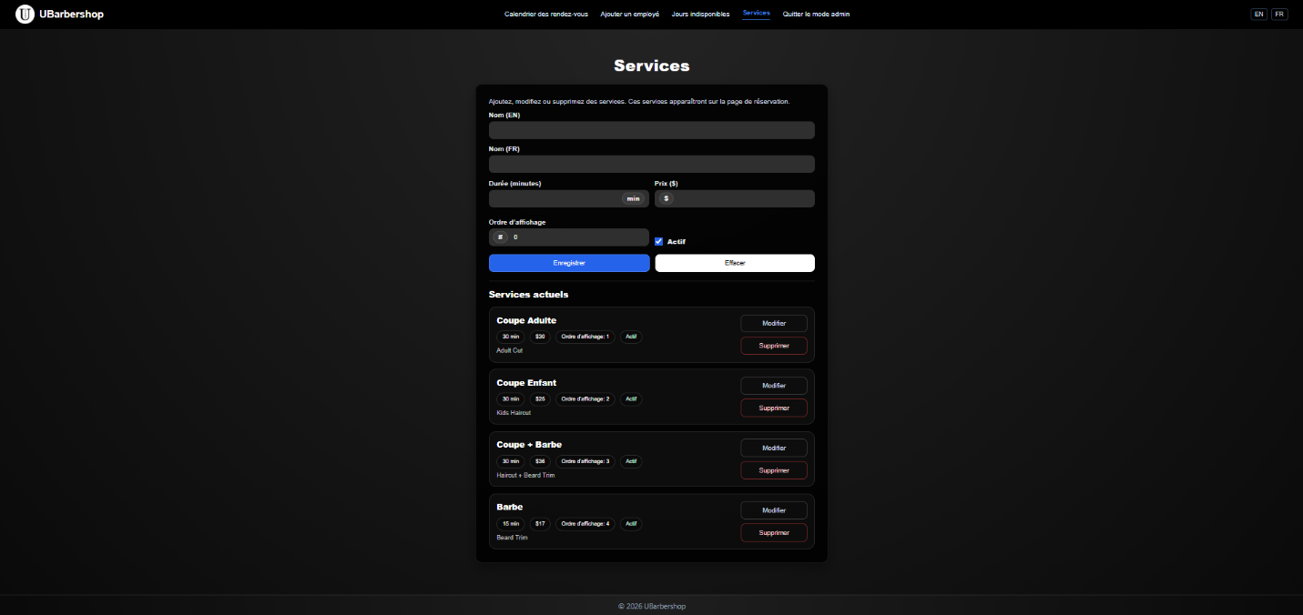

Task Breakdown
- Frontend
  - We used an internet programming project template (Audréane)
- Database
  - Design the database according to the ERD (Audréane)
  - Implementing the database in PHP (Victor, Audréane, Jonathan)
- Back-end
  - Translation of original code in JavaScript into PHP (Audréane, Jonathan, Victor)
  - Implementation of Slim with MVC configuration (Victor)
  - Optimization of the code (Jonathan)
- Integration
  - Confirmation and cancelation Email (Victor, Audréane, Jonathan)
  - Flash messages (Jonathan)
- Deployment
  - Choose a web host (Jonathan, Victor)
  - Buy the domain name (Audréane)
- Testing
  - Security of all the different inputs (Victor)
  - Check if all the data are correctly stored in the database (Jonathan)

Tools & Technologies
Everything will primarily be handled with PHP, for the libraries of our features, we will be using the Firebase SDK which allows the use of Firebase services to be able to do login, authentication, search, and CRUD, for the change between French and English we will be using an internationalization library.
We will be using Brevo to send out confirmation and cancelation emails. We are using Brevo because it can handle up to 300 emails a day for free. We will implement it by creating templates on their website and connecting the API key to our project. We considered using EmailJS instead however, even if it is easier to implement, it can only support a maximum of 100 emails a month which in this businesses case is not enough.
We will use AI for help with questions on things we haven’t learned in class yet. We will also use it for inspiration on layouts and visuals. We haven't yet decided on a web host yet, so we will also ask AI for the best options in this case.

