REPUBLIC OF CAMEROON
Peace-Work-Fatherland
MINISTRY OF HIGHER EDUCATION
INSTITUT UNIVERSITAIRE DE LA COTE


REPUBLIQUE DU CAMEROUN
Paix-Travail-Patrie
MINISTAIRE DE LENSEIGNEMENT
SUPERIEUR
INSTITUT UNIVERSITAIRE DE LA
COTE




INTERNSHIP REPORT


DESIGN AND IMPLEMENTATION OF A WEB PLATFORM FOR A TRAINING DATA CENTRALISATION MANAGEMENT SYSTEM CASE OF ECA CONSEILS

Internship done from 07th of July to 29th of August 2025 in partial fulfillment of the HND (Higher National Diploma)
Field of study: Computer Engineering
Specialty: software engineering
Written and presented by KENGNE SOPGOUI AUDREY DARILLE
Matricule: IUC23E0081044
Under the supervision of:

ACADEMIC SUPERVISOR
Mr. WOLONWO NIXON

PROFESSIONAL SUPERVISOR
Mr. SERGE ETIENNI

ACADEMIC YEAR

2025 - 2026

CERTIFICATION

This is to certify that an internship with the theme: “DESIGN AND IMPLEMENTATION OF A WEB PLATFORM FOR A TRAINING DATA CENTRALISATION MANAGEMENT SYSTEM”: case of ECA CONSEILS, is originally written and presented by KENGNE SOPGOUI AUDREY DARILLE after a two month of internship carried out at ECA to meet up with the partial requirement and regulation governing the award of the Higher National Diploma (HND) of Institute Universitaire de la Cote in the field software engineering.

ACADEMIC SUPERVISOR
Mr. WOLONWO NIXON
SIGNATURE: ………………………… DATE: …………………………………
PROFESSIONAL SUPERVISOR
Mr. SERGE ETIENNI
SIGNATURE: …………………………. DATE: ………………………………….

HEAD OF DEPARTMENT
Mr. FONKOU CONFIANCE
SIGNATURE: …………………………. DATE: ………………………………….

DEDICATION

ACKNOWLEDGEMENTDEDICATION

TO MY FAMILY.

ACKNOWLEDGEMENT

ACKNOWLEDGEMENT

The accomplishment of this work required the assistance of some people. Failing to quote them individually here, they receive my most sincere thanks. We are practically grateful to:
- Mr. GUIMEZAP PAUL, Founder and President of IUC for the establishment of this structure for the purpose of training student.
- Dr TCHIKDJE PRUDENCE, Director of SEAS for his attention and encouragements towards us the students
- Mr. WOLONWO NIXON, my academic supervisor, who have been a source of inspiration and motivation for me. Always providing me with task that helped me through my journey.
- ALL MY TEACHERS for my knowledge they installed in me.
- Mrs. SAMIRA HAMADOU, General Manager of ECA, who gave me the opportunity to learn within this company.
- I would like to thank Mr. OLIVIER TAYOU, IT Audit Director, who generally coordinated this work.
- I also thank Mr. SERGE ETIENNI, who, as my internship supervisor, taught me a great deal and shared his knowledge in the field of audit and the socio-professional world.
- I thank Mrs. NELLY TCHATA, IT auditor, for her kindness and professionalism.
- I thank Mr. STAFORT MUKAM, IT Support at ECA, for his guidance, expertise, and assistance.
- I take this opportunity to express my gratitude to the various managers and all the staff of ECA.
- MY LOVELY AND SUPPORTIVE FAMILY for all their moral and financial support especially for the furthering my education.
- All my FRIENDS AND CLASSMATES who contributed in one way or the other for the realization of this project.
- To everyone I have failed to mention here, thank you.

ABSTRACT

ABSTRACT

Training and knowledge management are essential for improving organizational performance and supporting employee development. Many organizations still rely on manual or fragmented systems to organize training programs and manage knowledge resources, which often leads to inefficiencies, poor accessibility, and difficulties in monitoring training activities. To address these issues, this project focuses on the design and development of a Training Management and Knowledge Centralization Platform that allows organizations to efficiently manage training programs and store knowledge in a centralized system. The platform was designed using software engineering principles and modeled with Unified Modeling Language (UML) and an Entity Relationship Diagram (ERD) to represent the system structure and database organization. The system was implemented using modern web technologies and a relational database to ensure usability, security, and scalability. The developed platform simplifies training management, improves access to knowledge resources, and enhances the monitoring of organizational learning activities.

RESUME

RESUME

La gestion des formations et des connaissances constitue un facteur cle pour améliorer la performance des organisations et favoriser le développement des employes. Pourtant, plusieurs organisations continuent d’utiliser des methodes manuelles ou des systemes fragmentés pour organiser les programmes de formation et gerer les ressources de connaissances, ce qui entraine souvent des inefficacités, un acces limite a l’information et des difficultes dans le suivi des activites de formation. Afin de repondre a ces defis, ce projet porte sur la conception et le développement d’une plateforme de gestion des formations et de centralisation des connaissances permettant aux organisations de mieux organiser leurs programmes de formation et de conserver les connaissances dans un systeme centralise. La plateforme a ete conçue en appliquant des principes du génie logiciel et modelisee a l’aide du Unified Modeling Language (UML) ainsi que d’un diagramme Entite-Relation (ERD) afin de representer l’architecture du systeme et la structure de la base de données. Le systeme an ensuite ete realise a l’aide de technologies web modernes associees a une base de données relationnelle afin de garantir l’ergonomie, la securite et l’evolutivite de la solution. La plateforme développee facilite ainsi la gestion des formations, ameliore l’acces aux ressources de connaissances et renforce le suivi des activites d’apprentissage au sein de l’organisation.

PREFACE

PREFACE

With the aim of ensuring a suitable development and providing business with competent and competitive workface in various fields, the Cameroon government through the ministry of higher education has opened the private institution of education. This then created the HIGER INSTITUTE OF TECHNOLOGY AND INDUSTRIAL DESIGN (ISTDI) by decree No
02/0094/MINESUP/DDES/ESUP of September 13 2002 and authorization of opening No01/02/MINESUP/DDES/ESUP of 18 September 2002, located in the coastal region, Wouri department, district of Douala 5th, in Logbessou district. The ISTDI then created the

UNIVERSITY INSTITUTE OF THE COAST by
5/05156/N/MINESDUP/DDES/ESUP/SAC/EBM.University Institute of the
consist of five (5) different institution which are:

  - School of Engineering and Applied Science

It consists of:

    - HND INDUSTRIAL PROGRAMS
      - Electrical power systems (EPS)
      - Industrial Computing and Automation (ICA)
      - Telecommunication (TEL)
      - Software Engineering (SWE)
      - Network Security (NWS)
      - Chemical Manufacturing (CM)
      - Mechanical Manufacturing (MEM)
      - Building Science and Technology (BST)

    - HND COMMERCIALS PROGRAMS
      - Marketing (MKT)
      - Management (MGT)
decree No Coast (IUC)

      - Accountancy (ACC)
      - Banking and Finance (BF)
      - Logistic and Transport Management (LTM)
    - BTS PROGRMANS
      - GENIE CIVILE (GC)
      - GEOMETRE TOPOGRAPH (GT)
      - BATIMENTS
      - TRAVEAUX PUBLIC (TPU)

    - BACHELORS OF ENGINEERING (B-Eng)
      - Computer Science Engineering
      - Electromechanical Engineering
      - Civil and Environmental Engineering

    - BACHELORS OF TECHNOLOGY (B-Tech)
      - Chemical Engineering
      - Electrical and Electronics Engineering
      - Civil Engineering
      - Software Engineering
      - Mechatronics Engineering
      - Industrial Automation and Computing
      - Welding and Fabrication Technology
      - Thermal Engineering Technology

    - BACHELORS OF HEALTH SCIENCE (B-HES)
      - Physiotherapy
      - Medical Laboratory
      - Nursing Science

    - LIPRO
      - Genie Civil

    - MPRO

      - Genie Civil

- L’institut Supérieur des Technologies et du Design Industriel (ISTDI)

It consists of:

  - BTS PROGRAMS

- Génie Chimique des procèdes (GCP)
- Maintenance des systèmes informatique (MSI)
- Informatique Industriel (II)
- Electrotechnique (ET)
- Electronique (EN)
- Froid et climatisation (FC)
- Maintenance et après-vente automobile (MAVA)
- Bâtiment (BAT)
- Travaux publics (TP)
- Géomètre topographe (GT)
- Energie Renouvelable (ER)
- Génie Bois (GB)
- Chaudronnerie (CH)
- Fabrication Mécanique (FM)

  - DSEP PROGRAM:
    - Réseaux et Télécommunication (RT)

  - LISCENCES PROFESSIONNELLES INDUSTRIELLES in partnership with the university of DSCHANG: VIII
    - Administration des systèmes Réseaux
    - Génie Logiciel
    - Automatique et Informatique Industriel
    - Electrotechnique
    - Electronique
    - Management des systèmes Automobiles
    - Maintenance et Expertise des Automobiles
    - Maintenance des systèmes Industriels

    - Génie Énergétique et Industriel
    - Production et commercialisation du bois
    - Génie Mécanique et productique

  - MASTER PROFESSIONNEL COMMERCIAL in partnership with the University of DSCHANG
    - Génie Electrique et informatique Industriel
    - Génie des Réseaux et Télécommunications
    - Systèmes d’information et de Génie Logiciel
    - Systèmes d’information Audit et Conseil

- L’institut de Commerce et d’Ingénierie d’affaire (ICIA)

  - BTS PROGRAMS
    - Action Commercial
    - Assurance
    - Banque et Finance
    - Communication d’Entreprise
    - Commerce International
    - Gestion Logistique et Transport
    - Informatique de Gestion

  - LISCENCES PROFESSIONNELLES COMMERCIALES ET GESTION in
partnership with the University of DSCHANG:
    - Assurance
    - Banque
    - Banque – Assurance
    - Comptabilité Control et Audit
    - Finance – Comptabilité
    - Gestion des Ressources Humaines
    - Logistique et Transport
    - Marketing
    - Management des Opération du Commerce International IX

  - MASTER PROFESSIONNEL COMMERCIAL in partnership with the University of DSCHANG:
    - Finance – Comptabilité
    - Audit Comptable et Financier
    - Banque
    - Fiscalité
    - Management des Organisation
    - Marketing – Communication
    - Gestion des Ressources Humaines
    - Logistique et Stratégique

  - MASTER ISUGA – France in partnership with EMBA France
    - EXECUTIVE MBA in partnership with ESSEC Douala

- L’institut d’Ingénierie Informatique d’Afrique Centrale (3IAC)

  - Cycle des TIC in partnership with CCNB-DIEPPE of CANADA
    - Réseautique et sécurité
    - Programmes et Analyse

  - MASTER EUROPEAN in partnership with 3IL France
    - Genie Logiciel
    - Administration des Systèmes Réseaux

  - MASTER PROFESSIONENEL in partnership with ENSP Yaoundé
    - Génie Civil
    - Génie Énergétique et Environnement
    - Génie Industriel et Maintenance

  - CYCLE INGENIEUR Information (3IL-France)
    - Pôle de Recherche Innovation et Entreprenariat

LES PROGRAMMES INTERNATIONAUX DES SCIENCE ET TECHNOLOGIES DE L’INNOVATION (PISTI)

  - Cycle des Classes Préparatoire au Grandes Ecoles d’Ingenieurs (CP) in partnership with the University of MAINE France
    - Classes préparatoires
    - License Sciences et technique
  - CYCLE INGENIEUR de Génie Industriel (Polytechnique- NANCY France)
  - INGENIEUR BIOMEDICAL in partnership with the University of Tor Vergata (ROME II)
  - ARCHITECTURE ET DESIGN INDUSTRIEL in partnership with the
University of CAMERINO (ROME I)

TABLE OF CONTENT
LIST OF FIGURES

LIST OF TABLES

LIST OF ACRONYMS

HND: Higher National Diploma

IUC: Institute Universitaire de la Cote
CSS: Cascading Style Sheet
DBMS: Database Management System OOP: Object Oriented Programming PHP: Hypertext Pre-processor
SDLC: System Development Life Cycle

SWE: Software Engineering

SQL: Structured Query Language

UML: Unified Modelling Language

XAMPP: Cross-platform, Apache, MySQL, PHP, and Perl

UX/UI: User Experience /User Interface.

GENERAL INTRODUCTION

In today’s digital environment, organizations increasingly rely on efficient information systems to manage and share knowledge. Training activities often generate large volumes of data that are scattered across different sources, making access, management, and analysis difficult. This situation reduces efficiency and limits effective decision-making.
To address this challenge, this project focuses on the design and implementation of a web platform for a training data centralisation management system. The proposed system aims to provide a unified environment for managing training programs, learning resources, and user information. By centralizing training data, the platform improves accessibility, ensures data consistency, and enhances collaboration among administrators, trainers, and trainees.
This project contributes to better training management by offering a structured, secure, and scalable solution that supports knowledge sharing and organizational learning.

To achieve our goal, we will present on one hand the internship which is divided into part as seen below:
PART 1: CONCEPTUAL FRAME WORK
Chapter 1: presentation of the company activities carried out during the internship period.

Chapter 2: activities carried out during the internship period.

PART 2: EMPERICAL STUDY
Chapter 3: diagnostic of existing system of ECA Conseils.

Chapter 4: Implementations of proposed system.

GENERAL CONCLUSION COST AND ESTIMATION REFERENCES




PART ONE: CONCEPTUAL FRAME WORK

CHAPTER ONE: PRESENTATION OF ECA CONSEILS AND INTERNSHIP ACTIVITIES

1.1 PRESENTATION OF ECA Conseils
In this section, we will explore ECA Conseils, ECA Conseils is a professional consulting firm that delivers tailored audit, tax, and legal expertise to organizations and individuals. The firm assists its clients in navigating complex regulatory and financial challenges while unlocking new business opportunities. Through this overview, we aim to provide a comprehensive understanding of how ECA Conseils is shaping the future of audit, tax and legal expertise.

MISSION OF ECA Conseils
ECA Conseils delivers tailored audit, tax, and legal expertise to help you navigate complex challenges and unlock new opportunities. It also provides a comprehensive range of services designed to meet the diverse needs of clients.

HISTORY OF ECA
ECA TAX & LEGAL was founded in 2011 following Ernst & Young's return to Cameroon and a merger with a local firm, while ECA S.A. has been operating since 1984. Both entities joined the Ernst & Young network in 2011, adopting the names "Ernst & Young Cameroon SARL" and "ECA-Ernst & Young Cameroon S.A." respectively, before rebranding to ECA TAX & LEGAL and ECA S.A. in October 2023, without any change in the continuity of their activities and in the provision of services to their clients. Our passionate, young, and experienced team is dedicated to exceeding client expectations, approaching each project with enthusiasm and expertise.

SERVICES OFFERED BY ECA Conseils
ECA Conseils offers the following services;

      - Audit and Statutory Audit.

      - Transactions and Taxations.

      - Accounting, Compliance, and Reporting.

LOCATION OF ECA Conseils
It is located on the 6th and 7th floors of the BICEC building in Akwa, on Boulevard de la Liberter, opposite the headquarters of Orange Cameroon.
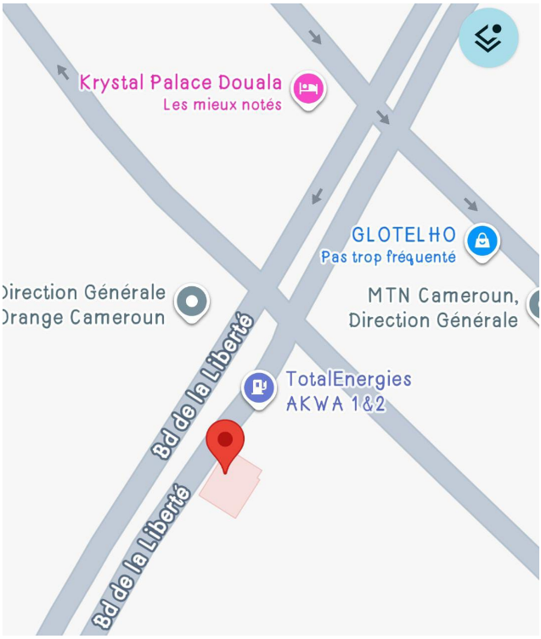
Figure 1: Location of ECA CONSEILS

ORGANISATIONAL STRUCTURE OF ECA CONSEILS
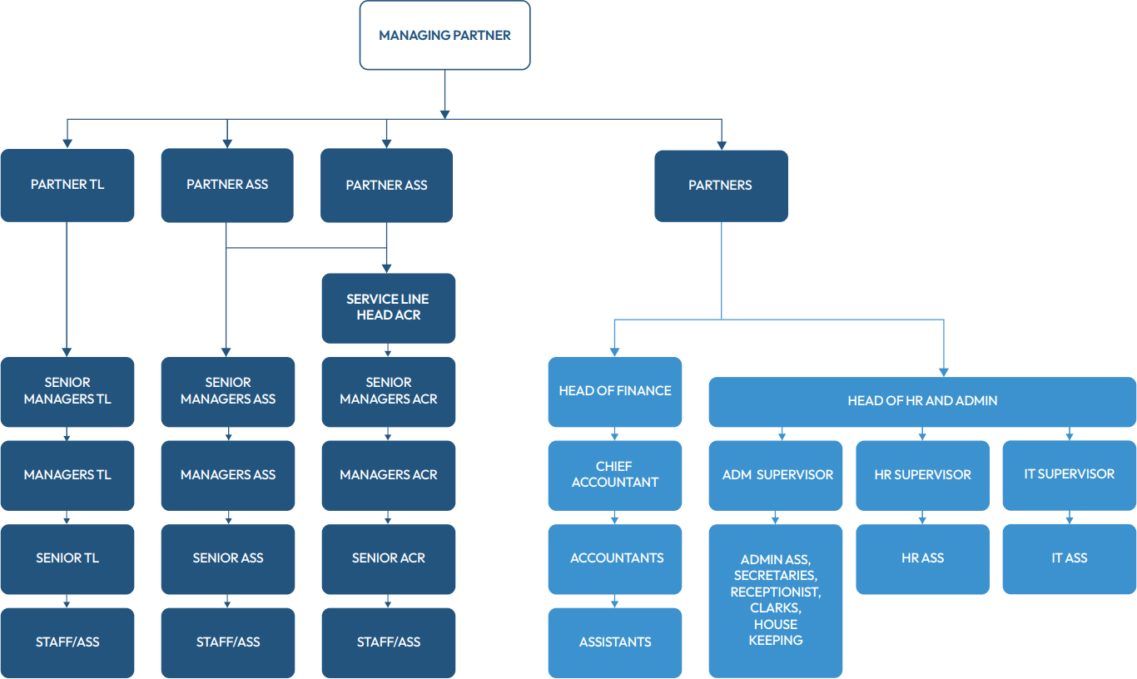
Figure2: Organizational Chart of ECA Conseils

DETAIL ON VARIOUS DEPARTMENTS

INTERNSHIP ACTIVITIES
This section outlines the various activities I undertook during my internship at ECA. The experience provided me with valuable insights into the practical applications of my academic knowledge, as well as opportunities to develop essential skills in a professional environment. The following activities were carried out; analysis of the existing training management process, collection of user requirements, design of system diagrams, development of a web-based platform, and testing of the proposed solution. Below, I will detail the specific tasks I completed, the challenges I faced, and the skills I acquired throughout my internship.
    - Introduction
Upon my arrival at ECA, I was warmly welcomed by Mr. Serge Etienni, my professional supervisor. He provided a thorough briefing on the company's mission, activities, and the expectations for my internship experience. Following this introduction, I was given a set of guidelines to follow, and my work commenced immediately.

PERIOD | PERFORMED ACTIVITIES |  | DIFFICULTIES ENCOUNTERED |  | SOLUTIONS PROPOSED |  | SKILL ACQUIRED
Week one | -Introduction to company and other interns in my field | -No major problem was encountered |  | -No problem hence no solution required |  | -Socialization skills  -Punctuality  -Team work  -Respect of hierarchy
Week two | -Recalls on basic web development: HTML, CSS, JAVASCRIPT | -No problem faced |  | - No problem encountered hence no solution |  | -Upgraded skills in basic web development
Week three | - Building of static websites with little interactivity | - Problem faced in mastering the syntax |  | - The solution was to be repetitive that is, write php code until mastering of the syntax |  | - Understanding basic concept of a backend web programing language.
Week four | - Introduction to relational database using MySQL.  -connection of MySQL to a php backend using XAMPP | -No major problem faced |  | - No problem encountered hence no solution |  | - Enhance management skills of a data base  -Basic CRUD skills
Week five and six | - Mini project, developing a sales management system | - No major problem faced |  | - No problem encountered hence no solution |  | - Enhance my coding skills and critical thinking
Week seven and eight | - Object oriented programming in php and communication with the database | - Problem encountered in implementing oop concept |  | - Problem solved by practicing |  | - Software architecture skills and organised coding
Table 1: Activities carried out during internship

    - JUSTIFICATION OF TOPIC
ECA Conseils regularly organizes training activities to strengthen staff competencies in audit, tax, and legal services. However, training data and learning resources were managed in a fragmented and manual manner, making access, monitoring, and data consistency difficult. This situation limited effective knowledge sharing and decision-making.
The justification of this project lies in the need to centralize training data within a single web platform in order to improve accessibility, organization, and tracking of training activities. By implementing a centralized system, ECA Conseils can reduce data loss, enhance collaboration, and ensure better management of internal knowledge. The project therefore responds to both organizational needs and modern information system practices.




PART TWO: EMPERICAL STUDIES.

CHAPTER TWO: DIAGNOSTIC OF THE EXISTING SYSTEM

INTRODUCTION
ECA Conseils regularly organizes training activities to strengthen staff competencies in audit, tax, and legal services.
Scope: The system will handle interns’ management, centralize, and monitored internal training data and resources.

PRESENTATION OF THE SYSTEM USED BY ECA CONSEILS
ECA Conseils delivers tailored audit, tax, and legal expertise to help you navigate complex challenges and unlock new opportunities.
Also, training data at ECA Conseils were managed using spreadsheets, emails, and physical documents. There was no centralized platform for storing or managing training information.

DATA FLOW DIAGRAMS

Data Flow Diagrams (DFDs) are a visual representation of the flow of data within a system. They are used primarily in the fields of software engineering and systems analysis to illustrate how information moves between processes, data stores, and external entities. DFDs help stakeholders understand the relationships and interactions between different components of a system, making them valuable tools for both system design and analysis.

A DFD typically consists of four main components: External entities, Data flows, Data stores, and Processes. Processes represent the operations or transformations that data undergoes within the system, while data stores indicate where data is stored for future use. Data flows are arrows that depict the movement of data between processes, data stores, and external entities, which are sources or destinations of data outside the system. This clear visual structure allows for easy identification of how data is processed and where it is stored.

Here are some data flow diagrams representing the flow of information in ECA Conseils;

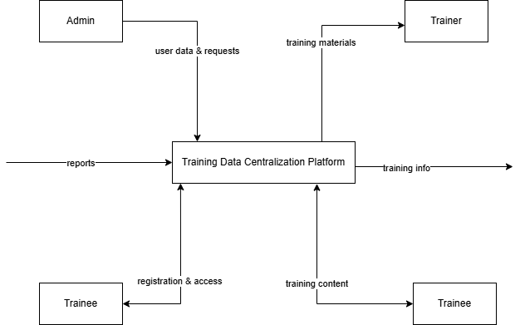
Figure 3: Level two data flow diagram

- The admin manages users, training sessions, and requests reports from the system.
- Trainers upload training materials and provide training-related information to the platform.
- Trainees register, access training content, and receive notifications from the system.
- The system centralizes all training data and ensures controlled access for each user type.
- Report and training information are generated and sent to the appropriate users.
- The interactions ensure efficient communication between users and the training data centralization platform.

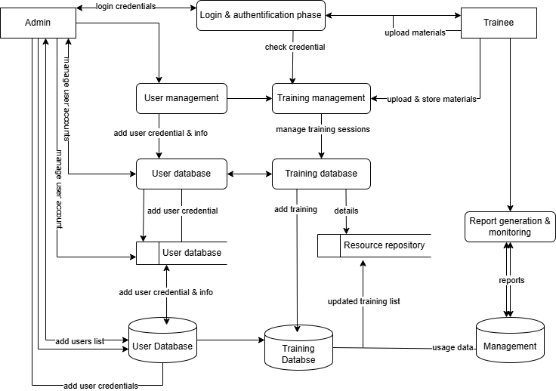

Figure 4: Level two data flow diagram

- The login and authentication system verifies user credentials before granting access.
- The user management module handles user registration, role assignment, and profile management.
- The training management module manages training sessions, schedules, and training details.
- The resources management module stores and organizes training materials uploaded by trainers.
- User, training, and resources data are stored in dedicated database to ensure data consistency and security.
- The reporting and monitoring generate reports based on training activities and user participation.

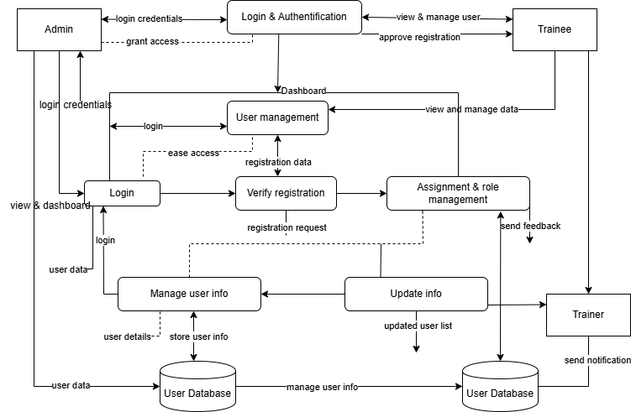
Figure 5: Level two data flow diagram

- The admin logs into the system to create, update, and manage user accounts and assign roles.
- The system verifies login credentials and grants access to authorized users.
- User registration requests are verified and stored in the user database.
- Trainers upload and manage training materials and training session information.
- Trainees access training content and submit requests related to training participation.
- Training data and user activities are recorded and uploaded in the database for monitoring and reporting purpose.

RESEARCH METHOD
In the course of my research, I used several methods to identify the problems:

- INTERVIEW: I asked the administrator of ECA Conseils and he gave me information of the about their system and how it works.
- OBSERVATION: During the free period I had while being at agent working place, I could see how they are interacting with clients.
- INTERNET: The internet provided me with essential information about what I needed and great solutions and manner of approach in order to solve the vulnerabilities of the existing system ECA Conseils.

ADVANTAGES OF THE PRESENT SYSTEM
- The existing system is simple and easy to use, requiring little or no technical expertise.
- It does not require high implementation costs since it relies on manual methods and basic digitals tools.
- Training data can be recorded quickly using spreadsheets, emails, or paper documents.
- Staff members are familiar with the current process, reducing the need for immediate training.

2.5 LIMITATIONS OF THE PRESENT SYTEM
- Training data is scattered across multiple sources, making access and retrieval difficult.
- Manual data handling increases the risk of errors, duplication, and data loss.
- There is no centralized platform for monitoring training activities and participant progress.
- Data security is weak, as sensitive training information is not adequately protected.
- Collaboration and knowledge sharing among staff are limited.
- Generating reports and tracking performance is time-consuming and inefficient.

CHARACTERISTICS OF THE NEW SYSTEM

- The system is web-based, allowing users to access training data anytime and from any authorized device.
- It provides centralized storage for all training data and learning resources.
- The system supports role-based access control for administrators, trainers, and trainees.
- It ensures secure authentication and authorization of users.
- The system allows easy upload, retrieval, and management of training materials.
- The system improves data consistency, reliability, and integrity.

CHAPTER THREE: ANALYSIS AND DESIGN OF ECA CONSEILS

3.1 INTRODUCTION
In order to bring forward an effective solution, a thorough analysis was carried out. The analysis phase is the first critical phase in software development. Therefore, in this chapter, a complete analysis of the proposed system is presented, stating the methodology used, requirements, and system design of the system.

3.2 GENERAL PRESENTATION OF THE METHOD OF ANALYSIS

SYSTEM DEVELOPMENT LIFE CYCLE
SDLC is a term used in Information Systems and Software Engineering which refers to the structured process for building an application. It is also called the Software Development Process. It is subdivided into Planning, Analysis, Design, Implementation, Testing, Deployment, and Maintenance depending on the methodology used.
Some methodologies include: Waterfall, Iterative, V-Shape, Agile, and Prototype.
For this project, the Agile methodology was adopted because it allows flexibility, continuous improvement, and progressive system development through iterative cycles.

PLANNING PHASE
This phase is also known as the requirement gathering phase and is one of the most fundamental stages in the SDLC. It consists of drafting a work plan and carrying out feasibility studies to understand what needs to be done.
At ECA Conseils, training data was managed using spreadsheets, emails, and physical documents. There was no centralized system for storing training materials, tracking participation, or generating reports. This created inefficiencies and difficulties in accessing training information.
To solve this problem, a web-based platform was proposed to centralize all training data sources and improve training management processes.
Requirements were gathered using:
- Direct observation of training processes.
- Review of internal documents.
    - REQUIREMENTS GATHERING

3.3.1.1 ACTORS OF THE SYSTEM
These are the people that would use the system;
- Admin: Responsible for managing users, trainings, and system monitoring.
- Trainer: Responsible for creating training sessions and uploading materials.
- Trainee: staff members who participate in trainings and access resources.

3.3.1.2 FUNCTIONAL REQUIREMENT
Functional requirements are those requirements that describe what the system can do.
Identifier | User story
REQ-1 | AS an admin, I can create user accounts.
REQ-2 | As an admin, I can assign roles (trainer or trainee or admin).
REQ-3 | As an admin, I can create and manage training sessions.
REQ-4 | AS a trainer, I can upload training materials.
REQ-5 | As a trainer, I can update training information.
REQ-6 | As a trainee, I can view and access training resources.
REQ-7 | As a user, I can log into the system securely.
REQ-8 | As a user, I can update my personal information.
Table 2: After requirement analysis

Identifier | User story
REQ-1a | As an admin, I can delete user accounts.
REQ-1b | As an admin, I can update training details.
REQ-4a | As a trainer, I can delete uploaded materials.
REQ-4b | As a user, I can change my password.
Table 3: USER STORY TABLE

3.3.1.3 NON-FUNCTIONAL REQUIREMENT
The non-functional requirements are those requirements that describes how the system should perform.
- Performance: the system should support multiple users accessing it simultaneously.
- Security: the system must provide secure authentication and protect sensitive training data.
- Usability: the interface should be simple and user-friendly.
- Scalability: the system should support future expansion.
- Availability: the system should be accessible during working hours.
- Backup: the system should perform regular database backups.

Category | Requirements
Performance | The system should support up to 500 concurrent users.
Scalability | The system secure authentication and role-based access control.
Security | System uptime of at least 99%.
Availability | Simple and intuitive interface.
Usability | Support and intuitive interface.
Maintainability | Easy to update and modify.
Backup | The system should daily automate database backup.
Table 4: NON-FUNCTIONAL REQUIREMENT TABLE

SYSTEM ANALYSIS
This phase involves analyzing the existing training management process and identifying system boundaries and limitations. It breaks down the problem into manageable components to design a more efficient solution without negatively affecting operations at ECA Conseils.

3.4.1 JUSTIFICATION OF METHODOLOGY USED
For this project I used the Agile Methodology. The agile model is an SDLC model used for Software development. Agile is a software development lifecycle (SDLC) model that emphasizes flexibility, collaboration, and iterative progress. It is designed to accommodate changing requirements and improve efficiency by delivering functional software in small, incremental pieces, known as iterations or sprints. It is made up of seven phases.
- Requirement Gathering and Analysis: Here, requirements were collected through interviews and observations. Analysis evaluates whether the requirements are feasible and if the project goals can be achieved within budget constraints.
- Design Phase: This phase involves establishing the technical requirements (e.g. programming languages, data structures, services) needed to fulfill the requirements identified in the previous phase. The design output includes logical and physical diagrams, and the design may represent a new system or modification of an existing one.
- Implementation: During this phase, the designs are translated into code using appropriate programming languages. This phase transforms the design specifications into functional software. Once developed, the software is installed on users’ machines for testing and use.
- Testing: Throughout the development process, testing is conducted to ensure the software meets quality standards. This can include unit testing, integrating testing, and user acceptance testing, often occurring concurrently with implementation.
- Deployment: This phase involves releasing the completed software to users. Deployment may include training users and providing documentation to support the transition.
- Maintenance: After deployment, the software enters the maintenance phase, where bugs and issues are identified and resolved. This phase may also involve updating the software to adapt to new requirements or improve performance.
- Review and Evaluation: After deployment, teams conduct reviews or evaluations to gather feedback from users and stakeholders. This feedback is essential for continuous improvement and informs future iterations.
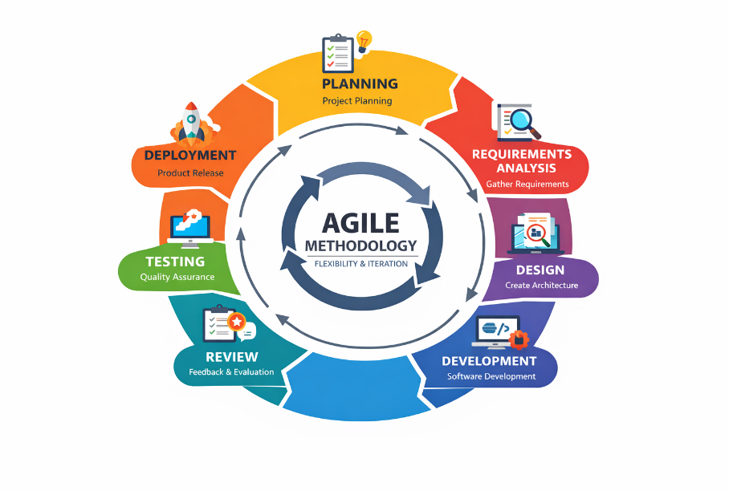
Figure 6: Agile methodology

3.4.2 MODELLING LANGUAGE

The modelling language I used to implement this application is the Unified Modelling Language. it is a general-purpose developmental modelling language in the software engineering field which intends to provide a standard way to visualize the design of a system.

MODELLING TOOLS
For this system, we used;
- Draw.io: Used to create UML diagrams such as use case diagrams, sequence diagrams, class diagrams, and state diagrams.
- Figma: Used to design the graphical user interface (UI) templates and prototypes of the application.
- StarUMl: Used to create UML diagrams (sequence diagrams, state chart diagrams, activity diagrams).
- Canva: Used for designing the application logo and other simple graphical elements.

DESIGN PHASE

USE CASE DIAGRAM
A use case is a list of actions or events typically defining the interactions between a role and a
system to achieve a goal. The role is known in UML as an actor and may be human or an external
system.
A use case diagram consists of a boundary which defines the system of interest in relation to the
world around it, the actors which are usually individuals involved in the functionality of the
system, the use cases which are specific roles played by the actors within and around the system
and finally, the relationships between and among the actors and the use cases.

USE CASE ANALYSIS
- Actors Goal List
Initiator | Initiator’s goal | Participants | Use case name
Admin | Create user account | Database | Add user
 | Modify user information | database | Edit user
 | Delete user account | Database | Delete user
 | Create training session | Database | Add training
 | Modify training session | Database | Edit training
 | Delete training session | Database | Delete training
Trainer | Upload training materials | Database | Upload material
 | Modify training materials | Database | Edit material
Trainee | View training materials | Database | View training
Table 5: ACTOR GOAL LIST TABLE

- Use case description
Use case name | Add user
Actors | Admin
Actor’s goal | Register a new user (Trainer or Trainee)
Preconditions | - The admin has valid login credentials.  - The system is operational.
Flow of Events for Main Success Scenario | - Admin logs into the system.  - Admin clicks on user management.  - Admin selects “Add new user”.  - Admin fills in required information (name, email, role).  - Admin click Save.
Flow of Events for Main Alter Scenario | Form rejected if required fields are missing.  Form rejected to user list.
Postconditions | - The user information is successfully stored in the database.  - The admin is redirected to user list.
Assumption | Admin is interacting with the system interface.
Table 6: Add user use case

Use case name | Add training session
Actors | Admin
Actor’s goal | Create a new training session
Preconditions | - The admin is logged in.  - System is operational.
Flow of Events for Main Success Scenario | - The admin selects training management.  - The admin clicks “create new training”.  - The admin enters training details (title, description, date).  - The admin clicks save.
Flow of Events for Main Alter Scenario | Form rejected if information is incomplete.
Postconditions | - Training session is stored in the database.  - Admin is redirected to training list.
TABLE 7: Add training session use case

Use case name | Upload training material
Actors | Trainer
Actor’s goal | Upload training resources
Preconditions | - The trainer has valid login credentials.  - The training session exists.
Flow of Events for Main Success Scenario | - The trainer logs in.  - The trainer selects assigned training session.  - The trainer clicks “upload material”.  - The trainer selects file and submits.
Flow of Events for Main Alter Scenario | - File upload fails due to unsupported format.  - File size exceeds allowed limit.
Postconditions | - File path is stored in the database.  - Materials become available to trainees.
TABLE 8: Upload training materials use case

Use case name | View training material
Actors | Trainee
Actor’s goal | Access training resources
Preconditions | - The trainee has valid login credentials.  - The training materials exist.
Flow of Events for Main Success Scenario | - Trainee logs in.  - Selects assigned training session.  - Views or download available materials.
Postconditions | Training materials are displayed successfully.
TABLE 9: View training materials use case

Use case name | Generate report
Actors | Admin
Actor’s goal | Generate training activity report
Preconditions | - Amin logged in.  - Training data exists.
Flow of Events for Main Success Scenario | - The admin selects reports.  - The admin chooses report type.  - The admin system generates report.  - The admin downloads or views report.
Postconditions | Report is successfully generated.
TABLE 10: Generate report use case

Use case name | Reset password
Actors | Admin, Trainer, Trainee
Actor’s goal | Change password
Preconditions | - User is logged into the system.
Flow of Events for Main Success Scenario | - The user goes into the system.  - Selects change password.  - Enters new password and confirms.  - Click save.
Flow of Events for Main Alter Scenario | - Passwords do not match.  - Password does not meet security criteria.
Postconditions | - Password is updated in the database.  - User is redirected to dashboard.
TABLE 11: Reset password use case
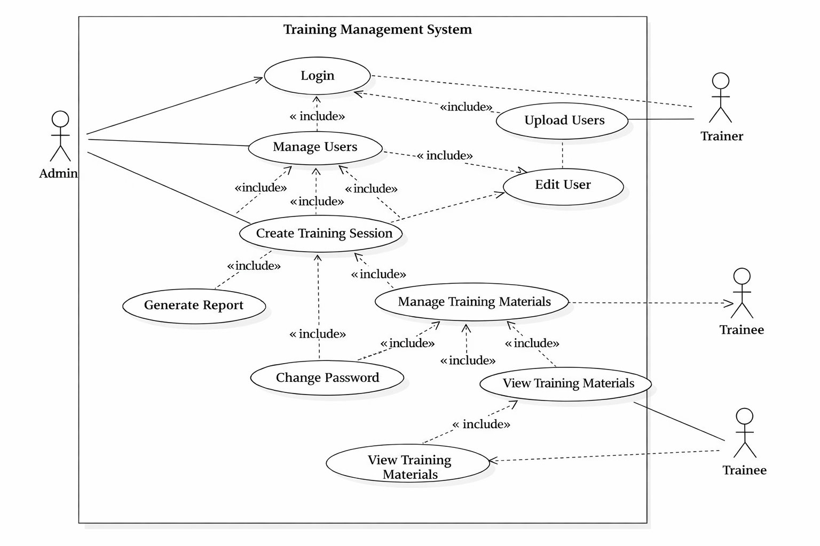
Figure 7: Use case diagram

3.5.2 SEQUENCE DIAGRAM
A sequence diagram is an interaction diagram that details how operations are carried out, what messages are sent and when. Sequence diagram is organized according to time. The time progresses as you go down the page. The object involved in the operation are listed from left to right according to when they take part in the message sequence. The purpose of a sequence diagram is to capture the behavior of a system, describe the message flow in the system, structural organization of objects and to describe interaction among objects.

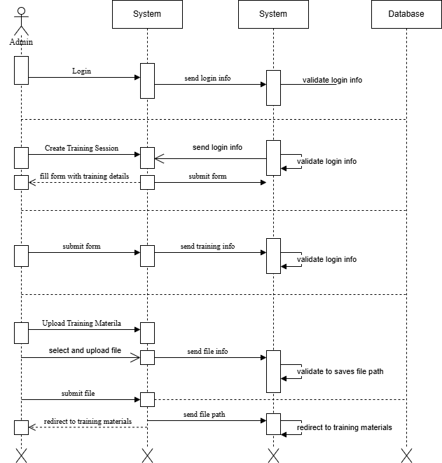

Figure 8: System Admin Sequence Diagram

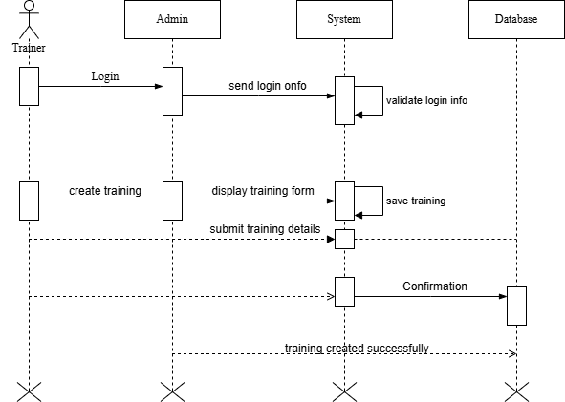

Figure 9: System Trainer Sequence Diagram

T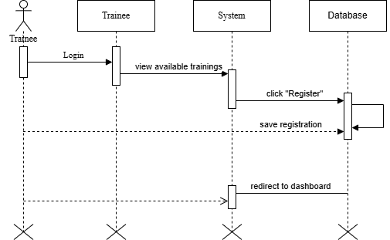

Figure 10: System Trainee Sequence Diagram

STATE CHART DIAGRAM
A state chart diagram is a visual representation of the states of an object and the transitions between those states. It illustrates how an object behaves in response to various events over time. Key components include states, transitions, events, and actions. This type of diagram is commonly used in software engineering to model dynamic behavior. It aids in understanding and documenting system functionalities.
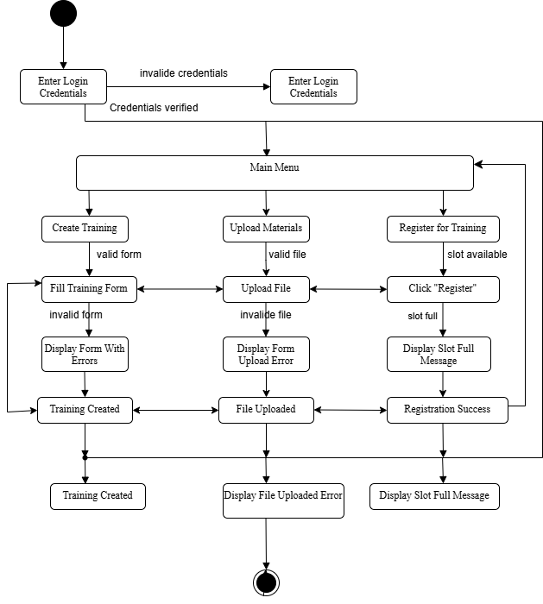
Figure 11: System State Chart Diagram

DEPLOYMENT DIAGRAM
A deployment diagram is a type of diagram used in Unified Modeling Language (UML) to visualize the physical deployment of artifacts (like software components, files, or executable programs) on hardware devices or nodes. It shows how various software components (e.g., databases, web servers, applications) interact and are physically deployed on machines, network devices, or servers in a system.

3.4.5 CLASS DIAGRAM
A class diagram is to visualize, describe, document various different aspects of the system, and also construct executable software code. It shows the attributes, classes, functions, and relationships to give an overview of the system. It constitutes class, names, attributes, and functions in a separate compartment that help in software development.
The classes involve in this system are;

3.4.6. UX/UI DESIGN
The UX/UI design plays a crucial role in enhancing users experience and interaction with software application. A well-crafted UI allows user to navigate through features and functionalities intuitively, making tasks more efficient and enjoyable. ECA CONSEILS UX/UI design incorporate user-friendly elements, clear navigation, and aesthetical pleasing visuals to create an engaging experience. The design prioritizes accessibility and useability, ensuring that users can easily understand and utilize the application’s features without extensive training. The design process involved careful consideration of user feedback and best practices in interface design, resulting in a cohesive and functional application.
In the following section, we will present the UX/UI designs created using Figma;

3.4.7. APP LOGO
The logo of an application serves as a vital element of its brand identity, encapsulating its purpose and values in a single visual mark. For the ECA CONEILS application, we aimed to create a logo that reflects its focus on.



Figure 15: APP LOGO

.
CHAPTER FOUR: IMPLEMENTATION DETAILS AND RESULTS OBTAINED

INTRODUCTION
Following the analysis phase, we moved on to the implementation of the application, which encompasses development aspects. This phase involved defining the software specifications necessary for building the application. I carefully selected the tools and technologies that would facilitate the development process, ensuring compatibility and efficiency. Additionally, I outlined the system architecture and identified any external dependencies. This comprehensive approach allowed for a smoother transition from design to implementation, setting the stage for the successful deployment of the application.

IMPLEMENTATION DETAILS
    - TOOLS AND TECHNOLOGIES USED

TYPES OF TOOLS | TOOLS | DESCRIPTION
Database |   XAMPP SERVER | For this project, we decided to use XAMPP for the testing which is a model of web service stacks named as an acronym of its original components:  Cross-platform application Apache HTTP Server used as a server for hosting the web application locally during development. It is  used to run PHP scripts on local machine. MySQL used to execute Structured Query Language (SQL) on web pages.
Web programming |   Visual studio code | This tool offers an integrated editor for PHP, HTML, Bootstrap CSS, JavaScript, Laravel, and MySQL, featuring real-time code analysis, error detection, and automated refactoring capabilities. Web browser for this task, we chose to utilize Google Chrome.
Design |  | Figma is a cloud-based design tool that enables collaborative interface design and prototyping for web and mobile applications. Launched in 2016, Figma is particularly popular among UI/UX designers due to its real-time collaboration features and intuitive interface.
Design |  | StarUML is a powerful UML (Unified Modeling Language) modeling tool designed for software development and systems design. It provides a comprehensive environment for creating various UML diagrams, including class diagrams, sequence diagrams, use case diagrams, and more. StarUML is particularly useful for software architects, developers, and analysts.
Design |  | Draw.io is an online diagramming tool used to create technical diagrams such as flowcharts, UML diagrams, system architectures, and database models. It provides various templates and graphical components for system design.

TABLE 12: Tools used

 | LANGUAGE | DESCRIPTION
 |     HTML BLADE | Blade is a templating engine provided by the Laravel PHP framework. Blade allows developers to write HTML with embedded PHP code, making it easier to create dynamic web applications. It offers features like template inheritance, sections, and control structures (such as loops and conditionals), which simplify the process of generating HTML based on dynamic data.
 |  | CSS (Cascading Style Sheets) is a stylesheet language used to describe the presentation and formatting of a document written in HTML or XML. It enables web developers to control the layout, colors, fonts, and overall visual appearance of a website, separating content from design.
 |     JAVA SCRIPT | JavaScript is a high-level, dynamic programming language primarily used for adding interactivity and functionality to websites. It enables developers to create responsive user interfaces, manipulate the Document Object Model (DOM), and handle events in real time.
 |  |  | Hypertext Pre-processor is a language specially designed for the development of web applications. It is easy and simple to learn, extremely flexible, easy integration and compatibility, efficient performance, cost efficient, easily connects to database.
 |  |  | MySQL is an open-source relational database management system (RDBMS) that uses Structured Query Language (SQL) for managing and manipulating data. It is widely used for web applications and is a key component of the LAMP stack (Linux, Apache, MySQL, PHP/Python).
TABLE 13: Languages used

FRAMEWORK | DESCRIPTION
 | Laravel is a free, open-source PHP web application framework that follows the Model-View-Controller (MVC) architectural pattern. It provides a robust set of tools and features for building web applications, ranging from simple websites to complex enterprise-level applications. Laravel emphasizes developer productivity, code simplicity, and elegant syntax. It includes features like routing, caching, database abstraction, authentication, and more, making it easier for developers to build and maintain PHP applications.
 | Bootstrap is a widely used front-end framework designed for developing responsive and mobile-first websites. It provides a collection of pre-styled components, such as buttons, forms, and navigation bars, along with a grid system for layout management. Bootstrap enables developers to create visually appealing web applications quickly by using its ready-made classes and components. Its responsive design ensures that applications look great on various devices and screen sizes. With a strong community and extensive documentation, Bootstrap simplifies the process of building modern web interfaces.
TABLE 14: Frameworks used

SYSTEM ARCHITECTURE OVERVIEW

FRONTEND IMPLEMENTATION

BACKEND IMPLEMENTATION

DATABASE IMPLEMENTATION

SECURITY AND DATA PROTECTION

GENERAL CONCLUSION

GENERAL CONCLUSION

The management of training activities and organizational knowledge remains a challenge for many organizations that still rely on manual or poorly structured systems, which often result in inefficiencies, limited access to information, and difficulties in monitoring learning activities. To address this problem, the Training Management and Knowledge Centralization Platform was designed and developed to provide a user-friendly and efficient system that facilitates the organization of training programs and the centralized management of knowledge resources. The developed platform integrates features such as centralized data management, automated training tracking, and improved access to knowledge, which contribute to better organization and monitoring of learning activities within the organization. The implementation and testing of the system demonstrated that it can significantly simplify training management processes and improve accessibility to organizational knowledge. However, continuous improvement of the platform is recommended, particularly by strengthening system security, improving the user interface, and integrating additional functionalities to better meet organizational needs. As a perspective for future work, the system could be extended with advanced features such as mobile access, real-time analytics, and integration with other enterprise management systems in order to further enhance organizational learning and knowledge sharing.

PROBLEM FACED DURING THE DESIGN AND IMPLEMENTATION OF ECA CONSEILS

PROBLEM FACED DURING THE DESIGN AND IMPLEMENTATION OF ECA CONSEILS

REFERNECES

REFERNECES

COURSES
- Mr. FOKAM MICHEL “Information System, Web Programming”, Lecturer at IUC.
- Mr. FOUTHE ALEX LANDRY “Object Oriented Programming, Management of computer Projects”, Lecturer at IUC.
- Mr. TATSOPTEU ENDELLY “Database and SQL”, Lecturer at IUC.
- Mr. FOMAZOU TCHINDA “Software Engineering”, Lecturer at IUC.

INTERNET
- W3School Web Tutorials https://www.w3schools.com
- https://laravel.com/docs/10.x on the 10/08/2024
- https://openclassrooms.com/en/courses/3504441-introduction-a- jquery/3639666-utilisez-des-methodes-jquery on the 30/05/2024
- YouTube – PHP & MYSQL Full Project Tutorials

