Nuradrey Natasyia Admunady - 51018015

Quiz 2 Praktikum Cloud Computing

1.

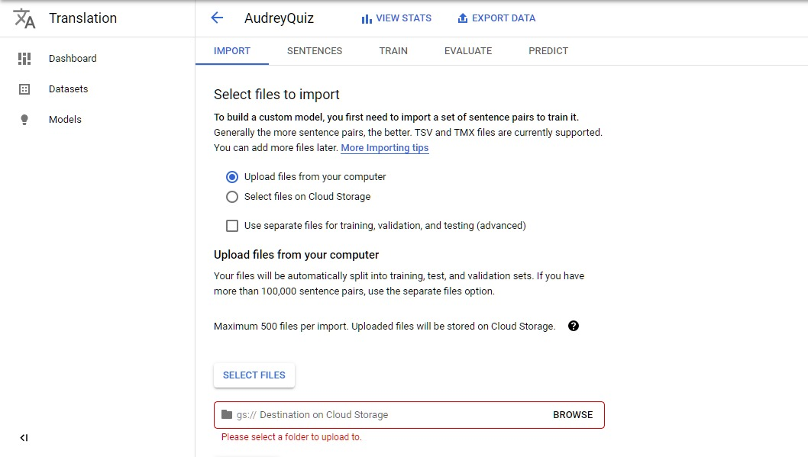

2.

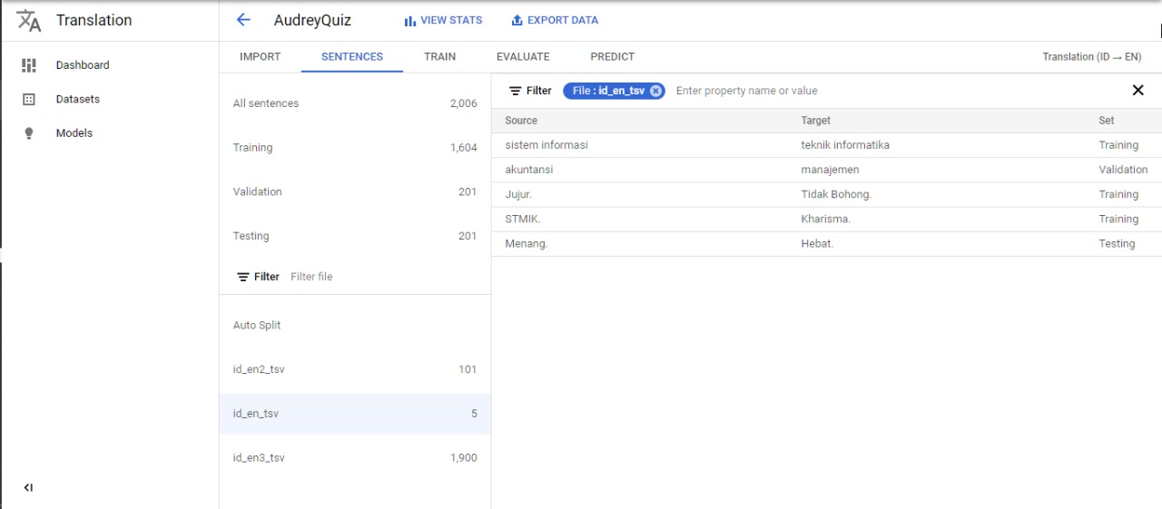

3.

