|  |
| --- |
| **BUSINESS INFORMATION TECHNOLOGY** |
| IT Seminar  BACK-END of Multilingual |
| May 2018 |

**TABLE OF CONTENT**

INTRODUCTION 1

1 GETTING READY 2

2 CHAT.JS 4

ADMIN MESSAGE RECEIVED 4

NEW MESSAGE RECEIVED 4

LEFT MESSAGE RECEIVED 4

LEFT MESSAGE RECEIVED 4

UPDATE USERS LIST MESSAGE RECEIVED 4

DOCUMENT READY 4

STORE THE URL VALUES 4

JOIN THE ROOM 5

SEND MESSAGE METHOD 5

STORE MESSAGE VALUE 5

RESET MESSAGE INPUT 5

SEND MESSAGE TO SOCKET 5

INTRODUCTION

This document was elaborated in the context of the IT Seminar in Finland. Its goal is to discover a new topic, to gain all the essential knowledge and finally to present it, as a leisure in front of the class during the IT Seminar in Finland.

In this document, we will present a Backend exercise related to JavaScript.

1. GETTING READY

To begin you should install Webstorm and Chrome.

Download Webstorm :

<https://www.jetbrains.com/webstorm/download/#section=mac>

Download Chrome :

<https://www.google.fr/chrome/?brand=CHBD&gclid=CjwKCAjwlcXXBRBhEiwApfHGTUv4wfVJerrEojBGHokujWeC2twURK2kLZBQes44tbAc54u9VqvLNhoC1xMQAvD_BwE>

When it is all set you need start Webstorm and import the project “SecondStepExercise” which you have download on cyberlearn.

Click on open and choose the project “SecondStepExercise”.

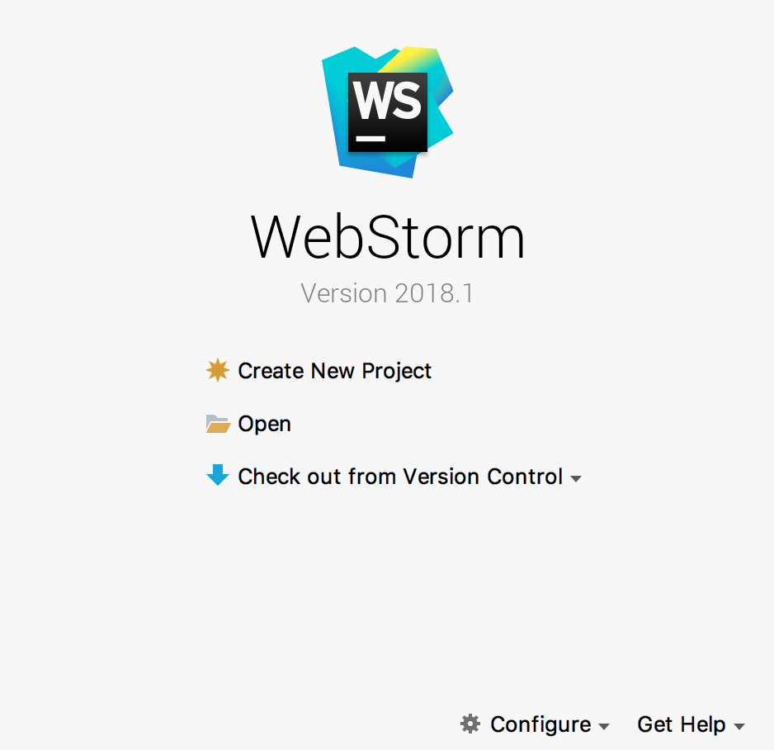

When it is open, here what you should see :

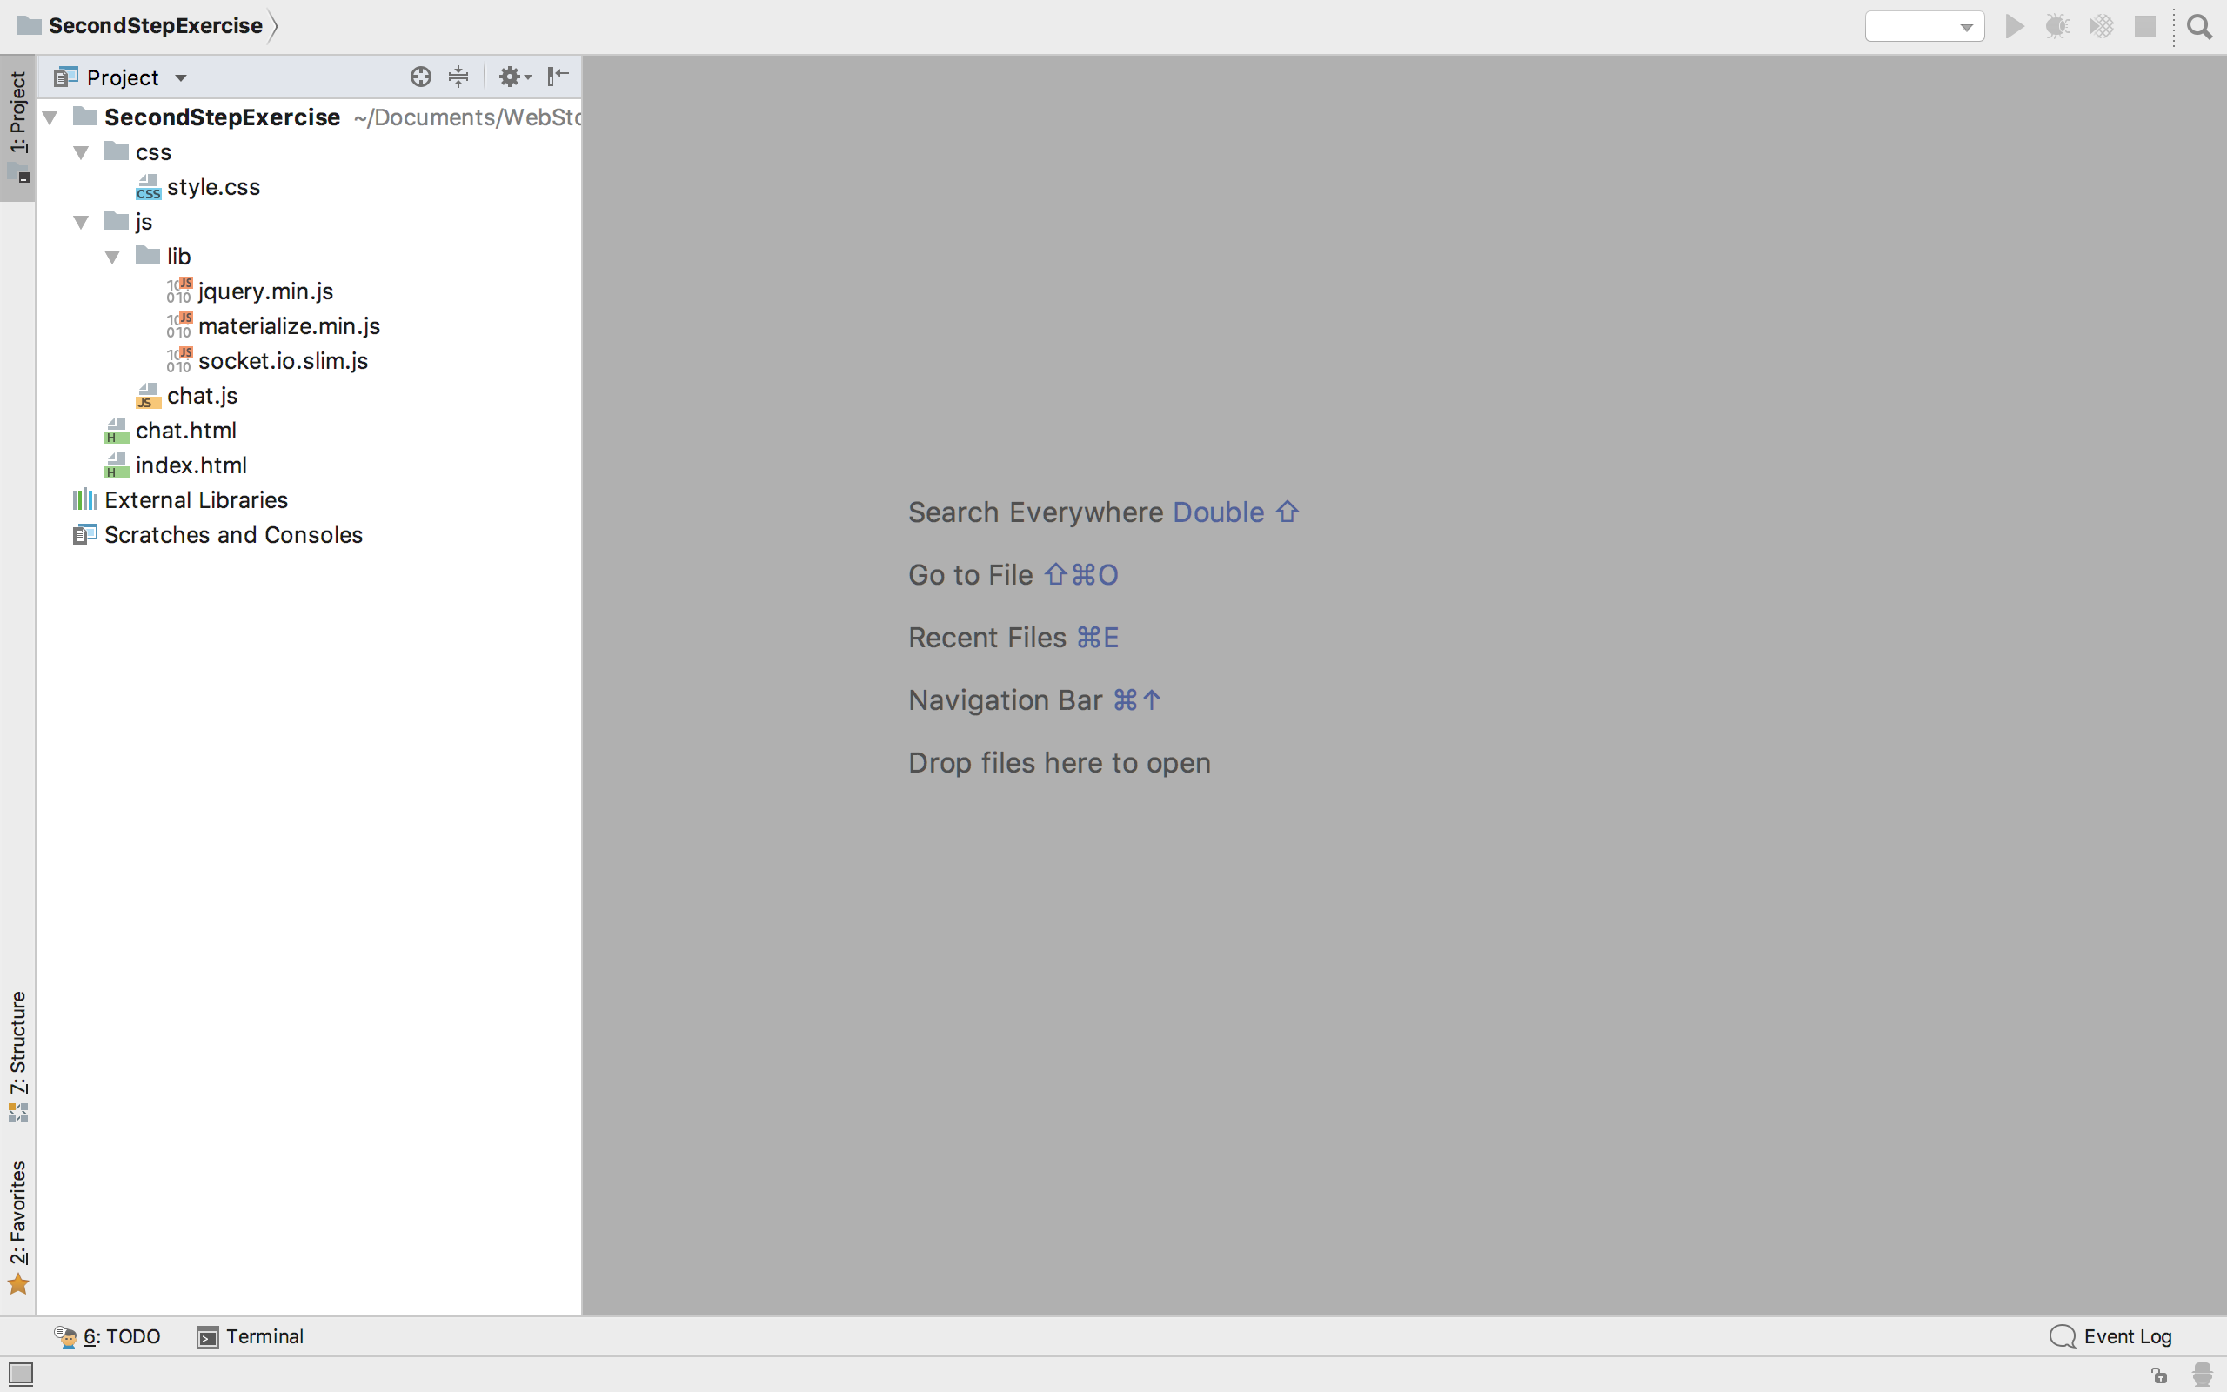

* The style.css is where all the css is written.
* The Directory lib is where all the module are install.
* The chat.js is where the javascript is written.
* The index.html and chat.html are where all the HTML are written.

1. CHAT.JS

Go on the chat.js file.

If you want to verify what you are implementing go on Chrome on this link :

<http://localhost:63342/SecondStepExercise/chat.html?_ijt=jsv0vmtj41ea4qesec4bn7dcid>

ADMIN MESSAGE RECEIVED

Implement the method adminMessage

NEW MESSAGE RECEIVED

Implement the method newMessage

LEFT MESSAGE RECEIVED

Implement the method leftMessage

LEFT MESSAGE RECEIVED

Implement the method joinMessage

UPDATE USERS LIST MESSAGE RECEIVED

Implement the method updateUserList

DOCUMENT READY

Implement document.ready()

STORE THE URL VALUES

Store those URL values :

**var** url

***$nickname***

***$room***

***$language***

JOIN THE ROOM

Emite the method join with the $socket

SEND MESSAGE METHOD

Implement the function sendMessage()

STORE MESSAGE VALUE

Store message value **var** $message

RESET MESSAGE INPUT

Then reset the message

SEND MESSAGE TO SOCKET

Emite the method sendMessage with the $socket