|  |
| --- |
| **BUSINESS INFORMATION TECHNOLOGY** |
| IT Seminar  FRONT-END of Multilingual |
| May 2018 |

**TABLE OF CONTENT**

INTRODUCTION 1

1. GETTING READY 2

2. INDEX.HTML 4

2.1. FORM TITLE 4

2.2. FORM NICKNAME 4

2.3. FORM ROOM 5

2.4. FORM LANGUAGE 5

2.5. BUTTON 6

3. CHAT.HTML 6

3.1. CHAT SIDE BAR 7

3.2. CHAT INPUT 7

3.3. CHAT BUTTON 8

INTRODUCTION

This document was elaborated in the context of the IT Seminar in Finland. Its goal is to discover a new topic, to gain all the essential knowledge and finally to present it, as a leisure in front of the class during the IT Seminar in Finland.

In this document, we will present a Frontend exercise related to HTML.

# GETTING READY

To begin you should install Webstorm and Chrome.

Download Webstorm :

<https://www.jetbrains.com/webstorm/download/>

Download Chrome :

<https://www.google.fr/chrome/?brand=CHBD&gclid=CjwKCAjwlcXXBRBhEiwApfHGTUv4wfVJerrEojBGHokujWeC2twURK2kLZBQes44tbAc54u9VqvLNhoC1xMQAvD_BwE>

When it is all set you need start Webstorm and import the project “Firststep” which you have download on cyberlearn.

Click on open and choose the project “Firststep”.

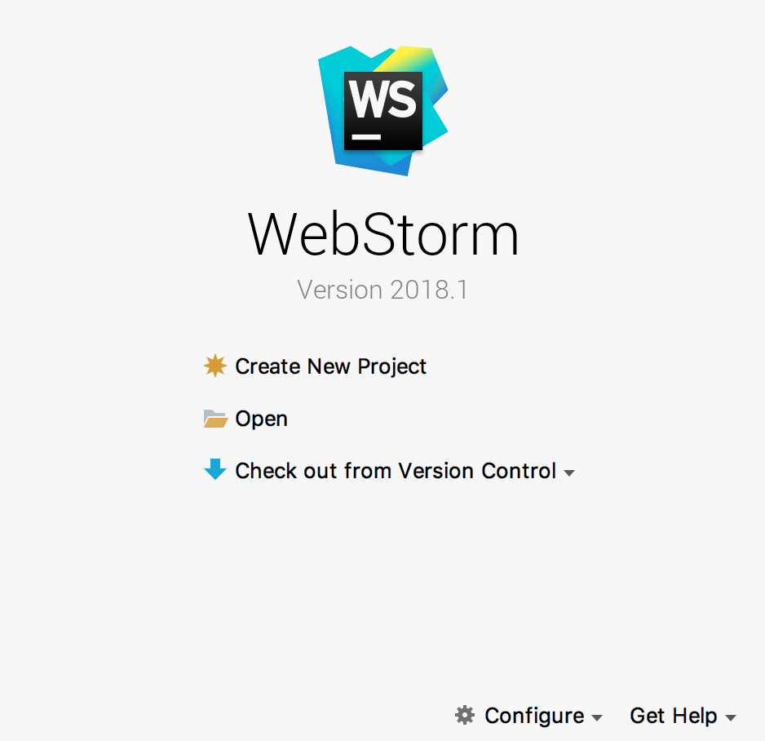

When it is open, here what you should see:

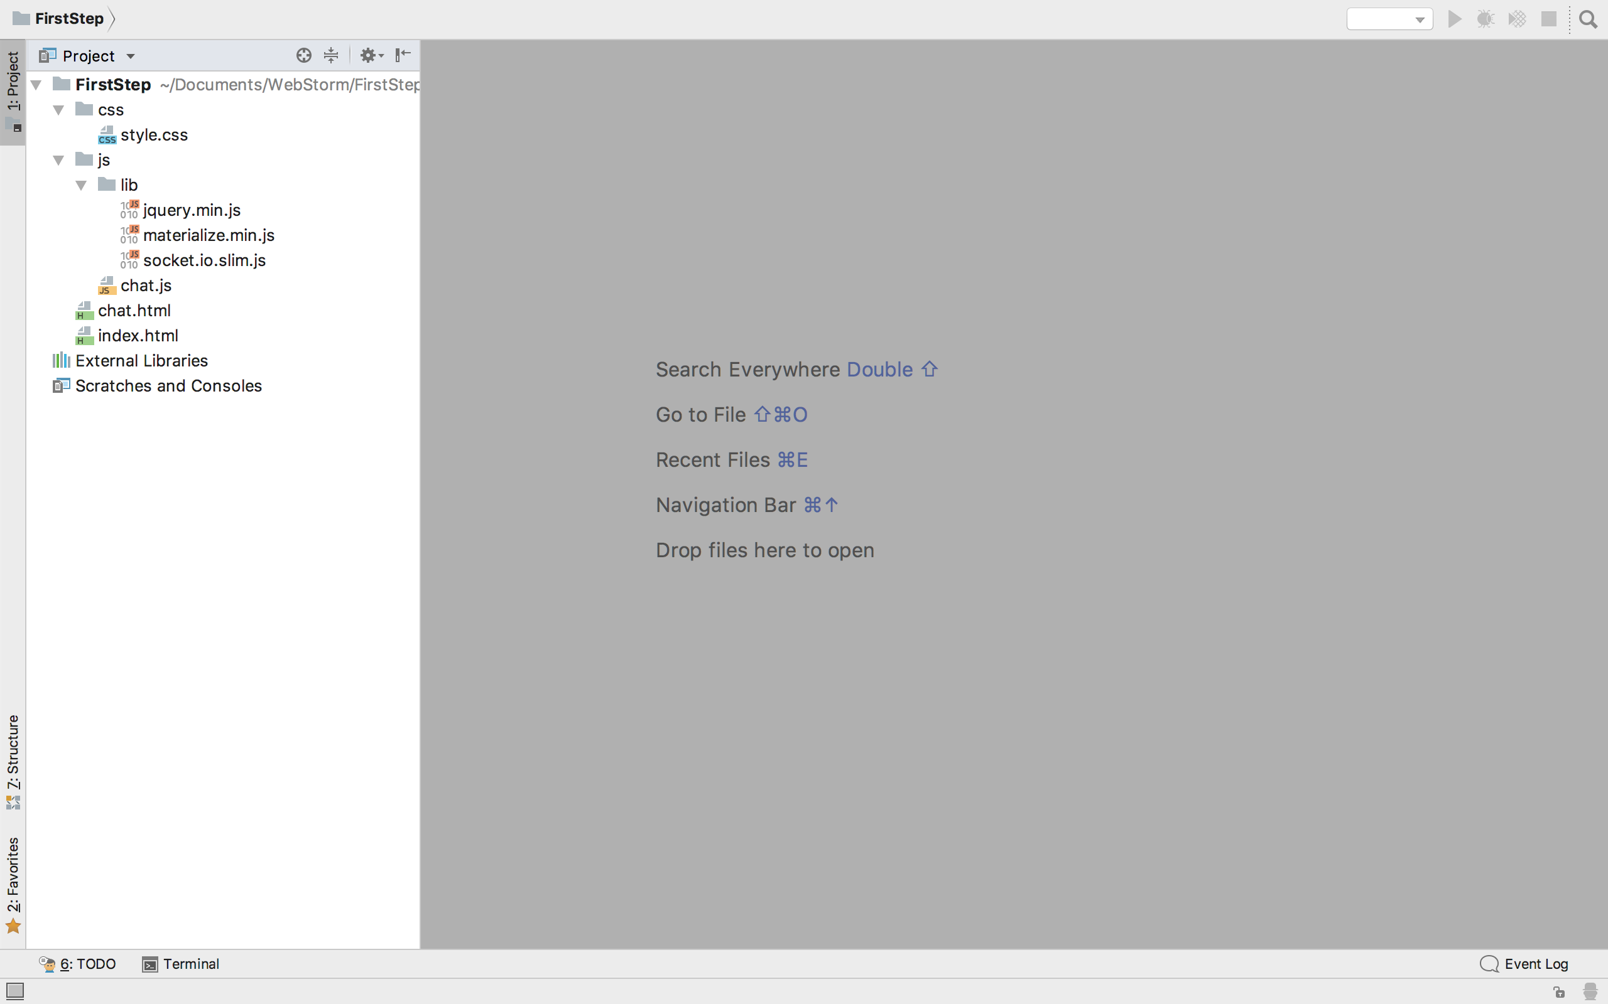

* The style.css is where all the css is written.
* The Directory lib is where all the modules are installed.
* The chat.js is where the javascript is written.
* The index.html and chat.html are where all the HTML are written.

# INDEX.HTML

Go on the index.html file.

If you want to verify what you are implementing go on Chrome on this link:

<http://localhost:63342/FirstStep/index.html?_ijt=8di82cpjfkdm9c6570cohaodtk>

## FORM TITLE

Add a title in the in the form in h3.

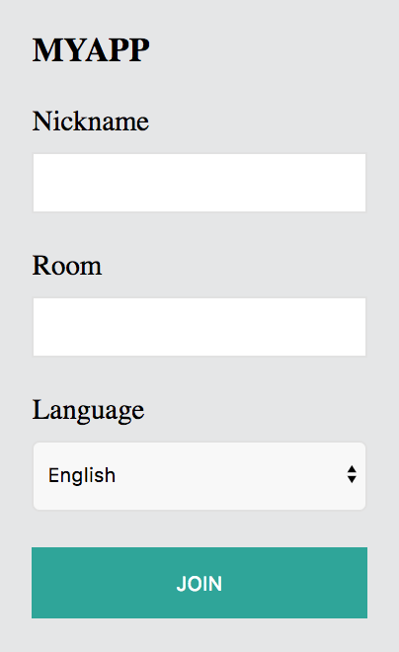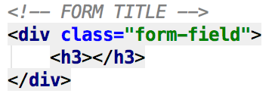

## FORM NICKNAME

Add a label and make sure it is required and it is a text.

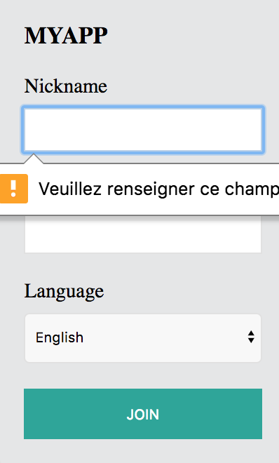

## FORM ROOM

Add a label and make sure it is required and it is a number.

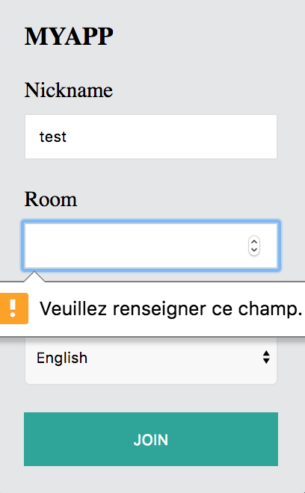

## FORM LANGUAGE

Add a list named “language”. The value in the list for the language is like this: **value="en-EN"**

Do the same structure for French, Spanish, German, Italian, Dutch, Polish.

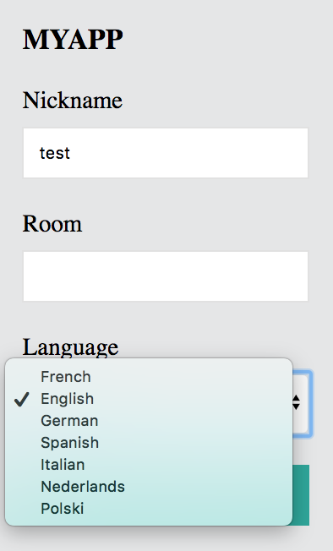

## BUTTON

Add a JOIN button.

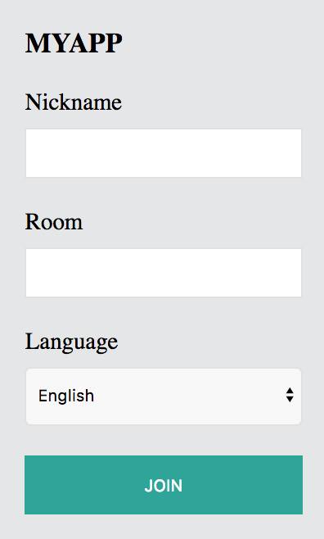

Now your index.html is done. If you want you can add some css in the file style.css to make it nicer.

# CHAT.HTML

Open chat.html. Here you going to implement the chat page.

If you want to verify what you are implementing go on Chrome on this link :

<http://localhost:63342/FirstStep/chat.html?nickname=test&room=4&language=en-EN>

## CHAT SIDE BAR

Add a title for the side bar

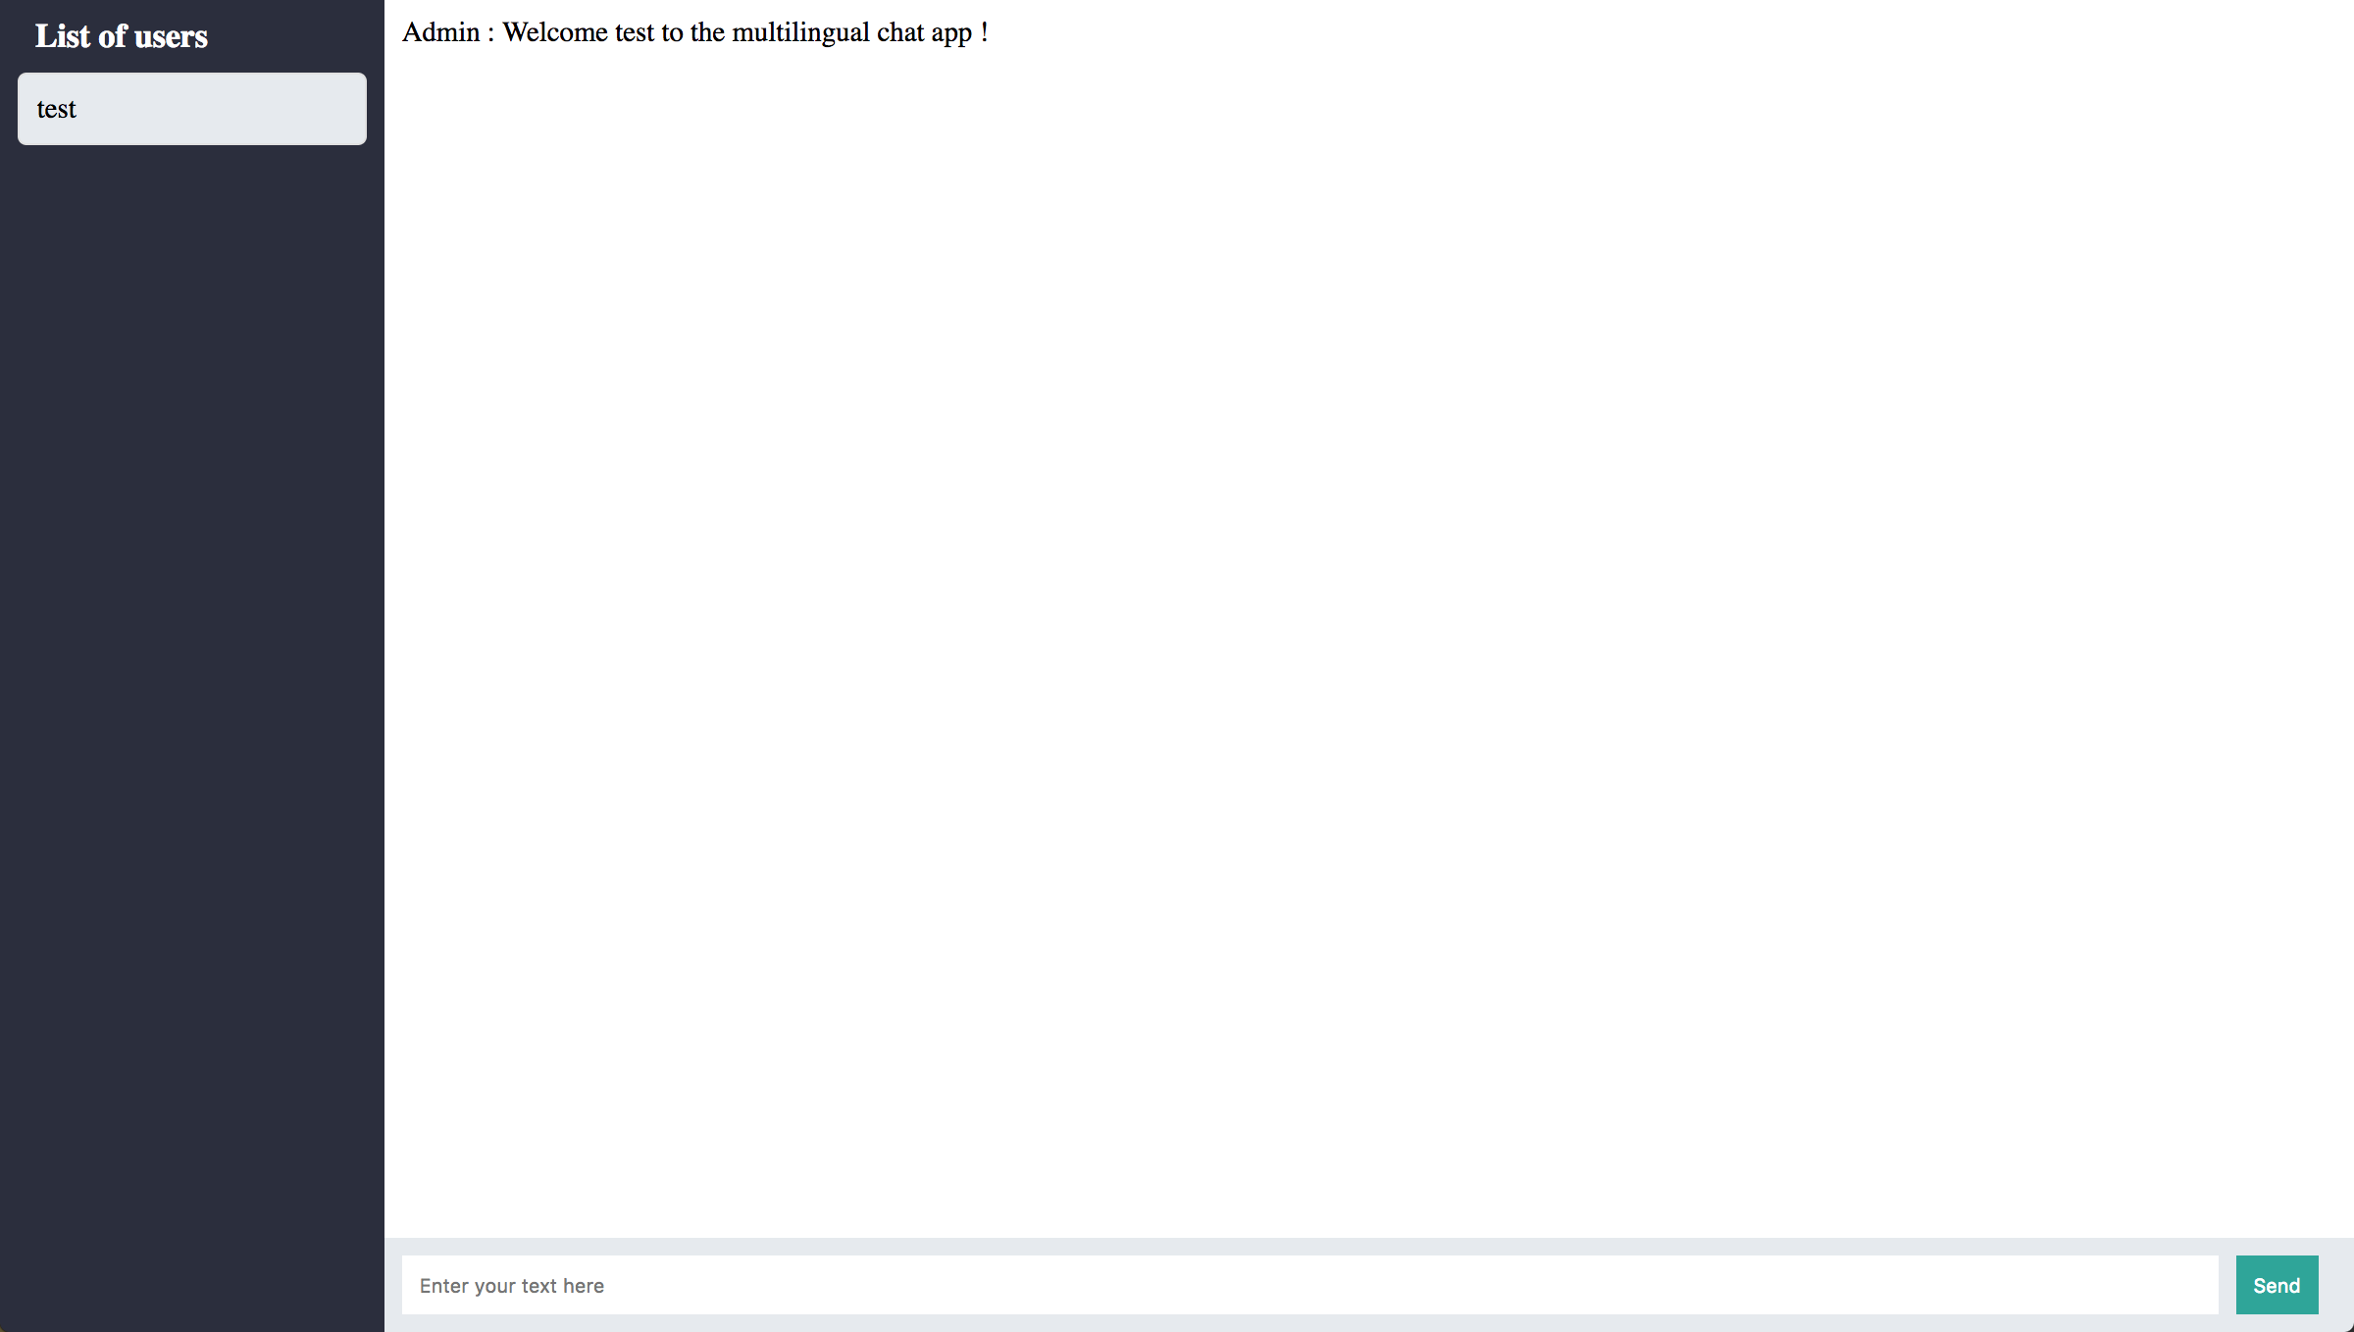

## CHAT INPUT

Add in the form an input with a name as “message”, the type has to be text and write in the placeholder what it should appear.



## CHAT BUTTON

Add in the form a button with a type of button and add a parameter like this : **onclick="***sendMessage*()**"**



Now your chatroom is ready. If you want you can add some css in the file style.css to make it nicer.