|  |
| --- |
| **BUSINESS INFORMATION TECHNOLOGY** |
| IT Seminar  BACK-END of Multilingual |
| May 2018 |

**TABLE OF CONTENT**

INTRODUCTION 1

INTRODUCTION

This document was elaborated in the context of the IT Seminar in Finland. Its goal is to discover a new topic, to gain all the essential knowledge and finally to present it, as a leisure in front of the class during the IT Seminar in Finland.

In this document, we will present a Backend exercise related to JavaScript.

# GETTING READY

To begin you should install Webstorm and Chrome.

Download Webstorm :

<https://www.jetbrains.com/webstorm/download/#section=mac>

Download Chrome :

<https://www.google.fr/chrome/?brand=CHBD&gclid=CjwKCAjwlcXXBRBhEiwApfHGTUv4wfVJerrEojBGHokujWeC2twURK2kLZBQes44tbAc54u9VqvLNhoC1xMQAvD_BwE>

When it is all set you need start Webstorm and import the project “ThirdStepExercise” which you have download on cyberlearn.

Click on open and choose the project “ThirdStepExercise”.

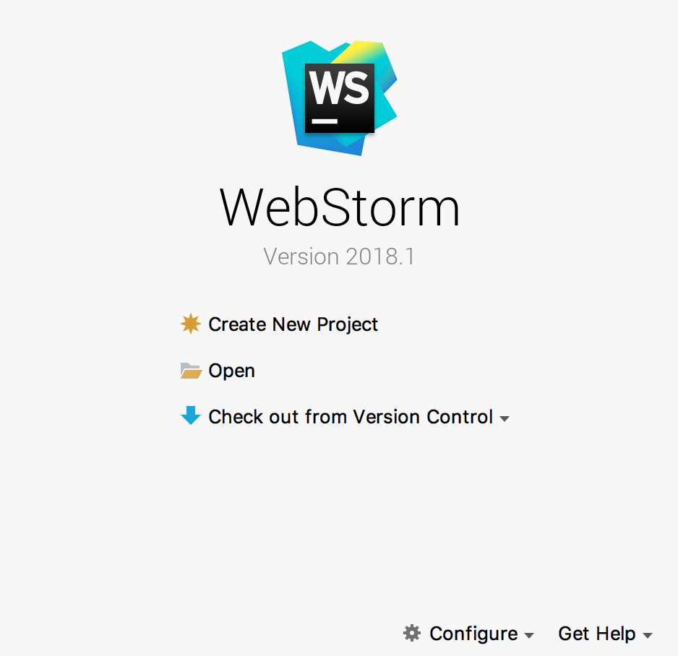

When it is open, here what you should see :

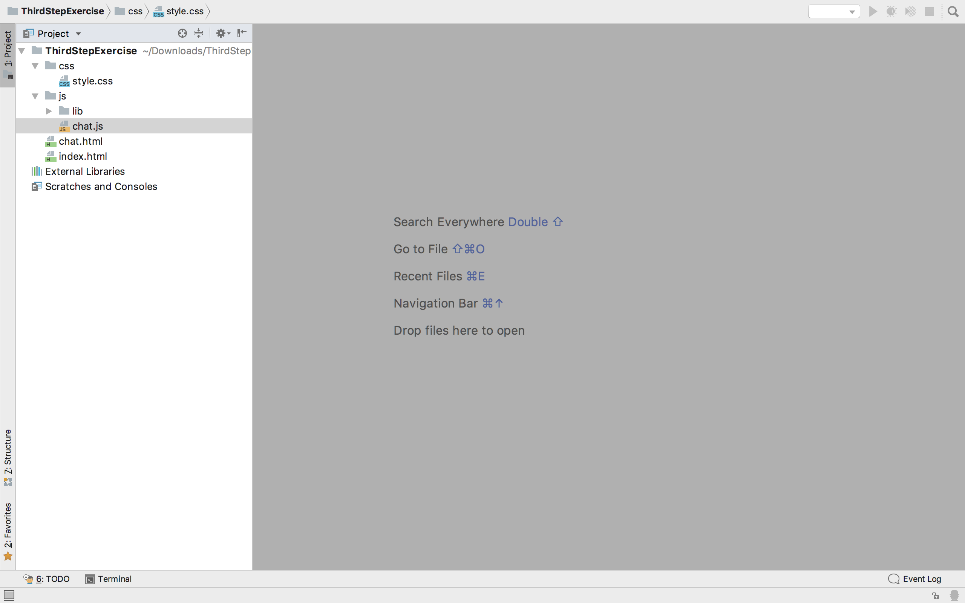

* The style.css is where all the css is written.
* The Directory lib is where all the module are install.
* The chat.js is where the javascript is written.
* The index.html and chat.html are where all the HTML are written.

# CHAT.HTML

Open chat.html. Here you going to change a little bit the chat page.

If you want to verify what you are implementing go on Chrome on this link :

<http://localhost:63342/ThirdStepExercise/chat.html?_ijt=jsv0vmtj41ea4qesec4bn7dcid>

## CHAT INPUT

Add in the form an input with a name as “message”, the type has to be text and write in the placeholder what it should appear. Be careful it should not be possible to write on it !

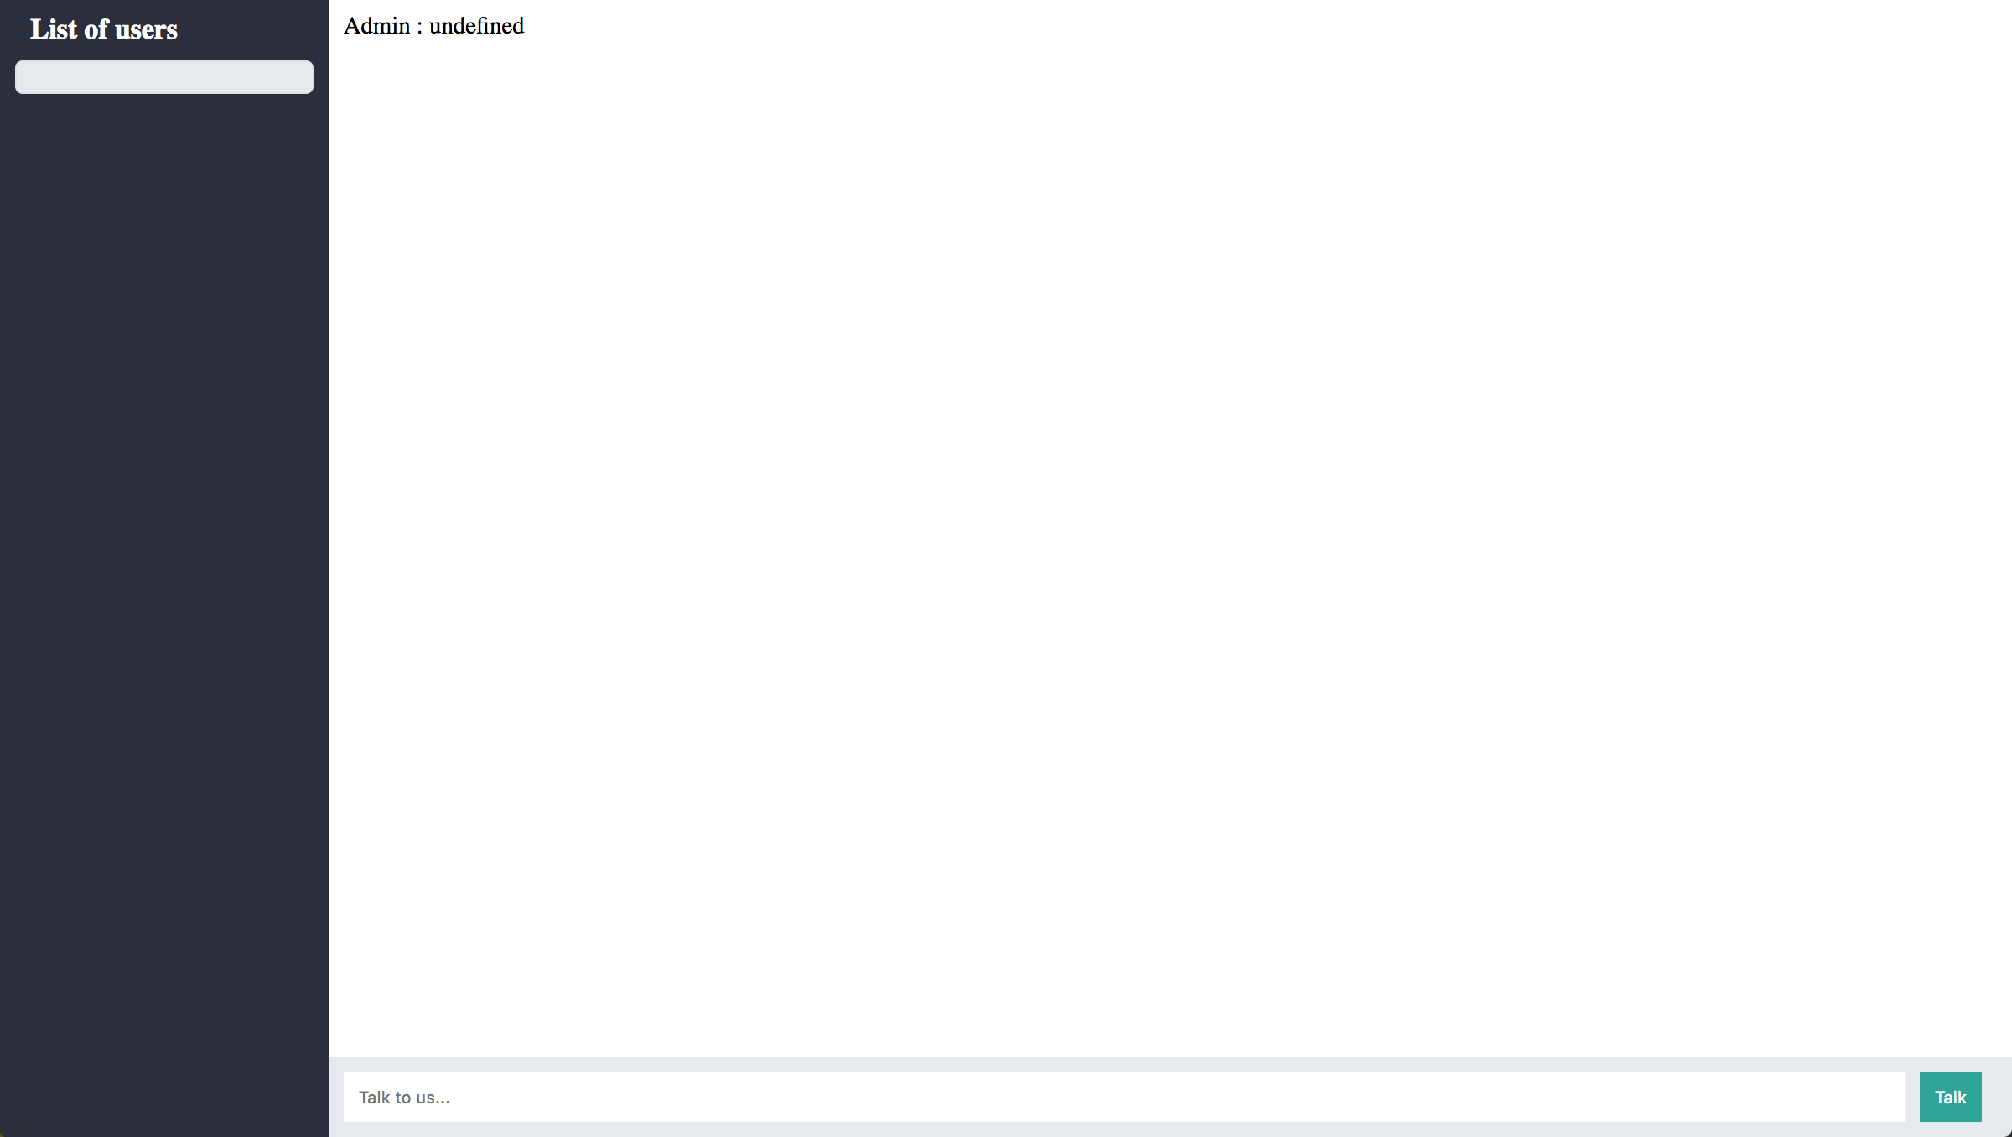

## CHAT BUTTON

Add in the form a button with an id as record-button with a type of button and add a parameter like this : **onclick="***sendMessage*()**"**



# CHAT.JS

Go on the chat.js file.

If you want to verify what you are implementing go on Chrome on this link :

<http://localhost:63342/ThirdStepExercise/chat.html?_ijt=jsv0vmtj41ea4qesec4bn7dcid>

## SEND MESSAGE METHOD

Implement the function sendMessage()

## CONFIGURE RECOGNITION

* You need to initialise recognition
* Set $recognizing variable to true when recording
* Set $recognizing variable to false when stop recording
* Set $recognizing variable to false when error occured
* Set $recognition onresult function