1. 22 distinct tuples.
2. In Enrolled, foreign key constraints are sid, cid. In teaches, foreign key constraints are fid, cid. In meets_in, they are cid, rno.

There can be some limits on the salary.

3.

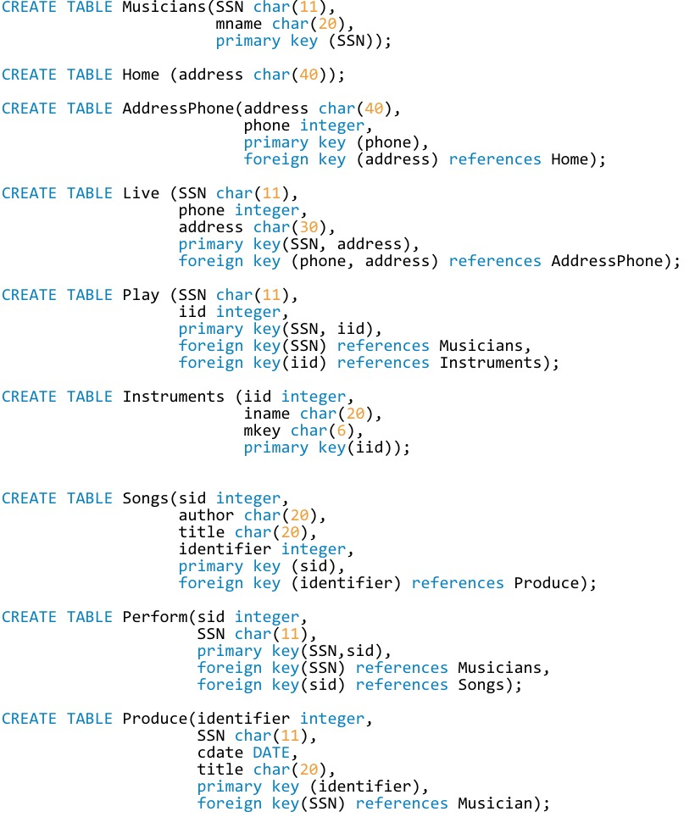

4.

The participant constraint cannot be shown in the table.

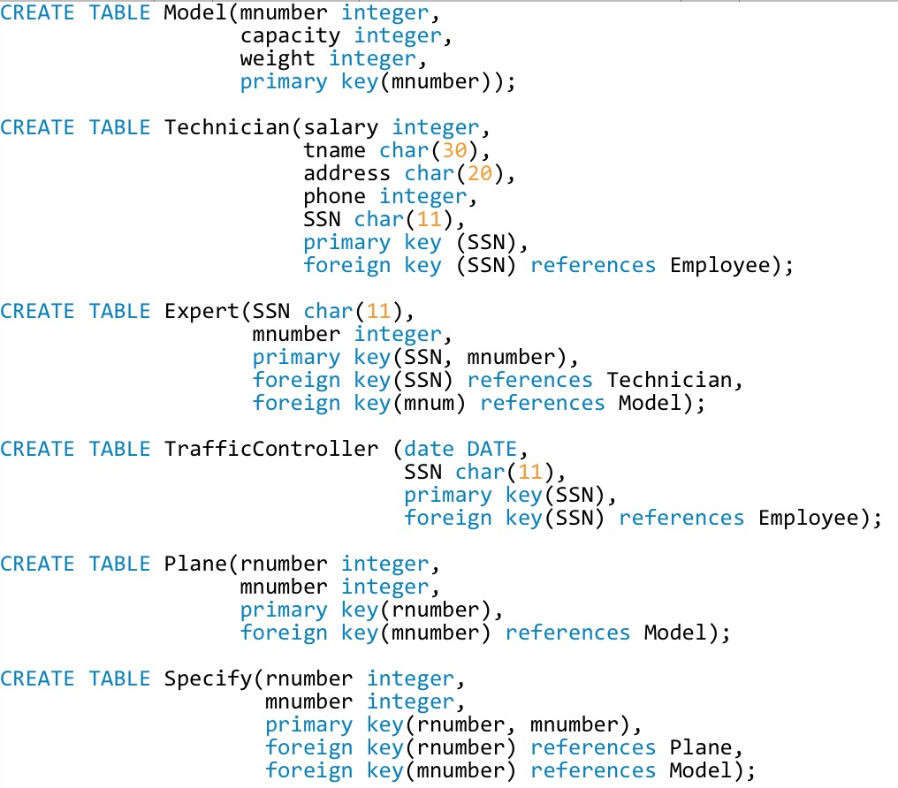

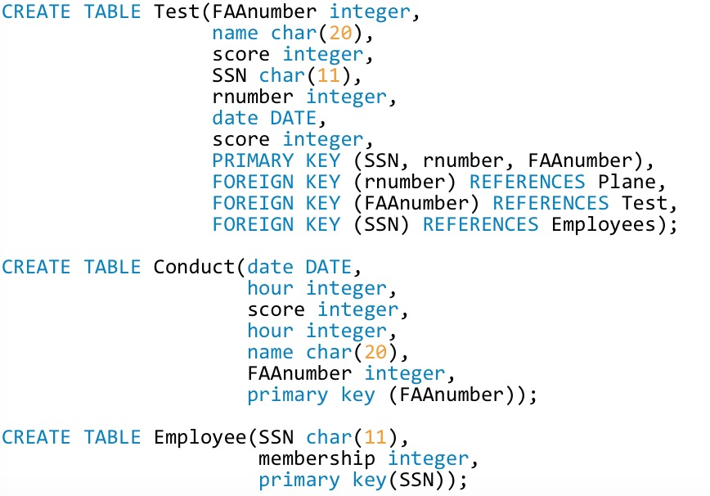

The constraint that tests on a plane must be conducted by a technician who is an expert on that model can be written as:

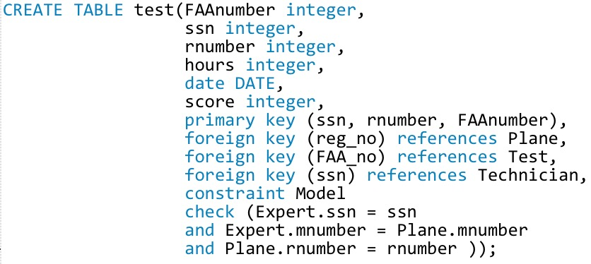

6-11

