GLOBAL HIV TRENDS &
TREATMENT EFFECTIVENESS
ANALYSIS

A Data-Driven Public Health Analysis Report
Specialization: Healthcare | Business Focus: Public Health | Tool: Power BI
Data Source: World Health Organization (WHO)
Coverage: 150 countries • 6 WHO regions • 2000–2024

Table of Contents

1. Executive Summary
This report analyses three decades of global HIV data (2000–2024) drawn from the World Health Organization, covering 150 countries across 6 WHO regions and four core indicators: new infections, HIV-related deaths, people living with HIV (PLHIV), and antiretroviral therapy (ART) coverage. The objective is to determine whether HIV infections are truly declining, whether expanding treatment access is reducing mortality, and how the overall burden of the disease is evolving.
The headline story is one of significant but incomplete progress. Since 2000, new infections have fallen by roughly 59% and annual deaths by roughly 66% (and 70% below their 2004 peak), even as the number of people living with HIV has continued to climb. This combination — fewer new infections and deaths but a growing prevalence pool — is the signature of a disease that has shifted from a fatal illness to a manageable chronic condition. It also signals a rising long-term care burden that health systems must sustain.
Headline Indicators (2024)
983.9K  New Infections  −59% vs 2000 | 523.3K  HIV Deaths  −70% vs 2004 peak | 35.2M  People w/ HIV  Rising prevalence | 79%  ART Coverage  PLHIV-weighted
Key findings at a glance:
- Infections are declining, but the pace has stalled. New infections barely changed between 2023 and 2024 (+0.25%), suggesting prevention gains are plateauing.
- Treatment is working. The country-level correlation between ART coverage and death rate is negative (r ≈ −0.48): higher coverage is associated with lower mortality.
- Africa carries the heaviest burden. The African region accounts for roughly 75% of PLHIV and the majority of new infections and deaths.
- Coverage gaps create risk. Several high-burden countries — Pakistan, Indonesia, Madagascar, Congo, Philippines — still report ART coverage at or below 50%.

2. Project Background & Objectives

2.1 Context
Over the past three decades, the WHO and partners have invested heavily in combating HIV through prevention programmes, awareness campaigns, and the rollout of antiretroviral therapy. ART has transformed HIV from a near-certain fatal diagnosis into a chronic, manageable condition for millions. Despite this, HIV remains a major public health concern — particularly in regions with limited healthcare infrastructure — and questions persist about the true effectiveness and sustainability of current interventions.

2.2 Problem Statement
Although HIV data is widely available, stakeholders lack a unified analytical framework to (1) evaluate the effectiveness of treatment programmes, (2) understand the relationship between infections, deaths, and treatment, and (3) identify regions requiring urgent intervention. This gap limits strategic planning and the efficient allocation of scarce resources.

2.3 Objectives
- Disease monitoring — track the global spread of HIV over time.
- Evaluate treatment impact — assess how ART coverage affects mortality.
- Support strategic decisions — enable policymakers to target high-risk regions.

2.4 Business Questions
The analysis is structured to answer twelve business questions, including: how infections and deaths are trending over time; the total burden of PLHIV; overall treatment coverage; mortality and survival rates; which countries record the most deaths per 1,000 new infections; which regions are most affected; which countries have the best and worst treatment access; whether high-infection countries have adequate coverage; and whether higher ART coverage correlates with lower mortality.

3. Data Description & Methodology

3.1 Dataset
The dataset contains 9,763 annual records sourced from the WHO. Each row records a single indicator value for one country in one year. The raw structure is long-format with the following fields:
Field | Description
indicator | HIV metric recorded (one of four indicators)
location_code | WHO region code (AFR, AMR, EMR, EUR, SEAR, WPR)
continent | WHO region name
country | Country name (150 unique countries)
year | Calendar year (2000–2024)
value | Numeric value — a count or a percentage
The four indicators are:
- New infections — newly reported HIV cases; measures disease spread (incidence).
- HIV deaths — deaths caused by HIV; measures severity and mortality impact.
- People living with HIV — total individuals currently living with HIV; measures burden (prevalence).
- ART coverage (%) — share of HIV-positive individuals receiving treatment; measures treatment access.

3.2 Data Quality Notes
Two important characteristics shape the analysis. First, the data is mixed-unit: three indicators are counts (which can be summed) and one (ART coverage) is a percentage (which must be averaged, ideally weighted by PLHIV, never summed). Second, reporting cadence differs by indicator: PLHIV and deaths are reported annually for every year, whereas new infections and ART coverage are reported every five years until 2020 and annually thereafter (2000, 2005, 2010, 2015, 2020–2024). Trend comparisons therefore use these common comparable years to avoid mistaking missing years for zeros.

3.3 Methodology
The project follows a four-stage workflow: data collection from the WHO source, data modelling into a star schema, analysis and visualisation in Power BI, and a set of actionable recommendations. The raw long table was cleaned and reshaped into a dimensional model so that it can support flexible slicing by year, region, country, and indicator.

4. Data Model (Star Schema)
The data was modelled as a star schema with one fact table and three dimension tables. This structure keeps measures in a central fact table and descriptive attributes in surrounding dimensions, which makes the model fast, intuitive to filter, and easy to extend.
Table | Type | Grain / Keys | Purpose
Fact_HIV | Fact | One row per indicator × country × year | Stores the numeric Value and foreign keys
Dim_Geography | Dimension | CountryKey (PK) | Country, RegionCode, WHO_Region
Dim_Indicator | Dimension | IndicatorKey (PK) | Indicator name, Measure_Type, Unit
Dim_Date | Dimension | DateKey = Year (PK) | Year, Decade, ART era band
Relationships are one-to-many from each dimension to the fact table, filtering in a single direction (dimension → fact). The accompanying workbook HIV_Star_Schema_Model.xlsx contains all four tables plus a data dictionary, ready to load into Power BI.

4.1 Core KPI Definitions (DAX)
KPI | Definition
Death Rate | Total HIV deaths ÷ Total people living with HIV
Survival Rate | 1 − Death Rate
Deaths per 1,000 Infections | (Total deaths ÷ Total new infections) × 1,000
Avg ART Coverage | Average of ART coverage % (PLHIV-weighted for global)
YoY Growth | (This year − Prior year) ÷ Prior year

5. Analysis & Insights

5.1 Are infections truly declining?
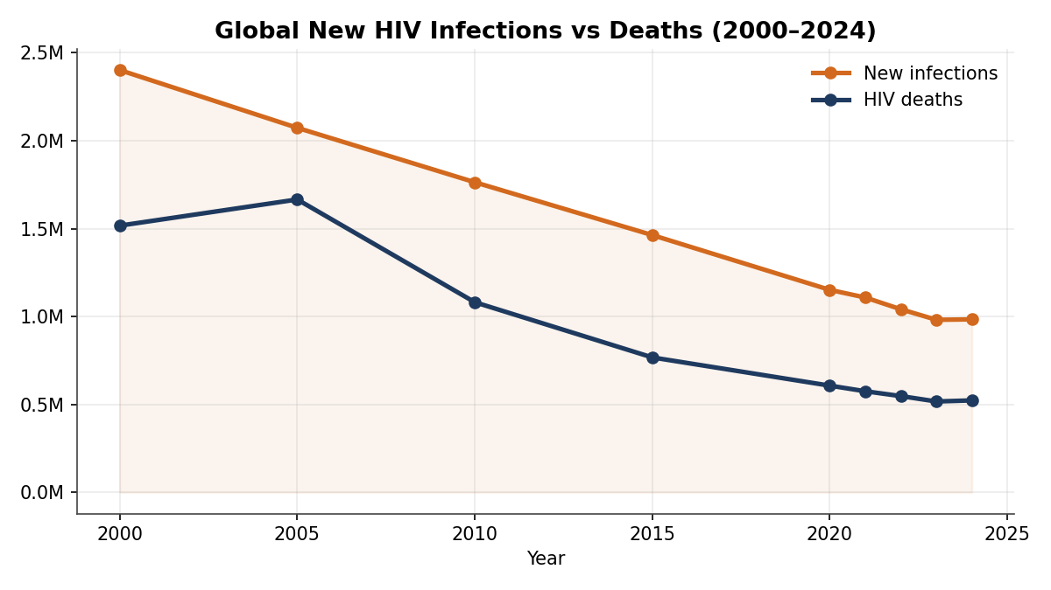
Figure 1 — Global new infections and deaths, 2000–2024.
New infections fell from about 2.40 million in 2000 to 0.98 million in 2024 — a decline of roughly 59%. Deaths fell even faster, from 1.52 million in 2000 (peaking near 1.74 million in 2004) to 0.52 million in 2024, around 70% below the peak. The trends are unambiguously downward, confirming that prevention and treatment have changed the trajectory of the epidemic. However, the curve has flattened: between 2023 and 2024 new infections were essentially unchanged (+0.25%), a warning that the easy gains may be behind us and that renewed prevention effort is needed to keep the decline going.

5.2 How is the overall burden evolving?
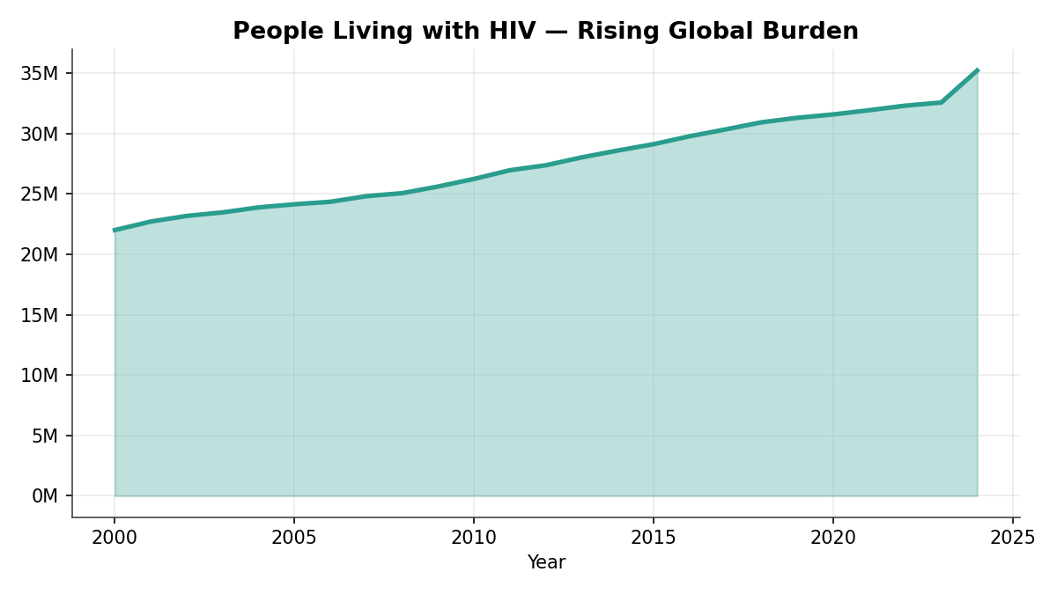
Figure 2 — People living with HIV, 2000–2024.
While infections and deaths fall, the number of people living with HIV has risen steadily — from about 22 million in 2000 to 35.2 million in 2024. This is the expected and, in fact, desirable consequence of effective treatment: people who would once have died are now living long lives on ART. The implication for policymakers is structural — the global care burden grows every year, so funding for lifelong treatment, monitoring, and supply chains must be sustained well beyond the period when new infections are falling.

5.3 Is treatment access expanding?
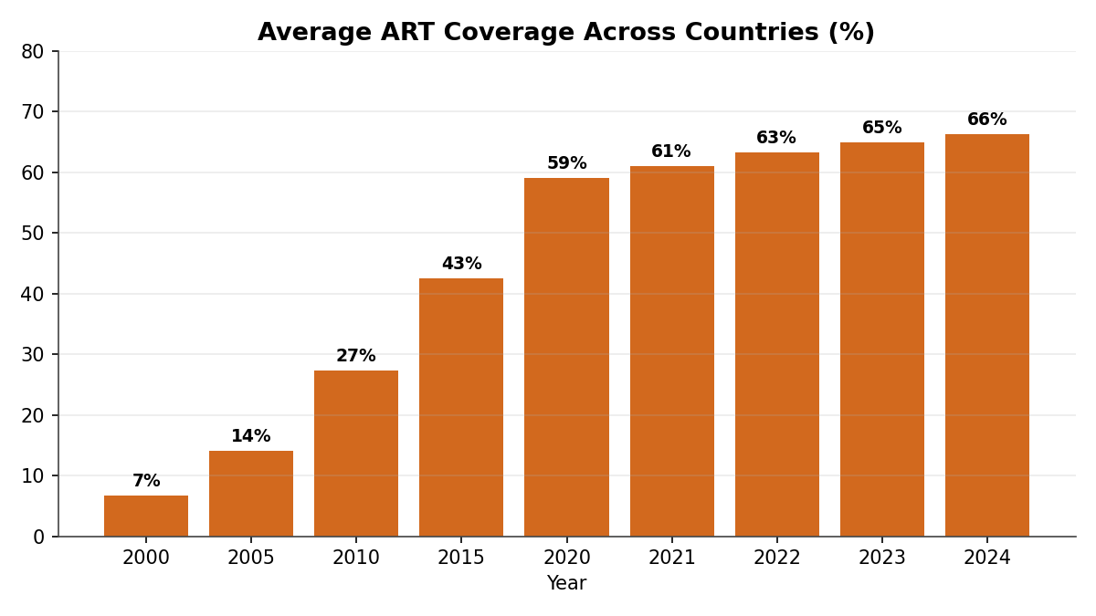
Figure 3 — Average ART coverage across reporting countries.
Average ART coverage across reporting countries rose from about 7% in 2000 to 27% in 2010, 59% in 2020, and 66% by 2024 (roughly 79% when weighted by the number of people living with HIV). This dramatic scale-up is the single biggest driver of the mortality decline. The remaining gap between coverage and the global 95% treatment target shows there is still meaningful ground to close, especially in lower-coverage regions.

5.4 Which regions are most affected?
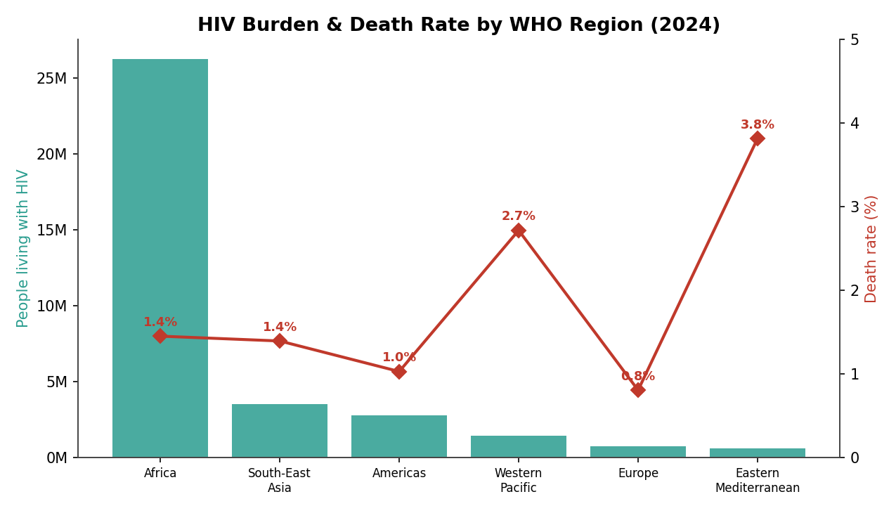
Figure 4 — HIV burden and death rate by WHO region (2024).
The African region dominates the global burden, with about 26.3 million people living with HIV — roughly three-quarters of the world total — along with the majority of new infections (about 652,000) and deaths (about 380,000). However, raw burden and death rate are not the same thing. The Eastern Mediterranean region records the highest death rate at 3.81%, followed by the Western Pacific at 2.71%, both well above Africa's 1.45%. These elevated death rates point to regions where treatment access is lagging relative to the size of the epidemic.

5.5 Does higher ART coverage reduce mortality?
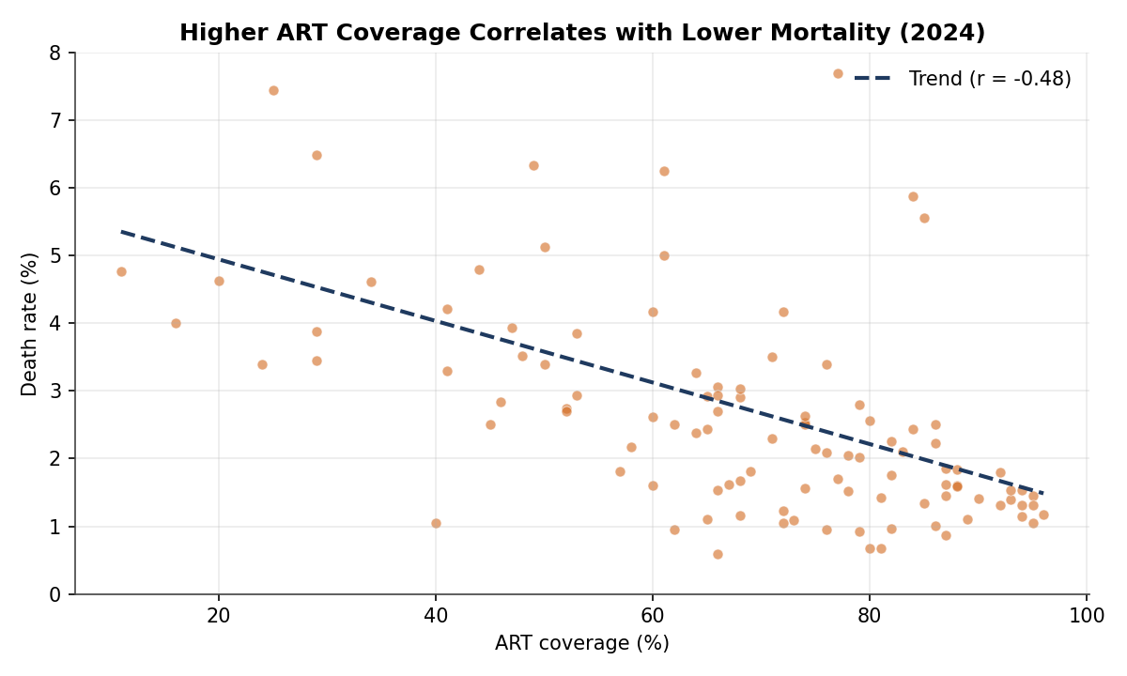
Figure 5 — ART coverage vs. death rate, by country (2024).
Plotting each country's ART coverage against its death rate reveals a clear negative relationship (Pearson r ≈ −0.48 across 108 countries): countries with higher treatment coverage tend to have lower death rates. This is the central evidence that treatment programmes are effective. The correlation is moderate rather than perfect because mortality also depends on how early people are diagnosed, treatment adherence, co-infections, and health-system quality — but the direction is unmistakable and supports continued investment in ART scale-up.

5.6 Where is the system least efficient?
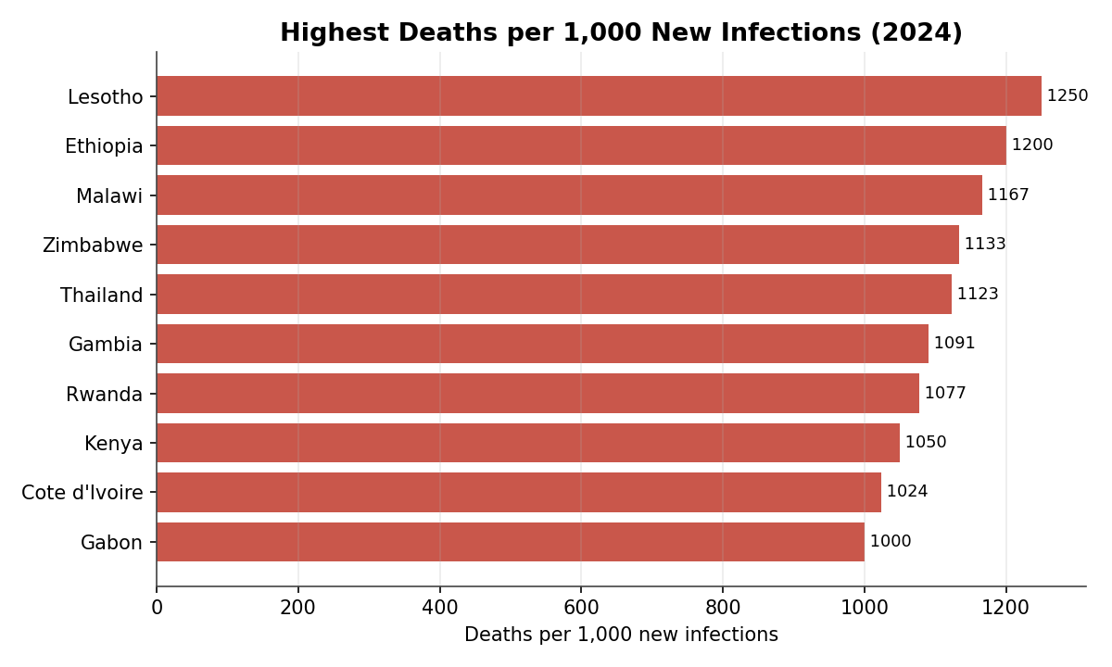
Figure 6 — Highest deaths per 1,000 new infections (2024).
Normalising deaths by new infections highlights where the epidemic is least survivable. Lesotho (about 1,250 deaths per 1,000 new infections), Ethiopia, Malawi, Zimbabwe, and Thailand top the list. A ratio above 1,000 means a country records more deaths than new infections in a year — a signature of a mature epidemic with a large existing prevalence pool and, in several cases, gaps in sustained treatment. These countries warrant a focus on retention-in-care and viral suppression rather than only new-infection prevention.

5.7 Do high-infection countries have adequate coverage?
Most very high-infection countries have reasonably strong coverage — South Africa (81%), Mozambique (82%), Nigeria (83%), Tanzania (87%), Uganda (85%), and Zambia (94%). The notable exceptions are the Philippines (40%) and Indonesia (41%), both in the Western Pacific / South-East Asia regions, where rising infections meet weak treatment access — a dangerous combination that helps explain those regions' elevated death rates.

5.8 Which countries are most at risk?
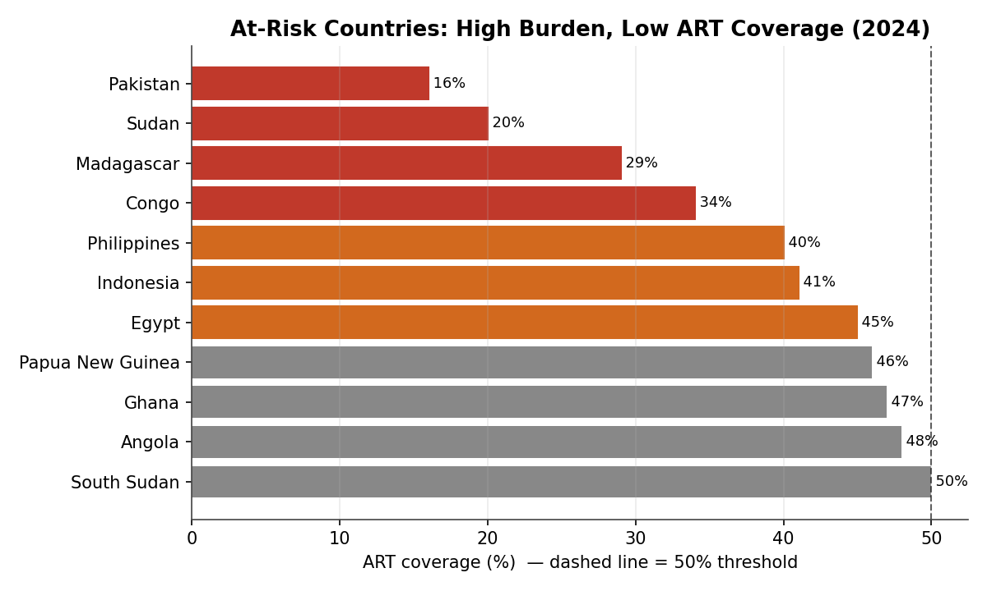
Figure 7 — High-burden countries with ART coverage at or below 50% (2024).
Combining burden with coverage isolates the countries most at risk: those with at least 50,000 people living with HIV but ART coverage at or below 50%. Pakistan (16%), Sudan (20%), Madagascar (29%), Congo (34%), the Philippines (40%), Indonesia (41%), Egypt (45%), Papua New Guinea (46%), Ghana (47%), Angola (48%), and South Sudan (50%) form a clear priority list for urgent intervention. Pakistan and Indonesia stand out because they pair very low coverage with large or rising case numbers.

6. Recommendations
The analysis translates into five actionable recommendations for the WHO, national health ministries, and donor partners:
- Prioritise the coverage laggards. Direct treatment funding and technical support to the at-risk list — Pakistan, Indonesia, Madagascar, Congo, the Philippines, Sudan, and Angola — where low ART coverage meets significant burden. Closing these gaps offers the largest available mortality reduction.
- Re-energise prevention. With new infections plateauing since 2023, renew investment in proven prevention (PrEP, testing, education, harm reduction), concentrating on the African region and on rising-infection settings such as the Philippines.
- Protect treatment for the growing prevalence pool. Because people living with HIV keeps rising, lock in sustainable, long-term financing for lifelong ART, supply chains, and viral-load monitoring so that mortality gains are not reversed.
- Target high-mortality-ratio countries with retention programmes. In Lesotho, Ethiopia, Malawi, Zimbabwe, and Thailand, focus on early diagnosis, treatment adherence, and viral suppression rather than only new-infection prevention.
- Strengthen data reporting. Move the remaining five-yearly indicators (infections, ART coverage) to annual reporting across all countries to enable timelier monitoring and faster course-correction.

6.1 Conclusion
The global HIV response over the last 25 years is a public-health success in motion: infections down 59%, deaths down 70% from their peak, and treatment coverage up roughly ten-fold. Yet the job is unfinished. A plateau in new infections, persistent regional disparities, a structurally rising care burden, and a clutch of high-burden, low-coverage countries mean that sustained, targeted, data-driven investment remains essential. The dimensional model and dashboard built in this project give stakeholders exactly the unified analytical framework needed to direct that investment where it will save the most lives.

