Nasdaq Baltic universe: maximum-netSD portfolio
Study period: 2023-01-01 to 2026-10-23 | Portfolio ceiling: EUR 15,000 | Existing positions may be sold
Return statistics use complete common trading dates through 2026-10-23. Valuation, whole-share quantities and EUR trade amounts use each share's latest observed close through 2026-10-23.

Optimisation result
The best numerical solution found has netSD 0.881356 (OUT=104, IN=0, denominator=118). It is evaluated against one fixed reference network containing 55 quality-approved shares, the current portfolio, and the ten earlier training/full-data portfolios.
Current-portfolio netSD is 0.576271; the optimised-portfolio value is 0.881356. Historical gross dividends for the final whole-share quantities are EUR 2383.60. These historical dividends are a counterfactual, before tax and without reinvestment, rather than a forecast.

Decision guide
Primary model scenario: Baltic_NetSD. Existing positions may be sold and the model reallocates up to EUR 15,000. Table 3 is the single canonical model trade list for this scenario. This is a model output rather than personalised investment advice.
Alternative scenario: curent_update_baltic. Every existing position is retained and only additional purchases are allowed. Table 3A belongs only to this alternative and must not be combined with Table 3 quantities.
The Priority field in Table 3A and the single-share-addition experiments are diagnostics, not a trade execution sequence. Technical BUY/HOLD/SELL signals are timing diagnostics and do not override the portfolio optimiser.
Suggested execution process: (1) refresh prices, cash and order-book depth; (2) select one scenario; (3) review liquidity and transaction costs; (4) place limit orders, splitting illiquid trades; (5) recalculate quantities and residual cash after fills. In-sample results and the unstable holdout test require paper trading or walk-forward validation before relying on the allocation.
Return and technical analysis uses common observations through 2026-10-23; valuation prices and trade quantities are refreshed through 2026-10-23. The 70/30 validation uses an earlier fixed split and is reported separately from the complete-period analysis.

Table 1. Optimisation objective and constraint checks
Component | Restriction or objective | Obtained value | Result
Objective: netSD | maximum value found numerically | 0.88135593 | Reported
Budget | invested <= 15000 | 14899.52200043 | Satisfied
Residual cash | >= 0 | 100.47799957 | Satisfied
Full-investment weights | sum(w) = 1 | 1.00000000 | Satisfied
Long only | min(w) >= 0 | 0.00000000 | Satisfied
Sales | existing positions may be reduced to zero | -330.00000000 | Allowed
Minimum mean | >= 0.00033472 | 0.00055284 | Satisfied
Historical dividends | descriptive only; excluded from objective | 2383.59984000 | EUR historical gross cash

Table 2. Eligible Nasdaq Baltic shares and the optimised allocation
asset | name | market | last_price | optimal_weight_percent | current_shares | target_shares | trade_shares | allocation_change_direction | invested_EUR | historical_dividend_cash
AIR | Airobot Technologies | TLN | 1.8500 | 0.0000 | 0 | 0 | 0 | HOLD | 0.0000 | 0.0000
AKO1L | Akola Group | VLN | 1.8500 | 0.1372 | 0 | 11 | 11 | BUY | 20.3500 | 0.0000
AMG1L | Amber Grid | VLN | 1.2000 | 0.0000 | 0 | 0 | 0 | HOLD | 0.0000 | 0.0000
APG1L | Apranga | VLN | 3.8200 | 10.8282 | 200 | 425 | 225 | BUY | 1623.5000 | 437.7500
ARC1T | Arco Vara | TLN | 1.0400 | 0.0000 | 0 | 0 | 0 | HOLD | 0.0000 | 0.0000
AUG1L | AUGA group | VLN | 0.0670 | 0.0000 | 0 | 0 | 0 | HOLD | 0.0000 | 0.0000
BAL1R | Amber Latvijas balzams | RIG | 0.9600 | 0.0000 | 0 | 0 | 0 | HOLD | 0.0000 | 0.0000
BERCM | Bercman Technologies | TLN | 1.0450 | 0.0000 | 0 | 0 | 0 | HOLD | 0.0000 | 0.0000
CPA1T | Coop Pank | TLN | 2.3850 | 0.1703 | 0 | 10 | 10 | BUY | 23.8500 | 2.6700
CTS1L | City Service | VLN | 0.1560 | 0.0000 | 0 | 0 | 0 | HOLD | 0.0000 | 0.0000
DGR1R | DelfinGroup | RIG | 1.7000 | 0.9833 | 0 | 86 | 86 | BUY | 146.2000 | 28.1392
EFT1T | EfTEN Real Estate Fund | TLN | 19.3500 | 2.1484 | 0 | 16 | 16 | BUY | 309.6000 | 71.4016
EWA1L | East West Agro | VLN | 11.5000 | 0.0000 | 0 | 0 | 0 | HOLD | 0.0000 | 0.0000
GRG1L | Grigeo Group | VLN | 1.0100 | 3.5279 | 543 | 523 | -20 | SELL | 528.2300 | 88.9100
HAE1T | Harju Elekter Group | TLN | 5.3600 | 4.2253 | 100 | 118 | 18 | BUY | 632.4800 | 68.4400
HPR1T | Hepsor | TLN | 4.4000 | 0.0000 | 0 | 0 | 0 | HOLD | 0.0000 | 0.0000
IDX1R | INDEXO | RIG | 2.5400 | 0.0000 | 0 | 0 | 0 | HOLD | 0.0000 | 0.0000
IGN1L | Ignitis grup<U+0117> | VLN | 21.7000 | 8.2865 | 0 | 57 | 57 | BUY | 1236.9000 | 223.3830
INC1L | INVL Technology | VLN | 5.4000 | 0.0000 | 0 | 0 | 0 | HOLD | 0.0000 | 0.0000
INL1L | INVL Baltic Farmland | VLN | 7.1000 | 0.0000 | 0 | 0 | 0 | HOLD | 0.0000 | 0.0000
INR1L | INVL Baltic Real Estate | VLN | 2.7400 | 0.0000 | 0 | 0 | 0 | HOLD | 0.0000 | 0.0000
IVL1L | Invalda INVL | VLN | 25.6000 | 0.0000 | 0 | 0 | 0 | HOLD | 0.0000 | 0.0000
KNE1L | KN Energies | VLN | 0.4790 | 10.0992 | 0 | 3162 | 3162 | BUY | 1514.5980 | 203.6328
KNR1L | Kauno energija | VLN | 2.1000 | 0.0000 | 0 | 0 | 0 | HOLD | 0.0000 | 0.0000
LGD1L | LITGRID | VLN | 1.1100 | 0.0000 | 0 | 0 | 0 | HOLD | 0.0000 | 0.0000
LHV1T | LHV Group | TLN | 3.2750 | 2.1530 | 0 | 98 | 98 | BUY | 320.9500 | 42.1400
LINDA | Linda Nektar | TLN | 4.0600 | 0.0000 | 0 | 0 | 0 | HOLD | 0.0000 | 0.0000
MAGIC | TextMagic | TLN | 1.7950 | 0.0000 | 0 | 0 | 0 | HOLD | 0.0000 | 0.0000
MDARA | MADARA Cosmetics | RIG | 9.8800 | 0.0000 | 0 | 0 | 0 | HOLD | 0.0000 | 0.0000
MODE | Modera | TLN | 5.1500 | 0.0000 | 0 | 0 | 0 | HOLD | 0.0000 | 0.0000
MOLNR | J. Molner | TLN | 20.6000 | 4.1123 | 0 | 29 | 29 | BUY | 597.4000 | 0.0000
MRK1T | Merko Ehitus | TLN | 27.0000 | 9.4783 | 20 | 52 | 32 | BUY | 1404.0000 | 283.4000
NCN1T | Nordecon | TLN | 0.5320 | 0.0000 | 0 | 0 | 0 | HOLD | 0.0000 | 0.0000
NEOFI | NEO Finance | VLN | 2.2000 | 0.0000 | 0 | 0 | 0 | HOLD | 0.0000 | 0.0000
PKG1T | Pro Kapital Grupp | TLN | 0.6000 | 0.0000 | 0 | 0 | 0 | HOLD | 0.0000 | 0.0000
PRF1T | PRFoods | TLN | 0.0518 | 0.0000 | 0 | 0 | 0 | HOLD | 0.0000 | 0.0000
PZV1L | Pieno <U+017E>vaig<U+017E>d<U+0117>s | VLN | 1.7750 | 7.7218 | 0 | 652 | 652 | BUY | 1157.3000 | 273.8400
ROE1L | Artea Bankas | VLN | 0.8820 | 0.8677 | 416 | 147 | -269 | SELL | 129.6540 | 19.9920
RSU1L | Roki<U+0161>kio s<U+016B>ris | VLN | 4.4000 | 5.1628 | 0 | 176 | 176 | BUY | 774.4000 | 123.2000
SAF1R | SAF Tehnika | RIG | 16.2000 | 0.0000 | 100 | 0 | -100 | SELL | 0.0000 | 0.0000
SAUNA | Saunum Group | TLN | 2.5000 | 0.0000 | 0 | 0 | 0 | HOLD | 0.0000 | 0.0000
SCM1R | Siguldas ciltslietu un m<U+0101>ksl<U+012B>g<U+0101>s aps<U+0113>klo<U+0161>anas stacija | RIG | 7.0000 | 0.0000 | 0 | 0 | 0 | HOLD | 0.0000 | 0.0000
SFG1T | Silvano Fashion Group | TLN | 1.0550 | 0.0000 | 0 | 0 | 0 | HOLD | 0.0000 | 0.0000
SKN1T | Nordic Fibreboard | TLN | 0.4500 | 0.0000 | 0 | 0 | 0 | HOLD | 0.0000 | 0.0000
TAL1T | Tallink Grupp | TLN | 0.6500 | 8.6521 | 700 | 1996 | 1296 | BUY | 1297.4000 | 299.4000
TEL1L | Telia Lietuva | VLN | 2.2300 | 1.8270 | 0 | 122 | 122 | BUY | 272.0600 | 37.8200
TKM1T | TKM Grupp | TLN | 8.9000 | 1.1815 | 288 | 19 | -269 | SELL | 169.1000 | 50.3500
TPD1T | Trigon Property Development | TLN | 0.5200 | 0.0000 | 0 | 0 | 0 | HOLD | 0.0000 | 0.0000
TSM1T | Tallinna Sadam | TLN | 1.2000 | 0.0000 | 330 | 0 | -330 | SELL | 0.0000 | 0.0000
TVE1T | Tallinna Vesi | TLN | 10.9000 | 3.0993 | 0 | 42 | 42 | BUY | 457.8000 | 81.4800
UTR1L | Utenos trikota<U+017E>as | VLN | 0.3300 | 0.0000 | 0 | 0 | 0 | HOLD | 0.0000 | 0.0000
VBL1L | Vilniaus baldai | VLN | 9.8500 | 0.0000 | 0 | 0 | 0 | HOLD | 0.0000 | 0.0000
VIRSI | VIR<U+0160>I-A | RIG | 4.4100 | 5.1544 | 0 | 175 | 175 | BUY | 771.7500 | 47.6512
VLP1L | Vilky<U+0161>ki<U+0173> pienin<U+0117> | VLN | 15.7500 | 10.1834 | 42 | 96 | 54 | BUY | 1512.0000 | 0.0000
ZMP1L | <U+017D>emaitijos pienas | VLN | 2.8600 | 0.0000 | 0 | 0 | 0 | HOLD | 0.0000 | 0.0000
allocation_change_direction describes the optimiser's target relative to current holdings. It is not the current execution recommendation; use current_execution_decision in Tables 3 and 3A for that purpose.

Table 3. Baltic_NetSD target allocation and current execution decisions
execution_phase | asset | name | last_price | target_weight_percent | current_shares | trade_shares | trade_EUR | target_shares | invested_EUR | timing_assessment | current_execution_decision | historical_dividend_cash
1 | GRG1L | Grigeo Group | 1.0100 | 3.5279 | 543 | -20 | -20.2000 | 523 | 528.2300 | HOLD | SELL | 88.9100
1 | ROE1L | Artea Bankas | 0.8820 | 0.8677 | 416 | -269 | -237.2580 | 147 | 129.6540 | HOLD | SELL | 19.9920
1 | TSM1T | Tallinna Sadam | 1.2000 | 0.0000 | 330 | -330 | -396.0000 | 0 | 0.0000 | HOLD | SELL | 0.0000
1 | SAF1R | SAF Tehnika | 16.2000 | 0.0000 | 100 | -100 | -1620.0001 | 0 | 0.0000 | HOLD | SELL | 0.0000
1 | TKM1T | TKM Grupp | 8.9000 | 1.1815 | 288 | -269 | -2394.0999 | 19 | 169.1000 | HOLD | SELL | 50.3500
2 | KNE1L | KN Energies | 0.4790 | 10.0992 | 0 | 3162 | 1514.5980 | 3162 | 1514.5980 | HOLD | WAIT | 203.6328
2 | IGN1L | Ignitis grup<U+0117> | 21.7000 | 8.2865 | 0 | 57 | 1236.9000 | 57 | 1236.9000 | HOLD | WAIT | 223.3830
2 | PZV1L | Pieno <U+017E>vaig<U+017E>d<U+0117>s | 1.7750 | 7.7218 | 0 | 652 | 1157.3000 | 652 | 1157.3000 | HOLD | WAIT | 273.8400
2 | MRK1T | Merko Ehitus | 27.0000 | 9.4783 | 20 | 32 | 864.0000 | 52 | 1404.0000 | HOLD | WAIT | 283.4000
2 | APG1L | Apranga | 3.8200 | 10.8282 | 200 | 225 | 859.5000 | 425 | 1623.5000 | HOLD | WAIT | 437.7500
2 | VLP1L | Vilky<U+0161>ki<U+0173> pienin<U+0117> | 15.7500 | 10.1834 | 42 | 54 | 850.5000 | 96 | 1512.0000 | HOLD | WAIT | 0.0000
2 | TAL1T | Tallink Grupp | 0.6500 | 8.6521 | 700 | 1296 | 842.4000 | 1996 | 1297.4000 | HOLD | WAIT | 299.4000
2 | RSU1L | Roki<U+0161>kio s<U+016B>ris | 4.4000 | 5.1628 | 0 | 176 | 774.4000 | 176 | 774.4000 | HOLD | WAIT | 123.2000
2 | VIRSI | VIR<U+0160>I-A | 4.4100 | 5.1544 | 0 | 175 | 771.7500 | 175 | 771.7500 | HOLD | WAIT | 47.6512
2 | MOLNR | J. Molner | 20.6000 | 4.1123 | 0 | 29 | 597.4000 | 29 | 597.4000 | HOLD | WAIT | 0.0000
2 | TVE1T | Tallinna Vesi | 10.9000 | 3.0993 | 0 | 42 | 457.8000 | 42 | 457.8000 | HOLD | WAIT | 81.4800
2 | LHV1T | LHV Group | 3.2750 | 2.1530 | 0 | 98 | 320.9500 | 98 | 320.9500 | HOLD | WAIT | 42.1400
2 | EFT1T | EfTEN Real Estate Fund | 19.3500 | 2.1484 | 0 | 16 | 309.6000 | 16 | 309.6000 | HOLD | WAIT | 71.4016
2 | TEL1L | Telia Lietuva | 2.2300 | 1.8270 | 0 | 122 | 272.0600 | 122 | 272.0600 | HOLD | WAIT | 37.8200
2 | DGR1R | DelfinGroup | 1.7000 | 0.9833 | 0 | 86 | 146.2000 | 86 | 146.2000 | HOLD | SKIP | 28.1392
2 | HAE1T | Harju Elekter Group | 5.3600 | 4.2253 | 100 | 18 | 96.4800 | 118 | 632.4800 | HOLD | SKIP | 68.4400
2 | CPA1T | Coop Pank | 2.3850 | 0.1703 | 0 | 10 | 23.8500 | 10 | 23.8500 | HOLD | SKIP | 2.6700
2 | AKO1L | Akola Group | 1.8500 | 0.1372 | 0 | 11 | 20.3500 | 11 | 20.3500 | HOLD | SKIP | 0.0000
trade_shares is the optimiser's allocation change, not an instruction to trade immediately. current_execution_decision is the only action recommendation: BUY requires a material allocation increase and BUY technical timing; WAIT means timing does not support the planned increase; SKIP means the purchase is below EUR 100 or below 1% target weight; SELL follows a negative allocation change; zero change is HOLD. trade_EUR is the signed transaction amount before costs.

Table 3A. curent_update_baltic: allocation when every current position must be retained
diagnostic_priority | asset | name | netSD | technical_signal | current_execution_decision | last_price | target_weight_percent | current_shares | target_shares | trade_shares | invested_EUR | dividend_per_share_2025 | dividend_cash_2025 | dividend_per_share_2026 | dividend_cash_2026
1 | KNE1L | KN Energies | 0.3983 | HOLD | WAIT | 0.4790 | 3.6828 | 0 | 1153 | 1153 | 552.2870 | 0.0227 | 26.1731 | 0.0286 | 32.9758
2 | VLP1L | Vilky<U+0161>ki<U+0173> pienin<U+0117> | 0.3983 | HOLD | WAIT | 15.7500 | 7.7031 | 42 | 73 | 31 | 1149.7500 | 0.0000 | 0.0000 | 0.0000 | 0.0000
3 | MRK1T | Merko Ehitus | 0.3898 | HOLD | WAIT | 27.0000 | 7.6311 | 20 | 42 | 22 | 1134.0000 | 1.9000 | 79.8000 | 1.2500 | 52.5000
4 | MOLNR | J. Molner | 0.0424 | HOLD | WAIT | 20.6000 | 3.3637 | 0 | 24 | 24 | 494.4000 | 0.0000 | 0.0000 | 0.0000 | 0.0000
5 | APG1L | Apranga | 0.3220 | HOLD | WAIT | 3.8200 | 8.1795 | 200 | 321 | 121 | 1226.2200 | 0.2400 | 77.0400 | 0.2700 | 86.6700
6 | GRG1L | Grigeo Group | 0.4068 | HOLD | WAIT | 1.0100 | 7.5907 | 543 | 1127 | 584 | 1138.2700 | 0.0000 | 0.0000 | 0.0500 | 56.3500
7 | RSU1L | Roki<U+0161>kio s<U+016B>ris | 0.2458 | HOLD | WAIT | 4.4000 | 3.6514 | 0 | 124 | 124 | 545.6000 | 0.2000 | 24.8000 | 0.2000 | 24.8000
8 | PZV1L | Pieno <U+017E>vaig<U+017E>d<U+0117>s | 0.2288 | HOLD | WAIT | 1.7750 | 1.4182 | 0 | 119 | 119 | 211.2250 | 0.1400 | 16.6600 | 0.1400 | 16.6600
9 | AKO1L | Akola Group | 0.2203 | HOLD | WAIT | 1.8500 | 2.0203 | 0 | 163 | 163 | 301.5500 | 0.0000 | 0.0000 | 0.0000 | 0.0000
10 | VIRSI | VIR<U+0160>I-A | 0.1695 | HOLD | WAIT | 4.4100 | 3.5136 | 0 | 119 | 119 | 524.7900 | 0.0493 | 5.8718 | 0.0593 | 7.0509
11 | ROE1L | Artea Bankas | 0.1949 | HOLD | WAIT | 0.8820 | 3.1740 | 416 | 539 | 123 | 475.3980 | 0.0610 | 32.8790 | 0.0000 | 0.0000
12 | TAL1T | Tallink Grupp | 0.0932 | HOLD | WAIT | 0.6500 | 4.8565 | 700 | 1120 | 420 | 728.0000 | 0.0600 | 67.2000 | 0.0300 | 33.6000
13 | DGR1R | DelfinGroup | 0.0678 | HOLD | WAIT | 1.7000 | 1.9968 | 0 | 176 | 176 | 299.2000 | 0.0981 | 17.2656 | 0.0699 | 12.3024
14 | HAE1T | Harju Elekter Group | 0.1186 | HOLD | WAIT | 5.3600 | 5.0518 | 100 | 141 | 41 | 755.7600 | 0.1500 | 21.1500 | 0.2500 | 35.2500
15 | TVE1T | Tallinna Vesi | 0.0932 | HOLD | WAIT | 10.9000 | 1.7725 | 0 | 24 | 24 | 261.6000 | 0.5300 | 12.7200 | 0.5700 | 13.6800
16 | LHV1T | LHV Group | 0.0847 | HOLD | WAIT | 3.2750 | 1.7304 | 0 | 79 | 79 | 258.7250 | 0.0900 | 7.1100 | 0.1700 | 13.4300
17 | SAF1R | SAF Tehnika | -0.1356 | HOLD | HOLD | 16.2000 | 10.8000 | 100 | 100 | 0 | 1620.0001 | 0.0000 | 0.0000 | 0.0000 | 0.0000
18 | TSM1T | Tallinna Sadam | -0.0085 | HOLD | HOLD | 1.2000 | 2.6400 | 330 | 330 | 0 | 396.0000 | 0.0730 | 24.0900 | 0.0730 | 24.0900
19 | IGN1L | Ignitis grup<U+0117> | 0.3729 | HOLD | SKIP | 21.7000 | 0.5495 | 0 | 3 | 3 | 65.1000 | 1.3460 | 4.0380 | 0.0000 | 0.0000
20 | TKM1T | TKM Grupp | 0.0763 | HOLD | SKIP | 8.9000 | 17.4712 | 288 | 294 | 6 | 2616.5999 | 0.6500 | 191.1000 | 0.6000 | 176.4000
21 | EFT1T | EfTEN Real Estate Fund | 0.1102 | HOLD | SKIP | 19.3500 | 0.3401 | 0 | 2 | 2 | 38.7000 | 1.1100 | 2.2200 | 1.2000 | 2.4000
22 | CPA1T | Coop Pank | 0.0763 | HOLD | SKIP | 2.3850 | 0.5991 | 0 | 37 | 37 | 88.2450 | 0.0700 | 2.5900 | 0.0650 | 2.4050
23 | TEL1L | Telia Lietuva | 0.1356 | HOLD | SKIP | 2.2300 | 0.2636 | 0 | 17 | 17 | 37.9100 | 0.1100 | 1.8700 | 0.1400 | 2.3800
current_execution_decision is the only action recommendation. BUY requires a material allocation increase and BUY technical timing; WAIT means timing does not support the planned increase; SKIP means the proposed purchase is below EUR 100 or below 1% target weight; HOLD means no allocation change; SELL means a negative allocation change. Diagnostic priority is not an execution order. Dividend columns use official 2025 and 2026 payments.
curent_update_baltic keeps every currently held share, permits purchases only, and uses the EUR 15,000 ceiling. Its calculated netSD is 0.813559, with OUT=96 and IN=0; the remaining cash is EUR 80.67.

Table 4. Current and optimised portfolios
Portfolio | netSD | OUT | IN | denominator | mean | SD | Historical dividends EUR | Portfolio value EUR
Current | 0.576271 | 70 | 2 | 118 | 0.000335 | 0.005109 | 1486.446000 | 8451.041972
Optimised | 0.881356 | 104 | 0 | 118 | 0.000553 | 0.004268 | 2383.599840 | 15000.000000
curent_update_baltic | 0.813559 | 96 | 0 | 118 | 0.000432 | 0.004071 | 2367.048443 | 14919.329990
Figure 1. Optimiser target changes relative to current holdings: two adjacent portfolio bars for every share
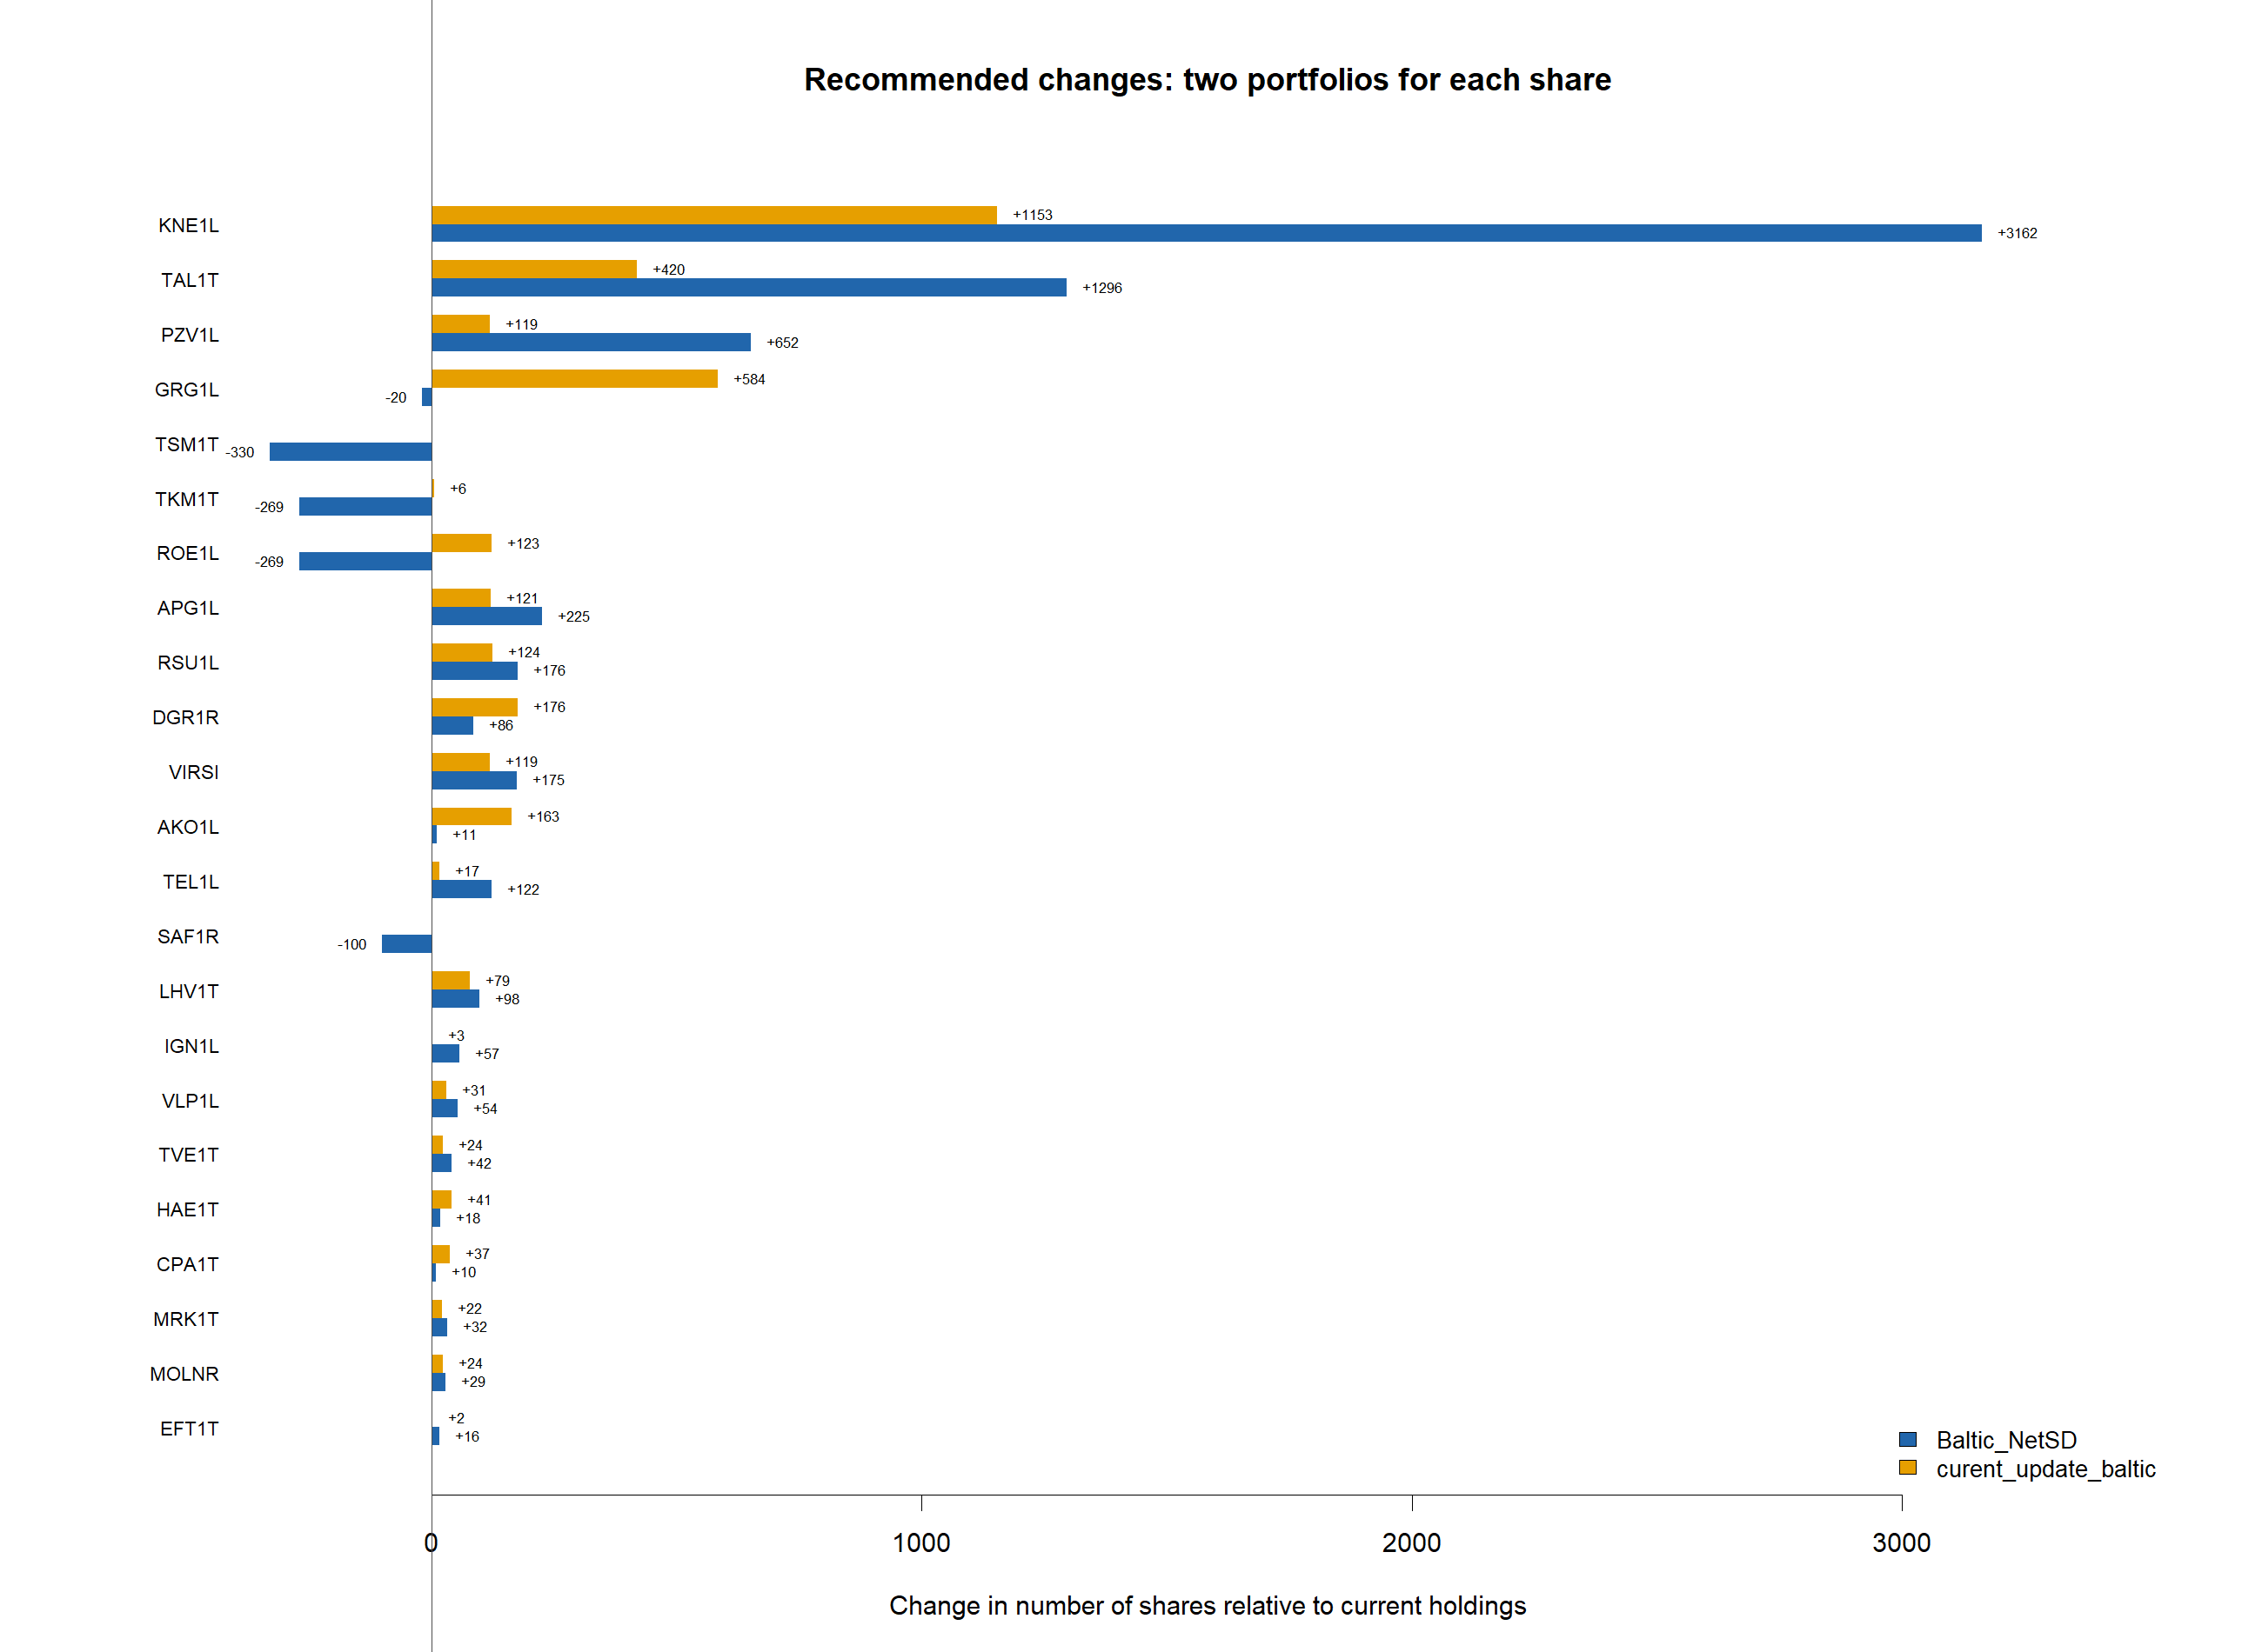
Each share has two adjacent bars. The blue bar is the change required for Baltic_NetSD, where negative values are sales. The orange bar is the additional purchase required for curent_update_baltic; it cannot be negative because every current position is retained. Both use the EUR 15,000 ceiling.
Figure 2. Capital allocation and historical gross dividend contribution
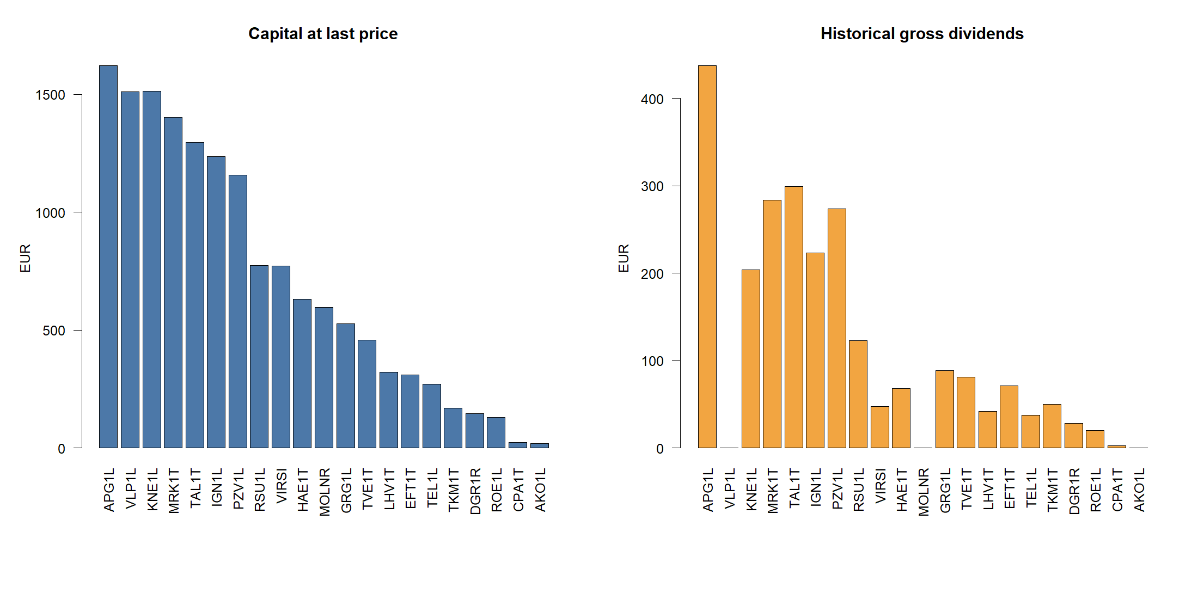

Earnings outcomes and subsequent price changes
Official announcement text allowed 217 of 349 earnings releases to be classified. Higher or lower profit refers to the issuer's explicit comparison with the earlier comparable period. In line or unchanged is used only for an explicit plan, forecast, expectation or unchanged-profit statement. Loss requires an explicit realised net or operating loss.

Table 4A. Conditional price statistics by reported profit outcome
profit_outcome | horizon | events | conditional_mean_return | conditional_variance_return | conditional_median_return | positive_return_share | conditional_mean_abnormal | conditional_variance_abnormal | conditional_median_abnormal
Higher profit | 1d | 141 | 0.151 | 2.087 | 0.000 | 38.298 | 0.151 | 2.006 | 0.013
Higher profit | 5d | 141 | -0.051 | 7.214 | -0.149 | 41.135 | -0.034 | 6.514 | -0.061
Higher profit | 21d | 141 | -0.466 | 25.273 | -0.416 | 40.426 | 0.121 | 23.599 | -0.024
In line / unchanged | 1d | 16 | 2.998 | 36.588 | 0.169 | 50.000 | 3.098 | 34.948 | 0.394
In line / unchanged | 5d | 16 | 2.590 | 34.904 | -0.310 | 43.750 | 2.889 | 30.352 | 0.924
In line / unchanged | 21d | 16 | 3.864 | 100.780 | 1.712 | 62.500 | 4.357 | 96.460 | 2.513
Loss | 1d | 19 | -0.484 | 0.674 | -0.339 | 10.526 | -0.536 | 0.715 | -0.260
Loss | 5d | 19 | -0.703 | 2.793 | -0.164 | 26.316 | -0.709 | 2.756 | -0.238
Loss | 21d | 19 | -1.373 | 16.902 | -1.042 | 36.842 | -0.453 | 17.505 | -0.135
Lower profit | 1d | 41 | -0.395 | 2.607 | 0.000 | 36.585 | -0.461 | 2.418 | -0.317
Lower profit | 5d | 41 | -0.660 | 8.150 | -0.258 | 39.024 | -0.694 | 7.366 | -0.429
Lower profit | 21d | 41 | -0.823 | 13.917 | -0.772 | 34.146 | -0.496 | 13.659 | -0.618
Means, medians and positive shares are percentages; variances are squared percentage points. Abnormal return is the share return minus the equal-weight Baltic-market return over the same horizon.

Table 4B. Kruskal-Wallis tests across profit-outcome groups
horizon_days | groups | classified_events | kruskal_H | p_value | p_BH | conclusion
1 | 4 | 217 | 9.7887 | 0.0205 | 0.3681 | No adjusted evidence
5 | 4 | 217 | 6.2338 | 0.1008 | 0.5008 | No adjusted evidence
21 | 4 | 217 | 3.8982 | 0.2727 | 0.7551 | No adjusted evidence
The BH adjustment covers the full family of share-level, pooled and pairwise tests. The estimates describe historical association and do not establish that an announcement caused the subsequent return.

Statistical and performance analysis

Table 5. Empirical statistics of portfolio and S&P 500 daily returns
entity | observations | mean | median | SD | minimum | maximum | skewness | kurtosis | VaR_95 | ES_95
Current | 754 | 0.000372 | 0.000434 | 0.005296 | -0.036151 | 0.042276 | -0.068292 | 17.920560 | 0.006098 | 0.011960
Markowitz_training | 754 | 0.000241 | 0.000273 | 0.004391 | -0.025519 | 0.027713 | -0.520195 | 10.981693 | 0.005870 | 0.010445
MAD_training | 754 | 0.000257 | 0.000312 | 0.004399 | -0.028989 | 0.026779 | -0.832805 | 12.978086 | 0.005528 | 0.010546
Minimax_training | 754 | 0.000550 | 0.000279 | 0.005514 | -0.021554 | 0.025382 | 0.223792 | 6.678445 | 0.007255 | 0.012166
Robust_training | 754 | 0.000304 | 0.000209 | 0.004492 | -0.026819 | 0.026893 | -0.405017 | 10.523807 | 0.005622 | 0.010451
NetSD_training | 754 | 0.000598 | 0.000187 | 0.005841 | -0.027866 | 0.047554 | 0.650172 | 11.973562 | 0.007314 | 0.012066
Markowitz_full | 754 | 0.000349 | 0.000327 | 0.004392 | -0.030086 | 0.026550 | -0.617330 | 11.268384 | 0.005750 | 0.010350
MAD_full | 754 | 0.000361 | 0.000371 | 0.004460 | -0.034511 | 0.026269 | -0.908080 | 13.474040 | 0.005471 | 0.010602
Minimax_full | 754 | 0.000428 | 0.000111 | 0.005185 | -0.021604 | 0.025497 | -0.023890 | 6.813094 | 0.007042 | 0.011904
Robust_full | 754 | 0.000359 | 0.000350 | 0.004525 | -0.034840 | 0.026102 | -1.003316 | 14.193867 | 0.005461 | 0.010813
NetSD_full | 754 | 0.000564 | 0.000368 | 0.005173 | -0.036431 | 0.032351 | -0.308413 | 11.580399 | 0.006450 | 0.011610
Baltic_NetSD | 754 | 0.000519 | 0.000334 | 0.004363 | -0.024753 | 0.027429 | -0.290296 | 10.337352 | 0.004767 | 0.009689
curent_update_baltic | 754 | 0.000426 | 0.000226 | 0.004198 | -0.021557 | 0.024053 | -0.221740 | 9.693609 | 0.004944 | 0.009664
SP500 | 754 | 0.000879 | 0.001368 | 0.011062 | -0.062006 | 0.097992 | 0.100965 | 14.865600 | 0.016061 | 0.025050
Baltic_NetSD has mean daily return 0.000519, median 0.000334 and daily standard deviation 0.004363. Its historical 95% VaR is 0.004767 and ES (CVaR) is 0.009689. VaR is the loss threshold exceeded on approximately 5% of days; ES is the average return in that adverse tail.
Figure 3. Histograms and kernel densities; every panel uses the same return-axis limits
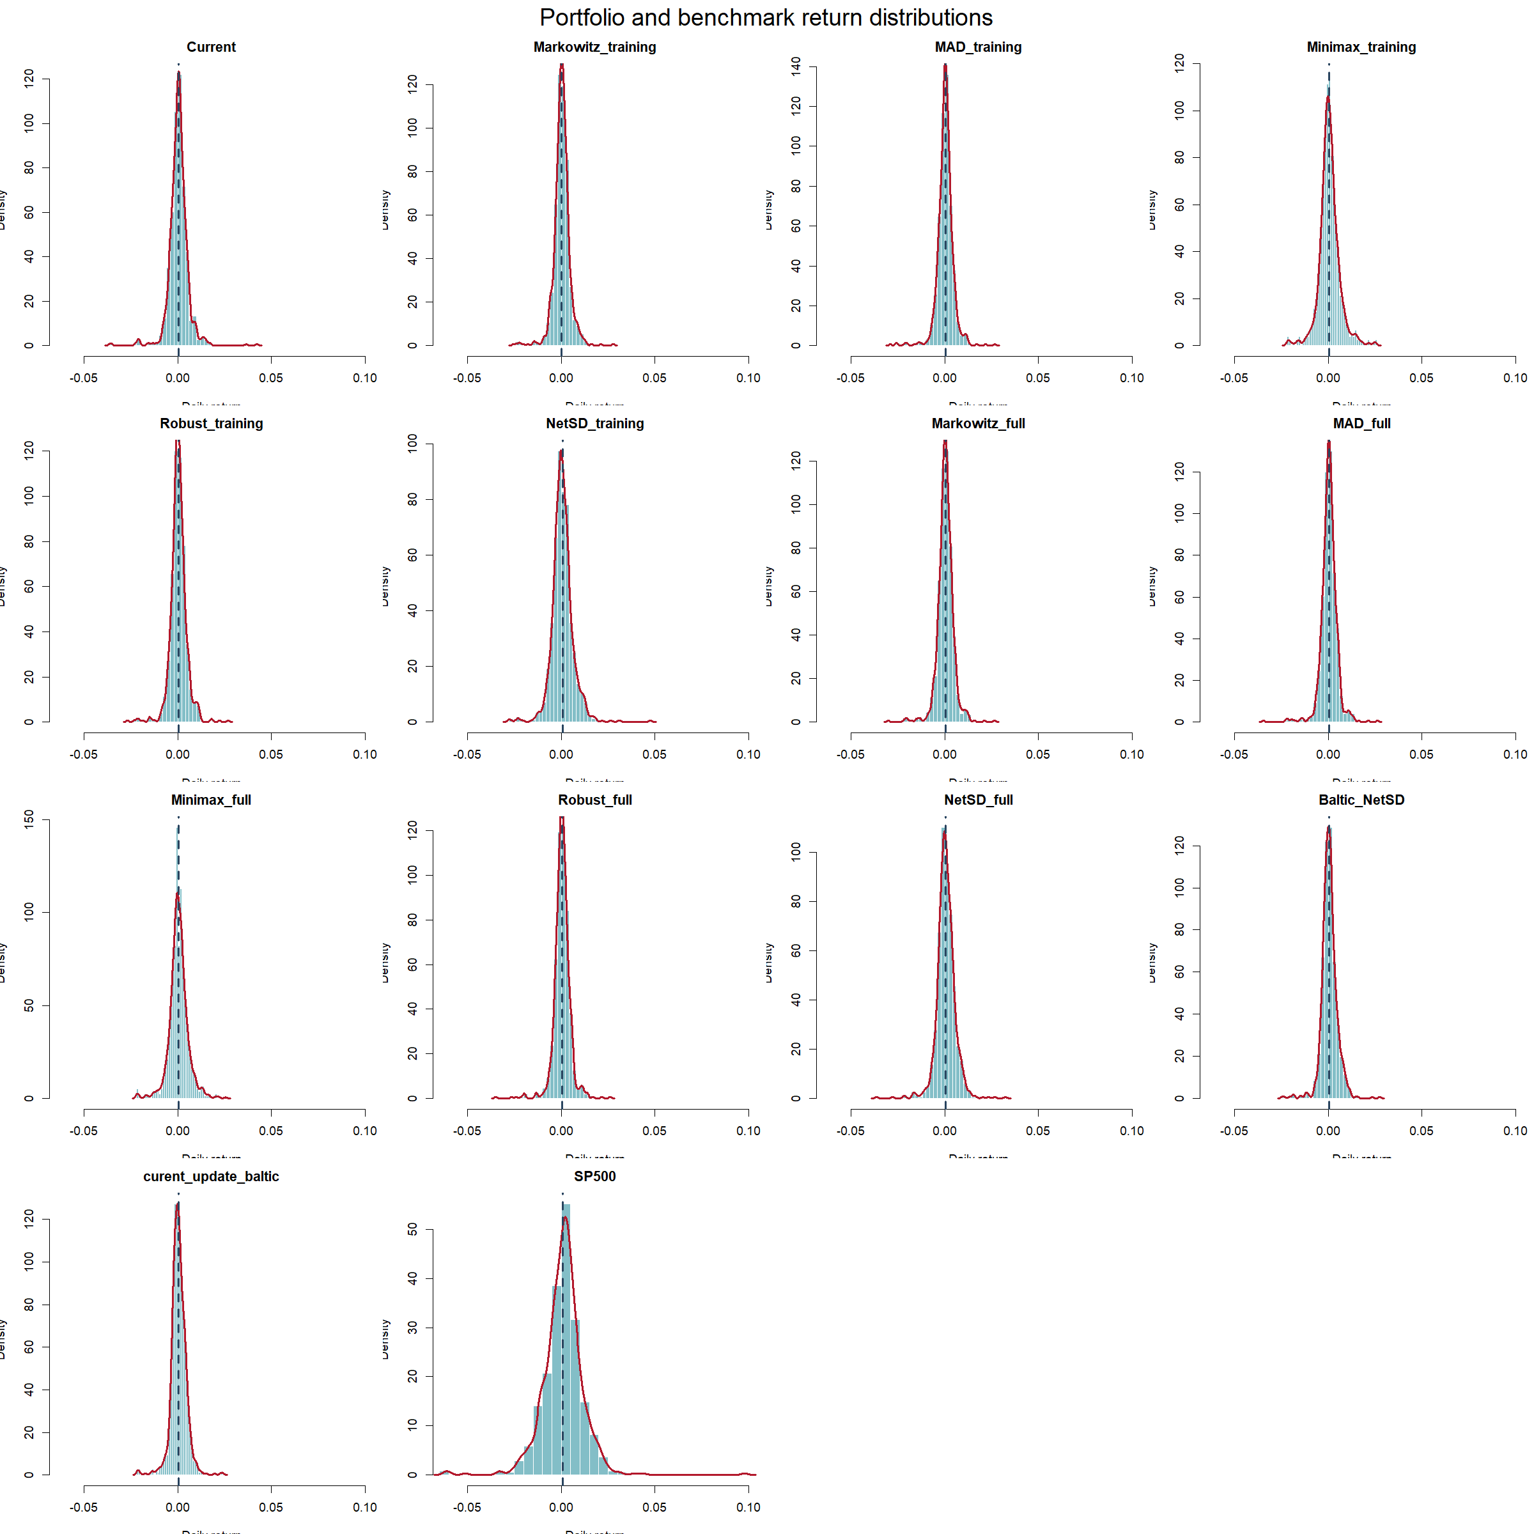
The recalculated Baltic_NetSD maximum daily return is 0.027429. The earlier value 0.168092 on 2025-06-25 was traced to RKB1R, whose unadjusted close moved from EUR 0.107 to EUR 0.476 between common Baltic trading dates. RKB1R belongs to the Baltic Secondary List. After excluding every Secondary List share from the investable set, this observation no longer enters the portfolio return; RKB1R is now excluded from both the investable set and every netSD reference network, so the suspect observation cannot affect the objective or its denominator.
Figure 4a. Portfolio and S&P 500 complete empirical CDF; right side truncated at return 0.05
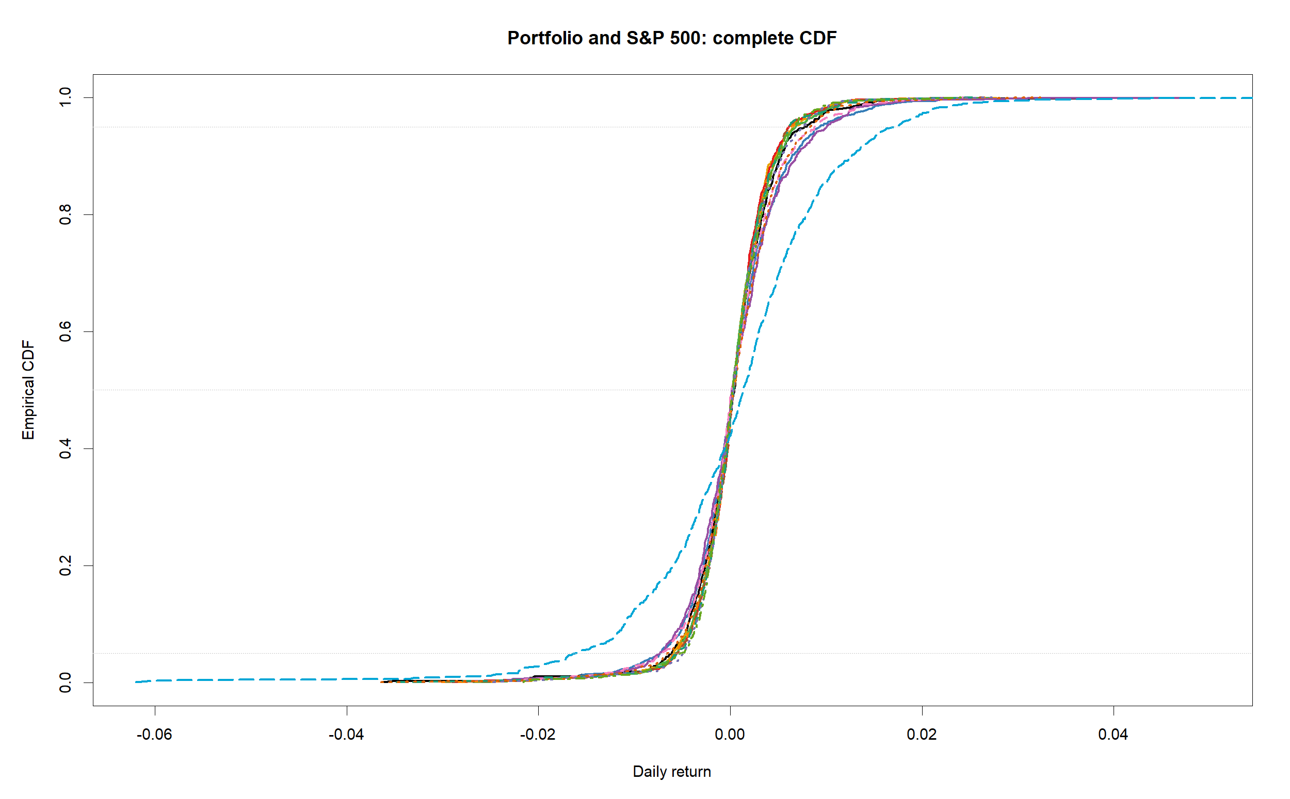
Figure 4b. Portfolio and S&P 500 empirical CDF: enlarged left tail
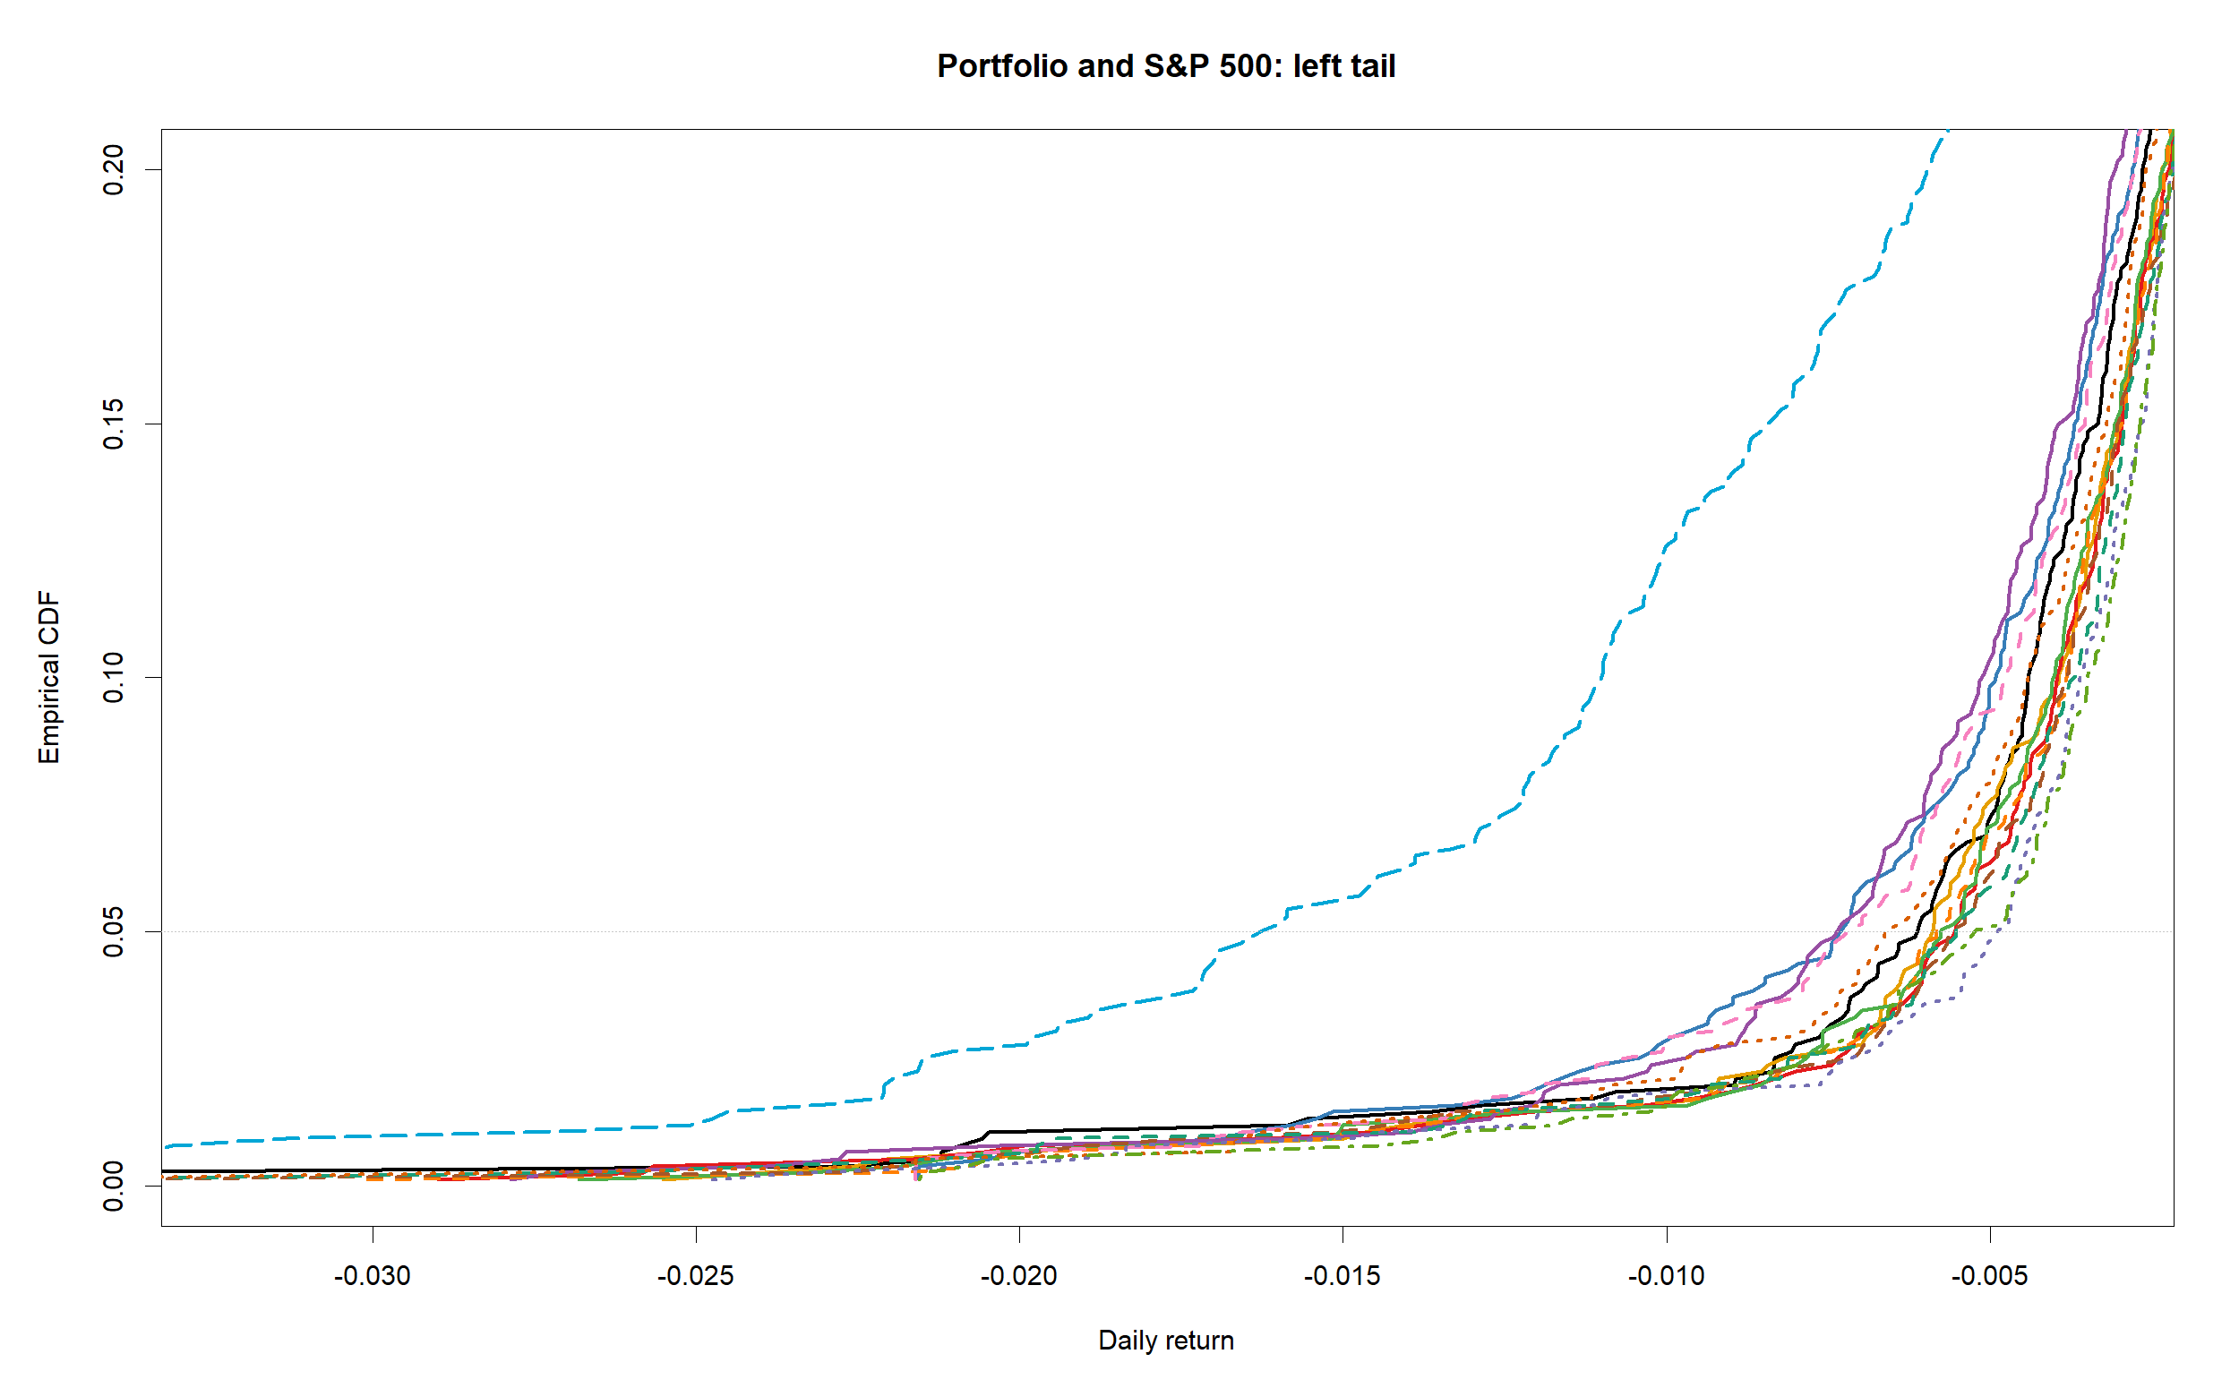
Figure 4c. Portfolio and S&P 500 empirical CDF: enlarged centre
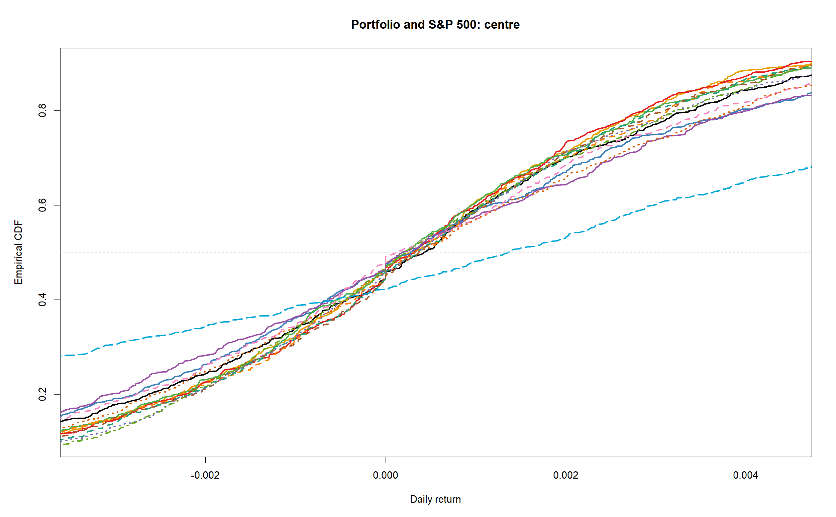
Figure 4d. Portfolio and S&P 500 empirical CDF: enlarged right tail
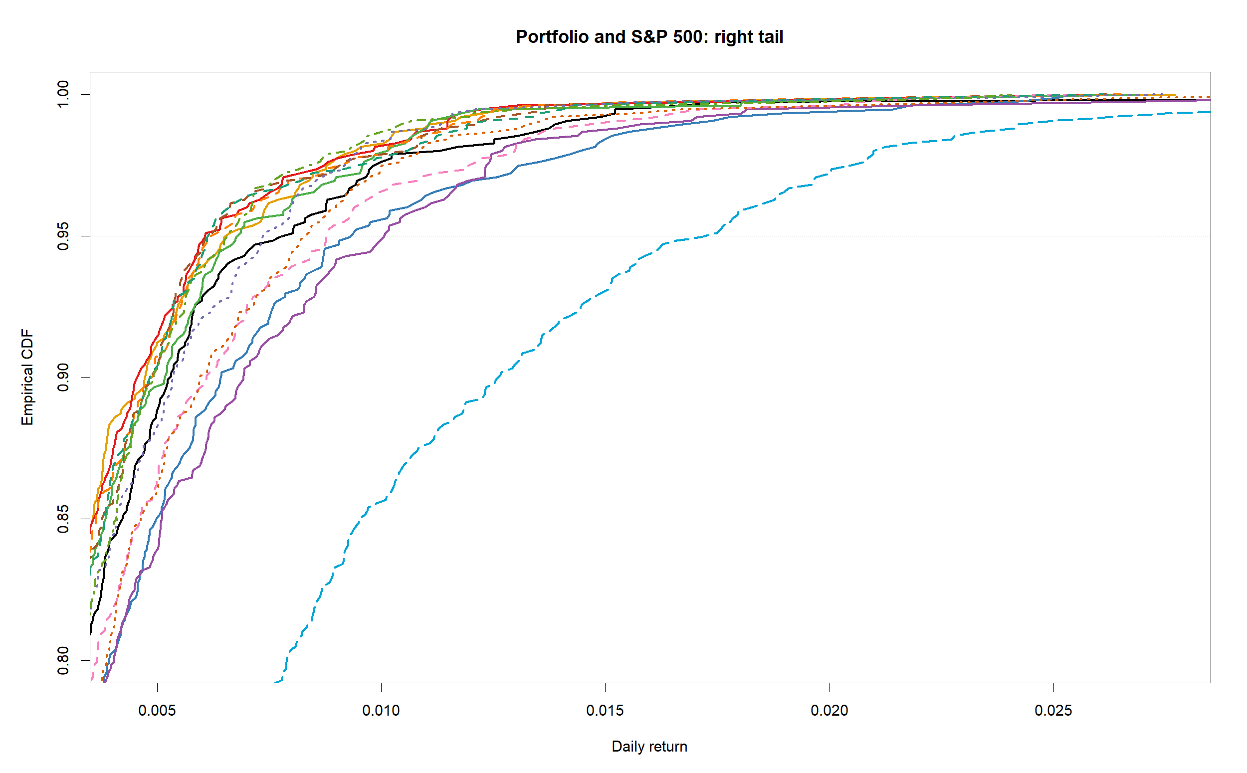
Figure 4e. Separate colour and line-pattern key for Figures 4 and 6
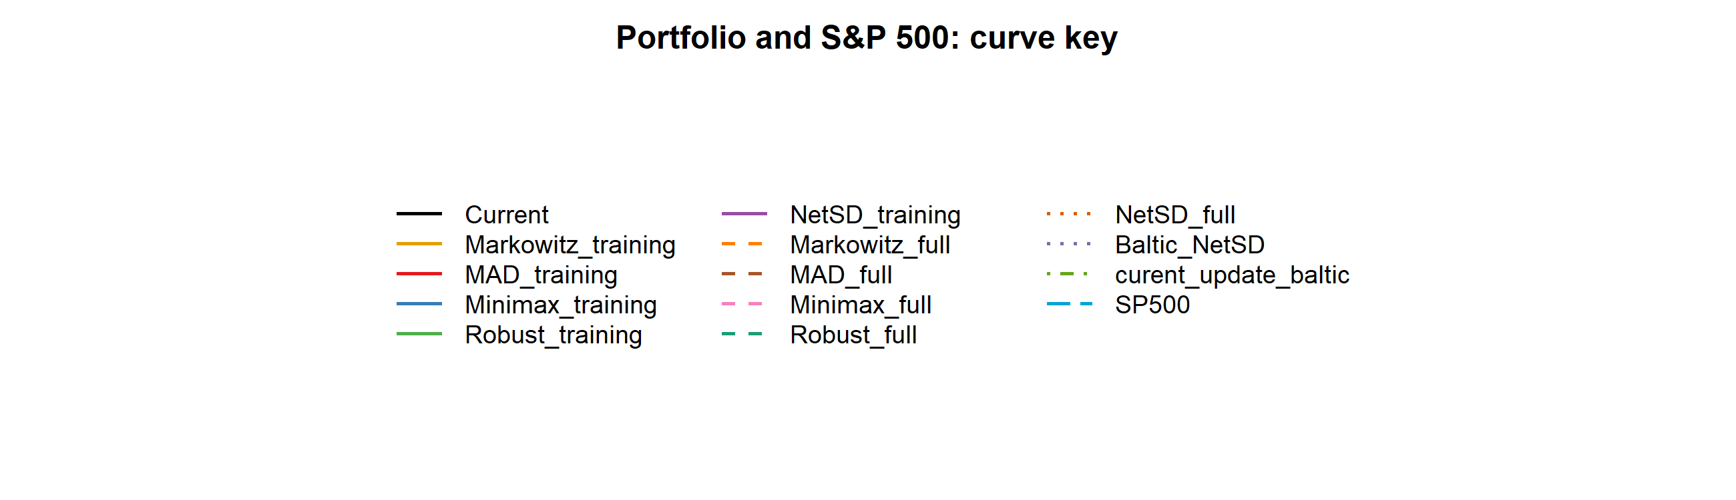
Figure 5a. Individual-share complete empirical CDF restricted to returns from -0.30 to 0.30
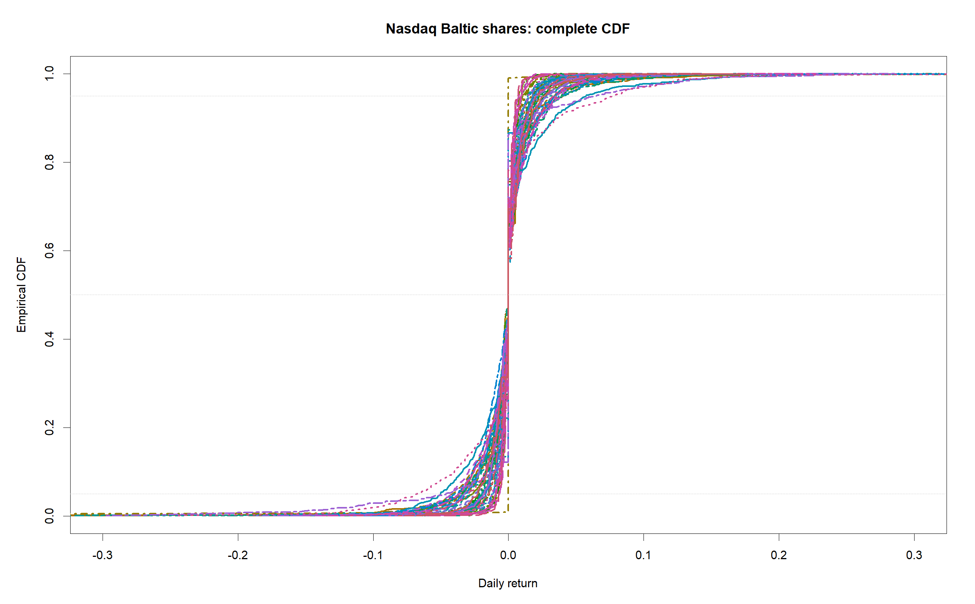
Figure 5b. Individual-share empirical CDF: enlarged left tail
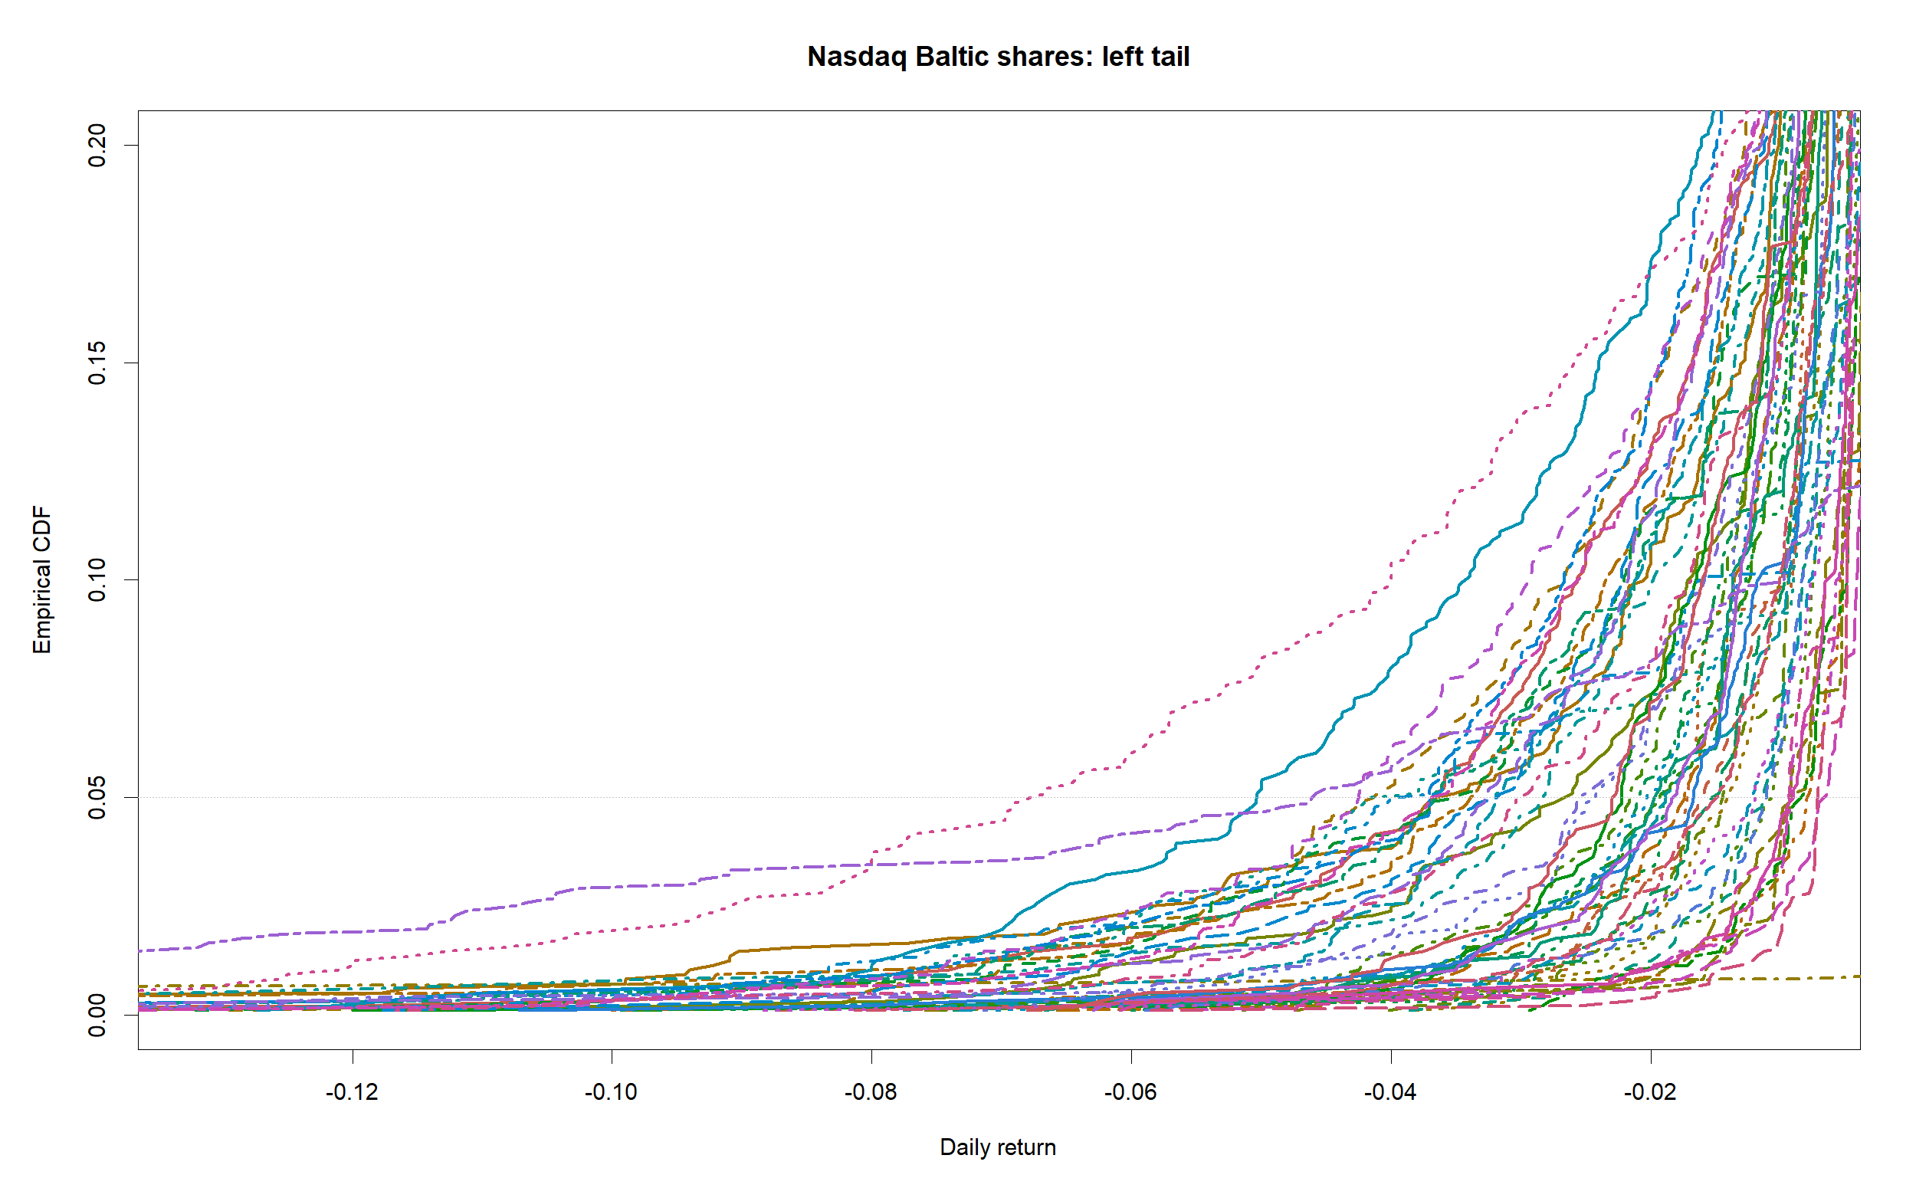
Figure 5c. Individual-share empirical CDF: enlarged centre
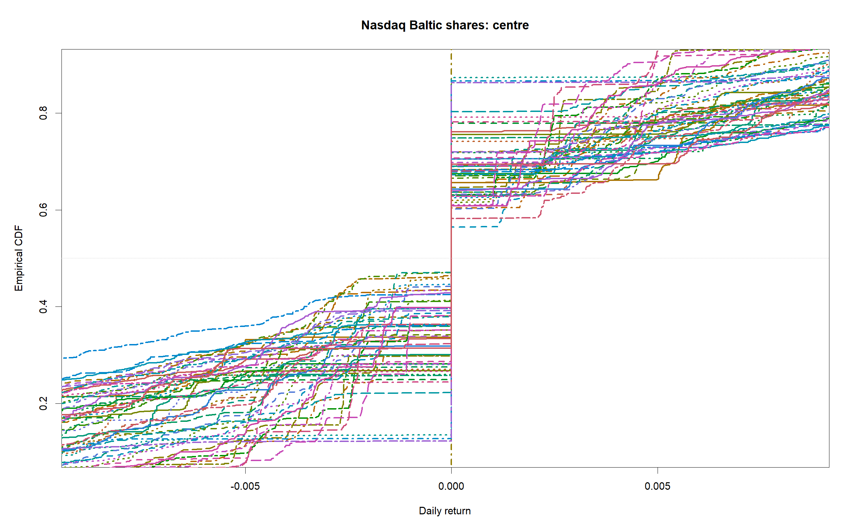
Figure 5d. Individual-share empirical CDF: enlarged right tail
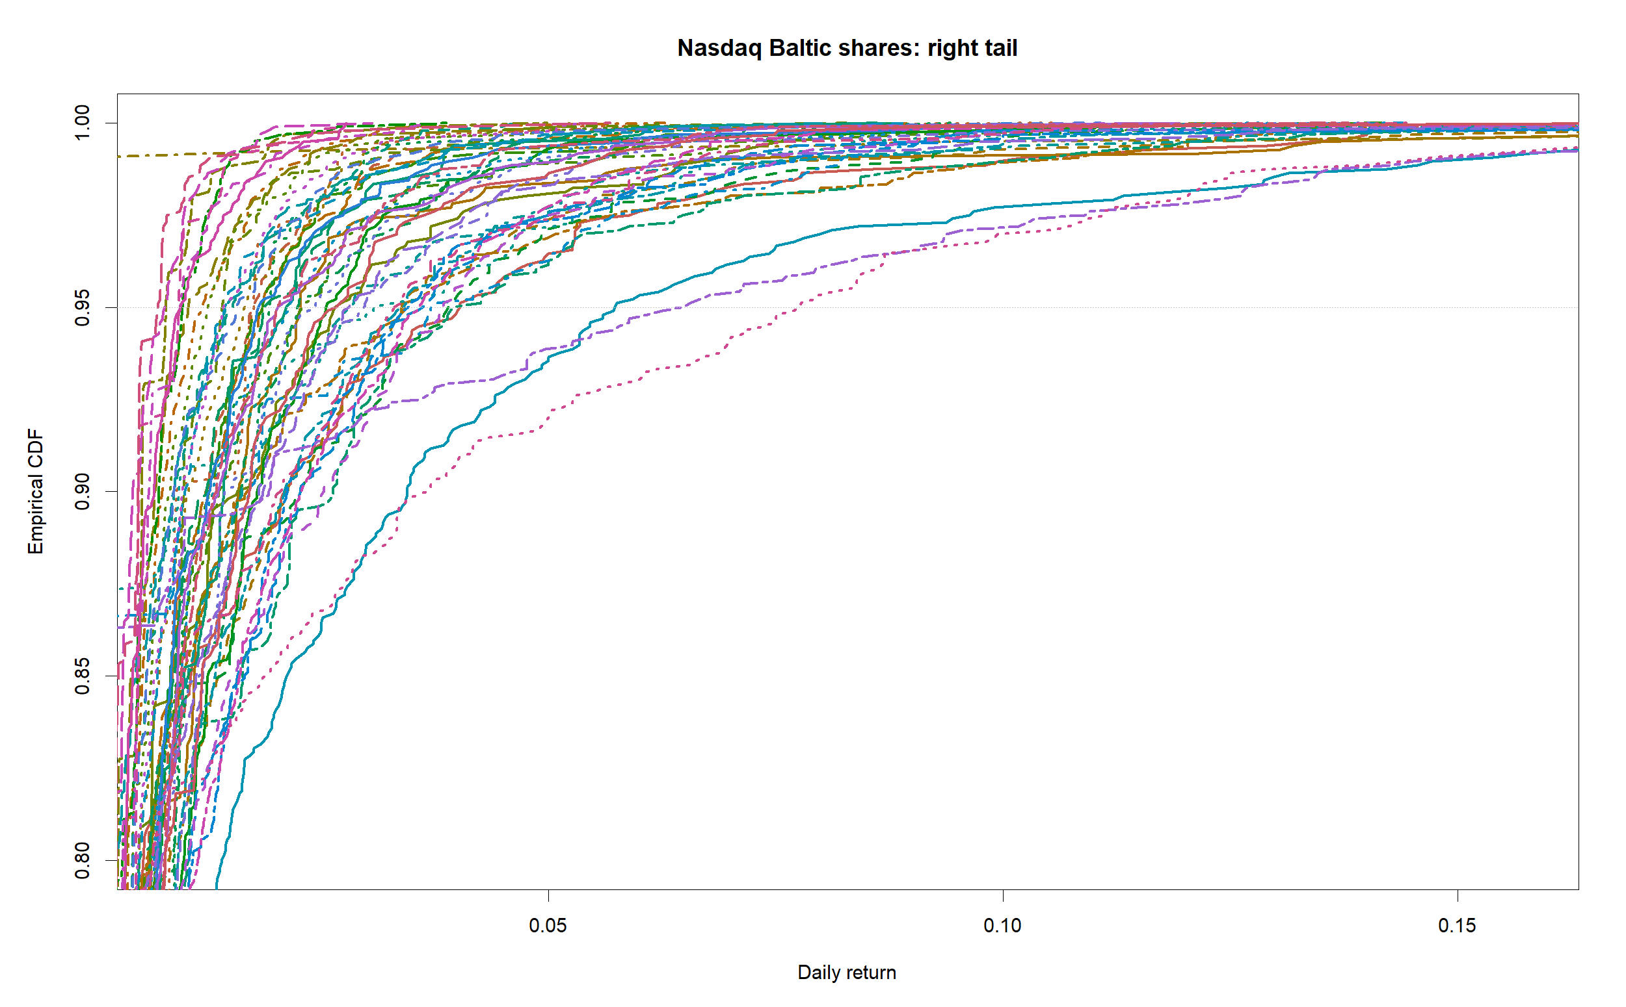
Figure 5e. Separate colour and line-pattern key for Figures 5 and 7
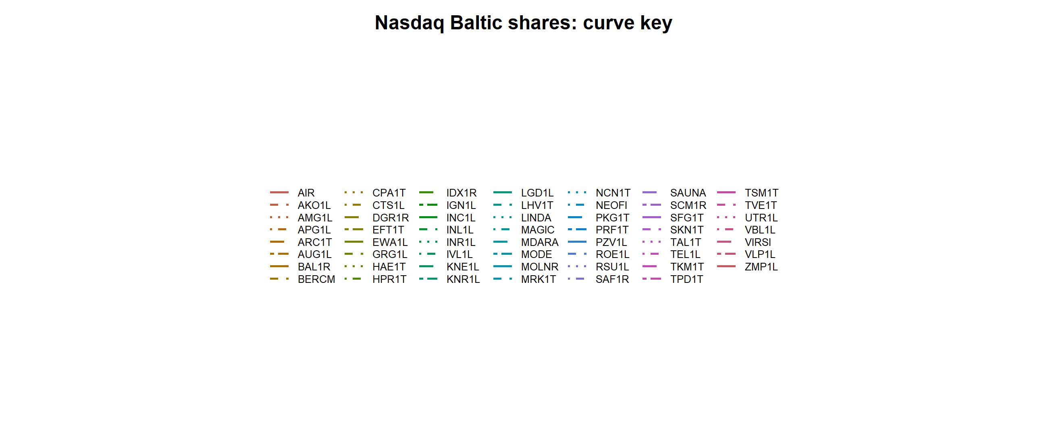
Figure 6a. Portfolio and benchmark FSD component H1(x)
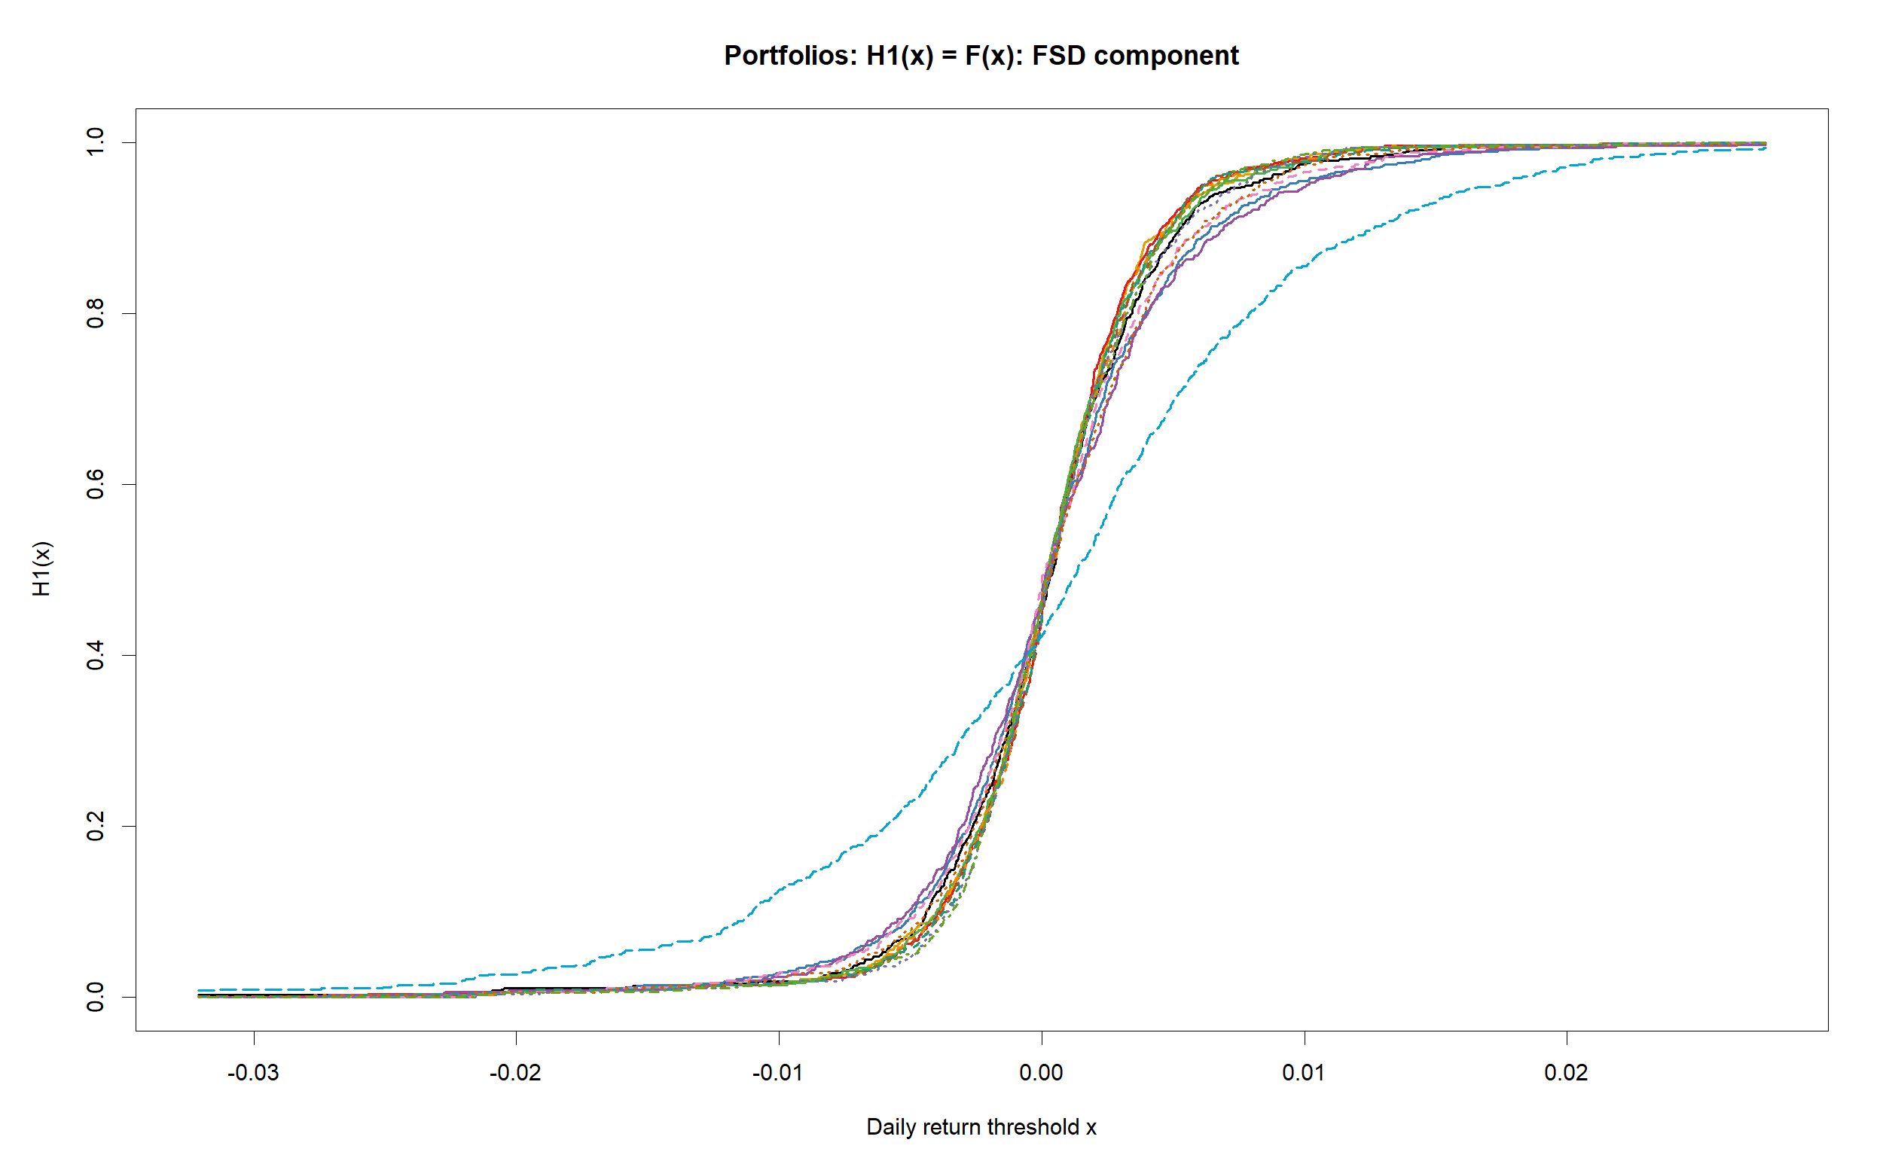
Figure 6b. Portfolio and benchmark SSD component H2(x): enlarged right side with curve-end labels
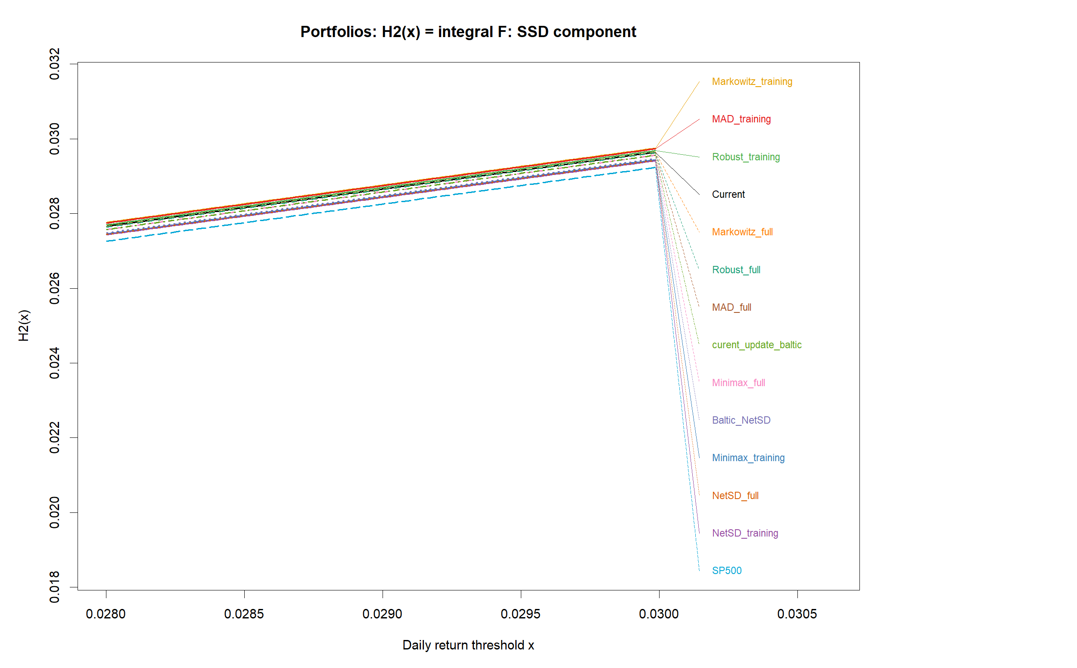
Figure 6c. Portfolio and benchmark TSD component H3(x): enlarged right side with curve-end labels
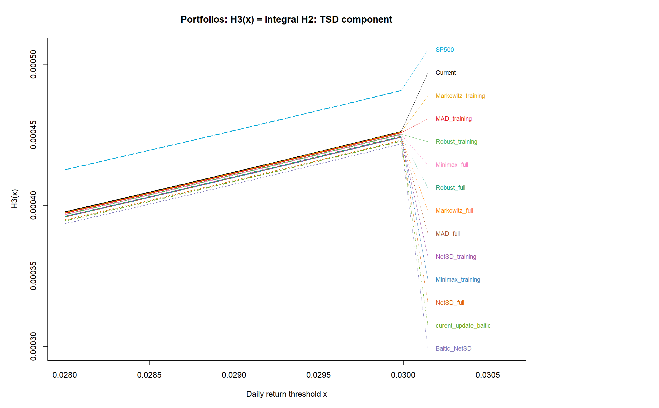
Figure 7a. Individual-share FSD component H1(x)
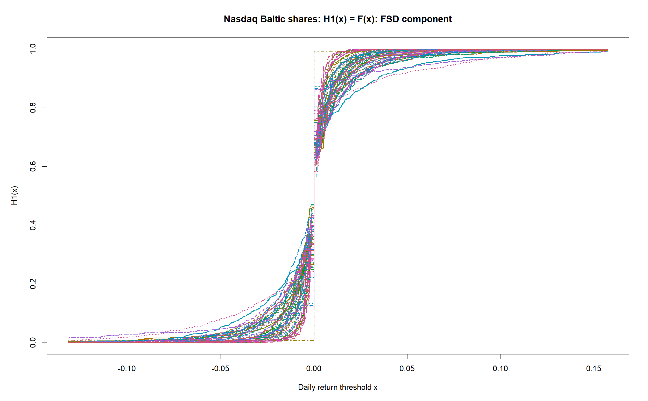
Figure 7b. Individual-share SSD component H2(x): enlarged right side with curve-end labels
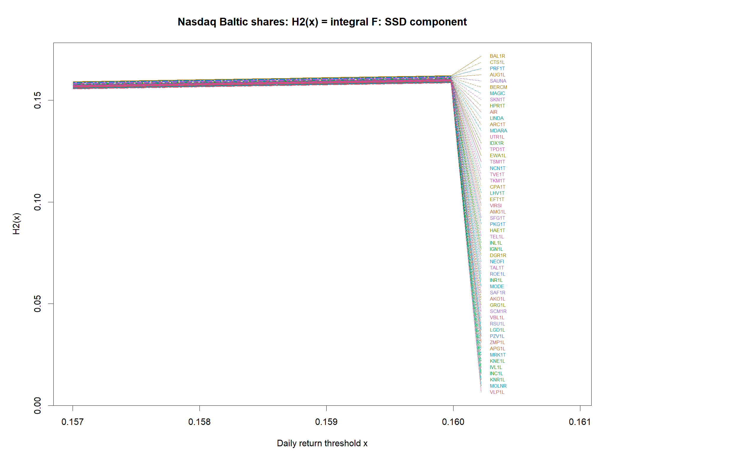
Figure 7c. Individual-share TSD component H3(x): enlarged right side with curve-end labels
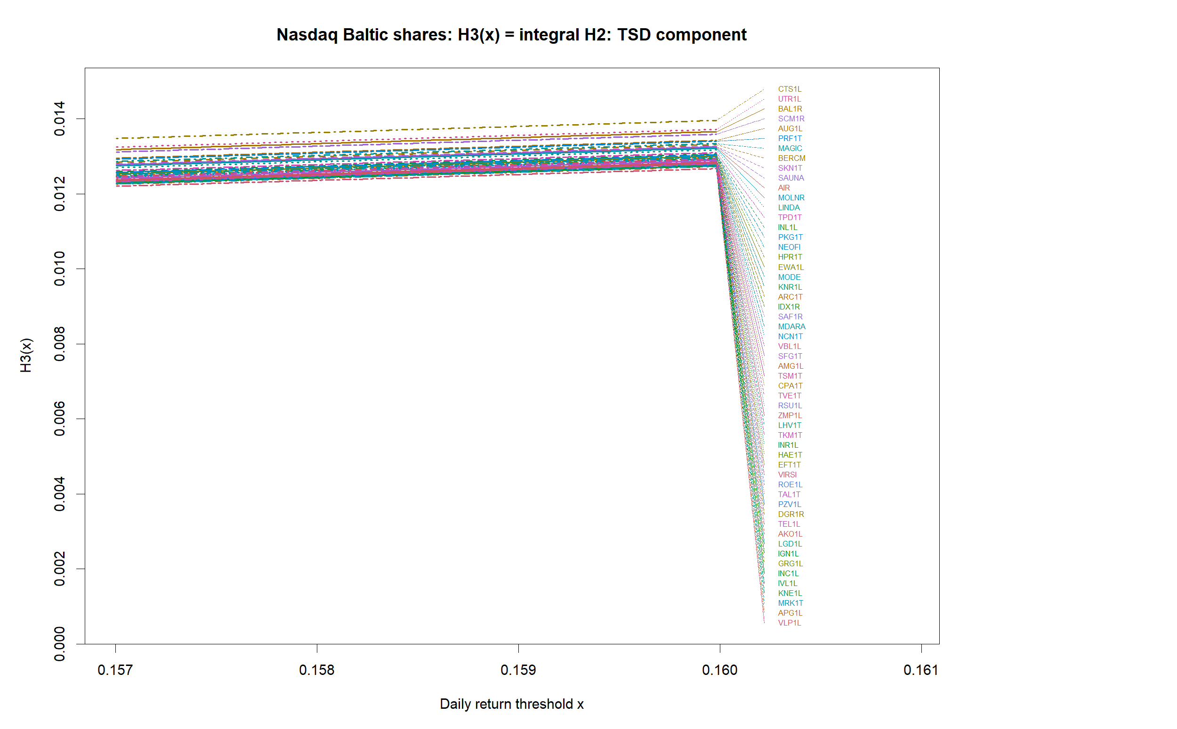
For every entity, H1(x)=F(x) is the empirical CDF used for FSD. H2(x)=∫H1(u)du is the cumulative FSD component used for SSD, and H3(x)=∫H2(u)du is the cumulative SSD component used for TSD. The CSV files accompanying the report contain every displayed entity as a separate column on the same return-threshold grid.
Figure 7d. Baltic_NetSD minus every other portfolio: FSD-component differences
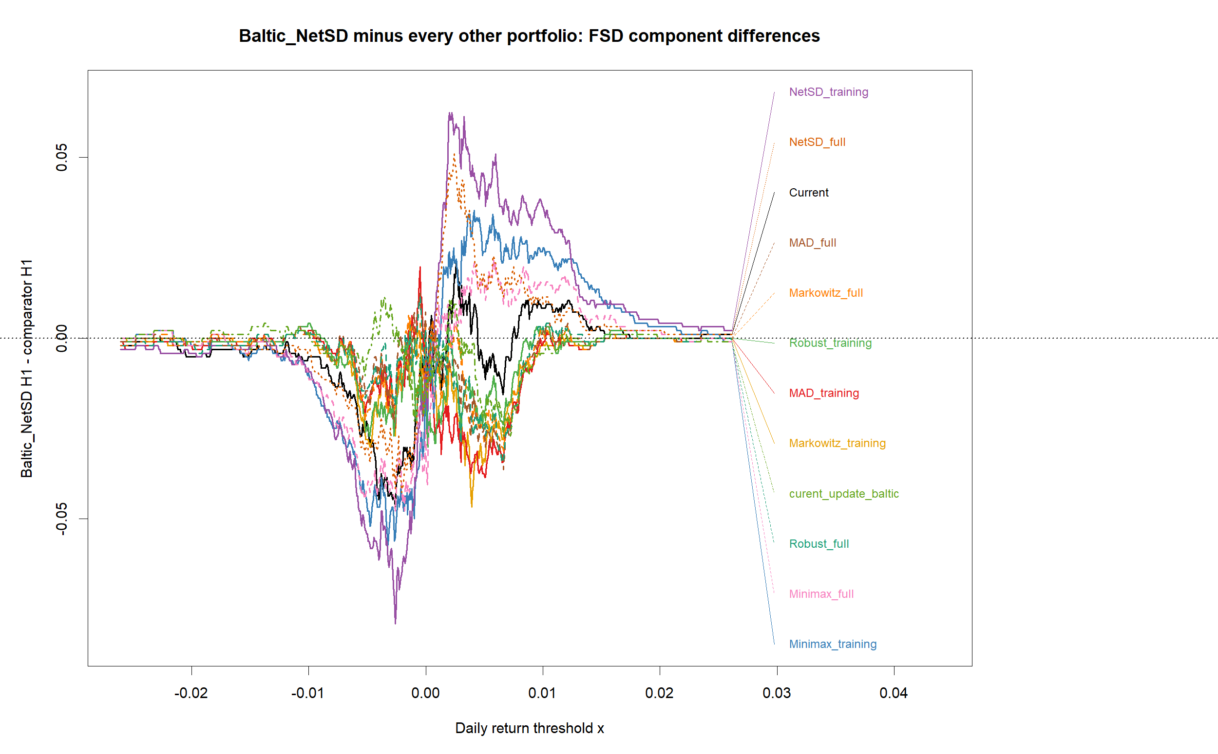
Figure 7e. Baltic_NetSD minus every other portfolio: SSD-component differences
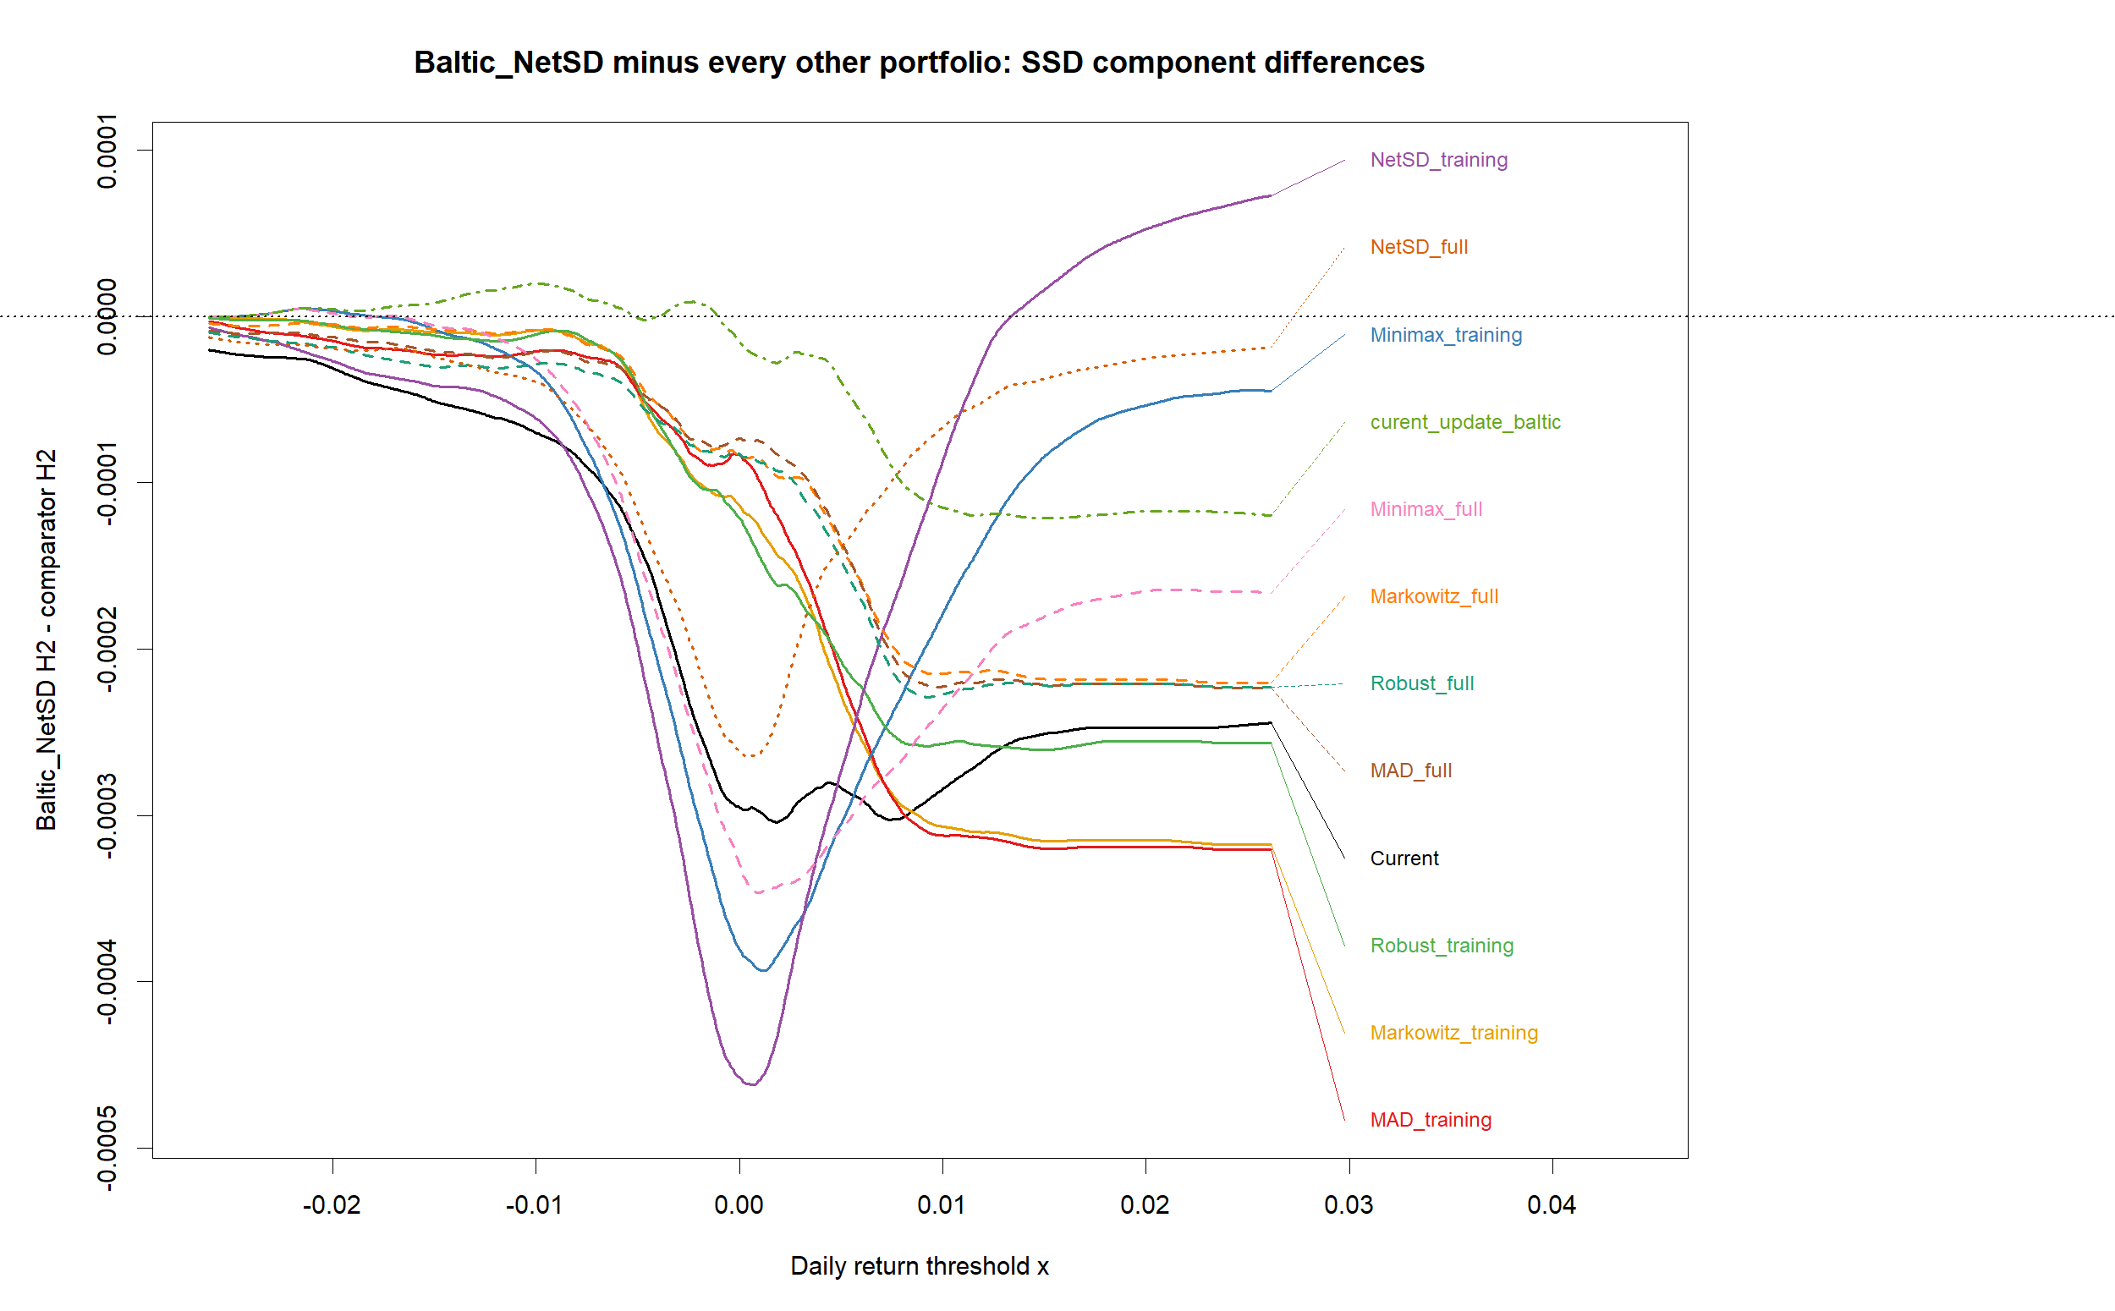
Figure 7f. Baltic_NetSD minus every other portfolio: TSD-component differences
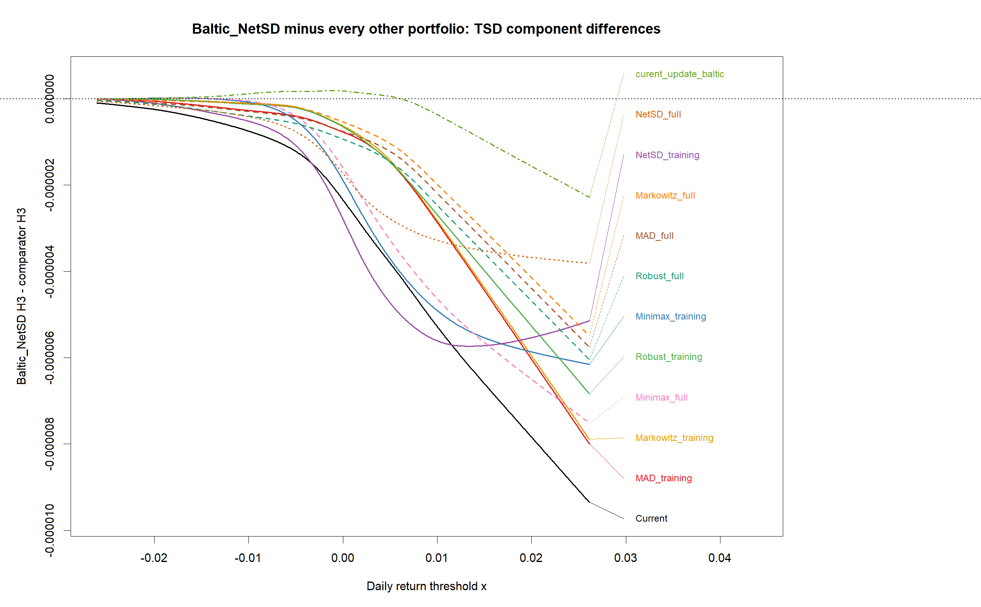
Figure 7g. Baltic_NetSD minus every individual share: FSD-component differences
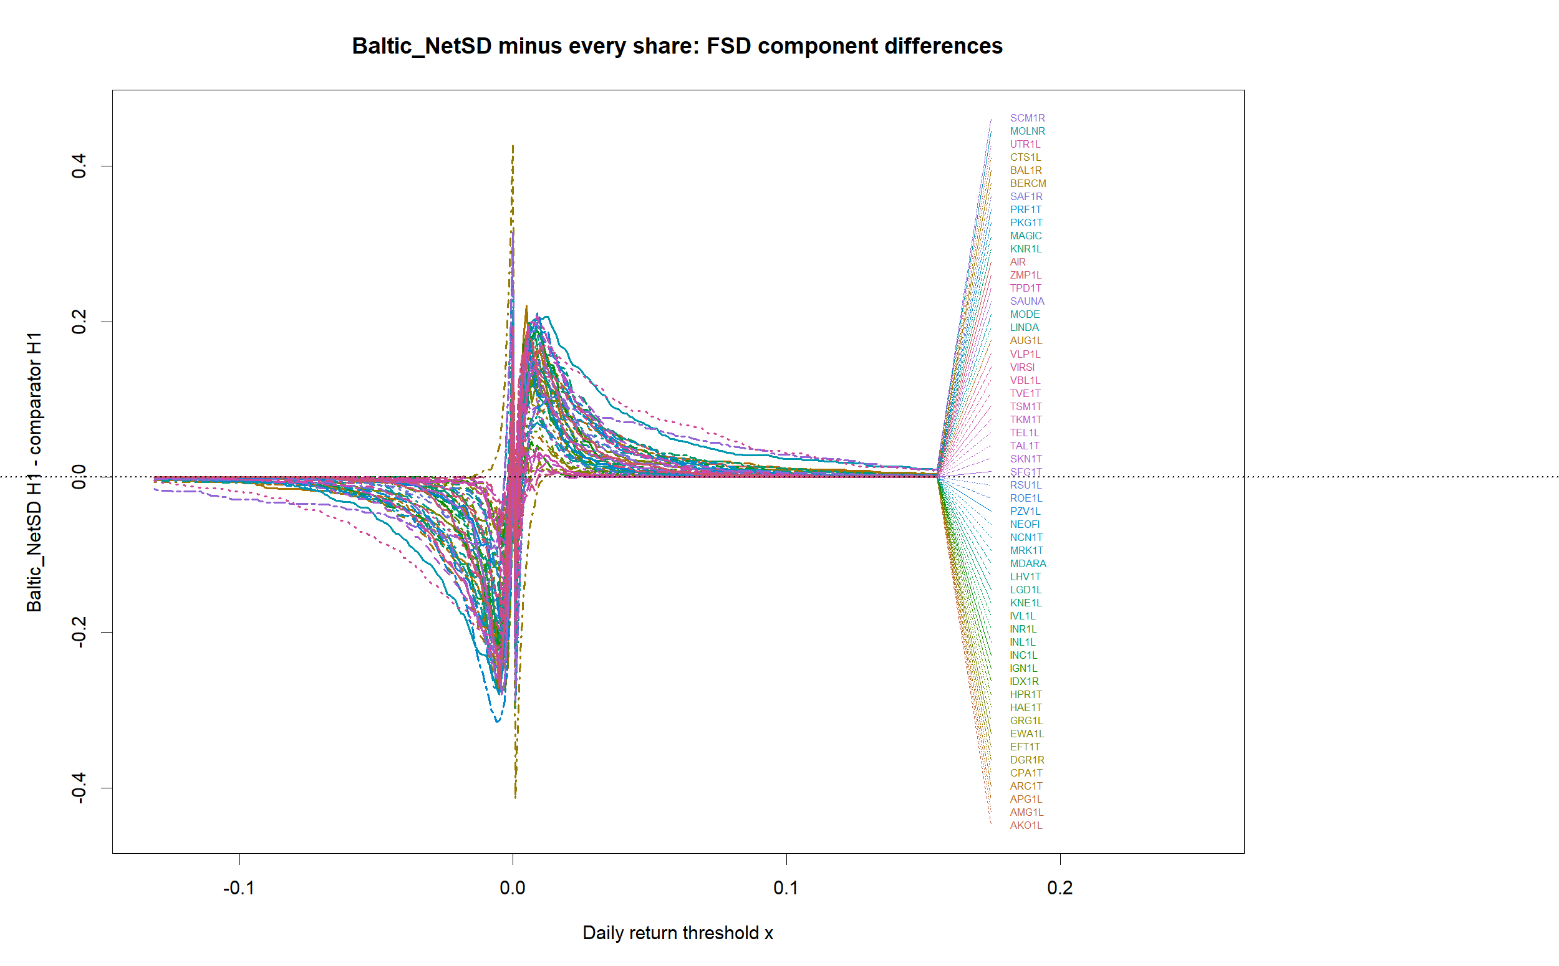
Figure 7h. Baltic_NetSD minus every individual share: SSD-component differences
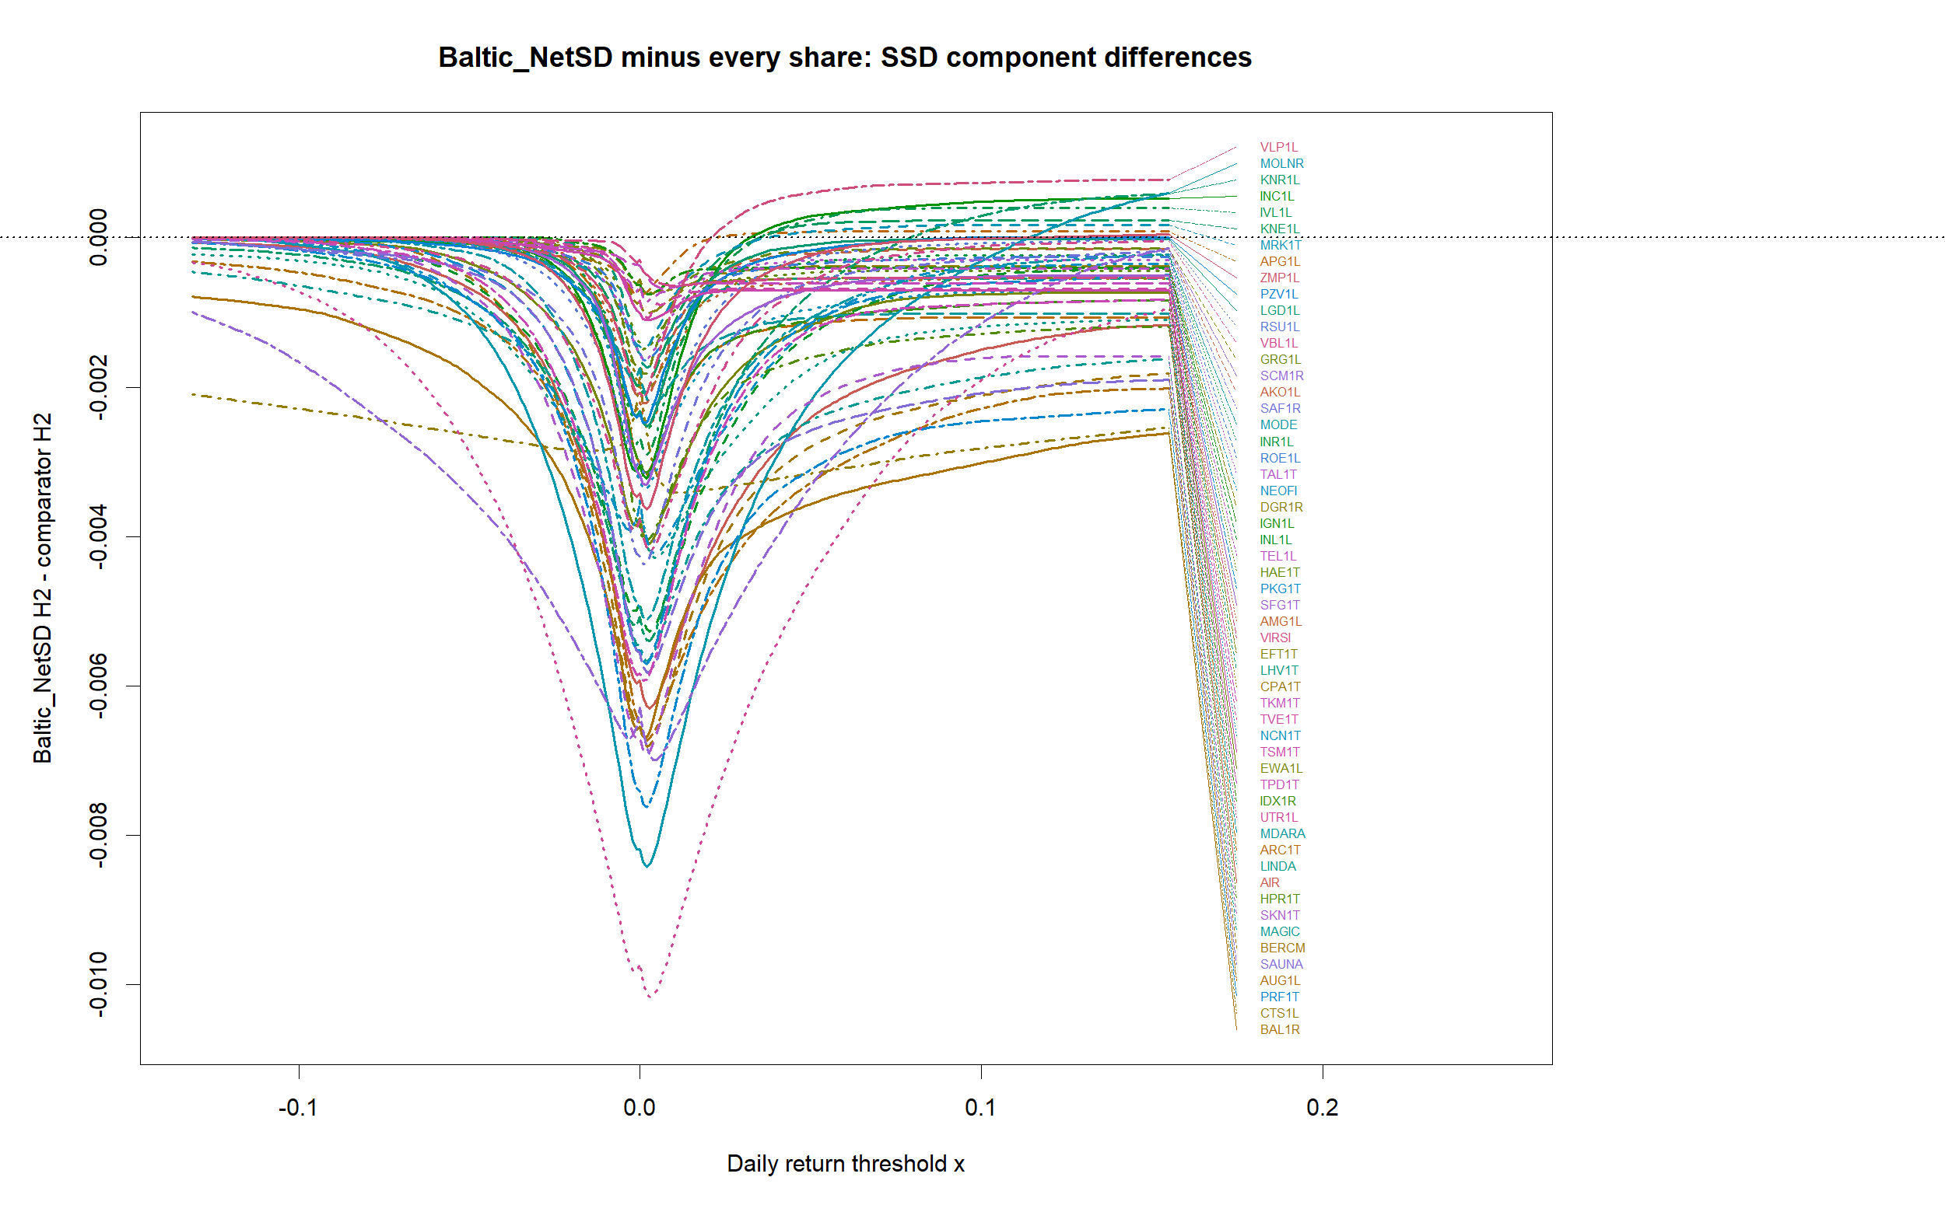
Figure 7i. Baltic_NetSD minus every individual share: TSD-component differences
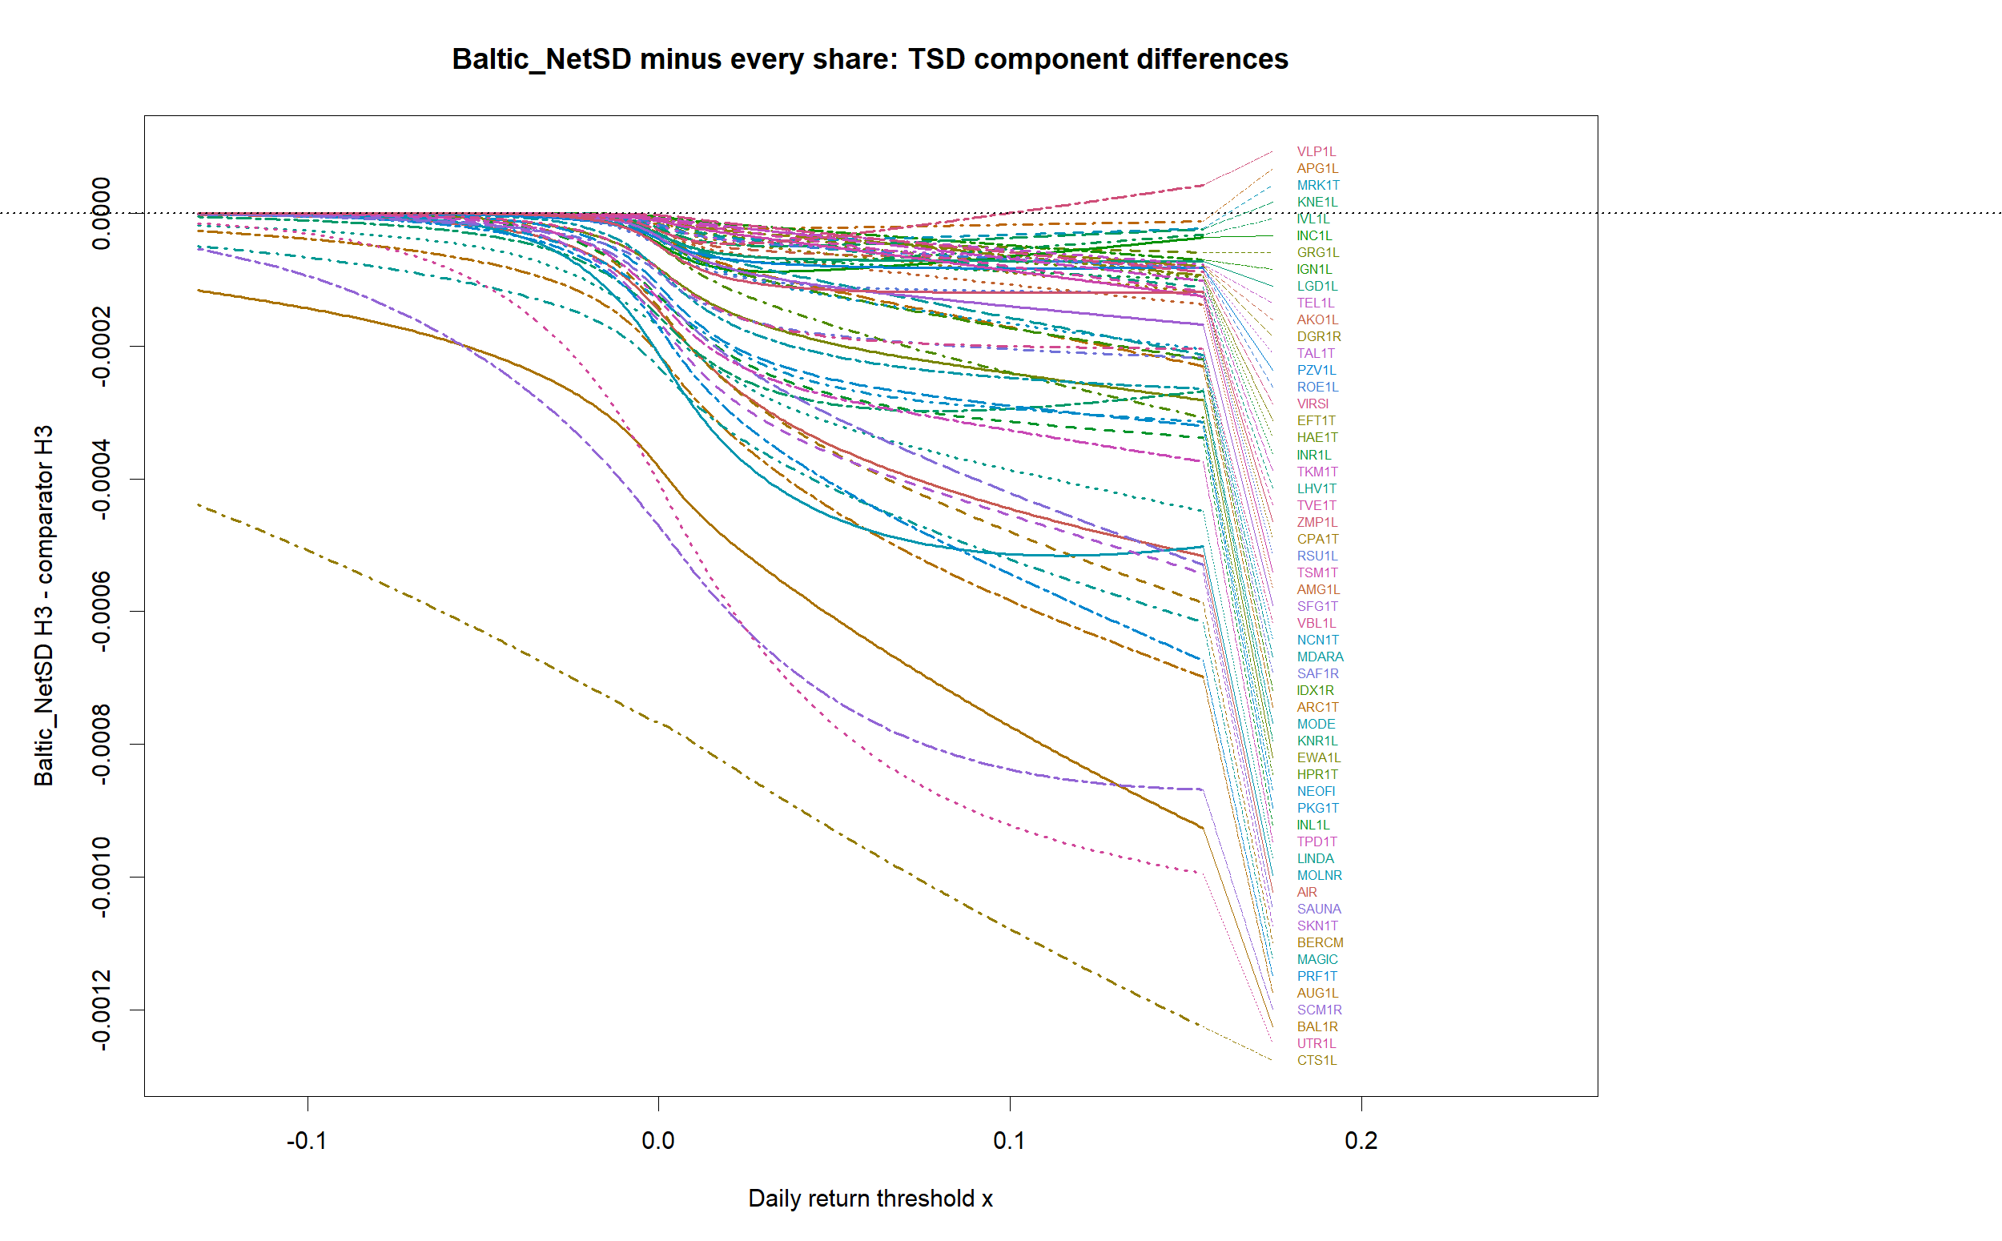
Each difference is calculated pointwise as Hq_Baltic_NetSD(x) - Hq_comparator(x). A negative value means that the Baltic_NetSD integrated-distribution component is smaller at that threshold; dominance requires the relevant difference to remain nonpositive over the complete support, with at least one strict inequality.

Local SSD advantages at large return thresholds

Table 7A. Local right-side SSD-component advantages over Baltic_NetSD
comparator | type | local_advantage_from_x | display_upper_x | end_difference | maximum_difference
NetSD_training | portfolio | 0.013372 | 0.026120 | 0.000073 | 0.000073
VLP1L | share | 0.021776 | 0.154871 | 0.000774 | 0.000774
MOLNR | share | 0.114148 | 0.154871 | 0.000598 | 0.000598
KNR1L | share | 0.079384 | 0.154871 | 0.000587 | 0.000587
INC1L | share | 0.032701 | 0.154871 | 0.000526 | 0.000526
IVL1L | share | 0.035681 | 0.154871 | 0.000399 | 0.000399
KNE1L | share | 0.035681 | 0.154871 | 0.000235 | 0.000235
MRK1T | share | 0.037668 | 0.154871 | 0.000167 | 0.000167
APG1L | share | 0.022769 | 0.154871 | 0.000090 | 0.000090
ZMP1L | share | 0.113155 | 0.154871 | 0.000044 | 0.000044
PZV1L | share | 0.097263 | 0.154871 | 0.000004 | 0.000004
These are local, right-side comparisons and must not be interpreted as SSD over the complete return domain. A positive difference H2_Baltic_NetSD(x)-H2_comparator(x) means that the comparator has the smaller, hence locally preferable, SSD component at that threshold. Among portfolios this occurs for NetSD_training. The five strongest share cases at the displayed endpoint are VLP1L, MOLNR, KNR1L, INC1L, IVL1L. Smaller positive endpoint differences also occur for KNE1L, MRK1T, APG1L, ZMP1L, PZV1L. The table reports the threshold from which the advantage remains positive to the displayed upper endpoint. The listed shares are therefore candidates for further investment analysis, while the absence of full-support dominance means this chart alone is insufficient for an investment decision.
The result that may appear surprising in the difference figures is therefore real but local. NetSD_training has a smaller H2 component than Baltic_NetSD from x=0.012089 to the displayed right endpoint, and NetSD_full does so from x=0.016037. Neither portfolio SSD-dominates Baltic_NetSD over the complete support because the required inequality fails at smaller x values. The listed shares deserve separate investment analysis because their upper-threshold SSD components are favourable. RKB1R is absent from these recalculated comparisons because its suspect unadjusted prices fail the data-quality screen. A local right-side advantage is evidence about one part of the distribution and is not full-domain SSD dominance.

Table 6. Weight concentration and diversification
portfolio | HHI_weights | effective_number | maximum_weight | number_positive | diversification_ratio
Current | 0.162333 | 6.160194 | 0.303300 | 10 | 2.092194
Markowitz_training | 0.173946 | 5.748903 | 0.325443 | 10 | 2.239505
MAD_training | 0.202077 | 4.948602 | 0.379940 | 10 | 2.186633
Minimax_training | 0.169523 | 5.898915 | 0.279680 | 10 | 2.071445
Robust_training | 0.180150 | 5.550933 | 0.349431 | 10 | 2.248422
NetSD_training | 0.188413 | 5.307499 | 0.337844 | 10 | 1.956346
Markowitz_full | 0.152149 | 6.572488 | 0.295792 | 10 | 2.311799
MAD_full | 0.182270 | 5.486352 | 0.338655 | 10 | 2.240153
Minimax_full | 0.157248 | 6.359400 | 0.258417 | 10 | 2.106087
Robust_full | 0.215235 | 4.646077 | 0.386466 | 10 | 2.178503
NetSD_full | 0.132893 | 7.524846 | 0.188213 | 10 | 2.222264
Baltic_NetSD | 0.074173 | 13.482076 | 0.108282 | 21 | 2.602806
curent_update_baltic | 0.079775 | 12.535330 | 0.174712 | 23 | 2.797039
For Baltic_NetSD, HHI=0.074173; lower is better because less capital is concentrated in a few shares. Its effective number of equally weighted positions is 13.48, the largest weight is 10.83%, and the diversification ratio is 2.603; a value above 1 means portfolio volatility is below the weighted average volatility of its components.
Figure 8. HHI concentration comparison
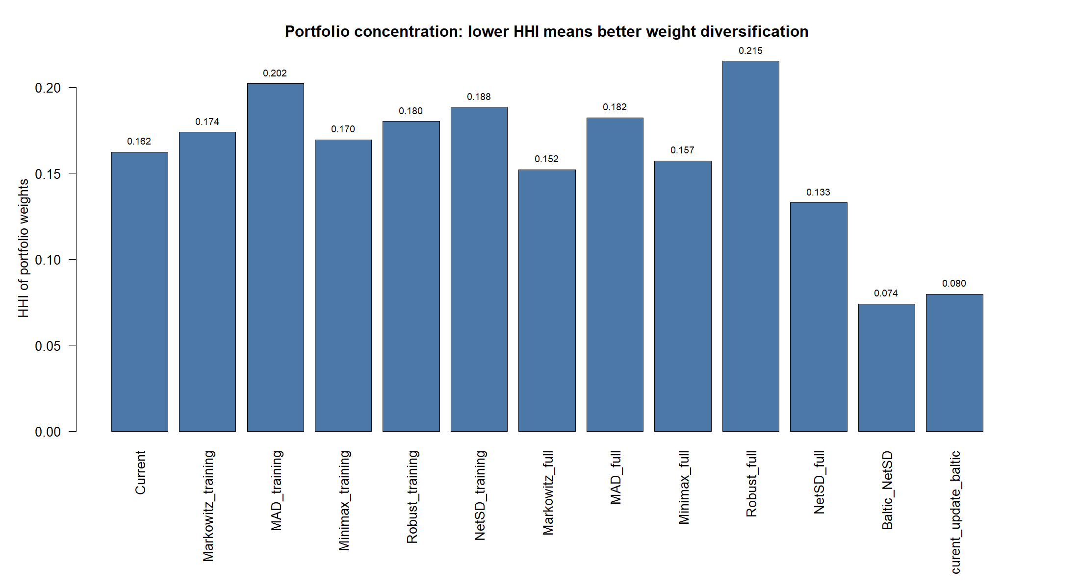

Table 7. Canonical comparable netSD results
entity | OUT | IN | denominator | netSD | mean | SD
Current | 70 | 2 | 118 | 0.576271 | 0.000335 | 0.005109
Markowitz_training | 65 | 0 | 118 | 0.550847 | 0.000236 | 0.004204
MAD_training | 64 | 1 | 118 | 0.533898 | 0.000232 | 0.004204
Minimax_training | 83 | 0 | 118 | 0.703390 | 0.000507 | 0.005307
Robust_training | 72 | 0 | 118 | 0.610169 | 0.000296 | 0.004320
NetSD_training | 89 | 0 | 118 | 0.754237 | 0.000652 | 0.005838
Markowitz_full | 74 | 0 | 118 | 0.627119 | 0.000331 | 0.004221
MAD_full | 72 | 1 | 118 | 0.601695 | 0.000328 | 0.004265
Minimax_full | 76 | 0 | 118 | 0.644068 | 0.000385 | 0.004964
Robust_full | 72 | 1 | 118 | 0.601695 | 0.000329 | 0.004334
NetSD_full | 86 | 0 | 118 | 0.728814 | 0.000540 | 0.005023
Baltic_NetSD | 104 | 0 | 118 | 0.881356 | 0.000553 | 0.004268
curent_update_baltic | 96 | 0 | 118 | 0.813559 | 0.000432 | 0.004071
Baltic_NetSD has OUT=104 and IN=0. Dividing OUT-IN by the common network fixed denominator 118 gives netSD=0.881356. A larger netSD is better within this exact fixed reference system.
For curent_update_baltic, IN=0 because Baltic_NetSD dominates it by third-order stochastic dominance over the complete empirical support. There are no incoming FSD or SSD relations. Thus IN=1 is one directed TSD relation from Baltic_NetSD, rather than one adverse observation or one share.

Table 8. Systematic risk relative to S&P 500
entity | CAPMBeta | CAPMAlpha | JensenAlpha | SpecificRisk | SystematicRisk | TotalRisk | TrackingError_Annualized | Information_Annualized
Current | 0.055908 | 0.000323 | 0.081660 | 0.083448 | 0.009817 | 0.084023 | 0.185622 | -0.723208
Markowitz_training | 0.043206 | 0.000203 | 0.050076 | 0.069239 | 0.007587 | 0.069654 | 0.181735 | -0.928451
MAD_training | 0.044827 | 0.000217 | 0.053922 | 0.069341 | 0.007871 | 0.069787 | 0.181511 | -0.906364
Minimax_training | 0.060198 | 0.000497 | 0.130431 | 0.086840 | 0.010571 | 0.087481 | 0.186507 | -0.453022
Robust_training | 0.051135 | 0.000259 | 0.065265 | 0.070689 | 0.008979 | 0.071257 | 0.181011 | -0.838236
NetSD_training | 0.060448 | 0.000545 | 0.143918 | 0.092046 | 0.010615 | 0.092656 | 0.188952 | -0.375479
Markowitz_full | 0.048497 | 0.000306 | 0.078069 | 0.069156 | 0.008516 | 0.069678 | 0.180845 | -0.771540
MAD_full | 0.050756 | 0.000316 | 0.080840 | 0.070190 | 0.008913 | 0.070753 | 0.180878 | -0.753228
Minimax_full | 0.046378 | 0.000388 | 0.099591 | 0.081846 | 0.008144 | 0.082250 | 0.186408 | -0.635660
Robust_full | 0.053148 | 0.000312 | 0.079679 | 0.071181 | 0.009333 | 0.071790 | 0.180879 | -0.756616
NetSD_full | 0.061296 | 0.000510 | 0.134683 | 0.081350 | 0.010763 | 0.082059 | 0.183839 | -0.435101
Baltic_NetSD | 0.039645 | 0.000484 | 0.127932 | 0.068869 | 0.006962 | 0.069220 | 0.182173 | -0.503316
curent_update_baltic | 0.047164 | 0.000385 | 0.100180 | 0.066080 | 0.008282 | 0.066597 | 0.179907 | -0.654354
SP500 | 1.000000 | 0.000000 | 0.000000 | 0.000000 | 0.175597 | 0.175597 | 0.000000 | nan
CAPM beta measures sensitivity to S&P 500: beta below 1 means a smaller average response to market movements, while beta above 1 means greater sensitivity. SpecificRisk is the residual component not explained by the benchmark; SystematicRisk is the benchmark-related component; TotalRisk combines both.

Table 8A. Individual-share netSD and admissibility for the new optimisation
asset | OUT | IN | denominator | netSD | segment | positive_netSD | secondary_list | admissible
AIR | 5 | 96 | 118 | -0.771186 | First North Baltic Share List | False | False | False
AKO1L | 36 | 10 | 118 | 0.220339 | Baltic Main List | True | False | True
AMG1L | 30 | 30 | 118 | 0.000000 | Baltic Secondary List | False | True | False
APG1L | 40 | 2 | 118 | 0.322034 | Baltic Main List | True | False | True
ARC1T | 17 | 40 | 118 | -0.194915 | Baltic Main List | False | False | False
AUG1L | 1 | 113 | 118 | -0.949153 | Baltic Secondary List | False | True | False
BAL1R | 0 | 118 | 118 | -1.000000 | Baltic Secondary List | False | True | False
BERCM | 6 | 91 | 118 | -0.720339 | First North Baltic Share List | False | False | False
CPA1T | 32 | 23 | 118 | 0.076271 | Baltic Main List | True | False | True
CTS1L | 0 | 88 | 118 | -0.745763 | Baltic First North Foreign Shares trading list | False | False | False
DGR1R | 30 | 22 | 118 | 0.067797 | Baltic Main List | True | False | True
EFT1T | 36 | 23 | 118 | 0.110169 | Baltic Main List | True | False | True
EWA1L | 16 | 80 | 118 | -0.542373 | First North Baltic Share List | False | False | False
GRG1L | 54 | 6 | 118 | 0.406780 | Baltic Main List | True | False | True
HAE1T | 38 | 24 | 118 | 0.118644 | Baltic Main List | True | False | True
HPR1T | 15 | 62 | 118 | -0.398305 | Baltic Main List | False | False | False
IDX1R | 19 | 64 | 118 | -0.381356 | Baltic Main List | False | False | False
IGN1L | 54 | 10 | 118 | 0.372881 | Baltic Main List | True | False | True
INC1L | 33 | 2 | 118 | 0.262712 | Baltic Secondary List | True | True | False
INL1L | 12 | 60 | 118 | -0.406780 | Baltic Secondary List | False | True | False
INR1L | 31 | 20 | 118 | 0.093220 | Baltic Secondary List | True | True | False
IVL1L | 46 | 0 | 118 | 0.389831 | Baltic Secondary List | True | True | False
KNE1L | 47 | 0 | 118 | 0.398305 | Baltic Main List | True | False | True
KNR1L | 11 | 2 | 118 | 0.076271 | Baltic Secondary List | True | True | False
LGD1L | 46 | 4 | 118 | 0.355932 | Baltic Secondary List | True | True | False
LHV1T | 34 | 24 | 118 | 0.084746 | Baltic Main List | True | False | True
LINDA | 5 | 91 | 118 | -0.728814 | First North Baltic Share List | False | False | False
MAGIC | 3 | 104 | 118 | -0.855932 | First North Baltic Share List | False | False | False
MDARA | 18 | 52 | 118 | -0.288136 | First North Baltic Share List | False | False | False
MODE | 26 | 30 | 118 | -0.033898 | First North Baltic Share List | False | False | False
MOLNR | 5 | 0 | 118 | 0.042373 | First North Baltic Share List | True | False | True
MRK1T | 46 | 0 | 118 | 0.389831 | Baltic Main List | True | False | True
NCN1T | 25 | 51 | 118 | -0.220339 | Baltic Main List | False | False | False
NEOFI | 8 | 54 | 118 | -0.389831 | First North Baltic Share List | False | False | False
PKG1T | 20 | 46 | 118 | -0.220339 | Baltic Main List | False | False | False
PRF1T | 1 | 104 | 118 | -0.872881 | Baltic Secondary List | False | True | False
PZV1L | 37 | 10 | 118 | 0.228814 | Baltic Main List | True | False | True
ROE1L | 42 | 19 | 118 | 0.194915 | Baltic Main List | True | False | True
RSU1L | 37 | 8 | 118 | 0.245763 | Baltic Main List | True | False | True
SAF1R | 10 | 26 | 118 | -0.135593 | Baltic Main List | False | False | False
SAUNA | 4 | 95 | 118 | -0.771186 | First North Baltic Share List | False | False | False
SCM1R | 1 | 7 | 118 | -0.050847 | Baltic Secondary List | False | True | False
SFG1T | 28 | 32 | 118 | -0.033898 | Baltic Main List | False | False | False
SKN1T | 4 | 99 | 118 | -0.805085 | Baltic Secondary List | False | True | False
TAL1T | 30 | 19 | 118 | 0.093220 | Baltic Main List | True | False | True
TEL1L | 40 | 24 | 118 | 0.135593 | Baltic Main List | True | False | True
TKM1T | 31 | 22 | 118 | 0.076271 | Baltic Main List | True | False | True
TPD1T | 13 | 86 | 118 | -0.618644 | Baltic Secondary List | False | True | False
TSM1T | 30 | 31 | 118 | -0.008475 | Baltic Main List | False | False | False
TVE1T | 35 | 24 | 118 | 0.093220 | Baltic Main List | True | False | True
UTR1L | 1 | 58 | 118 | -0.483051 | Baltic Secondary List | False | True | False
VBL1L | 23 | 24 | 118 | -0.008475 | Baltic Secondary List | False | True | False
VIRSI | 37 | 17 | 118 | 0.169492 | First North Baltic Share List | True | False | True
VLP1L | 47 | 0 | 118 | 0.398305 | Baltic Main List | True | False | True
ZMP1L | 37 | 4 | 118 | 0.279661 | Baltic Secondary List | True | True | False
A share is investment-admissible only when its individual netSD is strictly positive and it does not belong to the Baltic Secondary List. Secondary List shares remain in the dominance reference network used to calculate netSD, but their portfolio weights are fixed at zero.
Figure 9. Classical mean-SD efficient frontier and observed portfolios
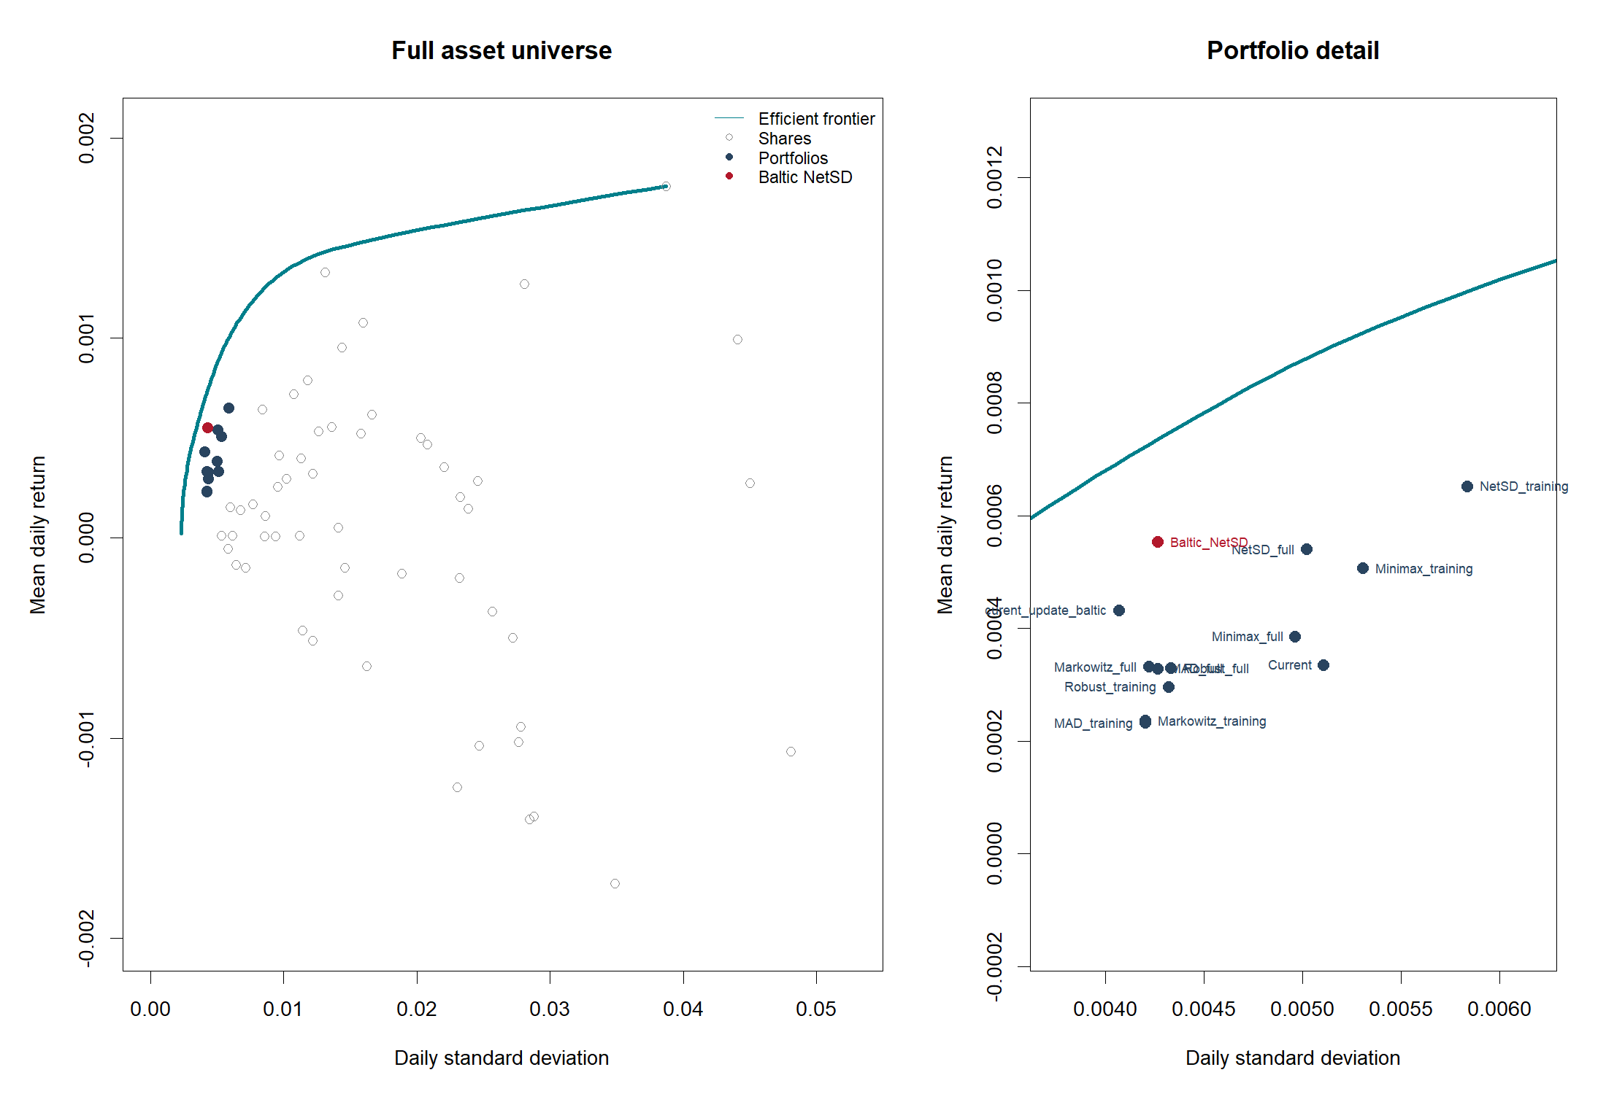
The curve is the single long-only Markowitz efficient frontier calculated from all 55 quality-approved shares. Shares and previously formed portfolios are points. Baltic_NetSD is highlighted in red because it maximises the stochastic-dominance objective rather than variance, so it need not lie on the Markowitz curve.
Figure 10. Cumulative returns, daily returns and drawdowns
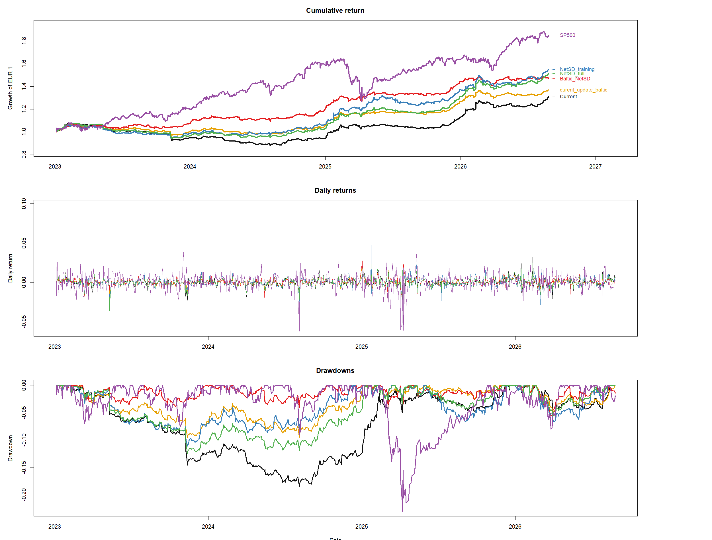

Table 9. Complete PerformanceAnalytics comparison
Measure | Current | Markowitz_training | MAD_training | Minimax_training | Robust_training | NetSD_training | Markowitz_full | MAD_full | Minimax_full | Robust_full | NetSD_full | Baltic_NetSD | curent_update_baltic
ArithmeticReturn | 0.000372 | 0.000241 | 0.000257 | 0.000550 | 0.000304 | 0.000598 | 0.000349 | 0.000361 | 0.000428 | 0.000359 | 0.000564 | 0.000519 | 0.000426
GeometricReturn | 0.000358 | 0.000231 | 0.000247 | 0.000535 | 0.000294 | 0.000581 | 0.000339 | 0.000351 | 0.000415 | 0.000349 | 0.000550 | 0.000510 | 0.000418
AnnualizedReturn_Arithmetic | 0.093795 | 0.060664 | 0.064647 | 0.138561 | 0.076694 | 0.150794 | 0.087853 | 0.090945 | 0.107941 | 0.090458 | 0.142039 | 0.130821 | 0.107470
AnnualizedReturn_Geometric | 0.094446 | 0.059957 | 0.064174 | 0.144198 | 0.076960 | 0.157742 | 0.089160 | 0.092447 | 0.110197 | 0.091833 | 0.148701 | 0.136999 | 0.110966
CumulativeReturn | 0.310002 | 0.190320 | 0.204546 | 0.496369 | 0.248368 | 0.549995 | 0.291162 | 0.302856 | 0.367224 | 0.300668 | 0.514060 | 0.468376 | 0.370061
Volatility | 0.005296 | 0.004391 | 0.004399 | 0.005514 | 0.004492 | 0.005841 | 0.004392 | 0.004460 | 0.005185 | 0.004525 | 0.005173 | 0.004363 | 0.004198
Volatility_Annualized | 0.084078 | 0.069699 | 0.069833 | 0.087538 | 0.071303 | 0.092717 | 0.069724 | 0.070799 | 0.082304 | 0.071837 | 0.082113 | 0.069266 | 0.066640
MaximumDrawdown | 0.184321 | 0.170565 | 0.166458 | 0.145632 | 0.150634 | 0.110949 | 0.141632 | 0.136609 | 0.174744 | 0.131373 | 0.124629 | 0.055730 | 0.095309
AverageDrawdown | 0.022361 | 0.021181 | 0.024093 | 0.014172 | 0.017703 | 0.020492 | 0.019664 | 0.019764 | 0.014241 | 0.016581 | 0.017062 | 0.010210 | 0.010753
AverageDrawdownLength | 55.384615 | 56.076923 | 65.727273 | 20.911765 | 36.150000 | 31.636364 | 39.444444 | 44.062500 | 27.692308 | 42.000000 | 30.217391 | 18.540541 | 25.250000
AverageRecoveryTime | 28.692308 | 26.307692 | 36.181818 | 11.147059 | 15.850000 | 18.636364 | 16.277778 | 17.312500 | 17.153846 | 20.117647 | 18.173913 | 8.540541 | 14.785714
Sharpe_Daily | 0.070274 | 0.054828 | 0.058316 | 0.099711 | 0.067757 | 0.102453 | 0.079373 | 0.080919 | 0.082616 | 0.079323 | 0.108968 | 0.118976 | 0.101590
Sharpe_Annualized | 1.115565 | 0.870369 | 0.925745 | 1.582866 | 1.075601 | 1.626395 | 1.260008 | 1.284544 | 1.311488 | 1.259213 | 1.729806 | 1.888684 | 1.612688
Sharpe_VaR | 0.061035 | 0.041013 | 0.046411 | 0.075791 | 0.054129 | 0.081810 | 0.060634 | 0.065962 | 0.060826 | 0.065734 | 0.087386 | 0.108907 | 0.086254
Sharpe_ES | 0.031120 | 0.023047 | 0.024326 | 0.045194 | 0.029121 | 0.049594 | 0.033683 | 0.034039 | 0.035983 | 0.033196 | 0.048549 | 0.053580 | 0.044131
Sortino | 0.102717 | 0.077301 | 0.080958 | 0.156878 | 0.097848 | 0.164841 | 0.113279 | 0.113784 | 0.124671 | 0.111091 | 0.163729 | 0.180480 | 0.152330
Calmar | 0.512400 | 0.351519 | 0.385525 | 0.990151 | 0.510905 | 1.421754 | 0.629521 | 0.676730 | 0.630620 | 0.699027 | 1.193148 | 2.458257 | 1.164275
Omega | 1.249138 | 1.178571 | 1.196080 | 1.337834 | 1.225276 | 1.355174 | 1.267086 | 1.279779 | 1.270559 | 1.277048 | 1.381485 | 1.423537 | 1.345228
Sterling | 0.332181 | 0.221599 | 0.240840 | 0.587047 | 0.307060 | 0.747773 | 0.368992 | 0.390717 | 0.401090 | 0.396906 | 0.661984 | 0.879719 | 0.568157
Burke | 0.720324 | 0.534231 | 0.570253 | 1.132896 | 0.685965 | 1.183233 | 0.812841 | 0.840856 | 0.870767 | 0.824759 | 1.196132 | 1.268369 | 1.025103
Martin | 1.040231 | 0.627890 | 0.714898 | 2.028405 | 0.974642 | 3.204131 | 1.253345 | 1.411333 | 1.146605 | 1.531761 | 2.446004 | 7.921596 | 2.619115
UlcerIndex | 0.090793 | 0.095489 | 0.089766 | 0.071089 | 0.078962 | 0.049231 | 0.071138 | 0.065503 | 0.096107 | 0.059953 | 0.060793 | 0.017294 | 0.042368
PainIndex | 0.068255 | 0.079338 | 0.074146 | 0.053805 | 0.060851 | 0.039381 | 0.054254 | 0.049798 | 0.072031 | 0.045829 | 0.046268 | 0.013430 | 0.032473
PainRatio | 1.383728 | 0.755715 | 0.865501 | 2.680021 | 1.264729 | 4.005567 | 1.643371 | 1.856433 | 1.529861 | 2.003807 | 3.213890 | 10.200907 | 3.417202
VaR_Loss | 0.006098 | 0.005870 | 0.005528 | 0.007255 | 0.005622 | 0.007314 | 0.005750 | 0.005471 | 0.007042 | 0.005461 | 0.006450 | 0.004767 | 0.004944
ES_Loss | 0.011960 | 0.010445 | 0.010546 | 0.012166 | 0.010451 | 0.012066 | 0.010350 | 0.010602 | 0.011904 | 0.010813 | 0.011610 | 0.009689 | 0.009664
DownsideDeviation | 0.003624 | 0.003114 | 0.003169 | 0.003505 | 0.003110 | 0.003630 | 0.003078 | 0.003172 | 0.003436 | 0.003231 | 0.003443 | 0.002876 | 0.002800
DrawdownDeviation | 0.006996 | 0.006542 | 0.006336 | 0.006304 | 0.006181 | 0.005743 | 0.005891 | 0.005650 | 0.006854 | 0.005387 | 0.005592 | 0.003835 | 0.004347
Rachev | 1.086522 | 1.010456 | 0.999723 | 1.219854 | 1.074294 | 1.260973 | 1.034670 | 1.023239 | 1.132297 | 1.028083 | 1.139201 | 1.198820 | 1.117016
AdjustedSharpe | 0.238305 | 0.585413 | 0.476947 | 1.068482 | 0.607402 | 0.304491 | 0.407486 | 0.109796 | 0.946247 | 0.062817 | -0.274498 | -0.343612 | 0.346803
Skewness | -0.068292 | -0.520195 | -0.832805 | 0.223792 | -0.405017 | 0.650172 | -0.617330 | -0.908080 | -0.023890 | -1.003316 | -0.308413 | -0.290296 | -0.221740
Kurtosis | 17.920560 | 10.981693 | 12.978086 | 6.678445 | 10.523807 | 11.973562 | 11.268384 | 13.474040 | 6.813094 | 14.193867 | 11.580399 | 10.337352 | 9.693609
UpsidePotential | 0.515006 | 0.510189 | 0.493841 | 0.621242 | 0.532197 | 0.628954 | 0.537408 | 0.520477 | 0.585463 | 0.512073 | 0.592918 | 0.606606 | 0.593577
UpsideRisk | 0.003876 | 0.003100 | 0.003058 | 0.004288 | 0.003251 | 0.004610 | 0.003149 | 0.003152 | 0.003902 | 0.003184 | 0.003897 | 0.003318 | 0.003153
BernardoLedoit | 1.249138 | 1.178571 | 1.196080 | 1.337834 | 1.225276 | 1.355174 | 1.267086 | 1.279779 | 1.270559 | 1.277048 | 1.381485 | 1.423537 | 1.345228
DRatio | 0.650570 | 0.747781 | 0.690573 | 0.651694 | 0.707733 | 0.653847 | 0.637883 | 0.624730 | 0.735948 | 0.636352 | 0.620966 | 0.587681 | 0.656023
Hurst | 0.406788 | 0.376610 | 0.383345 | 0.323217 | 0.374531 | 0.386128 | 0.385912 | 0.394260 | 0.333053 | 0.392467 | 0.390552 | 0.374544 | 0.360058
Kappa | 0.059750 | 0.047414 | 0.047912 | 0.103580 | 0.059853 | 0.105585 | 0.068414 | 0.066397 | 0.081701 | 0.064004 | 0.098032 | 0.108877 | 0.094094
Kelly | 13.268190 | 12.487490 | 13.256645 | 18.082037 | 15.084864 | 17.541574 | 18.071419 | 18.143451 | 15.934698 | 17.528819 | 21.066282 | 27.267158 | 24.199836
Prospect | -0.412645 | -0.463809 | -0.435146 | -0.423577 | -0.445088 | -0.415301 | -0.416882 | -0.394582 | -0.451319 | -0.390135 | -0.372757 | -0.352177 | -0.399227
Information_Daily | -0.039288 | -0.051230 | -0.049915 | -0.024080 | -0.045896 | -0.019843 | -0.042013 | -0.040955 | -0.034291 | -0.041151 | -0.023082 | -0.026836 | -0.035288
Information_Annualized | -0.723208 | -0.928451 | -0.906364 | -0.453022 | -0.838236 | -0.375479 | -0.771540 | -0.753228 | -0.635660 | -0.756616 | -0.435101 | -0.503316 | -0.654354
CAPMAlpha | 0.000323 | 0.000203 | 0.000217 | 0.000497 | 0.000259 | 0.000545 | 0.000306 | 0.000316 | 0.000388 | 0.000312 | 0.000510 | 0.000484 | 0.000385
JensenAlpha | 0.081660 | 0.050076 | 0.053922 | 0.130431 | 0.065265 | 0.143918 | 0.078069 | 0.080840 | 0.099591 | 0.079679 | 0.134683 | 0.127932 | 0.100180
Treynor_Daily | 0.006407 | 0.005349 | 0.005507 | 0.008882 | 0.005754 | 0.009618 | 0.006990 | 0.006914 | 0.008946 | 0.006561 | 0.008977 | 0.012855 | 0.008856
Treynor_Annualized | 1.689304 | 1.387697 | 1.431596 | 2.395385 | 1.505013 | 2.609531 | 1.838477 | 1.821410 | 2.376057 | 1.727874 | 2.425929 | 3.455630 | 2.352759
Modigliani | 0.000777 | 0.000606 | 0.000645 | 0.001103 | 0.000749 | 0.001133 | 0.000878 | 0.000895 | 0.000914 | 0.000877 | 0.001205 | 0.001316 | 0.001124
TrackingError_Daily | 0.011693 | 0.011448 | 0.011434 | 0.011749 | 0.011403 | 0.011903 | 0.011392 | 0.011394 | 0.011743 | 0.011394 | 0.011581 | 0.011476 | 0.011333
TrackingError_Annualized | 0.185622 | 0.181735 | 0.181511 | 0.186507 | 0.181011 | 0.188952 | 0.180845 | 0.180878 | 0.186408 | 0.180879 | 0.183839 | 0.182173 | 0.179907
M2Sortino | 0.100886 | 0.065429 | 0.069834 | 0.154329 | 0.083892 | 0.168060 | 0.097245 | 0.100398 | 0.118385 | 0.099491 | 0.159437 | 0.150455 | 0.122510
Appraisal | 0.978581 | 0.723234 | 0.777636 | 1.501970 | 0.923278 | 1.563545 | 1.128890 | 1.151736 | 1.216810 | 1.119391 | 1.655600 | 1.857604 | 1.516047
CAPMBeta | 0.055908 | 0.043206 | 0.044827 | 0.060198 | 0.051135 | 0.060448 | 0.048497 | 0.050756 | 0.046378 | 0.053148 | 0.061296 | 0.039645 | 0.047164
ActiveReturn | -0.134243 | -0.168732 | -0.164515 | -0.084492 | -0.151730 | -0.070948 | -0.139529 | -0.136242 | -0.118492 | -0.136856 | -0.079988 | -0.091691 | -0.117723
OmegaExcessReturn | 0.073700 | 0.042127 | 0.046031 | 0.124130 | 0.059152 | 0.136958 | 0.071540 | 0.074288 | 0.090526 | 0.073333 | 0.128991 | 0.120530 | 0.094937
BetaCoSkewness | -0.999356 | -0.959772 | -1.065311 | -0.835962 | -0.927877 | -0.827654 | -1.030847 | -1.037174 | -1.000984 | -1.035570 | -0.874472 | -1.879771 | -1.523893
BetaCoKurtosis | 0.076518 | 0.049766 | 0.051962 | 0.027976 | 0.048447 | 0.040237 | 0.046366 | 0.052530 | 0.023982 | 0.057409 | 0.051165 | -0.026949 | 0.026775
CDD | 0.038498 | 0.042171 | 0.043671 | 0.028151 | 0.041756 | 0.058993 | 0.038028 | 0.041178 | 0.026091 | 0.043712 | 0.040211 | 0.037004 | 0.026867
CoSkewness | -0.000000 | -0.000000 | -0.000000 | -0.000000 | -0.000000 | -0.000000 | -0.000000 | -0.000000 | -0.000000 | -0.000000 | -0.000000 | -0.000000 | -0.000000
CoKurtosis | 0.000000 | 0.000000 | 0.000000 | 0.000000 | 0.000000 | 0.000000 | 0.000000 | 0.000000 | 0.000000 | 0.000000 | 0.000000 | -0.000000 | 0.000000
FamaBeta | 0.478814 | 0.396928 | 0.397687 | 0.498518 | 0.406063 | 0.528009 | 0.397068 | 0.403193 | 0.468710 | 0.409101 | 0.467620 | 0.394460 | 0.379509
MSquaredExcess | -0.025588 | -0.063187 | -0.054791 | 0.049291 | -0.031874 | 0.057019 | -0.003372 | 0.000487 | 0.005223 | -0.003429 | 0.072684 | 0.096540 | 0.051848
NetSelectivity | -0.015054 | -0.030816 | -0.026773 | 0.030192 | -0.015903 | 0.036992 | -0.001645 | 0.000241 | 0.003008 | -0.001723 | 0.041761 | 0.046790 | 0.024177
Selectivity | 0.081660 | 0.050076 | 0.053922 | 0.130431 | 0.065265 | 0.143918 | 0.078069 | 0.080840 | 0.099591 | 0.079679 | 0.134683 | 0.127932 | 0.100180
SpecificRisk | 0.083448 | 0.069239 | 0.069341 | 0.086840 | 0.070689 | 0.092046 | 0.069156 | 0.070190 | 0.081846 | 0.071181 | 0.081350 | 0.068869 | 0.066080
SystematicRisk | 0.009817 | 0.007587 | 0.007871 | 0.010571 | 0.008979 | 0.010615 | 0.008516 | 0.008913 | 0.008144 | 0.009333 | 0.010763 | 0.006962 | 0.008282
TotalRisk | 0.084023 | 0.069654 | 0.069787 | 0.087481 | 0.071257 | 0.092656 | 0.069678 | 0.070753 | 0.082250 | 0.071790 | 0.082059 | 0.069220 | 0.066597
UpCapture | 0.087756 | 0.059931 | 0.063277 | 0.118747 | 0.078970 | 0.122515 | 0.078371 | 0.080591 | 0.087404 | 0.083093 | 0.118425 | 0.091341 | 0.087089
UpNumber | 0.577982 | 0.550459 | 0.571101 | 0.548165 | 0.568807 | 0.548165 | 0.575688 | 0.580275 | 0.541284 | 0.582569 | 0.564220 | 0.557339 | 0.550459
UpPercent | 0.176606 | 0.142202 | 0.139908 | 0.167431 | 0.153670 | 0.199541 | 0.149083 | 0.139908 | 0.174312 | 0.142202 | 0.165138 | 0.155963 | 0.162844
DownCapture | 0.000331 | 0.004213 | 0.003748 | -0.013238 | 0.009362 | -0.022872 | -0.004510 | -0.005348 | -0.016742 | -0.001623 | -0.017733 | -0.038680 | -0.016586
DownNumber | 0.490566 | 0.500000 | 0.490566 | 0.490566 | 0.515723 | 0.500000 | 0.484277 | 0.484277 | 0.522013 | 0.496855 | 0.503145 | 0.474843 | 0.496855
DownPercent | 0.883648 | 0.893082 | 0.893082 | 0.861635 | 0.883648 | 0.874214 | 0.893082 | 0.889937 | 0.883648 | 0.883648 | 0.877358 | 0.889937 | 0.893082
Table 9 contains all 72 measures calculated directly with PerformanceAnalytics: measures are rows and portfolios are columns. S&P 500 is the benchmark for CAPM, information, tracking-error, capture and systematic-risk measures. It remains in Table 5 and the figures; it is omitted from Table 9 because its information ratio relative to itself has a zero tracking-error denominator.

Decision risks and implementability

Liquidity and turnover

Table 10. Proposed trades and observed one-year market liquidity
asset | trade_shares | trade_value_EUR | median_daily_turnover_EUR | zero_volume_fraction | trade_to_median_turnover | liquidity_flag
KNE1L | 3162 | 1514.5980 | 14161.4250 | 0.0158 | 0.1070 | MEDIUM
TVE1T | 42 | 457.8000 | 14530.0500 | 0.0158 | 0.0315 | MEDIUM
DGR1R | 86 | 146.2000 | 12376.3920 | 0.0277 | 0.0118 | MEDIUM
HAE1T | 18 | 96.4800 | 17456.3600 | 0.0158 | 0.0055 | MEDIUM
GRG1L | -20 | 20.2000 | 11752.0000 | 0.0158 | 0.0017 | MEDIUM
TKM1T | -269 | 2394.0999 | 39910.2800 | 0.0158 | 0.0600 | LOW
VLP1L | 54 | 850.5000 | 21683.2000 | 0.0158 | 0.0392 | LOW
APG1L | 225 | 859.5000 | 24132.5100 | 0.0158 | 0.0356 | LOW
EFT1T | 16 | 309.6000 | 20341.5000 | 0.0158 | 0.0152 | LOW
MRK1T | 32 | 864.0000 | 58779.0000 | 0.0158 | 0.0147 | LOW
TAL1T | 1296 | 842.4000 | 77165.1590 | 0.0158 | 0.0109 | LOW
TSM1T | -330 | 396.0000 | 45355.4640 | 0.0158 | 0.0087 | LOW
TEL1L | 122 | 272.0600 | 56472.5200 | 0.0158 | 0.0048 | LOW
IGN1L | 57 | 1236.9000 | 286475.2000 | 0.0158 | 0.0043 | LOW
ROE1L | -269 | 237.2580 | 182092.0290 | 0.0158 | 0.0013 | LOW
LHV1T | 98 | 320.9500 | 263808.0900 | 0.0158 | 0.0012 | LOW
AKO1L | 11 | 20.3500 | 22121.8250 | 0.0158 | 0.0009 | LOW
CPA1T | 10 | 23.8500 | 81459.8250 | 0.0158 | 0.0003 | LOW
MOLNR | 29 | 597.4000 | 90.4000 | 0.2964 | 6.6084 | HIGH
RSU1L | 176 | 774.4000 | 1122.4000 | 0.0514 | 0.6900 | HIGH
VIRSI | 175 | 771.7500 | 2716.5600 | 0.0277 | 0.2841 | HIGH
PZV1L | 652 | 1157.3000 | 4316.8000 | 0.0158 | 0.2681 | HIGH
SAF1R | -100 | 1620.0001 | 8096.0000 | 0.0277 | 0.2001 | HIGH
Median daily turnover and zero-volume frequency use official Nasdaq Baltic price-volume observations from the last 365 calendar days of the sample. Trade-to-turnover is the proposed absolute order value divided by median daily turnover. HIGH flags median turnover below EUR 5,000 or an order above 20% of median turnover; MEDIUM flags below EUR 20,000 or above 10%. These are transparent screening thresholds, not a guarantee of execution. HIGH trades should be split, limited or omitted after checking the live order book.

Table 11. Illustrative transaction-cost and turnover scenario
portfolio | turnover_EUR | number_of_trades | estimated_cost_EUR | high_liquidity_risk_trades | cost_percent_of_15000
Baltic_NetSD | 15783.5960 | 23 | 210.6643 | 5 | 1.4044
curent_update_baltic | 6468.2880 | 21 | 119.8644 | 4 | 0.7991
The cost scenario uses max(EUR 3, 0.25% of trade value) commission plus an assumed spread/impact of 0.25%, 0.75% or 2.00% for LOW, MEDIUM or HIGH liquidity risk. These are sensitivity assumptions rather than broker quotes. Reported historical returns and dividends are gross; subtract the displayed cost before interpreting an implementation result.

Capital concentration

Table 12. Top-position and effective-position concentration
portfolio | positions | top5_share | top10_share | HHI | effective_positions
Baltic_NetSD | 21 | 0.4934 | 0.8003 | 0.0744 | 13.4371
curent_update_baltic | 23 | 0.5195 | 0.7686 | 0.0802 | 12.4628

Table 12A. Baltic_NetSD: country, list and industry concentration
dimension | category | capital_percent
country_market | RIG | 6.16
country_market | TLN | 34.98
country_market | VLN | 58.85
segment | Baltic Main List | 90.81
segment | First North Baltic Share List | 9.19
Industry | Basic Materials | 3.55
Industry | Consumer Discretionary | 25.92
Industry | Consumer Staples | 23.25
Industry | Financials | 5.37
Industry | Health Care | 4.01
Industry | Industrials | 23.83
Industry | Telecommunications | 1.83
Industry | Utilities | 11.37
Industry | nan | 0.87
Supersector | Banks | 2.31
Supersector | Basic Resources | 3.55
Supersector | Construction and Materials | 9.42
Supersector | Financial Services | 3.06
Supersector | Food, Beverage and Tobacco | 23.25
Supersector | Health Care | 4.01
Supersector | Industrial Goods and Services | 14.41
Supersector | Retail | 17.21
Supersector | Telecommunications | 1.83
Supersector | Travel and Leisure | 8.71
Supersector | Utilities | 11.37
Supersector | nan | 0.87

Table 12B. curent_update_baltic: country, list and industry concentration
dimension | category | capital_percent
country_market | RIG | 16.38
country_market | TLN | 45.39
country_market | VLN | 38.23
segment | Baltic Main List | 93.17
segment | First North Baltic Share List | 6.83
Industry | Basic Materials | 7.63
Industry | Consumer Discretionary | 34.15
Industry | Consumer Staples | 14.80
Industry | Financials | 4.59
Industry | Health Care | 3.31
Industry | Industrials | 19.02
Industry | Telecommunications | 11.11
Industry | Utilities | 2.19
Industry | nan | 3.19
Supersector | Banks | 2.33
Supersector | Basic Resources | 7.63
Supersector | Construction and Materials | 7.60
Supersector | Financial Services | 2.26
Supersector | Food, Beverage and Tobacco | 14.80
Supersector | Health Care | 3.31
Supersector | Industrial Goods and Services | 11.42
Supersector | Retail | 29.27
Supersector | Telecommunications | 11.11
Supersector | Travel and Leisure | 4.88
Supersector | Utilities | 2.19
Supersector | nan | 3.19
The number of holdings is not a diversification measure. Top-five and top-ten shares show how much capital is concentrated in the largest positions; HHI and the effective number of positions measure weight concentration. Country, list, industry and supersector totals expose common economic exposures that a position count conceals. Very small positions add trading complexity while making little difference to risk.

In-sample, out-of-sample and complete-period validation

Table 13A. In-sample portfolio-return statistics for the 70% training window
period | portfolio | observations | mean | median | SD | minimum | maximum
In-sample training | Markowitz | 527 | 0.000027 | 0.000176 | 0.004759 | -0.025519 | 0.017324
In-sample training | MAD | 527 | 0.000036 | 0.000107 | 0.004809 | -0.028989 | 0.017095
In-sample training | Minimax | 527 | 0.000366 | 0.000275 | 0.005969 | -0.021554 | 0.030058
In-sample training | Robust | 527 | 0.000156 | 0.000159 | 0.004914 | -0.026819 | 0.018079
In-sample training | NetSD | 527 | 0.000634 | 0.000275 | 0.006803 | -0.030548 | 0.047554
In-sample training | Current | 527 | 0.000027 | 0.000183 | 0.006017 | -0.040123 | 0.024829

Table 13B. Out-of-sample portfolio-return statistics for the 30% holdout window
period | portfolio | observations | mean | median | SD | minimum | maximum
Out-of-sample test | Markowitz | 227 | 0.000967 | 0.000772 | 0.004877 | -0.022545 | 0.027713
Out-of-sample test | MAD | 227 | 0.000945 | 0.000731 | 0.004771 | -0.025817 | 0.026779
Out-of-sample test | Minimax | 227 | 0.001338 | 0.000600 | 0.006351 | -0.022953 | 0.029115
Out-of-sample test | Robust | 227 | 0.000917 | 0.000450 | 0.005004 | -0.023252 | 0.026893
Out-of-sample test | NetSD | 227 | 0.001277 | 0.000641 | 0.006417 | -0.027866 | 0.026494
Out-of-sample test | Current | 227 | 0.001373 | 0.000708 | 0.006532 | -0.022371 | 0.046525
Tables 13A and 13B use the same fixed 70/30 split. Portfolio weights are estimated from the training window and then left unchanged in the holdout window. Table 5 remains the complete-period description; it must not be interpreted as an independent test.

Table 13C. Existing 70/30 holdout experiment: portfolio-only netSD on unseen test data
entity | out | in | network_denominator | netSD
Markowitz | 3 | 0 | 6 | 0.500000
MAD | 0 | 0 | 6 | 0.000000
Minimax | 3 | 0 | 6 | 0.500000
Robust | 0 | 1 | 6 | -0.166667
NetSD | 0 | 2 | 6 | -0.333333
Current | 3 | 0 | 6 | 0.500000
SP500 | 0 | 6 | 6 | -1.000000
The final Baltic_NetSD weights were selected on the complete 2023–2026 sample. Their 13.70% annualised geometric return and 1.89 annualised Sharpe ratio are therefore in-sample descriptions, not forecasts. The earlier 70/30 experiment is the available independent check: weights were fixed from the first 70% and assessed on the last 30%. Its NetSD portfolio has a negative test-network netSD, which is direct evidence of model-selection instability. No trade should rely on the full-sample figures without a new walk-forward or future-paper-trading test.
netSD counts outgoing minus incoming FSD, SSD and TSD relations relative to a fixed comparison network. It has no monetary unit and does not state expected profit, maximum loss or suitability for an investor. Use it as a distribution-ranking signal together with return, volatility, drawdown, VaR/ES, liquidity, concentration and cost results.
The S&P 500 series is a USD price-index benchmark. It excludes dividends and has not been converted into EUR investor returns, so it is retained only as a broad market sensitivity reference. Direct performance claims require a total-return benchmark converted to EUR over identical dates.
Dividend values are historical gross cash distributions. They are excluded from optimisation and are neither a forecast nor an assessment of dividend sustainability. Company valuation, earnings quality, debt, free cash flow and payout coverage have not been modelled; each proposed purchase therefore requires a separate fundamental review.

Model

Exact mathematical formulation of the netSD portfolio
Let R_tj be the return of share j on date t, w_j its final portfolio weight, and r_p,t = Σ_j w_j R_tj the candidate portfolio return. Let K denote the fixed reference set consisting of 55 quality-approved shares, the current portfolio, and ten earlier portfolios.
For entity i, define H_i^(1)(x)=F_i(x) and H_i^(q)(x)=∫_{-∞}^x H_i^(q-1)(u)du for q=2,3. Entity i dominates entity k at order q when H_i^(q)(x) ≤ H_k^(q)(x) for every observed support point x, with a strict inequality for at least one x. The third-order comparison additionally requires E[R_i] ≥ E[R_k]. Let a_ik^(q)=1 when this condition holds and 0 otherwise.
OUT(p)=Σ_{k∈K}Σ_{q=1}^3 a_pk^(q), IN(p)=Σ_{k∈K}Σ_{q=1}^3 a_kp^(q), D=max_i{OUT(i)+IN(i)}, netSD(p)=[OUT(p)-IN(p)]/D.
Primary optimisation problem: max_w netSD(w), subject to Σ_j w_j=1; w_j≥0; μᵀw≥μ_current; and w_j=0 for every share j whose individual netSD_j≤0 or which belongs to the Baltic Secondary List. Selling existing holdings is allowed, so current positions do not impose lower bounds. Historical dividends are reported separately and do not enter the objective.
The individual-share screening score is calculated before the new candidate enters the network: netSD_j=(OUT_j-IN_j)/D_ref in the fixed 67-entity reference system. This prevents the candidate from changing its own admissible investment universe.
The unchanged reference set contains 55 quality-approved shares, the current portfolio, and ten earlier portfolios: Markowitz, MAD, Minimax, Robust and NetSD estimated from the training sample and from the complete sample. The larger pairwise matrices are diagnostics only; their expanded-network ratios are not presented as the optimisation score.
The objective is discrete and non-convex. ISRES evaluates candidate portfolios numerically. The report therefore states the best solution found; it does not claim a mathematical certificate of global optimality.

Data coverage
The official Nasdaq Baltic list contained 67 shares. 55 shares had Yahoo closing-price history covering the complete study window and entered the common-date return matrix. Shares with incomplete or unavailable histories are excluded from both the optimisation and Table 2. No price interpolation or zero-return replacement was used.
Sources: official Nasdaq Baltic share-list and dividend/event workbooks; Yahoo Finance unadjusted closing prices downloaded through quantmod; official Nasdaq Baltic corrections for MODE and MOLNR in 2025 and the complete VIRSI history. Return analysis ends 2026-10-23; latest valuation prices run through 2026-10-23.

