Update3: Baltic shares and Swedbank Robur funds
Prepared 2026-10-31 14:29. Decision ceiling: EUR 15,000.

1. Portfolio construction
Update3 extends the existing penalised-netSD model with Swedbank Robur funds. Exactly two or three funds are required; each selected fund must have at least 2% weight. Emerging Europe C is mandatory because its mandate excludes Russia and Belarus and its currently reported regional allocation contains no China. The China screen must be rechecked whenever the fund publishes new holdings. The optimiser solves the two-fund and three-fund versions separately and retains the better penalised objective for each sales regime.
Fund NAV returns are already net of ongoing fund expenses. Deducting the same percentage from those returns again would double count the fee. The objective therefore uses observed net NAV returns. The report separately shows the weighted annual fee and its approximate EUR amount at the planned allocation.

1.1. Planned portfolio composition

Sales allowed
Shares
Ticker | Name | Price | Current shares | Target shares | Change | Weight % | EUR
VLP1L | Vilkyškių pieninė | 15.750 | 42 | 98.000 | 56.000 | 10.298 | 1543.500
PZV1L | Pieno žvaigždės | 1.790 | 0 | 600.000 | 600.000 | 7.171 | 1074.000
MRK1T | Merko Ehitus | 26.900 | 20 | 39.000 | 19.000 | 7.047 | 1049.100
KNE1L | KN Energies | 0.477 | 928 | 2204.000 | 1276.000 | 7.010 | 1051.308
LHV1T | LHV Group | 3.250 | 0 | 260.000 | 260.000 | 5.636 | 845.000
APG1L | Apranga | 3.800 | 200 | 209.000 | 9.000 | 5.315 | 794.200
MOLNR | J. Molner | 19.800 | 0 | 33.000 | 33.000 | 4.466 | 653.400
GRG1L | Grigeo Group | 1.010 | 543 | 493.000 | -50.000 | 3.322 | 497.930
TEL1L | Telia Lietuva | 2.250 | 0 | 214.000 | 214.000 | 3.222 | 481.500
AKO1L | Akola Group | 1.875 | 0 | 242.000 | 242.000 | 3.030 | 453.750
CPA1T | Coop Pank | 2.375 | 0 | 170.000 | 170.000 | 2.705 | 403.750
ROE1L | Artea Bankas | 0.819 | 416 | 462.000 | 46.000 | 2.523 | 378.378
RSU1L | Rokiškio sūris | 4.260 | 91 | 82.000 | -9.000 | 2.342 | 349.320
TKM1T | TKM Grupp | 8.880 | 288 | 38.000 | -250.000 | 2.278 | 337.440
EFT1T | EfTEN Real Estate Fund | 19.550 | 0 | 13.000 | 13.000 | 1.695 | 254.150
HAE1T | Harju Elekter Group | 5.200 | 100 | 36.000 | -64.000 | 1.251 | 187.200
TAL1T | Tallink Grupp | 0.647 | 700 | 285.000 | -415.000 | 1.230 | 184.395
DGR1R | DelfinGroup | 1.715 | 0 | 102.000 | 102.000 | 1.166 | 174.930
VIRSI | VIRŠI-A | 4.400 | 0 | 39.000 | 39.000 | 1.154 | 171.600
Funds
ISIN | Fund | NAV EUR | Estimated units | Weight % | EUR | Annual fee % | Fee EUR/year
SE0014261764 | Swedbank Robur Technology C | 27.250 | 80.437 | 14.612 | 2191.872 | 1.380 | 30.248
SE0019354200 | Swedbank Robur Emerging Europe C | 23.236 | 80.876 | 12.528 | 1879.219 | 1.600 | 30.067

No sales
Shares
Ticker | Name | Price | Current shares | Target shares | Change | Weight % | EUR
TKM1T | TKM Grupp | 8.880 | 288 | 294.000 | 6.000 | 17.462 | 2610.720
SAF1R | SAF Tehnika | 16.500 | 100 | 100.000 | 0.000 | 11.000 | 1650.000
VLP1L | Vilkyškių pieninė | 15.750 | 42 | 73.000 | 31.000 | 7.752 | 1149.750
APG1L | Apranga | 3.800 | 200 | 274.000 | 74.000 | 6.942 | 1041.200
MRK1T | Merko Ehitus | 26.900 | 20 | 34.000 | 14.000 | 6.139 | 914.600
TAL1T | Tallink Grupp | 0.647 | 700 | 1297.000 | 597.000 | 5.595 | 839.159
KNE1L | KN Energies | 0.477 | 928 | 1495.000 | 567.000 | 4.756 | 713.115
GRG1L | Grigeo Group | 1.010 | 543 | 655.000 | 112.000 | 4.411 | 661.550
HAE1T | Harju Elekter Group | 5.200 | 100 | 109.000 | 9.000 | 3.796 | 566.800
ROE1L | Artea Bankas | 0.819 | 416 | 640.000 | 224.000 | 3.499 | 524.160
MOLNR | J. Molner | 19.800 | 0 | 21.000 | 21.000 | 2.838 | 415.800
RSU1L | Rokiškio sūris | 4.260 | 91 | 96.000 | 5.000 | 2.742 | 408.960
TSM1T | Tallinna Sadam | 1.192 | 330 | 330.000 | 0.000 | 2.622 | 393.360
CPA1T | Coop Pank | 2.375 | 0 | 116.000 | 116.000 | 1.852 | 275.500
DGR1R | DelfinGroup | 1.715 | 0 | 158.000 | 158.000 | 1.810 | 270.970
TEL1L | Telia Lietuva | 2.250 | 0 | 116.000 | 116.000 | 1.754 | 261.000
PZV1L | Pieno žvaigždės | 1.790 | 0 | 80.000 | 80.000 | 0.956 | 143.200
LHV1T | LHV Group | 3.250 | 0 | 28.000 | 28.000 | 0.626 | 91.000
Funds
ISIN | Fund | NAV EUR | Estimated units | Weight % | EUR | Annual fee % | Fee EUR/year
SE0014261764 | Swedbank Robur Technology C | 27.250 | 26.290 | 4.776 | 716.392 | 1.380 | 9.886
SE0013876927 | Swedbank Robur Access Edge Japan C | 15.587 | 44.675 | 4.642 | 696.362 | 0.250 | 1.741
SE0019354200 | Swedbank Robur Emerging Europe C | 23.236 | 26.010 | 4.029 | 604.367 | 1.600 | 9.670

1.2. Fund candidate audit
ISIN | Fund | Fee % | Risk 1–7 | Observations | First return | Last return | Individual netSD | Admissible
SE0013876950 | Swedbank Robur Access Edge Em Mkt C | 0.4600 | 4 | 922 | 2023-01-04 | 2026-10-29 | 0.3233 | True
SE0015192331 | Swedbank Robur Access Edge Europe C | 0.3600 | 4 | 956 | 2023-01-04 | 2026-10-29 | 0.4737 | True
SE0015192349 | Swedbank Robur Access Edge Global C | 0.2800 | 4 | 931 | 2023-01-04 | 2026-10-29 | 0.5489 | True
SE0013876927 | Swedbank Robur Access Edge Japan C | 0.2500 | 4 | 897 | 2023-01-05 | 2026-10-29 | 0.2030 | True
SE0015192315 | Swedbank Robur Access Edge Sweden C | 0.2900 | 5 | 958 | 2023-01-04 | 2026-10-29 | 0.3308 | True
SE0015192323 | Swedbank Robur Access Edge USA C | 0.2400 | 4 | 931 | 2023-01-04 | 2026-10-29 | 0.5038 | True
SE0019354200 | Swedbank Robur Emerging Europe C | 1.6000 | 5 | 859 | 2023-05-04 | 2026-10-29 | 0.5113 | True
SE0014261897 | Swedbank Robur Fastighet C | 1.2700 | 4 | 931 | 2023-01-04 | 2026-10-29 | 0.1278 | True
SE0014261756 | Swedbank Robur Global High Dividend C | 1.0900 | 3 | 931 | 2023-01-04 | 2026-10-29 | 0.5639 | True
SE0014261889 | Swedbank Robur Global Impact C | 0.7700 | 4 | 931 | 2023-01-04 | 2026-10-29 | 0.4511 | True
SE0014261871 | Swedbank Robur Healthcare C | 1.2900 | 4 | 931 | 2023-01-04 | 2026-10-29 | 0.2632 | True
SE0014261764 | Swedbank Robur Technology C | 1.3800 | 5 | 931 | 2023-01-04 | 2026-10-29 | 0.2707 | True

1.3. Objective and constraints
The objective is the existing Update2 criterion: maximise netSD minus penalties for the squared number of new share positions, effective position count, new share positions below 1%, and share positions producing less than EUR 10 of five-year-average annual dividend cash. Fund fees are embedded in NAV and are not subtracted again.
Component | Restriction
Budget | Total planned value ≤ EUR 15,000
Long only | All weights ≥ 0
Fund count | Exactly 2 or 3
Minimum selected fund weight | 2%
Mandatory emerging-market fund | Emerging Europe C: Russia excluded by mandate; no China in current reported regions
New share purchase | Either zero or at least 10 shares
No-sales case | Every current share holding is a lower bound
Return | Expected daily return ≥ Current portfolio mean

2. Results
Portfolio | Funds | netSD | OUT | IN | Ann. return | Ann. SD | Max DD | Sortino | Rachev | Weighted fee % | Fee EUR/year
Update3: sales allowed | 2 | 0.8496 | 113 | 0 | 0.1991 | 0.0836 | -0.0979 | 0.2143 | 1.0902 | 0.4021 | 60.3153
Update3: no sales | 3 | 0.6767 | 90 | 0 | 0.1273 | 0.0688 | -0.0817 | 0.1678 | 1.0341 | 0.1420 | 21.2970
The netSD values use the expanded Update3 reference system containing the eligible shares, all audited funds and the existing portfolios. They must not be compared numerically with older netSD values that used a smaller denominator.
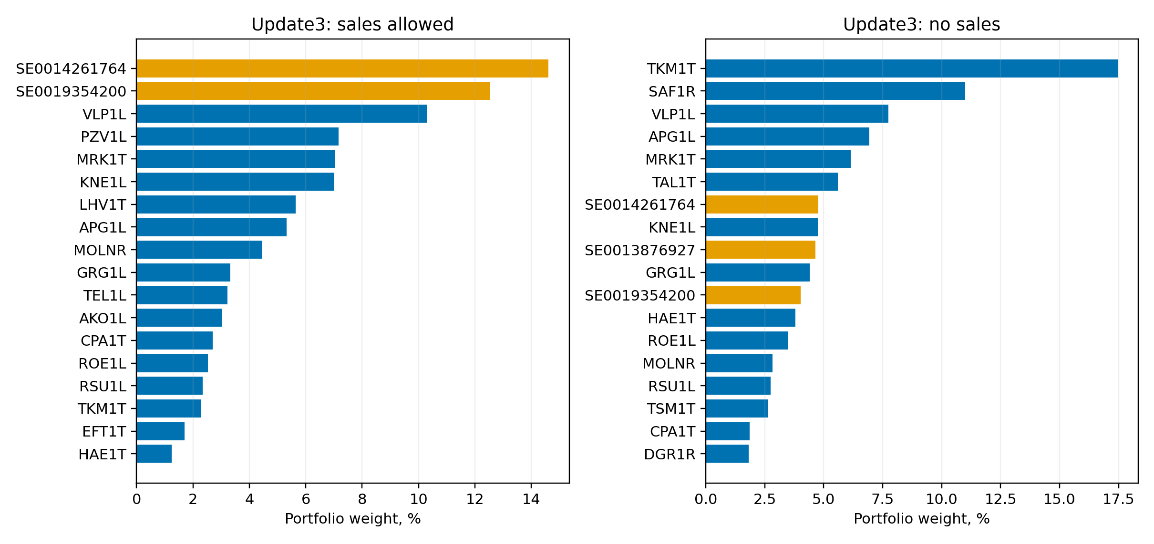

2.1. Two-fund versus three-fund solutions
case | fund_count | netSD | OUT | IN | penalised_objective | new_positions | effective_count
sell2 | 2 | 0.84962 | 113 | 0 | 0.79485 | 9 | 12.98216
sell3 | 3 | 0.84962 | 113 | 0 | 0.78176 | 9 | 13.52930
no_sell2 | 2 | 0.66165 | 88 | 0 | 0.61203 | 7 | 12.89254
no_sell3 | 3 | 0.67669 | 90 | 0 | 0.62889 | 6 | 13.05378
With sales allowed, the two- and three-fund candidates obtain the same netSD, but the two-fund solution has the better penalised objective. Without sales, the three-fund solution improves both netSD and the penalised objective.

2.2. Full-period and 70/30 period statistics
Period | Portfolio | Observations | Mean daily | Annualised return | Annualised SD | Maximum drawdown | Sortino | Rachev
Full | Current | 884 | 0.0003 | 0.0775 | 0.0782 | -0.1586 | 0.0905 | 1.0043
Full | Update2: sales allowed | 884 | 0.0005 | 0.1186 | 0.0683 | -0.0586 | 0.1635 | 1.1506
Full | Update2: no sales | 884 | 0.0004 | 0.1033 | 0.0674 | -0.0773 | 0.1413 | 1.0167
Full | Update3: sales allowed | 884 | 0.0007 | 0.1991 | 0.0836 | -0.0979 | 0.2143 | 1.0902
Full | Update3: no sales | 884 | 0.0005 | 0.1273 | 0.0688 | -0.0817 | 0.1678 | 1.0341
In-sample segment | Current | 618 | 0.0000 | -0.0005 | 0.0756 | -0.1586 | 0.0026 | 0.8076
In-sample segment | Update2: sales allowed | 618 | 0.0005 | 0.1197 | 0.0679 | -0.0501 | 0.1642 | 1.1246
In-sample segment | Update2: no sales | 618 | 0.0002 | 0.0578 | 0.0683 | -0.0773 | 0.0763 | 0.8974
In-sample segment | Update3: sales allowed | 618 | 0.0008 | 0.2068 | 0.0852 | -0.0979 | 0.2149 | 1.0831
In-sample segment | Update3: no sales | 618 | 0.0003 | 0.0778 | 0.0693 | -0.0817 | 0.0989 | 0.9252
Held-out segment | Current | 266 | 0.0010 | 0.2829 | 0.0831 | -0.0514 | 0.3747 | 1.5932
Held-out segment | Update2: sales allowed | 266 | 0.0004 | 0.1162 | 0.0694 | -0.0549 | 0.1619 | 1.2094
Held-out segment | Update2: no sales | 266 | 0.0008 | 0.2165 | 0.0650 | -0.0505 | 0.3531 | 1.3865
Held-out segment | Update3: sales allowed | 266 | 0.0007 | 0.1815 | 0.0798 | -0.0668 | 0.2136 | 1.1154
Held-out segment | Update3: no sales | 266 | 0.0009 | 0.2511 | 0.0671 | -0.0547 | 0.3875 | 1.3686
The Update3 weights were estimated on the full sample. Consequently, the final 30% segment above is a period breakdown, not a genuine out-of-sample test. A defensible predictive claim requires re-estimating the weights using only the first 70% and freezing them before evaluating the remaining 30%.
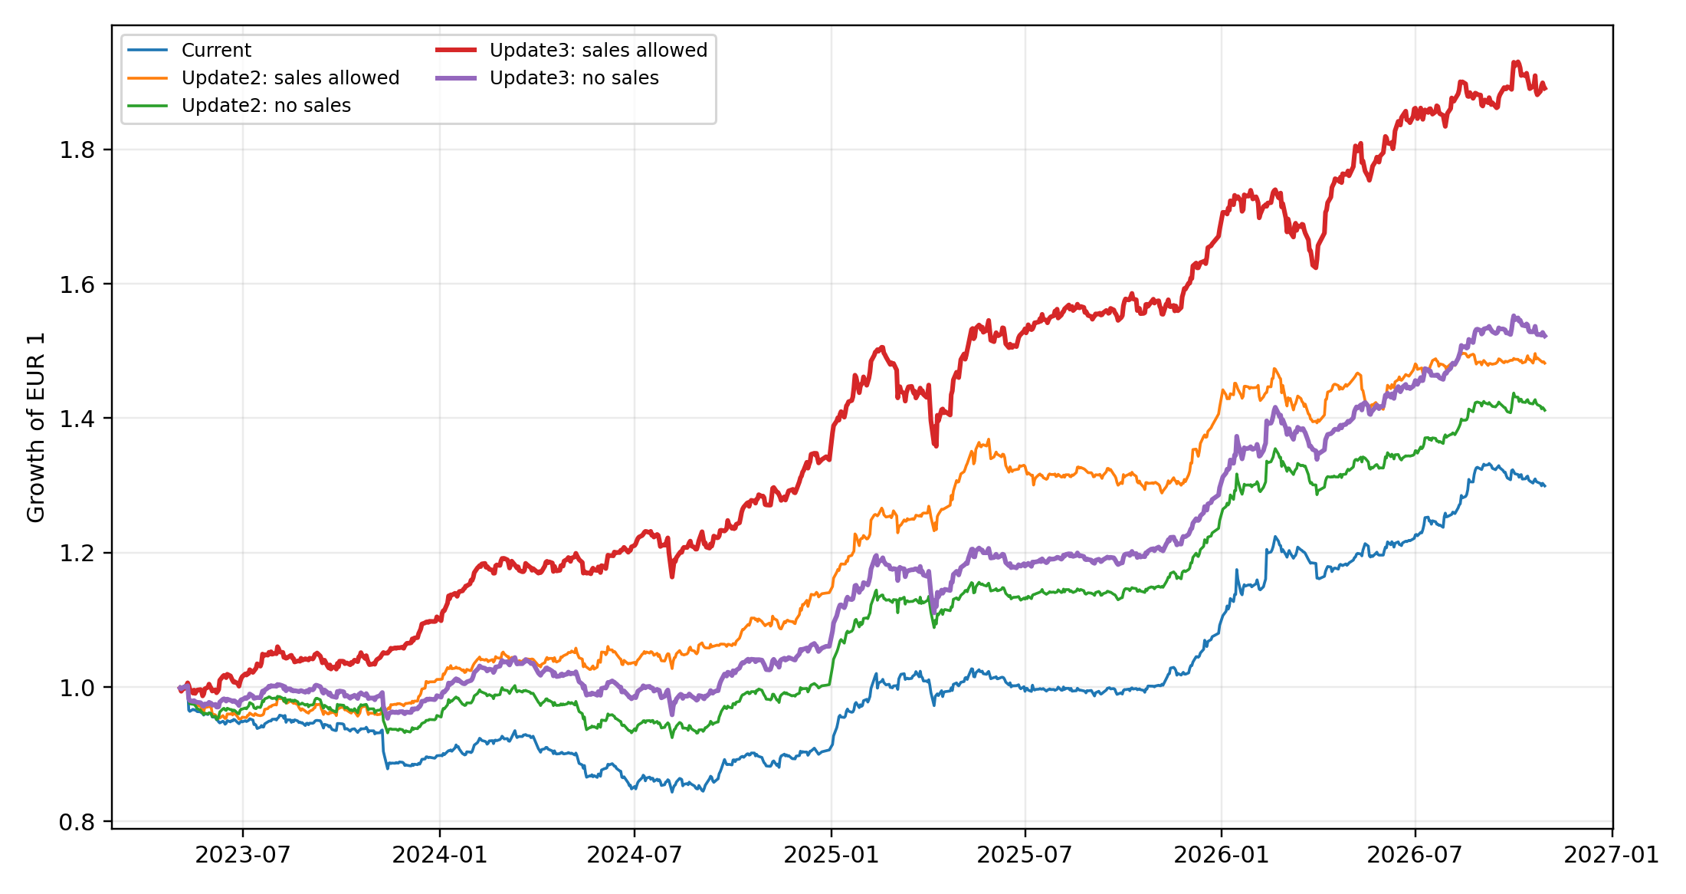

3. Interpretation and limitations
- The sales-allowed portfolio allocates about 27% to two funds. Its estimated fund cost is approximately EUR 60 per year at the planned weights.
- The no-sales portfolio can invest only the capital remaining above the current holdings. It allocates about 13.4% to three funds, with an estimated fund cost of about EUR 21 per year.
- Emerging Europe C has a 1.60% total fee and a concentrated regional and financial-sector exposure. Its inclusion is a user constraint rather than a conclusion that it is the best unconstrained fund.
- Mutual funds are valued once daily and an order executes at an unknown future NAV. Planned EUR amounts are therefore targets rather than guaranteed execution values.
- Fund NAV series do not have exchange volume or bid–ask spread measures comparable with Baltic shares. They should not be scored with the same liquidity diagnostics.
- The analysis is historical and does not establish expected future return. Fund and share allocations should be reviewed after a genuine walk-forward test.

