Recommendation On Douban Book

Version History
Document Version | Author | Changes | Date
0.1 | Danny Liu | Initial version | 09/29/2013

内容目录
1 Overview 3
2 Data Model 3
2.1 People – Book 3
2.2 Book – Tag 3
2.3 People - Tag 4
3 Recommendation 4
3.1 Content Based 4
3.2 Collaborative Filtering Based 4

Overview
This document is about the ways to recommend a book for douban users. Basically, algorithms that used can be classified to collaborative filtering based(CF) and content based(CB).

Data Model
Data can crawl from douban is people, book and tag, so three models can be built to build the connections between these three entities. All models are in format as the following picture:
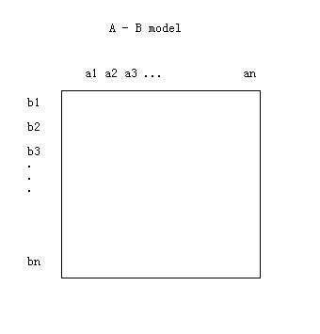

People – Book
People-book model is the connection between book and people(who read which books). So it can be used for collaborative filtering.
Model path: /user/danny/recommendation/data/douban/people-book
Format is as following:
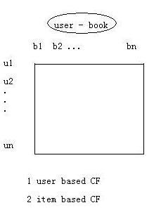

Book – Tag
Book-Tag model is the connection between book and tag(which book have which tags). So it can be used for content based recommendation(in a word: to find the book that most like this book).
Model path: /user/danny/recommendation/data/douban/book-tag-unscale
Format is as following:
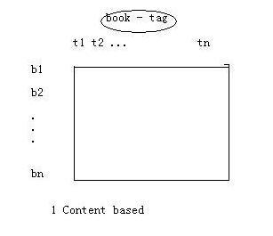

People - Tag
People-Tag model is the connection between people and tag(which people have which tags). This model have two functions:
1) One is for clustering the people(find those people who have the same interest). So it can be used as the pretreatment of CF(That is to say let the people who have the same interest to recommend a book for you).
2) When come a new book, find the people who like most of the tags of this book.
Model path: /user/danny/recommendation/data/douban/people-tag
Format is as following:

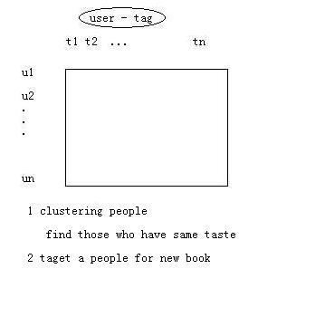
Recommendation
Project is in server 192.168.225.201:/home/user/data_mining/recommendation. As for the command and options, please refer to 'README'.

Content Based
Content based recommendation is suitable for case of when there is no much data of interaction between book and people. It has not cold-start problem and is very easy to explain. Douban book page(section '喜欢读..的人也喜欢...') is most likely content based recommendation.

Example:
To recommend a book for who have read book '4031698', you can run:
hadoop jar recommendation-0.0.1-SNAPSHOT.jar knn -dp /user/danny/recommendation/data/douban/book-tag -cp /user/danny/cluster/kmeans/douban/book-tag-unscale -u 4031698

Collaborative Filtering Based

3.2.1 User Based
In a word, let those who have the same book as you to recommend a book you have not read for you(让那些和你读过很多相同的书的人推荐一本你没读过的书).
Example:
To recommend a book for user 'koalarun', you can run:
hadoop jar recommendation-0.0.1-SNAPSHOT.jar user -dp /user/danny/recommendation/data/douban/people-book -u koalarun

If you want those who have the same taste as you to recommend, add option:
-cp /user/danny/cluster/kmeans/douban/people-tag

3.2.2 Item Based
In a word, find a book who is most like the book you read. Word 'like' means for book A and B, the more people who have both read A and B, the more A like B.
Example:
To recommend a book for user 'koalarun', you can run:
hadoop jar recommendation-0.0.1-SNAPSHOT.jar item -dp /user/danny/recommendation/data/douban/people-book -u koalarun

