Open Rhino and Grasshopper file in following folder:

ifmm_lib\production\11_IFMM_NEST_FinalWall_Fab

**FABRICATION INTERFACE**

**A Opening the files**

Once the GH file is opened, you need to do the following steps:

1. Press the **init button** from the fabrication component.

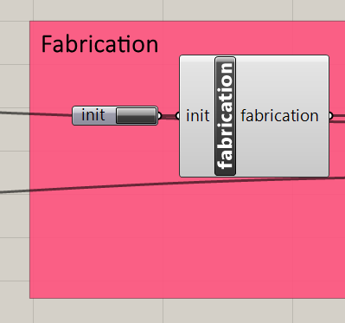

1. Press the following 4 buttons once:

refresh, start_timer, stop_timer, self_update (false>true>false)

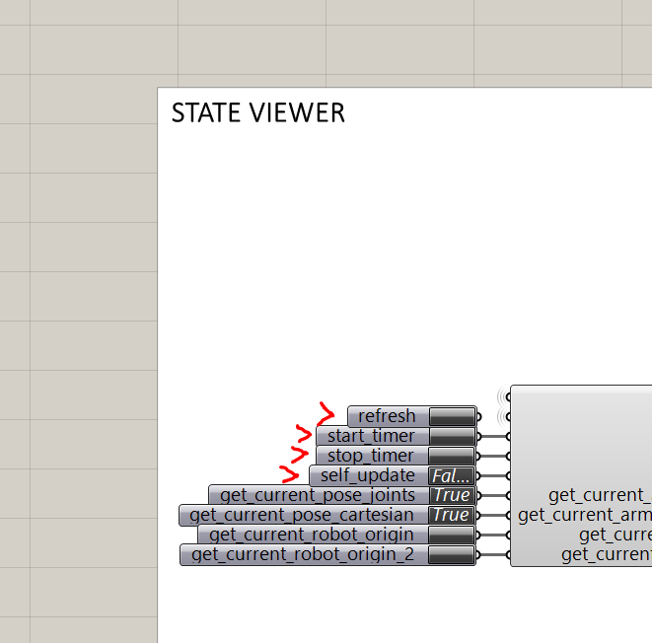

**B Setting the starting node**

You can define from which node to start the fabrication by setting the parameters of the   
🡪 **row number**,   
🡪 the **index of the node** within the row   
🡪 and the **surface 1 or surface 2** of the mesh

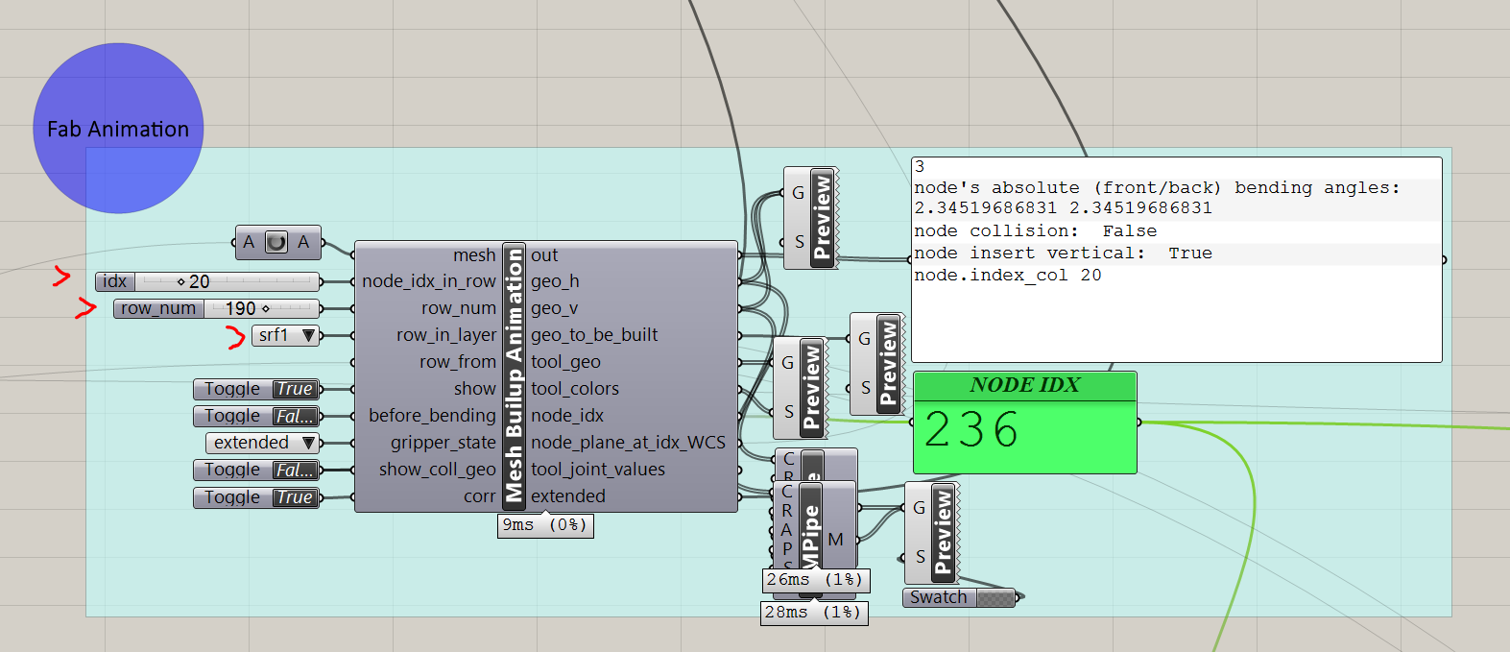

The preview of this (if not turned off) is the blue tool head:

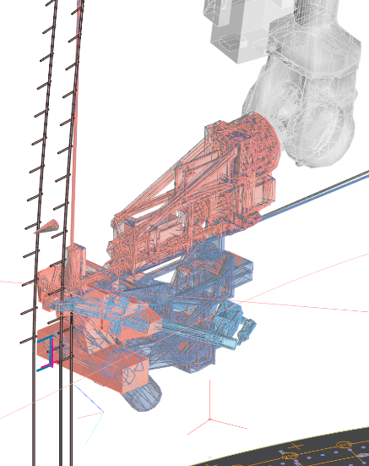

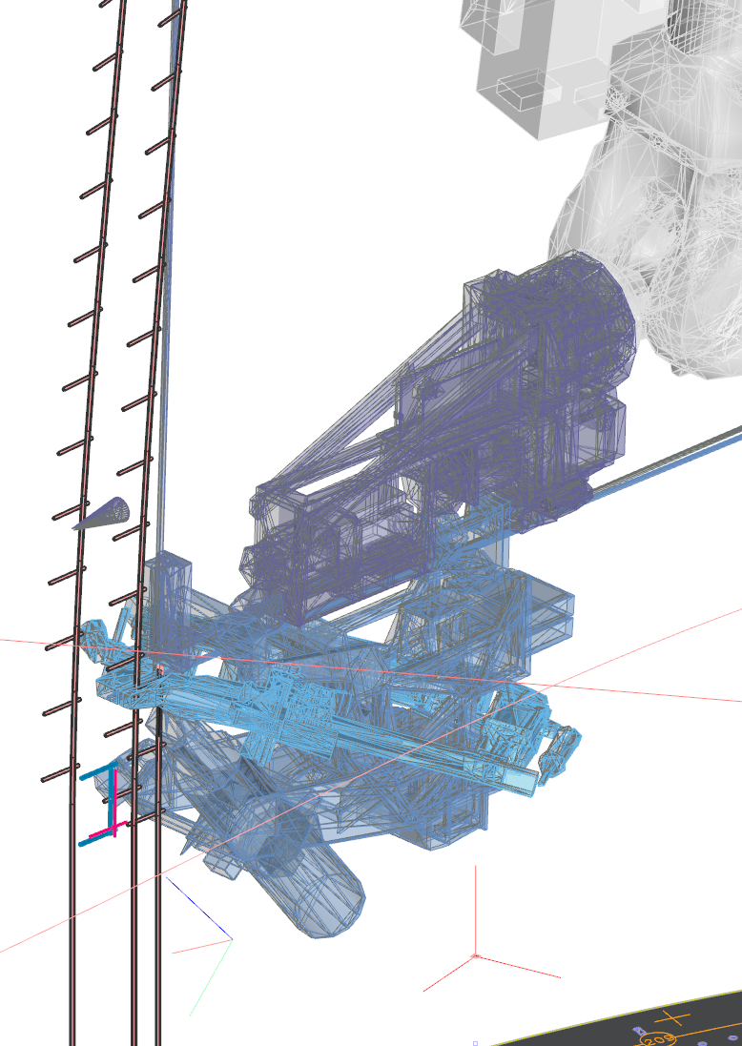 🡪

Since this **only a preview**, you need to set the node of the fabrication start with another button: 🡪 **start from task index**

Only this sets the node for the fabrication start and sets the preview of the red tool head on top of the blue tool head!

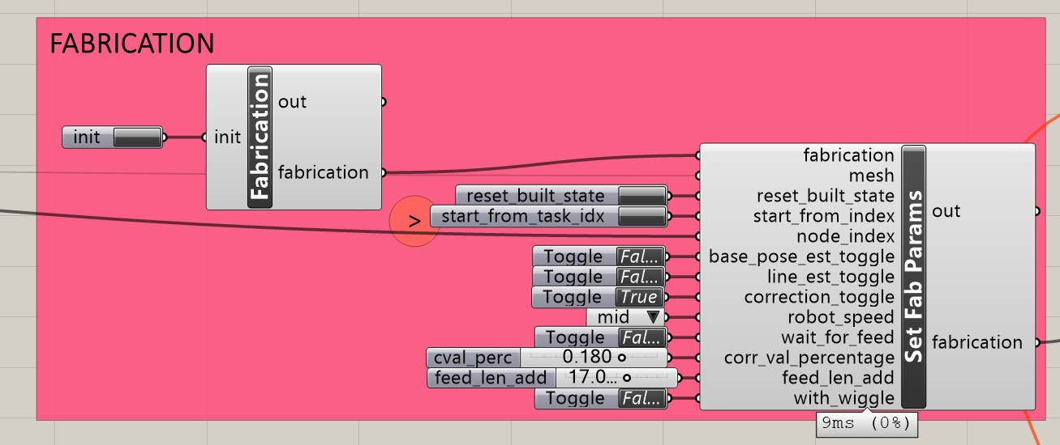

**C Connecting the clients**

Before starting the fabrication, you need to make sure that **all clients are connected.**

You have two possibilities to do that:

1. 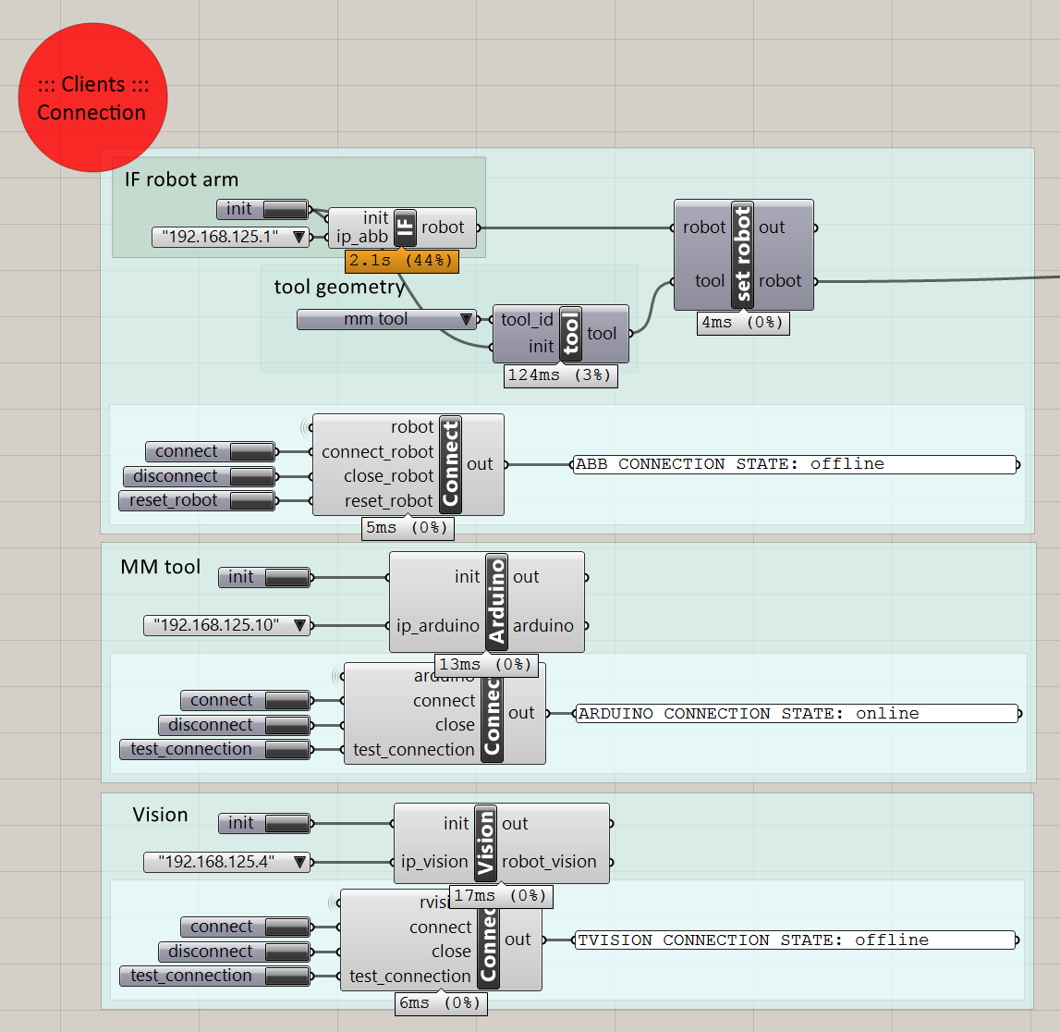

This is the interface to connect to all clients individually. (1. IF robot arm (= ABB Controller), 2. MM tool (= Arduino) 3. Vision (= IF on-board computer))

Once you press connect, you will see the print-out, which tells you which client is off- or online.

**Careful -->** all client servers must run, before you are able to connect to them.

1. 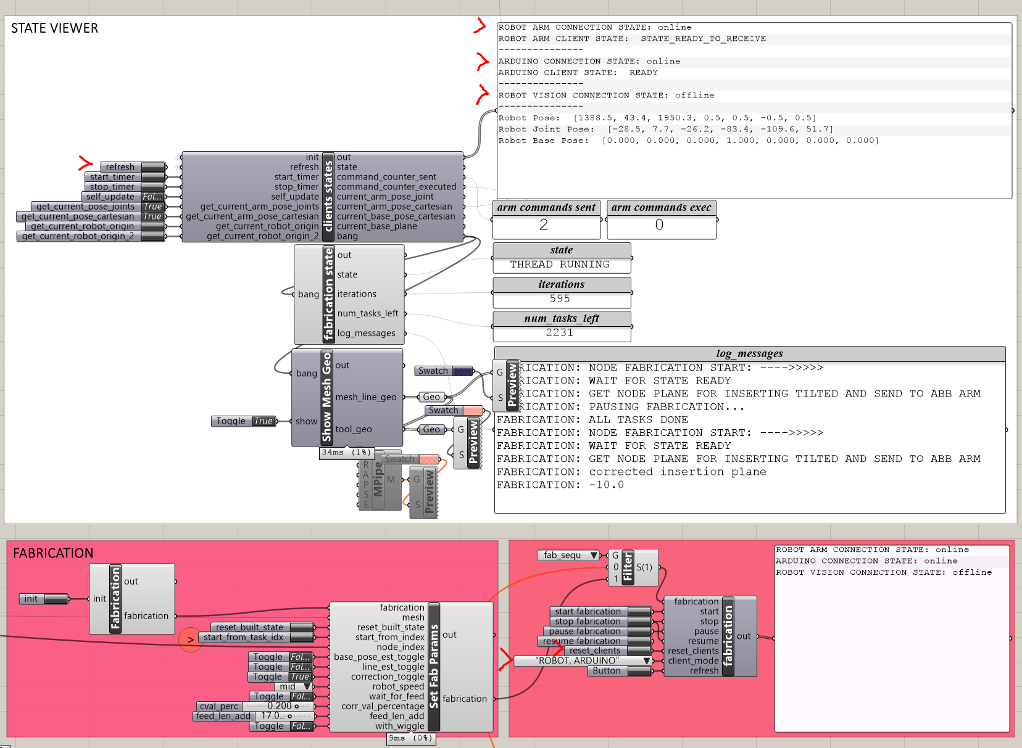

When you press refresh in the **state viewer**, the printout box at the top gives you feedback about the connection state of all clients, as well as the state of the fabrication. (Once you start the timer, it will always give you a live update, this uses a lot of processing power though.) For fabricating the mesh, the clients MM tool (Arduino) and **IF robot arm** need to be online, and the parameter **line_est_toggle** must be set to False, and **correction_toggle** must be set to True. For scanning the mesh, the clients **Vision** and **IF robot arm** need to be online, and the parameter **line_est_toggle** must be set to True, and **correction_toggle** must be set to False.

If you press **reset clients**, it resets the clients that you choose in the dropdown menu (E.g. “ROBOT”/”ARDUINO”). Usually, this button is used after you stopped the fabrication.

**D Starting the fabrication or scanning process**

Once the 🡪 **clients are online**, the 🡪 **right parameters are set**, and the 🡪 **correct node index for starting is set**, you can press **start fabrication**.

**E Stopping the fabrication or scanning process**

Usually, the fabrication or scanning process only needs to be stopped only at the end of the day, or when something went wrong. If the Arduino is in the middle of a routine, the button with the two lines (=) on the ABB handheld needs to be pressed, before the fabrication **stop button** can be pressed.

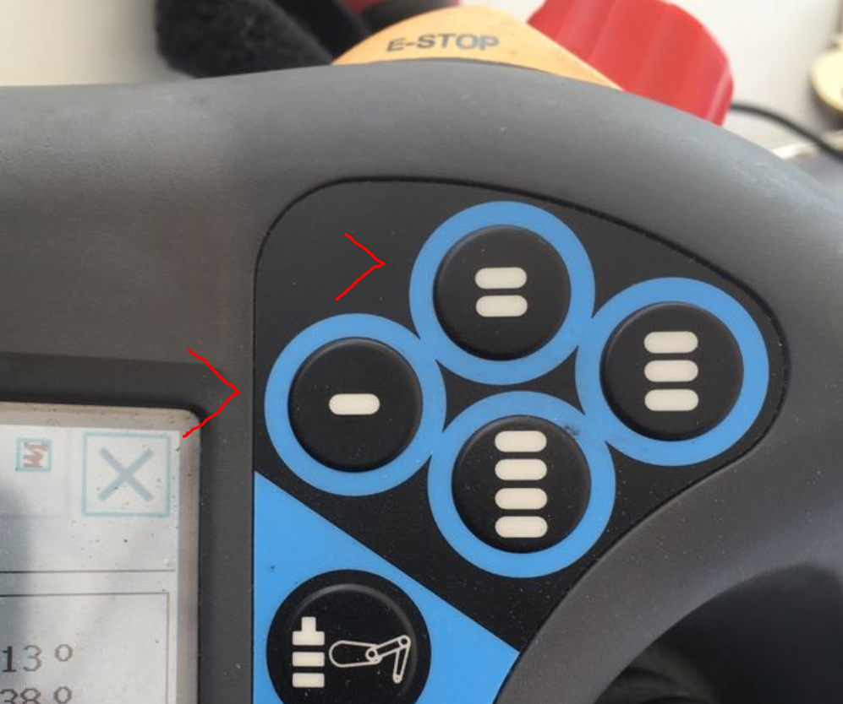

FYI: - “Arduino enable button”

= “Arduino stop button”

When Arduino is out of a routine, the stop button can be pressed. This also stops the connection to the clients. Therefore, before being able to start the fabrication again, the button **“reset clients”** needs to be pressed.

If you want to see the **printouts of the serial port of the Arduino client**, you can open the **serial monitor** from the **Arduino IDE**. **Careful 🡪** when the serial monitor is opened, the Arduino program restarts. Therefore, it is better to open it once before connecting, or the connection has to be reset after opening the serial monitor.

