**DELTA V3.0**

**User Guide**

**Contributors**

**P. Thunis, A. Pederzoli, E. Georgievia,**

**C. Cuvelier, D. Pernigotti**

**Joint Research Centre, Ispra**

Version 1

04 December 2012

Table of Contents

Concepts 3

1. Introduction 4

2. Basic principles 4

3. Overview 5

3.1. Exploration 6

3.2. Benchmarking 7

4. Model quality Objective and Performance criteria 7

4.1. Model quality Objective (MQO) 7

4.2. Performance criteria for Bias, R and SD 8

4.3. An expression for the measurement uncertainty 9

5. Benchmarking report 10

5.1. Hourly frequency 10

5.2. Yearly frequency 13

6. References 15

User’s Guide 16

1. Installation and running steps 17

2. Preparation of input files 17

2.1. Init.ini 18

2.2. Startup.ini 18

2.3. Observation file 20

2.3.1. Hourly Frequency 20

2.3.2. Yearly Frequency 21

2.4. Model file 22

2.4.1. Hourly Frequency 22

2.4.2. Yearly Frequency 25

2.5. Tuning DELTA to yearly output 25

3. Exploration mode 26

3.1. The data selection interface 26

3.2. The analysis interface 27

3.3. The main graphical interface 29

3.4. Top menu selections 31

4. Benchmarking mode 32

5. Distributed Dataset: Po-Valley 32

6. Utility program 32

6.1. Data-Check Integrity Tool 32

6.2. CSV to NetCDF 33

6.3. Preproc-CDF 33

Annexes 34

TEMPLATE: Diagram name (Elaboration name) 35

BARPLOT (Mean, Stddev, Exc. Days) 36

BARPLOT (Spatial Correlation) 37

BARPLOT (R, Mbias, RMSE, IOA, RDE, NMB, RPE, FAC2, NMSD) 38

SCATTER (Mean mod vs. mean obs) 39

SCATTER (One station/group – All time values) 40

TIME SERIES 41

TARGET (8H Max, Daily, Hourly) 42

SUMMARY REPORT (8H Max, Daily, Hourly) 43

MPC correlation (8H Max, Daily, Hourly) 44

MPC std. Dev. (8H Max, Daily, Hourly) 45

Taylor 46

Soccer - Meteo 47

Soccer- AQ (Daily, 8H max, Hourly) 48

Q-Q plot (One station/Group All values) 49

Dynamic evaluation (Day-Night) 50

Dynamic evaluation (Summer-Winter) 51

Dynamic evaluation (Weekdays – Weekends) 52

Google Earth (Mean, Exc. Days, Bias, NMB, Std. Dev, R, RMSE, RDE, σM/σO, NMSD) 53

Part I

# Concepts

## 

## Introduction

This document describes version 3.0 of the DELTA tool. This tool is an IDL-based evaluation software which includes the main assets of the EuroDelta, CityDelta, and POMI tools (Cuvelier et al. 2007; Thunis et al. 2007). It allows the user to perform rapid diagnostics of air quality and meteorological model performances. Although DELTA focuses on the air pollutants mentioned in the Air Quality Directive 2008 (AQD) it can be used for other variables as well. As it works on the comparison of time series at specific locations it addresses all relevant spatial scales (from local to regional). Some material about DELTA has been already presented in different documents:

**METHOD2012**: *Performance criteria to evaluate air quality modeling applications, P. Thunis, A. Pederzoli, D. Pernigotti. Atmospheric Environment, Volume 59, November 2012, Pages 476-482*

**UNCERT2012**: Set of 2 papers:

* *Model quality objectives based on measurement uncertainty: Part 1: Ozone, P. Thunis, D. Pernigotti and M. Gerboles, 2012, (document available on DELTA web site)*
* *Model quality objectives based on measurement uncertainty: Part II:PM10 and NO2. D. Pernigotti, P. Thunis, M. Gerboles and C. Belis, (document available on DELTA web site)*

**PROCBENCH***:* *A procedure for air quality models benchmarkin. 2011. P. Thunis, E. Georgieva, S. Galmarini (document available on DELTA web site)*

We will here recall the main concepts and details of the DELTA Tool, as well as the improvements made in version 3.0 with respect to previous versions.

## Basic principles

* DELTA works with modelled-observed data pairs at surface level, i.e. temporal series of modelled and monitored data at selected ground level locations (e.g. monitoring stations). In theory the software works therefore independently of model gridding and spatial scale. Of course the user must use an appropriate methodology to ensure comparability between grid-cell averaged model results and punctual measurements.
* A minimum data availability is required for statistics to be produced at a given station. Presently the requested percentage of available data over the selected period is 75% as defined in the AQD 2008. For other variables than discussed in the AQD the same percentage threshold applies.
* Although DELTA focuses mostly on the evaluation of single model results, it allows analysing multiple model results. This is intended to help in the comparison of the results from different model versions.
* The current statistical diagrams and indicators proposed in DELTA have been selected based on literature review (see PROCBENCH). Usage of composite diagrams (e.g. Taylor, Target,…) has been favoured.
* Model results are assessed (when possible) with respect to “performance criteria” which indicate the level of accuracy considered to be acceptable for regulatory applications (see METHOD2012 and UNCERT2012 for more details). These performance criteria are currently available for O3, NO2 and PM10.
* Both meteorological (scalars only) and air quality data can be handled by DELTA.
* Statistics for a single station are only produced in DELTA when data availability of paired modelled and observed data is at least of 75% for the time period considered. When time averaging operations are performed the same availability criteria of 75% applies. For example daily averages will be performed only if data for 18 hours are available. Similarly O3 daily maximum 8-hour means will be performed only when 6 hourly values are available.
* Benchmarking is included in the DELTA software to allow the production of model performance summary reports by the users (see Section 5). For this benchmarking DELTA focuses on the evaluation of modelling applications related to the AQD. Pollutants and temporal scales are therefore those relevant to the AQD, i.e. O3, PM10 and NO2 data covering an entire calendar year.

## Overview

The structure of the software is schematically presented in Figure 1. There are four main modules:

* *Input module* – refers to air quality and meteorological data, both from modelling and monitoring, prepared in a specific format. Instructions on how to prepare these input files are given in the User’s Guide (part II of this document);
* *Configuration module* - includes configuration files, which link the input to the desired statistical elaboration. One of these files is the *startup.ini* file (to be prepared by the user) which contains details on the monitoring stations and measured variables (see User’s Guide). Another important configuration file, embedded in the tool is the *performance and goal criteria* file which lists the performance criteria used in DELTA for the different species;
* *Analysis module* – is the core of the DELTA where different statistical indicators and diagrams are produced. This module can be operated in two modes – exploration and benchmarking (explained in sections 3.1 and 3.2, respectively)
* *Output module* – includes the results of the selected statistical elaborations (graphics or statistics values). For the benchmarking mode this output follows a predefined template, not modifiable by the user (see Section 5).

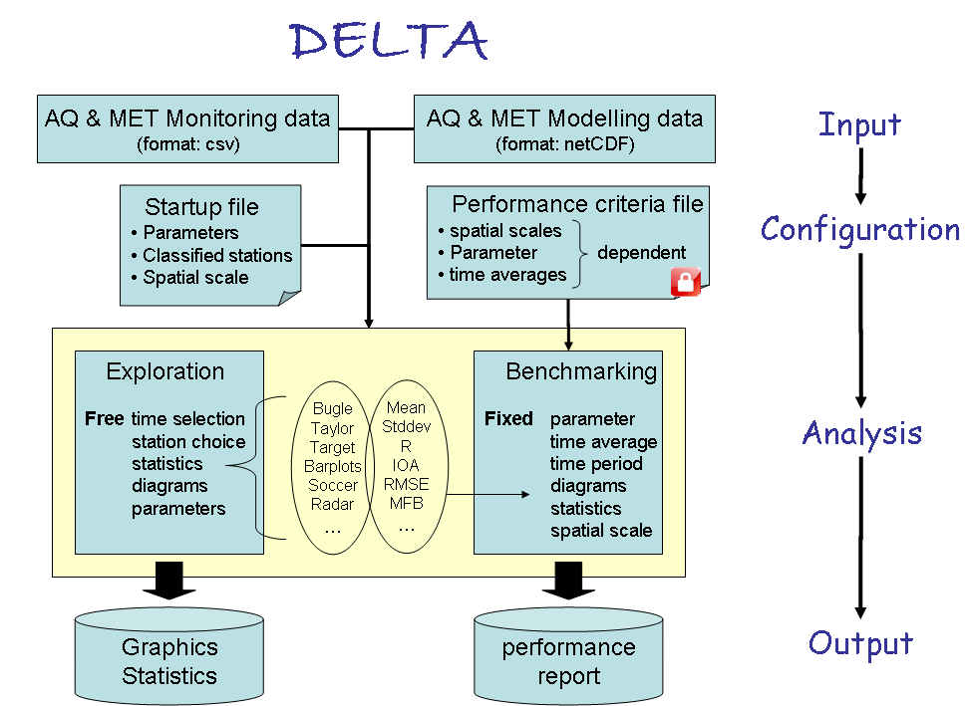

Figure . Structure of the DELTA software

Within the analysis two main modes exist: exploration and benchmarking mode. They are described in the next sections.



### Exploration

This mode allows the user to analyse different statistical metrics and diagrams, using various time intervals, various stations, various parameters (meteorological variables or pollutants) and different model versions. Different types of analysis can be performed:

* Temporal analysis can be performed with different options (running averages, daily min/max/mean, selection of seasons, week days/ week-end, and daylight/ night time hours.
* Spatial analysis can be performed in two ways: based on the classification of the monitoring stations in different geographical entities or by using the Google Earth option, a functionality which permits to visualise a statistical parameter at each station as a point on a 2D map
* Multidimensional analysis can be performed. Dimensions here refer to monitoring stations, models, scenarios and parameters. One or more element for each of those dimensions can be chosen and overlaid on a single diagram.

### Benchmarking

This mode allows to produce summary reports containing performance criteria and goals for different statistical indicators related to a given model application in the frame of the AQD. The reports are obtained through an automatic procedure and follow a pre-defined template structured around core indicators and diagrams (see Section 5). Some bounds for specific statistical indicators (performance criteria) are included, aiming to help in the assessment of the model performance.

Contrary to the exploration mode described above, freedom left to the user in benchmarking mode is minimal. DELTA then automatically produces the performance report.

The template for reporting model performances is application specific (assessment or planning). In the current prototype version only assessment templates are considered and have been prepared for O3, NO2 and PM10. In terms of diagrams and indicators, the template is independent of spatial scale and pollutant but performance criteria (see next Section) can be pollutant and/or scale specific. Note that specific templates are proposed for models delivering annual averages only.

## Model quality Objective and Performance criteria

The main statistical indicators referred to in the follow-up analysis are:

|  |  |
| --- | --- |
| *Normalised Mean Bias* |  |
| *RootMeanSquare Error* |  |
| *Correlation Coefficient* |  |
| *Centred Root Mean Square error* |  |
| *Normalised mean standard deviation* |  |



### Model quality Objective (MQO)

As described in METHOD2012 and UNCERT2012 the main quality indicator (MQO) used to test model results for a given application is defined as:

|  |  |  |
| --- | --- | --- |
|  |  |  |

Where RMSU is the quadratic mean of the expanded measurement uncertainty U. With this formulation for the MQO the error between observed and modelled values (numerator) is compared to the absolute measured uncertainty (denominator). Three cases can occur:

* + - 1. MQO≤0.5. In this case the RMSE between observed and modeled values is less than the observation uncertainty. Model results are in average within the range of the observation uncertainty for that station and it is meaningless to further improve model performances.
      2. 0.5<MQO≤1. In this case the RMSE between observed and modeled values is in average larger than the range of observation uncertainty but the model might still be a better predictor of the “true value” than observations.
      3. MQO>1. In this case model results are further away from the “true value” than observations.

This approach is flexible as it allows introducing more detailed information on observation uncertainty as they become available. Such an analysis is proposed in UNCERT2012 and is briefly summarized in Section 4.3 below). Note also that the MQO threshold remains always unity regardless of the pollutant or scale considered. Details on these interpretations are available in METHOD2012.

For annual average values, the MQO expressed in (1) reduces to



### Performance criteria for Bias, R and SD

As described in METHOD2012 the equation relating some statistical indicators among themselves:



can be used to derive performance criteria for 3 other indicators: R, NMB NMSD as follows:

|  |  |  |
| --- | --- | --- |
| **Indicator** | **Performance criteria** | **Reference** |
| Bias |  | (2) |
| Correlation |  | (3) |
| Standard deviation |  | (4) |

It is important to note that the performance criteria for R, NMB and NMSD represent necessary but not sufficient conditions to ensure that the MQO is fulfilled. They are used here to indicate which aspects of the modeling application need to be improved. Indicative values for these indicators as a function of geographic area or station type are provided in METHOD2012.

Since the performance criteria for R, NMSD and NMB are station and time dependent (through σO and the mean concentration), normalized criteria can also be defined from Equation (2), (3) and (4) as follows:

|  |  |  |
| --- | --- | --- |
| **Indicator** | **Performance criteria** | **Reference** |
| Bias |  | (5) |
| Correlation |  | (6) |
| Standard deviation |  | (7) |

One of the main advantages of this approach is to provide a selection of statistical indicators with a consistent set of performance criteria based on one single input: the observation uncertainty U. The main RMSE-based performance criteria (i.e. the MQO) provides a general overview of the model performances while the associated Performance criteria for correlation, standard deviation and Bias can be used to highlight which of the model performances aspects need to be improved.

### An expression for the measurement uncertainty

In equation (1) to (7) the quadratic mean of the uncertainty is used as main normalization factor. The derivation of RMSU in terms of known quantities (allowing a simple implementation and calculation in DELTA) is detailed in UNCERT2012 and only the final formulation is provided here:



Where:

* represents the estimated relative measurement uncertainty around the daily/hourly Limit Values (LV) of the AQD for a reference time averaging.
* α is the fraction of the uncertainty which is non-proportional to the concentration level around the Limit Value.
* k is the coverage factor. Each value of k gives a particular confidence level that the true value lays within the interval of confidence consisting in Oi ± U. Most commonly, the expanded uncertainty is scaled by using the coverage factor k = 2, to give a level of confidence of approximately 95 percents. Levels of confidence of 90% and 99% would lead to coverage factors around k=1.40 and k=2.6, respectively. More details are provided in METHOD2012 and UNCERT2012 regarding the link between the confidence levels associated to the measurements and model results on one hand and the confidence level associated to the modeled-to-measured differences as used in the MQO (see Eq. 1).
* Neff and Nnp are used for annual averages only and account for the compensation of errors due to random noise and other factors like periodic re-calibration of the instruments. For other than annual values, both Neff and Nnp are assigned values equal to unity.

The following values have been proposed for O3, NO2 and PM10 for hourly/daily values

|  |  |  |  |  |  |  |
| --- | --- | --- | --- | --- | --- | --- |
|  | k |  | LV (ug/m3) | α | Neff | Nnp |
| NO2 | 2 | 0.12 | 200 | 0.02 | 1 | 1 |
| O3 | 1.40 | 0.09 | 120 | 0.62 | 1 | 1 |
| PM10 | 2 | 0.105 | 50 | 0.01 | 1 | 1 |

These values can be used to produce the relative uncertainty curves for each compound (see figure below)

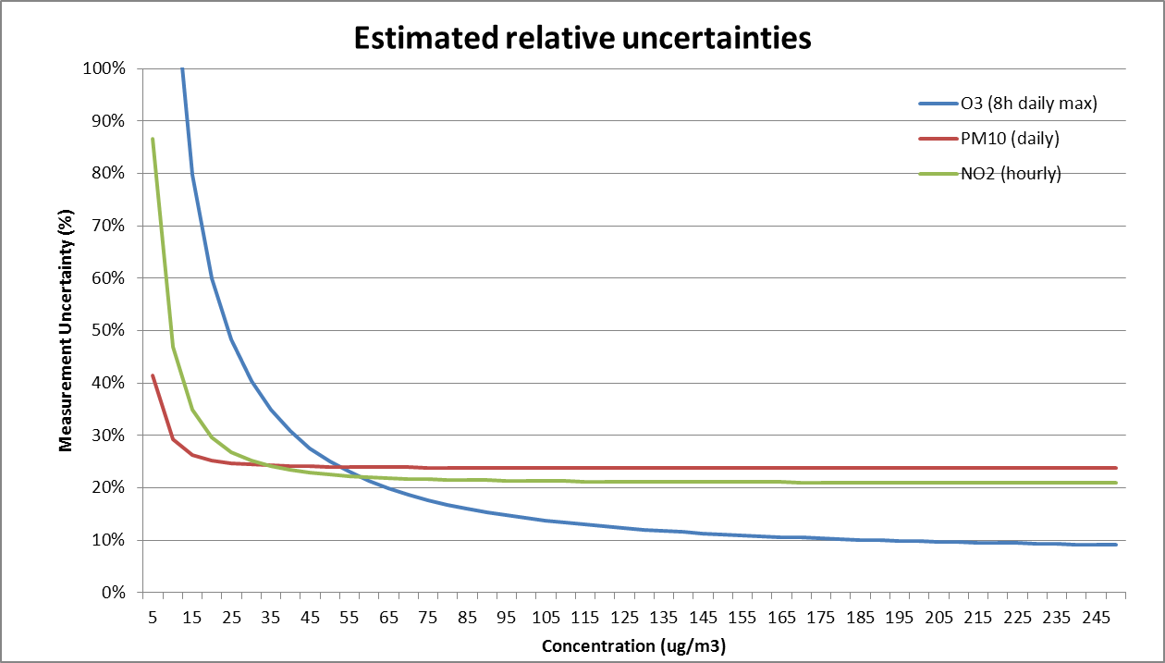

And for annual averages the following values have been set:

|  |  |  |  |
| --- | --- | --- | --- |
|  | Average | Neff | Nnp |
| NO2 | Yearly | 5.6 | 69 |
| O3 | 8h | 1 | 1 |
| PM10 | Yearly | 40 | 40 (?) |

Further notes:

* For all statistical indicators used in DELTA the approach to derive the maximum RDE in the AQD has been followed. This means that performance criteria must be fulfilled for at least 90% of the available stations.

* Performance criteria are mainly used in the benchmarking mode but are also available in exploration mode for some diagrams

## Benchmarking report

These reports are currently available for NO2, O3 and PM10. For O3 only the 8h daily maximum frequency report is available.



### Hourly frequency

#### *Target Diagram (Fig2 Upper diagram)*

MQO as described by Equation (1) is used as main indicator. In the normalised Target diagram, it represents the distance between the origin and a given station point. As mentioned above the performance criterion for the target indicator is set to unity regardless of spatial scale and pollutant and it is expected to be fulfilled by at least 90% of the available stations.

The percentage of stations fulfilling the target criterion is indicated in the upper left corner and is meant to be used as the main indicator in the benchmarking procedure. As mentioned above, values higher than 90% must be reached. In addition to the information mentioned above the proposed Target diagram also provides the following information:

* A distinction between stations according to whether their error is dominated by bias (either negative or positive), by correlation or standard deviation.
* Identification of performances for single stations or group of stations (e.g. different geographical regions in this example) by the use of symbols and colours.

More details on this adapted Target diagram can be found in METHOD2012.

#### *Summary Report (Fig.2 Lower diagram)*

The summary statistics table provides information on model performances. It is meant as a complementary source of information to the MQO (upper diagram) to identify model strengths and weaknesses. It is structured as follows:

* ROWS 1-2 provide the measured observed means and number of exceedances for the selected stations.
* ROWS 3-5 provide an overview of the temporal statistics for bias, correlation and standard deviation. Each point represents a specific station. Values for these three parameters are estimated by equation (5), (6) and (7) respectively. The green shaded area represents criteria fulfilment.
* ROWS 6-7 provide an overview of spatial statistics for correlation and standard deviation. Average values over the selected time period are first calculated for each station and these values are then used to compute the spatial correlation and standard deviation. Criteria (6) and (7) are used for this purpose.
* ROW 8 provides the RDE estimate for comparison with the previously used MQO. Values below the AQD 2008 threshold for this indicator are requested.

The second column provide information on the number of stations fulfilling the performance criteria, Green for above 90% of the stations, orange between 75 and 90% and red below 75%. Note that for indicators reaching values beyond the proposed scale, the symbol representing the station will be plotted in the middle of the dashed zone on the right/left side of the proposed scale

|  |
| --- |
|  |
|  |

Figure : Example of benchmarking performance summary report (here daily average PM10 concentration).

### Yearly frequency

#### *Scatter Diagram (Fig.3 Upper diagram)*

The MQO described in Section 4.1 for yearly averaged results (i.e. based on the bias) is used as main indicator. In the scatter plot, it is used to represent the distance from the 1:1 line. As mentioned above the performance criterion for the indicator is set to unity regardless of spatial scale and pollutant and it is expected to be fulfilled by at least 90% of the available stations.

The Scatter diagram also provides information on performances for single stations or group of stations (e.g. different geographical regions in this example below) by the use of symbols and colours.

More details on the scatter diagram and possible options can be found in METHOD2012.

#### *Summary Report* *(Fig.3 Lower diagram)*

The summary statistics table provides information on model performances. It is meant as a complementary source of information to the bias-based MQO to identify model strengths and weaknesses. It is structured as follows:

* ROWS 1-2 provide the measured observed means and number of exceedances for the selected stations.
* ROWS 3-4 provide an overview of spatial statistics for correlation and standard deviation. Annual values are used to calculate the spatial correlation and standard deviation. Criteria (6) and (7) are here used
* ROW 8 provides the RDE estimate. Values below the AQD2008 threshold for this indicator are requested.

The second column provide information on the number of stations fulfilling the performance criteria, Green for above 90% of the stations, orange between 75 and 90% and red below 75%. For indicators reaching values beyond the proposed scale, the symbol representing the station will be plotted in the middle of the dashed zone on the right/left side of the proposed scale

|  |
| --- |
|  |
|  |

Figure 3: Example of benchmarking performance summary report (here yearly average NO2 concentration).

## References

Cuvelier C., P. Thunis, R. Vautard, M. Amann, B. Bessagnet, M. Bedogni, R. Berkowicz, J. Brandt, F. Brocheton, P. Builtjes, C. Carnavale, A. Coppalle, B. Denby, J. Douros, A. Graf, O. Hellmuth, A. Hodzic, C. Honoré, J. Jonson, A. Kerschbaumer, et al., 2007: CityDelta: A model intercomparison study to explore the impact of emission reductions in European cities in 2010. Atmospheric Environment, Volume 41, Issue 1, Pages 189-207

Thunis P., L. Rouil, C. Cuvelier, R. Stern, A. Kerschbaumer, B. Bessagnet, M. Schaap, P. Builtjes, L. Tarrason, J. Douros, N. Moussiopoulos, G. Pirovano, M. Bedogni, 2007, Analysis of model responses to emission-reduction scenarios within the CityDelta project, Atmospheric Environment, Volume 41, Issue 1, January 2007, Pages 208-220

Thunis P., E. Georgieva, S. Galmarini, 2010: A procedure for air quality models benchmarking. (<http://fairmode.ew.eea.europa.eu/fol568175/work-groups>)

P. Thunis, A. Pederzoli, D. Pernigotti, 2010: Performance criteria to evaluate air quality modeling applications, Atmospheric Environment, Volume 59, November 2012, Pages 476-482

Thunis P., D. Pernigotti and M. Gerboles Model quality objectives based on measurement uncertainty: Part 1: Ozone. 2012 (document available on DELTA web site)

Pernigotti D., P. Thunis, M. Gerboles and C. Belis.2012. Model quality objectives based on measurement uncertainty: Part II:PM10 and NO2. (document available on DELTA web site)

Part II

# User’s Guide

## Installation and running steps

The current version (3.0) of the Delta tool was installed and developed under a Windows environment. The next steps refer to the installation on a Windows XP machine.

**Installation steps**

* Go to the IDL Web site

[http://www.exelisvis.com/language/en-us/productsservices/idl.aspx](http://www.exelisvis.com/language/en-us/productsservices/idl.aspx%20)  and register as a new user (or login as an old user). If you register as a new user, you will receive an email with a link to activate your account (this can take 24 hours).

* Go to ‘Downloads’ – ‘Product Downloads’, and select: IDL, Windows, Product Download. Click on the version for your operating system (32 bits, or 64 bits).
* Click on the purpose of your download, and your agreement with the laws.
* Click on ‘IDL 8.2 – Microsoft Windows …’ to start the download. Both IDL and IDL-VM will be downloaded (but you do not need any license to run IDL-VM).
* Install "IDL-VM" (i.e. run "idl82_winXX_setup.exe"). Set the installation directory for example as C:\ITT. At the end of the installation you do NOT have to run the license application (“No”).
* Right-click on the IDL8.2-VM icon – go to properties and set the ‘Start in’ to the location of your idl *.sav files (i.e. the IDL executables).
* Follow next steps instructions on the DELTA home page (<http://aqm.ies.jrc.it/DELTA/>) under the “Download” section

**Running steps**

* Run IDL VM (double-click icon).
* In the window browse and select appropriate ".sav”.
* Since the program has to read-in the data, it will take some time before it pops up.

## Preparation of input files

In order to run the tool, the following files have to be prepared by the user

* Two configuration files: <startup.ini> and <init.ini>. The same configuration files can be used for several models and years. The two files should be placed in folder ...\resource.
* Files with observed data (one file for each monitoring station). These files should be in .csv format and be placed in folder ...\data\monitoring
* Files with modeled data at the locations of the stations (one file per model and scenario). Such files should be in .cdf format (except for yearly averaged output where the choice exists between csv and cdf formats), and there should be one file for each model and year. Each .cdf file may contain model results for several locations (stations). The .cdf files should be placed in folder ...\data\modeling. There is a utility to create such cdf files from csv files (see Section 6.2).

### Init.ini

The resource folder contains an ASCII file named init.ini where specific software (WORD, ADOBE...) location information should be provided. The user should modify the paths according to his personal installation settings. The right hand side of the following lines (end of the *init.ini* file) should be adapted:

BROWSER_LOCATION=C:\Program Files\Mozilla Firefox\firefox.exe

WORKSHEET_LOCATION=C:\Program Files\Microsoft Office\OFFICE11\EXCEL.EXE

DOCUMENTSREADER_LOCATION=C:\Program Files\Microsoft Office\OFFICE11\WINWORD.EXE

NOTEPAD_LOCATION=notepad.exe

PDFREADER_LOCATION=C:\Program Files\Adobe\Acrobat 7.0\Acrobat\Acrobat.exe

GOOGLEEARTH_LOCATION=C:\Program Files\Google\Google Earth\client\googleearth.exe

### Startup.ini

The configuration file (startup.ini) is common to both inputs with hourly and yearly frequencies. The file is in ASCII format and contains some general information about the spatial scale, the parameters selected for evaluation and the characteristics of the monitoring stations. The file has three main sections:

* MODEL – includes information about the year, spatial scale and input frequency.
* PARAMETERS - includes variable names and measurement units
* MONITORING – includes list of all stations with their siting characteristics and parameters measured.

**Example:**

[MODEL]

2009;

hour;

Local;

[PARAMETERS]

;Species*type*measure unit

SO2;POL;gm-3

NO2;POL; gm-3

PM25;POL; gm-3

PM10;POL; gm-3

WS;MET; msec-1

WD;MET;degree

TEMP;MET; ˚C

[MONITORING]

Stat_Code;Stat_Name;Stat_Abbreviation;Altitude;Lon;Lat;GMTlag;Region;Stat_Type;Area_Type;Siting; listOfvariables

IT00000;station_0;STAT0;681.;8.931;44.31;GMT+1;Lombardia;Background;Urban;Plane;TEMP*PM10*O3;

IT00001;station_1;STAT1;962.;10.03;44.97;GMT+1;Veneto;Traffic;SubUrban;Hilly;TEMP*O3;

IT00002;station_2;STAT2;851.;11.34;44.18;GMT+1;Piemonte;traffic;urban;Mountain;WS*PM10*O3*SO2;

IT00003;station_3;STAT3;806.;7.597;46.02;GMT+1;Emilia-Romagna;Industrial;Rural;Valley;WS;

IT00004;station_4;STAT4;769.;8.222;44.29;GMT+1;Lombardia;Background;Urban;Plane;TEMP*O3;

IT00005;station_5;STAT5;163.;9.193;45.85;GMT+1;Friuli Venezia Giulia;Unknown;Unknown;Coastal;PM10;

...

<EOF>

**Description:**

[MODEL] section:

* *Year*: year of interest (for bissextile years only first 8760 data are considered)
* *Frequency*: Either hour or year. This parameter should be set to “hour” for models delivering outputs with an hourly or daily frequency and set to “year’ for models delivering outputs as annual averages (see User’s Guide Section 2.5).
* *scale*: Either local (traffic), urban or regional. Not used currently

[PARAMETERS] section:

* *Species*: name of the variable
* *Type*: “POL” and “MET” indicate air quality and meteorological variables respectively. Other categories can be defined by the user at his convenience.
* M*easure units*: the units MUST be μgm-3 for concentrations. For the other variables, see the units at the beginning of the section.

Notes:

* Each row contains the name of a parameter [measurement unit], available in his dataset.
* Parameter names and units are obligatory (since they are used in the benchmarking procedure): O3 [μgm-3], NO2 [μgm-3], PM10 [μgm-3], WS [ms-1], WD [deg] (wind speed and wind direction), TEMP [degC] - temperature, SH [g/kg] (specific humidity)

[MONITORING] section

The first row contains the labels. Each subsequent row refers to a given station, where:

* *Stat_Code*: national identification of the station e.g. AT0001ST, or VEN00356, or user’s assigned code (e.g. STAT001)
* *Stat_Name*: combination of letters and/or numbers ; only the symbol “_” is allowed blanks and special characters are not allowed
* *Stat_Abbreviation*: station name abbreviation (4 letters). The abbreviation will be the one identifying the station on the DELTA output graphs and statistics
* *Altitude*: height above sea level (in meters)
* *Lon, Lat*: Longitude and Latitude (in decimal degrees)
* *GMTlag*: Time zone
* Region: Name of the administrative region to which the station belongs. In alternative – a user defined region (Naming rules similar to “Stat_Name”)
* *Stat_Type*: background, traffic, industrial
* *Area_Type*: urban, suburban, rural
* *Siting*: Categories are proposed: mountain, hilly, plane, valley or coastal. They will be used eventually to group stations and calculate average statistics for each group; If other categories suit better user’s stations, they can be defined here.
* *listOfvariables*..: The variables measured at each station , (PM10, O3, WS etc). The variables are separated by an asterisk.

Notes:

* It is left to the user to assign appropriate fields to classify stations. In our example, REGION, STAT_type, Area_Type and Siting are selected but other choices could have been made. These choices will configure the widget menus to help with the selection of stations according to the chosen fields.
* There are a few modifications between the version 2.0 and 3.0 of the startup.ini. However the user can use its version 2.0 of the file with DELTA version 3.0. The startup file will update automatically and three new lines will be inserted.

Particular requirements**:**

* Each blank row or each line beginning with "[", ";" or "#" will be discarded
* No blanks between fields are permitted
* Line breaks are not allowed.
* The three section markers: “MODEL”, “[PARAMETERS]” and “[MONITORING]” are compulsory,
* Station codes must be univocal
* The station names should not include blanks and special characters such as “.”,” ’ ”, “;”
* Only the symbol “_” is allowed.
* Variables must be separated by an asterisk.
* The station names must be EXACTLY the same used in the observation data files and modeled data files.

### Observation file

### Hourly Frequency

Monitoring stations to be used with the tool may have either air quality data, either meteorological data or both.

***Files names and type:***

* Each station must have an associated file (‘csv’ type) containing the data, e.g. <**station_1.csv>**
* The file names should be consistent with the naming rules used in the configuration file <startup.ini>

***Files location:***

….\data\monitoring

***Files structure:***

The first row must contain the labels of the columns: year (4 digits), month (1-12), hour (0-23) and the names of the observed parameters at each station. Following lines should include the observed values on an hourly basis (8760 rows if entire year is available). If for a given hour data are missing for all parameters, the line can be omitted. Data are recognized by their associated date and time.

**Example: filename <station_1.csv>**

year;month;day;hour;O3;PM10;WS;WD;TEMP;

2005;1;1;0;40.1;55.4;0.75;310;15.6;

2005;1;1;1; 40.1;55.4;0.75;310;15.6;

2005;1;1;2; 40.1;55.4;0.75;310;15.6;

…

2005;12;31;23; 40.1;55.4;0.75;310;15.6;

<EOF>

**Particular requirements:**

* The station names used in startup.ini must be used for each one of these files.
* For non-annual average values each file must contain observation values on an hourly basis. For bissextile years, the december 31th values will be omitted.
* Data will be read by dates. Missing dates (i.e. lines) will automatically be treated by DELTA as -999.
* If data are monitored on a daily basis (e.g PM10), please put the daily value at all hours from 0 to 23 for this day.
* If both air quality and meteorological measurements are available for the same site, the data must be included in the same file (as in the example above)
* Each blank row or beginning with "[", ";" or "#" "#" will be discarded
* No spaces are permitted between the fields.
* Line breaks are not allowed.

### Yearly Frequency

***Files names and type:***

* Each station must have an associated file (‘csv’ type) containing the data, e.g. <**station_1.csv>**
* The file names should be consistent with the naming rules used in the configuration file <startup.ini> (see Section **Error! Reference source not found.**).

***Files location:***

….\data\monitoring

***Files structure:***

The first row must start with the label “YearlyAvg” to indicate that yearly averaged results are used. Should follow the year (4 digits) and species of interest. All fieds should be separated by the “;” symbol. Row 2 should contain the numeric observed values for the parameters mentioned in row 1.

**Example: filename <station_1.csv>**

YearlyAvg;2009;PM10;NO2;WS

; parameter1;parameter2;parameter3

55.1;15.6; 2.1

<EOF>

**Particular requirements:**

* The station names used in startup.ini must be used for each one of these files.
* If data are missing the gaps should be filled by -999.
* If both air quality and meteorological measurements are available for the same site, the data must be included in the same file (as in the example above)
* Each blank row or beginning with "[", ";" or "#" "#" will be discarded
* No spaces are permitted between the fields.
* Line breaks are not allowed.

### Model file

### Hourly Frequency

Modeled data can be prepared in one of the following formats:

* netcdf (option 1) format (one single file for a given model and time period with separate ncdf-variables for each station and species)
* netcdf (option 2) format (one single file for a given model and time period with separate ncdf-variables for each station)
* csv format (similar to the one described for the observations) (an IDL processor is provided on the web site to convert them in netcdf format)

**Description of the netcdf (option 1) format**

* One single netcdf file should be provided for a given model. It must contain a time profile for each station and variable listed in <startup.ini >.
* The names of the parameters should be the same as in the configuration file <startup.ini>.

***Files location:*** ….\data\modeling

***Files structure:***

Each data block inside the netCDF file should be named as “Stat_name_Parameter” (see examples below) where “Stat_name” is the name of the station corresponding to the one set in the <startup.ini >, and “Parameter” refers to the modeled pollutants and meteorological variables, as indicated in the <startup.ini >

Each data block should contain either (a) 1 year of hourly data for each station and parameter (1dimensional array with 8760 hourly data). Or (b) a specific time period smaller than the entire year. In the latter case an additional attribute should be included in the netCDF file to set the initial starting time (in hours) as follows (global attributes: StartHour = 1320 indicating that the period of interest starts at hour=1320). Within the specific time period data should be continuous, i.e. include missing values as “-999”.

Modelled data at a given station may contain either air quality fields, meteorological fields or both.

**Example: <2008_WRFCHIM_TIME.cdf>**

netcdf 2008_WRFCHIM_TIME.cdf {

dimensions:

T = 8760 ;

variables:

float station_0_CO2(T);

float station_1_NO2(T);

float station_1_WS(T);

float station_1_WD(T);

float station_2_CO2(T);

float station_2_NO2(T);

float station_2_WS(T);

float station_2_WD(T);

}

**Example: <2008_WRFCHIM_TIME.cdf> with time period less than entire year**

netcdf 2008_WRFCHIM_TIME.cdf {

dimensions:

T = 8760 ;

global attributes:

StartHour = 1320s ;

variables:

float station_0_CO2(T);

float station_1_NO2(T);

float station_1_WS(T);

float station_1_WD(T);

float station_2_CO2(T);

float station_2_NO2(T);

float station_2_WS(T);

float station_2_WD(T);

}

**Particular requirements:**

* If a parameter is entirely missing (i.e not provided by the model) for a station, but the same parameter is present in the monitoring dataset for the same station, the user must include that parameter in the *.netcdf file as a hourly series of “-999”.

**Description of the netcdf (option 2) format**

* One single netcdf file should be provided for a given model. It must contain a time profiles for each station listed in <startup.ini >.

* All parameters within a given variable (e.g. NO2, PM10...) should be listed in a systematic order defined in a global attribute
* The names of the parameters should be the same as in the configuration file <startup.ini> (see Section **Error! Reference source not found.**).

***Files location:***

….\data\modeling

***Files structure:***

Each data block inside the netCDF file should be named as “Stat_name_Parameter” (see examples below) where “Stat_name” is the name of the station corresponding to the one set in the <startup.ini >

Each data block should contain either (a) 1 year of hourly data for each station and parameter (1dimensional array with 8760 hourly data). Or (b) a specific time period smaller than the entire year. In the latter case an additional attribute should be included in the netCDF file to set the initial starting time (in hours) as follows (global attributes: StartHour = 1320 indicating that the period of interest starts at hour=1320). Within the specific time period data should be continuous, i.e. include missing values as “-999”.

Modelled data at a given station may contain either air quality fields, meteorological fields or both.

**Example: <2008_CHIM_TIME.cdf>**

netcdf 2008_CHIM_TIME.cdf {

dimensions:

V = 3 ;

T = 8760 ;

variables:

float station_0 (T,V);

float station_1 (T,V);

float station_2 (T,V);

// global attributes :

: Parameters = 78b, 79b, 50b, 32b, 80b, 77b, 49b, 48b, 32b, 79b, 51b ;

}

Here ‘78b, 79b, 50b, 32b, 80b, 77b, 49b, 48b, 32b, 79b, 51b’ is the byte format of ‘NO2 PM10 O3’.

**Example: <2008_CHIM_TIME.cdf> with given time period (less than entire year)**

netcdf 2008_CHIM_TIME.cdf {

dimensions:

V = 3 ;

T = 8760 ;

global attributes:

StartHour = 1320s ;

variables:

float station_0 (T,V);

float station_1 (T,V);

float station_2 (T,V);

// global attributes :

: Parameters = 78b, 79b, 50b, 32b, 80b, 77b, 49b, 48b, 32b, 79b, 51b ;

}

Here ‘78b, 79b, 50b, 32b, 80b, 77b, 49b, 48b, 32b, 79b, 51b’ is the byte format of ‘NO2 PM10 O3’.

**Particular requirements:**

If a parameter is entirely missing (i.e not provided by the model) for a station, but the same parameter is present in the monitoring dataset for the same station, the user must include that parameter in the *.netcdf file as a hourly series of “-999”.

### Yearly Frequency

Modeled data should be prepared in ASCII (*csv)* format. One single file should be provided for a given model. It must contain annual average values for each station listed in <startup.ini >.

***File name:*** <YEAR_MODELNAME_TIME.csv>

***Files location:*** .\data\modeling

***Files structure:***

YearlyAvg;2009;O3;PM10...

;Station;ValueParam1;ValueParam2...

Illmitz;40.3;45.34

Pillers;78;54.54

...

### Tuning DELTA to yearly output

By default the input files are configured for hourly frequency models but for models delivering annual averages it is possible to tune all configuration files to keep only relevant diagrams and elaborations within the selection menus (e.g. all diagrams using correlation will be discarded).For doing this, go in your startup.ini file and set the frequency parameter to “year”.

## Exploration mode

For calculating a given statistical indicator and visualize it by a diagram the user has first to make selections in two interface windows – “data selection” and “analysis window” (activated through the starting window, see Section 3.3). The data selection and analysis interfaces are described in sections 3.1 and 3.2 respectively. Finally the main DELTA graphical interface, result of options previously selected by the user in the other interfaces, is described in section 3.3.

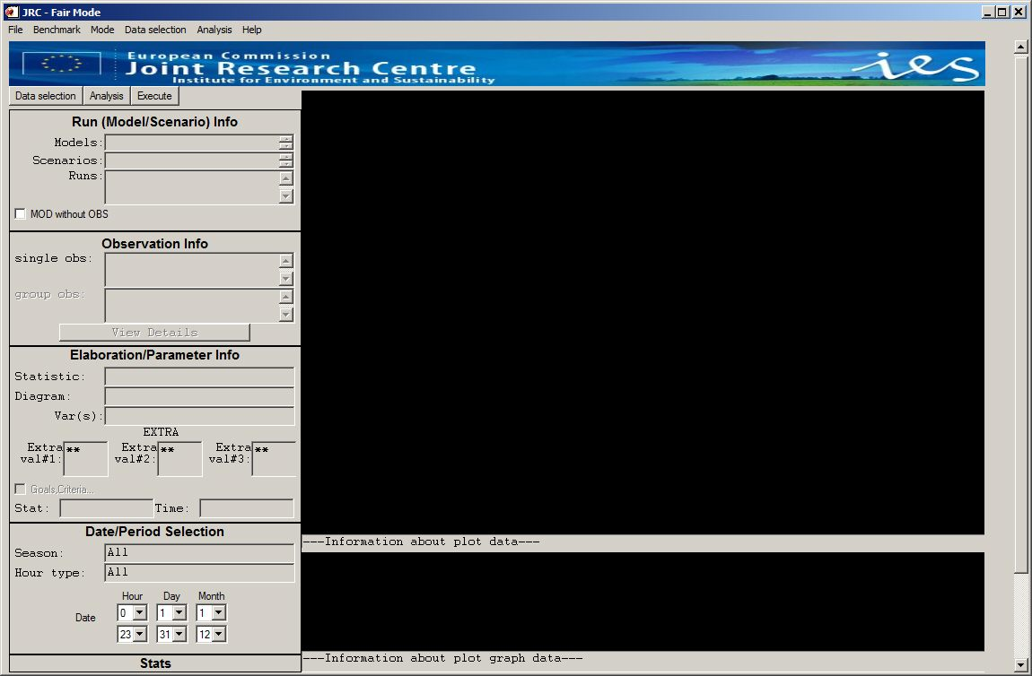

Figure The DELTA main interface (starting window)

### The data selection interface

A selection has to be made by the user in terms of

* a model/scenario (year) binome
* a parameter (e.g. NO2)
* a monitoring station

An example is given in Figure 4. Some filters are available to facilitate the selection of the appropriate monitoring stations in terms of regions, types. These filters are defined in the configuration file <startup.ini>, where the user can make the station classification categories case specific.

Note: When a user selects a parameter (e.g. O3) in the "data selection" window, all stations measuring that parameter automatically appear in the "available" section. The user can then make his selection among these available stations and add them in the “selected” section. At this stage the user can still change his mind and select another parameter (e.g. PM10). The list of selected stations will be updated after warning the user.

The user has also the possibility to save the choices made on this window and to reload them at a later time. This modality can be useful to avoid repeating frequently used selections. In order to save the selections in the data selection window, choose “save data” from the top “data selection” pop up menu. A new window appears with the request to put a file name. File extension must be *.ent. By default the file is saved in the dir…. \save.To reload the saved selections, -choose “load data” from the top “data selection” pop up menu.

A set of stations can either be treated as a number of single entities or as a group. In the case of groups the user will be asked to select between “mean” and “90% percentile”options. In the first case the mean of the stations statistical indicators will be represented as a single number on the diagram whereas in the second option the worst statistical indicator among 90% of the available stations (rejecting 10%) is selected. This latter choice is used with diagrams in which performance criteria are present and indicate whether this criteria is fulfilled for the selected group of stations.

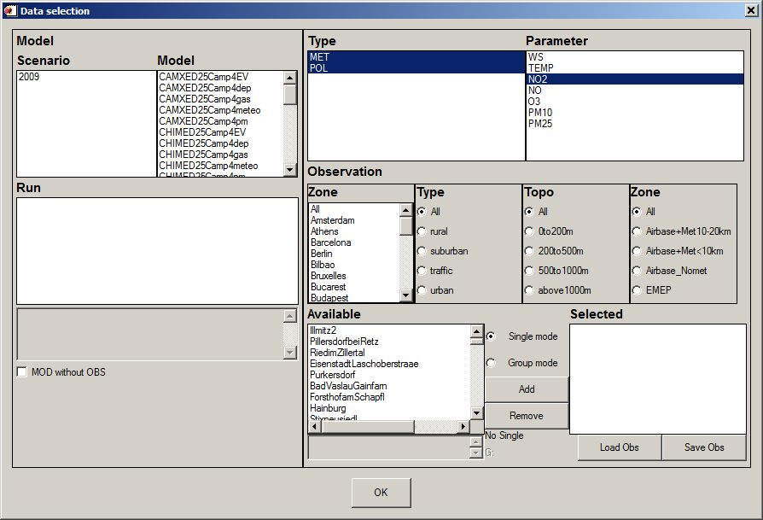

Figure : DELTA data selection interface. Example of EC4 macs stations from the EuroDelta modeling exercise

### The analysis interface

The analysis interface (Figure 5) allows the user to select the type of statistics and diagram, as well as the desired temporal operations to be performed on the original data (“group by Time” and “Daily Stat”). Available diagrams are described in the Annexes Section (Part III).

Each of these plot types can be selected to illustrate different statistical metrics (statistics column). This is especially true for the barplots which is the common way to visualise single statistical metrics (Mean, RMSE, bias, IOA, Exceedance days...). Some of these statistics require threshold values which can be included (e.g. SOMO, exceedance days…) on the same window.

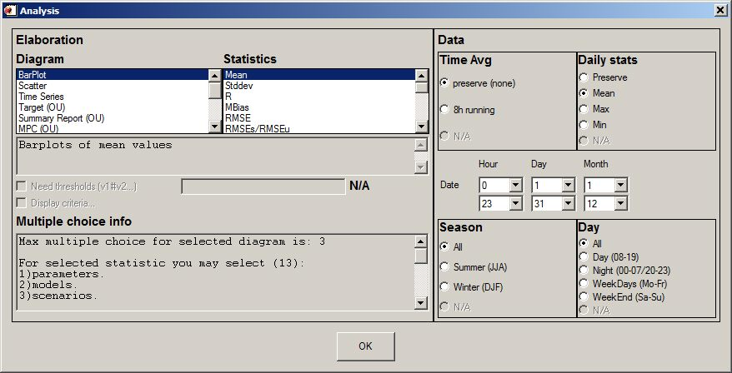

Figure : DELTA analysis selection interface

The lower left part of the analysis selection interface (“multiple choices info”) gives information on the different possibilities offered to the user in terms of combination of parameters, stations, and models to generate the diagram. These possibilities give the degree of freedom in selecting items of the four main entities: scenario (year); model; parameter; monitoring stations. The allowed multiple choices for a given diagram are pre-defined in the tool and are described in the Annex.

On the right side of the analysis selection interface, time operations can be chosen to be performed on the selected modelled-observed data pairs, i.e.:

* **Time Avg**.: Time series kept as originally formatted (1h) or 8h running average
* **Daily Stats**: Statistical operation applied for each day: mean, max or min.
* **Season**: choice between summer, winter and entire year
* **Day**: Selection between night time hours, daylight hours, entire 24h day, week-ends and week days.

Note that for some statistics and pollutant choices, these flags will be automatically filled to the adequate values.

Similarly to the data selection interface the user has also the possibility to save the choices made on this window and to reload them at a later time. This modality can be useful to avoid repeating frequently used selections. In order to save the selections in the analysis window, choose “save analysis” from the top “analysis” pop up menu. A new window appears with the request to put a file name. File extension must be *.elb. By default the file is saved in the dir…. \save.To reload the saved selections, -choose “load analysis” from the top “analysis” pop up menu.

### The main graphical interface

The screen is divided into two main areas:

* The left side memorises the choices made by the user in the previous interfaces which lead to the generation of a given diagram.
* The right side hosts the diagram and accompanying legend (which also summarizes the options selected by the user). Only one diagram is shown at a time (i.e. no multiple windows).

Notes

* For most graphics an additional window will appear allowing the user to drag the mouse on the diagram and retrieve information about the quantitative values of the different points/stations represented on the diagram. This mouse recognize functionality can be set in “on/off” mode under the main menu “mode” with the inactivated Hide/Show Recognize sub-menu voice.
* For most graphics, a “dump” file will be generated containing all diagram values. This file is named “DumpFile.dat” and can be visualized in the “dump” sub-directory. An additional file can be created when the summary reports are performed. This file contains the main statistical indicators for the selected stations. It is found in the same sub-directory and is named according to the choices made by the user (species + model name).

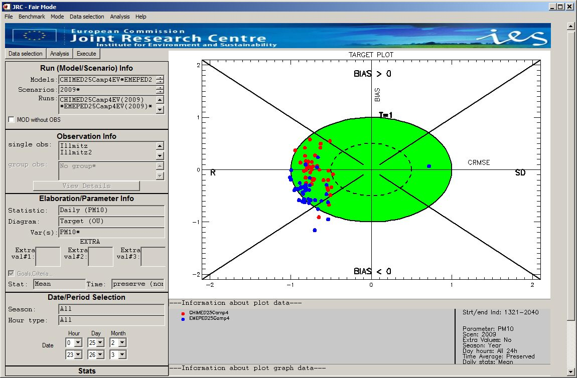

Figure : DELTA main graphical window. The example shown is the target plot for maximum daily 8h mean O3 as calculated by two models at a 43 station

### Top menu selections

* **File**
  + Save image: Save main window diagram in various format (jpeg, tif...)
  + BatchComposition: Allow the user to create his own batch composed of 1 to 4 different graphics
  + BatchSave: Save current elaboration as batch
  + BatchRestore: Restore batch from existing ones.
  + Exit
* **Benchmark** (see Section 4)
  + Assessment
    - daily 8h maximum O3
    - Daily averaged PM10
    - Hourly NO2
    - Yearly PM10
    - Yearly NO2
  + Planning (not available yet)
* **Mode**
  + Select mode (inactive)
  + Hide/Show Recognize Info: Mouse recognize window is turned on/off
* **Data selection**
  + Select data: Opens the “Data selection” window (similar to “data selection”).
  + Save data: Save current “data selection”
  + Restore data: Restore “data selection” from existing ones.
* **Analysis**
  + Select Analysis: Opens the “Analysis” window (similar to “Analysis”).
  + Save Analysis: Save current analysis choices.
  + Restore Analysis: Restore “analysis” from existing ones
* **Help**
  + Help file: Open the current DELTA version User’s guide (docx format). The correct directory in which “winword.exe” is located should be specified in the “init.ini” file in the “resource” directory.
  + Data check Integrity Tool: Open an independant window with the Check-IO processor to check consistency of the input data (see Section 6.1)
  + Delta WWW: Open the DELTA WWW homepage. The correct directory in which the browser executable is located should be specified in the “init.ini” file in the “resource” directory.
  + About: Versioning information
  + Disclaimer:

## Benchmarking mode

At present the automatic production of performance reports is available for the following pollutant concentrations and time frequencies:

* daily maximum 8h mean O3
* Daily averaged PM10
* Hourly NO2
* Yearly PM10
* Yearly NO2

Reports similar to those presented in Section 5 of the “Concepts” part of this document.

*Important*:

* Currently the performance report is produced automatically for one single model. This single model is selected by default and corresponds to the top-of-the-list model when opening the data-selection interface. For applying the procedure to other models the user is requested to play with the model data files in the ../fairmode/data/modeling directory and leave in this directory only the model on which the performance report should be produced.

## Distributed Dataset: Po-Valley

This dataset contains the results from a model inter-comparison exercise performed by six air quality models for year 2005. The model domain covers the Po Valley (Italy) with at 6 x6 km2 resolution (95x65 cells) grid. Pollutant concentrations have been simulated by 5 transport chemical (CHIMERE, TCAM, CAMX, RCG, MINNI ) and 2 meteorological models (MM5 and TRAMPER).

More details about the POMI exercise can be found at the POMI website http://aqm.jrc.it/POMI/index.html. Observations from 63 monitoring sites located in the Po Valley are also provided. Sites have been classified in regions and station types (suburban, urban and rural).

## Utility program

### Data-Check Integrity Tool

Check_IO is an idl-based tool which checks the consistency among the modeling results file (NetCdf), the observation files (csv) and the main configuration file (startup.ini). This program runs automatically from the top menu under the “help” voice as “Data Check Integrity Tool”.

There are currently 18 steps included in this consistency check:

1. Checking existence of relevant directories
2. Checking existence of “startup.ini” file
3. Checking existence of appropriate sections within startup.ini
4. Checking correctness of “PARAMETERS” section within Startup.ini
5. Checking correctness of “MONITORING” section within Startup.ini
6. Checking for possible redundancy in station names in startup.ini
7. Checking consistency of the number of stations between startup.ini and obs files
8. Checking consistency of the station names between startup.ini and obs files
9. Checking consistency of the species names between startup.ini and obs files
10. Checking number of lines in obs files
11. Checking for extreme values in obs files
12. Checking for zero values (information check only)
13. Checking for existence of model file
14. Checking for correct attribute in model netCdf file
15. Checking correctness of time dimension in model file
16. Checking model extreme values
17. Checking consistency between species available in startup.ini and model file
18. Producing statistic report

Check_IO produces a log report, as well as a summary report with details concerning the various checks.

### CSV to NetCDF

This program available on the Delta web site allows to produce a model file in NetCdf format from files in csv format similar to the one described for monitoring data. This program works only for data produced with an hourly frequency.

### Preproc-CDF

The Deltapreprocessor is an idl-based tool for the extraction of time series at observational locations from meteorological or air quality model output for use in the DELTA Tool. Input to the PreProcessor is the configuration file 'startup.ini' containing the variables (meteorological variables , and pollutants) to be treated, as well as geographical information about the observational stations. Model output should be in netCDF format with all the variables defined on longitude-latitude coordinates at ground level and hourly frequency. Three interpolation techniques are available for producing the modeled time series at the observational stations:

(i) NN (Nearest Neighbour) where the values at a station are taken from the nearest lon-lat grid point.

(ii) BIL (Bilinear) where a bilinear interpolation is performed on the grid cell in which the station is located; for this the gridcell is first transformed into a square using a bilinear mapping.

(iii) DW (Distance Weighted) where a weighted mean value is calculation in the station grid-cell. The weights are the inverse of the distance from the station to the 4 gridpoints.

Output of the PreProcessor is written to a netCDF file.

During the PreProcessing a number of checks are performed to guarantee the conformity with the DELTA Tool conventions.

The DeltaPreProcessor is available as an idl-executable (sav fle) and runs under the IDL-Virtual Machine in a Windows environment.

Part III

# Annexes

In this Annex all diagrams/elaborations available in DELTA are detailed according to the following template:

|  |  |  |  |  |  |  |  |  |  |
| --- | --- | --- | --- | --- | --- | --- | --- | --- | --- |
| TEMPLATE: Diagram name (Elaboration name) | | | | | | | *Elaboration numbers (internal use)* | | |
|  | | | | | | | | | |
| DIAGRAM example | | | | | | | **X axis** | |  |
| **Y axis** | |  |
|  | | |
| **Parameters** | | Possible choice |
|  | | |
| **Time Avg** | | Possible options in the DELTA menu |
| **Daily Stats** | |
| **Season** | |
| **Day** | |
|  | | |
| **Threshold** | | Required or not |
|  | | |
| Description | Brief description of diagram | | | | | | | | |
|  | | | | | | | | | |
| MQO | If Model quality objective and/or model performance criteria are available for the diagram/elaboration a description of the criteria used is provided here. The list of parameters together with specific requirements (time averaging…) is also provided. If groups are allowed to be selected, this will as well be mentioned. | | | | | | | | |
|  | | | | | | | | | |
| Options | **O**BS | **M**OD | **P**AR | **S**CEN | Other |  | | Single  mode | Group  mode |
| Possible options in terms of multiple choices. A cross in OBS means that more than one station can be selected (similar for MOD, PAR and SCEN). If other options are available these will be mentioned under the “other” column. Foe example, O-M means that more than one model and more than one station can be selected at the same time. | | | | | Can single stations be selected? | Can station groups be selected? |

|  |  |  |  |  |  |  |  |  |  |
| --- | --- | --- | --- | --- | --- | --- | --- | --- | --- |
| BARPLOT (Mean, Stddev, Exc. Days) | | | | | | | *1,2,9* | | |
|  | | | | | | | | | |
|  | | | | | | | **X axis** | | Stations |
| **Y axis** | | Value |
|  | | |
| **Parameters** | | FREE |
|  | | |
| **Time Avg** | | FREE |
| **Daily Stats** | | FREE |
| **Season** | | FREE |
| **Day** | | FREE |
|  | | |
| **Threshold** | | Limit Value for Exc. days |
|  | | |
| Description | Bar-plots with observed values represented with grey filled bars. Modeled values are indicated with colored circles. In case of multiple choice involving three entities (e.g. models, observations and parameters, multiple bars will appear. | | | | | | | | |
|  | | | | | | | | | |
| MQO | N\A | | | | | | | | |
|  | | | | | | | | | |
| Options | **O**BS | **M**OD | **P**AR | **S**CEN | Other |  | | Single  mode | Group  mode |
| X | X | X | X | P-O  P-M  P-S  M-S  M-O  S-O  P-M-O  P-S-O  M-S-O | YES | YES |

|  |  |  |  |  |  |  |  |  |
| --- | --- | --- | --- | --- | --- | --- | --- | --- |
| BARPLOT (Spatial Correlation) | | | | | | | *14* | |
|  | | | | | | | | |
|  | | | | | | | **X axis** | Station Groups |
| **Y axis** | Value |
|  | |
| **Parameters** | FREE |
|  | |
| **Time Avg** | FREE |
| **Daily Stats** | FREE |
| **Season** | FREE |
| **Day** | FREE |
|  | |
| **Threshold** | N\A |
|  | |
| Description | For all stations included in a selected group (Note that this diagram only works with groups!) a time average is calculated for the time period selected. All observed and modeled values within a given group are then correlated to each other to provide a single value per selected group of stations. | | | | | | | |
|  | | | | | | | | |
| MQO | N\A | | | | | | | |
|  | | | | | | | | |
| Options | **O**BS | **M**OD | **P**AR | **S**CEN | Other |  | Single  mode | Group  mode |
| X | X | X | X | P-O  M-O |  | NO | YES |

|  |  |  |  |  |  |  |  |  |  |
| --- | --- | --- | --- | --- | --- | --- | --- | --- | --- |
| BARPLOT (R, Mbias, RMSE, IOA, RDE, NMB, RPE, FAC2, NMSD) | | | | | | | *2, 3, 4, 7, 8, 23, 30, 33, 54* | | |
|  | | | | | | | | | |
|  | | | | | | | **X axis** | | Stations |
| **Y axis** | | Values |
|  | | |
| **Parameters** | | FREE |
|  | | |
| **Time Avg** | | FREE |
| **Daily Stats** | | FREE |
| **Season** | | FREE |
| **Day** | | FREE |
|  | | |
| **Threshold** | | N|A |
|  | | |
| Description | For all stations the selected characteristic is plotted as a colored circle. In case of multiple choice involving two entities (e.g. models and observations) two coloured circles will appear while for multiple choice involving three entities (e.g. models, parameters and observations) multiple bars will appear. | | | | | | | | |
|  | | | | | | | | | |
| MQO | N|A | | | | | | | | |
|  | | | | | | | | | |
| Options | **O**BS | **M**OD | **P**AR | **S**CEN | Other |  | | Single  mode | Group  mode |
| X | X | X | X | P-O  P-M  P-S  M-S  M-O  S-O  P-M-O  P-S-O  M-S-O |  | | YES | YES |

|  |  |  |  |  |  |  |  |  |  |  |  |  |  |
| --- | --- | --- | --- | --- | --- | --- | --- | --- | --- | --- | --- | --- | --- |
| SCATTER (Mean mod vs. mean obs) | | | | | | | | | *6* | | | | |
|  | | | | | | | | | | | | | |
| Description: G:\image | | | | | | | | | **X axis** | | Mean Observations | | |
| **Y axis** | | Mean Model values | | |
|  | | | | |
| **Parameters** | | | FREE | |
|  | | | | |
| **Time Avg** | | | FREE | |
| **Daily Stats** | | | FREE | |
| **Season** | | | FREE | |
| **Day** | | | FREE | |
|  | | | | |
| **Threshold** | | | N/A | |
|  | | | | |
| Description | The scatter diagram plots mean modeled values against mean measurements. If only one model, one parameter and one scenario selected, different symbols and colors are used to represent the different stations. Otherwise dots are used for each station (or group of stations) with colors depending on scenario, model or parameter (see example). Dashed and solid lines indicate RMSE/2RMSU ratios of 0.5 and 1, respectively. | | | | | | | | | | | | |
|  | | | | | | | | | | | | | |
| MQO | For each concentration a green shaded area corresponding to where  . Justifications for neglecting the standard deviation term can be found in Section 5.2 (Scatter diagram). | | | | | | | | | | | | |
| MQO are valid for the following parameters/ time statistic choices | | | | | | | | | | | | |
| *Parameter* | | | *Time Avg* | | | | *Daily Stats* | | *Season* | | *Day* | *Group* |
| PM10 | | | preserve | | | | Mean | | Free | | N/A | NO |
| O3 | | | 8H | | | | Max | | Free | | N/A | NO |
| NO2 | | | preserve | | | | preserve | | Free | | Free | NO |
|  | | | | | | | | | | | | | |
| Options | **O**BS | **M**OD | **P**AR | | **S**CEN | Other |  | | Single  mode | | | Group  mode | |
| X | X | X | | X | O-M  O-P |  | | YES | | | YES | |

|  |  |  |  |  |  |  |  |  |  |  |  |  |  |
| --- | --- | --- | --- | --- | --- | --- | --- | --- | --- | --- | --- | --- | --- |
| SCATTER (One station/group – All time values) | | | | | | | | | *13* | | | | |
|  | | | | | | | | | | | | | |
|  | | | | | | | | | **X axis** | | Observations | | |
| **Y axis** | | Model values | | |
|  | | | | |
| **Parameters** | | | FREE | |
|  | | | | |
| **Time Avg** | | | N/A | |
| **Daily Stats** | | | N/A | |
| **Season** | | | FREE | |
| **Day** | | | N/A | |
|  | | | | |
| **Threshold** | | | N/A | |
|  | | | | |
| Description | The scatter diagram plots all time modeled values against measurements for one single station/group selected. If a group is selected, the average of all station values at each time are averaged and plotted against the corresponding modeled value. Dashed and solid lines indicate RMSE/2RMSU ratios of 0.5 and 1, respectively. | | | | | | | | | | | | |
|  | | | | | | | | | | | | | |
| MQO | For each concentration a green shaded area corresponding to where  . | | | | | | | | | | | | |
| MQO are valid for the following parameters/ time statistic choices | | | | | | | | | | | | |
| *Parameter* | | | *Time Avg* | | | | *Daily Stats* | | *Season* | | *Day* | *Group* |
| PM10 | | | preserve | | | | Mean | | Free | | N/A | NO |
| O3 | | | 8H | | | | Max | | Free | | N/A | NO |
| NO2 | | | preserve | | | | preserve | | Free | | Free | NO |
|  | | | | | | | | | | | | | |
| Options | **O**BS | **M**OD | **P**AR | | **S**CEN | Other |  | | Single  mode | | | Group  Mode | |
| X | X | X | | X | O-M  O-P |  | | YES | | | NO | |

|  |  |  |  |  |  |  |  |  |
| --- | --- | --- | --- | --- | --- | --- | --- | --- |
| TIME SERIES | | | | | | | *12* | |
|  | | | | | | | | |
|  | | | | | | | **X axis** | Time |
| **Y axis** | Values |
|  | |
| **Parameters** | FREE |
|  | |
| **Time Avg** | FREE |
| **Daily Stats** | FREE |
| **Season** | FREE |
| **Day** | FREE |
|  | |
| **Threshold** | N\A |
|  | |
| Description |  | | | | | | | |
|  | | | | | | | | |
| MQO | N/A | | | | | | | |
|  | | | | | | | | |
| Options | **O**BS | **M**OD | **P**AR | **S**CEN | Other |  | Single  Mode | Group  mode |
|  | X |  | X |  |  | YES | NO |

|  |  |  |  |  |  |  |  |  |  |  |  |  |  |
| --- | --- | --- | --- | --- | --- | --- | --- | --- | --- | --- | --- | --- | --- |
| TARGET (8H Max, Daily, Hourly) | | | | | | | | | *21,52,81* | | | | |
|  | | | | | | | | | | | | | |
|  | | | | | | | | | **X axis** | | CRMSE / 2RMSU | | |
| **Y axis** | | BIAS / 2RMSU | | |
|  | | | | |
| **Parameters** | | NO2, O3, PM10 | | |
|  | | | | |
| **Time Avg** | | See MQO below | | |
| **Daily Stats** | |
| **Season** | |
| **Day** | |
|  | | | | |
| **Threshold** | | N/A | | |
|  | | | | |
| Description | The Target diagram plots for each station the normalized CRMSE against the normalized BIAS. The distance from the origin represents the normalized RMSE. The screen is divided into four areas distinguishing the main source of error type for each station (Negative and positive bias, correlation (R), and standard deviation (SD). Different symbols and colors are used to represent the different stations. Dashed and solid lines indicate RMSE/2RMSU ratios of 0.5 and 1, respectively. The number of stations fulfilling RMSE/2RMSU < 1 is indicated in the upper left part of the diagram and should be larger than 90%. The Target diagram is only available with associated MQO (see below). This diagram is not available for yearly average values. More details can be found in Section 5.1. | | | | | | | | | | | | |
|  | | | | | | | | | | | | | |
| MQO | The green shaded area corresponds to . The CRMSE related error are examined to see whether it is dominated by R or by SD. The following ratio is used to assign a given station either to the left or right side of the target diagram (see section 4.3 and METHOD2012 for more details) | | | | | | | | | | | | |
| MQO are valid for the following parameters/ time statistic choices | | | | | | | | | | | | |
| *Parameter* | | | *Time Avg* | | | | *Daily Stats* | | *Season* | | *Day* | *Group* |
| O3 | | | 8H | | | | Max | | Free | | N/A | 90% |
| NO2 | | | Preserve | | | | Preserve | | Free | | N/A | 90% |
| PM10 | | | Preserve | | | | Mean | | Free | | Free | 90% |
|  | | | | | | | | | | | | | |
| Options | **O**BS | **M**OD | **P**AR | | **S**CEN | Other |  | | Single  Mode | | | Group  mode | |
| X | X |  | |  | O-M |  | | Yes | | | Only 90% option | |

|  |  |  |  |  |  |  |  |  |  |  |  |  |  |  |
| --- | --- | --- | --- | --- | --- | --- | --- | --- | --- | --- | --- | --- | --- | --- |
| SUMMARY REPORT (8H Max, Daily, Hourly) | | | | | | | | | *83,31,84* | | | | | |
|  | | | | | | | | | | | | | | |
|  | | | | | | | | | **X axis** | | | N/A | | |
| **Y axis** | | | N/A | | |
|  | | | | | |
| **Parameters** | | | O3, PM10,NO2 | | |
|  | | | | | |
| **Time Avg** | | | See MQO below | | |
| **Daily Stats** | | |
| **Season** | | |
| **Day** | | |
|  | | | | | |
| **Threshold** | | | | Used for RDE calculation | |
|  | | | | | |
| Description | The summary report is available for both hourly and yearly frequency (in this case a simplified version is produced). All details can be found in Section 5.1 and 5.2 | | | | | | | | | | | | | |
|  | | | | | | | | | | | | | | |
| MQO | For details on how green areas are defined, see Section 4.3. | | | | | | | | | | | | | |
| MQO are valid for the following parameters/ time statistic choices | | | | | | | | | | | | | |
| *Parameter* | | | *Time Avg* | | | | *Daily Stats* | | | *Season* | | *Day* | *Group* |
| O3 | | | 8H | | | | Max | | | Free | | N/A | NO |
| NO2 | | | Preserve | | | | Preserve | | | Free | | N/A | NO |
| PM10 | | | Preserve | | | | Mean | | | Free | | Free | NO |
|  | | | | | | | | | | | | | | |
| Options | **O**BS | **M**OD | **P**AR | | **S**CEN | Other |  | | | Single  mode | | | Group  mode | |
| X |  |  | |  |  |  | | | YES | | | NO | |

|  |  |  |  |  |  |  |  |  |  |  |  |  |  |
| --- | --- | --- | --- | --- | --- | --- | --- | --- | --- | --- | --- | --- | --- |
| MPC correlation (8H Max, Daily, Hourly) | | | | | | | | | *78,15,16* | | | | |
|  | | | | | | | | | | | | | |
|  | | | | | | | | | **X axis** | | RMSU/σO | | |
| **Y axis** | | R | | |
|  | | | | |
| **Parameters** | | O3, PM10, NO2 | | |
|  | | | | |
| **Time Avg** | | See MQO below | | |
| **Daily Stats** | |
| **Season** | |
| **Day** | |
|  | | | | |
| **Threshold** | | N\A | | |
|  | | | | |
| Description | This diagram plots correlation as function of the quadratic mean of the uncertainty divided by the station observed standard deviation. It provides for each station (represented by a symbol) an indication of whether the time correlation fulfills a minimum level of quality (green area) | | | | | | | | | | | | |
|  | | | | | | | | | | | | | |
| MQO | Similarly to the Target diagram the dashed and solid line correspond to the correlation performance criteria values set by equations: and , respectively (see equation (3)). | | | | | | | | | | | | |
| MQO are valid for the following parameters/ time statistic choices | | | | | | | | | | | | |
| *Parameter* | | | *Time Avg* | | | | *Daily Stats* | | *Season* | | *Day* | *Group* |
| O3 | | | 8H | | | | Max | | N/A | | N/A | 90% |
| NO2 | | | Preserve | | | | Preserve | | N/A | | N/A | 90% |
| PM10 | | | Preserve | | | | Mean | | N/A | | N/A | 90% |
|  | | | | | | | | | | | | | |
| Options | **O**BS | **M**OD | **P**AR | | **S**CEN | Other |  | | Single  mode | | | Group  mode | |
| X | X |  | |  | M-O |  | | YES | | | YES | |

|  |  |  |  |  |  |  |  |  |  |  |  |  |  |
| --- | --- | --- | --- | --- | --- | --- | --- | --- | --- | --- | --- | --- | --- |
| MPC std. Dev. (8H Max, Daily, Hourly) | | | | | | | | | *79, 25, 32* | | | | |
|  | | | | | | | | | | | | | |
|  | | | | | | | | | **X axis** | | RMSU/σO | | |
| **Y axis** | | NMSD | | |
|  | | | | |
| **Parameters** | | O3, PM10, NO2 | | |
|  | | | | |
| **Time Avg** | | See MQO below | | |
| **Daily Stats** | |
| **Season** | |
| **Day** | |
|  | | | | |
| **Threshold** | | N\A | | |
|  | | | | |
| Description | This diagram plots NMSD as function of the quadratic mean of the uncertainty divided by the station observed standard deviation. It provides for each station (represented by a symbol) an indication of whether the normalized standard deviation (NMSD) fulfills a minimum level of quality (green area) | | | | | | | | | | | | |
|  | | | | | | | | | | | | | |
| MQO | Similarly to the Target diagram the dashed and solid line correspond to the correlation performance criteria values set by equations: and , respectively (see equation (4)). | | | | | | | | | | | | |
| MQO are valid for the following parameters/ time statistic choices | | | | | | | | | | | | |
| *Parameter* | | | *Time Avg* | | | | *Daily Stats* | | *Season* | | *Day* | *Group* |
| O3 | | | 8H | | | | Max | | N/A | | N/A | 90% |
| NO2 | | | Preserve | | | | Preserve | | N/A | | N/A | 90% |
| PM10 | | | Preserve | | | | Mean | | N/A | | N/A | 90% |
|  | | | | | | | | | | | | | |
| Options | **O**BS | **M**OD | **P**AR | | **S**CEN | Other |  | | Single  mode | | | Group  mode | |
| X | X |  | |  | M-O |  | | YES | | | YES | |

|  |  |  |  |  |  |  |  |  |  |  |
| --- | --- | --- | --- | --- | --- | --- | --- | --- | --- | --- |
| Taylor | | | | | | | *19* | | | |
|  | | | | | | | | | | |
|  | | | | | | | **X axis** | | σM/σO | |
| **Y axis** | | σM/σO | |
|  | | | |
| **Parameters** | | FREE | |
|  | | | |
| **Time Avg** | | FREE | |
| **Daily Stats** | | FREE | |
| **Season** | | FREE | |
| **Day** | | FREE | |
|  | | | |
| **Threshold** | | N\A | |
|  | | | |
| Description | The Taylor diagram provides for each station an indication on Correlation (angular distance), standard deviation (model standard deviation larger than observed one when the station symbol lies beyond the dashed line) and CRMSE (distance between the station symbol and the black asterisk on the X axis. | | | | | | | | | |
|  | | | | | | | | | | |
| MQO | N/A | | | | | | | | | |
|  | | | | | | | | | | |
| Options | **O**BS | **M**OD | **P**AR | **S**CEN | Other |  | | Single  mode | | Group  mode |
| X | X | X |  | P-O  M-O |  | | YES | | YES |

|  |  |  |  |  |  |  |  |  |  |  |  |  |  |  |
| --- | --- | --- | --- | --- | --- | --- | --- | --- | --- | --- | --- | --- | --- | --- |
| Soccer - Meteo | | | | | | | | | *17* | | | | | |
|  | | | | | | | | | | | | | | |
|  | | | | | | | | | **X axis** | | | BIAS | | |
| **Y axis** | | | RMSE | | |
|  | | | | | |
| **Parameters** | | | WS, TEMP | | |
|  | | | | | |
| **Time Avg** | | | FREE | | |
| **Daily Stats** | | | FREE | | |
| **Season** | | | FREE | | |
| **Day** | | | FREE | | |
|  | | | | | |
| **Threshold** | | | N/A | | |
|  | | | | | |
| Description | The soccer diagram provides for each station indication on RMSE and bias performance criteria (identified by the green area). | | | | | | | | | | | | | |
|  | | | | | | | | | | | | | | |
| MQO | Performance criteria for WS and TEMP are fixed according to literature values (see PROCBENCH) | | | | | | | | | | | | | |
| MQO are valid for the following parameters/ time statistic choices | | | | | | | | | | | | | |
| *Parameter* | | | *Time Avg* | | | | *Daily Stats* | | | *Season* | | *Day* | *Group* |
| WS | | | Free | | | | Free | | | Free | | Free | 90% |
| TEMP | | | Free | | | | Free | | | Free | | Free | 90% |
|  | | | | | | | | | | | | | | |
| Options | **O**BS | **M**OD | **P**AR | | **S**CEN | Other |  | | | Single  mode | | | Group  mode | |
| X | X | X | |  | P-O  M-O |  | | | YES | | | YES | |

|  |  |  |  |  |  |  |  |  |  |  |  |  |  |  |
| --- | --- | --- | --- | --- | --- | --- | --- | --- | --- | --- | --- | --- | --- | --- |
| Soccer- AQ (Daily, 8H max, Hourly) | | | | | | | | | *20,22,34* | | | | | |
|  | | | | | | | | | | | | | | |
|  | | | | | | | | | **X axis** | | | Non-dimensional | | |
| **Y axis** | | | Non-dimensional | | |
|  | | | | | |
| **Parameters** | | | PM10, O3, NO2 | | |
|  | | | | | |
| **Time Avg** | | | See MQO below | | |
| **Daily Stats** | | |
| **Season** | | |
| **Day** | | |
|  | | | | | |
| **Threshold** | | | N|A | | |
|  | | | | | |
| Description | For each station the 3 performance criteria for Bias, R and NMSD (equations 5 to 7) are calculated. Values for the bias and correlation normalized indicator are directly represented in the right part of the diagram (x>0). If the standard deviation indicator is not fulfilled then the station symbol will lie on the negative part of the x axis. This allows to identify what type of errors is predominating in the results. In the green area all performance criteria are fulfilled. | | | | | | | | | | | | | |
|  | | | | | | | | | | | | | | |
| MQO | See Equation 5 to 7 for more details | | | | | | | | | | | | | |
| MQO are valid for the following parameters/ time statistic choices | | | | | | | | | | | | | |
| *Parameter* | | | *Time Avg* | | | | *Daily Stats* | | | *Season* | | *Day* | *Group* |
| O3 | | | 8H | | | | Max | | | N/A | | N/A | 90% |
| NO2 | | | Preserve | | | | Preserve | | | N/A | | N/A | 90% |
| PM10 | | | Preserve | | | | Mean | | | N/A | | N/A | 90% |
|  | | | | | | | | | | | | | | |
| Options | **O**BS | **M**OD | **P**AR | | **S**CEN | Other |  | | | Single  mode | | | Group  mode | |
| X | X |  | |  | O-M |  | | | YES | | | YES | |

|  |  |  |  |  |  |  |  |  |  |  |
| --- | --- | --- | --- | --- | --- | --- | --- | --- | --- | --- |
| Q-Q plot (One station/Group All values) | | | | | | | *29* | | | |
|  | | | | | | | | | | |
|  | | | | | | | **X axis** | | Observed | |
| **Y axis** | | Modelled | |
|  | | | |
| **Parameters** | | FREE | |
|  | | | |
| **Time Avg** | | FREE | |
| **Daily Stats** | | FREE | |
| **Season** | | FREE | |
| **Day** | | FREE | |
|  | | | |
| **Threshold** | | N/A | |
|  | | | |
| Description | Same as scatter but both observed and modeled values are independently sorted. | | | | | | | | | |
|  | | | | | | | | | | |
| MQO | N\A | | | | | | | | | |
|  | | | | | | | | | | |
| Options | **O**BS | **M**OD | **P**AR | **S**CEN | Other |  | | Single  mode | | Group  mode |
|  | X | X |  |  |  | | YES | | NO |

|  |  |  |  |  |  |  |  |  |  |  |
| --- | --- | --- | --- | --- | --- | --- | --- | --- | --- | --- |
| Dynamic evaluation (Day-Night) | | | | | | | *71* | | | |
|  | | | | | | | | | | |
|  | | | | | | | **X axis** | | Observed day/ night difference | |
| **Y axis** | | Modeled day/ night difference | |
|  | | | |
| **Parameters** | | FREE | |
|  | | | |
| **Time Avg** | | FREE | |
| **Daily Stats** | | FREE | |
| **Season** | | FREE | |
| **Day** | | FREE | |
|  | | | |
| **Threshold** | | N/A | |
|  | | | |
| Description | Scatter plots of modeled vs. observed day-night mean differences. Well behaving results should lie along the 1 to 1 line. Lower right and upper left part of the graphs indicate poor results. | | | | | | | | | |
|  | | | | | | | | | | |
| MQO | N\A | | | | | | | | | |
|  | | | | | | | | | | |
| Options | **O**BS | **M**OD | **P**AR | **S**CEN | Other |  | | Single  mode | | Group  mode |
| X | X | X |  |  |  | | YES | | YES |

|  |  |  |  |  |  |  |  |  |  |  |
| --- | --- | --- | --- | --- | --- | --- | --- | --- | --- | --- |
| Dynamic evaluation (Summer-Winter) | | | | | | | *72* | | | |
|  | | | | | | | | | | |
|  | | | | | | | **X axis** | | Observed day/ night difference | |
| **Y axis** | | Modeled day/ night difference | |
|  | | | |
| **Parameters** | | FREE | |
|  | | | |
| **Time Avg.** | | FREE | |
| **Daily Stats** | | FREE | |
| **Season** | | FREE | |
| **Day** | | FREE | |
|  | | | |
| **Threshold** | | FREE | |
|  | | | |
| Description | Scatter plots of modeled vs. observed day-night mean differences. Well behaving results should lie along the 1 to 1 line. Lower right and upper left part of the graphs indicate poor results. | | | | | | | | | |
|  | | | | | | | | | | |
| MQO | N/A | | | | | | | | | |
|  | | | | | | | | | | |
| Options | **O**BS | **M**OD | **P**AR | **S**CEN | Other |  | | Single  mode | | Group  mode |
| X | X | X |  |  |  | | YES | | YES |

|  |  |  |  |  |  |  |  |  |  |  |
| --- | --- | --- | --- | --- | --- | --- | --- | --- | --- | --- |
| Dynamic evaluation (Weekdays – Weekends) | | | | | | | *73* | | | |
|  | | | | | | | | | | |
|  | | | | | | | **X axis** | | Observed weekdays/ week-end difference | |
| **Y axis** | | Modeled weekdays/ week-end difference | |
|  | | | |
| **Parameters** | | FREE | |
|  | | | |
| **Time Avg** | | FREE | |
| **Daily Stats** | | FREE | |
| **Season** | | FREE | |
| **Day** | | FREE | |
|  | | | |
| **Threshold** | | N\A | |
|  | | | |
| Description | Scatter plots of modeled vs. observed day-night mean differences. Well behaving results should lie along the 1 to 1 line. Lower right and upper left part of the graphs indicate poor results. | | | | | | | | | |
|  | | | | | | | | | | |
| MQO | N/A | | | | | | | | | |
|  | | | | | | | | | | |
| Options | **O**BS | **M**OD | **P**AR | **S**CEN | Other |  | | Single  mode | | Group  mode |
| X | X | X |  |  |  | | YES | | YES |

|  |  |  |  |  |  |  |  |  |  |  |
| --- | --- | --- | --- | --- | --- | --- | --- | --- | --- | --- |
| Google Earth (Mean, Exc. Days, Bias, NMB, Std. Dev, R, RMSE, RDE, σM/σO, NMSD) | | | | | | | *58,59,60,61,62,63, 64,67,68,69* | | | |
|  | | | | | | | | | | |
|  | | | | | | | **X axis** | | N\A | |
| **Y axis** | | N\A | |
|  | | | |
| **Parameters** | | FREE | |
|  | | | |
| **Time Avg** | | FREE | |
| **Daily Stats** | | FREE | |
| **Season** | | FREE | |
| **Day** | | FREE | |
|  | | | |
| **Threshold** | | XXX | |
|  | | | |
| Description |  | | | | | | | | | |
|  | | | | | | | | | | |
| MQO |  | | | | | | | | | |
|  | | | | | | | | | | |
| Options | **O**BS | **M**OD | **P**AR | **S**CEN | Other |  | | Single  Mode | | Group  mode |
|  |  |  |  |  |  | | YES | | NO |

**File**:

Save Image

Batch Composition

Batch Save

Batch Restore

Exit

**Help**

Help file

Data-Check Integrity Tool

Fairmode WWW

About

Disclaimer

Check Mod-obs button: should only be available for expert use.

About (EXIT button does not work!)

Mode – select mode should be inactive (grey)