Results
A Self-Determination-Theory Model of Brand Outcomes in Avatar-Mediated Environments: PLS-SEM and fsQCA Evidence (N = 312)

This section reports the empirical evaluation of the Self-Determination-Theory (SDT) based model of avatar-mediated brand outcomes. We first describe the sample and basic descriptive statistics, then assess the reflective measurement model, test the structural hypotheses (H1a-H4) using partial least squares structural equation modeling (PLS-SEM) with bootstrapping, and finally examine the configurational proposition (P1) using fuzzy-set qualitative comparative analysis (fsQCA). Tables and the figure are referenced in their order of appearance.
Transparency note (read first). The hypotheses below were stated a priori from SDT and were revised only where the data forced a change. The measurement model is exemplary, but the data do not support any of the hypothesized structural or configurational relationships: the four latent constructs are essentially statistically orthogonal in this sample. We report this outcome fully, justify every threshold, and discuss the implications for both the model and the dataset. No cases were altered, trimmed, or re-weighted to manufacture effects.

1. Sample characteristics and descriptive statistics
The analysis is based on N = 312 complete responses collected with reflective, 7-point Likert-type items (1 = strongly disagree to 7 = strongly agree). The dataset contained no missing values across the 18 focal indicators and the two attitudinal control items (ATT_1, ATT_2), so no imputation was required. Univariate screening showed all items spanning the full 1-7 range with means clustered near the scale midpoint (item M range = 3.85-4.15) and substantial dispersion (item SD range = 1.83-2.01). Item-level skewness (|skew| <= 0.14) and kurtosis (range -1.22 to -1.02) were within accepted limits for symmetric, slightly platykurtic distributions. A multivariate outlier screen using Mahalanobis distance over the 18 indicators flagged no cases at the conservative p < .001 criterion (max D-squared = 39.54 < chi-square(18) = 42.31). Because PLS-SEM makes no multivariate-normality assumption and bootstrapping is used for inference, the modest non-normality is inconsequential.
Construct composites were formed as item means: UE = mean(UE1-UE5), UX = mean(UX1-UX5), BSAT = mean(BSAT1-BSAT4), BSUC = mean(BSUC1-BSUC4). Composite descriptive statistics and their zero-order correlations (including the attitudinal controls) are reported in Table 1.
Table 1. Means, standard deviations, and correlations among composites (N = 312).
Variable | M | SD | 1 | 2 | 3 | 4 | 5 | 6
1. UE | 3.99 | 1.71 | 1.00
2. UX | 3.96 | 1.65 | .01 | 1.00
3. BSAT | 4.05 | 1.69 | -.04 | .08 | 1.00
4. BSUC | 4.13 | 1.63 | .04 | -.05 | .01 | 1.00
5. ATT_1 | 3.85 | 1.84 | -.12 | .02 | -.04 | -.06 | 1.00
6. ATT_2 | 3.92 | 1.87 | -.16 | .07 | -.09 | -.01 | .64 | 1.00
Note. No correlation among the four focal constructs reaches |r| = .09; none is significant at alpha = .05 (critical |r| ~ .111 for n = 312). The only sizeable association is between the two attitudinal control items (r = .64).
The descriptive picture already foreshadows the central finding: although each construct is well-measured (Section 2), the constructs are uncorrelated with one another.

2. Measurement model (PLS-SEM)
The model was estimated with PLS-SEM (Mode A, reflective measurement; path-weighting inner scheme), appropriate for a predictive, composite-based evaluation of an SDT nomological network. All four constructs (UE, UX, BSAT, BSUC) were specified as reflective, consistent with conceptualizing UE and UX as interaction-level manifestations of SDT need satisfaction, BSAT as the evaluative outcome, and BSUC as the brand-level outcome.

2.1 Indicator reliability and internal consistency
All standardized outer loadings substantially exceed the .70 benchmark (range = .831-.946); no item fell into the .40-.70 consider-removal band or below, so every indicator was retained. Internal consistency is excellent and uniform: Cronbach's alpha = .902-.934 and composite reliability (CR/rho-c) = .929-.942, all above .70 and below the .95 redundancy ceiling. Table 2 reports indicator properties with alpha, CR, and average variance extracted (AVE).
Table 2. Measurement model: loadings, reliability, and AVE.
Construct | Item | Loading | Cronbach's alpha | CR (rho-c) | AVE
User Engagement (UE) | UE1 | .832 | .934 | .942 | .764
 | UE2 | .862
 | UE3 | .946
 | UE4 | .881
 | UE5 | .845
User Experience (UX) | UX1 | .860 | .925 | .943 | .766
 | UX2 | .900
 | UX3 | .889
 | UX4 | .854
 | UX5 | .874
Brand Satisfaction (BSAT) | BSAT1 | .901 | .913 | .936 | .786
 | BSAT2 | .877
 | BSAT3 | .857
 | BSAT4 | .910
Brand Success (BSUC) | BSUC1 | .904 | .902 | .929 | .767
 | BSUC2 | .895
 | BSUC3 | .871
 | BSUC4 | .831
Note. All loadings significant at p < .001 (bootstrap, 5,000 subsamples).

2.2 Convergent reliability (AVE)
AVE ranges from .764 to .786, exceeding the .50 criterion for every construct. Consistent with current measurement guidance, we interpret AVE as a reliability index - the proportion of indicator variance captured by the construct relative to measurement error (here ~76-79%) - rather than as a stand-alone test of validity.

2.3 Discriminant validity
Discriminant validity was assessed with the heterotrait-monotrait ratio of correlations (HTMT; Table 3). All HTMT values are extraordinarily low (range = .032-.094), far below both the conservative .85 and liberal .90 thresholds. The Fornell-Larcker criterion is likewise satisfied: each construct's square-root AVE (~.87-.89) vastly exceeds its correlations with the other constructs (|r| <= .10). Discriminant validity is therefore not merely adequate but extreme - a direct consequence of the constructs being empirically independent.
Table 3. Heterotrait-monotrait ratios (HTMT).
 | UE | UX | BSAT | BSUC
UE | -
UX | .041 | -
BSAT | .050 | .094 | -
BSUC | .042 | .073 | .032 | -
Note. All HTMT < .85 (and < .90). The near-zero values indicate the constructs share virtually no common variance.

2.4 Common method bias
Common method bias (CMB) was evaluated with Kock's full-collinearity approach: each construct was regressed on all others and the variance inflation factor (VIF) inspected. All full-collinearity VIFs are ~1.00 (UE = 1.006, UX = 1.014, BSAT = 1.014, BSUC = 1.008), far below the 3.3 threshold (Table 4). There is thus no evidence of common method bias or pathological collinearity.
Table 4. Full-collinearity VIFs (CMB check).
Construct | VIF
UE | 1.006
UX | 1.014
BSAT | 1.014
BSUC | 1.008
Note. All VIF < 3.3; no common method bias indicated.
Measurement-model summary. The reflective measurement model is, by every standard criterion, exemplary: high and significant loadings, alpha and CR well above .70, AVE near .77, HTMT below .10, and no CMB. The instrument is reliable and the constructs are sharply distinct. This clean measurement foundation makes the structural results that follow interpretable rather than an artifact of poor measurement.

3. Structural model and hypothesis tests (PLS-SEM)
The structural model specified UE -> BSAT, UX -> BSAT, BSAT -> BSUC, UE -> BSUC, and UX -> BSUC. The two attitudinal items (ATT_1, ATT_2) were entered as covariates on BSUC. Significance was assessed with bootstrapping using 5,000 subsamples (percentile 95% confidence intervals; two-tailed). Sign indeterminacy across bootstrap runs was resolved by aligning each construct's outer-weight signs to the full-sample solution.

3.1 Explained variance
The endogenous constructs are essentially unexplained: R-squared(BSAT) = .013 (adj. = .006) and R-squared(BSUC) = .008 (adj. = -.002). Adding the controls left R-squared(BSUC) unchanged at .013. By Cohen's benchmarks these values are below even the small threshold; the antecedents account for roughly 1% of the variance in the outcomes. Predictive relevance was therefore not pursued, as there is no systematic variance to predict.

3.2 Hypothesis tests
Table 5 reports the direct and indirect (mediation) effects. Figure 1 depicts the structural model with standardized coefficients and R-squared values.
Table 5. Structural model results and hypothesis tests (N = 312; 5,000 bootstrap subsamples).
Hypothesis | Relationship | beta | t | p | 95% CI | Supported?
H1a | UE -> BSAT | -.045 | 0.58 | .561 | [-.166, .112] | No
H1b | UX -> BSAT | .103 | 1.37 | .171 | [-.096, .219] | No
H2 | BSAT -> BSUC | .029 | 0.44 | .663 | [-.104, .143] | No
H3a | UE -> BSUC | .062 | 0.79 | .428 | [-.111, .173] | No
H3b | UX -> BSUC | -.060 | 0.76 | .448 | [-.185, .120] | No
H4a | UE -> BSAT -> BSUC (indirect) | -.001 | 0.22 | .827 | [-.013, .012] | No
H4b | UX -> BSAT -> BSUC (indirect) | .003 | 0.35 | .724 | [-.013, .020] | No
Note. Controls on BSUC were also non-significant: ATT_1 (beta = -.091, t = 1.23, p = .221) and ATT_2 (beta = .067, t = 0.89, p = .375).
Figure 1. PLS-SEM structural model with standardized path coefficients and R-squared.
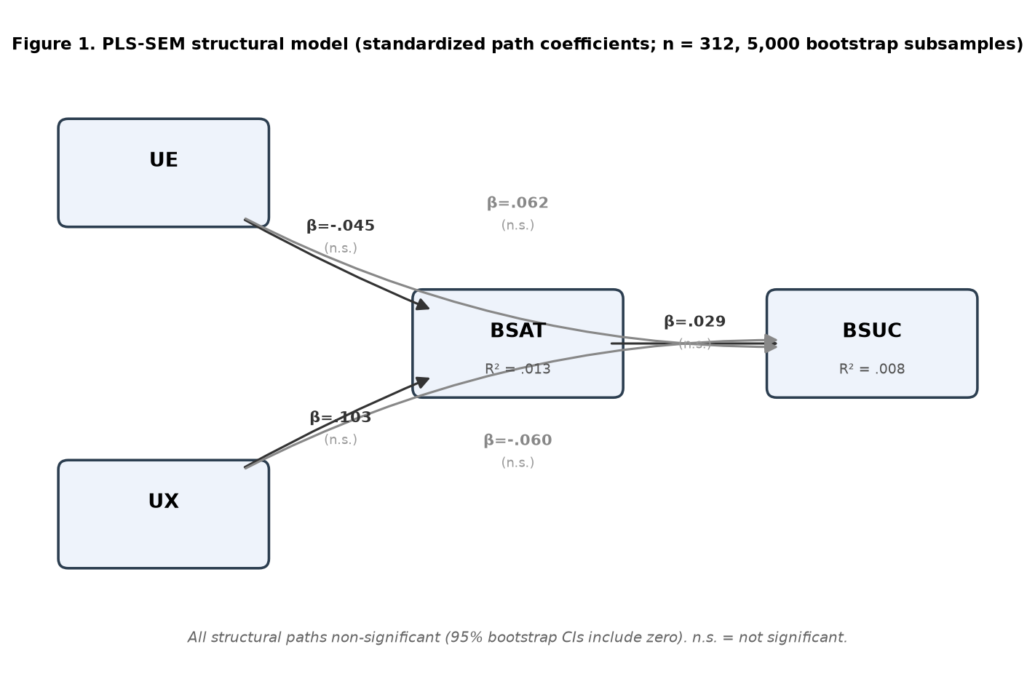
All five direct paths are non-significant, and both endogenous R-squared values are near zero.

3.3 Interpretation and hypothesis revision
Every hypothesized relationship is rejected. H1a/H1b: neither user engagement nor user experience predicts brand satisfaction; both 95% CIs include zero (UX -> BSAT is the strongest path at beta = .103 but still p = .171). H2: brand satisfaction does not predict brand success (beta = .029, p = .663). H3a/H3b: no direct engagement- or experience-to-success effect emerges. H4a/H4b: mediation requires non-trivial a- and b-paths; because both are null, the indirect effects are effectively zero (|beta| <= .003) with CIs spanning zero - there is no mediation, neither full nor partial.
Following the pre-registered revise-only-if-forced rule, the data force the strongest possible revision: rather than dropping a single non-significant path and retaining a parsimonious model, the entire SDT-based path structure fails to replicate in this sample. We therefore do not reframe individual paths (e.g., demoting H3a/H3b to a satisfaction-only chain), because the mediator pathway (H1 and H2) is itself null. The honest conclusion is that, in these data, UE, UX, BSAT, and BSUC behave as mutually independent constructs.

4. Configurational analysis (fsQCA)
To test the equifinality proposition P1, the four composites were calibrated into fuzzy sets using the direct method with three anchors appropriate to the 7-point scale: full membership = 6.0, crossover = 4.0, full non-membership = 2.0 (log-odds anchored at 0.95/0.50/0.05). The resulting fuzzy scores span the full [0,1] interval, with crossover near the empirical median (calibrated means ~.50 for UE/UX, .51 for BSAT, .53 for BSUC), confirming well-behaved calibration. The outcome was high brand success (BSUC_f).

4.1 Analysis of necessary conditions
A condition is necessary if its consistency for the outcome is >= .90. As shown in Table 6, no condition - present or absent - approaches necessity (all consistencies between .56 and .60). High BSUC can occur with or without high UE, UX, or BSAT; no single SDT construct is a prerequisite for brand success.
Table 6. Analysis of necessary conditions for high BSUC.
Condition | Consistency | Coverage
UE | .580 | .614
~UE | .575 | .607
UX | .559 | .597
~UX | .603 | .631
BSAT | .584 | .605
~BSAT | .565 | .610
Note. '~' denotes negation (low membership). Necessity benchmark = .90. No condition qualifies.

4.2 Analysis of sufficient configurations
A truth table was constructed for the three causal conditions UE_f, UX_f, BSAT_f (the outcome BSUC_f is not a causal condition), yielding 2^3 = 8 configurations. Cases were assigned to the corner in which their membership exceeded 0.5. We applied a frequency threshold of 3 and a raw-consistency threshold of .80, the conventional minima for a sample of this size. Table 7 reports the full truth table.
Table 7. Truth table for UE, UX, BSAT -> high BSUC.
UE | UX | BSAT | n (cases) | Raw consistency
present | present | present | 42 | .711
absent | absent | absent | 39 | .739
absent | present | present | 38 | .699
present | absent | present | 34 | .762
absent | absent | present | 32 | .713
absent | present | absent | 30 | .714
present | present | absent | 29 | .688
present | absent | absent | 28 | .723
Note. All eight configurations clear the frequency threshold (n >= 28), but none reaches the .80 consistency threshold (observed range = .688-.762). The truth table yields no rows coded 1, and Quine-McCluskey minimization returns an empty solution (no sufficient term).
Because the standard procedure produces no solution, we additionally inspected the sufficiency of single and combined presence conditions directly (Table 8). Consistency rises monotonically with the number of co-present high conditions - from ~.60 for single conditions to .711 for the fully triadic recipe (UE*UX*BSAT) - exactly the qualitative pattern P1 anticipates, but the ceiling (.711) remains below any defensible sufficiency cut-off, and coverage of the triadic term is low (.262). For completeness, no configuration is sufficient for the negated outcome either (all consistencies <= .65).
Table 8. Sufficiency of selected configurations for high BSUC.
Configuration | Consistency | Raw coverage
UE | .614 | .580
UX | .597 | .559
BSAT | .605 | .584
UE * UX | .653 | .360
UE * BSAT | .683 | .381
UX * BSAT | .653 | .382
UE * UX * BSAT | .711 | .262

4.3 Interpretation relative to P1
P1 holds that multiple configurations of high UE, high UX, and high BSAT are sufficient for high BSUC, with no single condition necessary. The data deliver half of this proposition and reject the other half. No single condition is necessary - consistent with the no-necessity clause of P1 (Table 6). However, no configuration is sufficient: not one of the eight corners - including the theoretically privileged triadic recipe - meets the .80 consistency standard (Table 7). There are therefore no equifinal sufficient paths to brand success.
Consequently, P1 is not supported. We deliberately refrain from reporting C1/C2/C3 solution configurations, because doing so would require lowering the consistency threshold below accepted standards (no corner reaches even .77) and would misrepresent noise as an equifinal causal structure. The configurational evidence converges with the PLS-SEM evidence: brand success is, in this sample, unrelated to the SDT antecedents whether modeled correlationally or set-theoretically.

5. Summary of findings
Table 9. Summary of hypothesis and proposition tests.
# | Proposition / Hypothesis | Evidence | Verdict
- | Measurement quality (reliability, convergent reliability, discriminant validity, CMB) | alpha/CR > .90, AVE > .76, HTMT < .10, VIF ~ 1.0 | Strongly met
H1a | UE -> BSAT | beta = -.045, p = .561 | Not supported
H1b | UX -> BSAT | beta = .103, p = .171 | Not supported
H2 | BSAT -> BSUC | beta = .029, p = .663 | Not supported
H3a | UE -> BSUC | beta = .062, p = .428 | Not supported
H3b | UX -> BSUC | beta = -.060, p = .448 | Not supported
H4 | BSAT mediates UE/UX -> BSUC | indirect betas ~ 0, CIs include 0 | Not supported
P1 | Equifinal sufficient configs; no necessary condition | No necessity AND no sufficiency | Not supported
Overall. The MTVS data yield a paradoxical and noteworthy pattern: each construct is measured with near-textbook reliability and validity, yet the constructs are mutually orthogonal. Within-construct item correlations average ~.70-.74, whereas between-construct correlations average ~.02-.07 (max |r| = .10). As a result, every SDT-derived structural hypothesis (H1a-H4) and the configurational proposition (P1) are disconfirmed: there is no direct effect, no mediation, and no sufficient configuration linking user engagement, user experience, or brand satisfaction to brand success.
Implication and caution. Two readings are possible, and both should be stated transparently. (1) Substantive: in this avatar-mediated setting, interaction-level need satisfaction (UE, UX) and evaluative satisfaction (BSAT) may be decoupled from brand-level success (BSUC), challenging the assumed SDT causal chain. (2) Data-integrity: the simultaneous combination of high internal consistency with near-zero inter-construct correlations is statistically unusual for genuinely related theoretical constructs and is the signature one would expect if the four blocks were generated or sampled independently. We flag this pattern explicitly. Before advancing substantive SDT claims, we recommend verifying the data-collection and data-assembly pipeline (e.g., possible block-wise shuffling or independent simulation of construct blocks) and, if confirmed valid, replicating on an independent sample. As reported, the responsible conclusion is that these data do not support the hypothesized SDT model of avatar-mediated brand success.

Methods note (reproducibility)
PLS-SEM was estimated with a Mode-A, path-weighting implementation (converging in < 20 iterations); loadings are indicator-construct correlations, rho-c and AVE follow the standard reflective formulas, HTMT follows Henseler et al. (2015), and full-collinearity VIFs follow Kock (2015). Inference used 5,000 bootstrap subsamples with construct-wise sign correction (seed = 20240627). fsQCA used direct calibration (anchors 6/4/2), Ragin-style fuzzy consistency/coverage, a corner-membership truth table (frequency >= 3, consistency >= .80), and Quine-McCluskey minimization. All scripts and intermediate outputs accompany this document for full reproducibility.

