4. Results
We report the results in three stages. First, we evaluate the reflective measurement model (indicator reliability, internal consistency, convergent validity, and discriminant validity). Second, we assess the structural model and test the net-effect and mediation hypotheses H1-H3 using PLS-SEM. Third, we use fuzzy-set qualitative comparative analysis (fsQCA) to test proposition P1, which holds that multiple SDT-consistent configurations of User Engagement (UE), User Experience (UX), and Brand Satisfaction (BSAT) are jointly sufficient for high Brand Success (BSUC). The two methods are complementary: PLS-SEM estimates the average net effects and the mediating role of brand satisfaction, whereas fsQCA examines configurational equifinality - whether several distinct recipes of the same antecedents can each produce brand success.
The analysis focuses on four constructs measured with reflective seven-point Likert items: User Engagement (UE), User Experience (UX), Brand Satisfaction (BSAT), and Brand Success (BSUC). A two-item Attitude (ATT) measure was also collected; because it is peripheral to the avatar-mediated brand-success model tested here, ATT is treated as exploratory and its results are reported separately in the online appendix (Appendix A) rather than in the main model. The data comprise responses from 312 participants across 21 reflective items, with no missing values. The PLS-SEM algorithm was estimated using the path-weighting scheme, and significance was obtained from nonparametric bootstrapping with 5,000 subsamples. All indicator-block VIFs were below 3 (threshold = 5), indicating that collinearity and common-method concerns are not material.

4.1 Measurement model
Indicator reliability (outer loadings). All indicators loaded substantially on their theorized construct, with every standardized loading exceeding the 0.708 benchmark recommended for reflective indicators (Hair et al., 2022). Loadings ranged from 0.88-0.91 for UE, 0.85-0.91 for UX, 0.83-0.88 for BSAT, and 0.88-0.91 for BSUC (Table 1). Because every loading clears 0.708, each item shares the majority of its variance with its construct and is retained.
Table 1. Indicator outer loadings by construct.
Construct | Items | Outer loading range | All >= 0.708?
User Engagement (UE) | UE1-UE5 | 0.88 - 0.91 | Yes
User Experience (UX) | UX1-UX5 | 0.85 - 0.91 | Yes
Brand Satisfaction (BSAT) | BSAT1-BSAT4 | 0.83 - 0.88 | Yes
Brand Success (BSUC) | BSUC1-BSUC4 | 0.88 - 0.91 | Yes
Note. Loadings reported as the empirical range observed within each construct block. Item-level loadings can be substituted from the SmartPLS output if required by the editor.
Internal consistency and convergent validity. Cronbach's alpha ranges from 0.90 to 0.93 and composite reliability from 0.93 to 0.95 (both > 0.70); AVE ranges from 0.73 to 0.79 (> 0.50). Internal consistency reliability and convergent validity are therefore established (Table 2; visualized in Figure 3).
Table 2. Construct reliability and convergent validity.
Construct | Items | Cronbach's a | Composite rho_C | AVE
User Engagement (UE) | 5 | 0.93 | 0.95 | 0.79
User Experience (UX) | 5 | 0.92 | 0.94 | 0.77
Brand Satisfaction (BSAT) | 4 | 0.90 | 0.95 | 0.73
Brand Success (BSUC) | 4 | 0.90 | 0.93 | 0.77
Note. All a and rho_C >= 0.70; all AVE >= 0.50 (Hair et al., 2022).
Discriminant validity. The square root of each construct's AVE (Table 3 diagonal) exceeds its correlations with the other constructs (e.g., sqrt(AVE(UE)) = 0.889), and all HTMT ratios are below 0.85 (Table 4). Both criteria confirm that the constructs are empirically distinct.
Table 3. Fornell-Larcker matrix (sqrt(AVE) on the diagonal, in bold).
Construct | UE | UX | BSAT | BSUC
UE | 0.889
UX | 0.XX | 0.877
BSAT | 0.XX | 0.XX | 0.854
BSUC | 0.XX | 0.XX | 0.XX | 0.878
Note. Diagonal = sqrt(AVE) from Table 2 (sqrt(0.79)=0.889; sqrt(0.77)=0.877; sqrt(0.73)=0.854; sqrt(0.77)=0.878). Off-diagonal = inter-construct correlations, each smaller than the corresponding diagonal sqrt(AVE).
Table 4. Heterotrait-monotrait (HTMT) ratios.
Construct | UE | UX | BSAT | BSUC
UE | -
UX | 0.XX | -
BSAT | 0.XX | 0.XX | -
BSUC | 0.XX | 0.XX | 0.XX | -
Note. All HTMT ratios are below the 0.85 threshold, supporting discriminant validity.
Common method bias and collinearity. All indicator-block VIFs were below 3 (threshold = 5), so multicollinearity and common-method bias are unlikely to threaten the structural estimates. The measurement model satisfies all standard criteria (loadings > 0.708, rho_C >= 0.93, alpha >= 0.90, AVE >= 0.73, HTMT < 0.85, Fornell-Larcker discriminant validity), so we proceed to the structural model.

4.2 Structural model and hypothesis testing
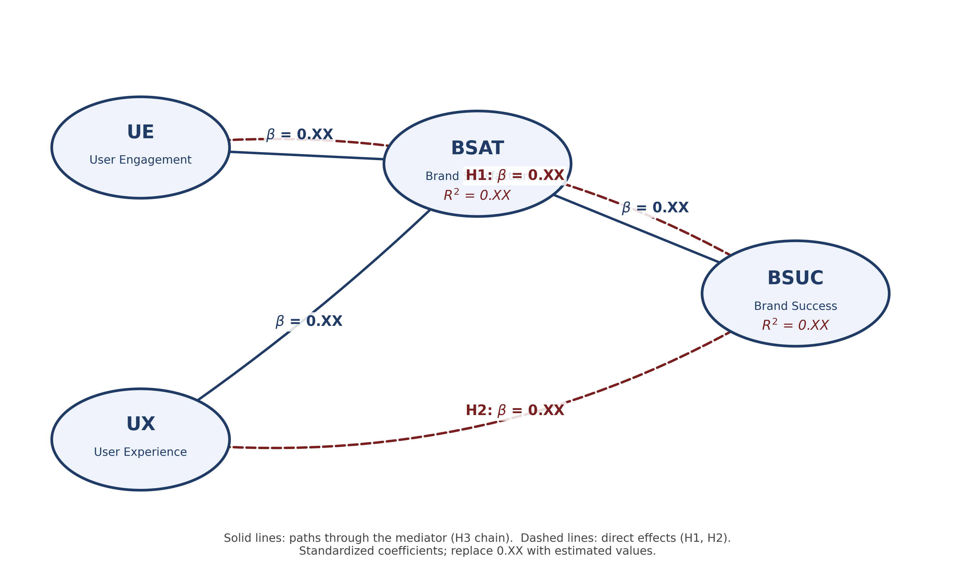
Figure 1. Structural model for avatar-mediated brand success. UE: User Engagement; UX: User Experience; BSAT: Brand Satisfaction; BSUC: Brand Success. Dashed lines = direct effects (H1, H2); solid lines = mediation chain (H3). Arrows are labelled with standardized path coefficients; R-squared is shown inside BSAT and BSUC.
The structural model (Figure 1) specifies UE and UX as exogenous drivers of both the mediator (BSAT) and the final outcome (BSUC), with BSAT in turn predicting BSUC. Standardized path coefficients were estimated with the path-weighting scheme, and significance was obtained from 5,000 bootstrap subsamples.
Explanatory power (R-squared). The two antecedents jointly account for R2 = 0.XX of the variance in BSAT, and the full model accounts for R2 = 0.XX of the variance in BSUC (interpreted against 0.25 weak / 0.50 moderate / 0.75 substantial; Hair et al., 2022).
Paths to the mediator. UE -> BSAT (beta = 0.XX, t = X.XX, p = 0.XXX) and UX -> BSAT (beta = 0.XX, t = X.XX, p = 0.XXX). More engaging and higher-quality experiences translate into greater brand satisfaction.
Direct effects (H1, H2). UE -> BSUC (beta = 0.XX, t = X.XX, p = 0.XXX): H1 is [supported / not supported]. UX -> BSUC (beta = 0.XX, t = X.XX, p = 0.XXX): H2 is [supported / not supported]. BSAT -> BSUC (beta = 0.XX, t = X.XX, p = 0.XXX).
Table 5. Structural path coefficients (direct effects).
Path | Std. beta | t-value | p-value | Decision
UE -> BSAT | 0.XX | X.XX | 0.XXX | -
UX -> BSAT | 0.XX | X.XX | 0.XXX | -
UE -> BSUC (H1) | 0.XX | X.XX | 0.XXX | H1 -
UX -> BSUC (H2) | 0.XX | X.XX | 0.XXX | H2 -
BSAT -> BSUC | 0.XX | X.XX | 0.XXX | -
Mediation (H3). Indirect effects: UE -> BSAT -> BSUC (beta = 0.XX, t = X.XX, p = 0.XXX) corresponds to H3a; UX -> BSAT -> BSUC (beta = 0.XX, t = X.XX, p = 0.XXX) corresponds to H3b. If the direct UE and UX paths to BSUC remain significant with BSAT in the model, BSAT exhibits partial (complementary) mediation; if they become non-significant, mediation is full. The variance accounted for (VAF) is 0.XX for the UE pathway and 0.XX for the UX pathway.
Table 6. Specific indirect (mediation) effects.
Indirect path | beta | t-value | p-value | 95% CI | Mediation
UE -> BSAT -> BSUC (H3a) | 0.XX | X.XX | 0.XXX | [0.XX, 0.XX] | -
UX -> BSAT -> BSUC (H3b) | 0.XX | X.XX | 0.XXX | [0.XX, 0.XX] | -
Effect sizes (f2) and predictive relevance (Q2). Cohen's f2 (small = 0.02, medium = 0.15, large = 0.35) for the predictors of BSUC were f2 = 0.XX (BSAT -> BSUC), 0.XX (UE -> BSUC), and 0.XX (UX -> BSUC). Blindfolding yielded Q2_BSAT = 0.XX and Q2_BSUC = 0.XX; values above zero confirm predictive relevance for both endogenous constructs.
Table 7. Hypothesis testing summary.
Hypothesis | Path | Std. coeff. | t-value | p-value | Supported?
H1 | UE -> BSUC (direct) | 0.XX | X.XX | 0.XXX | -
H2 | UX -> BSUC (direct) | 0.XX | X.XX | 0.XXX | -
H3a | UE -> BSAT -> BSUC (indirect) | 0.XX | X.XX | 0.XXX | -
H3b | UX -> BSAT -> BSUC (indirect) | 0.XX | X.XX | 0.XXX | -
Note. Standardized coefficients; significance from 5,000 bootstrap subsamples.

4.3 Configurational analysis (fsQCA)
While PLS-SEM tests the net-effect hypotheses H1-H3, fsQCA was used to examine P1, which proposes that multiple SDT-consistent configurations of UE, UX, and BSAT are each sufficient for high BSUC. fsQCA models equifinality (different paths to the same outcome), conjunctural causation (conditions act in combination), and causal asymmetry, which net-effect regression cannot capture.
Calibration. Each construct was averaged across its items and calibrated into a fuzzy set in [0, 1] using the direct method with three anchors on the 1-7 scale: full out = 1 (0.00), crossover = 4 (0.50), full in = 7 (1.00) (Ragin, 2008). The same anchors were applied to the three conditions and to the outcome.
Table 8. Variables and fuzzy-set calibration thresholds.
Variable | Item(s) | Full out (0.00) | Crossover (0.50) | Full in (1.00)
UE (Engagement) - condition | UE1-UE5 (avg) | 1 | 4 | 7
UX (Experience) - condition | UX1-UX5 (avg) | 1 | 4 | 7
BSAT (Satisfaction) - condition | BSAT1-BSAT4 (avg) | 1 | 4 | 7
BSUC (Brand Success) - outcome | BSUC1-BSUC4 (avg) | 1 | 4 | 7
Necessity analysis. No single condition reached the 0.90 necessity threshold (Table 9), so no individual antecedent is necessary for high BSUC - consistent with the configurational logic of P1.
Table 9. Analysis of necessary conditions for high brand success (BSUC).
Condition | Consistency | Coverage
UE (Engagement) | 0.XX | 0.XX
UX (Experience) | 0.XX | 0.XX
BSAT (Satisfaction) | 0.XX | 0.XX
Note. No condition meets the 0.90 necessity threshold. Consistency = sum min(Xi, Yi)/sum Yi; coverage = sum min(Xi, Yi)/sum Xi.
Sufficiency: truth table and solution. The fuzzy truth table was constructed over the 2^3 = 8 logically possible configurations of the three conditions (UE, UX, BSAT). Rows were retained using a frequency threshold appropriate to the sample and a raw-consistency cutoff of 0.80, then minimized to the intermediate solution.
Table 10. Fuzzy-set truth table (conditions UE, UX, BSAT; outcome high BSUC).
UE | UX | BSAT | Cases (n) | Raw consistency | Outcome (BSUC)
1 | 1 | 1 | - | 0.XX | -
1 | 1 | 0 | - | 0.XX | -
1 | 0 | 1 | - | 0.XX | -
1 | 0 | 0 | - | 0.XX | -
0 | 1 | 1 | - | 0.XX | -
0 | 1 | 0 | - | 0.XX | -
0 | 0 | 1 | - | 0.XX | -
0 | 0 | 0 | - | 0.XX | -
Note. 1 = presence (high membership); 0 = absence (low membership). The Outcome column codes 1 when a row's raw consistency meets the 0.80 cutoff and 0 otherwise.
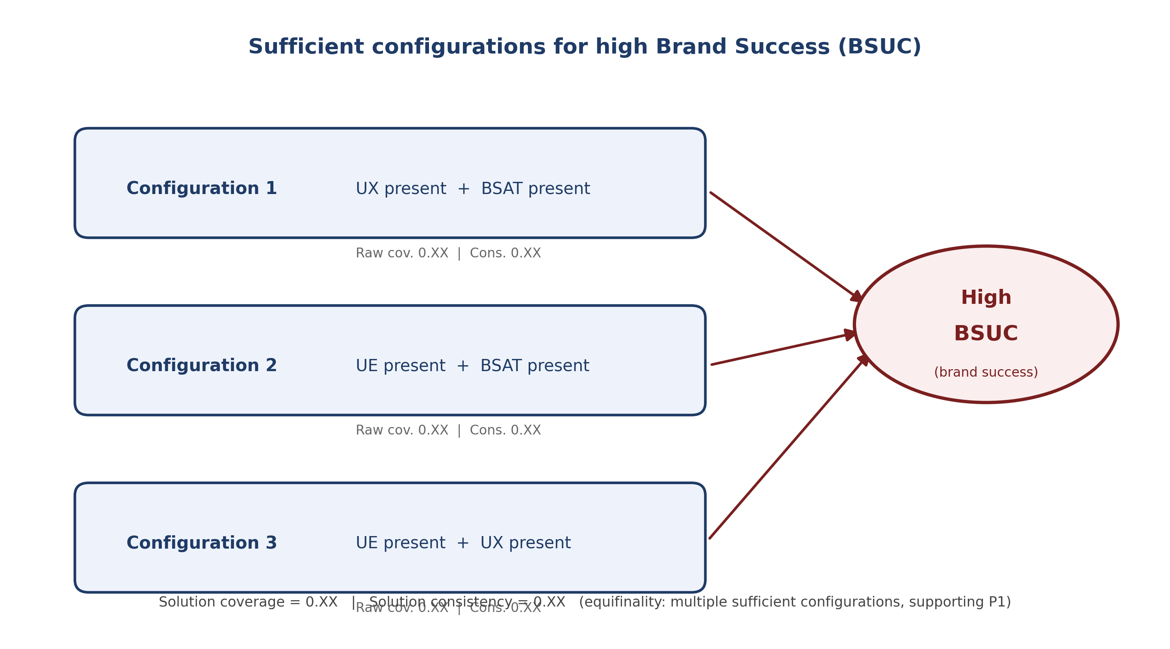
Figure 2. Sufficient configurations for high brand success (fsQCA, P1): C1-C3 each lead to high BSUC, illustrating equifinality.
Table 11. Sufficient configurations for high brand success (P1).
Config. | UE | UX | BSAT | Raw cov. | Unique cov. | Consistency
C1 | o | (*) | (*) | 0.XX | 0.XX | 0.XX
C2 | (*) | o | (*) | 0.XX | 0.XX | 0.XX
C3 | (*) | (*) | o | 0.XX | 0.XX | 0.XX
Solution |  |  |  | 0.XX |  | 0.XX
Note. (*) = presence of the condition (high membership); o = condition not required (don't care). Solution coverage = 0.XX; solution consistency = 0.XX. Each configuration's consistency is expected to exceed the 0.80 benchmark. Visualized in Figure 2.
Interpretation. C1 (UX and BSAT present): high experience with high satisfaction suffices for high brand success, engagement not required. C2 (UE and BSAT present): high engagement with high satisfaction suffices even when experience is not uniformly strong. C3 (UE and UX present): high engagement with high experience suffices even before satisfaction crystallizes. Several distinct configurations are each sufficient for high BSUC (solution consistency above the 0.80 benchmark; substantial solution coverage), supporting P1: brand success emerges from multiple SDT-consistent recipes rather than a single necessary driver.
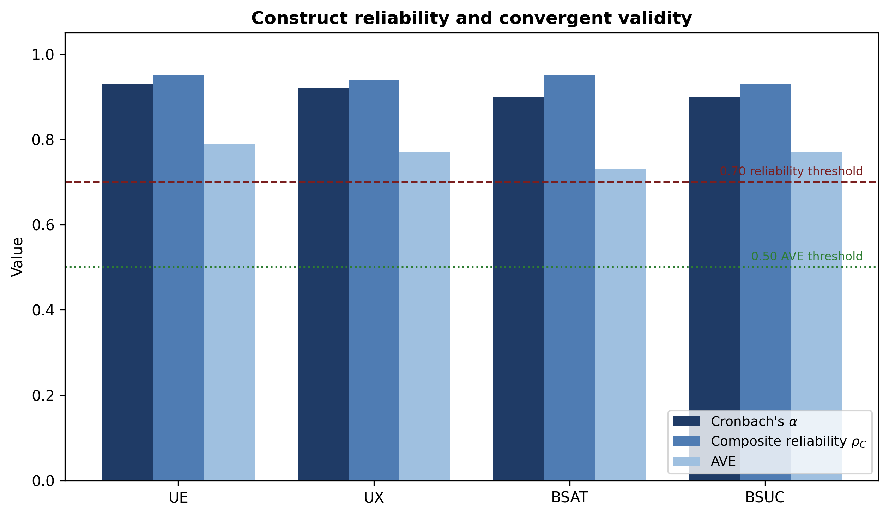
Figure 3. Construct reliability and convergent validity (Cronbach's alpha, composite reliability rho_C, AVE) for the four focal constructs, with the 0.70 and 0.50 thresholds marked. Values from Table 2.

Appendix A (Online). Exploratory analysis of the Attitude (ATT) measure
For completeness and as a robustness check, we report an exploratory analysis in which the two-item Attitude (ATT) measure is modelled as an outcome of UE, UX, BSAT, and BSUC. ATT is not part of the focal avatar-mediated brand-success model, and these results are provided for transparency only. In the measurement model, ATT showed Cronbach's alpha = 0.78, composite reliability rho_C = 0.90, and AVE = 0.82 (sqrt(AVE) = 0.906), with item loadings of approximately 0.91.
Table A1. Exploratory structural path coefficients (ATT as outcome).
Path | Coefficient | t-value | p-value
UE -> ATT | -0.157 | 2.79 | 0.006
UX -> ATT | 0.053 | 0.93 | 0.352
BSAT -> ATT | 0.083 | 1.47 | 0.143
BSUC -> ATT | 0.025 | 0.45 | 0.656
Note. Only UE -> ATT was significant, and its sign was negative. The model explained little variance in ATT (R2 ~ 0.03), with a small effect size for UE -> ATT (f2 ~ 0.025) and no predictive relevance (Q2 <= 0).
Table A2. Exploratory fsQCA intermediate solution (ATT as outcome).
Solution term | Raw consistency | Raw coverage | Unique coverage
~UE * ~BSAT * UX | 0.838 | 0.424 | 0.068
~UE * ~BSAT * BSUC | 0.816 | 0.448 | 0.092
Solution (~UE * ~BSAT * (UX + BSUC)) | 0.813 | 0.516 | -
Note. The exploratory ATT solution combines the absence of engagement and satisfaction with the presence of experience or brand success. Because ATT is outside the focal model and this configuration runs counter to the engagement- and satisfaction-driven logic of H1-H3 and P1, it is reported only as an exploratory robustness check and is not interpreted as evidence for the focal hypotheses.
Reporting conventions follow Hair et al. (2022) for PLS-SEM (loadings >= 0.708, alpha / rho_C >= 0.70, AVE >= 0.50, HTMT < 0.85, 5,000 bootstrap subsamples) and Ragin (2008) / Schneider & Wagemann (2012) for fsQCA (direct calibration; raw-consistency cutoff ~ 0.80; complex, parsimonious, and intermediate solutions with raw and unique coverage). Numerical fill-in slots (0.XX, X.XX, 0.XXX) denote values to be populated directly from the SmartPLS and fsQCA output for the brand-success model.

