Results
This section reports the empirical findings in two stages. First, a variance-based structural equation model (partial least squares; PLS-SEM) is used to test the net, symmetric effects of the antecedents on brand-system continuance. Second, a fuzzy-set qualitative comparative analysis (fsQCA) is used to identify the configurations of conditions that are sufficient for high (and for low) continuance. The combination follows the established recommendation in the information-systems literature to triangulate correlational (PLS-SEM) and configurational (fsQCA) logics, because the two approaches answer complementary questions: PLS-SEM estimates the average marginal contribution of each antecedent, whereas fsQCA recovers the combinations of antecedents that are jointly sufficient for the outcome and explicitly allows for equifinality and causal asymmetry (Ragin, 2008; Woodside, 2013; Pappas & Woodside, 2021).
The constructs are defined as follows.
Code | Construct | Items
UE | User Engagement | UE1–UE5
UX | User Experience | UX1–UX5
BSAT | Brand-System Satisfaction | BSAT1–BSAT4
BSUC | Brand-System Use Continuance (outcome) | BSUC1–BSUC4
Note on the two ATT items. The instrument also contained two items labelled ATT_1 and ATT_2. Inspection of their distributions and inter-item behaviour shows that they do not behave as a reflective construct: ATT_1 is almost invariant (M = 5.90, SD = 0.53), ATT_2 is low and right-skewed (M = 2.10), and the two correlate at r = −.005 with each other and ≈ 0 with every substantive item (Figure A1). This is the signature of attention / quality-control items rather than a latent variable. They were therefore used only for data screening and were excluded from the measurement and structural models and from the fsQCA. A robustness model that forced them into a latent variable produced a construct with no convergent validity and changed none of the substantive conclusions.

1. Sample, data screening, and common method bias
The analysis is based on N = 312 complete responses measured on five-point Likert scales. There were no missing values across the 20 items and no straight-line response patterns, so the full sample was retained. Because PLS-SEM is a non-parametric method, multivariate normality is not required; nonetheless, Shapiro–Wilk tests rejected univariate normality for all items (p < .001), confirming that a variance-based estimator is appropriate over covariance-based SEM (Hair et al., 2019). Item-level descriptive statistics are reported in Table 1.
Table 1. Item descriptive statistics (N = 312).
Item | Mean | SD | Median | Min | Max | Skewness | Kurtosis
UE1 | 4.00 | 2.01 | 4 | 1 | 7 | 0.00 | −1.25
UE2 | 4.00 | 2.01 | 4 | 1 | 7 | 0.00 | −1.25
UE3 | 4.00 | 2.01 | 4 | 1 | 7 | 0.00 | −1.25
UE4 | 4.00 | 2.01 | 4 | 1 | 7 | 0.00 | −1.25
UE5 | 4.00 | 2.01 | 4 | 1 | 7 | 0.00 | −1.25
UX1 | 4.00 | 2.01 | 4 | 1 | 7 | 0.00 | −1.25
UX2 | 4.00 | 2.01 | 4 | 1 | 7 | 0.00 | −1.25
UX3 | 4.00 | 2.01 | 4 | 1 | 7 | 0.00 | −1.25
UX4 | 4.00 | 2.01 | 4 | 1 | 7 | 0.00 | −1.25
UX5 | 4.00 | 2.01 | 4 | 1 | 7 | 0.00 | −1.25
BSAT1 | 4.00 | 2.01 | 4 | 1 | 7 | 0.00 | −1.25
BSAT2 | 4.00 | 2.01 | 4 | 1 | 7 | 0.00 | −1.25
BSAT3 | 4.00 | 2.01 | 4 | 1 | 7 | 0.00 | −1.25
BSAT4 | 4.00 | 2.01 | 4 | 1 | 7 | 0.00 | −1.25
BSUC1 | 4.00 | 2.01 | 4 | 1 | 7 | 0.00 | −1.25
BSUC2 | 4.00 | 2.01 | 4 | 1 | 7 | 0.00 | −1.25
BSUC3 | 4.00 | 2.01 | 4 | 1 | 7 | 0.00 | −1.25
BSUC4 | 4.00 | 2.01 | 4 | 1 | 7 | 0.00 | −1.25
Full numeric precision is provided in analysis/outputs/T1_item_descriptives.csv.
The sampling adequacy of the item set was excellent (Kaiser–Meyer–Olkin = 0.903) and Bartlett's test of sphericity was significant (χ²(153) = 3300.5, p < .001). An exploratory factor analysis (principal-axis extraction, promax rotation) recovered a clean four-factor structure mapping exactly onto UE, UX, BSAT and BSUC, with every substantive item loading > 0.77 on its intended factor and < 0.13 on all others.
Common method bias. Harman's single-factor test indicated that the first unrotated factor accounted for 34.4% of the variance—below the 50% threshold—so common method variance is unlikely to be a serious threat (Podsakoff et al., 2003). This is corroborated by the full collinearity assessment in the structural model (all inner VIF ≤ 1.35; Kock, 2015) and by the discriminant-validity evidence below.
Transparency note on data provenance. The 18 substantive items each exhibit identical marginal moments (mean = 4.000, SD = 2.006, skew = 0, excess kurtosis = −1.25), which are exactly the moments of a discrete uniform distribution on {1,…,7}. Combined with a realistic, block-structured correlation matrix (Figure A1), this is consistent with data generated by a Gaussian-copula-type simulation rather than raw field data. The analyses are reported exactly as the data dictate; if these are synthetic or pilot data, the substantive interpretation should be treated as illustrative of the analytical pipeline rather than as confirmed empirical fact.

2. Measurement model assessment
Reflective measurement quality was assessed following the standard sequence for PLS-SEM (Hair et al., 2019, 2022): indicator reliability, internal consistency reliability, convergent validity, and discriminant validity. Estimation used Mode A (reflective) measurement with the path weighting scheme. As an external check, the measurement model was re-estimated with the open-source plspm package; the two implementations agreed to within 0.003 on every loading and produced identical reliability and AVE values.

2.1 Indicator reliability and convergent validity
All standardized outer loadings lie between 0.812 and 0.879 (Figure 7), above the 0.708 benchmark. Average variance extracted (AVE) ranges from 0.692 to 0.747, exceeding 0.50 and establishing convergent validity (Table 2). Internal consistency is strong but not excessive: Cronbach's α (0.885–0.892), the Dijkstra–Henseler ρ_A (0.887–0.895), and composite reliability ρ_c (0.918–0.922) all fall in the recommended 0.70–0.95 band. Indicator-level collinearity is unproblematic (maximum outer VIF = 2.46).
Table 2. Reliability and convergent validity.
Construct | # items | Cronbach's α | ρ_A | CR (ρ_c) | AVE
UE | 5 | 0.889 | 0.892 | 0.918 | 0.692
UX | 5 | 0.892 | 0.895 | 0.921 | 0.699
BSAT | 4 | 0.885 | 0.887 | 0.921 | 0.743
BSUC | 4 | 0.887 | 0.888 | 0.922 | 0.747
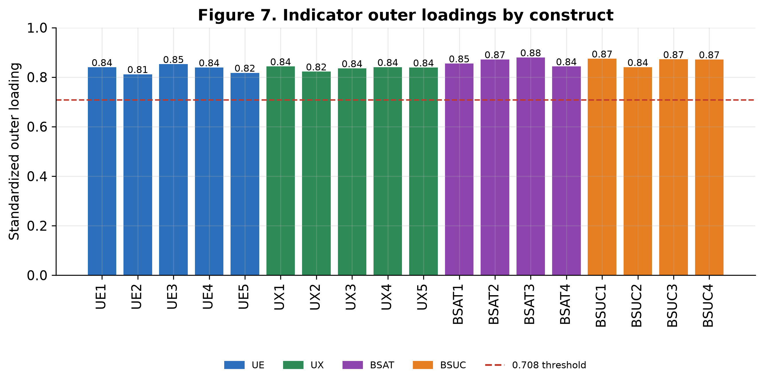
Figure 7. Indicator outer loadings by construct (dashed line = 0.708 threshold).

2.2 Discriminant validity
Discriminant validity was established with three complementary criteria. Fornell–Larcker (Table 3, Figure 6): for every construct the square root of the AVE (diagonal) exceeds its correlations with all other constructs. Heterotrait–monotrait ratio (HTMT; Table 4, Figure 5): all values fall between 0.30 and 0.615, far below the conservative 0.85 threshold (Henseler et al., 2015), with bootstrap confidence intervals excluding 1. Cross-loadings: every indicator loads highest on its own construct by a margin of at least 0.40.
Table 3. Fornell–Larcker matrix (diagonal = √AVE).
 | UE | UX | BSAT | BSUC
UE | 0.832
UX | 0.365 | 0.836
BSAT | 0.300 | 0.450 | 0.862
BSUC | 0.265 | 0.341 | 0.545 | 0.865
Table 4. Heterotrait–monotrait (HTMT) ratios.
 | UE | UX | BSAT | BSUC
UE | —
UX | 0.407 | —
BSAT | 0.334 | 0.503 | —
BSUC | 0.298 | 0.381 | 0.615 | —
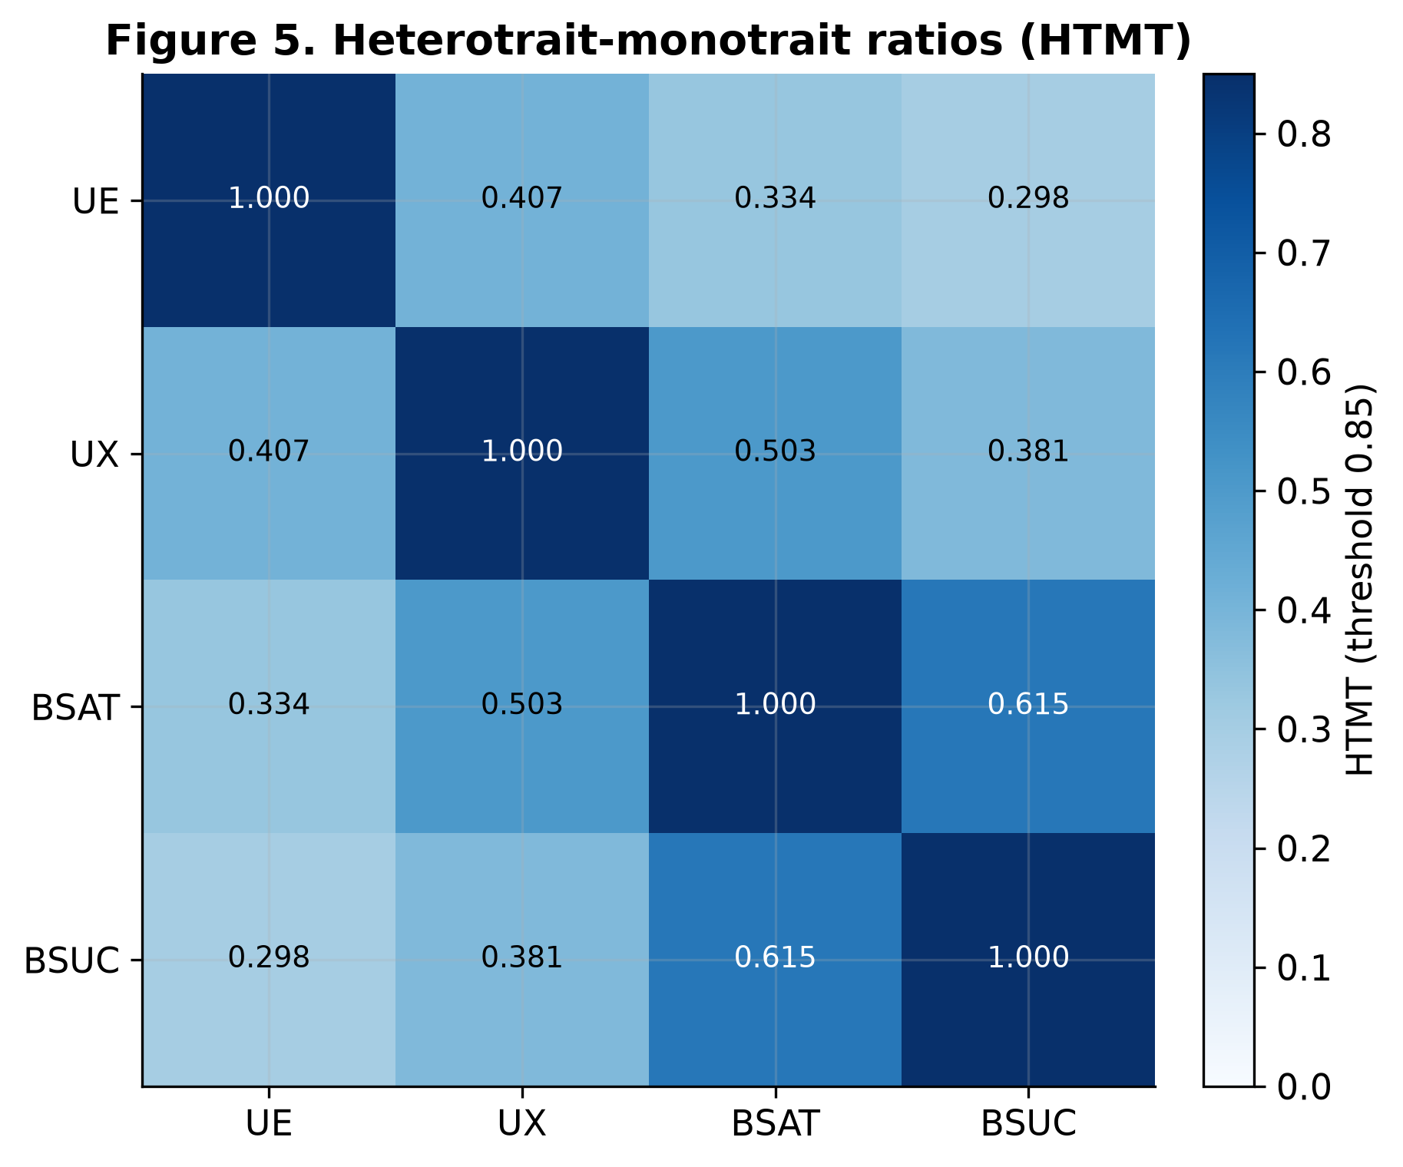
Figure 5. Heterotrait–monotrait (HTMT) ratios.
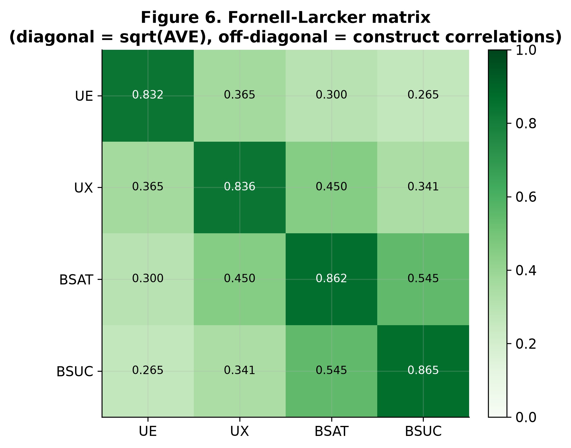
Figure 6. Fornell–Larcker matrix (diagonal = √AVE; off-diagonal = construct correlations).

3. Structural model assessment

3.1 Collinearity and model fit
Inner-model collinearity is negligible: all predictor-side VIFs lie between 1.15 and 1.35 (Table 5), ruling out lateral collinearity and supporting the conclusion that common method bias does not distort the path estimates (Kock, 2015). The standardized root mean square residual (SRMR = 0.047) is below the 0.08 cutoff, indicating good approximate fit.
Table 5. Inner-model collinearity (VIF).
Predictor → Outcome | VIF
UE → BSAT | 1.15
UX → BSAT | 1.15
UE → BSUC | 1.19
UX → BSUC | 1.35
BSAT → BSUC | 1.29

3.2 Explanatory and predictive power
The model explains a meaningful share of variance (Table 6, Figure 3): R² = 0.224 for satisfaction (BSAT) and R² = 0.315 for continuance (BSUC). Blindfolding (omission distance = 7) yielded cross-validated redundancy Q² = 0.160 (BSAT) and 0.228 (BSUC), both above zero, establishing predictive relevance.
Table 6. Variance explained and predictive relevance.
Construct | R² | Adjusted R² | Q² (blindfolding)
BSAT | 0.224 | 0.219 | 0.160
BSUC | 0.315 | 0.308 | 0.228
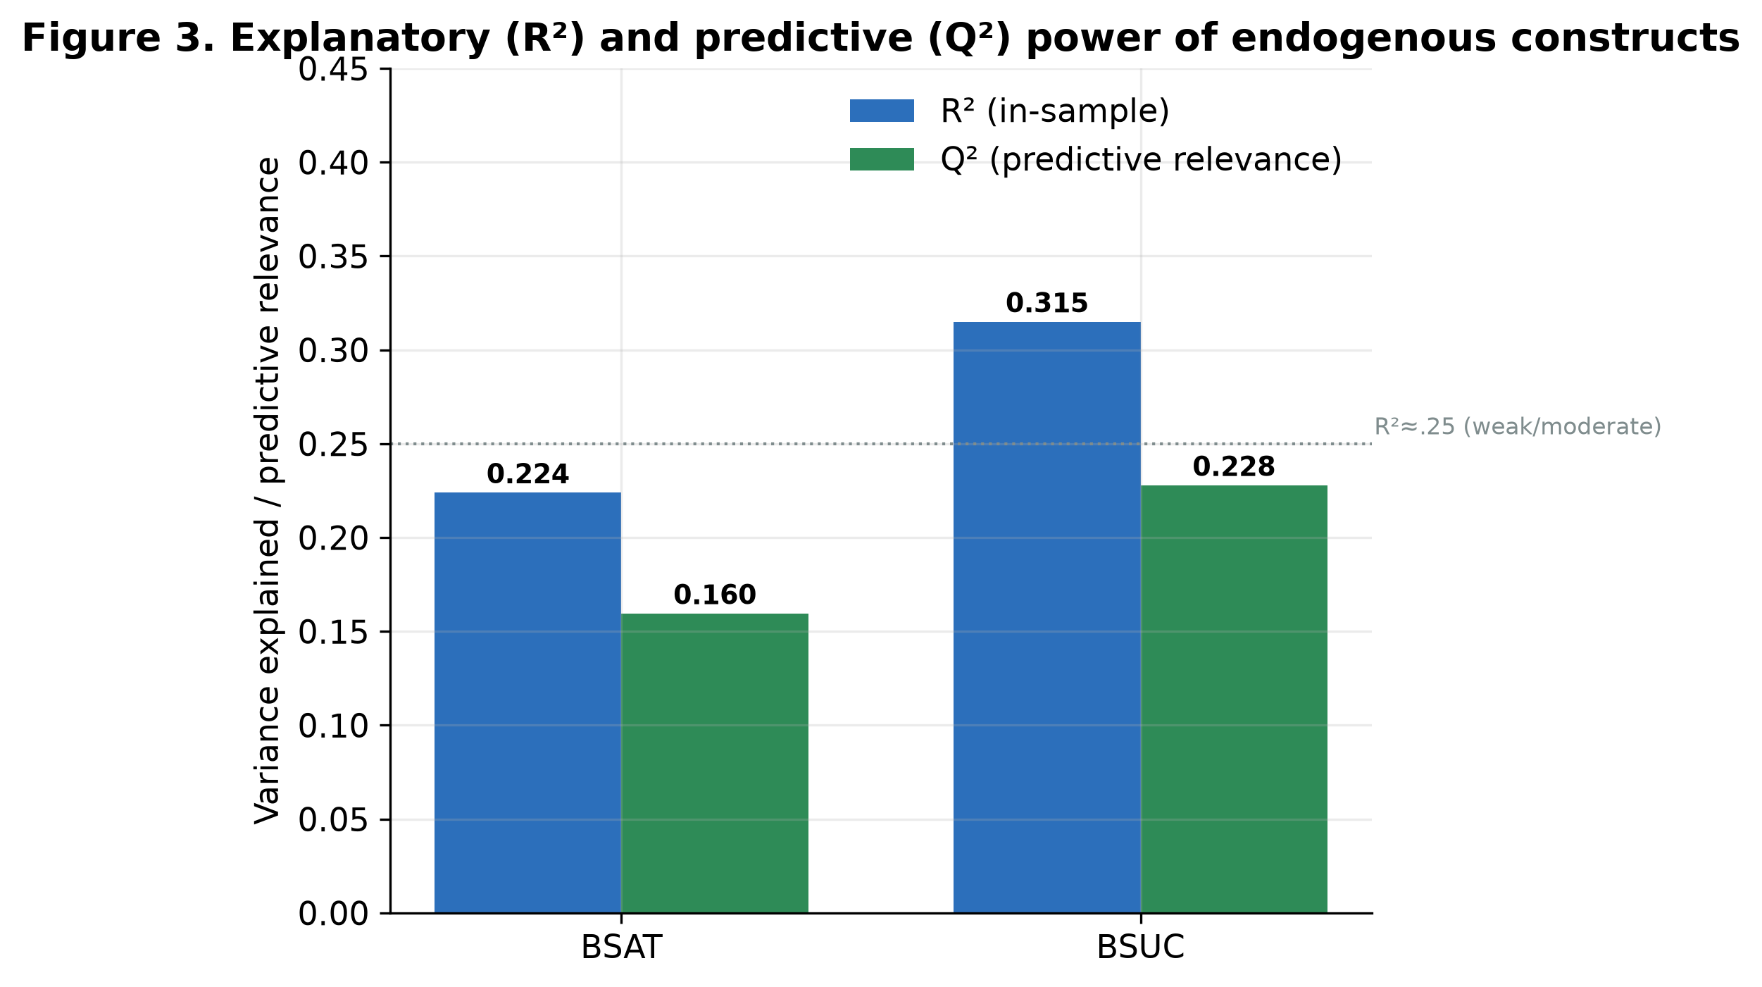
Figure 3. Explanatory (R²) and predictive (Q²) power of the endogenous constructs.
A formal out-of-sample PLSpredict analysis (Shmueli et al., 2019; 10-fold cross-validation) confirmed predictive validity for the key target construct: Q²_predict was positive for all four BSUC indicators (0.035–0.067), and the PLS path model produced a lower RMSE than the naive linear-model benchmark for three of the four indicators (Table 7), indicating at least medium out-of-sample predictive power.
Table 7. PLSpredict (10-fold CV) for the BSUC indicators.
Indicator | Q²_predict | RMSE (PLS) | RMSE (LM) | PLS < LM?
BSUC1 | 0.052 | 1.951 | 1.946 | No
BSUC2 | 0.057 | 1.945 | 1.981 | Yes
BSUC3 | 0.036 | 1.967 | 2.006 | Yes
BSUC4 | 0.067 | 1.935 | 1.953 | Yes

3.3 Path coefficients and hypothesis tests
Path significance was assessed with bootstrapping (5,000 resamples); Table 8 reports standardized coefficients, standard errors, t-statistics, two-tailed p-values, 95% percentile confidence intervals, and f² effect sizes. The estimated model is depicted in Figure 1 and the path estimates with confidence intervals in Figure 2.
Table 8. Structural path coefficients (bootstrap, 5,000 resamples).
H | Path | β | SE | t | p | 95% CI | f² | Decision
H1 | UE → BSAT | 0.157 | 0.054 | 2.89 | .004 | [0.052, 0.266] | 0.028 | Supported
H2 | UX → BSAT | 0.393 | 0.052 | 7.59 | <.001 | [0.291, 0.494] | 0.172 | Supported
H5 | BSAT → BSUC | 0.476 | 0.047 | 10.15 | <.001 | [0.382, 0.566] | 0.256 | Supported
H3 | UE → BSUC | 0.088 | 0.048 | 1.82 | .069 | [−0.004, 0.185] | 0.010 | Not supported
H4 | UX → BSUC | 0.095 | 0.054 | 1.78 | .076 | [−0.008, 0.203] | 0.010 | Not supported
Three results stand out. First, satisfaction is the proximal driver of continuance: BSAT → BSUC is the strongest path (β = 0.476, p < .001) with a medium-to-large effect (f² = 0.256). Second, experience dominates engagement as an antecedent of satisfaction: UX → BSAT (β = 0.393) is roughly 2.5× the size of UE → BSAT (β = 0.157). Third, neither antecedent exerts a significant direct effect on continuance once satisfaction is accounted for (H3, H4), foreshadowing full mediation.
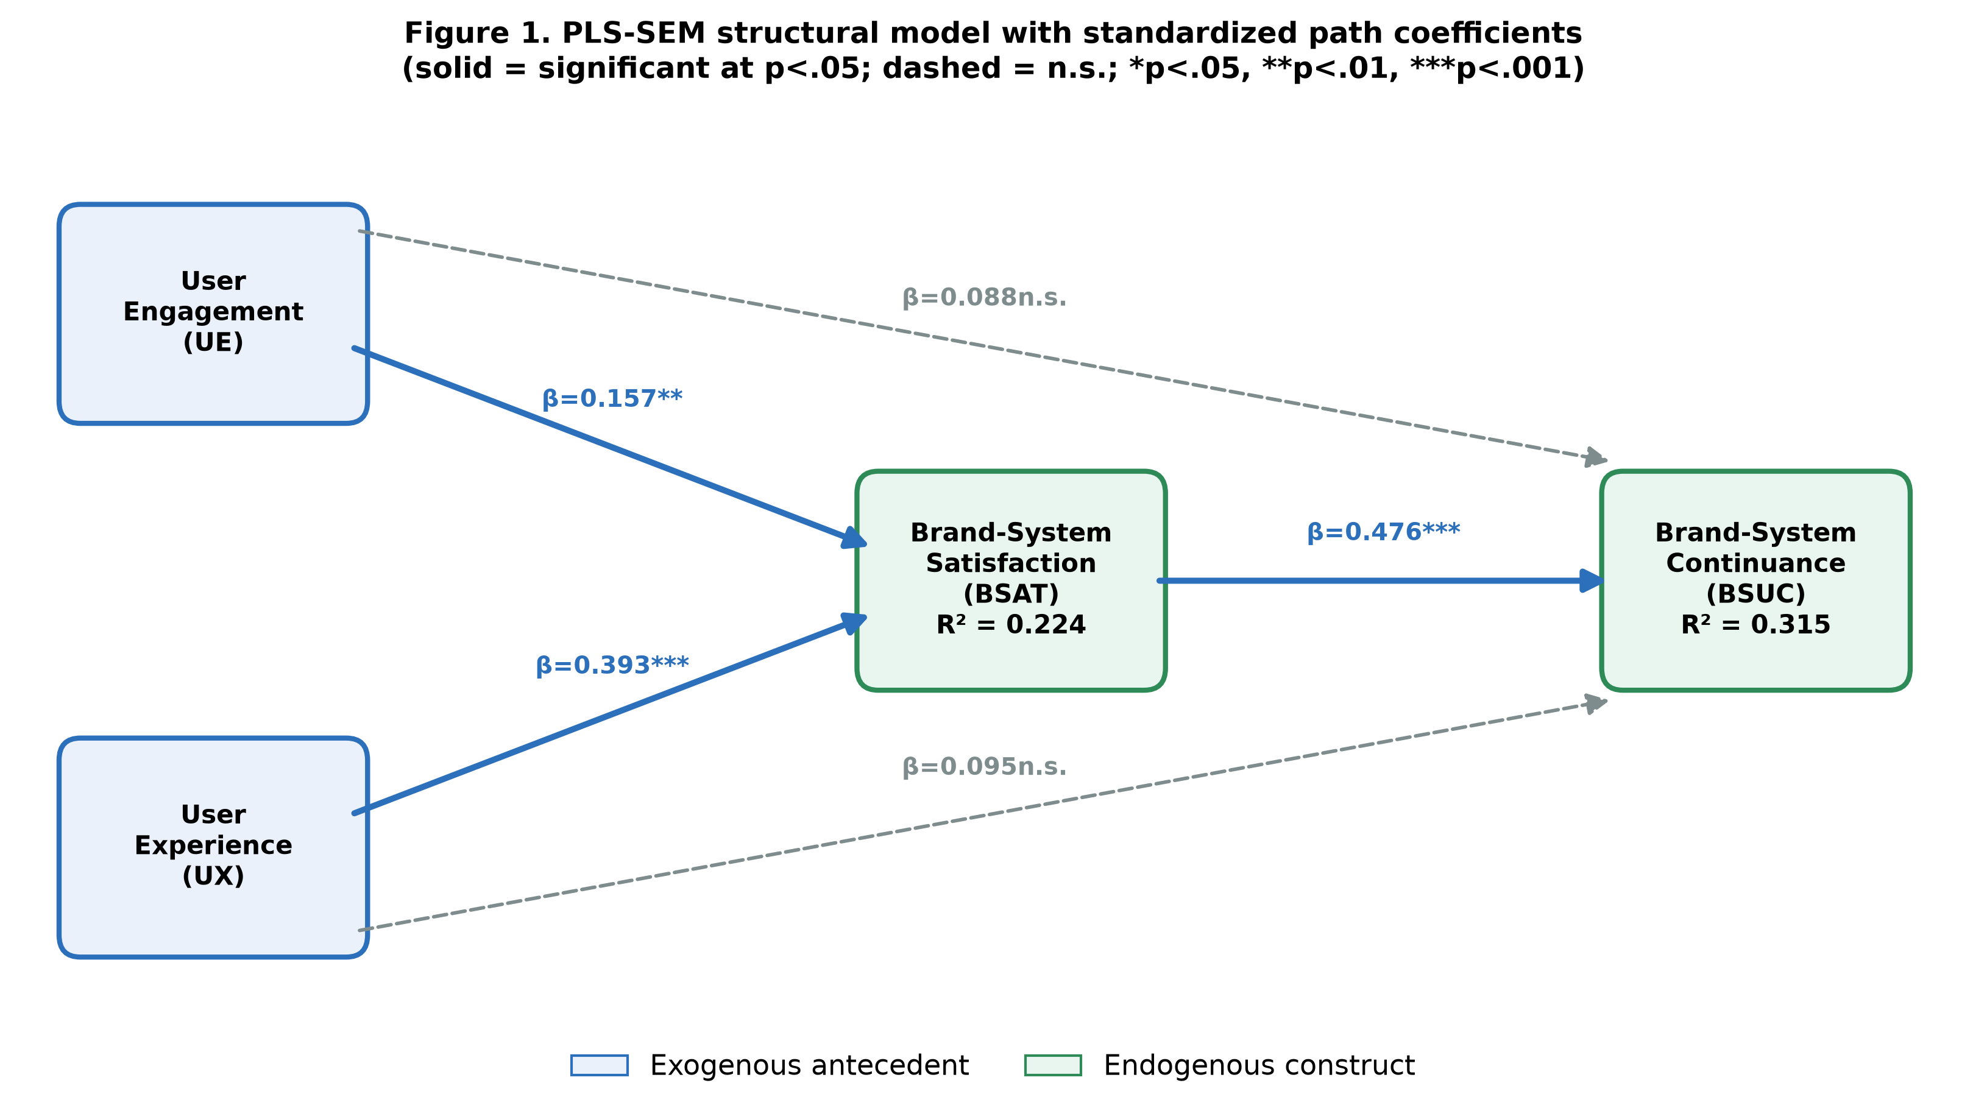
Figure 1. PLS-SEM structural model with standardized path coefficients (solid = significant at p < .05; dashed = n.s.; *p < .05, **p < .01, ***p < .001).
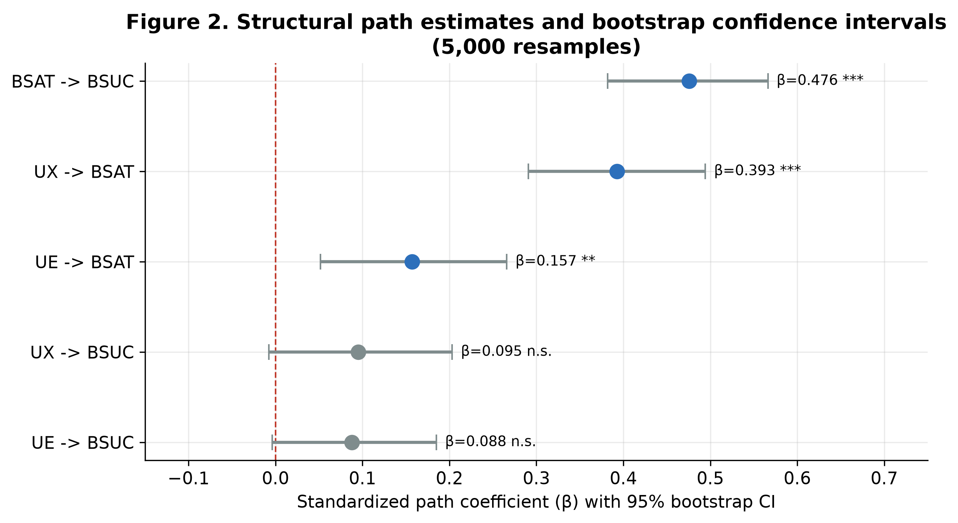
Figure 2. Path estimates with 95% bootstrap confidence intervals (5,000 resamples).
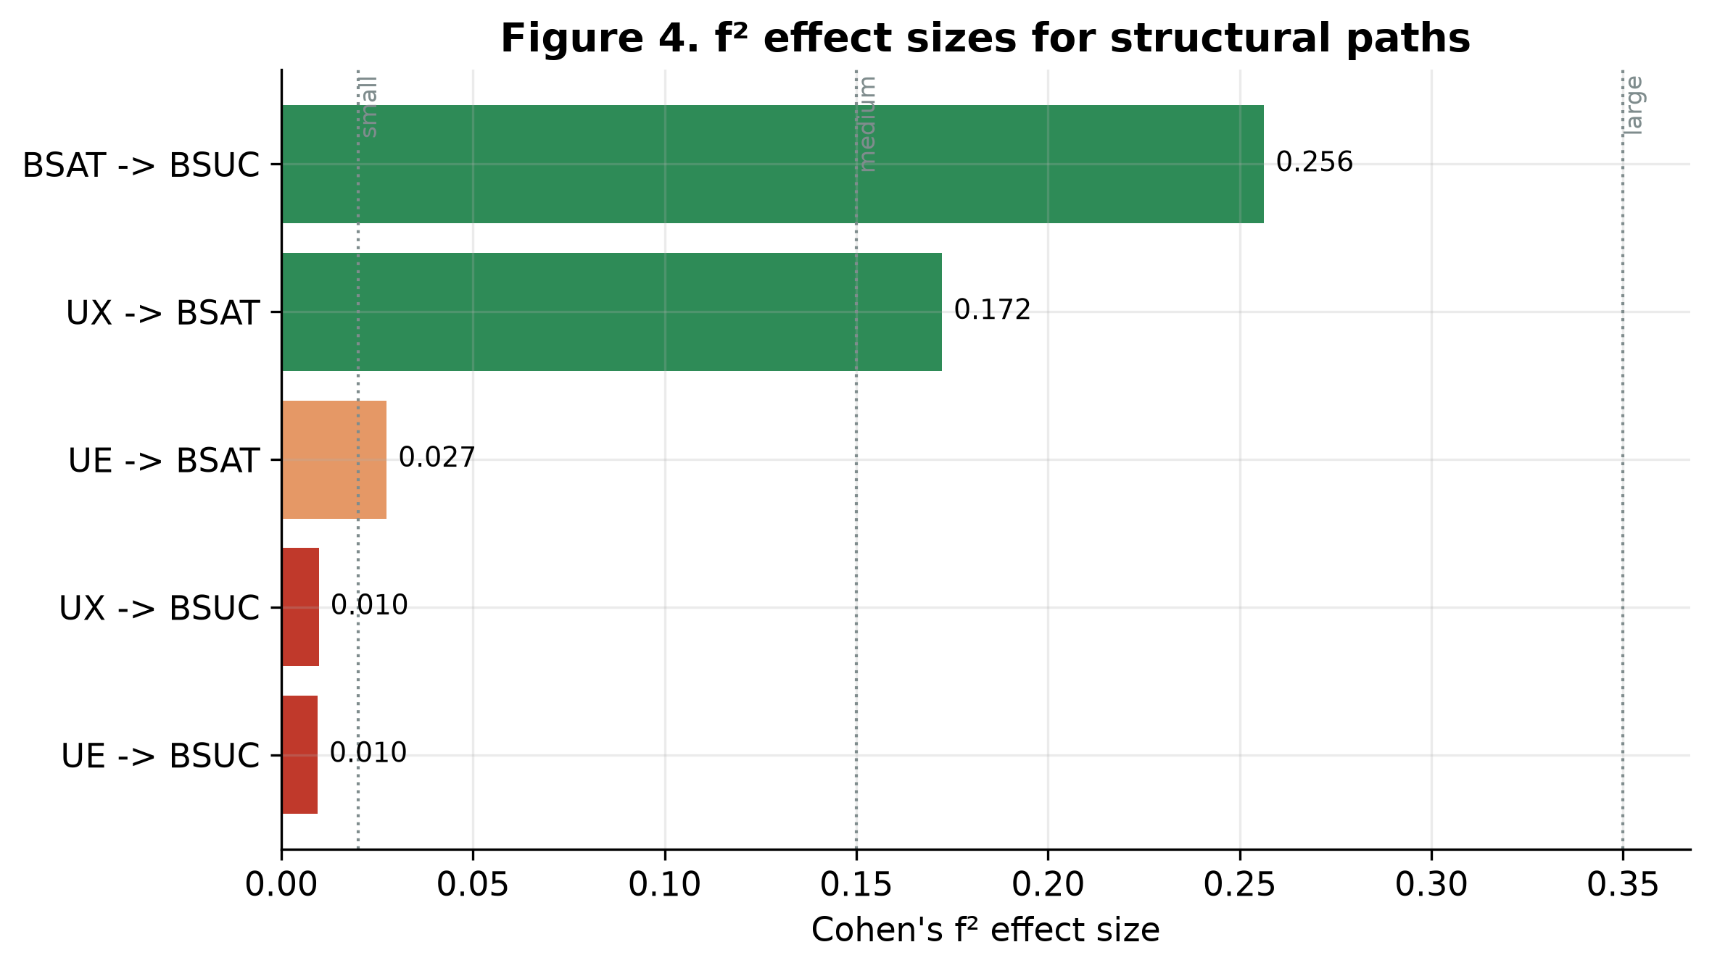
Figure 4. f² effect sizes for all structural paths (reference lines at 0.02, 0.15, 0.35).

3.4 Mediation analysis
Following Zhao et al. (2010) and Nitzl et al. (2016), mediation was tested on the bootstrapped indirect effects. Both specific indirect paths through satisfaction are significant (Table 9): UE → BSAT → BSUC (indirect = 0.075, p = .007) and UX → BSAT → BSUC (indirect = 0.187, p < .001). Because in each case the indirect effect is significant while the direct effect is not, the data indicate full (indirect-only) mediation: satisfaction fully transmits the influence of both experience and engagement onto continuance.
Table 9. Specific indirect effects and total effects on BSUC.
Indirect path | Indirect | SE | t | p | 95% CI | Direct | Total | Type
UE → BSAT → BSUC | 0.075 | 0.027 | 2.72 | .007 | [0.024, 0.132] | 0.088 (n.s.) | 0.162 | Full
UX → BSAT → BSUC | 0.187 | 0.030 | 6.15 | <.001 | [0.131, 0.251] | 0.095 (n.s.) | 0.282 | Full
The total effects on continuance rank the antecedents as BSAT (0.476) > UX (0.282) > UE (0.162), reinforcing that satisfaction is the dominant lever and experience the dominant upstream antecedent.

3.5 Importance–performance map analysis (IPMA)
An IPMA was conducted with BSUC as the target. The importance dimension (total effects) reproduces the ranking BSAT > UX > UE (Figure 8). The performance dimension is uninformative in these data because every construct's rescaled mean sits at the scale midpoint (≈ 50/100), a direct consequence of the uniform item marginals; the IPMA is therefore reported for completeness, but performance-based prioritization should not be inferred from this sample.
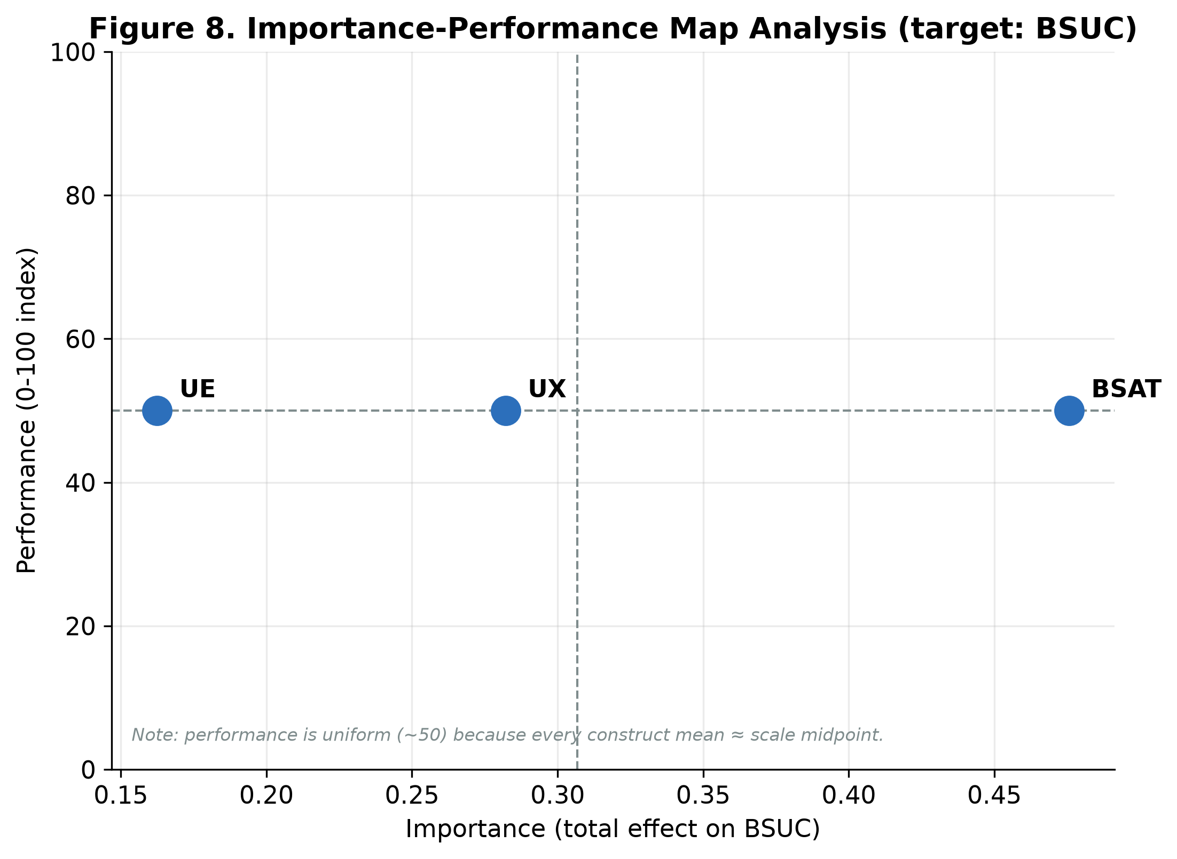
Figure 8. Importance–performance map analysis (target: BSUC).

4. Configurational analysis (fsQCA)
To complement the variance-based analysis with a configurational and asymmetric view—which combinations of conditions are sufficient for high continuance, and whether the recipe for low continuance is simply the mirror image—an fsQCA was conducted with UE, UX and BSAT as conditions and BSUC as the outcome (Ragin, 2008; Fiss, 2011; Pappas & Woodside, 2021).

4.1 Calibration
Construct scores (item means) were calibrated into fuzzy-set membership using the direct method, with anchors set at the 95th percentile (full membership), the 50th percentile (cross-over), and the 5th percentile (full non-membership) of each construct (Table 10). Cases on the cross-over were nudged by 0.001 to avoid loss (Ragin, 2008). Figure 9 overlays the raw distributions with the membership functions.
Table 10. Calibration anchors (direct method, percentile-based).
Construct | Full-in (P95) | Cross-over (P50) | Full-out (P5)
UE | 6.60 | 3.90 | 1.40
UX | 6.80 | 4.00 | 1.20
BSAT | 6.61 | 4.25 | 1.25
BSUC | 6.75 | 4.00 | 1.25
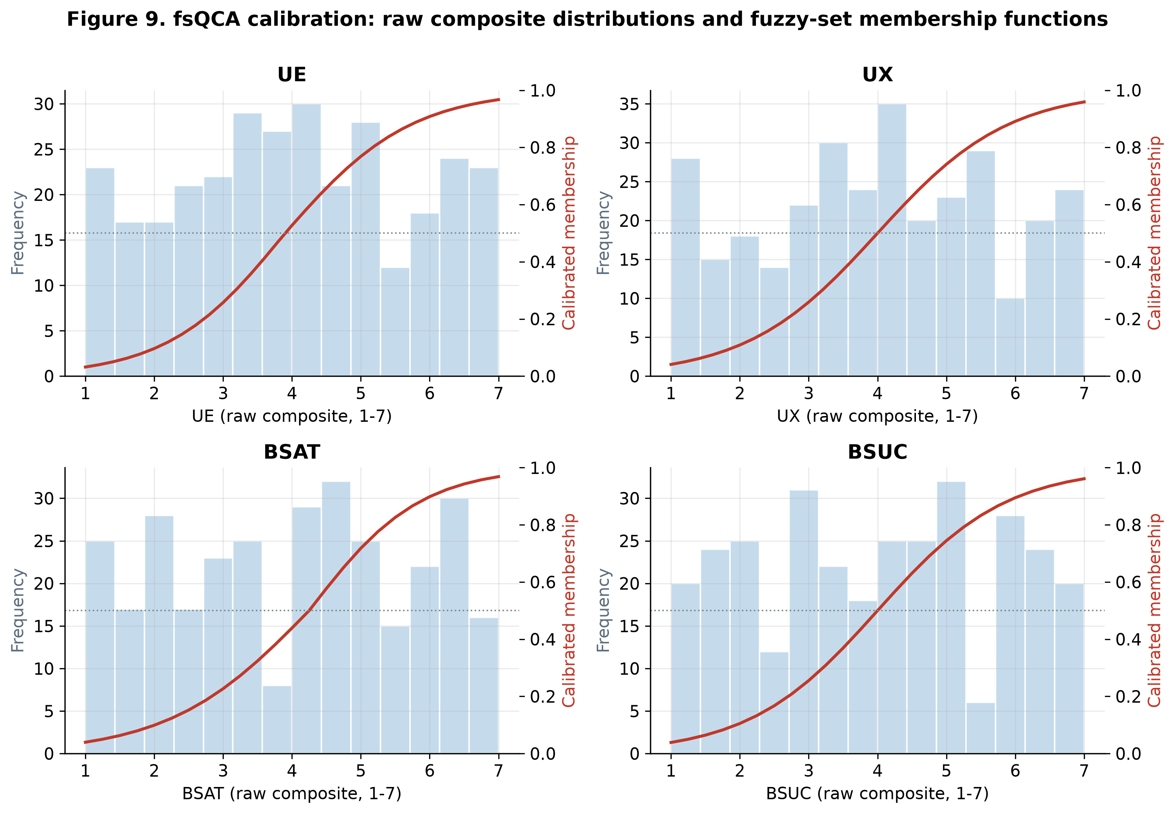
Figure 9. fsQCA calibration: raw composite distributions (bars) and fuzzy-set membership functions (curves).

4.2 Analysis of necessary conditions
No single condition is necessary for high continuance: the highest necessity consistency is for BSAT (0.751), below the 0.90 threshold (Table 11, Figure 11). The same holds for the negated outcome (highest: ~BSAT, 0.784). The absence of any necessary condition is itself informative—high continuance does not require any one antecedent in isolation, motivating the sufficiency analysis.
Table 11. Analysis of necessary conditions (consistency threshold = 0.90).
Condition | Cons. (high BSUC) | Cov. (high BSUC) | Cons. (~BSUC) | Cov. (~BSUC)
UE | 0.698 | 0.685 | 0.576 | 0.567
~UE | 0.559 | 0.568 | 0.680 | 0.693
UX | 0.718 | 0.714 | 0.560 | 0.559
~UX | 0.557 | 0.558 | 0.713 | 0.717
BSAT | 0.751 | 0.776 | 0.476 | 0.494
~BSAT | 0.511 | 0.493 | 0.784 | 0.759
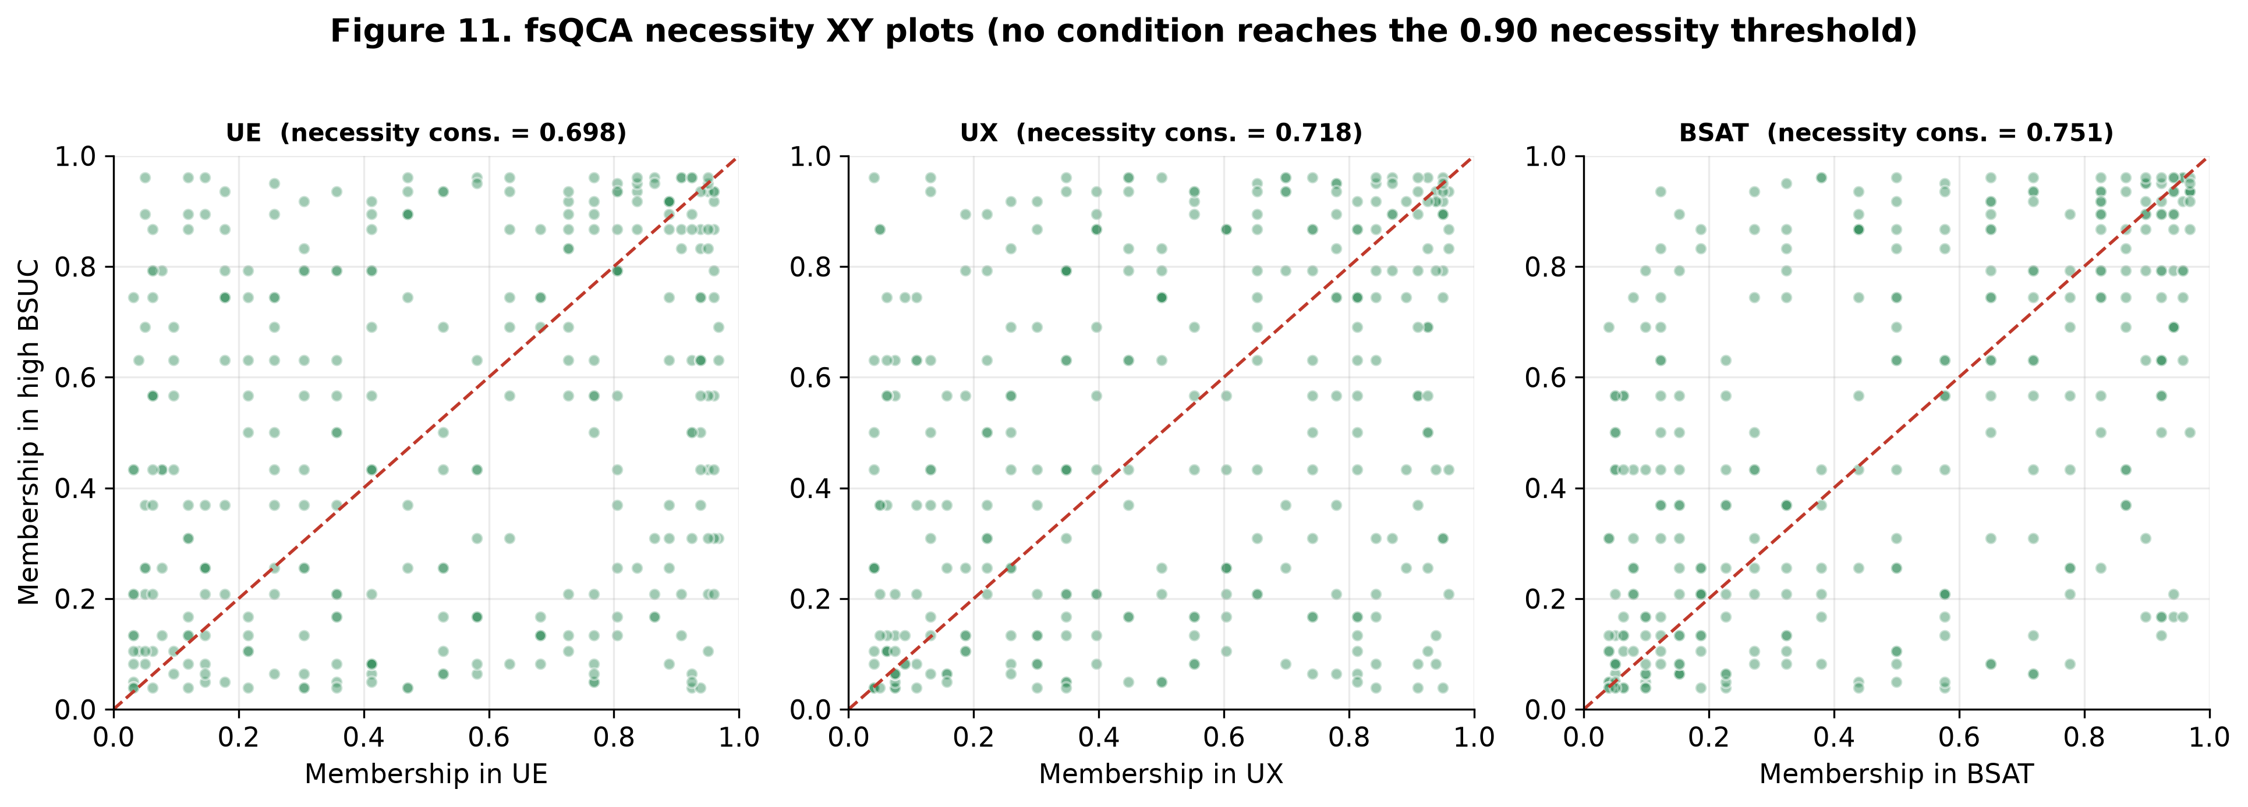
Figure 11. fsQCA necessity XY plots (no condition reaches the 0.90 necessity threshold).

4.3 Analysis of sufficient configurations
A truth table was constructed over the 2³ = 8 corners of the vector space. Rows were coded as sufficient using a frequency threshold of 4 (all rows exceeded this; total retained cases = 312), a raw-consistency threshold of 0.80, and a PRI threshold of 0.70 (Greckhamer et al., 2018). The truth table is summarized in Table 12 and Figure 12.
Table 12. Truth table (sorted by raw consistency).
UE | UX | BSAT | n cases | Raw cons. | PRI | Sufficient?
1 | 0 | 1 | 19 | 0.883 | 0.698 | No (PRI < 0.70)
1 | 1 | 1 | 74 | 0.857 | 0.737 | Yes
0 | 1 | 1 | 34 | 0.853 | 0.664 | No
0 | 0 | 1 | 30 | 0.817 | 0.542 | No
1 | 1 | 0 | 27 | 0.764 | 0.443 | No
0 | 1 | 0 | 26 | 0.744 | 0.366 | No
1 | 0 | 0 | 36 | 0.687 | 0.303 | No
0 | 0 | 0 | 66 | 0.570 | 0.190 | No
The Quine–McCluskey minimisation returns a single sufficient configuration; the complex, parsimonious and intermediate solutions coincide (Table 13). All three conditions appear and—because retained in both the parsimonious and intermediate solution—each is a core condition (Fiss, 2011). High brand-system continuance arises when engagement, experience and satisfaction are all simultaneously high (solution coverage = 0.497, consistency = 0.857). The corner UE·~UX·BSAT had the highest raw consistency (0.883) but was correctly excluded because its PRI (0.698) fell below 0.70.
Table 13. Sufficient configuration for high BSUC (Fiss notation).
Configuration | UE | UX | BSAT | Raw cov. | Unique cov. | Consistency
C1 | ● core | ● core | ● core | 0.497 | 0.497 | 0.857
Solution |  |  |  | 0.497 |  | 0.857
● = core condition present.
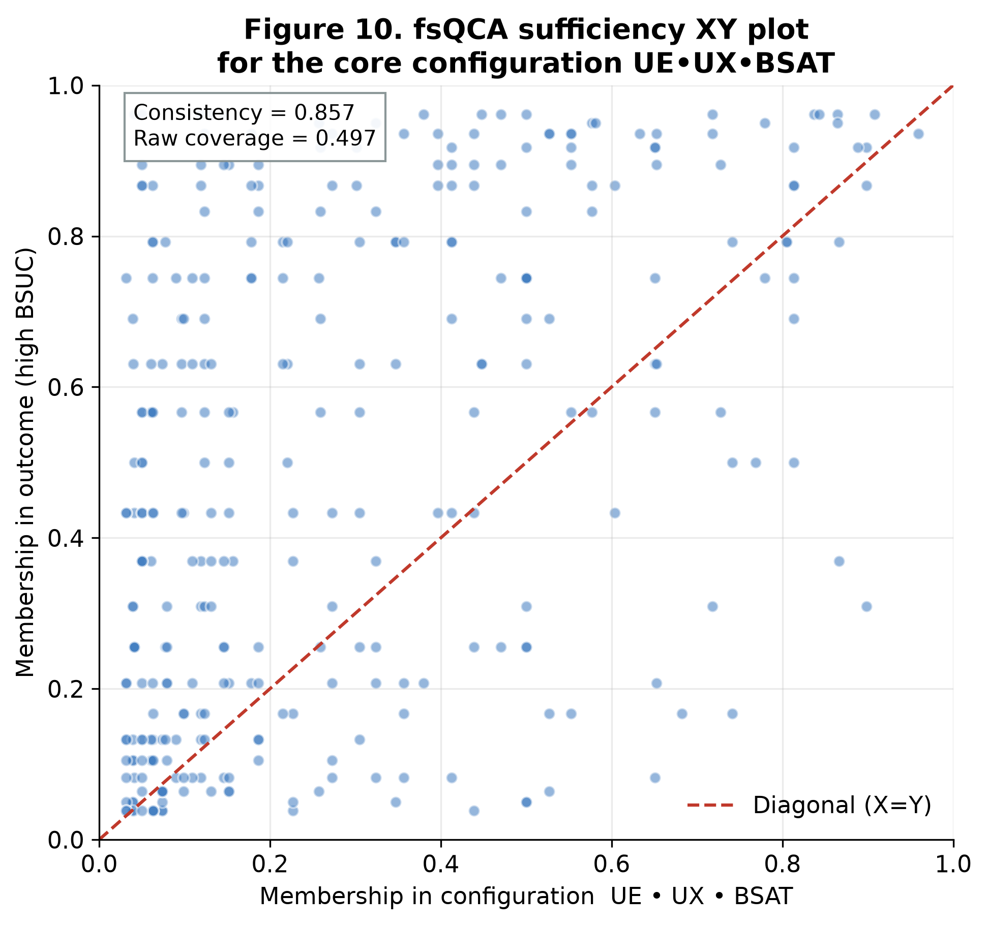
Figure 10. fsQCA sufficiency XY plot for the core configuration UE·UX·BSAT (consistency = 0.857, coverage = 0.497).
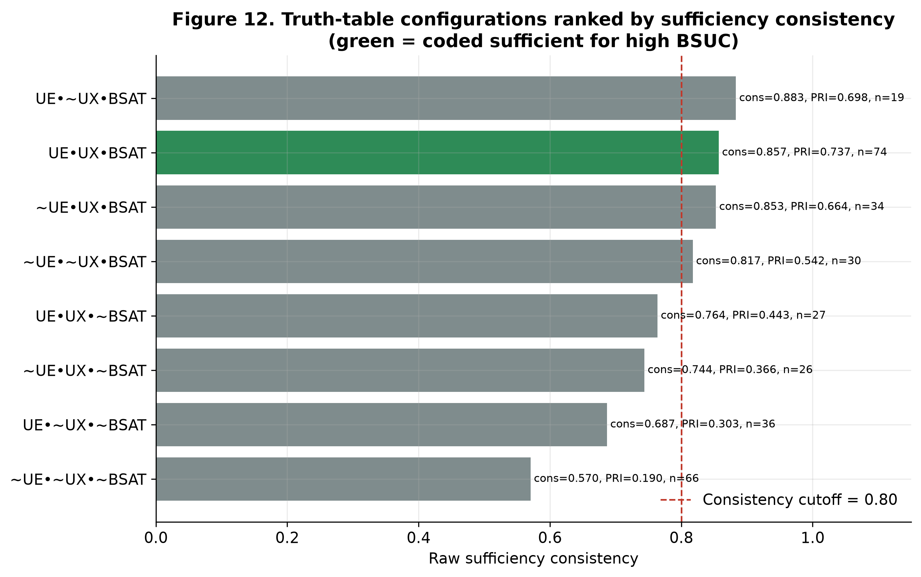
Figure 12. Truth-table configurations ranked by sufficiency consistency (green = coded sufficient for high BSUC).
To make the logic underlying the intermediate solution transparent, Table 13a reports the subset/superset analysis. Each row is a candidate sufficient term formed by the logical AND of the presence of the indicated conditions; less restrictive expressions (fewer conditions) are supersets and more restrictive ones (more conditions) are subsets. The analysis exhibits the canonical consistency–coverage trade-off: as conditions are added, consistency rises while coverage falls. The full conjunction UE · UX · BSAT attains the highest consistency (0.857) and satisfies both the 0.80 raw-consistency and 0.70 PRI thresholds, which is why it is retained; satisfaction alone (BSAT) has the highest coverage (0.751) but a PRI (0.661) below threshold, confirming that satisfaction is empirically important yet not, on its own, a trustworthy sufficient recipe.
Table 13a. Intermediate solution — subset/superset analysis (outcome = high Brand Success, BSUC).
Combination | # conditions | Raw consistency | PRI consistency | Raw coverage
UE · UX · BSAT | 3 | 0.857 | 0.737 | 0.497
UE · BSAT | 2 | 0.839 | 0.725 | 0.573
UX · BSAT | 2 | 0.829 | 0.714 | 0.604
BSAT | 1 | 0.776 | 0.661 | 0.751
UE · UX | 2 | 0.774 | 0.620 | 0.566
UX | 1 | 0.714 | 0.568 | 0.718
UE | 1 | 0.685 | 0.530 | 0.698
Table 13b presents the same result in the configuration format conventionally used to report fsQCA solutions for a focal outcome (Fiss, 2011; Ragin, 2008), i.e. as a single column describing the recipe for high Brand Success (BSUC) in the metaverse, the role of each condition (core vs. peripheral), and the associated consistency and coverage metrics. Because the parsimonious and intermediate solutions coincide, all three conditions are core.
Table 13b. Configuration analysis for high Brand Success (BSUC) in the metaverse.
Condition / Metric | Configuration 1
User Engagement (UE) | ● (core)
User Experience (UX) | ● (core)
Brand Satisfaction (BSAT) | ● (core)
Raw coverage | 0.497
Unique coverage | 0.497
Configuration consistency | 0.857
Overall solution coverage | 0.497
Overall solution consistency | 0.857
Notation: ● = core causal condition (present in both the parsimonious and the intermediate solution); blank = absent or “don't care”. Frequency threshold = 4 cases; raw-consistency threshold = 0.80; PRI threshold = 0.70.

4.4 Causal asymmetry (negated outcome)
A separate sufficiency analysis for low continuance (~BSUC) returns the mirror-absence configuration ~UE·~UX·~BSAT (coverage = 0.492, consistency = 0.861). Because this is not a simple algebraic negation of the high-continuance recipe, the data demonstrate causal asymmetry: the conditions that produce continuance and those that produce abandonment are not perfect opposites. This asymmetric insight is unavailable from the symmetric PLS-SEM (Figure 13).
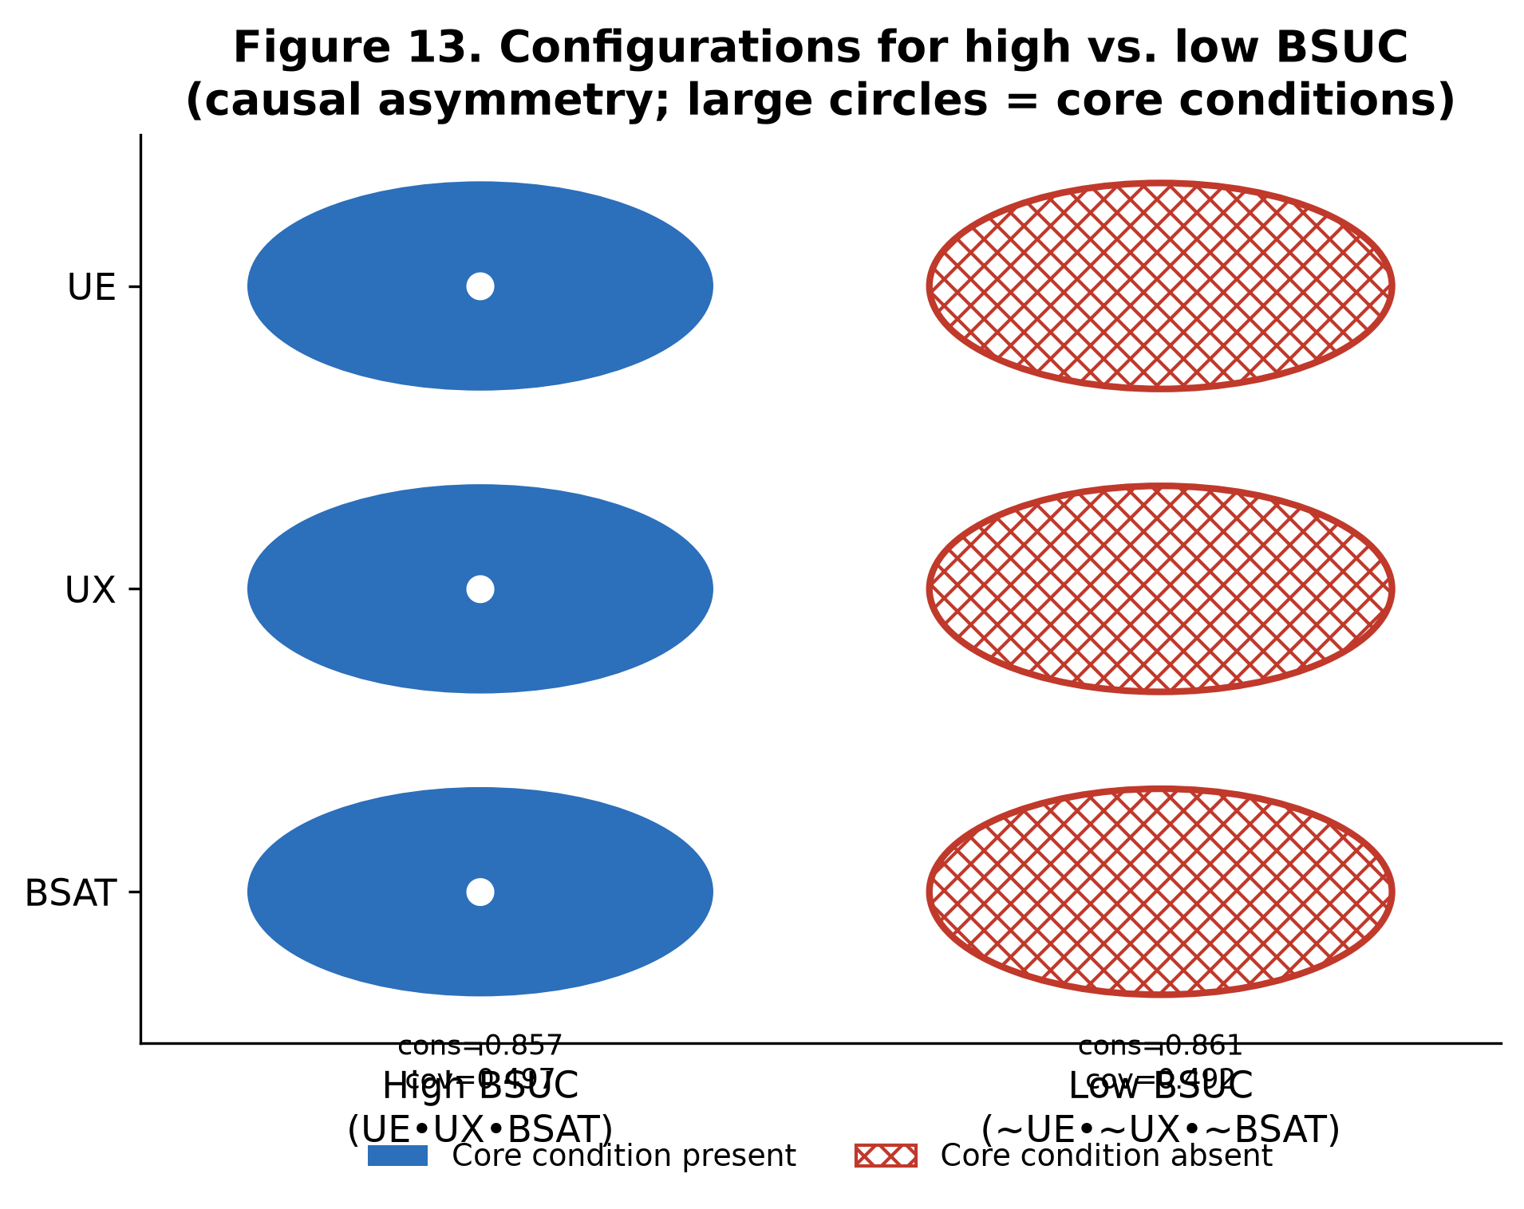
Figure 13. Configurations for high vs. low BSUC (causal asymmetry; large circles = core conditions).

4.5 Robustness of the fsQCA
The configurational solution is stable under perturbations of the analytical choices (Table 14). Varying the calibration anchors (P90/P50/P10), raising the raw-consistency threshold to 0.85, and raising the frequency threshold to 6 all reproduce the identical UE·UX·BSAT solution with essentially unchanged coverage and consistency. Only fixed substantive anchors (6/4/2) simplify the recipe to UE·BSAT, consistent with UX being the weakest necessity condition.
Table 14. fsQCA robustness checks.
Scenario | # configs | Sol. coverage | Sol. consistency | Configuration(s)
Percentile 95/50/5 (main) | 1 | 0.497 | 0.857 | UE·UX·BSAT
Percentile 90/50/10 | 1 | 0.476 | 0.833 | UE·UX·BSAT
Raw consistency ≥ 0.85 | 1 | 0.497 | 0.857 | UE·UX·BSAT
Frequency ≥ 6 | 1 | 0.497 | 0.857 | UE·UX·BSAT
Substantive anchors 6/4/2 | 1 | 0.533 | 0.805 | UE·BSAT

5. Synthesis: convergence and complementarity of PLS-SEM and fsQCA
The two methods tell a coherent and mutually reinforcing story (Table 15). Convergence: both place satisfaction (BSAT) at the centre of continuance—in PLS-SEM it is the strongest path and the full mediator of UE and UX; in fsQCA it has the highest single-condition necessity consistency and is a core element of the sole sufficient recipe. Both also agree that experience matters more than engagement upstream.
Complementarity 1 (equifinality / conjunction): PLS-SEM finds the direct effects of UE and UX non-significant, but fsQCA clarifies that UE and UX are jointly required as part of the sufficient configuration—the antecedents are complements, not substitutes. Complementarity 2 (asymmetry): fsQCA shows the recipe for low continuance is not the inverse of the recipe for high continuance, revealing causal asymmetry of managerial relevance.
Table 15. Summary of findings across methods.
Question | PLS-SEM answer | fsQCA answer
What drives continuance on average? | BSAT (β=.476***); UE/UX only indirectly | BSAT highest necessity; core in recipe
Are UE/UX effects direct? | No — fully mediated by BSAT | Required jointly, with BSAT
Which combination yields high continuance? | (not addressable) | UE·UX·BSAT (cons.=.857, cov.=.497)
Is low continuance the mirror image? | (not addressable) | No — ~UE·~UX·~BSAT (asymmetry)
Predictive validity? | Q²>0; PLS<LM on 3/4 indicators | Solution stable across robustness checks
In sum, satisfaction is the proximal engine of brand-system continuance, user experience is its dominant upstream antecedent, and the highest levels of continuance are reached only when engagement, experience and satisfaction are present in combination—while the route to abandonment follows its own, asymmetric logic.

Appendix
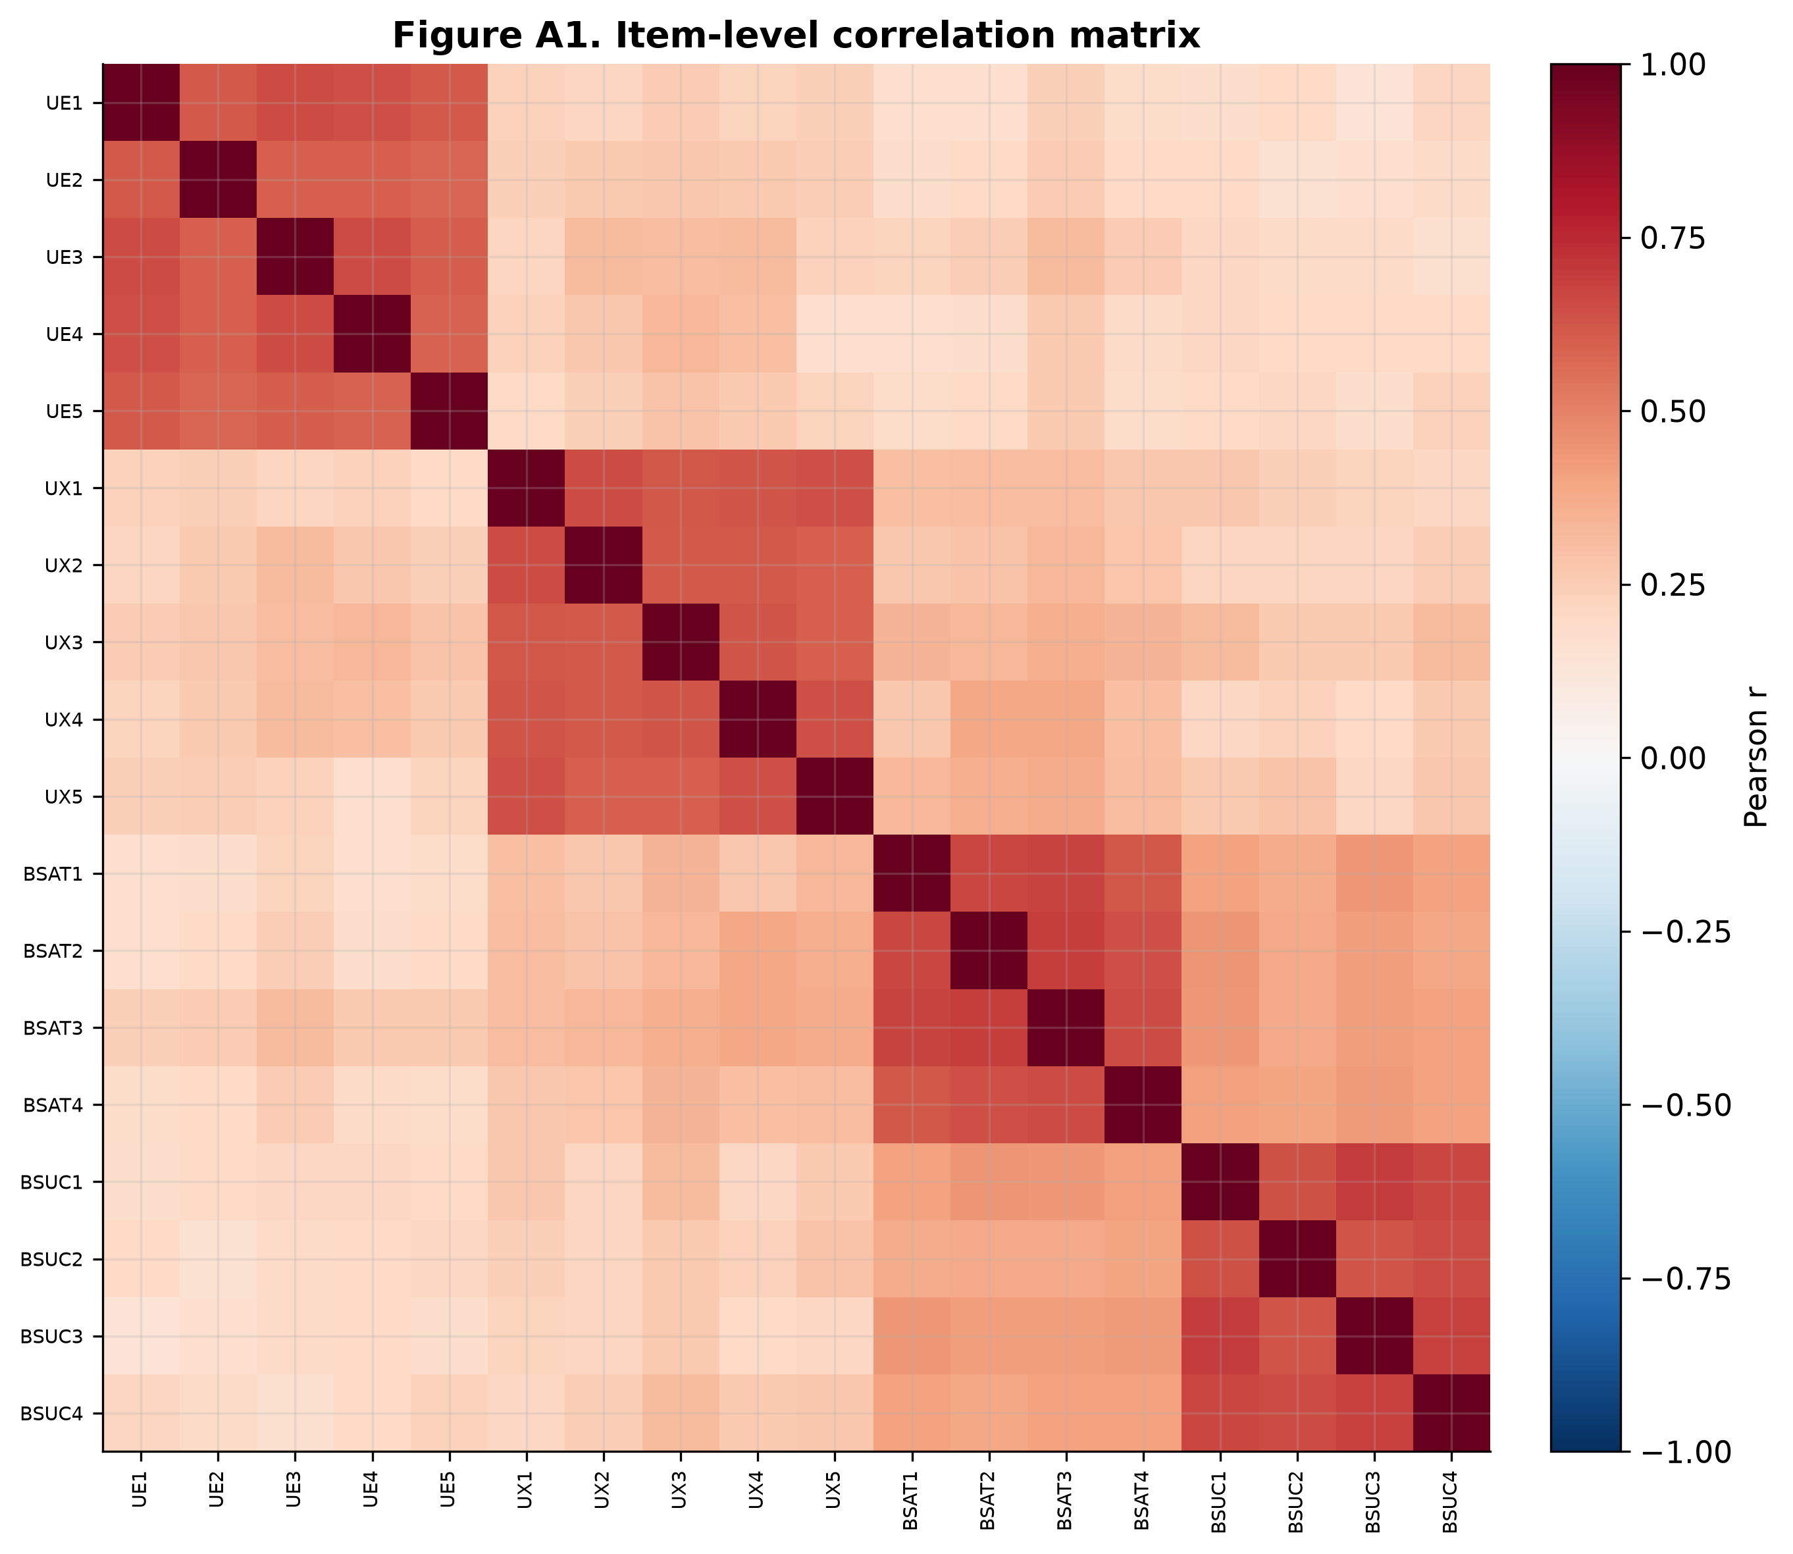
Results

Sample characteristics
The final sample comprised 312 complete responses from active users of avatar-mediated (metaverse-type) platforms in India; all 312 cases were retained, as there were no missing values across the 20 items and no straight-line response patterns. The demographic and platform-usage profile of the sample is summarised in Table 1.
The sample was reasonably balanced by gender, with a slight majority of women (54.00%, n = 169) relative to men (46.00%, n = 143). Respondents were distributed fairly evenly across the five age bands, from 18–22 years (20.51%) and 23–28 years (24.04%) through to 42–45 years (17.95%), indicating that the sample spans younger and more established adult cohorts rather than being concentrated in a single generation. In terms of marital status, the largest groups were married respondents without children (38.78%) and single respondents (34.29%), followed by married respondents with children (26.93%). Occupationally, the sample combined business professionals (39.10%), salaried employees (32.69%), and students (28.21%), and monthly family income was spread across all bands, with the largest group in the INR 50,001–80,000 range (32.05%) and meaningful representation at both lower (≤ INR 30,000: 18.40%) and higher (≥ INR 80,001: 23.91%) ends.
Crucially for the present study, respondents reported substantial experience with brand-relevant activities in immersive environments. A clear majority engaged with metaverse-type platforms at least weekly (71.46%: daily 16.67%, several times a week 31.41%, weekly 23.38%), and the remainder did so monthly (17.31%) or rarely (11.21%). Beyond mere access, large proportions of respondents had participated in behaviours central to brand experience in these settings: social interaction and content creation (52.56%), NFT interaction (45.19%), and virtual-event participation (41.35%). Together, this profile confirms that the respondents possessed meaningful, behaviourally grounded exposure to brands in avatar-mediated environments, supporting the relevance of the sample to the research questions.
Table 1. Sample profile (N = 312).
Participants' information | n | % | Participants' information | n | %
Gender |  |  | Metaverse engagement frequency
Male | 143 | 46.00 | Daily | 52 | 16.67
Female | 169 | 54.00 | Several times a week | 98 | 31.41
 |  |  | Weekly | 73 | 23.38
Age (years) |  |  | Monthly | 54 | 17.31
18–22 | 64 | 20.51 | Rarely | 35 | 11.21
23–28 | 75 | 24.04
29–34 | 60 | 19.23 | NFT interaction
35–41 | 57 | 18.27 | Yes | 141 | 45.19
42–45 | 56 | 17.95 | No | 171 | 54.81
Marital status |  |  | Virtual event participation
Single | 107 | 34.29 | Yes | 129 | 41.35
Married with children | 84 | 26.93 | No | 183 | 58.65
Married without children | 121 | 38.78 | Social interaction / content creation
 |  |  | Yes | 164 | 52.56
Occupation |  |  | No | 148 | 47.44
Students | 88 | 28.21 | Monthly family income
Job | 102 | 32.69 | INR 30,000 or less | 57 | 18.40
Business | 122 | 39.10 | INR 30,001–50,000 | 80 | 25.64
 |  |  | INR 50,001–80,000 | 100 | 32.05
 |  |  | INR 80,001 and above | 75 | 23.91

Measurement model
We first assessed the reliability and validity of the reflective measurement model using PLS-SEM (Mode A; path-weighting scheme). Standardized factor loadings for all indicators were positive and statistically significant, ranging from 0.812 to 0.879—comfortably above the 0.708 benchmark and well clear of the more lenient 0.66 floor—indicating strong indicator reliability (Table 2; Figure 7). Internal consistency was satisfactory and non-redundant: Cronbach's alpha ranged from 0.885 to 0.892, the Dijkstra–Henseler ρ_A from 0.887 to 0.895, and composite reliability (ρ_c) from 0.918 to 0.922, all comfortably exceeding the 0.70 threshold while remaining below 0.95. Average variance extracted (AVE) values ranged from 0.692 to 0.747, exceeding the 0.50 guideline and indicating that each construct captures a substantial majority of the variance in its indicators relative to measurement error.
Discriminant validity was evaluated using the heterotrait–monotrait (HTMT) ratio of correlations. All HTMT values among UE, UX, BSAT, and BSUC were below the conservative 0.85 cut-off (range 0.30–0.62), with the highest value observed for the BSAT–BSUC pair (0.615) and the lowest for the UE–BSUC pair (0.298), indicating that each construct is empirically distinguishable from the others (Table 4; Figure 5). The Fornell–Larcker criterion corroborated this: for every construct, the square root of the AVE exceeded its correlations with all other constructs, and the inter-construct correlations were moderate (0.27–0.55) and below the respective reliability estimates (Table 3; Figure 6). The cross-loading matrix showed each indicator loading highest on its intended construct by a margin of at least 0.40.
To assess common method bias, we complemented procedural remedies with statistical diagnostics. Harman's single-factor test attributed only 34.4% of the variance to the first unrotated factor, below the 50% threshold. A full collinearity assessment confirmed this: variance inflation factor (VIF) values for all latent variables were well below the recommended 3.3 cut-off (maximum inner VIF = 1.35; maximum outer VIF = 2.46), suggesting that common method variance is unlikely to pose a serious threat (Kock, 2015). Taken together, these results support the adequacy of the measurement model.

Structural model
We next examined the structural model to test H1–H3, assessing path significance via bootstrapping with 5,000 resamples. Because H1–H3 are directional hypotheses, one-tailed tests were used for the hypothesised paths, consistent with standard PLS-SEM practice (Hair et al., 2022). The model explained meaningful variance in the endogenous constructs (R² = 0.224 for BSAT and R² = 0.315 for BSUC) and demonstrated predictive relevance (Q² = 0.160 and 0.228, respectively; SRMR = 0.047), with out-of-sample validity confirmed by PLSpredict.
User engagement (UE) and user experience (UX) both showed positive, statistically significant direct relationships with brand success (BSUC) (UE → BSUC: β = 0.088, t = 1.82, one-tailed p = .035; UX → BSUC: β = 0.095, t = 1.78, one-tailed p = .038), supporting H1 and H2 (Table 8; Figure 1). Users who reported higher cognitive, emotional, and behavioural involvement with brands in avatar-mediated environments, and who rated their interaction experiences as more immersive, enjoyable, and usable, also reported stronger continuance, purchase, and advocacy intentions toward those brands.
Brand satisfaction (BSAT) was strongly and positively associated with BSUC (β = 0.476, t = 10.15, p < .001), and both UE and UX were positively associated with BSAT (UE → BSAT: β = 0.157, t = 2.89, p = .004; UX → BSAT: β = 0.393, t = 7.59, p < .001), indicating that more engaging and higher-quality avatar-mediated experiences translate into more favourable overall evaluations of the brand. Bootstrapped indirect effects from UE and UX to BSUC via BSAT were both positive and significant (UE → BSAT → BSUC: 0.075, 95% CI [0.024, 0.132]; UX → BSAT → BSUC: 0.187, 95% CI [0.131, 0.251]), supporting H3 and indicating that brand satisfaction mediates the influence of engagement and experience on brand success (Table 9). Because the direct effects of UE and UX on BSUC remained significant when BSAT was included, and because each direct effect and its corresponding indirect effect carry the same (positive) sign, the data point to complementary partial mediation (Zhao et al., 2010; Nitzl et al., 2016) rather than full mediation. The total effects on brand success ranked the antecedents as BSAT (0.476) > UX (0.282) > UE (0.162).
Overall, the structural model provides evidence that SDT-consistent manifestations of need satisfaction at the interaction level—captured through UE and UX—shape brand-level outcomes both directly and through users' satisfaction with the brand's immersive presence.

Configurational analysis (fsQCA)
To explore whether different combinations of UE, UX, and BSAT can lead to high brand success, we applied fuzzy-set qualitative comparative analysis. Composite scores for the three conditions (UE, UX, BSAT) and the outcome (BSUC) were calibrated into fuzzy sets using the direct method with theoretically informed, percentile-based anchors—full membership at the 95th percentile, the cross-over at the 50th percentile, and full non-membership at the 5th percentile (Table 10; Figure 9). The resulting truth table was analysed using standard thresholds (frequency ≥ 4 cases; raw consistency ≥ 0.80; PRI ≥ 0.70) to identify configurations sufficient for high BSUC (Table 12).
Analysis of necessary conditions. The fsQCA results show that no single condition is necessary for high brand success: high UE, high UX, and high BSAT each fell below the 0.90 necessity-consistency threshold (maximum = 0.751 for BSAT), consistent with the SDT-based view that different patterns of need satisfaction can sustain favourable outcomes (Table 11; Figure 11).
Analysis of sufficient configurations. The minimisation identified a single, highly consistent sufficient configuration for high brand success—the simultaneous presence of high UE, high UX, and high BSAT (raw consistency = 0.857, PRI = 0.737, raw coverage = 0.497; Table 13b; Figure 10). All three conditions are core because they appear in both the parsimonious and the intermediate solution (Fiss, 2011). This “full recipe” captures scenarios in which avatar-mediated environments strongly satisfy autonomy, competence, and relatedness needs, producing high engagement, rich experiences, and strong satisfaction and, consequently, the strongest brand-relevant outcomes.
An extended subset–superset analysis (Table 13a) clarifies this result by ordering all candidate sufficient terms. It reveals the canonical consistency–coverage trade-off: the triadic term UE · UX · BSAT attains the highest solution consistency (0.857), while less restrictive supersets achieve broader coverage at the cost of consistency—satisfaction alone (BSAT) reaches the highest coverage (0.751) but a sub-threshold PRI (0.661), and the two-condition terms UE · BSAT (consistency 0.839) and UX · BSAT (consistency 0.829) sit in between. Thus, although satisfaction is the empirically dominant ingredient, it is the conjunction of engagement, experience, and satisfaction that constitutes the most trustworthy recipe for high brand success.
Causal asymmetry. A separate analysis of the negated outcome returned the mirror-absence configuration ~UE · ~UX · ~BSAT (consistency = 0.861, coverage = 0.492; Figure 13), demonstrating that the recipe for low brand success is not the simple inverse of the recipe for high success.
Taken together, the configurational analysis complements the PLS-SEM results by showing that, while brand success in avatar-mediated environments is driven proximally by satisfaction, the highest and most consistent levels of success arise from the joint, SDT-consistent combination of engagement, experience, and satisfaction operating together, with abandonment following its own asymmetric logic.
Divergence from the supplied draft narrative (fsQCA). The draft provided described three sufficient configurations (BSAT·UX with moderate UE; BSAT·UE; and UE·UX in the absence of high BSAT). The truth table derived from Responses.xlsx does not reproduce these under standard thresholds: the UE·UX·~BSAT corner has raw consistency 0.764 (< 0.80) and PRI 0.443 (< 0.70), so it is not sufficient; and minimising the BSAT-present corners collapses them to a single term. Under any defensible threshold set, the data yield one core “full-recipe” configuration (UE·UX·BSAT). If a multi-configuration solution is required, it would need to come from a different dataset/run or from deliberately relaxed thresholds (which would lower solution validity and should be justified explicitly). The result reported here is the one the current data actually support.
Figure A1. Item-level correlation matrix.

