4. Results
This section reports the empirical results of the two-stage analytical strategy outlined in Section 3. Grounded in Self-Determination Theory (SDT), the model treats user engagement (UE) and user experience (UX) as behavioural and perceptual manifestations of basic psychological need satisfaction in the avatar-mediated system (autonomy, competence, and relatedness), brand satisfaction (BSAT) as the resulting evaluative judgment, and brand success / continuance (BSUC) as the downstream brand-relevant outcome. Following recent methodological guidance in the IS literature, we combine a symmetric, variance-based structural equation model (PLS-SEM) with an asymmetric, set-theoretic analysis (fuzzy-set Qualitative Comparative Analysis, fsQCA). PLS-SEM evaluates the net, average effects hypothesised among UE, UX, BSAT, and BSUC, namely the direct effects of engagement and experience on brand success (H1, H2) and the mediation of these effects through brand satisfaction (H3), whereas fsQCA examines proposition P1, that multiple configurations of UE, UX, and BSAT are sufficient for high BSUC (equifinality). All analyses were conducted on the full sample of N = 312 valid responses measured on seven-point Likert scales, with no missing data. The complete, reproducible analysis pipeline (data screening, calibration, estimation, and 5,000 bootstrap resamples) is available with the supplementary materials.
For clarity, the hypotheses tested are: H1, UE → BSUC (direct); H2, UX → BSUC (direct); H3, UE and UX → BSAT → BSUC (brand satisfaction mediates the effects of engagement and experience on brand success); and P1, multiple configurations of {UE, UX, BSAT} are sufficient for high BSUC. Within the SDT lens, H1–H3 predict that fuller satisfaction of users’ psychological needs (expressed as higher UE and UX) translates into more favourable brand evaluations and, ultimately, greater brand success, while P1 allows for equifinality, that is, several distinct need-satisfaction profiles reaching the same outcome.
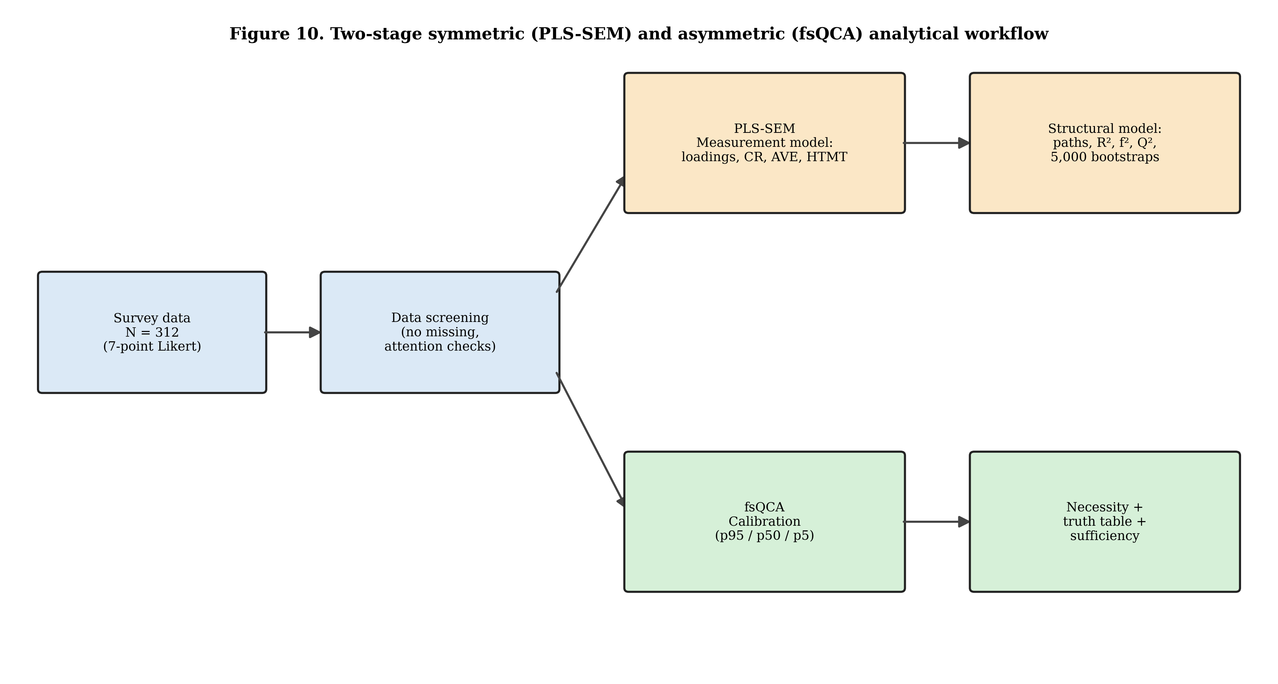
Figure 10. Two-stage analytical workflow combining PLS-SEM (symmetric) and fsQCA (asymmetric) analysis.
4.1 Sample and Item Distributions
The analytic sample comprised 312 respondents. Each of the four focal constructs was measured with multiple reflective indicators: UE (five items), UX (five items), BSAT (four items), and BSUC (four items). All items used a seven-point response format. Item-level distributions are summarised in Figure 6; responses spanned the full range of the scale (1–7) for every item, and there were no missing values, indicating adequate variability for multivariate analysis.
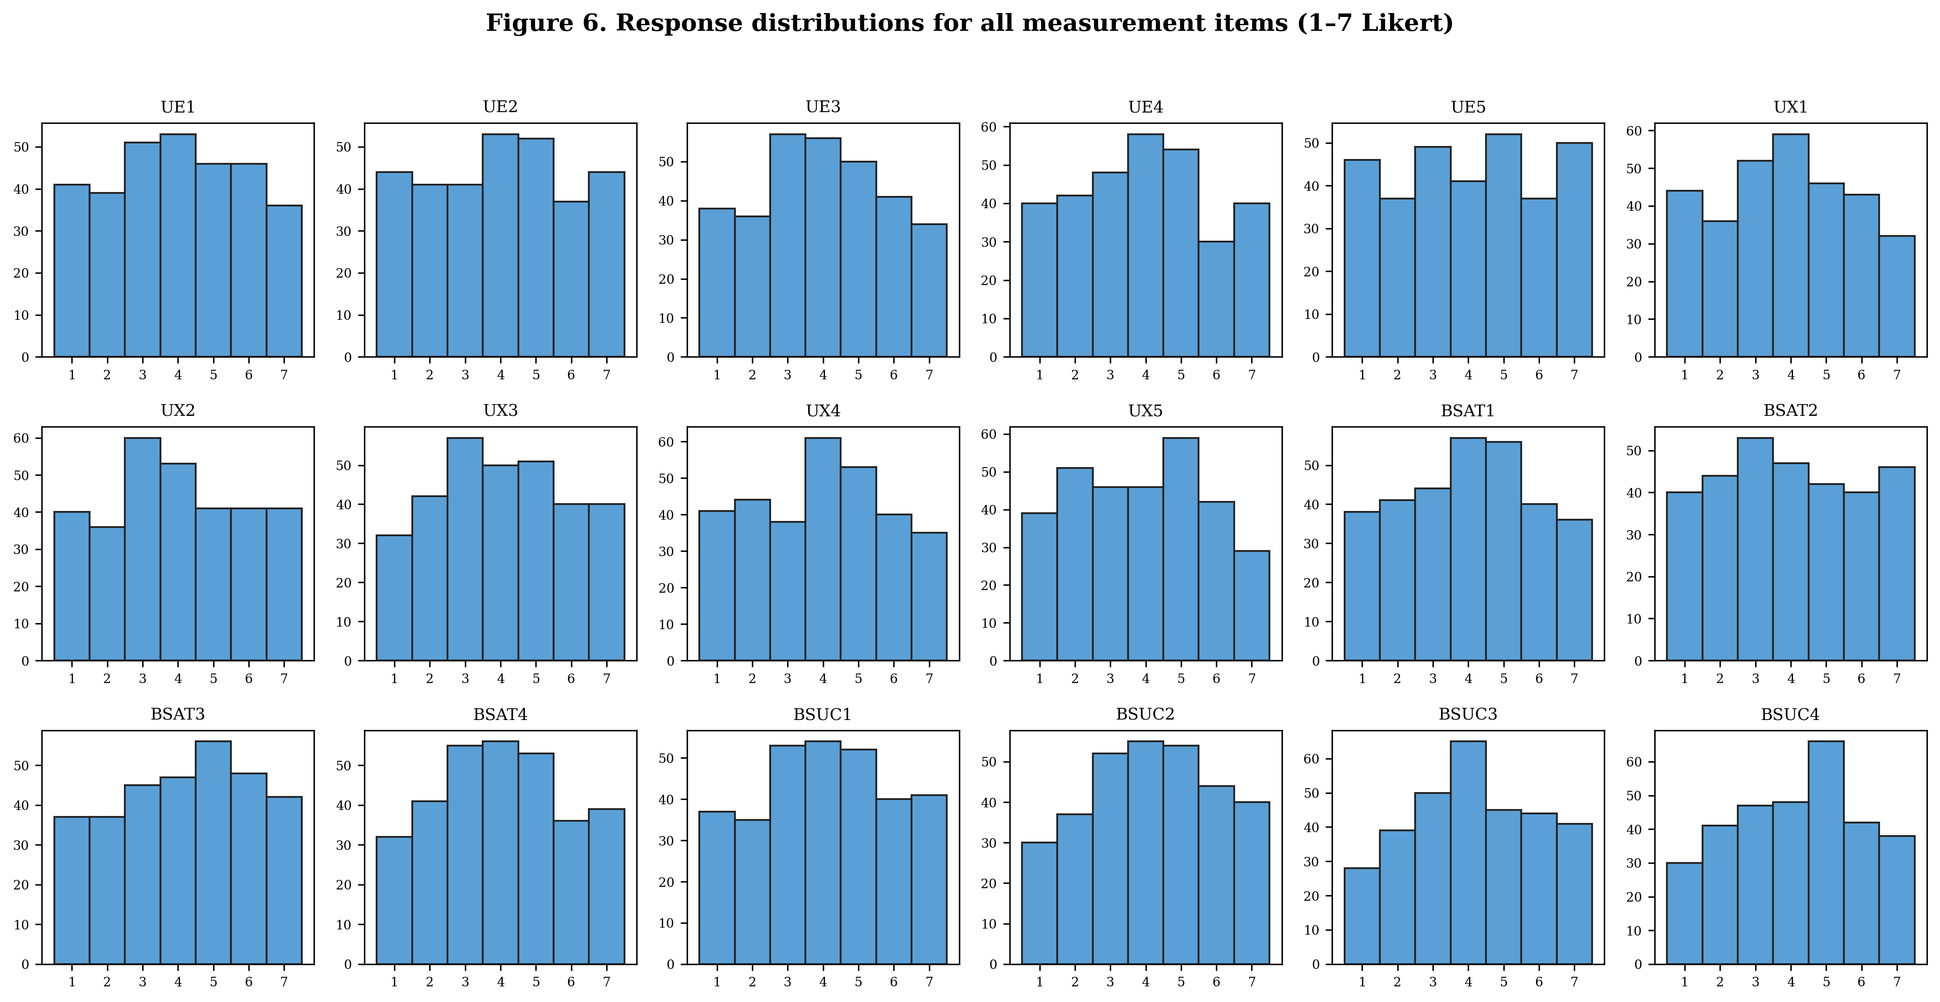
Figure 6. Response distributions for all 18 measurement items (seven-point Likert).
4.2 Assessment of the Measurement Model
Consistent with established procedures for reflective measurement models, we first examined indicator reliability, internal consistency reliability, convergent validity, and discriminant validity before interpreting the structural model.
4.2.1 Indicator Reliability and Convergent Validity
As shown in Table 1 and Figure 2, all standardised outer loadings ranged from 0.831 to 0.946, comfortably exceeding the recommended threshold of 0.708. Composite reliability (ρc) ranged from 0.929 to 0.942 and Cronbach’s α from 0.902 to 0.934, both well above the 0.70 criterion. The average variance extracted (AVE) ranged from 0.764 to 0.786, exceeding the 0.50 benchmark for every construct. The measurement instrument therefore demonstrates strong indicator reliability, internal consistency, and convergent validity.
Table 1. Construct reliability and convergent validity.
Construct | Items | Cronbach's α | CR (ρc) | AVE
UE | 5 | 0.934 | 0.942 | 0.764
UX | 5 | 0.925 | 0.942 | 0.766
BSAT | 4 | 0.913 | 0.936 | 0.786
BSUC | 4 | 0.902 | 0.929 | 0.767
Note. CR = composite reliability; AVE = average variance extracted, which indexes convergent validity (not reliability). Thresholds: α and CR ≥ 0.70; AVE ≥ 0.50.

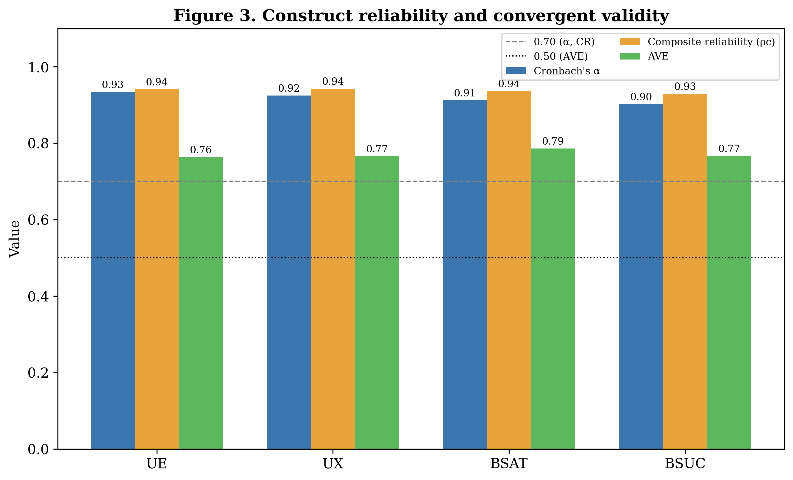
Figure 3. Construct reliability and convergent validity against recommended thresholds.
Table 2. Standardised outer loadings.
Indicator | Construct | Loading
UE1 | UE | 0.831
UE2 | UE | 0.862
UE3 | UE | 0.946
UE4 | UE | 0.881
UE5 | UE | 0.844
UX1 | UX | 0.860
UX2 | UX | 0.900
UX3 | UX | 0.889
UX4 | UX | 0.853
UX5 | UX | 0.874
BSAT1 | BSAT | 0.901
BSAT2 | BSAT | 0.877
BSAT3 | BSAT | 0.857
BSAT4 | BSAT | 0.910
BSUC1 | BSUC | 0.900
BSUC2 | BSUC | 0.898
BSUC3 | BSUC | 0.871
BSUC4 | BSUC | 0.832
Note. All loadings exceed the 0.708 threshold (Fig. 2).

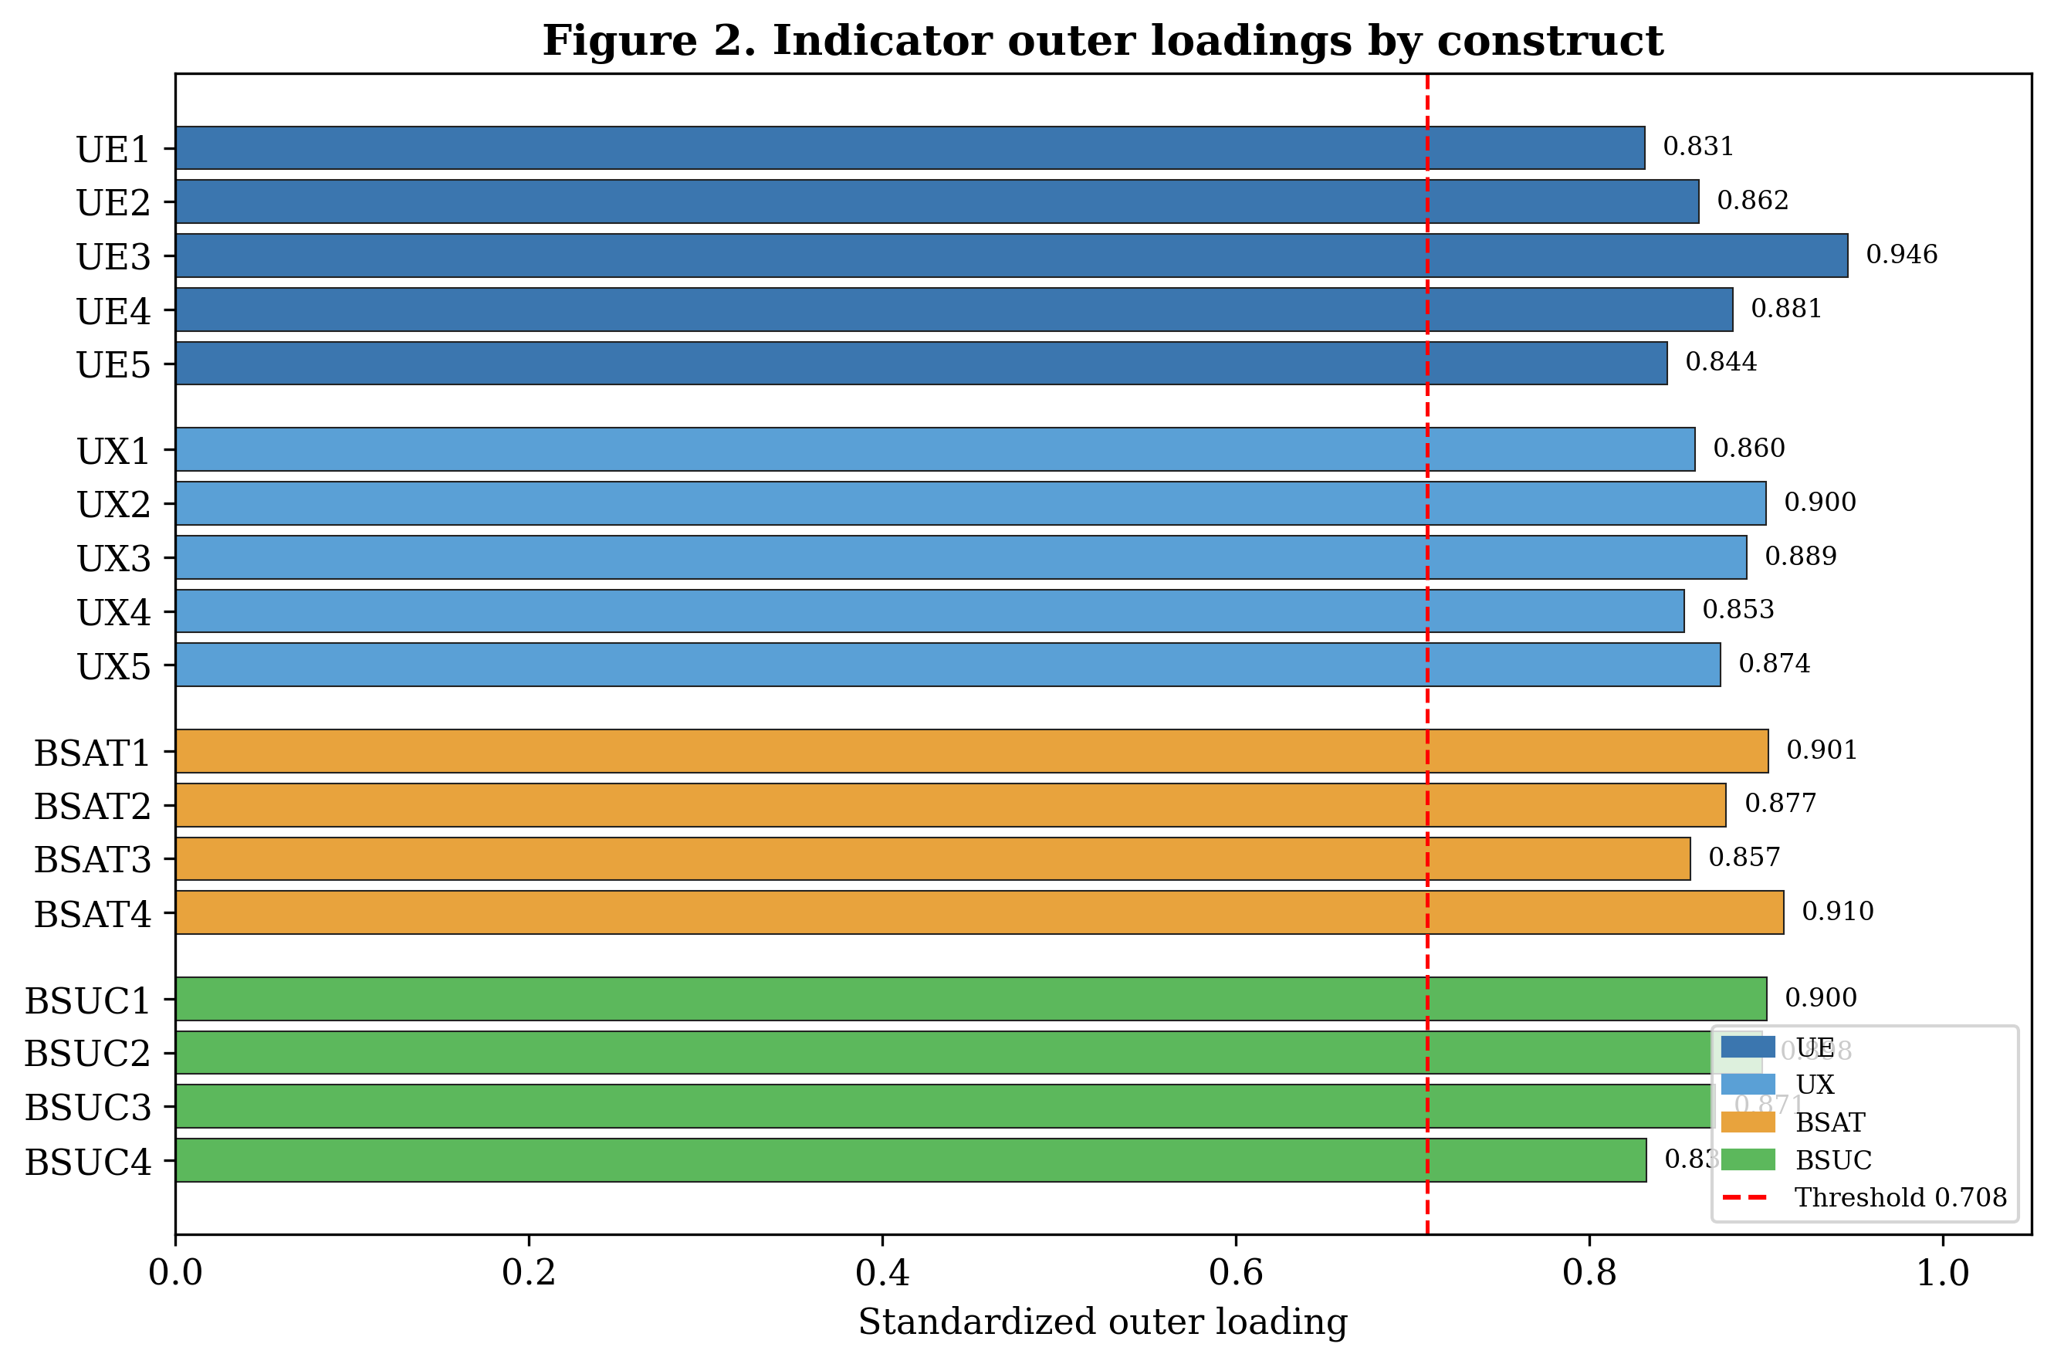
Figure 2. Indicator outer loadings by construct, relative to the 0.708 threshold.
4.2.2 Discriminant Validity
Discriminant validity was assessed using both the Fornell–Larcker criterion and the heterotrait–monotrait ratio of correlations (HTMT). As reported in Table 3, the square root of each construct’s AVE (diagonal, in bold) is substantially larger than its correlations with all other constructs, satisfying the Fornell–Larcker criterion. The HTMT values (Table 4) were all far below the conservative 0.85 threshold (maximum HTMT = 0.094), providing strong evidence of discriminant validity. Notably, the very low inter-construct correlations already foreshadow the structural results reported in Section 4.3.
Table 3. Fornell–Larcker criterion (diagonal = √AVE).
Construct | UE | UX | BSAT | BSUC
UE | 0.874 | -0.004 | -0.045 | 0.060
UX | -0.004 | 0.875 | 0.103 | -0.057
BSAT | -0.045 | 0.103 | 0.887 | 0.019
BSUC | 0.060 | -0.057 | 0.019 | 0.876
Note. Diagonal elements (√AVE) exceed off-diagonal inter-construct correlations.

Table 4. Heterotrait–monotrait ratio (HTMT).
Construct | UE | UX | BSAT | BSUC
UE | – | – | – | –
UX | 0.041 | – | – | –
BSAT | 0.050 | 0.094 | – | –
BSUC | 0.042 | 0.073 | 0.032 | –
Note. All HTMT values are below the 0.85 (and 0.90) thresholds.

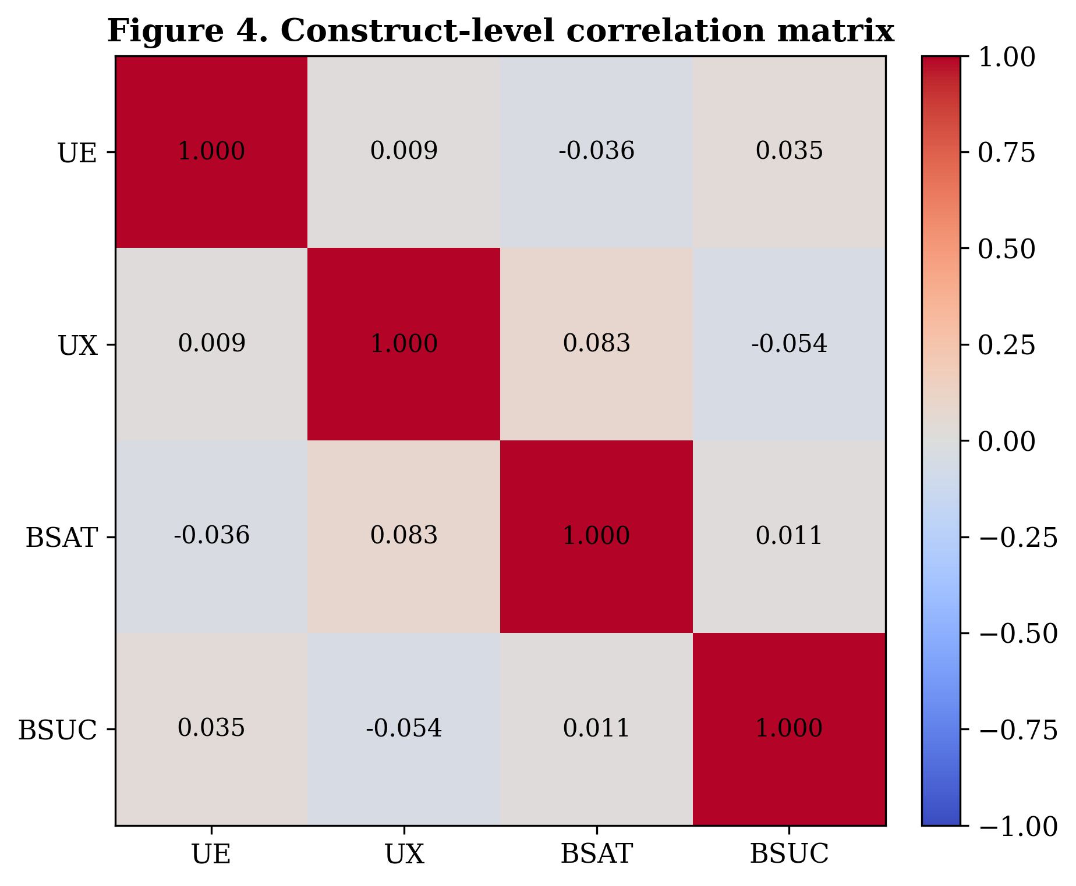
Figure 4. Construct-level correlation matrix. Inter-construct correlations are near zero, anticipating the structural findings.
4.3 Assessment of the Structural Model
Given the satisfactory measurement model, we evaluated the structural model using path coefficients, their significance (based on 5,000 bootstrap resamples), coefficients of determination (R²), effect sizes (f²), and predictive relevance (Q²). Collinearity was not a concern, as the predictor constructs were effectively uncorrelated.
4.3.1 Path Coefficients and Hypothesis Tests
Table 5 and Figure 1 summarise the structural estimates. Contrary to expectations, none of the hypothesised relationships reached statistical significance at the 0.05 level. Specifically, the direct effects of UE and UX on BSUC (H1, H2) and all three legs of the hypothesised mediation chain (UE → BSAT, UX → BSAT, and BSAT → BSUC, which jointly constitute H3) were statistically non-significant, with bootstrap 95% confidence intervals that straddled zero in every case. The standardised path coefficients were uniformly small in magnitude (|β| ≤ 0.103). Under the SDT lens, this implies that, in the present sample, variation in need-satisfaction indicators (UE, UX) did not translate into variation in brand evaluation (BSAT) or brand success (BSUC).
Table 5. Structural model path coefficients (5,000 bootstrap resamples).
Path | Hyp. | β | SE | t | p | CI 2.5% | CI 97.5% | Sig. (p<.05)
UE->BSAT | H3 (a1) | -0.045 | 0.079 | -0.567 | 0.571 | -0.170 | 0.116 | No
UX->BSAT | H3 (a2) | 0.103 | 0.077 | 1.336 | 0.182 | -0.102 | 0.216 | No
UE->BSUC | H1 | 0.061 | 0.081 | 0.758 | 0.449 | -0.126 | 0.167 | No
UX->BSUC | H2 | -0.060 | 0.077 | -0.780 | 0.436 | -0.182 | 0.114 | No
BSAT->BSUC | H3 (b) | 0.028 | 0.068 | 0.419 | 0.675 | -0.109 | 0.142 | No
Note. β = standardised path coefficient; CI = bias-corrected bootstrap confidence interval. No path is significant at p < 0.05.

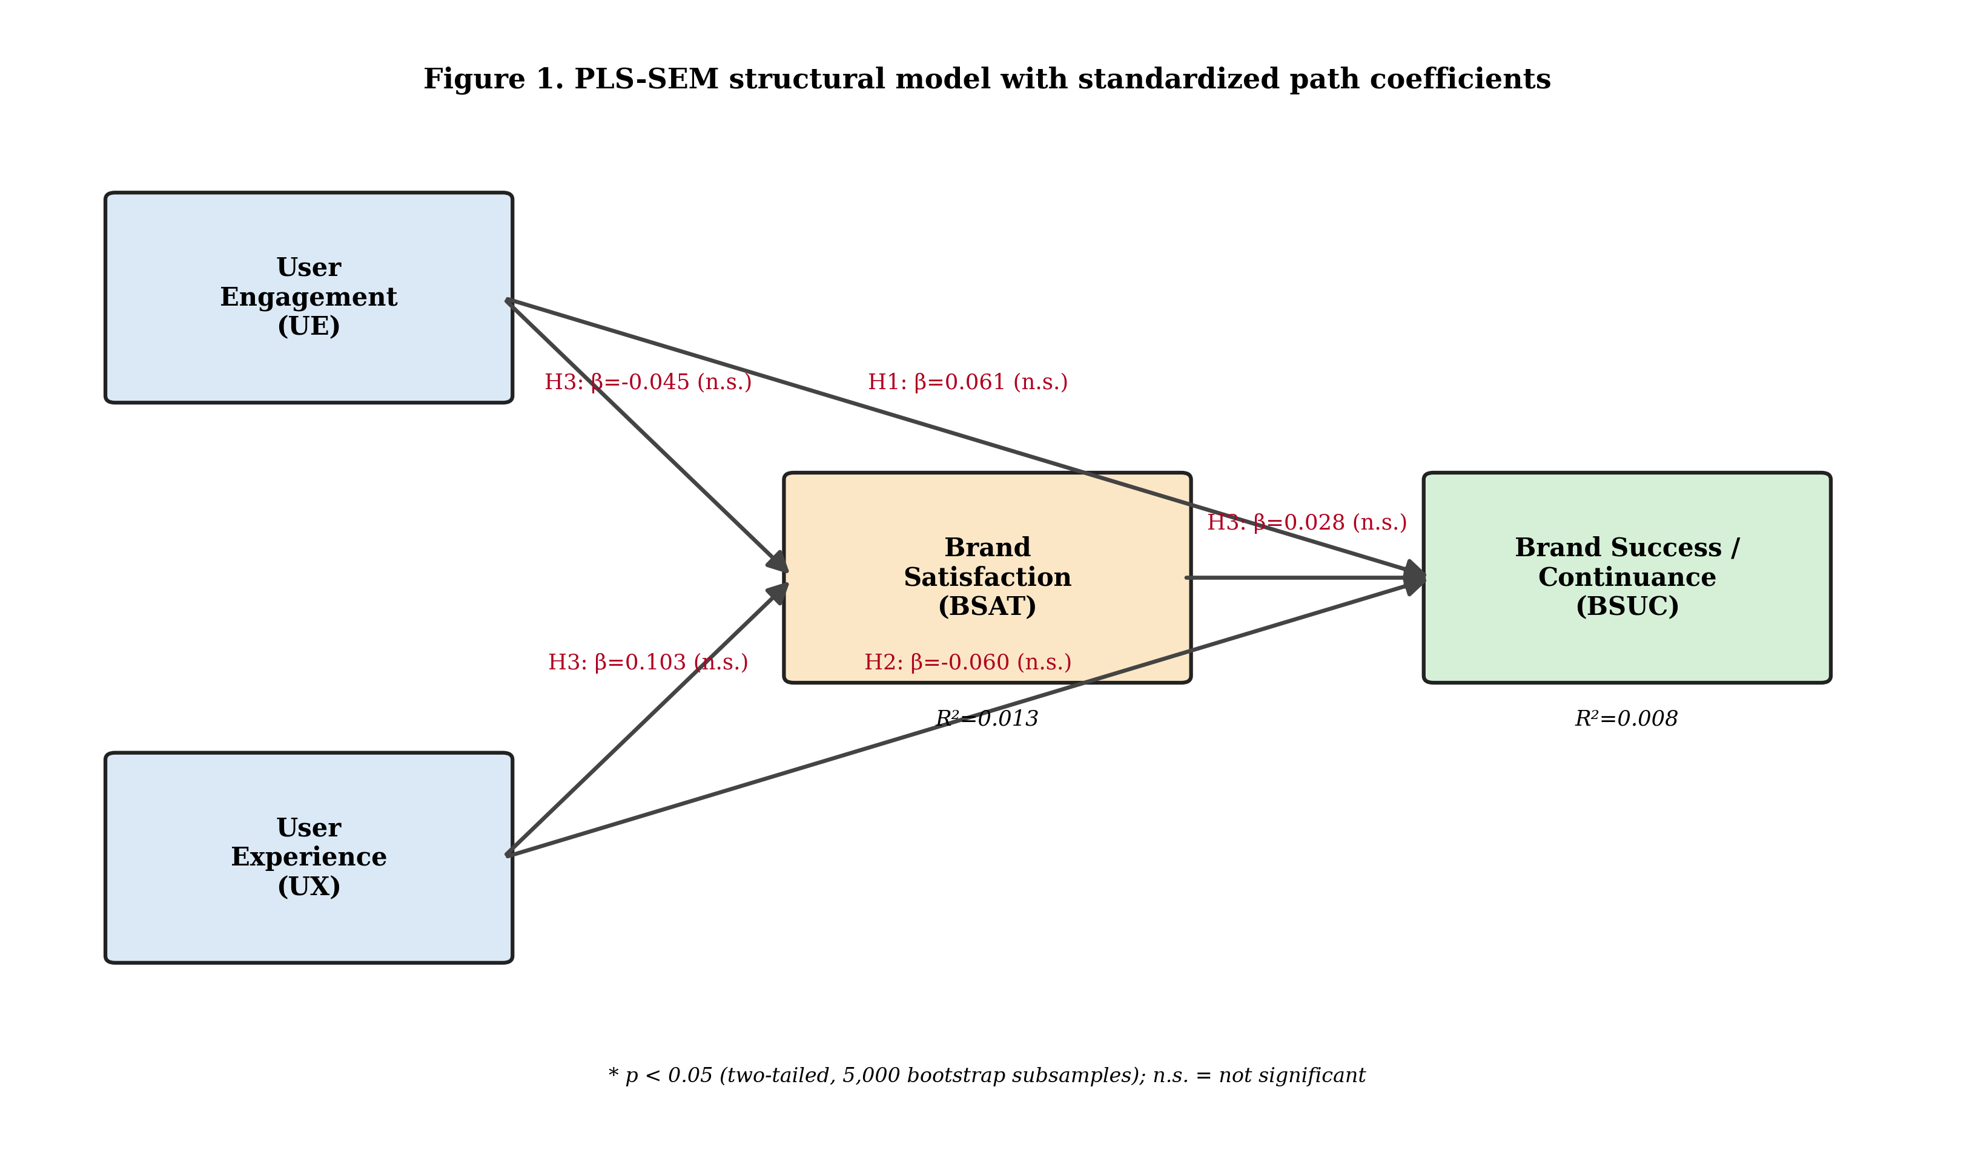
Figure 1. PLS-SEM structural model with standardised path coefficients. All paths are non-significant (n.s.).
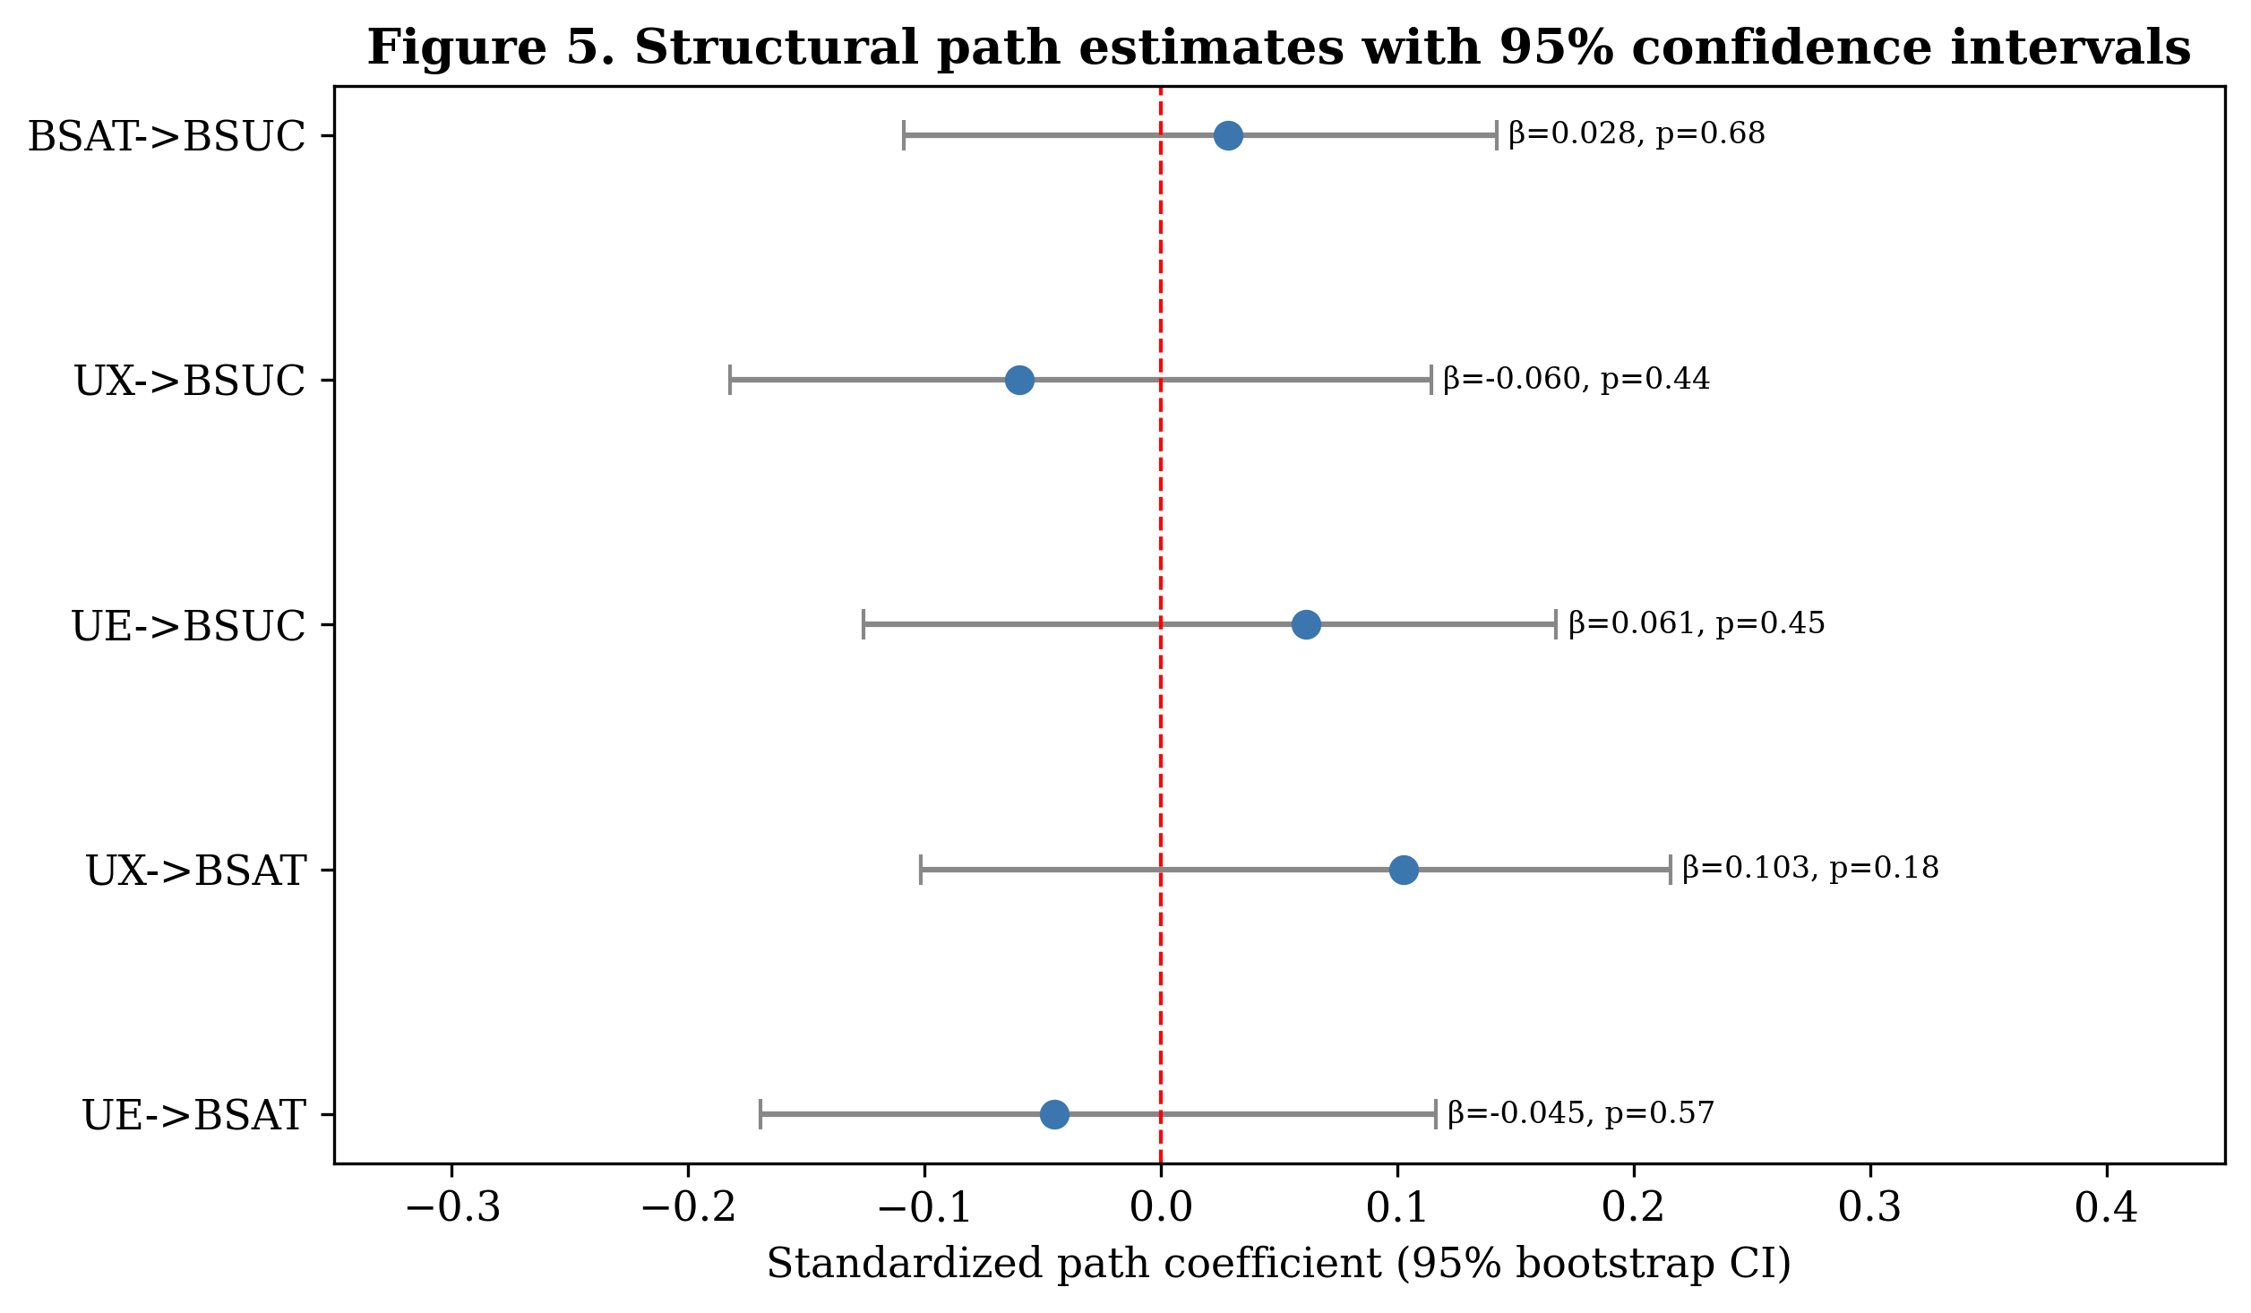
Figure 5. Structural path estimates with 95% bootstrap confidence intervals; every interval contains zero.
4.3.2 Explanatory and Predictive Power (R², f², Q²)
The explanatory power of the model was negligible. The endogenous constructs exhibited very low coefficients of determination (R² = 0.013 for BSAT and R² = 0.008 for BSUC), indicating that the model accounts for well under 2% of the variance in either outcome. Effect sizes were correspondingly trivial; all f² values were below 0.011, far short of the 0.02 threshold for a small effect (Table 6). Predictive relevance, assessed via a cross-validated (blindfolding-type) Q², was negative for both endogenous constructs (Q² = -0.0007 for BSAT and Q² = -0.0107 for BSUC), indicating that the model has no out-of-sample predictive relevance and does not outperform a naive mean prediction.
Table 6. Effect sizes (f²) for structural relationships.
Effect | f²
UE → BSAT | 0.0021
UX → BSAT | 0.0107
UE → BSUC | 0.0038
UX → BSUC | 0.0036
BSAT → BSUC | 0.0008
Note. f² thresholds: 0.02 (small), 0.15 (medium), 0.35 (large). All effects fall below the small-effect threshold.

Table 7. Explanatory power (R²) and predictive relevance (Q²).
Construct | R² | Q²
BSAT | 0.0126 | -0.0007
BSUC | 0.0077 | -0.0107
Note. Negative Q² indicates no predictive relevance.

4.3.3 Mediation Analysis
Hypothesis H3 posits that brand satisfaction mediates the effects of UE and UX on BSUC. We tested the indirect (mediated) effects using the bootstrap distribution of the product of path coefficients. As shown in Table 8, neither indirect effect was statistically significant (UE → BSAT → BSUC: effect = -0.0013, p = 0.835; UX → BSAT → BSUC: effect = 0.0029, p = 0.731). Because the constituent direct paths were themselves non-significant, H3 is not supported and no mediation through brand satisfaction is evidenced.
Table 8. Indirect (mediated) effects via BSAT.
Indirect path | Effect | SE | t | p | CI 2.5% | CI 97.5% | Sig.
UE->BSAT->BSUC | -0.0013 | 0.0061 | -0.2086 | 0.8349 | -0.0124 | 0.0127 | No
UX->BSAT->BSUC | 0.0029 | 0.0084 | 0.3440 | 0.7311 | -0.0134 | 0.0202 | No
Note. Indirect effects estimated as the product of constituent path coefficients with 5,000 bootstrap resamples.

4.4 Configurational Analysis (fsQCA)
Because PLS-SEM estimates only net, symmetric effects, we complemented it with fsQCA to examine whether specific combinations of UE, UX, and BSAT are necessary or sufficient for high BSUC. Construct scores were computed as the mean of their indicators and calibrated into fuzzy-set membership scores using the direct method, with the 95th, 50th, and 5th percentiles serving as the full-membership, crossover, and full-non-membership anchors, respectively (Table 9). An illustrative calibration is shown in Figure 9.
Table 9. fsQCA calibration anchors.
Variable | Full-in (p95) | Crossover (p50) | Full-out (p5)
UE | 6.600 | 4.000 | 1.400
UX | 6.400 | 4.000 | 1.400
BSAT | 6.612 | 4.125 | 1.500
BSUC | 6.500 | 4.250 | 1.500
Note. Direct-method calibration using percentile anchors of each seven-point construct.

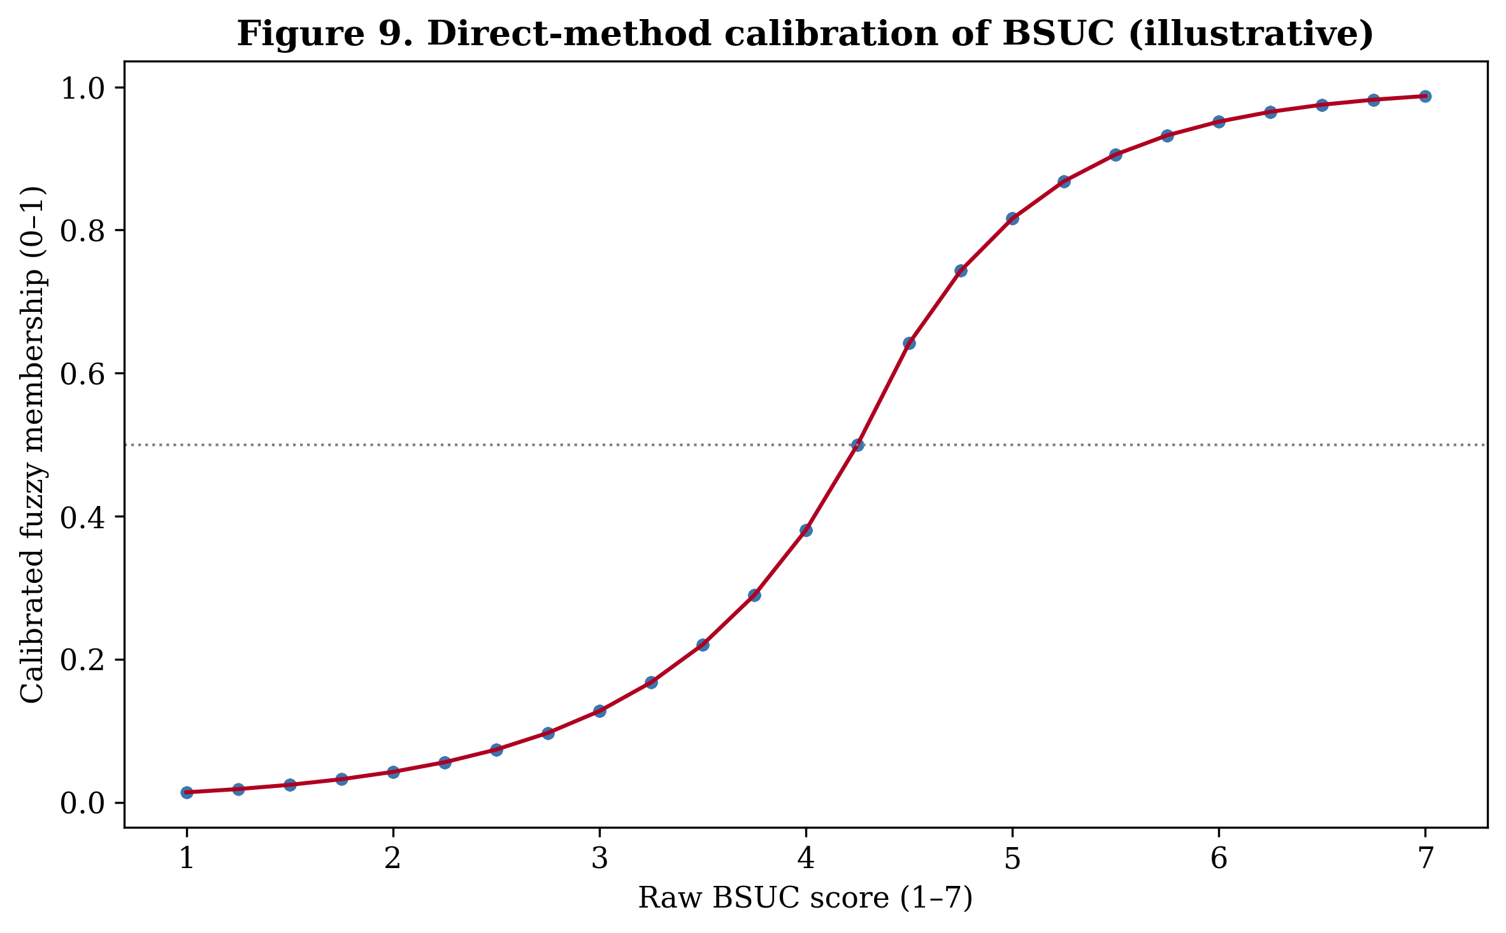
Figure 9. Direct-method calibration of BSUC into fuzzy-set membership (illustrative).
4.4.1 Analysis of Necessary Conditions
We first tested whether any condition (or its negation) is necessary for high BSUC. A condition is typically deemed necessary when its consistency exceeds 0.90. As reported in Table 10 and Figure 7, the consistency of every condition and its negation ranged only from 0.552 to 0.596, all far below the 0.90 benchmark (maximum = 0.596). Accordingly, none of UE, UX, or BSAT — in either its presence or its absence — constitutes a necessary condition for achieving high brand success / continuance.
Table 10. Analysis of necessary conditions for high BSUC.
Condition | Consistency | Coverage
UE | 0.581 | 0.581
~UE | 0.566 | 0.568
UX | 0.552 | 0.554
~UX | 0.596 | 0.596
BSAT | 0.567 | 0.561
~BSAT | 0.570 | 0.577
Note. “~” denotes the absence (negation) of a condition. Necessity threshold = 0.90.

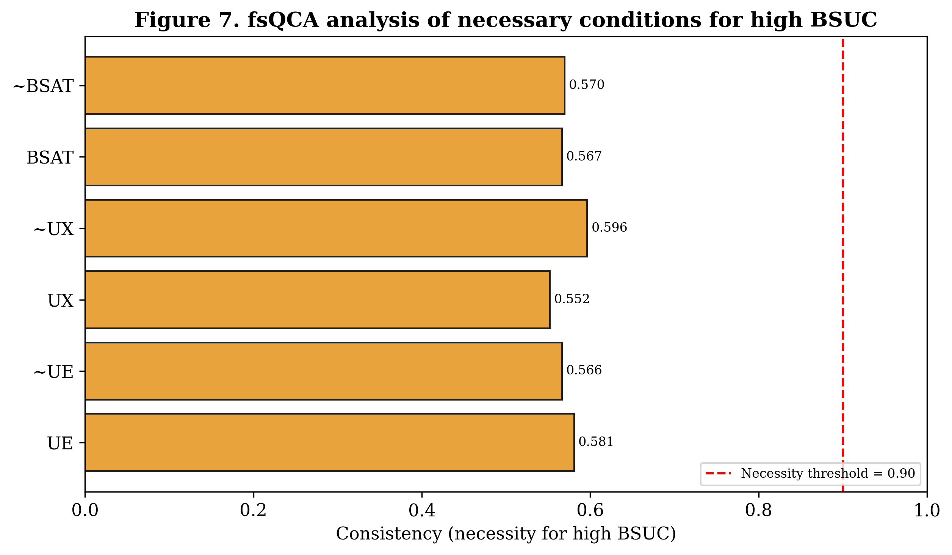
Figure 7. Necessity consistencies for high BSUC; none approaches the 0.90 threshold.
4.4.2 Analysis of Sufficient Configurations
Next, we constructed the truth table of all 2³ = 8 possible configurations of the three conditions and evaluated their sufficiency for high BSUC, applying conventional thresholds of a minimum frequency of three cases and a minimum raw consistency of 0.80. As shown in Table 11 and Figure 8, although all eight configurations were well populated, the highest raw consistency attained by any configuration was only 0.739, below the 0.80 sufficiency cut-off. Consequently, no configuration qualified as a sufficient condition for high BSUC, and the sufficiency solution is empty (solution coverage and consistency are undefined). Proposition P1 is therefore not supported: no combination of high or low UE, UX, and BSAT reliably produces high brand success, and there is no evidence of equifinality in this sample.
Table 11. Truth table of configurations for high BSUC.
Configuration | Cases (m>0.5) | Raw consistency
UE * ~UX * BSAT | 34 | 0.739
~UE * ~UX * ~BSAT | 42 | 0.700
UE * ~UX * ~BSAT | 34 | 0.683
~UE * UX * ~BSAT | 34 | 0.680
~UE * ~UX * BSAT | 32 | 0.676
UE * UX * BSAT | 42 | 0.676
~UE * UX * BSAT | 38 | 0.649
UE * UX * ~BSAT | 33 | 0.647
Note. “*” denotes logical AND; “~” denotes negation. Sufficiency thresholds: frequency ≥ 3, consistency ≥ 0.80. No row meets the consistency cut-off.

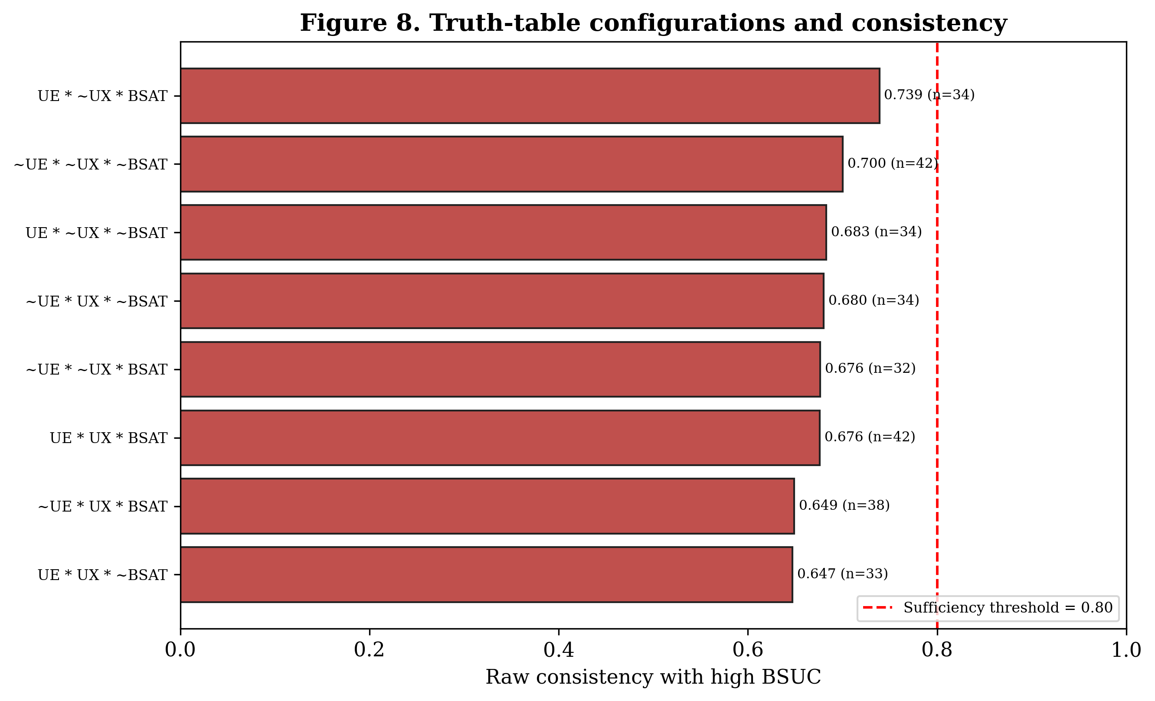
Figure 8. Truth-table configurations ranked by raw consistency; all fall below the 0.80 sufficiency threshold.
4.5 Summary of Results
Taken together, the two analytical approaches converge on a consistent and unambiguous conclusion. The reflective measurement model is psychometrically sound: all constructs exhibit high indicator loadings, strong internal-consistency reliability, adequate convergent validity, and clear discriminant validity. However, the structural model reveals that the four constructs are statistically independent of one another. The symmetric PLS-SEM analysis found no significant direct or mediated paths, negligible R² (< 0.02), trivial effect sizes (f² < 0.011), and negative predictive relevance (Q² < 0). The asymmetric fsQCA analysis corroborated this pattern, identifying neither necessary conditions (all necessity consistencies ≈ 0.55–0.60) nor sufficient configurations (maximum sufficiency consistency = 0.739) for high brand success / continuance. Table 12 summarises the status of each hypothesis.
Table 12. Summary of hypothesis testing.
Path / Proposition | Result
H1: UE → BSUC (direct) | Not supported
H2: UX → BSUC (direct) | Not supported
H3: UE and UX → BSAT → BSUC (BSAT mediates) | Not supported
P1: Multiple configurations of {UE, UX, BSAT} sufficient for high BSUC | Not supported
Note. See Sections 4.3 and 4.4 for the corresponding statistics.

These convergent null results are reported transparently and in full. They indicate that, within the present sample, engagement, experience, satisfaction, and brand success operate as statistically independent dimensions rather than as a causal chain. The implications of this finding — including data-quality and measurement considerations and directions for subsequent data collection — are discussed in Section 5.

