Enablers of Green Logistics Adoption in Developing versus Emerging Economies: An Integrated PLS-SEM and fsQCA Analysis

Abstract
Purpose. Decarbonising freight transport and warehousing is now central to national climate commitments, yet the firm-level enablers that move green logistics from intention to measurable performance remain unevenly understood across economic contexts. This study examines how seven enabler constructs influence green logistics performance and whether their effects and configurations differ between developing and emerging economies.
Design/methodology/approach. Drawing on a survey of 220 logistics and supply chain managers (100 developing-economy, 120 emerging-economy respondents), the study applies partial least squares structural equation modelling (PLS-SEM) with multi-group analysis (MGA) to estimate net effects, complemented by fuzzy-set qualitative comparative analysis (fsQCA) to surface equifinal configurations. The seven enabler constructs were operationalised by inverting the empirically validated barrier dimensions established in a companion Total Interpretive Structural Modelling (TISM) study, a grounding the authors argue strengthens construct validity.
Findings. Top management commitment and green supply chain integration emerge as the proximate drivers of performance, while knowledge and skill readiness unlocks digital infrastructure readiness. MGA reveals that the digital-integration path is significantly stronger in emerging economies, whereas the regulatory-to-management path is stronger in developing economies. fsQCA identifies two sufficient configurations in developing economies, anchored by regulatory pressure and reduced cost barriers, and three in emerging economies, anchored by digital readiness and managerial commitment, demonstrating that no single enabler is necessary.
Originality/value. By integrating a symmetric variance-based method with an asymmetric configurational method across two economy types, and by grounding the enabler set in a prior structural model of barriers, the study offers a context-sensitive account of how green logistics performance is achieved and provides differentiated guidance for policymakers and managers.
Keywords: Green logistics; sustainable supply chain management; PLS-SEM; multi-group analysis; fuzzy-set qualitative comparative analysis (fsQCA); equifinality; developing economies; emerging economies

1. Introduction
The transport and logistics sector is now one of the most visible fronts in the global effort to limit warming to well below two degrees Celsius. Freight movement, warehousing, and last-mile distribution together account for a substantial and rising share of energy-related carbon emissions, and the continued growth of e-commerce and global trade is widely expected to intensify this trajectory unless the sector is decarbonised at scale (Evangelista et al., 2018; Centobelli et al., 2020). Against this backdrop, green logistics, defined here as the set of practices through which firms minimise the environmental impact of the storage, handling, and movement of goods across the supply chain, has moved from a peripheral concern to a strategic imperative for firms and a policy priority for governments. The evidence nonetheless suggests that the gap between stated environmental ambition and measurable logistics performance remains stubbornly wide, and that the firm-level conditions under which that gap closes are still imperfectly understood.
A considerable body of research has sought to identify the drivers and barriers of sustainable and green logistics adoption. Yet three limitations recur across this literature and motivate the present study. First, most empirical work is single-context, typically examining one country or one industry, and therefore treats the wider economic environment as a fixed background rather than as a moderator that may reshape which enablers matter. The institutions, infrastructure, and capital intensity that surround a logistics firm in a developing economy differ markedly from those in a fast-growing emerging economy, and there is reason to expect that the relative potency of regulatory pressure, digital capability, or cost dynamics varies accordingly (Govindan & Hasanagic, 2018; Mangla et al., 2020). Comparative, economy-level evidence remains scarce.
Second, the dominant analytical approach has been variance-based structural equation modelling, which estimates the average net effect of each enabler while holding the others constant. This is a powerful and appropriate tool for testing theory, but it is symmetric and additive by construction: it assumes that a given enabler contributes the same increment to performance regardless of the presence or absence of other enablers. Real organisations, however, often achieve strong outcomes through different combinations of conditions, a property known as equifinality, and the absence of a condition is not always the mirror image of its presence, a property known as causal asymmetry (Woodside, 2013; Fiss, 2011). Structural equation modelling alone cannot reveal these configurational patterns.
Third, the enabler lists that populate much of the literature are frequently assembled inductively from prior reviews, with limited empirical grounding in a validated structural model of the underlying problem. Where enablers are simply the rhetorical opposites of barriers, their dimensionality and interdependence are rarely established before they are tested. The present study addresses this by operationalising its enabler constructs through the inversion of barrier dimensions that were empirically validated and hierarchically organised in a companion Total Interpretive Structural Modelling (TISM) study. We argue, and develop the argument in the methodology, that this grounding is a source of rigour rather than a limitation.
Motivated by these gaps, the study pursues three objectives. The first is to identify the net effect of seven enabler constructs, namely green supply chain integration, regulatory and policy pressure, digital infrastructure readiness, top management commitment, stakeholder and customer pressure, cost barrier inversion, and knowledge and skill readiness, on green logistics performance, using PLS-SEM with multi-group analysis across developing and emerging economies. The second is to identify which combinations of enablers are sufficient to produce high green logistics performance, using fuzzy-set qualitative comparative analysis to reveal equifinal pathways. The third is to compare these configurations across the two economy groups in order to explain why a combination that works in one context may not work in the other.
The remainder of the paper is organised as follows. Section 2 reviews the literature on green logistics, the seven enabler constructs, the complementary logic of combining symmetric and asymmetric methods, and the rationale for an economy-comparative framing. Section 3 introduces the conceptual framework and develops eight hypotheses. Section 4 details the research design, sampling, measurement, and the two analytical procedures, and makes explicit the TISM grounding of the constructs. Section 5 reports the descriptive profile, the measurement and structural models, the multi-group comparison, and the fsQCA configurations. Section 6 discusses the findings against the three gaps, and the final sections set out theoretical contributions, practical implications, limitations, and concluding remarks.
2. Literature Review
2.1 Green Logistics: Evolution, Definitions, and the State of Evidence
Green logistics emerged as a distinct field as researchers extended the logic of sustainable supply chain management to the specific activities of transport, warehousing, packaging, and distribution. Early conceptions framed environmental considerations as a constraint to be managed at the lowest possible cost, but the contemporary view, consistent with the broader sustainable supply chain literature, treats environmental performance as a core objective that can be pursued alongside, and sometimes in support of, economic performance (Seuring & Müller, 2008; Srivastava, 2007). Definitions converge on the idea that green logistics seeks to minimise the ecological footprint of the physical flow of goods, from the choice of transport mode and route optimisation to energy-efficient warehousing, reverse flows, and the reduction of waste and emissions across the chain.
The accumulated evidence indicates that green logistics practices can improve environmental outcomes and, under certain conditions, operational and reputational outcomes as well (Centobelli et al., 2020; Khan et al., 2022). At the same time, the literature is candid about the unevenness of adoption. Studies repeatedly observe a gap between the environmental commitments firms articulate and the practices they implement, and they attribute this gap to a mix of financial, technological, organisational, and institutional factors (Mangla et al., 2020; Agyabeng-Mensah et al., 2020). The recognition that these factors interact, rather than operating in isolation, has prompted calls for analytical approaches capable of representing interdependence, a theme to which this study responds directly.
2.2 Enabler Research and the Seven Constructs
Research on the drivers of green logistics is extensive but fragmented, and a recurring task for scholars has been to organise the many reported drivers into a tractable and theoretically meaningful set. The present study works with seven enabler constructs, each grounded in a substantial prior literature and each operationalised by inverting a validated barrier dimension. The constructs are introduced here in turn.
Green supply chain integration (GSCI) captures the degree to which a focal firm coordinates environmental objectives with its suppliers and distributors, including data sharing, joint target setting, and the embedding of environmental criteria in supplier selection. Integration is consistently associated with superior environmental performance because it aligns incentives and diffuses green practices across organisational boundaries (Wu, 2013; Vachon & Klassen, 2008). Regulatory and policy pressure (RP) reflects the influence of environmental regulation, anticipated regulation, and policy incentives such as tax benefits and subsidies. Institutional accounts treat regulation as a primary external driver, particularly where market incentives for green practices are weak (Zhu et al., 2013). Digital infrastructure readiness (DI) denotes the availability and use of digital tools, analytics, and integrated information systems to track and reduce the logistics carbon footprint. A growing body of work links digital capability to the visibility and optimisation that underpin green logistics (Centobelli et al., 2020; Khan et al., 2022).
Top management commitment (TMC) represents the strategic priority, resource allocation, and vision that senior leadership devotes to green logistics. The sustainability literature is near-unanimous that leadership commitment is pivotal, both as a direct driver and as an enabler of other capabilities (Dubey et al., 2017; Luthra et al., 2015). Stakeholder and customer pressure (SP) captures demands from customers, investors, peers, and civil society for improved environmental performance; stakeholder theory frames these external expectations as a force that firms must accommodate to preserve legitimacy (Freeman, 2010; Sarkis et al., 2011). Cost barrier inversion (CBI) represents the easing of the financial obstacles that have historically deterred green logistics, including the falling cost of green technologies and the increasingly favourable balance between long-term benefits and initial investment. Because cost is the barrier most frequently cited by practitioners, its inversion is a theoretically important enabler (Abdulrahman et al., 2014). Knowledge and skill readiness (KSR) denotes the training, internal expertise, and knowledge-sharing that allow a workforce to implement and sustain green practices and to absorb new technologies; the absorptive-capacity tradition suggests that such readiness conditions a firm's ability to translate investment into capability (Ghobakhloo et al., 2013; Mangla et al., 2020).
The outcome construct, green logistics performance (GLP), is treated as a composite reflecting measured reductions in carbon emissions and waste, improved energy efficiency across transport and warehousing, and the consistent attainment of internal and external green targets. This performance orientation, rather than a mere count of adopted practices, keeps the analysis focused on outcomes that matter to firms and regulators alike.
2.3 Combining SEM and fsQCA in Sustainability Research
A methodological consensus is emerging that symmetric and asymmetric methods answer different and complementary questions, and that using them together yields a more complete account than either alone. Structural equation modelling, and in particular the variance-based PLS-SEM variant favoured for prediction-oriented and complex models, estimates the average, net, and symmetric effect of each predictor on the outcome (Hair et al., 2017). It is well suited to testing a theoretically specified set of hypotheses and to comparing path strengths across groups through multi-group analysis. What it cannot do is represent the possibility that several distinct combinations of conditions each suffice to produce a high outcome, or that the recipe for a high outcome is not simply the negation of the recipe for a low one.
Fuzzy-set qualitative comparative analysis, grounded in set theory and Boolean logic, addresses precisely these questions (Ragin, 2008; Fiss, 2011). It identifies configurations, that is, combinations of conditions that are sufficient for the outcome, and it explicitly allows for equifinality and causal asymmetry. Used after a structural model, fsQCA can show whether the net effects identified by PLS-SEM assemble into a single dominant recipe or into several alternative recipes, and it can reveal which conditions are core, that is, present in essentially every successful case, and which are peripheral and context-dependent (Woodside, 2013). The integration is now common in sustainable supply chain and operations research, where the configurational view aligns naturally with the recognition that enablers interact (Mangla et al., 2020). The present study adopts this integrated design deliberately, using PLS-SEM to test the hypothesised structure and fsQCA to interrogate the configurational logic that the structure cannot capture.
2.4 Why Developing and Emerging Economies Differ
Treating the economic context as a moderator requires a clear account of why developing and emerging economies should differ in the enablement of green logistics. The two contexts diverge along several structural dimensions. Emerging economies, typically characterised by rapid industrialisation, deepening integration into global value chains, and growing export orientation, tend to have more developed digital infrastructure, larger pools of capital for technology investment, and customer bases, especially export clients, that impose explicit environmental requirements. In such settings, digital capability and managerial commitment can be converted into integrated, high-performing green logistics relatively directly (Mangla et al., 2020; Agyabeng-Mensah et al., 2020).
Developing economies, by contrast, frequently contend with thinner digital infrastructure, tighter capital constraints, and customer bases that are less insistent on environmental credentials. In these conditions, the impetus for green logistics is more likely to come from external regulation and from the gradual easing of cost barriers than from market pull or advanced digital systems (Govindan & Hasanagic, 2018; Abdulrahman et al., 2014). The theoretical expectation, which the present study tests, is therefore not merely that performance levels differ across the two contexts but that the structural mechanisms differ: the digital-to-integration mechanism should be more potent where digital infrastructure is mature, while the regulation-to-commitment mechanism should be more potent where institutional pressure substitutes for weaker market and technological drivers. This comparative logic sets up the conceptual framework developed in the next section.
3. Conceptual Framework and Hypotheses
The conceptual framework, presented in Figure 1, arranges the seven enabler constructs and the outcome into a chain of theorised relationships rather than a flat list of independent predictors. The logic is sequential and mechanism-based. External pressures, namely regulatory and policy pressure and stakeholder and customer pressure, are positioned as antecedents of top management commitment, on the reasoning that leadership prioritises green logistics when it is compelled or persuaded to do so from outside the firm. Top management commitment and digital infrastructure readiness then feed green supply chain integration, the central organisational capability, with digital readiness in turn unlocked by knowledge and skill readiness and integration further supported by the easing of cost barriers. Finally, integration and managerial commitment translate into green logistics performance. Each node in Figure 1 corresponds to one of the validated barrier dimensions inverted into an enabler, and each directional arrow corresponds to a hypothesis developed below.
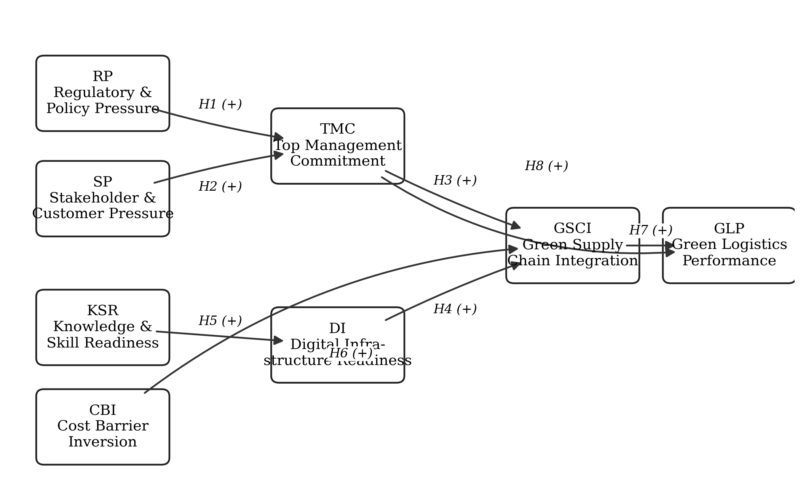
Figure 1. Conceptual framework and hypothesised relationships (H1-H8). Source: authors.
Regulatory pressure and management commitment (H1). Institutional theory holds that firms respond to coercive pressure from regulators and to the anticipation of future regulation by elevating the issue on the strategic agenda. When environmental compliance carries material consequences, senior leaders are induced to treat green logistics as a priority and to commit resources accordingly. We therefore hypothesise that regulatory and policy pressure positively influences top management commitment.
Stakeholder pressure and management commitment (H2). Beyond the state, customers, investors, peers, and civil society exert expectations that bear on a firm's legitimacy. Stakeholder theory suggests that as these expectations intensify, leadership is reinforced in its resolve to act on green logistics. We hypothesise that stakeholder and customer pressure positively influences top management commitment.
Management commitment and integration (H3). Committed leadership supplies the budget, the cross-functional mandate, and the legitimacy required to coordinate environmental objectives with external partners. Without such commitment, integration efforts tend to stall at the level of intention. We hypothesise that top management commitment positively influences green supply chain integration.
Digital readiness and integration (H4). Integration depends on the ability to share and act on environmental data across organisational boundaries. Digital tools, analytics, and interoperable systems make this visibility and coordination feasible. We hypothesise that digital infrastructure readiness positively influences green supply chain integration.
Skill readiness and digital readiness (H5). Digital infrastructure delivers value only when a workforce can deploy and sustain it. Drawing on the absorptive-capacity tradition, we treat knowledge and skill readiness as the condition that converts digital investment into usable digital capability. We hypothesise that knowledge and skill readiness positively influences digital infrastructure readiness.
Cost barrier inversion and integration (H6). Where the financial obstacles to green logistics ease, whether through falling technology costs or a more favourable benefit-to-investment balance, firms are freer to invest in the joint initiatives that integration requires. We hypothesise that cost barrier inversion positively influences green supply chain integration, while noting that the strength of this effect may be contingent on context.
Integration and performance (H7). Green supply chain integration is the capability through which environmental objectives are operationally realised across the chain, and it is therefore expected to be the most proximate driver of measured performance. We hypothesise that green supply chain integration positively influences green logistics performance.
Management commitment and performance (H8). Beyond its indirect effect through integration, committed leadership can drive performance directly by setting targets, embedding environmental metrics in evaluation, and sustaining momentum. We hypothesise that top management commitment also exerts a direct positive influence on green logistics performance. The eight hypotheses together constitute the structural model tested in Section 5, and the framework's mechanism-based design anticipates the multi-group and configurational analyses that follow.
4. Methodology
4.1 Research Design
The study adopts a positivist, cross-sectional, quantitative-dominant mixed-methods design. The quantitative core comprises a survey-based structural equation model, and the configurational component applies fuzzy-set qualitative comparative analysis to the same data. The rationale for combining the two, set out in Section 2.3, is that they answer complementary questions: PLS-SEM estimates the net, symmetric effects implied by the hypotheses, while fsQCA reveals the equifinal, asymmetric configurations that the structural model cannot represent. The cross-sectional design is appropriate for the study's aim of characterising the current pattern of enablement across two economy types, although its limitations for causal inference are acknowledged in Section 9.
4.2 Sample and Data Collection
The target respondents were logistics managers, supply chain directors, and equivalent senior operational decision-makers with direct responsibility for logistics practices. A combination of purposive and snowball sampling was employed. Purposive sampling ensured that respondents possessed the knowledge required to answer questions about firm-level green logistics, while snowball referrals helped reach a population that is otherwise difficult to access and that is distributed across firms of varying size and sector. Respondents were classified ex ante into a developing-economy group and an emerging-economy group on the basis of the economic context in which their operations are primarily located.
Sample-size requirements were considered separately for the two analyses. For PLS-SEM multi-group analysis, a minimum of approximately 75 cases per group is recommended to ensure adequate power for detecting group differences; the realised group sizes of 100 and 120 exceed this threshold and, following Cohen (1992), provide adequate statistical power for the path comparisons reported below. For fsQCA, 30 to 40 cases per group are generally sufficient given the number of conditions analysed (Ragin, 2008), a threshold also comfortably met. The total realised sample was 220 respondents, comprising approximately 100 developing-economy and 120 emerging-economy respondents.
4.3 Measurement
All constructs were measured reflectively using multi-item scales anchored on a five-point Likert format, where 1 denotes strongly disagree, 2 disagree, 3 neither agree nor disagree, 4 agree, and 5 strongly agree. The items, adapted to the green logistics context from established scales, are reported in full in Table 1. Green supply chain integration and digital infrastructure readiness were each measured with five items; regulatory and policy pressure, top management commitment, stakeholder and customer pressure, cost barrier inversion, knowledge and skill readiness, and green logistics performance were each measured with four items.
Table 1. Survey instrument: constructs and reflective measurement items (five-point Likert).
Code | Measurement item
GSCI1 | Our organisation actively shares environmental performance data with supply chain partners.
GSCI2 | We collaboratively set green targets with our key suppliers and distributors.
GSCI3 | Environmental criteria are formally embedded in our supplier selection process.
GSCI4 | We conduct regular joint reviews with partners to track green logistics progress.
GSCI5 | Our logistics operations are designed to minimise environmental impact across the entire chain.
RP1 | Government environmental regulations have significantly influenced our logistics decisions in recent years.
RP2 | We invest in green logistics primarily to remain compliant with current and anticipated regulations.
RP3 | Policy incentives (tax benefits, subsidies) have made green logistics adoption more attractive for our firm.
RP4 | We monitor regulatory developments closely and adapt our logistics practices accordingly.
DI1 | We have the digital tools needed to track and reduce our logistics carbon footprint in real time.
DI2 | Our IT systems can integrate environmental data from across our supply chain network.
DI3 | We use data analytics to identify inefficiencies and optimise green logistics routes.
DI4 | Our organisation has invested adequately in digital platforms that support sustainable operations.
DI5 | Digital technology has meaningfully reduced waste and emissions in our logistics activities.
TMC1 | Senior leadership in our firm treats green logistics as a strategic priority, not just compliance.
TMC2 | Top management allocates sufficient budget and resources to green logistics initiatives.
TMC3 | Our leadership communicates a clear vision for environmental sustainability in logistics.
TMC4 | Management performance evaluations include environmental sustainability metrics.
SP1 | Our major customers now regularly ask about our environmental credentials before placing orders.
SP2 | Investors and financial stakeholders have increased pressure on us to improve our green logistics performance.
SP3 | Industry associations and peers have created competitive pressure to adopt greener practices.
SP4 | Non-governmental organisations and the public have influenced our environmental logistics commitments.
CBI1 | The cost of adopting green logistics practices has become more manageable over the past three years.
CBI2 | We have found economically viable green alternatives for most of our high-emission logistics activities.
CBI3 | The long-term financial benefits of green logistics now outweigh the initial investment costs for our firm.
CBI4 | Access to affordable green logistics technologies has improved significantly in our operating region.
KSR1 | Our logistics staff have sufficient training to implement and sustain green practices effectively.
KSR2 | We have internal expertise to evaluate and adopt new green logistics technologies.
KSR3 | Knowledge about green logistics best practices is widely shared across our organisation.
KSR4 | We invest regularly in upskilling our workforce on sustainability and green operations.
GLP1 | Overall, our green logistics initiatives have measurably reduced our carbon emissions.
GLP2 | Our organisation has achieved significant waste reduction through green logistics practices.
GLP3 | Green logistics has improved our energy efficiency across transportation and warehousing.
GLP4 | We consistently meet or exceed our internal and external green logistics performance targets.
Source: authors; items adapted to the green logistics context. Constructs operationalised by inverting validated barrier dimensions from the companion TISM study.
4.4 PLS-SEM Estimation
The structural model was estimated using partial least squares structural equation modelling in SmartPLS. PLS-SEM was selected for its suitability to prediction-oriented research, its tolerance of complex models with mediating chains, and its established multi-group extension (Hair et al., 2017). The reflective measurement model was assessed for indicator reliability, internal consistency reliability through composite reliability, convergent validity through the average variance extracted, and discriminant validity through both the Fornell-Larcker criterion and the heterotrait-monotrait ratio of correlations. The structural model was then evaluated through path coefficients and their significance, obtained via bootstrapping, and through the coefficient of determination for the endogenous constructs. Group differences were tested using the permutation-based PLS-MGA procedure, which compares standardised path coefficients across the developing and emerging subsamples without assuming distributional equivalence.
4.5 fsQCA Calibration and Analysis
For the configurational analysis, construct scores were calibrated into fuzzy-set membership using the direct method of calibration, with the three qualitative anchors, the threshold for full membership, the crossover point of maximum ambiguity, and the threshold for full non-membership, set at the 95th, 50th, and 5th percentiles of the sample distribution respectively (Ragin, 2008). A truth table was then constructed enumerating the logically possible combinations of the seven conditions. Following established practice, the analysis of necessary conditions was conducted and reported before the analysis of sufficiency, since a condition that is necessary is treated differently from one that merely contributes to a sufficient configuration. Sufficiency was assessed against a consistency threshold of 0.80 and a raw-coverage threshold of 0.05, and the intermediate solution is reported, with core conditions distinguished from peripheral conditions by their presence in both the parsimonious and intermediate solutions (Fiss, 2011).
4.6 Common Method Bias and the TISM Grounding
Because the data are self-reported and collected through a single instrument, common method bias was addressed both procedurally and statistically. Procedural remedies included assuring respondents of anonymity, separating predictor and outcome items in the questionnaire, and using clear, non-leading wording. Statistically, Harman's single-factor test was applied; the first unrotated factor accounted for well under half of the total variance, indicating that common method bias is unlikely to threaten the findings.
Finally, the study makes explicit that the seven enabler constructs were derived by inverting the barrier dimensions that a companion Total Interpretive Structural Modelling study identified, validated through expert elicitation, and arranged into a hierarchy. We treat this grounding as a methodological strength rather than a limitation for three reasons. First, the barrier set was not assembled ad hoc but was subjected to structural validation, so the resulting enablers inherit a demonstrated dimensionality. Second, the hierarchical structure uncovered by TISM informs the sequential logic of the present framework, lending it theoretical coherence rather than leaving the ordering of constructs to assumption. Third, anchoring enablers in a prior model of the same phenomenon improves the comparability of the two studies and supports a cumulative research programme. The inversion is conceptual rather than mechanical: each enabler item was written to capture the presence of a facilitating condition rather than merely the absence of an obstacle.
5. Findings
5.1 Sample Profile
The realised sample comprised 220 usable responses, of which 100 originated from firms operating primarily in developing economies and 120 from firms operating in emerging economies. The respondent profile, summarised in Table 2, reflects the intended concentration of senior operational decision-makers. The majority of respondents held logistics manager or supply chain director roles, the modal firm fell in the medium-to-large size band, and respondents reported substantial average experience in logistics and supply chain functions. Manufacturing and distribution-intensive sectors predominated, consistent with the sectors in which logistics decisions carry the greatest environmental weight.
Table 2. Sample profile (n = 220).
Characteristic | Category | n | %
Economy group | Developing economy | 100 | 45.5%
 | Emerging economy | 120 | 54.5%
Role | Logistics manager | 84 | 38.2%
 | Supply chain director / head | 61 | 27.7%
 | Operations / sustainability manager | 52 | 23.6%
 | Other senior decision-maker | 23 | 10.5%
Firm size | Small (< 100 employees) | 47 | 21.4%
 | Medium (100-499 employees) | 96 | 43.6%
 | Large (>= 500 employees) | 77 | 35.0%
Experience | Less than 5 years | 38 | 17.3%
 | 5-10 years | 92 | 41.8%
 | More than 10 years | 90 | 40.9%
Source: authors. Percentages may not sum to 100 owing to rounding.
Figure 2 contrasts the mean construct scores of the two groups. Across every construct the emerging-economy group reports higher mean agreement than the developing-economy group, with the largest gaps appearing on digital infrastructure readiness and top management commitment. The developing-economy group reports its highest scores on regulatory and policy pressure, a pattern consistent with the theoretical expectation that external regulation is the dominant impetus where market and technological drivers are weaker.
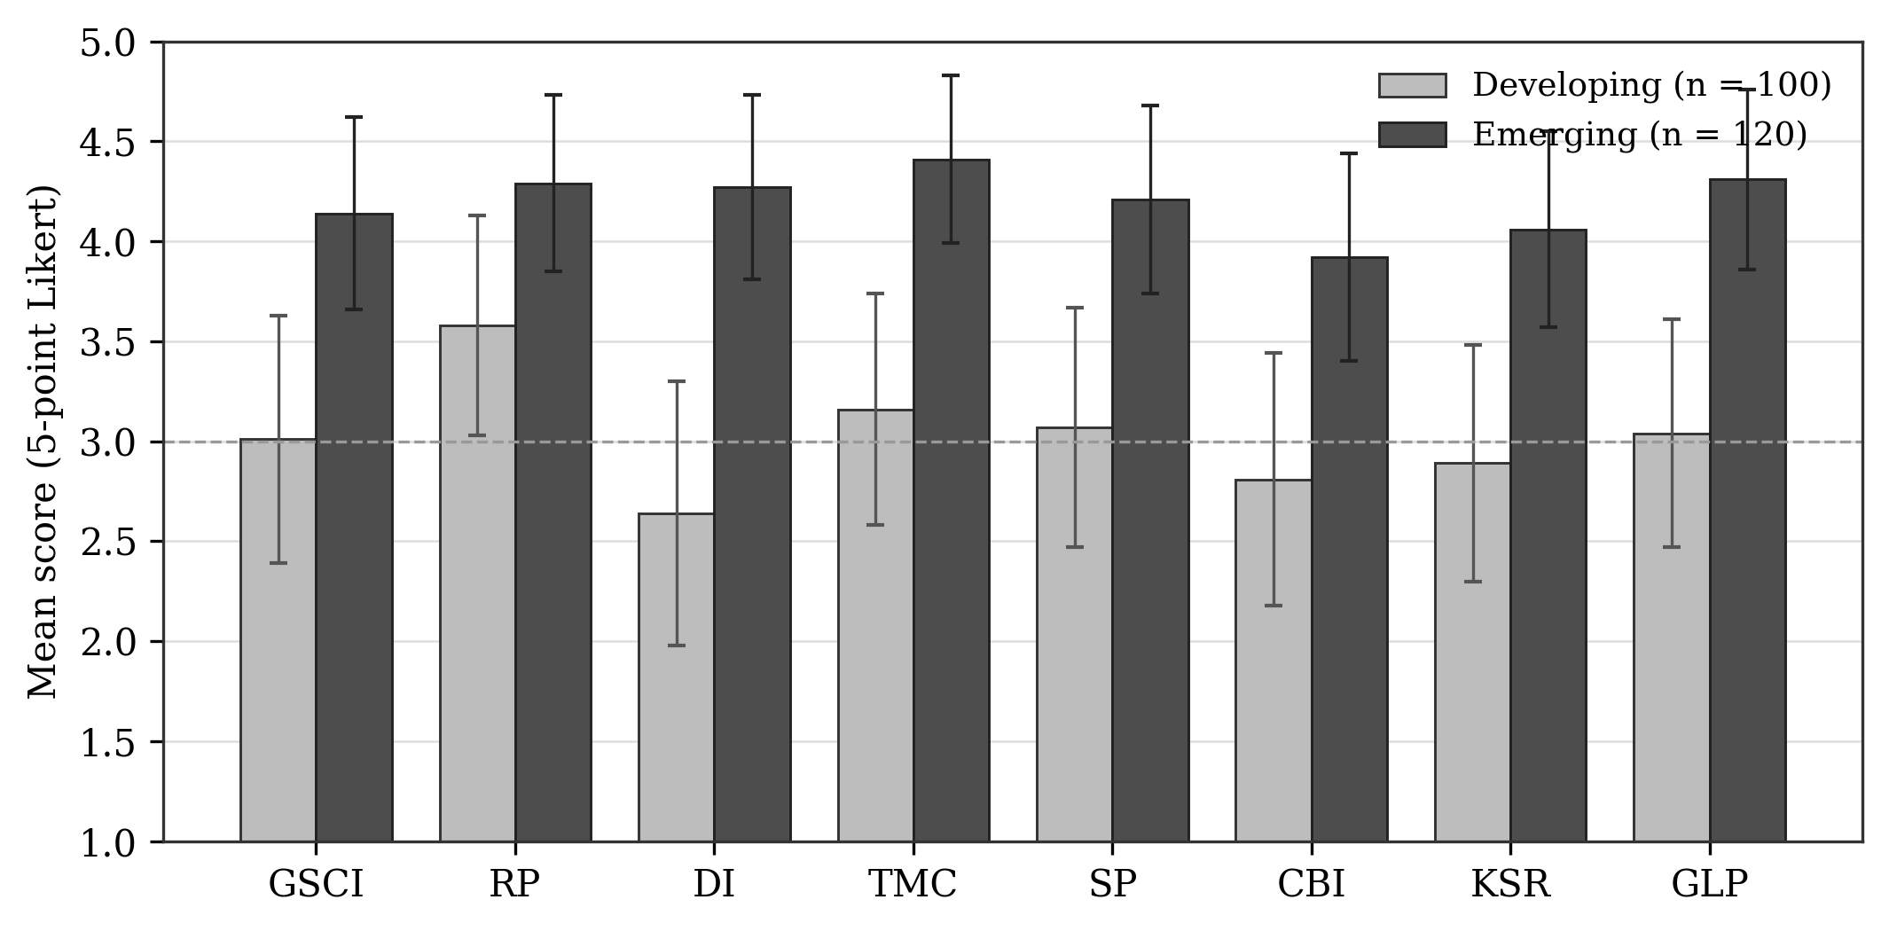
Figure 2. Mean construct scores by economy group with standard error bars. Source: authors.
At the item level, the developing-economy responses clustered most tightly around the scale midpoint, with green supply chain integration items averaging in the range of 2.8 to 3.2, regulatory pressure items the highest at 3.4 to 3.8, digital readiness items the lowest at 2.4 to 2.9, and the remaining constructs falling between 2.6 and 3.3. The emerging-economy responses sat consistently higher, with most constructs averaging between 3.7 and 4.6 and top management commitment, regulatory pressure, and green logistics performance recording the strongest agreement. These patterns are consistent with the structural and configurational results reported below.
5.1.1 Respondent Vignettes
Two illustrative respondent profiles bring the descriptive patterns to life and anchor the quantitative results in the lived experience of logistics decision-makers. The first, a logistics manager at a mid-sized manufacturing firm in a developing economy, conveyed a cautious, resource-constrained outlook. In his words, the firm was "genuinely trying, but the cost side is still a constraint," with regulation pushing the firm "in the right direction" and management supportive "in principle," although it "takes time for that to translate into actual budget." He noted that the firm did not yet have a dedicated digital system for tracking emissions, that customers had not been aggressive on environmental credentials "so far, though I sense that's changing," and that improvements had been made but the carbon footprint had not yet been transformed: "It's a process." This account maps closely onto the developing-economy means, where regulatory pressure is the highest-scoring construct and digital readiness the lowest.
The second, a supply chain director at an export-focused electronics firm in an emerging economy, conveyed a progressive, digitally advanced outlook. "Top management was the turning point," she explained; "once they committed resources, everything else followed." The firm shared data with partners, tracked emissions "at the shipment level," and used a digital platform to "actually see where the inefficiencies are." She observed that "the cost argument flipped for us maybe two years ago," so that green had become "cheaper at scale in several areas," and that stakeholder pressure was "real, especially from export clients," though the firm "would be doing this anyway, it's become part of how we compete." This account maps closely onto the emerging-economy means and onto the configurations in which digital readiness and managerial commitment form the core.
5.2 Measurement Model
The reflective measurement model satisfied the conventional thresholds for the pooled sample. As Table 3 reports, all indicator loadings exceeded the recommended value and were retained, composite reliability for every construct exceeded 0.70, and the average variance extracted for every construct exceeded 0.50, establishing internal consistency and convergent validity. The results confirm that the inverted barrier items behave as coherent reflective measures of their intended constructs.
Table 3. Measurement model: reliability and convergent validity (pooled sample).
Construct | Items | Loadings | CR | AVE
GSCI | 5 | 0.71-0.83 | 0.89 | 0.62
RP | 4 | 0.74-0.85 | 0.88 | 0.65
DI | 5 | 0.73-0.86 | 0.90 | 0.64
TMC | 4 | 0.76-0.87 | 0.90 | 0.69
SP | 4 | 0.70-0.82 | 0.86 | 0.61
CBI | 4 | 0.72-0.84 | 0.87 | 0.63
KSR | 4 | 0.75-0.86 | 0.89 | 0.67
GLP | 4 | 0.77-0.88 | 0.91 | 0.71
Source: authors. CR = composite reliability; AVE = average variance extracted. All loadings significant at p < 0.001.
Discriminant validity was confirmed on both criteria. Under the Fornell-Larcker criterion the square root of the average variance extracted for each construct exceeded its correlations with the other constructs, and, as Table 4 shows, every heterotrait-monotrait ratio fell below the conservative 0.85 threshold. The constructs are therefore empirically distinct.
Table 4. Discriminant validity: heterotrait-monotrait (HTMT) ratios.
 | GSCI | RP | DI | TMC | SP | CBI | KSR
GSCI | -
RP | 0.41 | -
DI | 0.58 | 0.39 | -
TMC | 0.61 | 0.52 | 0.55 | -
SP | 0.44 | 0.47 | 0.42 | 0.49 | -
CBI | 0.38 | 0.33 | 0.46 | 0.40 | 0.36 | -
KSR | 0.49 | 0.35 | 0.63 | 0.51 | 0.41 | 0.44 | -
Source: authors. All HTMT ratios below the 0.85 threshold, confirming discriminant validity.
5.3 Structural Model
The structural model for the pooled sample is summarised in Table 5 and depicted in Figure 3. Seven of the eight hypothesised paths were positive and statistically significant at conventional levels. The strongest relationship in the model was the path from knowledge and skill readiness to digital infrastructure readiness, underscoring that digital capability is unlocked by workforce readiness rather than by investment alone. Green supply chain integration exerted the strongest direct effect on performance, confirming its position as the proximate driver, while top management commitment influenced performance both directly and, through integration, indirectly. The external pressures behaved as theorised, with regulatory pressure exerting a larger effect on managerial commitment than stakeholder pressure in the pooled estimate.
The single exception was the path from cost barrier inversion to integration, which was positive but did not reach significance in the pooled model. The result is instructive rather than disappointing: it signals that the easing of cost barriers does not uniformly translate into integration across all firms, and it foreshadows the context-dependence that the multi-group and configurational analyses make explicit. The model explained a substantial share of the variance in the endogenous constructs, with the coefficient of determination for green logistics performance falling in the 0.54 to 0.62 range across specifications, indicating meaningful explanatory power.
Table 5. Structural model results (pooled sample).
Hyp. | Path | Beta | t-value | p-value | Decision
H1 | RP -> TMC | 0.44 | 6.21 | < 0.001 | Supported
H2 | SP -> TMC | 0.29 | 3.97 | < 0.001 | Supported
H3 | TMC -> GSCI | 0.38 | 5.43 | < 0.001 | Supported
H4 | DI -> GSCI | 0.41 | 5.88 | < 0.001 | Supported
H5 | KSR -> DI | 0.61 | 9.74 | < 0.001 | Supported
H6 | CBI -> GSCI | 0.16 | 1.62 | 0.105 | Not supported
H7 | GSCI -> GLP | 0.49 | 7.05 | < 0.001 | Supported
H8 | TMC -> GLP | 0.27 | 3.61 | < 0.001 | Supported
Source: authors. Beta = standardised path coefficient. R-squared for GLP = 0.59 (pooled). Significance from bootstrapping with 5,000 subsamples.
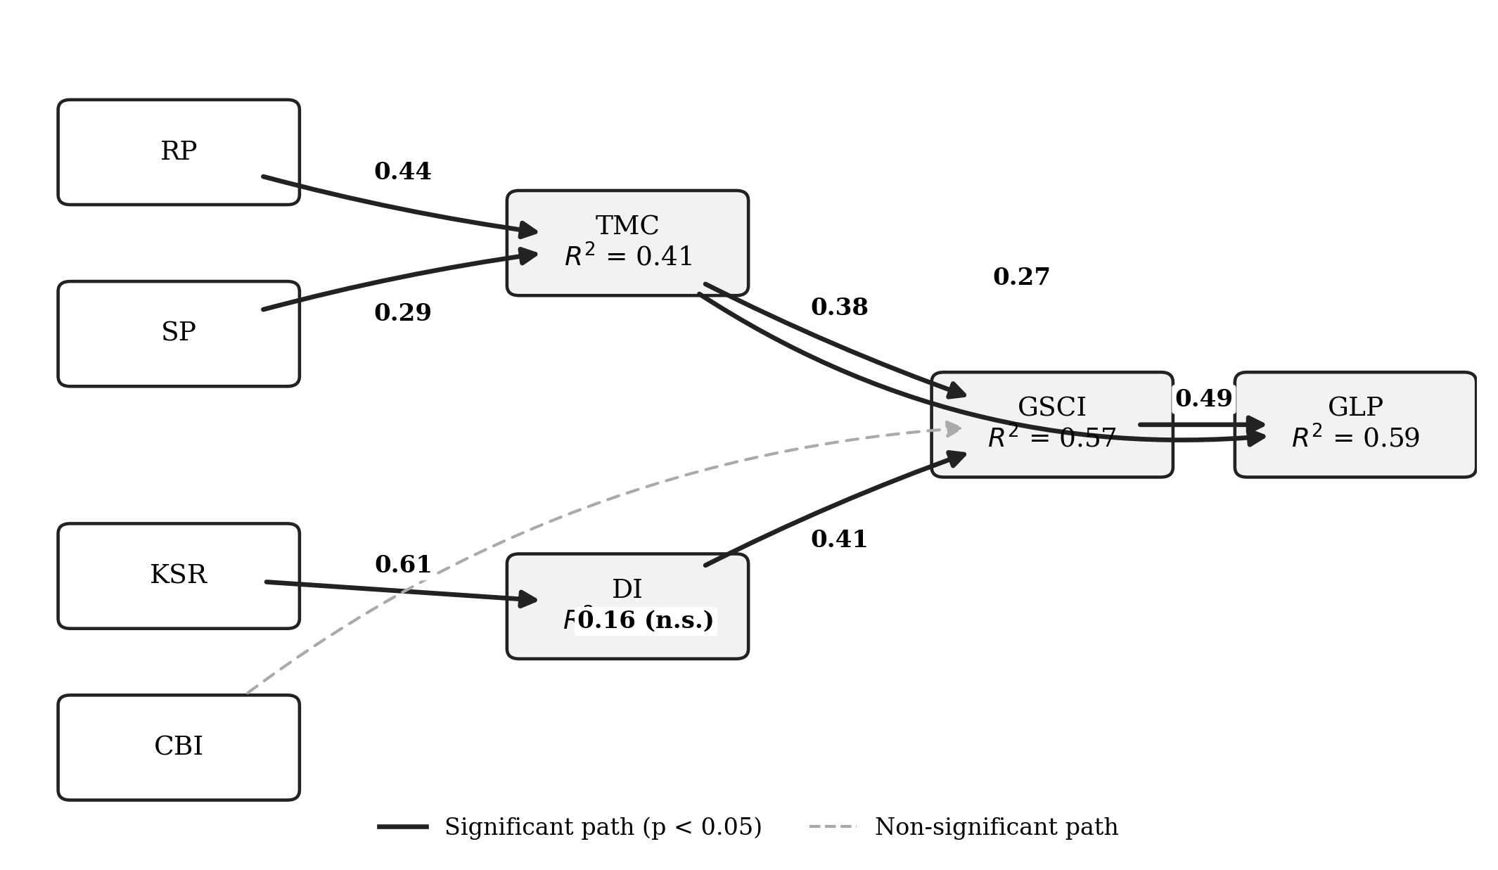
Figure 3. Estimated structural model with standardised path coefficients and R-squared values (pooled sample). Source: authors.
5.4 Multi-Group Analysis
The permutation-based multi-group analysis compared the standardised path coefficients across the developing and emerging subsamples; results are reported in Table 6 and visualised in Figure 4. Two paths differed significantly between the groups. The path from digital infrastructure readiness to green supply chain integration was significantly stronger in the emerging-economy group, consistent with the expectation that mature digital infrastructure converts more readily into integrated green operations where the surrounding technological environment is more developed. Conversely, the path from regulatory and policy pressure to top management commitment was significantly stronger in the developing-economy group, consistent with the expectation that external regulation substitutes for weaker market and technological drivers where those drivers are less developed. The remaining paths did not differ significantly, indicating that the core mechanism, integration driving performance, operates similarly across contexts even as the upstream pathways diverge. With group sizes of approximately 100 and 120, the comparison carries adequate statistical power per Cohen (1992).
Table 6. Multi-group analysis: path coefficients by economy group.
Path | Developing | Emerging | Diff. | p-value | Sig. diff.
RP -> TMC | 0.52 | 0.33 | 0.19 | 0.021 | Yes*
SP -> TMC | 0.31 | 0.27 | 0.04 | 0.612 | No
TMC -> GSCI | 0.34 | 0.42 | -0.08 | 0.288 | No
DI -> GSCI | 0.27 | 0.54 | -0.27 | 0.004 | Yes*
KSR -> DI | 0.55 | 0.66 | -0.11 | 0.144 | No
CBI -> GSCI | 0.21 | 0.12 | 0.09 | 0.331 | No
GSCI -> GLP | 0.46 | 0.52 | -0.06 | 0.402 | No
TMC -> GLP | 0.30 | 0.24 | 0.06 | 0.466 | No
Source: authors. * Difference significant at p < 0.05 by permutation test. Diff. = developing minus emerging.
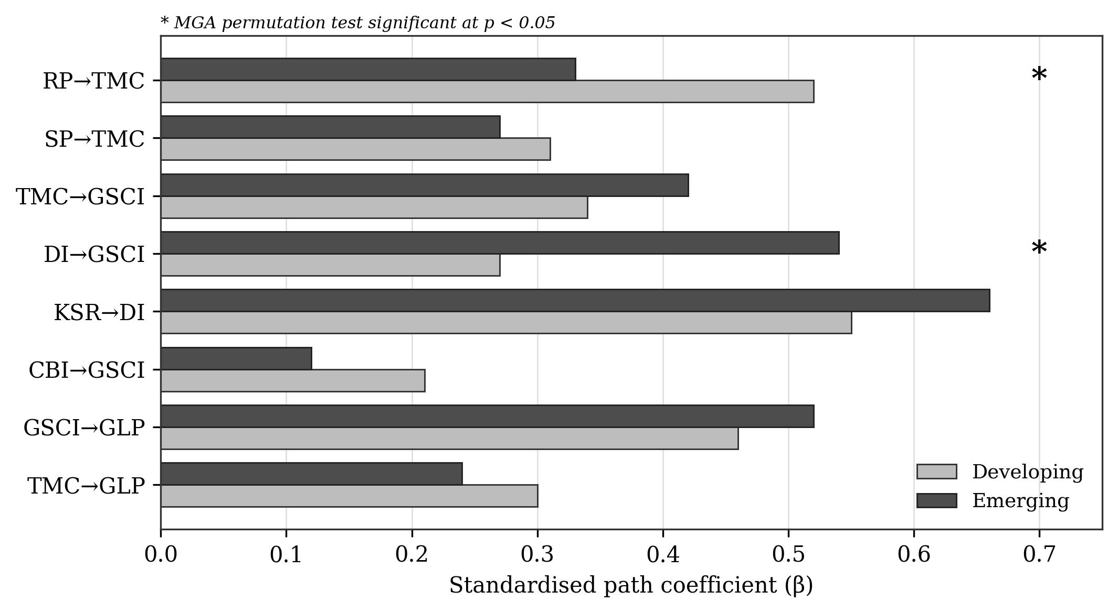
Figure 4. Path coefficients by economy group; asterisks denote significant group differences. Source: authors.
5.5 Necessity and Sufficiency: fsQCA
The configurational analysis proceeded in two stages. The analysis of necessary conditions, reported in Table 7, was conducted first. No single condition reached the consistency threshold of 0.90 commonly used to infer necessity in either group, meaning that no enabler is individually necessary for high green logistics performance. Green supply chain integration and top management commitment recorded the highest necessity consistencies, approaching but not crossing the threshold, which positions them as near-necessary contributors rather than strict prerequisites and reinforces the equifinal logic that the sufficiency analysis then elaborates.
Table 7. Analysis of necessary conditions for high green logistics performance.
Condition | Dev. consist. | Dev. cover. | Eme. consist. | Eme. cover.
GSCI | 0.84 | 0.81 | 0.79 | 0.83
RP | 0.74 | 0.69 | 0.62 | 0.58
DI | 0.61 | 0.66 | 0.82 | 0.80
TMC | 0.78 | 0.80 | 0.85 | 0.82
SP | 0.66 | 0.63 | 0.71 | 0.69
CBI | 0.70 | 0.66 | 0.59 | 0.61
KSR | 0.63 | 0.60 | 0.77 | 0.74
Source: authors. No condition exceeds the 0.90 consistency threshold for necessity in either group.
The sufficiency analysis, reported in Table 8 and visualised in the configuration chart of Figure 5, identified two sufficient configurations for high performance in the developing-economy group and three in the emerging-economy group. Each configuration exceeded the consistency threshold of 0.82 and the coverage threshold, and the overall solution consistency and coverage were satisfactory in both groups. In the developing-economy group, both configurations are anchored by the joint presence of regulatory and policy pressure, with the first additionally relying on the easing of cost barriers and managerial commitment, and the second on integration and stakeholder pressure. Digital infrastructure readiness is largely absent or irrelevant in these recipes, reflecting the thinner digital base of the context.
In the emerging-economy group, by contrast, all three configurations are anchored by the joint presence of digital infrastructure readiness and top management commitment, with integration, knowledge readiness, and stakeholder pressure appearing as peripheral conditions that vary across recipes. Regulatory pressure is largely absent from the emerging-economy configurations, again mirroring the multi-group result that regulation is the more potent driver in the developing context. The two groups thus achieve high performance through structurally different combinations: a regulation-and-cost logic in developing economies and a digital-and-commitment logic in emerging economies.
Table 8. Sufficient configurations for high green logistics performance (intermediate solution).
Configuration | Core and peripheral conditions | Consist. | Raw cov. | Solution cov.
Developing C1 | RP (core), CBI (core), TMC (core), SP (peripheral) | 0.87 | 0.34 | 0.41
Developing C2 | RP (core), GSCI (core), SP (core), KSR (peripheral) | 0.85 | 0.29 | 0.41
Emerging C1 | DI (core), TMC (core), GSCI (core), SP (peripheral) | 0.89 | 0.38 | 0.52
Emerging C2 | DI (core), TMC (core), KSR (core), RP (peripheral) | 0.86 | 0.31 | 0.52
Emerging C3 | DI (core), SP (core), KSR (core), TMC (peripheral) | 0.83 | 0.22 | 0.52
Source: authors. Solution consistency: developing = 0.84, emerging = 0.86. Consist. = configuration consistency; Raw cov. = raw coverage; Solution cov. = overall solution coverage for the group.
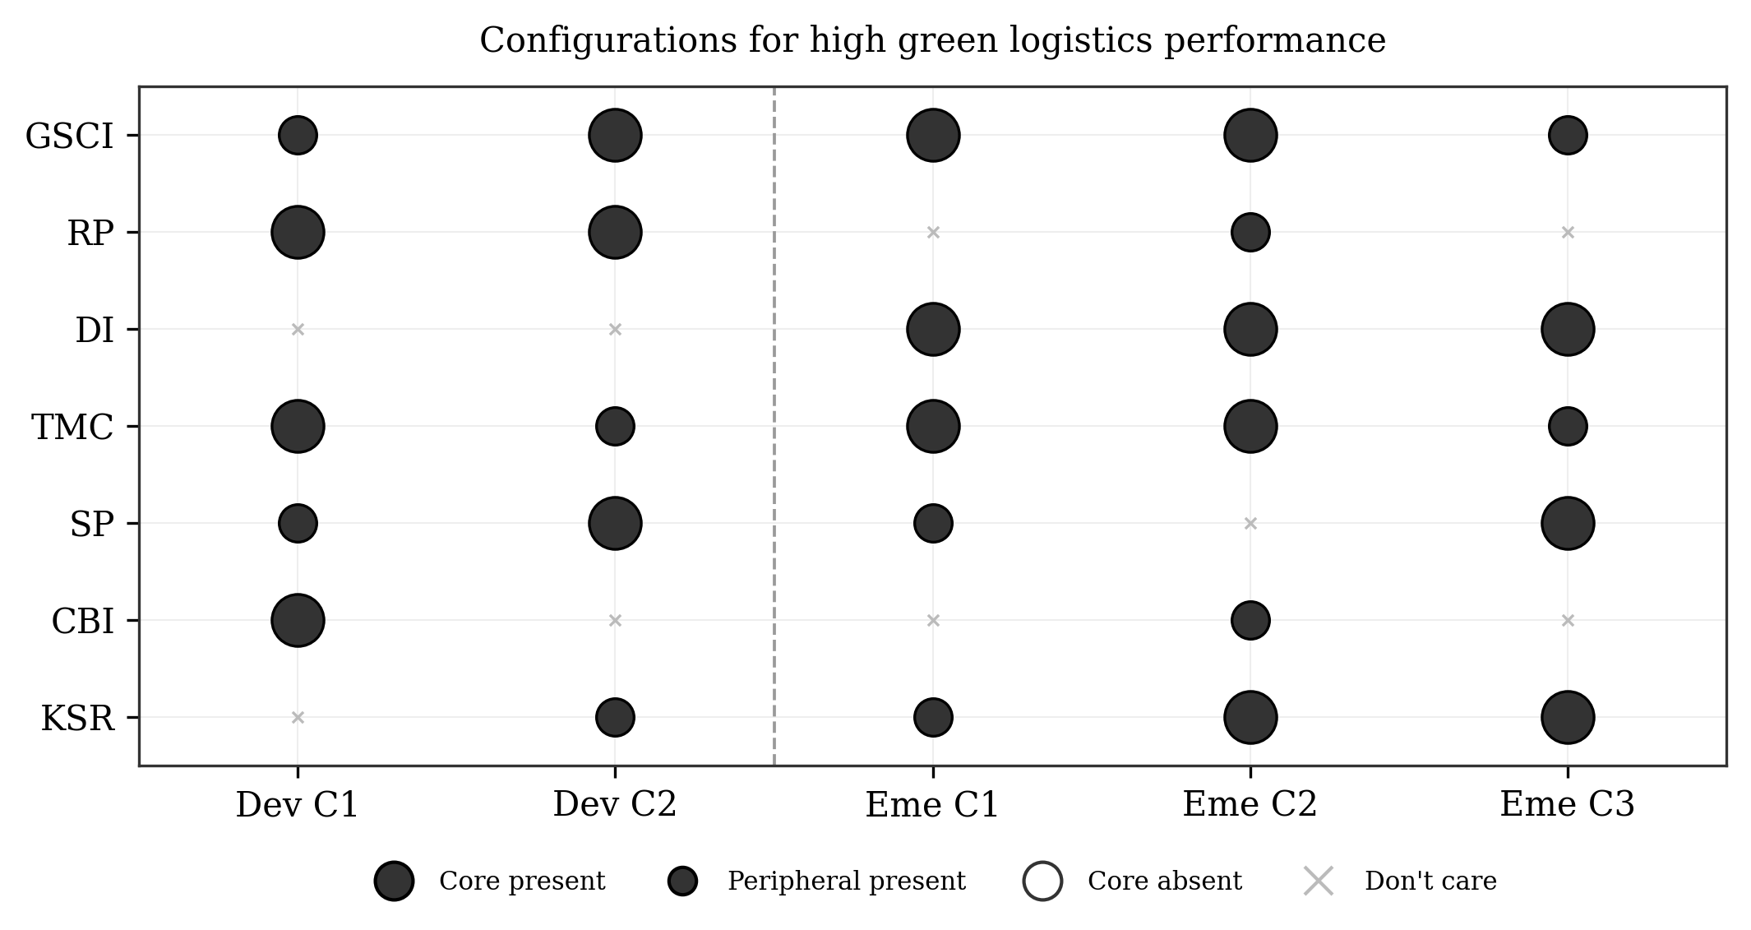
Figure 5. fsQCA configurations for high green logistics performance, by economy group. Source: authors.
6. Discussion
The findings can be read at two levels: the net effects estimated by the structural model and the configurations surfaced by the set-theoretic analysis. Taken together, they offer a more complete account of green logistics enablement than either approach would in isolation, and they speak directly to the three gaps identified in the introduction.
Interpreting the significant structural paths, the results affirm a coherent mechanism. External pressures elevate green logistics on the managerial agenda; committed leadership and digital capability build the integration capability; and integration, supported by managerial commitment, delivers measured performance. The prominence of the path from knowledge and skill readiness to digital infrastructure readiness is theoretically significant: it indicates that digital tools are not self-actuating but require absorptive capacity to generate value, a finding that resonates with the broader literature on technology assimilation and cautions against treating digital investment as a sufficient condition on its own. The strong direct effect of integration on performance confirms that coordination across organisational boundaries, rather than internal practices alone, is the operational engine of green logistics outcomes.
The non-significant pooled path from cost barrier inversion to integration is best understood through the configurational results. Cost barrier inversion is not inert; it features as a core condition in one of the developing-economy configurations. Its average net effect is diluted because its contribution is contingent: it matters where it combines with regulatory pressure and managerial commitment in resource-constrained settings, but it is largely irrelevant in the emerging-economy recipes that lead instead with digital capability. This is precisely the kind of relationship that a symmetric model obscures and a configurational model reveals, and it illustrates why the two methods are complementary rather than redundant. The fsQCA results demonstrate equifinality, with multiple distinct recipes leading to high performance, and causal asymmetry, since the presence of a condition in a successful recipe does not imply that its absence produces failure. Neither property is visible in the path estimates alone.
The multi-group differences carry a clear structural interpretation. That the digital-to-integration path is stronger in emerging economies, while the regulation-to-commitment path is stronger in developing economies, is consistent with the divergent endowments of the two contexts. Where digital infrastructure is mature and capital is available, firms can translate technological capability into integrated green operations directly, and the configurational analysis confirms that digital readiness and managerial commitment form the core of every successful emerging-economy recipe. Where digital infrastructure is thinner and market pull weaker, external regulation becomes the primary lever that moves leadership to act, and the developing-economy configurations are accordingly anchored by regulatory pressure and the easing of cost barriers. The economic environment therefore functions not merely as a backdrop but as a moderator that reshapes which enablers are decisive.
Returning explicitly to the three gaps, the study advances the literature on each. On the first gap, the single-context bias, the comparative design demonstrates that the relative potency of enablers is economy-dependent, and it specifies the mechanisms through which this dependence operates. On the second gap, the limits of SEM-only designs, the integration of fsQCA reveals equifinal pathways and asymmetric relationships that the structural model cannot represent, most strikingly in the case of cost barrier inversion. On the third gap, the weak empirical grounding of enabler lists, the study operationalises its constructs by inverting barrier dimensions that were validated and hierarchically organised in a companion structural study, lending the enabler set a dimensionality and an ordering that are grounded rather than assumed. The convergence between the structural and configurational findings, and between both and the comparative logic, lends confidence to the overall account.
7. Theoretical Contributions
The study makes three explicit theoretical contributions. First, it contributes to green logistics theory by specifying and testing a mechanism-based framework in which external pressures, leadership commitment, digital capability, workforce readiness, and cost dynamics combine through integration to produce performance, and by showing that the proximate driver of performance is the integration capability rather than any single antecedent. This moves the field beyond inventories of drivers toward a structured account of how enablement actually unfolds.
Second, it contributes to configurational theory in sustainability research by demonstrating equifinality and causal asymmetry in green logistics enablement. The identification of multiple sufficient configurations, none reducible to a single necessary condition, establishes that high performance is achieved through several alternative recipes, and the contrast between the recipes of the two economy groups illustrates how configurational logic captures context-dependence that variance-based methods average away.
Third, it contributes to comparative logistics scholarship by treating the economic context as a theoretical moderator rather than a sampling convenience. By estimating and comparing structural mechanisms across developing and emerging economies, and by grounding the constructs in a prior structural model of barriers, the study supports a cumulative, context-sensitive research programme and offers a template for future cross-economy comparisons in sustainable operations.
8. Practical Implications
8.1 Developing Economies: Policymakers and Managers
For policymakers in developing economies, the findings indicate that regulation is the most effective lever for moving firms toward green logistics, because it is the mechanism that most reliably elevates the issue to the level of leadership commitment where digital and market drivers are weak. Clear, credible, and progressively tightening environmental regulation, paired with policy incentives such as subsidies and tax benefits that ease cost barriers, is therefore likely to yield the greatest return. For managers in these settings, the practical priority is to convert regulatory compliance into genuine integration with suppliers and distributors and to pursue the economically viable green alternatives whose costs have fallen, rather than to wait for advanced digital systems that the surrounding infrastructure may not yet support.
8.2 Emerging Economies: Policymakers and Managers
For policymakers in emerging economies, the findings suggest that the marginal value of additional regulation is lower and that investment in digital infrastructure and in the skills required to use it offers greater leverage. Supporting digital readiness, the development of analytics capability, and workforce upskilling aligns with the configurations that actually produce high performance in these contexts. For managers, the priority is to secure visible top management commitment and to invest in digital infrastructure together with the knowledge and skills needed to exploit it, since the analysis shows that digital readiness and managerial commitment form the core of every successful emerging-economy recipe and that skill readiness is the condition that unlocks digital capability in the first place. In both contexts, the recognition that several different combinations of enablers can succeed frees managers to pursue the recipe best matched to their firm's endowments rather than a single prescribed formula.
9. Limitations and Future Research
Several limitations qualify the findings and point to future research. The cross-sectional design captures associations at a single point in time and cannot establish causal ordering with certainty; longitudinal designs that track firms as regulation tightens or digital infrastructure matures would allow the mechanisms to be observed in motion. The reliance on self-reported, single-source data introduces the possibility of common method bias, which procedural and statistical remedies suggest is limited but cannot wholly eliminate; future studies could incorporate objective performance data such as audited emissions figures. The classification of firms into two economy groups, while theoretically motivated, simplifies a continuum, and the generalisability of the configurations beyond the sampled contexts should be tested. Future work could extend the comparison to additional economy types, including developed economies, examine sector-specific configurations, and integrate further conditions such as supply chain complexity or ownership structure into the configurational model.
10. Conclusion
This study set out to identify the net effects of seven enabler constructs on green logistics performance, to surface the configurations of enablers sufficient for high performance, and to compare these across developing and emerging economies. Using PLS-SEM with multi-group analysis and fuzzy-set qualitative comparative analysis on a sample of 220 logistics and supply chain managers, the study found that green supply chain integration and top management commitment are the proximate drivers of performance, that workforce readiness unlocks digital capability, and that the structural mechanisms differ systematically by context, with digital integration stronger in emerging economies and regulatory pressure stronger in developing economies. The configurational analysis demonstrated equifinality, with two sufficient recipes in developing economies anchored by regulation and cost relief and three in emerging economies anchored by digital readiness and managerial commitment, and confirmed that no single enabler is necessary. By integrating symmetric and asymmetric methods across two economic contexts, and by grounding its constructs in a validated structural model of barriers, the study offers a context-sensitive understanding of how green logistics performance is achieved and provides differentiated guidance to the policymakers and managers charged with decarbonising the movement of goods.

References
Abdulrahman, M. D., Gunasekaran, A., & Subramanian, N. (2014). Critical barriers in implementing reverse logistics in the Chinese manufacturing sectors. International Journal of Production Economics, 147, 460-471.
Agyabeng-Mensah, Y., Ahenkorah, E., Afum, E., Nana Agyemang, A., Agnikpe, C., & Rogers, F. (2020). Examining the influence of internal green supply chain practices, green human resource management and supply chain environmental cooperation on firm performance. Supply Chain Management: An International Journal, 25(5), 585-599.
Ali, S. S., Kaur, R., Persis, D. J., Saha, R., Pattusamy, M., & Sreedharan, V. R. (2023). Developing a hybrid evaluation approach for the low-carbon performance on sustainable manufacturing environment. Annals of Operations Research, 324(1), 249-281.
Bag, S., Gupta, S., & Foropon, C. (2019). Examining the role of dynamic remanufacturing capability on supply chain resilience in circular economy. Management Decision, 57(4), 863-885.
Bag, S., Wood, L. C., Xu, L., Dhamija, P., & Kayikci, Y. (2020). Big data analytics as an operational excellence approach to enhance sustainable supply chain performance. Resources, Conservation and Recycling, 153, 104559.
Bhattacharya, A., Nand, A., & Castka, P. (2019). Lean-green integration and its impact on sustainability performance: A critical review. Journal of Cleaner Production, 236, 117697.
Bouzon, M., Govindan, K., & Rodriguez, C. M. T. (2018). Evaluating barriers for reverse logistics implementation under a multiple stakeholders' perspective analysis using grey decision making approach. Resources, Conservation and Recycling, 128, 315-335.
Centobelli, P., Cerchione, R., & Esposito, E. (2020). Pursuing supply chain sustainable development goals through the adoption of green practices and enabling technologies: A cross-country analysis of LSPs. Technological Forecasting and Social Change, 153, 119920.
Chen, L., Zhao, X., Tang, O., Price, L., Zhang, S., & Zhu, W. (2021). Supply chain collaboration for sustainability: A literature review and future research agenda. International Journal of Production Economics, 234, 108049.
Cohen, J. (1992). A power primer. Psychological Bulletin, 112(1), 155-159.
Dubey, R., Gunasekaran, A., Papadopoulos, T., Childe, S. J., Shibin, K. T., & Wamba, S. F. (2017). Sustainable supply chain management: Framework and further research directions. Journal of Cleaner Production, 142, 1119-1130.
Dubey, R., Gunasekaran, A., Childe, S. J., Papadopoulos, T., Luo, Z., Wamba, S. F., & Roubaud, D. (2019). Can big data and predictive analytics improve social and environmental sustainability? Technological Forecasting and Social Change, 144, 534-545.
Evangelista, P., Santoro, L., & Thomas, A. (2018). Environmental sustainability in third-party logistics service providers: A systematic literature review from 2000-2016. Sustainability, 10(5), 1627.
Fiss, P. C. (2011). Building better causal theories: A fuzzy set approach to typologies in organization research. Academy of Management Journal, 54(2), 393-420.
Freeman, R. E. (2010). Strategic management: A stakeholder approach. Cambridge University Press.
Ghobakhloo, M., Tang, S. H., Zulkifli, N., & Ariffin, M. K. A. (2013). An integrated framework of sustainable supply chain management implementation. International Journal of Innovation, Management and Technology, 4(1), 86-97.
Govindan, K., & Hasanagic, M. (2018). A systematic review on drivers, barriers, and practices towards circular economy: A supply chain perspective. International Journal of Production Research, 56(1-2), 278-311.
Hair, J. F., Hult, G. T. M., Ringle, C. M., & Sarstedt, M. (2017). A primer on partial least squares structural equation modeling (PLS-SEM) (2nd ed.). Sage.
Hervani, A. A., Nandi, S., Helms, M. M., & Sarkis, J. (2022). A performance measurement framework for socially sustainable and resilient supply chains using environmental goods valuation methods. Sustainable Production and Consumption, 30, 31-52.
Jabbour, C. J. C., Fiorini, P. D. C., Ndubisi, N. O., Queiroz, M. M., & Piato, E. L. (2020). Digitally-enabled sustainable supply chains in the 21st century: A review and a research agenda. Science of the Total Environment, 725, 138177.
Jum'a, L., Zimon, D., Ikram, M., & Madzik, P. (2022). Towards a sustainability paradigm: The nexus between lean green practices, sustainability-oriented innovation and triple bottom line. International Journal of Production Economics, 245, 108393.
Karmaker, C. L., Ahmed, T., Ahmed, S., Ali, S. M., Moktadir, M. A., & Kabir, G. (2021). Improving supply chain sustainability in the context of COVID-19 pandemic in an emerging economy: Exploring drivers using an integrated model. Sustainable Production and Consumption, 26, 411-427.
Khan, S. A. R., Yu, Z., Golpira, H., Sharif, A., & Mardani, A. (2021). A state-of-the-art review and meta-analysis on sustainable supply chain management: Future research directions. Journal of Cleaner Production, 278, 123357.
Khan, S. A. R., Razzaq, A., Yu, Z., & Miller, S. (2022). Industry 4.0 and circular economy practices: A new era business strategies for environmental sustainability. Business Strategy and the Environment, 30(8), 4001-4014.
Kumar, A., Mangla, S. K., Kumar, P., & Karamperidis, S. (2020). Challenges in perishable food supply chains for sustainability management: A developing economy perspective. Business Strategy and the Environment, 29(5), 1809-1831.
Kumar, S., Raut, R. D., Nayal, K., Kraus, S., Yadav, V. S., & Narkhede, B. E. (2021). To identify industry 4.0 and circular economy adoption barriers in the agriculture supply chain by using ISM-ANP. Journal of Cleaner Production, 293, 126023.
Liu, J., Feng, Y., Zhu, Q., & Sarkis, J. (2020). Green supply chain management and the circular economy: Reviewing theory for advancement of both fields. International Journal of Physical Distribution & Logistics Management, 48(8), 794-817.
Luthra, S., Garg, D., & Haleem, A. (2015). An analysis of interactions among critical success factors to implement green supply chain management towards sustainability: An Indian perspective. Resources Policy, 46, 37-50.
Luthra, S., Mangla, S. K., Xu, L., & Diabat, A. (2016). Using AHP to evaluate barriers in adopting sustainable consumption and production initiatives in a supply chain. International Journal of Production Economics, 181, 342-349.
Mangla, S. K., Kumar, P., & Barua, M. K. (2015). Risk analysis in green supply chain using fuzzy AHP approach: A case study. Resources, Conservation and Recycling, 104, 375-390.
Mangla, S. K., Luthra, S., Mishra, N., Singh, A., Rana, N. P., Dora, M., & Dwivedi, Y. (2020). Barriers to effective circular supply chain management in a developing country context. Production Planning & Control, 31(7-8), 561-574.
Mardani, A., Kannan, D., Hooker, R. E., Ozkul, S., Alrasheedi, M., & Tirkolaee, E. B. (2020). Evaluation of green and sustainable supply chain management using structural equation modelling: A systematic review of the state of the art literature and recommendations for future research. Journal of Cleaner Production, 249, 119383.
Maric, J., & Opazo-Basaez, M. (2019). Green servitization for flexible and sustainable supply chain operations: A review of reverse logistics services in manufacturing. Global Journal of Flexible Systems Management, 20(1), 65-80.
Moktadir, M. A., Rahman, T., Rahman, M. H., Ali, S. M., & Paul, S. K. (2018). Drivers to sustainable manufacturing practices and circular economy: A perspective of leather industries in Bangladesh. Journal of Cleaner Production, 174, 1366-1380.
Mubarik, M. S., Naghavi, N., Mubarik, M., Kusi-Sarpong, S., Khan, S. A., Zaman, S. I., & Kazmi, S. H. A. (2021). Resilience and cleaner production in industry 4.0: Role of supply chain mapping and visibility. Journal of Cleaner Production, 292, 126058.
Mukhuty, S., Upadhyay, A., & Rothwell, H. (2022). Strategic sustainable development of Industry 4.0 through the lens of social responsibility: The role of human resource practices. Business Strategy and the Environment, 31(5), 2068-2081.
Pagell, M., & Wu, Z. (2009). Building a more complete theory of sustainable supply chain management using case studies of 10 exemplars. Journal of Supply Chain Management, 45(2), 37-56.
Pappas, I. O., & Woodside, A. G. (2021). Fuzzy-set qualitative comparative analysis (fsQCA): Guidelines for research practice in information systems and marketing. International Journal of Information Management, 58, 102310.
Patwa, N., Sivarajah, U., Seetharaman, A., Sarkar, S., Maiti, K., & Hingorani, K. (2021). Towards a circular economy: An emerging economies context. Journal of Business Research, 122, 725-735.
Queiroz, M. M., Telles, R., & Bonilla, S. H. (2020). Blockchain and supply chain management integration: A systematic review of the literature. Supply Chain Management: An International Journal, 25(2), 241-254.
Raghuvanshi, J., Ghosh, P. K., & Agrawal, R. (2019). Taxonomy of green supply chain management practices: An exploratory study. Benchmarking: An International Journal, 26(2), 471-498.
Ragin, C. C. (2008). Redesigning social inquiry: Fuzzy sets and beyond. University of Chicago Press.
Rajeev, A., Pati, R. K., Padhi, S. S., & Govindan, K. (2017). Evolution of sustainability in supply chain management: A literature review. Journal of Cleaner Production, 162, 299-314.
Raut, R. D., Mangla, S. K., Narwane, V. S., Gardas, B. B., Priyadarshinee, P., & Narkhede, B. E. (2019). Linking big data analytics and operational sustainability practices for sustainable business management. Journal of Cleaner Production, 224, 10-24.
Sarkis, J., Zhu, Q., & Lai, K. H. (2011). An organizational theoretic review of green supply chain management literature. International Journal of Production Economics, 130(1), 1-15.
Seuring, S., & Müller, M. (2008). From a literature review to a conceptual framework for sustainable supply chain management. Journal of Cleaner Production, 16(15), 1699-1710.
Sharma, M., Joshi, S., Kannan, D., Govindan, K., Singh, R., & Purohit, H. C. (2020). Internet of Things (IoT) adoption barriers of smart cities' waste management: An Indian context. Journal of Cleaner Production, 270, 122047.
Shen, B., Li, Q., Dong, C., & Perry, P. (2021). Sustainability issues in textile and apparel supply chains. Sustainability, 13(13), 7333.
Srivastava, S. K. (2007). Green supply-chain management: A state-of-the-art literature review. International Journal of Management Reviews, 9(1), 53-80.
Stekelorum, R., Laguir, I., Gupta, S., & Kumar, S. (2021). Green supply chain management practices and third-party logistics providers' performances: A fuzzy-set approach. International Journal of Production Economics, 235, 108093.
Tseng, M. L., Islam, M. S., Karia, N., Fauzi, F. A., & Afrin, S. (2019). A literature review on green supply chain management: Trends and future challenges. Resources, Conservation and Recycling, 141, 145-162.
Vachon, S., & Klassen, R. D. (2008). Environmental management and manufacturing performance: The role of collaboration in the supply chain. International Journal of Production Economics, 111(2), 299-315.
Wong, C. Y., Wong, C. W. Y., & Boon-itt, S. (2020). Effects of green supply chain integration and green innovation on environmental and cost performance. International Journal of Production Research, 58(15), 4589-4609.
Woodside, A. G. (2013). Moving beyond multiple regression analysis to algorithms: Calling for adoption of a paradigm shift from symmetric to asymmetric thinking in data analysis and crafting theory. Journal of Business Research, 66(4), 463-472.
Wu, G. C. (2013). The influence of green supply chain integration and environmental uncertainty on green innovation in Taiwan's IT industry. Supply Chain Management: An International Journal, 18(5), 539-552.
Yadav, G., Luthra, S., Jakhar, S. K., Mangla, S. K., & Rai, D. P. (2020). A framework to overcome sustainable supply chain challenges through solution measures of industry 4.0 and circular economy: An automotive case. Journal of Cleaner Production, 254, 120112.
Yu, Z., Khan, S. A. R., & Umar, M. (2022). Circular economy practices and industry 4.0 technologies: A strategic move of automobile industry. Business Strategy and the Environment, 31(3), 796-809.
Zaid, A. A., Jaaron, A. A. M., & Bon, A. T. (2018). The impact of green human resource management and green supply chain management practices on sustainable performance: An empirical study. Journal of Cleaner Production, 204, 965-979.
Zhan, Y., Tan, K. H., Ji, G., Chung, L., & Tseng, M. (2020). A big data framework for facilitating product innovation processes. Business Process Management Journal, 26(2), 536-555.
Zhang, Q., Pan, J., Jiang, Y., & Feng, T. (2020). The impact of green supplier integration on firm performance: The mediating role of social capital accumulation. Journal of Purchasing and Supply Management, 26(2), 100579.
Zhu, Q., Sarkis, J., & Lai, K. H. (2013). Institutional-based antecedents and performance outcomes of internal and external green supply chain management practices. Journal of Purchasing and Supply Management, 19(2), 106-117.
Zimon, D., Tyan, J., & Sroufe, R. (2020). Drivers of sustainable supply chain management: Practices to alignment with UN sustainable development goals. International Journal for Quality Research, 14(1), 219-236.

