ESG Disclosure to Supplier Governance: An Environmental Prioritisation Framework for Pharmaceutical Supply Chains

Abstract
This study examines how mandatory ESG disclosure can be used as a strategic mechanism for supplier governance in supply chains. Focusing on India’s Business Responsibility and Sustainability Reporting (BRSR) regime and the pharmaceutical industry, it explores how regulated ESG data can support focal firms in evaluating and prioritising suppliers’ environmental performance. The study develops a disclosure-anchored supplier governance framework based on publicly reported BRSR data from eight major listed Indian pharmaceutical firms. It integrates the Fuzzy Best-Worst Method to determine the relative importance of ESG criteria and Fuzzy TOPSIS to rank firms on environmental supplier-relevant performance dimensions. The results show that environmental criteria are the most influential in supplier prioritisation, with greenhouse gas emission intensity and renewable energy adoption emerging as the strongest factors. Community-oriented criteria are comparatively less decisive, and the rankings remain stable under substantial variation in criteria weights, indicating robustness of the framework. The paper extends sustainable supply chain management research by showing how mandatory ESG disclosure can function as an instrument of supplier governance rather than merely a compliance exercise. It contributes a replicable decision framework that links disclosure regulation, supplier evaluation and environmental governance, while offering practical guidance for supply chain managers, sustainability officers and regulators.

Keywords: ESG disclosure; BRSR; supplier environmental performance; institutional theory; stakeholder theory; pharmaceutical industry

1. Introduction
Climate risk, tightening environmental regulation and intensifying stakeholder scrutiny have moved the environmental performance of supply chains to the centre of corporate strategy. Firms are no longer judged only on the cost, quality and reliability of what they buy, but on the environmental and social conduct embedded across their value chains (Seuring and Müller, 2008; Carter and Rogers, 2008; Sarkis et al., 2011). Because a large share of a focal firm's environmental footprint, and of its exposure to regulatory and reputational risk, originates upstream, the governance of suppliers has become a strategic lever for environmental performance rather than an operational afterthought (Tachizawa and Wong, 2014; Gimenez and Tachizawa, 2012). How firms select, monitor and develop suppliers is therefore increasingly a question of corporate sustainability strategy.
A parallel and reinforcing development is the rise of mandatory ESG disclosure. Reporting regimes that were once voluntary and heterogeneous are being replaced by standardised, externally assured mandates that reshape corporate sustainability practice and stakeholder relations (Christensen, Hail and Leuz, 2021; Ioannou and Serafeim, 2017; Dhaliwal et al., 2011). India offers a paradigmatic case. In 2021 the Securities and Exchange Board of India (SEBI) introduced the Business Responsibility and Sustainability Reporting (BRSR) framework, requiring the 1,000 largest listed entities by market capitalisation to disclose standardised ESG information, and in 2023 it strengthened the mandate through BRSR Core, which imposes reasonable external assurance on a defined set of key performance indicators spanning greenhouse gas (GHG) intensity, energy and water use, waste, workforce safety and supply chain ESG assessment (SEBI, 2021; SEBI, 2023). BRSR thus functions as more than a compliance artefact: it is a coercive institutional pressure and a public, comparable information infrastructure that reshapes how listed firms and, by extension, their suppliers must account for environmental performance (DiMaggio and Powell, 1983; Delmas and Toffel, 2008).
These pressures are acute in the pharmaceutical industry, which combines high environmental intensity, stringent regulation and direct public-health salience (Sarkis and Talluri, 2002; Grimm et al., 2014). Active pharmaceutical ingredient (API) synthesis, solvent use, water withdrawal and chemical waste generate substantial footprints, and the most environmentally exposed nodes are frequently the least monitored upstream suppliers (Grimm et al., 2014). India is the world's third-largest pharmaceutical producer by volume and the largest supplier of generic medicines, accounting for a substantial share of global generic exports and vaccine supply (Pharmexcil, 2024). The environmental conduct of Indian pharmaceutical suppliers is therefore of systemic, not merely national, importance, and it is now increasingly visible through BRSR disclosure.
This convergence creates a distinct strategic tension. On one side, firms face coercive pressure to align their supply bases with corporate ESG commitments and net-zero trajectories under conditions of regulatory and investor scrutiny; failure to do so threatens their legitimacy with key stakeholders (Suchman, 1995; Aguilera et al., 2007). On the other side, the decision tools most firms use to evaluate suppliers were not designed for a mandatory-disclosure world: they typically rest on subjective expert surveys and proprietary judgements that are disconnected from regulated ESG data, prone to bias, and difficult to replicate or audit (You et al., 2015; Ecer, 2020; Zimmer et al., 2016). The strategic promise of mandatory ESG disclosure, that it can become an instrument for governing suppliers, has not been realised in practice or theorised in the literature.
Two research streams remain largely disconnected. The ESG disclosure literature, including emerging work on BRSR, concentrates on firm-level reporting, its determinants and its capital-market consequences, but says little about how disclosures can be used to govern the supply base (Christensen et al., 2021; Dhaliwal et al., 2011). The sustainable supply chain governance literature examines codes of conduct, audits and supplier development, yet its supplier-evaluation models rarely draw on mandatory, externally assured ESG disclosures, relying instead on expert elicitation (Govindan et al., 2015; Gualandris et al., 2015; Zimmer et al., 2016). The result is a gap at the intersection of the two: disclosure-anchored, regulation-driven supplier governance is under-theorised and under-operationalised, particularly in the environmentally critical Indian pharmaceutical sector.
Against this backdrop, the present study asks three questions. First, how can firms strategically use BRSR-mandated ESG disclosures to govern suppliers in pharmaceutical supply chains? Second, which environmental and ESG dimensions are most decisive in aligning supplier portfolios with corporate sustainability strategy under a mandatory-disclosure regime? Third, what do the resulting patterns imply, theoretically and practically, for the strategic use of regulatory disclosure to reconfigure supply chains? To answer these questions, we develop a disclosure-anchored decision framework that treats BRSR filings as the primary data infrastructure and combines the Fuzzy Best-Worst Method (Fuzzy BWM) for criteria weighting with Fuzzy TOPSIS for supplier ranking, applied to eight major listed Indian pharmaceutical firms. The method is deployed as a strategic instrument rather than an end in itself; its technical machinery is summarised in the main text and detailed in Appendix A.
The study makes three contributions. Theoretically, it integrates institutional, stakeholder and legitimacy perspectives to explain how mandatory ESG disclosure becomes a mechanism for extending institutional pressure into the supply base, and it advances four propositions linking disclosure, supplier governance and environmental outcomes, thereby extending ESG disclosure and sustainable supply chain governance research (Sarkis et al., 2011; Tachizawa and Wong, 2014; Christensen et al., 2021). Empirically and methodologically, it demonstrates how a national mandatory-disclosure regime can be turned into a transparent, replicable and audit-ready strategic decision tool, avoiding the biases of survey-based supplier evaluation (Zimmer et al., 2016; You et al., 2015). Practically, it offers corporate sustainability strategists, ESG and governance officers, investors and regulators an evidence-based account of how disclosure can be used to steer supply chains towards superior environmental performance. The remainder of the paper proceeds as follows. Section 2 develops the theoretical background and reviews the relevant literature. Section 3 presents the strategic decision framework and research design. Section 4 reports the results, Section 5 discusses their strategic, environmental and theoretical implications, and Section 6 draws out implications for practice and policy. Section 7 concludes with limitations and future research directions.

2. Theoretical Background and Literature Review

2.1 ESG Disclosure, Mandatory Reporting Regimes and Corporate Strategy
Corporate ESG disclosure has evolved from a voluntary, reputational exercise into a structured determinant of corporate strategy. Early frameworks such as the Global Reporting Initiative (GRI) standardised voluntary sustainability reporting, but their uptake, scope and assurance quality varied widely, limiting comparability across firms (Bai and Sarkis, 2010). A substantial body of work shows that disclosure is strategically consequential: firms that report credible non-financial information lower their cost of equity capital and strengthen investor relations (Dhaliwal et al., 2011), and disclosure choices are used to manage the expectations of powerful stakeholders (Aguilera et al., 2007). At the same time, voluntary regimes are vulnerable to selective disclosure and greenwashing, where firms publicise favourable indicators while omitting unfavourable ones (Delmas and Burbano, 2011; Marquis, Toffel and Zhou, 2016).
Mandatory reporting regimes change this calculus. By specifying which indicators must be disclosed and, increasingly, requiring external assurance, they raise the evidentiary standard of ESG data and constrain selective disclosure (Christensen, Hail and Leuz, 2021; Ioannou and Serafeim, 2017). Evidence indicates that mandatory sustainability reporting reshapes corporate practice, improves the comparability and reliability of ESG information, and alters the information environment in which strategy is formed (Ioannou and Serafeim, 2017; Christensen et al., 2021). India's BRSR framework exemplifies this shift. Its nine principles align with the National Guidelines on Responsible Business Conduct and overlap substantially with the GRI Universal Standards and climate-disclosure recommendations, while BRSR Core adds reasonable third-party assurance on a defined KPI set covering GHG intensity, energy, water, waste, workforce safety and supply chain ESG assessment (SEBI, 2021; SEBI, 2023). The literature, however, has examined BRSR and comparable mandates almost exclusively at the level of the reporting firm; how these disclosures might be used strategically to govern suppliers remains largely unaddressed.

2.2 Sustainable Supply Chain Governance and ESG-Oriented Supplier Management
Research on sustainable supply chain management (SSCM) establishes that a firm's environmental and social performance is co-produced with its suppliers, making the supply base a source of both risk and competitive advantage (Seuring and Müller, 2008; Carter and Rogers, 2008). Governance of sustainability in the supply base operates through mechanisms such as supplier codes of conduct, ESG criteria in sourcing decisions, audits, certification and supplier development (Gimenez and Tachizawa, 2012; Gualandris et al., 2015). Two broad governance logics are distinguished in this literature: assessment, in which buyers evaluate and monitor supplier conduct, and collaboration, in which buyers build supplier capability (Gimenez and Tachizawa, 2012; Marshall et al., 2015). Extending sustainability beyond first-tier suppliers is recognised as especially difficult, and multi-tier governance depends heavily on the visibility of supplier performance (Tachizawa and Wong, 2014; Foerstl et al., 2010).
Much of this work is either qualitative and managerial or relies on expert-driven multi-criteria models, and its data on supplier performance typically come from private audits or surveys rather than public, comparable disclosure (Govindan et al., 2015; Zimmer et al., 2016). Gualandris et al. (2015) argue that credible, verifiable evaluation is central to the accountability of sustainable supply chains, yet verification remains costly and fragmented. Bai and Sarkis (2010) demonstrated the feasibility of deriving supplier sustainability ratings from public GRI disclosures, but the voluntary, unassured nature of those reports limited comparability. The possibility that a mandatory, externally assured disclosure regime could anchor supplier governance, and thereby lower the cost and raise the credibility of supplier evaluation, has not been developed.

2.3 Fuzzy Multi-Criteria Decision-Making in Supplier Selection and Supply Risk
Supplier selection has long been modelled as a multi-criteria decision-making (MCDM) problem (Dickson, 1966; Weber, Current and Benton, 1991), and the incorporation of sustainability has expanded the criteria set to include environmental and social dimensions alongside cost, quality and delivery (Govindan et al., 2015). Because supplier sustainability information is often imprecise and expressed in linguistic terms, fuzzy set theory (Zadeh, 1965; Bellman and Zadeh, 1970) is widely used to represent such uncertainty, with TOPSIS (Hwang and Yoon, 1981) and its fuzzy extension providing a robust ranking apparatus (Chen, 2000; Awasthi, Chauhan and Goyal, 2010; Kannan, Jabbour and Jabbour, 2013). For criteria weighting, the Best-Worst Method reduces the number of pairwise comparisons and yields more consistent, uniquely determined weights than the Analytic Hierarchy Process, which has itself been applied to green sourcing (Saaty, 1980; Lee et al., 2009; Rezaei, 2015; Rezaei, 2016), and its fuzzy extension accommodates linguistic imprecision (Guo and Zhao, 2017). Hybrid Fuzzy BWM-TOPSIS designs have proven effective for green supplier selection (Gupta and Barua, 2017; Büyüközkan and Çifçi, 2012).
These methods provide strong decision support, but they share a limitation relevant to the present study: they are almost always populated with expert judgements or survey ratings rather than with mandatory, externally assured ESG disclosures, and they are rarely connected to regulatory compliance regimes (Ecer, 2020; You et al., 2015; Zimmer et al., 2016). As a consequence, their outputs are difficult to reproduce and audit, and they remain detached from the disclosure environment that now shapes corporate sustainability strategy. Repurposing these tools to operate on regulated ESG disclosure is the methodological move this study makes.

2.4 Theoretical Framing: Institutional, Stakeholder and Legitimacy Perspectives
We interpret BRSR-driven supplier governance through three complementary theoretical lenses. Institutional theory explains why organisations converge on similar practices under external pressure. DiMaggio and Powell (1983), building on Meyer and Rowan (1977), identify coercive, mimetic and normative isomorphism as mechanisms through which fields become homogeneous. A mandatory disclosure regime such as BRSR is a prototypical coercive pressure: it compels listed firms to measure, assure and publish specified environmental indicators (SEBI, 2021; SEBI, 2023). Crucially, institutional pressures do not stop at the focal firm. Because a firm's disclosed environmental performance depends partly on its suppliers, and because value-chain disclosure is being extended under BRSR, focal firms have an incentive to transmit these pressures upstream, converting a firm-level mandate into supply-base governance (Delmas and Toffel, 2008; Tachizawa and Wong, 2014). Firms nevertheless retain strategic agency in how they respond to institutional demands, ranging from acquiescence to manipulation (Oliver, 1991; Scott, 2014).
Stakeholder theory explains whose expectations drive this behaviour. Firms manage relationships with salient stakeholders, investors, regulators, customers and communities, whose claims must be balanced for the firm to prosper (Freeman, 1984; Aguilera et al., 2007). Standardised ESG disclosure lowers the information asymmetry between firms and these stakeholders, making supplier-related environmental performance observable and therefore governable. Legitimacy theory explains the motive: firms seek to demonstrate that their conduct is appropriate within socially constructed norms, and ESG disclosure and disclosure-based supplier governance are means of acquiring, maintaining and repairing legitimacy (Suchman, 1995; Bansal and Roth, 2000). Where disclosure is voluntary, legitimacy can be pursued symbolically through greenwashing (Delmas and Burbano, 2011; Marquis et al., 2016); mandatory assurance constrains such symbolic responses and pushes firms towards substantive action, including the reconfiguration of their supply bases. Read together with the natural-resource-based view, which treats superior environmental performance as a source of competitive advantage (Hart, 1995), these lenses imply that disclosure-anchored supplier governance is simultaneously a response to institutional pressure, a means of managing stakeholders, a legitimacy strategy and a potential source of advantage.
From this integrated framing we derive four propositions that link ESG disclosure, supplier governance and environmental outcomes and that guide the interpretation of our results:
Proposition 1. Under a mandatory, externally assured ESG disclosure regime, coercive institutional pressure raises the strategic salience of environmental criteria, so that firms weight supplier environmental performance, especially GHG intensity and renewable energy adoption, above social and governance criteria in supplier evaluation.
Proposition 2. Standardised, assured ESG disclosure reduces buyer-supplier information asymmetry, enabling disclosure-anchored supplier governance that substitutes for, and is more replicable and auditable than, private survey- or audit-based evaluation.
Proposition 3. To secure legitimacy with investors, regulators and other salient stakeholders, focal firms use disclosure-based supplier benchmarking to reconfigure their supply bases towards environmentally superior suppliers, thereby cascading institutional pressure upstream through the supply chain.
Proposition 4. Aligning supplier portfolios with disclosed environmental performance strengthens supply chain environmental outcomes and reduces regulatory and reputational risk, linking supplier governance to firm-level competitive and legitimacy advantages.

2.5 Synthesis and Research Gaps
Table 1 synthesises the most directly relevant studies by theme, method and contribution. Read through the theoretical framing above, the synthesis reveals a coherent gap. ESG disclosure research establishes that mandatory reporting reshapes strategy but stops at the firm boundary; SSCM research establishes the importance of supplier governance but relies on private or expert data; and fuzzy MCDM research offers robust decision tools that are disconnected from regulated disclosure. No prior study theorises or operationalises BRSR-anchored, disclosure-driven supplier governance in the environmentally critical Indian pharmaceutical sector. This study occupies precisely that intersection.
Table 1. Synthesis of key studies by theme, method and contribution
Study | Journal | Method | Key Contribution | Relevance to This Study
Seuring and Müller (2008) | J. of Cleaner Production | Literature review | SSCM triple-bottom-line framework first systematic SSCM map | ESG framework; sustainability criteria grouping
Carter and Rogers (2008) | IJPDLM | Conceptual | Stakeholder theory + risk in SSCM | Theoretical grounding for pharma SC sustainability
Dickson (1966) | J. of Purchasing | Survey | 23 vendor selection criteria | Historical anchor; criteria evolution
Weber et al. (1991) | European J. Op. Research | Meta-analysis | 74 supplier selection papers; price & quality dominant | Confirms multi-criteria complexity
Govindan et al. (2015) | J. of Cleaner Production | Systematic review | 197 green supplier selection papers; MCDM dominance | Criteria list; research gap identification
Zimmer et al. (2016) | Int. J. of Production Research | Systematic review | 113 sustainable supplier management papers | Survey-data limitation; secondary data gap
Saaty (1980) | Book (McGraw-Hill) | Methodology | Analytic Hierarchy Process (AHP) | Comparator method for BWM justification
Rezaei (2015) | Omega | Methodology | Best-Worst Method (BWM) fewer comparisons, higher consistency | Core weighting methodology
Rezaei (2016) | Omega | Methodology | Linear BWM model unique optimal weights | BWM formalisation; CR threshold
Zadeh (1965) | Information and Control | Theory | Fuzzy set theory | Mathematical foundation for TFNs
Bellman and Zadeh (1970) | Management Science | Theory | Decision-making in fuzzy environments | Linguistic variable basis
Chen (2000) | Fuzzy Sets & Systems | Methodology | Fuzzy TOPSIS with FPIS/FNIS | Core ranking methodology
Gupta and Barua (2017) | J. of Cleaner Production | Case study | Hybrid BWM–Fuzzy TOPSIS for green supplier selection | Direct methodological precedent
Guo and Zhao (2017) | Knowledge-Based Systems | Methodology | Fuzzy BWM with TFN comparisons | Fuzzy extension of BWM
Kannan et al. (2013) | European J. Op. Research | Case study | Fuzzy AHP + Fuzzy TOPSIS for green suppliers (electronics, Brazil) | Hybrid precedent; electronics sector
Büyüközkan and Çifçi (2012) | Expert Systems with Applications | Case study | Fuzzy DEMATEL-ANP-TOPSIS green supplier evaluation | Multi-method hybrid precedent
Awasthi et al. (2010) | Int. J. of Production Economics | Case study | Fuzzy TOPSIS for green urban logistics suppliers | Environmental criteria operationalisation
Grimm et al. (2014) | Int. J. of Production Economics | Case study | Sub-supplier management in pharma SC | Pharma sector justification
Sarkis and Talluri (2002) | J. of Supply Chain Management | Conceptual | Strategic supplier selection model | Pharma SC selection framework precedent
Bai and Sarkis (2010) | Int. J. of Production Economics | Case study | GRI secondary data + rough set for sustainability | Secondary disclosure data precedent
Ecer (2020) | Operational Research | Case study | Interval type-2 fuzzy AHP green supplier selection | Survey-dependency limitation

3. A Strategic Decision Framework and Research Design

3.1 From Method to Strategy
The framework is best understood not as a technical exercise but as a strategic decision-support instrument that helps firms align their supplier portfolios with corporate sustainability strategy under a mandatory-disclosure regime. It addresses two strategic decisions that every ESG-conscious buyer faces: which sustainability dimensions should carry the most weight in sourcing, given regulatory and stakeholder salience, and how do candidate suppliers compare against an ideal environmental profile once those priorities are applied. The first decision is supported by the Fuzzy Best-Worst Method, which translates managerial judgements about the strategic importance of ESG dimensions into transparent, internally consistent weights; the second is supported by Fuzzy TOPSIS, which converts disclosed performance into a ranked portfolio suitable for retention, development or exit decisions. Both steps are populated exclusively from BRSR disclosure, so the tool is replicable, audit-ready and directly tied to the regulatory regime that shapes firm strategy. Figure 1 summarises the process from ESG reporting through criteria construction and weighting to supplier ranking and strategic decisions; the underlying fuzzy arithmetic, linguistic scales and distance formulae are consolidated in Appendix A so that the main text remains focused on strategy.
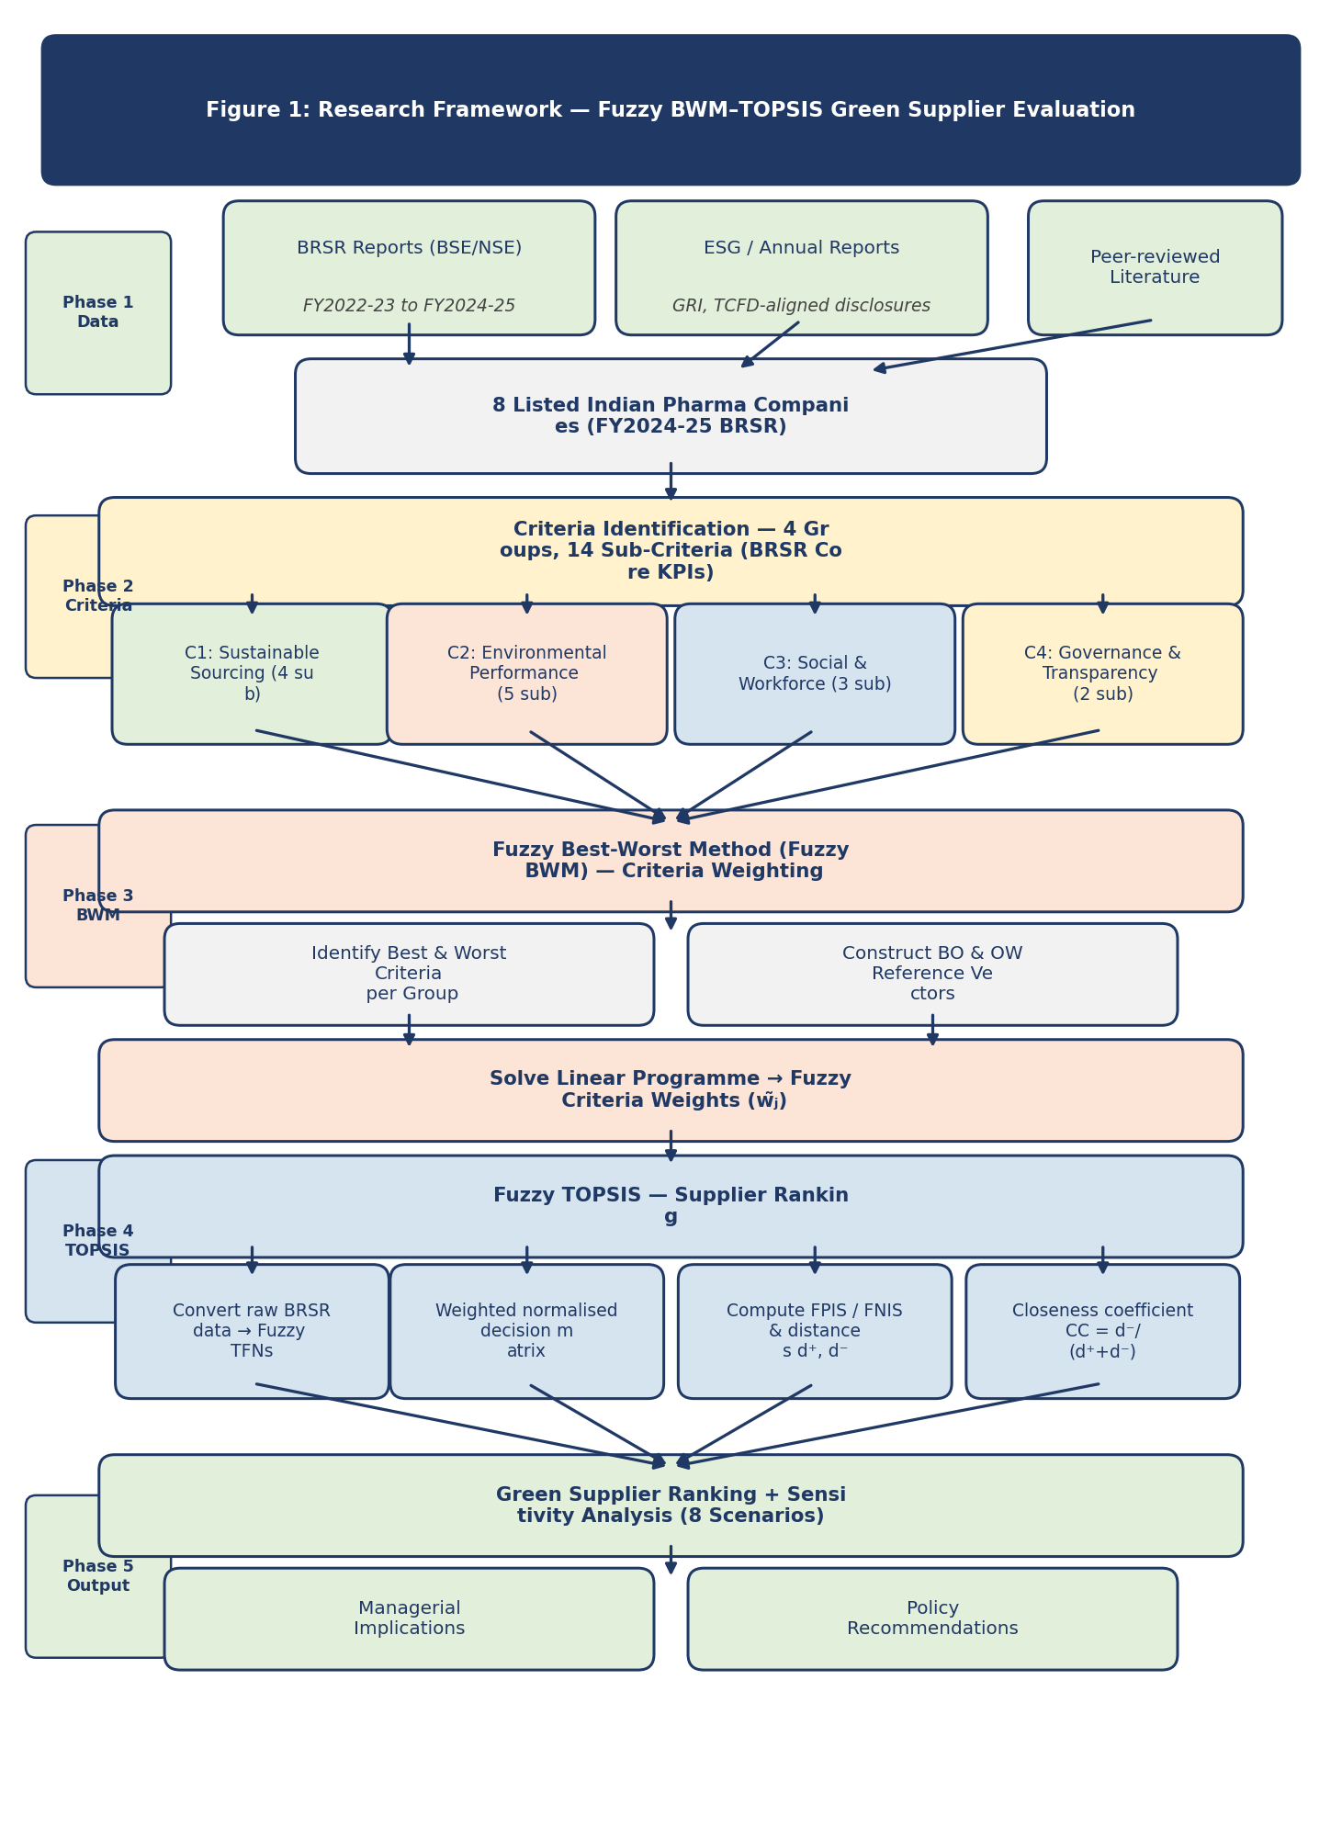
Figure 1. Strategic decision process: from BRSR disclosure to supplier governance decisions

3.2 BRSR as Strategic Data Infrastructure
All performance data are drawn from mandatorily disclosed, externally assured BRSR filings submitted by listed Indian pharmaceutical firms on the Bombay Stock Exchange and the National Stock Exchange, supplemented by firms' standalone ESG reports and, where relevant, GRI-aligned disclosures. Relying on assured regulatory disclosure rather than expert surveys is a strategic as well as a methodological choice: it removes the response bias, small and homogeneous panels and non-replicability that constrain survey-based supplier evaluation (You et al., 2015; Ecer, 2020; Zimmer et al., 2016), and it grounds the analysis in the very information environment to which boards, investors and regulators now attend (Christensen et al., 2021; Ioannou and Serafeim, 2017). In institutional terms, the framework operationalises the coercive pressure of BRSR as usable governance information (Proposition 2).

3.3 Sample
The sample comprises eight major listed Indian pharmaceutical firms selected on three criteria: inclusion in the BSE 200 index as at 31 March 2025 (ensuring mandatory BRSR filing), availability of a complete BRSR for at least FY 2023-24 (with FY 2024-25 used where published), and disclosure of the BRSR Core indicators mapped to the fourteen evaluation sub-criteria. The firms, Sun Pharma, Dr. Reddy's Laboratories, Cipla, Lupin, Aurobindo Pharma, Torrent Pharmaceuticals, Alkem Laboratories and Zydus Lifesciences, together account for roughly 72 per cent of the BSE Healthcare Index by market capitalisation and span the sector's principal business models, from formulation-focused exporters to API-integrated manufacturers. This coverage makes the sample strategically representative of the listed segment that BRSR governs.

3.4 Environmental and ESG Criteria Derived from BRSR
Fourteen sub-criteria in four groups were constructed in three steps: mapping BRSR Core KPIs relevant to supplier environmental and social performance (SEBI, 2023); aligning these with the criteria most frequently validated in the green supplier selection literature (Govindan et al., 2015; Zimmer et al., 2016); and incorporating pharmaceutical-specific environmental risks in API synthesis, solvent use and packaging (Grimm et al., 2014; Sarkis and Talluri, 2002). Environmental performance (group C2) is deliberately central, comprising GHG emission intensity, renewable energy share, water intensity, waste intensity and plastics extended-producer-responsibility compliance, because these are the dimensions most exposed to regulatory assurance and stakeholder scrutiny and most consequential for competitive and legitimacy-driven strategy (Hart, 1995; SEBI, 2023). GHG emission intensity is measured on Scope 1 and 2 emissions consistent with the corporate accounting standard of the Greenhouse Gas Protocol (WRI and WBCSD, 2004). Sustainable sourcing and governance (C1), social and workforce responsibility (C3), and governance and transparency (C4) complete the structure. Table 2 reports the criteria, their measurement and their BRSR source.
Table 2. Environmental and ESG supplier evaluation criteria mapped to BRSR indicators
Group | Code | Sub-Criterion | Measurement & Data Source | Type | BRSR Reference
C1 Sust. Sourcing & Governance | C1.1 | Sustainable sourcing procedures | Binary coded: Y=3, Partial=1.5, No=0 | Ben | BRSR Principle 2 EI-1
 | C1.2 | % inputs sourced sustainably | % of total inputs from certified/sustainable sources | Ben | BRSR Principle 2 EI-2
 | C1.3 | % key suppliers ESG-assessed | % of key suppliers covered by ESG/sustainability audit | Ben | BRSR Principle 9; ESG reports
 | C1.4 | Supplier code/policy breadth | Coded 0–3 by comprehensiveness of responsible sourcing policy | Ben | Company policy documents
C2 Environmental Performance | C2.1 | GHG emission intensity | Scope 1+2 emissions (tCO₂e) per ₹ crore of net revenue | Cost | BRSR Principle 6 EI-7
 | C2.2 | Renewable energy share | % of total energy from renewable sources | Ben | BRSR Principle 6 EI-1
 | C2.3 | Water intensity | Total water withdrawal (KL) per ₹ crore of revenue | Cost | BRSR Principle 6 EI-3
 | C2.4 | Waste intensity | Total waste generated (MT) per ₹ crore of revenue | Cost | BRSR Principle 6 EI-5/6
 | C2.5 | Plastics EPR compliance | 0–3 scale: no EPR → basic → neutral → positive+certified | Ben | BRSR Principle 2; CPCB portal
C3 Social & Workforce | C3.1 | LTIFR | Lost Time Injury Frequency Rate per million hours worked | Cost | BRSR Principle 3 EI-1
 | C3.2 | % women in workforce | Female employees as % of total permanent workforce | Ben | BRSR Principle 3 EI-3 (Table 20a)
 | C3.3 | Farmer/MSME programme scale | 0–3: none → ad hoc → structured → large certified programme | Ben | BRSR Principle 8; ESG reports
C4 Governance & Transparency | C4.1 | External ESG assurance quality | Coded: No=0; Limited=1; Reasonable 3rd party=3 | Ben | BRSR Core; Auditor reports
 | C4.2 | Policy breadth score | Count of themes in supplier code (env/labour/HR/OHS/anti-corr/biodiv/data) | Ben | Company policy documents
Note. Ben = benefit criterion (higher is better); Cost = cost criterion (lower is better). EI = Essential Indicator; KL = kilolitres; tCO2e = tonnes of CO2 equivalent; MT = metric tonnes.

3.5 Weighting and Ranking Procedure
Criteria weights were derived with the Fuzzy BWM (Rezaei, 2015; Rezaei, 2016; Guo and Zhao, 2017). Consistent with the strategic salience of environmental performance under BRSR Core, environmental performance (C2) was designated the best (most important) group and governance and transparency (C4) the worst; best-to-others and others-to-worst judgements were expressed as triangular fuzzy numbers and solved for weights, with the consistency ratio verified below the 0.10 threshold. Suppliers were then ranked with Fuzzy TOPSIS (Chen, 2000): disclosed indicator values were converted to linguistic ratings and triangular fuzzy numbers, cost criteria were inverted, the weighted normalised matrix was formed using the Fuzzy BWM weights, and each firm's closeness coefficient to the fuzzy positive ideal solution was computed, with higher values indicating closer approach to an ideal green profile. The linguistic scales, fuzzy arithmetic, reference vectors, the linear weighting model and the distance and closeness formulae are provided in full in Appendix A (Tables A1-A4 and Figure A1).

3.6 Robustness and Validity
Because criteria weights encode strategic priorities that reasonable managers may contest, robustness was assessed across eight weight scenarios, ranging from single-group inflation to equal weighting and to an extreme environment-only configuration (detailed in Appendix A, Table A5). Spearman rank correlations against the baseline test whether the strategic conclusions survive alternative prioritisations. Internal validity is supported by the mandatory external assurance of BRSR Core inputs, the acceptable consistency of the weighting model, and the sensitivity analysis; external validity rests on the sample's comprehensive coverage of the listed sector. As all data are public regulatory disclosures, the study involves no human subjects and requires no ethical approval.

4. Results

4.1 Strategic Salience of Criteria
The Fuzzy BWM weights reveal a clear strategic hierarchy. Environmental performance (C2) is by far the most salient group, with a defuzzified weight of 0.441, followed by sustainable sourcing and governance (C1, 0.239), social and workforce responsibility (C3, 0.188) and governance and transparency (C4, 0.132); the weighting model is internally consistent (consistency ratio 0.042, below the 0.10 threshold). Table 3 reports the group weights. The dominance of environmental performance is consistent with Proposition 1: under BRSR Core assurance and pharmaceutical regulatory exposure, environmental dimensions carry the greatest strategic weight in supplier evaluation.
Table 3. Fuzzy BWM weights for the four ESG criterion groups
Code | Criterion Group | Fuzzy Weight (l, m, u) | BNP Weight | Fuzzy Interval | Rank | CR < 0.10
C1 | Sustainable Sourcing & Governance | (0.155, 0.239, 0.310) | 0.239 | [0.155–0.310] | 2nd | 0.042
C2 | Environmental Performance | (0.330, 0.441, 0.512) | 0.441 | [0.330–0.512] | 1st | 0.042
C3 | Social & Workforce Responsibility | (0.115, 0.188, 0.260) | 0.188 | [0.115–0.260] | 3rd | 0.042
C4 | Governance & Transparency | (0.075, 0.132, 0.190) | 0.132 | [0.075–0.190] | 4th | 0.042
Note. BNP = defuzzified (best non-fuzzy performance) weight; weights sum to 1.000. C2 designated best and C4 worst, consistent with BRSR Core assurance priorities. Consistency ratio 0.042 (< 0.10).
At the indicator level, GHG emission intensity (C2.1) carries the highest global weight (0.154), ahead of renewable energy share (C2.2, 0.110), share of inputs sustainably sourced (C1.2, 0.091) and lost-time injury frequency (C3.1, 0.079). The lowest-weighted indicators, plastics EPR, farmer/MSME programme scale, sourcing procedures and supplier-policy breadth, are largely binary or coded disclosures with limited power to discriminate among firms that already meet BRSR thresholds. Strategically, this profile identifies decarbonisation and the renewable-energy transition as the dimensions on which supplier engagement yields the greatest movement in overall standing. Table 4 and Figure 2 present the full decomposition.
Table 4. Sub-criteria weight decomposition (group x local weight = global weight)
Group | Sub-Criterion | Code | Group Weight | Local BWM Wt. | Global Weight | Global Rank
C1 (0.239) | Sustainable sourcing procedures | C1.1 | 0.239 | 0.150 | 0.036 | 14th
C1 (0.239) | % inputs sourced sustainably | C1.2 |  | 0.380 | 0.091 | 3rd
C1 (0.239) | % suppliers ESG-assessed | C1.3 |  | 0.300 | 0.072 | 5th
C1 (0.239) | Supplier code/policy breadth | C1.4 |  | 0.170 | 0.041 | 12th
C2 (0.441) | GHG emission intensity (C) | C2.1 | 0.441 | 0.350 | 0.154 | 1st
C2 (0.441) | Renewable energy share | C2.2 |  | 0.250 | 0.110 | 2nd
C2 (0.441) | Water intensity (C) | C2.3 |  | 0.180 | 0.079 | 4th
C2 (0.441) | Waste intensity (C) | C2.4 |  | 0.120 | 0.053 | 9th
C2 (0.441) | Plastics EPR compliance | C2.5 |  | 0.100 | 0.044 | 11th
C3 (0.188) | LTIFR (C) | C3.1 | 0.188 | 0.420 | 0.079 | 4th
C3 (0.188) | % women in workforce | C3.2 |  | 0.340 | 0.064 | 7th
C3 (0.188) | Farmer/MSME programme scale | C3.3 |  | 0.240 | 0.045 | 10th
C4 (0.132) | External ESG assurance quality | C4.1 | 0.132 | 0.580 | 0.077 | 6th
C4 (0.132) | Supply-chain policy breadth | C4.2 |  | 0.420 | 0.056 | 8th
Note. (C) = cost criterion (lower raw value is better; ratings inverted before ranking). Global weight = group weight x within-group local weight.
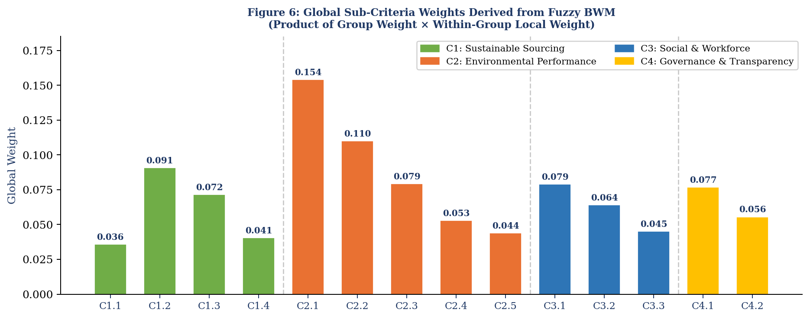
Figure 2. Global sub-criteria weights derived from the Fuzzy BWM
Note. Dashed lines separate the four criterion groups; global weights sum to 1.000. GHG intensity (C2.1) and renewable energy share (C2.2) dominate.

4.2 Supplier Portfolio: Rankings and Strategic Differentiation
Applying Fuzzy TOPSIS produces a clearly differentiated supplier portfolio (Table 5, Figure 3). Dr. Reddy's Laboratories ranks first (closeness coefficient 0.7723) and Aurobindo Pharma last (0.4615); the spread of 0.311 across a cohort of top listed firms shows that mandatory disclosure exposes strategically meaningful differences even among leaders. Four tiers emerge: a high-performer tier (Dr. Reddy's, Torrent, Sun Pharma), a moderate-high position (Zydus), a moderate tier (Cipla, Lupin), and weaker performers (Alkem and, notably, Aurobindo). For a focal firm, these tiers map directly onto strategic actions, preferred-supplier status, targeted development, or reconsideration of exposure, made defensible by their basis in assured disclosure (Proposition 3).
Table 5. Fuzzy TOPSIS supplier rankings and performance tiers
Rank | Company | d⁺ (Distance from FPIS) | d⁻ (Distance from FNIS) | CC = d⁻/(d⁺+d⁻) | Performance Tier | BRSR FY | Change vs. Mean
1 | Dr. Reddy's Laboratories | 0.1998 | 0.6778 | 0.7723 | High Performer | 2024-25 | ↑+0.078
2 | Torrent Pharmaceuticals | 0.2041 | 0.6770 | 0.7683 | High Performer | 2024-25 | ↑+0.074
3 | Sun Pharma | 0.2392 | 0.6396 | 0.7278 | High Performer | 2024-25 | ↑+0.033
4 | Zydus Lifesciences | 0.2427 | 0.6359 | 0.7238 | Moderate-High | 2024-25 | ↑+0.029
5 | Cipla | 0.3153 | 0.5585 | 0.6391 | Moderate | 2024-25 | ↓−0.055
6 | Lupin | 0.3654 | 0.5065 | 0.5809 | Moderate | 2024-25 | ↓−0.114
7 | Alkem Laboratories | 0.4149 | 0.4523 | 0.5216 | Low-Moderate | 2024-25 | ↓−0.173
8 | Aurobindo Pharma | 0.4675 | 0.4007 | 0.4615 | Weak Performer | 2024-25 | ↓−0.233
Note. CC = closeness coefficient (0-1); higher indicates closer approach to the ideal green profile. Sample mean CC = 0.6944. Data source: BRSR FY 2024-25 filings, BSE/NSE.
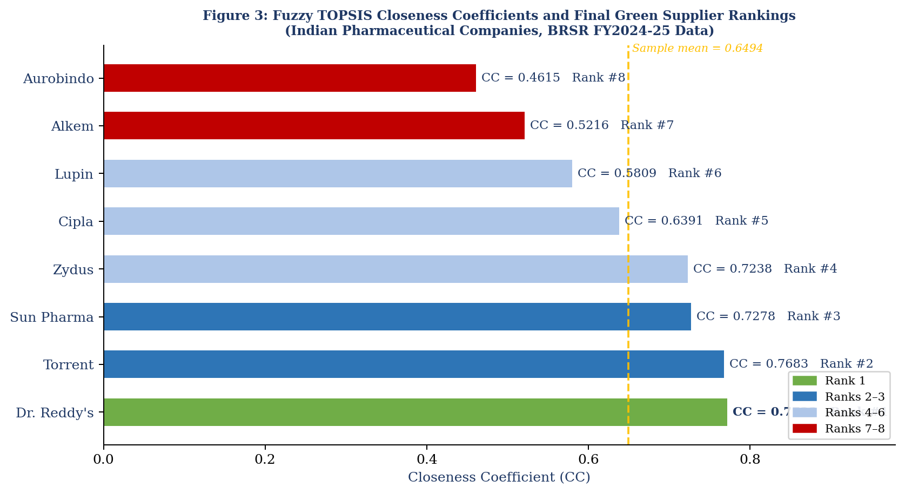
Figure 3. Supplier closeness coefficients and final rankings (n = 8)
Note. Dashed line = sample mean CC (0.6944).

4.3 Where Advantage and Exposure Lie: Group Performance Profiles
Disaggregating performance by group (Table 6, Figure 4) shows that differentiation is greatest on the most heavily weighted group, environmental performance, where scores range from 0.417 (Aurobindo) to 0.688 (Torrent and Dr. Reddy's). Governance and transparency, by contrast, is comparatively uniform, reflecting the standardising effect of BRSR on disclosure practices even where underlying environmental performance diverges. The strategic implication is that competitive separation among suppliers is driven by substantive environmental performance rather than by disclosure quality alone.
Table 6. Group-level performance scores relative to ideal and anti-ideal profiles
Rank | Company | C1 BNP Sust. Sourcing | C2 BNP Environmental | C3 BNP Social | C4 BNP Governance
1 | Dr. Reddy's Laboratories | 0.688 | 0.688 | 0.583 | 0.625
2 | Torrent Pharmaceuticals | 0.625 | 0.688 | 0.625 | 0.625
3 | Sun Pharma | 0.625 | 0.625 | 0.458 | 0.625
4 | Zydus Lifesciences | 0.625 | 0.625 | 0.458 | 0.625
5 | Cipla | 0.625 | 0.417 | 0.542 | 0.625
6 | Lupin | 0.417 | 0.583 | 0.375 | 0.417
7 | Alkem Laboratories | 0.417 | 0.417 | 0.458 | 0.417
8 | Aurobindo Pharma | 0.375 | 0.417 | 0.375 | 0.333
 | FPIS (Ideal) | 1.000 | 1.000 | 1.000 | 1.000
 | FNIS (Anti-Ideal) | 0.000 | 0.000 | 0.000 | 0.000
 | Sample Mean | 0.550 | 0.558 | 0.484 | 0.547
Note. Scores are defuzzified group ratings from the fuzzy decision matrix; higher is better. FPIS = fuzzy positive ideal solution; FNIS = fuzzy negative ideal solution.
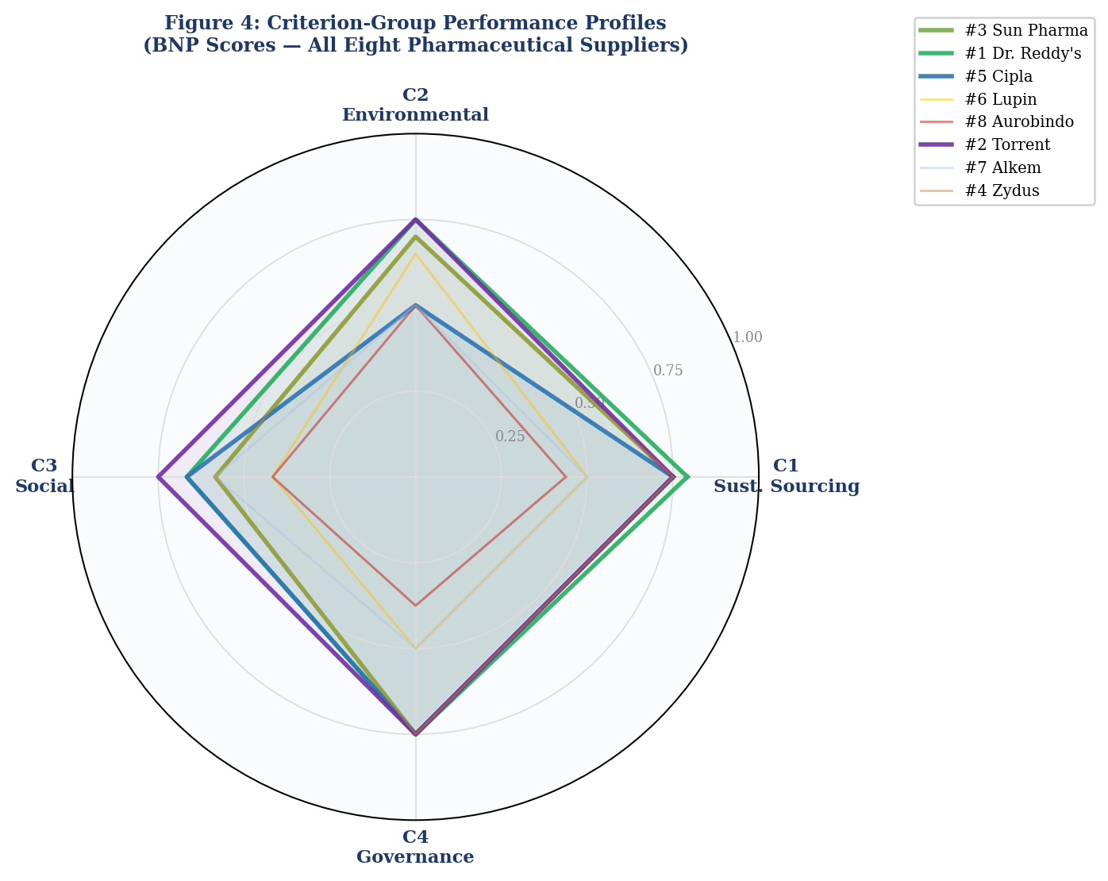
Figure 4. Group performance profiles for all eight suppliers (radar)
Note. Bold lines = top-four suppliers; dashed lines = remaining suppliers. Higher = better.

4.4 Robustness of the Strategic Conclusions
The rankings are highly robust to alternative strategic priorities. Across the eight weight scenarios, seven reproduce the baseline order exactly, and even the extreme environment-only configuration preserves the order almost entirely (Spearman rho = 0.976); Dr. Reddy's remains first and Aurobindo last in every scenario, and all firms remain within their tiers (Table 7, Figure 5). The strategic message, that a small group of environmental leaders is clearly separated from laggards, does not depend on the precise weighting and is therefore a reliable basis for portfolio decisions.
Table 7. Supplier rankings across eight weight scenarios and rank correlation with baseline
Company | Baseline Rank | S0 Baseline | S1 C1+20% | S2 C2+20% | S3 C3+20% | S4 C4+20% | S5 Equal | S6 C2 Only | S7 C1=C2
Dr. Reddy's | Rank 1 (High Performer) | 1 | 1 | 1 | 1 | 1 | 1 | 1 | 1
Torrent | Rank 2 (High Performer) | 2 | 2 | 2 | 2 | 2 | 2 | 2 | 2
Sun Pharma | Rank 3 (High Performer) | 3 | 3 | 3 | 3 | 3 | 3 | 3 | 3
Zydus | Rank 4 (Moderate-High) | 4 | 4 | 4 | 4 | 4 | 4 | 4 | 4
Cipla | Rank 5 (Moderate) | 5 | 5 | 5 | 5 | 5 | 5 | 5 | 5
Lupin | Rank 6 (Moderate) | 6 | 6 | 6 | 6 | 6 | 6 | 7 | 6
Alkem | Rank 7 (Low-Moderate) | 7 | 7 | 7 | 7 | 7 | 7 | 6 | 7
Aurobindo | Rank 8 (Weak Performer) | 8 | 8 | 8 | 8 | 8 | 8 | 8 | 8
Spearman ρ vs S0 |  | 1.000 | 1.000 | 1.000 | 1.000 | 1.000 | 1.000 | 0.976 | 1.000
Note. Only scenario S6 (environment-only) alters any rank (Alkem and Lupin swap). rho = Spearman correlation with the S0 baseline; rho > 0.90 indicates stable rankings. Scenario weight configurations are reported in Appendix A, Table A5.
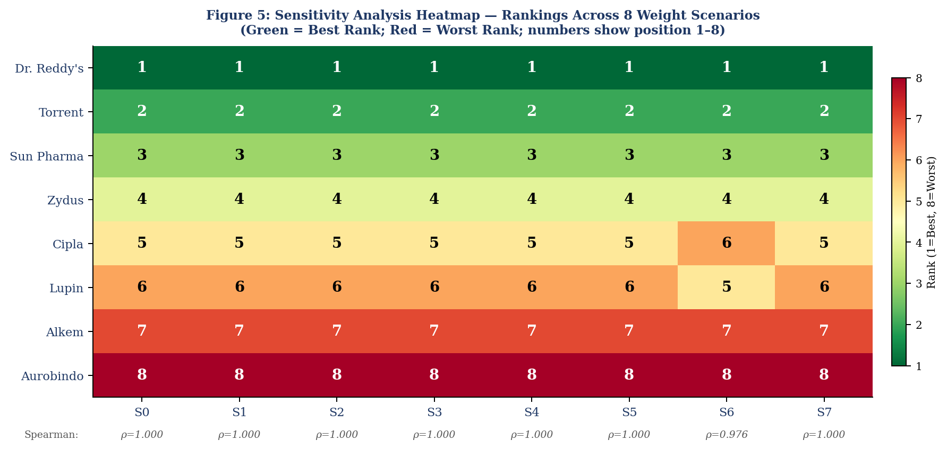
Figure 5. Sensitivity heatmap of supplier rankings across weight scenarios (S0-S7)
Note. Cell values denote rank (1 = best). Spearman rho >= 0.976 across all scenarios.

5. Discussion

5.1 Strategic Implications: Reconfiguring the Supply Base
The results show how mandatory ESG disclosure can be converted into supply chain strategy. The benchmarking tiers translate into concrete portfolio moves: high performers such as Dr. Reddy's and Torrent are candidates for preferred-supplier status and deeper collaboration, mid-tier firms such as Cipla and Lupin are candidates for targeted development on the specific dimensions where they lag, and weaker performers such as Aurobindo represent concentrated environmental and reputational exposure that a focal firm may need to manage, diversify or exit (Seuring and Müller, 2008; Foerstl et al., 2010). Because these judgements rest on assured disclosure rather than private ratings, they can be defended to boards, investors and regulators, and they can be embedded in supplier scorecards, preferred-vendor lists and sustainability-linked contract terms. This is disclosure-anchored supplier governance in action, and it operationalises the assessment logic of SSCM using a data source that prior work lacked (Gimenez and Tachizawa, 2012; Gualandris et al., 2015).
The profile analysis further shows that competitive separation is driven by substantive environmental performance, not disclosure cosmetics: governance disclosure is relatively uniform across firms, whereas environmental outcomes diverge sharply. This pattern is consistent with the argument that mandatory assurance curtails symbolic conformity and pushes firms towards substantive action, in contrast to voluntary regimes where legitimacy can be sought through selective disclosure (Delmas and Burbano, 2011; Marquis et al., 2016).

5.2 Environmental Implications: Decarbonisation as the Primary Lever
The dominance of GHG emission intensity and renewable energy share indicates that, in the pharmaceutical context under BRSR, supplier governance is above all a decarbonisation lever. Directing sourcing volume towards higher-ranked suppliers and concentrating supplier-development effort on emissions intensity and renewable-energy transition should yield the largest supply chain environmental gains, consistent with evidence that renewable electricity is the most immediate route to near-term emission reductions in manufacturing chains (Ghadimi, Wang and Lim, 2019). Water and waste intensity, while material to the sector's environmental risk profile (Grimm et al., 2014), are secondary drivers of differentiation here. By making these environmental gaps visible and comparable, disclosure-anchored governance contributes to emission reduction, environmental risk reduction and supply chain resilience at the ecosystem level (Proposition 4; Hart, 1995; Tachizawa and Wong, 2014).

5.3 Theoretical Implications: Disclosure as an Upstream Governance Mechanism
The findings substantiate the integrated framing and its propositions. Consistent with Proposition 1, environmental criteria dominate strategic prioritisation under a coercive disclosure regime, illustrating how institutional pressure is refracted into specific criterion salience (DiMaggio and Powell, 1983; Delmas and Toffel, 2008). Consistent with Proposition 2, assured disclosure reduces buyer-supplier information asymmetry sufficiently to support replicable, auditable supplier evaluation, extending the secondary-data argument of Bai and Sarkis (2010) from voluntary GRI reports to a legally mandated, assured regime. Consistent with Proposition 3, the visible separation of leaders from laggards gives focal firms both the means and the legitimacy incentive to reconfigure their supply bases, cascading institutional pressure upstream and thereby linking firm-level disclosure to multi-tier governance (Tachizawa and Wong, 2014; Suchman, 1995). The robustness of the rankings suggests that these strategic conclusions are structural rather than artefacts of particular weightings. Where earlier supplier-evaluation studies foreground social and governance criteria or treat all sustainability dimensions as broadly comparable (for example Büyüközkan and Çifçi, 2012), our results show environmental criteria dominating under BRSR, indicating that the disclosure regime itself shapes which sustainability dimensions become strategically decisive.

5.4 BRSR as Scalable Governance Infrastructure
A broader implication is that a national disclosure mandate can serve as scalable governance infrastructure. By standardising KPIs, mandating assurance and publishing filings, BRSR converts what was an episodic, costly and idiosyncratic evaluation task into a repeatable, always-current decision process (Christensen et al., 2021; Ioannou and Serafeim, 2017). This realises, in a mandatory setting, the promise Bai and Sarkis (2010) identified in voluntary disclosure. Limitations of the current implementation remain: some supporting quantitative detail, such as supplier-specific emission breakdowns, is not uniformly disclosed, requiring estimation for a minority of data points. As BRSR Core matures and value-chain disclosure is extended under SEBI's 2023 circular, data completeness and the precision of disclosure-anchored supplier governance should improve.

6. Implications for Practice and Policy

6.1 Corporate Sustainability Strategists and ESG/Governance Officers
For corporate sustainability strategists and ESG or governance officers, the framework offers a defensible way to align the supply base with corporate ESG targets, BRSR obligations and net-zero commitments. The criterion weights identify GHG intensity reduction and renewable-energy transition as the priorities on which supplier engagement yields the greatest improvement, providing a basis for capability-building roadmaps and for differentiated sourcing (Gimenez and Tachizawa, 2012; Marshall et al., 2015). Because the evidence base is assured public disclosure, supplier performance can be communicated to boards, audit committees and investors with an evidentiary standard approaching that of financial reporting, strengthening the internal legitimacy of sustainability decisions (Suchman, 1995; Aguilera et al., 2007). The tool also supports supplier engagement dialogues, since laggards can be shown precisely where and why they fall short.

6.2 Investors and Sustainability-Linked Lenders
For ESG-oriented investors and providers of sustainability-linked finance, the closeness coefficients and group profiles offer a supply-chain-level check on firm ESG scores, disaggregated in a way that broad ratings seldom provide (Dhaliwal et al., 2011). Because the inputs are assured, the approach reduces exposure to greenwashing and selective disclosure and can inform engagement, screening and the calibration of sustainability-linked loan covenants (Delmas and Burbano, 2011; Marquis et al., 2016).

6.3 Regulators and Standard-Setters
For regulators and stock exchanges, the study is evidence that a mandatory disclosure regime can be used not only for firm-level transparency but as an instrument of supply chain governance. The analysis shows that BRSR Core, in its current form, already supports rigorous quantitative supplier assessment across fourteen ESG criteria, and that extending value-chain disclosure would enable buyers to govern Tier-2 and Tier-3 suppliers with the same architecture (SEBI, 2023; Tachizawa and Wong, 2014). This suggests a design principle for ESG disclosure regimes: standardising and assuring a compact set of decision-relevant environmental KPIs, and progressively extending them along the value chain, amplifies their strategic effect by making them usable for upstream governance (Christensen et al., 2021; Ioannou and Serafeim, 2017). Regulators refining BRSR or comparable frameworks elsewhere can thus treat decision-usability, not only disclosure per se, as an explicit policy objective.

7. Conclusion, Limitations and Future Research
This study addressed a strategic problem created by the convergence of mandatory ESG disclosure and supply chain sustainability: how firms can use regulated disclosure to govern suppliers. Focusing on the environmentally critical Indian pharmaceutical sector under the BRSR regime, it developed a disclosure-anchored decision framework, combining the Fuzzy Best-Worst Method and Fuzzy TOPSIS over fourteen BRSR-based ESG criteria, and applied it to eight major listed firms. Its central contribution is conceptual as much as empirical: it reframes a national disclosure mandate as a strategic governance instrument and integrates institutional, stakeholder and legitimacy theory to explain how coercive disclosure pressure is transmitted into the supply base, advancing four propositions linking disclosure, supplier governance and environmental outcomes.
The environmental message is clear. Supplier prioritisation under BRSR is dominated by GHG emission intensity and renewable energy adoption, making disclosure-anchored governance primarily a decarbonisation lever, and the resulting rankings are robust to wide variation in strategic priorities. By turning assured, public disclosures into actionable supplier governance, the framework shows how firms can align supply bases with corporate sustainability strategy while strengthening environmental performance, risk reduction and resilience at the supply chain level.
Several limitations frame the contribution and point to future research. The analysis is cross-sectional, based on a single BRSR cycle and eight firms, uses a single expert panel for weighting, and relies on estimation for a minority of incompletely disclosed data points. Consistent with the agenda of Business Strategy and the Environment, promising extensions include longitudinal analysis of how supplier rankings and BRSR-supplier alignment evolve as disclosure quality matures; cross-country comparison of how different mandatory ESG regimes shape supplier governance; linking disclosure-anchored supplier performance to firms' financial and market outcomes to test the competitive-advantage logic of the natural-resource-based view (Hart, 1995); extension to Tier-2 and Tier-3 suppliers as value-chain disclosure expands (Tachizawa and Wong, 2014); and methodological refinements such as modelling interdependence among criteria and adopting richer fuzzy representations (Ecer, 2020). Collectively, these directions would deepen understanding of how regulatory ESG disclosure can be strategically harnessed to green corporate supply chains.

Data Availability Statement
The data supporting the findings of this study are derived from publicly available BRSR filings and ESG reports of the listed companies studied, accessible via the BSE and NSE and the companies' investor-relations portals. Compiled datasets are available from the corresponding author upon reasonable request.

Competing Interests Statement
The authors declare no competing interests.

References
Aguilera, R. V., Rupp, D. E., Williams, C. A., & Ganapathi, J. (2007). Putting the S back in corporate social responsibility: A multilevel theory of social change in organizations. Academy of Management Review, 32(3), 836-863. https://doi.org/10.5465/amr.2007.25275678
Awasthi, A., Chauhan, S. S., & Goyal, S. K. (2010). A fuzzy multicriteria approach for evaluating environmental performance of suppliers. International Journal of Production Economics, 126(2), 370-378. https://doi.org/10.1016/j.ijpe.2010.04.029
Bai, C., & Sarkis, J. (2010). Integrating sustainability into supplier selection with grey system and rough set methodologies. International Journal of Production Economics, 124(1), 252-264. https://doi.org/10.1016/j.ijpe.2009.11.023
Bansal, P., & Roth, K. (2000). Why companies go green: A model of ecological responsiveness. Academy of Management Journal, 43(4), 717-736. https://doi.org/10.5465/1556363
Bellman, R. E., & Zadeh, L. A. (1970). Decision-making in a fuzzy environment. Management Science, 17(4), B141-B164. https://doi.org/10.1287/mnsc.17.4.B141
Büyüközkan, G., & Çifçi, G. (2012). A novel hybrid MCDM approach based on fuzzy DEMATEL, fuzzy ANP and fuzzy TOPSIS to evaluate green suppliers. Expert Systems with Applications, 39(3), 3000-3011. https://doi.org/10.1016/j.eswa.2011.08.162
Carter, C. R., & Rogers, D. S. (2008). A framework of sustainable supply chain management: Moving toward new theory. International Journal of Physical Distribution & Logistics Management, 38(5), 360-387. https://doi.org/10.1108/09600030810882816
Chen, C.-T. (2000). Extensions of the TOPSIS for group decision-making under fuzzy environment. Fuzzy Sets and Systems, 114(1), 1-9. https://doi.org/10.1016/S0165-0114(97)00377-1
Christensen, H. B., Hail, L., & Leuz, C. (2021). Mandatory CSR and sustainability reporting: Economic analysis and literature review. Review of Accounting Studies, 26(3), 1176-1248. https://doi.org/10.1007/s11142-021-09609-5
Delmas, M. A., & Burbano, V. C. (2011). The drivers of greenwashing. California Management Review, 54(1), 64-87. https://doi.org/10.1525/cmr.2011.54.1.64
Delmas, M. A., & Toffel, M. W. (2008). Organizational responses to environmental demands: Opening the black box. Strategic Management Journal, 29(10), 1027-1055. https://doi.org/10.1002/smj.701
Dhaliwal, D. S., Li, O. Z., Tsang, A., & Yang, Y. G. (2011). Voluntary nonfinancial disclosure and the cost of equity capital: The initiation of corporate social responsibility reporting. The Accounting Review, 86(1), 59-100. https://doi.org/10.2308/accr.00000005
Dickson, G. W. (1966). An analysis of vendor selection systems and decisions. Journal of Purchasing, 2(1), 5-17. https://doi.org/10.1111/j.1745-493X.1966.tb00818.x
DiMaggio, P. J., & Powell, W. W. (1983). The iron cage revisited: Institutional isomorphism and collective rationality in organizational fields. American Sociological Review, 48(2), 147-160. https://doi.org/10.2307/2095101
Ecer, F. (2020). Multi-criteria decision making for green supplier selection using interval type-2 fuzzy AHP. Operational Research, 22(1), 199-229. https://doi.org/10.1007/s12351-020-00562-8
Foerstl, K., Reuter, C., Hartmann, E., & Blome, C. (2010). Managing supplier sustainability risks in a dynamically changing environment: Sustainable supplier management in the chemical industry. Journal of Purchasing and Supply Management, 16(2), 118-130. https://doi.org/10.1016/j.pursup.2010.03.011
Freeman, R. E. (1984). Strategic management: A stakeholder approach. Pitman.
Ghadimi, P., Wang, C., & Lim, M. K. (2019). Sustainable supply chain modeling and analysis: Past debate, present problems and future challenges. Resources, Conservation and Recycling, 140, 72-84. https://doi.org/10.1016/j.resconrec.2018.09.005
Gimenez, C., & Tachizawa, E. M. (2012). Extending sustainability to suppliers: A systematic literature review. Supply Chain Management: An International Journal, 17(5), 531-543. https://doi.org/10.1108/13598541211258591
Govindan, K., Rajendran, S., Sarkis, J., & Murugesan, P. (2015). Multi criteria decision making approaches for green supplier evaluation and selection: A literature review. Journal of Cleaner Production, 98, 66-83. https://doi.org/10.1016/j.jclepro.2013.06.046
Grimm, J. H., Hofstetter, J. S., & Sarkis, J. (2014). Critical factors for sub-supplier management: A sustainable food supply chains perspective. International Journal of Production Economics, 152, 159-173. https://doi.org/10.1016/j.ijpe.2013.12.011
Gualandris, J., Klassen, R. D., Vachon, S., & Kalchschmidt, M. (2015). Sustainable evaluation and verification in supply chains: Aligning and leveraging accountability to stakeholders. Journal of Operations Management, 38, 1-13. https://doi.org/10.1016/j.jom.2015.06.002
Guo, S., & Zhao, H. (2017). Fuzzy best-worst multi-criteria decision-making method and its applications. Knowledge-Based Systems, 121, 23-31. https://doi.org/10.1016/j.knosys.2017.01.010
Gupta, H., & Barua, M. K. (2017). Supplier selection among SMEs on the basis of their green innovation ability using BWM and fuzzy TOPSIS. Journal of Cleaner Production, 152, 242-258. https://doi.org/10.1016/j.jclepro.2017.03.125
Hart, S. L. (1995). A natural-resource-based view of the firm. Academy of Management Review, 20(4), 986-1014. https://doi.org/10.5465/amr.1995.9512280033
Hwang, C. L., & Yoon, K. (1981). Multiple attribute decision making: Methods and applications. Springer-Verlag. https://doi.org/10.1007/978-3-642-48318-9
Ioannou, I., & Serafeim, G. (2017). The consequences of mandatory corporate sustainability reporting (Harvard Business School Research Working Paper No. 11-100). Harvard Business School.
Kannan, D., Jabbour, A. B. L. de S., & Jabbour, C. J. C. (2013). Selecting green suppliers based on GSCM practices: Using fuzzy TOPSIS applied to a Brazilian electronics company. European Journal of Operational Research, 233(2), 432-447. https://doi.org/10.1016/j.ejor.2013.07.023
Lee, A. H. I., Kang, H. Y., Hsu, C. F., & Hung, H. C. (2009). A green supplier selection model for high-tech industry. Expert Systems with Applications, 36(4), 7917-7927. https://doi.org/10.1016/j.eswa.2008.11.052
Marquis, C., Toffel, M. W., & Zhou, Y. (2016). Scrutiny, norms, and selective disclosure: A global study of greenwashing. Organization Science, 27(2), 483-504. https://doi.org/10.1287/orsc.2015.1039
Marshall, D., McCarthy, L., Heavey, C., & McGrath, P. (2015). Environmental and social supply chain management sustainability practices: Construct development and measurement. Production Planning & Control, 26(8), 673-690. https://doi.org/10.1080/09537287.2014.963726
Meyer, J. W., & Rowan, B. (1977). Institutionalized organizations: Formal structure as myth and ceremony. American Journal of Sociology, 83(2), 340-363. https://doi.org/10.1086/226550
Oliver, C. (1991). Strategic responses to institutional processes. Academy of Management Review, 16(1), 145-179. https://doi.org/10.5465/amr.1991.4279002
Pharmaceuticals Export Promotion Council of India (Pharmexcil). (2024). Annual report 2023-24. Pharmexcil.
Rezaei, J. (2015). Best-worst multi-criteria decision-making method. Omega, 53, 49-57. https://doi.org/10.1016/j.omega.2014.11.009
Rezaei, J. (2016). Best-worst multi-criteria decision-making method: Some properties and a linear model. Omega, 64, 126-130. https://doi.org/10.1016/j.omega.2015.12.001
Saaty, T. L. (1980). The analytic hierarchy process: Planning, priority setting, resource allocation. McGraw-Hill.
Sarkis, J., & Talluri, S. (2002). A model for strategic supplier selection. Journal of Supply Chain Management, 38(1), 18-28. https://doi.org/10.1111/j.1745-493X.2002.tb00117.x
Sarkis, J., Zhu, Q., & Lai, K.-h. (2011). An organizational theoretic review of green supply chain management literature. International Journal of Production Economics, 130(1), 1-15. https://doi.org/10.1016/j.ijpe.2010.11.010
Scott, W. R. (2014). Institutions and organizations: Ideas, interests, and identities (4th ed.). Sage.
Securities and Exchange Board of India (SEBI). (2021). Business responsibility and sustainability reporting by listed entities (SEBI Circular No. SEBI/HO/CFD/CMD-2/P/CIR/2021/562, 10 May 2021). https://www.sebi.gov.in
Securities and Exchange Board of India (SEBI). (2023). BRSR Core: ESG disclosures for value chain (SEBI Circular No. SEBI/HO/CFD/PoD-2/P/CIR/2023/122, 12 July 2023). https://www.sebi.gov.in
Seuring, S., & Müller, M. (2008). From a literature review to a conceptual framework for sustainable supply chain management. Journal of Cleaner Production, 16(15), 1699-1710. https://doi.org/10.1016/j.jclepro.2008.04.020
Suchman, M. C. (1995). Managing legitimacy: Strategic and institutional approaches. Academy of Management Review, 20(3), 571-610. https://doi.org/10.5465/amr.1995.9508080331
Tachizawa, E. M., & Wong, C. Y. (2014). Towards a theory of multi-tier sustainable supply chains: A systematic literature review. Supply Chain Management: An International Journal, 19(5/6), 643-663. https://doi.org/10.1108/SCM-02-2014-0070
Weber, C. A., Current, J. R., & Benton, W. C. (1991). Vendor selection criteria and methods. European Journal of Operational Research, 50(1), 2-18. https://doi.org/10.1016/0377-2217(91)90033-R
World Resources Institute (WRI) & World Business Council for Sustainable Development (WBCSD). (2004). The greenhouse gas protocol: A corporate accounting and reporting standard (Rev. ed.). WRI/WBCSD. https://ghgprotocol.org/corporate-standard
You, X., Chen, T., & Liu, Q. (2015). An integrated multi-criteria decision making approach to sustainable supplier selection. Journal of Manufacturing Systems, 37, 479-486. https://doi.org/10.1016/j.jmsy.2015.04.002
Zadeh, L. A. (1965). Fuzzy sets. Information and Control, 8(3), 338-353. https://doi.org/10.1016/S0019-9958(65)90241-X
Zimmer, K., Fröhling, M., & Schultmann, F. (2016). Sustainable supplier management: A review of models supporting sustainable supplier selection, monitoring and development. International Journal of Production Research, 54(5), 1412-1442. https://doi.org/10.1080/00207543.2015.1079340

Appendix A. Technical Detail of the Fuzzy BWM-TOPSIS Procedure
This appendix consolidates the formal apparatus underlying the strategic decision framework described in Section 3, so that the main text can remain focused on strategy, theory and policy.

A.1 Triangular Fuzzy Numbers and Operations
Fuzzy set theory (Zadeh, 1965) represents imprecise, linguistically expressed information through a continuous membership function mu(x) in [0,1]. A triangular fuzzy number (TFN) A = (l, m, u) is defined by a lower bound l, a modal value m (where mu(x) = 1) and an upper bound u, with membership rising linearly from l to m and falling linearly from m to u (Figure A1). The operations used in this study are:
Addition: A1 (+) A2 = (l1 + l2, m1 + m2, u1 + u2)
Multiplication (positive TFNs): A1 (x) A2 ~= (l1 l2, m1 m2, u1 u2)
Defuzzification (centre of area): BNP(A) = (l + m + u) / 3
The best non-fuzzy performance (BNP) value converts fuzzy weights and closeness coefficients to crisp scores for reporting and ranking (Chen, 2000).
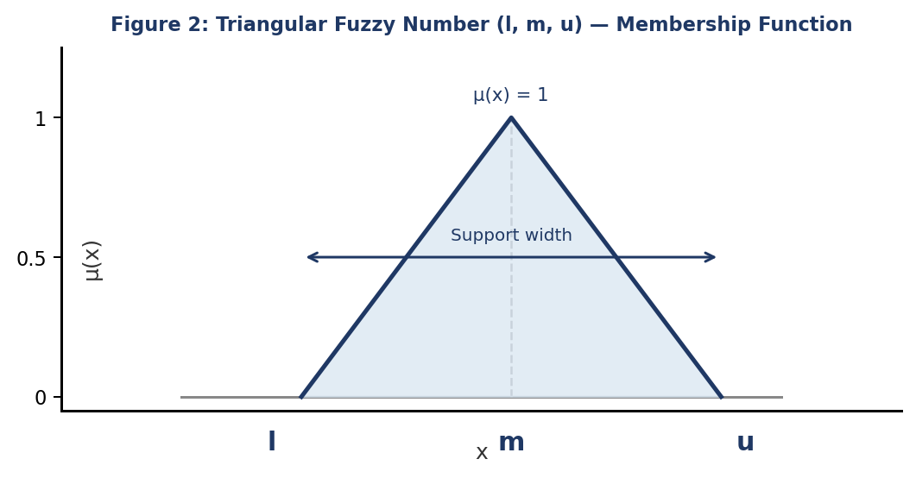
Figure A1. Triangular fuzzy number (l, m, u): membership function

A.2 Fuzzy Best-Worst Method (Criteria Weighting)
The Best-Worst Method (Rezaei, 2015; Rezaei, 2016) derives weights from a best-to-others (BO) vector and an others-to-worst (OW) vector rather than a full pairwise matrix. Its fuzzy extension (Guo and Zhao, 2017) expresses comparisons as TFNs drawn from the nine-point linguistic scale in Table A1. Environmental performance (C2) was designated best and governance and transparency (C4) worst; the reference vectors are given in Table A2.
Table A1. Linguistic scale and triangular fuzzy numbers for the Fuzzy BWM
Value | Linguistic Term | Triangular Fuzzy Number (l, m, u)
1 | Equally important | (1, 1, 1)
2 | Slightly more important | (1, 2, 3)
3 | Moderately more important | (2, 3, 4)
4 | More important | (3, 4, 5)
5 | Strongly more important | (4, 5, 6)
6 | Very strongly more important | (5, 6, 7)
7 | Extremely more important | (6, 7, 8)
8 | Dominantly more important | (7, 8, 9)
9 | Absolutely more important | (8, 9, 9)
Table A2. Fuzzy BWM reference vectors for the main criteria (best = C2; worst = C4)
Criterion | BO Vector (Best C2 over Cⱼ) | OW Vector (Cⱼ over Worst C4)
C1 Sustainable Sourcing & Governance | (1,2,3) | (3,4,5)
C2 Environmental Performance | (1,1,1) | (4,5,6)
C3 Social & Workforce Responsibility | (2,3,4) | (2,3,4)
C4 Governance & Transparency | (4,5,6) | (1,1,1)
The fuzzy weights are obtained by minimising the maximum absolute deviation between weight ratios and the comparison values:
min xi* subject to |wB/wj - aBj| <= xi* and |wj/wW - ajW| <= xi* for all j; sum of BNP(wj) = 1; lj <= mj <= uj; lj >= 0.
where aBj and ajW are the fuzzy comparison values from the BO and OW vectors and xi* is the fuzzy consistency parameter. The consistency ratio was 0.042 (< 0.10), confirming acceptable consistency (Rezaei, 2015). Resulting group weights are reported in the main text (Table 3).

A.3 Fuzzy TOPSIS (Supplier Ranking)
Fuzzy TOPSIS (Chen, 2000) ranks alternatives by their relative closeness to a fuzzy positive ideal solution (FPIS) and distance from a fuzzy negative ideal solution (FNIS). Disclosed indicator values were mapped to the linguistic ratings and TFNs in Table A3, with cost criteria inverted; the aggregated group-level decision matrix appears in Table A4.
Table A3. Linguistic scale and triangular fuzzy numbers for supplier ratings
Term | TFN (l, m, u) | Threshold Rule (Example: % Renewable Energy)
Very Low (VL) | (0.00, 0.00, 0.25) | 0–20% (benefit) / >80th pctile (cost)
Low (L) | (0.00, 0.25, 0.50) | 20–40% (benefit) / 60–80th pctile (cost)
Medium (M) | (0.25, 0.50, 0.75) | 40–60% (benefit) / 40–60th pctile (cost)
High (H) | (0.50, 0.75, 1.00) | 60–80% (benefit) / 20–40th pctile (cost)
Very High (VH) | (0.75, 1.00, 1.00) | 80–100% (benefit) / <20th pctile (cost)
Table A4. Aggregated fuzzy decision matrix at the criterion-group level (BRSR FY 2024-25)
Company | C1: Sust. Sourcing | C2: Environmental | C3: Social | C4: Governance
Sun Pharma | (0.50,0.75,1.00) H | (0.50,0.75,1.00) H | (0.25,0.50,0.75) M | (0.50,0.75,1.00) H
Dr. Reddy's | (0.50,0.75,1.00) H | (0.50,0.75,1.00) H | (0.50,0.75,1.00) H | (0.50,0.75,1.00) H
Cipla | (0.50,0.75,1.00) H | (0.25,0.50,0.75) M | (0.50,0.75,1.00) H | (0.50,0.75,1.00) H
Lupin | (0.25,0.50,0.75) M | (0.50,0.75,1.00) H | (0.25,0.50,0.75) M | (0.25,0.50,0.75) M
Aurobindo Pharma | (0.25,0.50,0.75) M | (0.25,0.50,0.75) M | (0.25,0.50,0.75) M | (0.25,0.50,0.75) M
Torrent Pharma | (0.50,0.75,1.00) H | (0.50,0.75,1.00) H | (0.50,0.75,1.00) H | (0.50,0.75,1.00) H
Alkem Laboratories | (0.25,0.50,0.75) M | (0.25,0.50,0.75) M | (0.50,0.75,1.00) H | (0.25,0.50,0.75) M
Zydus Lifesciences | (0.50,0.75,1.00) H | (0.50,0.75,1.00) H | (0.25,0.50,0.75) M | (0.50,0.75,1.00) H
The normalised matrix R = [rij] is scaled to [0,1]; the weighted normalised matrix is V = [vij] with vij = rij (x) wj. With FPIS vj* = (1,1,1) and FNIS vj- = (0,0,0), distances use the vertex method d(A1, A2) = sqrt( (1/3)[(l1-l2)^2 + (m1-m2)^2 + (u1-u2)^2] ) and the closeness coefficient is CCi = di- / (di* + di-), where di* and di- sum the criterion-wise distances to FPIS and FNIS. Suppliers are ranked in descending order of CCi.

A.4 Sensitivity Analysis Scenarios
Eight weight scenarios test the robustness of the rankings to alternative strategic priorities (Section 4.4). Their configurations are reported in Table A5; the resulting rankings and Spearman correlations appear in the main text (Table 7, Figure 5).
Table A5. Sensitivity analysis scenarios: criteria weight configurations (S0 = baseline)
ID | Scenario Description | w(C1) | w(C2) | w(C3) | w(C4) | Rationale
S0 | Baseline (BWM weights) | 0.213 | 0.393 | 0.168 | 0.118 | Original ranking
S1 | C1 inflated +20% | 0.302 | 0.361 | 0.154 | 0.108 | Sourcing-emphasis
S2 | C2 inflated +20% | 0.185 | 0.463 | 0.146 | 0.102 | Environment-emphasis
S3 | C3 inflated +20% | 0.189 | 0.350 | 0.250 | 0.105 | Social-emphasis
S4 | C4 inflated +20% | 0.192 | 0.355 | 0.152 | 0.207 | Governance-emphasis
S5 | Equal weights | 0.250 | 0.250 | 0.250 | 0.250 | Naïve equal
S6 | C2 only (w=1.0) | 0.000 | 1.000 | 0.000 | 0.000 | Extreme environmental
S7 | C1 = C2 equal; others halved | 0.303 | 0.303 | 0.084 | 0.059 | Sourcing-env balance

