Operationalizing Circular Accounting in Fragmented Supply Chains: A Moderated Serial-Mediation Analysis of Inter-Organizational Governance and Value Creation
Abstract
Achieving resource circularity across industrial supply chains requires granular visibility over material flows, waste streams, and value recovery opportunities; however, conventional management accounting systems remain bound by firm-level legal boundaries, rendering inter-organizational material losses systematically unrecorded and unmanaged within fragmented supply chains. To address this structural gap, this study conceptualizes and operationalizes circular accounting capability at the inter-organizational level to examine how tracking resource loops enhances information transparency, drives circular value-chain integration, and creates economic, environmental, and social value. Grounded in the dynamic capabilities view and value-chain governance theory, we derive a moderated serial-mediation structural model, compare three model specifications, and validate a pre-registrable empirical protocol. The construct's discriminant boundaries and content validity were established and refined across three rounds of expert feedback, raising content validity from 0.799 to 0.908. The empirical analysis demonstrates that circular accounting capability significantly enhances information transparency, enabling circular value-chain integration and holistic sustainable value creation. Crucially, value-chain governance acts as a critical conditional enabler rather than an additive factor, determining whether transparency successfully translates into joint inter-firm action, while specification testing rules out a fully serial mediation chain as indirect effects drop below 0.03 when path coefficients fall under 0.40. By expanding sustainability accounting beyond individual firm boundaries into multi-tier supply chain governance, this paper provides operations managers and supply chain practitioners with a validated framework to establish joint accounting mechanisms that reduce material losses across fragmented networks, offering the first inter-organizational operationalization of circular accounting capability and empirically demonstrating that governance conditions the conversion of accounting transparency into circular value creation.
Keywords: Circular economy; Circular accounting; Management accounting; Information transparency; Value-chain governance; Accountability

1. Introduction
A circular economy requires organisations to know what happens to their materials. Loop-closing decisions, whether to recover a by-product, invest in reprocessing capacity, or collect a discarded fraction, presuppose that resource flows, losses and recovery opportunities have been quantified and valued. Yet the accounting systems that would supply that information were built for linear flows: they recognise purchased inputs and saleable outputs, while the fraction leaving as waste is recognised only as an absence. Accounting's difficulty with circularity is therefore not a reporting inconvenience but a prior calculative problem: what is not measured cannot be managed, governed or assured.
This problem becomes acute in fragmented value chains. In a vertically integrated firm, sensing and acting are joined: information about a recoverable flow reaches a decision-maker with authority to redirect resources. In a fragmented chain, they are not. The producer who could observe how much of a harvest is rejected has no processing capacity; the processor who could valorise that material cannot see it; the trader between them has an interest in neither party seeing the other's prices. Nobody owns the loop, and no hierarchy coordinates its closure. Fragmentation is neither peripheral nor a feature of developing economies. Closing a resource loop characteristically requires coordination among actors with no prior exchange relationship (Farooque et al., 2019b; De Angelis et al., 2018), and that problem is documented extensively in advanced industrial settings: coordination redesign rather than technology is the binding constraint in European manufacturing (Bressanelli et al., 2019) and in Dutch business models (Vermunt et al., 2019); in the built environment, the European Union's largest waste stream, fragmented responsibility and weak information flow across many small contractors are the recurring obstacles (Adams et al., 2017; Hart et al., 2019); circular chains require coordination archetypes for which no template exists (Batista et al., 2018); and novel intermediaries emerge precisely because incumbent chains cannot coordinate loop closure unaided (Ratsimandresy and Miemczyk, 2024; Ubakivi-Hadachi and Kall, 2026). Wherever a recoverable flow crosses many hands and no actor controls it, the same structural problem obtains.
Research has begun to respond. A nascent accounting literature conceptualises circular accounting as a dynamic capability (Scarpellini et al., 2020; Aranda-Usón et al., 2024), and case work establishes that existing management accounting systems cannot support circular decisions (Aureli et al., 2025). In parallel, operations research shows that visibility is not self-executing, its effects contingent on integrating mechanisms (Williams et al., 2013), and that verification improves sustainability outcomes by aligning accountability rather than by adding information (Gualandris et al., 2015). Transparency without verification or consequence, as Sodhi and Tang (2019) put it, is inert.
Three gaps remain. First, circular accounting has been named but never operationalised as a measurable, actor-level construct, so its consequences cannot be estimated. Second, although several literatures assert that information must be verified, contested or enforced before it changes behaviour, none specifies governance as a conditional mechanism converting circular visibility into joint action, and none has estimated it. Third, circular performance is predominantly measured as material-flow efficiency, leaving circular value creation, meaning economic capture from recovery, environmental loss reduction and equitable social distribution, without an integrated measure (Corona et al., 2019; Kristensen and Mosgaard, 2020).
The accounting and governance mechanisms through which circular resource flows become measurable, visible and actionable across fragmented value chains therefore remain insufficiently theorised and untested. This paper develops a theory and specifies its test, asking:
- RQ1. Does circular accounting capability increase circular information transparency across the actors of a fragmented value chain?
- RQ2. Does circular information transparency translate into circular value-chain integration, and is that translation conditional on circular governance quality?
- RQ3. Through what indirect pathways does circular accounting capability affect economic, environmental and social circular value creation?
The paper makes four contributions. It operationalises circular accounting capability as a three-dimensional construct measurable at the individual chain actor and across organisational boundaries. It extends the dynamic capabilities view by identifying what substitutes for hierarchy when a capability's returns depend on coordination the focal actor does not control. It makes falsifiable the claim that governance is a conversion mechanism rather than an additive good. And it delivers a pre-registrable protocol, including a formal comparison of specification alternatives and a computed sample-size requirement, so the theory can be tested rather than asserted. Two boundaries are stated at the outset: the model is specified here, not estimated, and no empirical results are reported; and the framework applies under fragmentation, so where hierarchy performs the coordinating work the conditional effect should attenuate toward zero, which makes the scope condition testable.

2. Literature review

2.1 Circularity and its measurement problem
The concept stabilised through definitional consolidation (Kirchherr et al., 2017, 2023) around resource-loop closure, while diverging on whether circularity implies sustainable development (Geissdoerfer et al., 2017). Bocken et al. (2016) supplied the vocabulary of slowing, closing and narrowing loops, and Velenturf and Purnell (2021) insisted the object of circular management is value, not merely material. Corvellec et al. (2022) find the literature under-theorised and inclined to attribute agency to "the circular economy" rather than to identifiable actors and mechanisms, a criticism answered by naming actors and estimating mechanisms, which is what a structural model does.
The measurement literature makes accounting's relevance concrete. Corona et al. (2019) find circularity metrics dominated by physical indicators poorly connected to economic value and largely silent on social outcomes, and Kristensen and Mosgaard (2020) concur for firm-level indicators. Kirchherr et al. (2018) show the binding barriers in the European Union to be cultural, market and regulatory rather than technological, weak information and unclear responsibility prominent among them. Circularity is constrained less by what is technically possible than by what is calculated and who is answerable.

2.2 Accounting for circularity
Accounting's engagement with sustainability was framed by Burritt and Schaltegger (2010), who distinguished managerial from reporting-driven trajectories, and by Bebbington and Larrinaga (2014), who argued that sustainable development requires accounting to engage with systemic, boundary-crossing rather than entity-bounded phenomena, which licenses treating a value chain, not a firm, as the accounting domain.
Environmental management accounting supplies the closest instrumentation. Ferreira et al. (2010) developed a survey measure of its use and linked it to innovation; Gunarathne and Lee (2015) traced its role in organisational change, and Gunarathne et al. (2021) modelled institutional pressures, strategy and performance. Material flow cost accounting is most obviously aligned with circularity: Christ and Burritt (2015, 2017) reviewed it and applied it to food waste, and Tran et al. (2025) documented how organisational and institutional conditions shape its use. Henri and Journeault (2010) established that eco-controls improve environmental and, conditionally, economic performance, an early demonstration of the contingent relationship this paper generalises.
Circular-economy-specific accounting work is recent and largely qualitative. Scarpellini et al. (2020) showed environmental accounting practices function as dynamic capabilities shaping firms' circular scope; Aranda-Usón et al. (2024) developed the concept of circular accounting for material flows; Scarpellini et al. (2026) extended it to a stakeholder frame; Aureli et al. (2025) concluded that existing management accounting systems cannot support circular decisions. On the reporting side, Opferkuch et al. (2021, 2022) document fragmented circular disclosure, Massari and Giannoccaro (2023) analyse standards-based disclosure, Radu and Lux (2025) examine the public sector, and Johnstone (2024) analyses digital data enabling circular control.
Two features define the opportunity. The literature is overwhelmingly case-based or content-analytic rather than explanatory of outcomes, and where survey instruments exist they measure firm-internal environmental accounting, not accounting across an inter-organisational loop. Circular accounting is therefore a concept awaiting operationalisation and test. The concept is not claimed as novel, since it is Aranda-Usón et al.'s (2024), but it is operationalised here, moved across the organisational boundary, and placed in an estimable model.

2.3 Transparency, visibility and traceability
Operations research supplies the instrumentation accounting lacks. Barratt and Oke (2007) theorised visibility from a resource-based perspective, its value depending on how it is generated; Williams et al. (2013) supplied a validated measure and found its effect on responsiveness moderated by internal integration, the clearest precedent for a conditional visibility effect; Li et al. (2005) validated instruments for information sharing and quality. On transparency, Sodhi and Tang (2019) observe that disclosure without verification or consequence changes nothing, while Gualandris et al. (2015) show verification works by aligning accountability. In agri-food settings Kersten et al. (2024) reframe traceability under a circular lens and Makarenko et al. (2024) construct a transparency index explicitly for governance. This literature treats transparency as an output of information systems and an input to trust or responsiveness. It is never connected upstream to the accounting capability that makes information exist, nor conditioned downstream on governance quality in one estimated model, and its measures concern commercial rather than circular information.

2.4 Governance of value chains and of circularity
Gereffi et al. (2005) derive value-chain governance form from transaction complexity, codifiability of information, and supplier capability. Two implications matter. Codifiability is constitutive of governance form and accounting is the technology that raises it, making the accounting–governance link implicit in the theory; and the "captive" configuration, dispersed suppliers depending on concentrated intermediaries under low codifiability, describes fragmented chains precisely.
For circularity, Farooque et al. (2019b) show that closing loops requires coordination between previously unconnected actors, and Farooque, Zhang and Liu (2019a) find fragmented responsibility a leading barrier in circular food chains. De Angelis et al. (2018) and Batista et al. (2018) argue that circular chains demand governance arrangements linear chains do not supply, and Tong et al. (2024) analyse extended producer responsibility as a device for reallocating responsibility. In agricultural settings Österberg and Nilsson (2009) provide a validated measure of perceived participation in cooperative governance, and Gurung et al. (2024) examines producer organisations as governance vehicles. Governance is theorised structurally, as a type of chain architecture, or institutionally, as policy, and rarely as a measurable actor-level property positionable in a variance model. Where it is measured in agricultural settings it concerns generic cooperative participation, not responsibility for losses and recovery.

2.5 Circular performance and the empirical modelling stream
Flynn et al. (2010) is the benchmark for supply-chain integration and performance; Cao and Zhang (2011) validated collaboration instruments; Zhu et al. (2008) confirmed a measurement model for green supply chain practices including investment recovery. Circular-economy quantitative work has grown quickly, with Bag et al. (2020), Osei et al. (2024) and Forliano et al. (2026) linking analytics, stakeholder pressure and institutional context to circular practice and performance. The closest comparator is Kristoffersen et al. (2021), who model business analytics capability affecting circular economy implementation and firm performance through resource orchestration. Its logic, that an information capability requires an orchestrating mechanism, is the nearest structural analogue and must be credited. It differs on four axes: analytics not accounting; firm not chain level; orchestration as mediator not contingency; and generic performance not circular value creation.

2.6 The gap
Table I maps the literature against the four requirements the research problem implies.
Table I. Closest prior work against the four requirements of the research problem
Study or stream | Accounting or measurement capability construct | Inter-organisational level | Circular (loop-closing) value outcome | Estimated causal mechanism
Scarpellini et al. (2020) | Yes | No | Partial | Partial
Aranda-Usón et al. (2024) | Yes (concept only) | No | Partial | No
Aureli et al. (2025) | Yes (qualitative) | No | Yes | No
Ferreira et al. (2010) | Yes (EMA) | No | No | Yes
Henri and Journeault (2010) | Yes (eco-control) | No | No | Yes
Christ and Burritt (2015); Tran et al. (2025) | Yes (MFCA) | Partial | Partial | No
Opferkuch et al. (2021, 2022) | No (disclosure) | No | Yes | No
Williams et al. (2013) | No | Yes | No | Yes
Sodhi and Tang (2019) | No | Yes | No | Partial
Gualandris et al. (2015) | No | Yes | No | Yes
Gereffi et al. (2005) | No | Yes | No | No
Farooque et al. (2019b) | No | Yes | Yes | No
Flynn et al. (2010); Cao and Zhang (2011) | No | Yes | No | Yes
Zhu et al. (2008) | No | Partial | Partial | Yes
Kristoffersen et al. (2021) | Partial (analytics) | No | Partial | Yes
García-Granero et al. (2025) | Partial (indicators) | Partial | Yes | No
This study | Yes | Yes | Yes | Yes
No existing study occupies all four cells, and the near misses fail on different axes: the circular-accounting studies stay inside the firm; the closest structural model substitutes analytics for accounting; the transparency and governance studies carry the conditional logic but neither accounting nor circularity.

3. Theoretical framework

3.1 Selection of theory
Six candidate theories were assessed against the requirement to explain why an accounting capability is a capability, why measurement precedes cross-actor visibility, why visibility does not automatically produce joint action, why governance supplies the missing condition, and why the outcome is multi-dimensional.
The dynamic capabilities view is adopted as the primary lens, with value-chain governance theory as the sole complement. Four are declined for substantive reasons. Institutional theory explains adoption rather than value creation, and its central antecedent, regulatory pressure for circularity, has almost no variance here, since circularity regulation, extended producer responsibility and mandatory disclosure typically do not reach these actors; institutional conditions are modelled as controls instead. Stakeholder theory informs the multi-dimensional specification of circular value but generates no directional predictions among capabilities. The natural-resource-based view is firm-bounded and cannot accommodate a capability whose value depends on an inter-organisational arrangement. Resource dependence theory explains why fragmented chains remain information-poor, opacity sustaining intermediary power, and motivates the chain-position controls, but is silent on calculability. Contingency theory supplies the logical form of the moderation hypothesis and is used as such, but is a grammar rather than a substantive theory of what the variables are.

3.2 Mapping capabilities onto the mechanism
Teece's (2007) decomposition maps onto the model with unusual directness, which is the principal reason for its selection. Sensing is the identification of opportunity, and circular opportunities do not announce themselves. A discarded fraction, an off-grade consignment, an unrecovered by-product: none is an opportunity until quantified, valued and made comparable against an alternative use. Accounting is the sensing apparatus of circularity, which is why circular accounting capability enters as an antecedent rather than a practice.
Seizing requires mobilising resources and diffusing sensed information to those who must act. Within a firm this is internal; in a fragmented chain whoever senses a loss is rarely whoever can seize the recovery opportunity, so calculability must become cross-actor visibility. Circular information transparency is the inter-organisational form of seizing capacity.
Transforming is the recombination of assets and routines. Closing a loop is reconfiguration: material that previously exited the chain is redirected, requiring joint planning, shared assets and coordinated timing. Circular value-chain integration is reconfiguration at chain level, and the mechanism through which circular value is realised.

3.3 Why capability is insufficient, and what supplies the difference
Dynamic capabilities theory is not linear; a point frequently lost in capability-and-performance research. Teece (2007) is explicit that capabilities yield value only alongside co-specialised complementary assets and effective orchestration, and Eisenhardt and Martin (2000) likewise treat capabilities as necessary but not sufficient. This generates the paper's central argument as theory rather than as an ad hoc interaction:
“Circular information transparency is a capability output whose conversion into reconfiguration depends on an orchestrating complementary asset. In a single firm, hierarchy performs the orchestration. In a fragmented value chain there is no hierarchy, so orchestration must be supplied by governance”.
Value-chain governance theory specifies what governance does: it allocates responsibility, monitors conformance and enforces commitments. In a captive configuration with no codified loss standards, no actor holds responsibility for material leaving the chain as waste. Loss is nobody's account, and transparency about it therefore changes nothing, because visibility without an accountability relation creates no obligation to act. Where responsibility is allocated, visibility identifies whose problem the loss is; where monitoring exists, the information is credible rather than asserted; where decisions are participatory, actors can negotiate how recovered value is shared, absent which transparency may even reduce cooperation by exposing inequity; and where commitments are enforceable, an actor can invest in recovery assets without fearing hold-up.
The resulting model is presented in Figure 1.
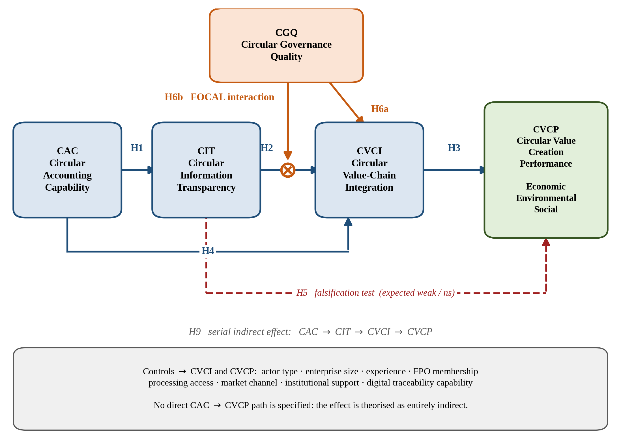
Figure 1. The conceptual model, showing hypotheses H1 to H9. Governance quality conditions the transparency-to-integration path; no direct path is specified from accounting capability to value creation. Source: Author(s)
Information is not modelled as a cause of governance. The dominant direction in the accounting literature runs from governance to disclosure quality, and while Gereffi et al. (2005) treat codifiability as determining governance form, they specify slow structural determination of chain architecture, not a short-run actor-level effect. A cross-sectional path from transparency to governance would be confounded by actor sophistication and chain position, so governance is treated as exogenous and conditioning.

4. Hypothesis development
Nine hypotheses follow, corresponding to the paths in Figure 1. Two are framed to permit disconfirmation, and the framework's failure conditions are stated explicitly in 4.4.

4.1 The mechanism
H1. Circular accounting capability is positively associated with circular information transparency. Information cannot be shared before it exists: where an actor does not quantify rejected volumes, cost spoilage or estimate by-product value, there is no circular information to make visible however willing it is to share. Accounting also codifies, converting tacit awareness that "a lot goes to waste" into transmissible form, and codifiability is what permits cross-boundary coordination (Gereffi et al., 2005; Christ and Burritt, 2015; Aranda-Usón et al., 2024).
H2. Circular information transparency is positively associated with circular value-chain integration. Coordinated recovery requires actors to know what material exists, in what quantity and condition, when and at what value. Where losses are invisible and downstream prices unknown, partners cannot agree quantities, schedules or shares of a flow they cannot jointly observe (Williams et al., 2013; Li et al., 2005; Kersten et al., 2024).
H3. Circular value-chain integration is positively associated with circular value creation performance. Circular value is realised only through changed material routing, and routing is a joint accomplishment: an actor cannot unilaterally valorise a by-product for which it has no processing capacity, offtake or logistics. Recovery requires aggregation to viable scale, timing against perishability and shared assets, generating economic, environmental and social value together (Flynn et al., 2010; Zhu et al., 2008; Farooque et al., 2019b).
H4. Circular accounting capability is positively associated with circular value-chain integration, over and above its indirect effect through transparency. Not every route from measurement to joint action passes through chain-wide visibility. An actor that has appraised a recovery opportunity gains bargaining and initiating capacity: it can propose an arrangement, quantify the mutual gain and negotiate a share without the information becoming generally visible.
H5. The direct association between circular information transparency and circular value creation performance is weak or non-significant once integration is accounted for. This hypothesis is framed to be disconfirmed. The claim is that information does not create circular value; changed material routing does. A strong direct effect net of integration would favour a simpler information-economics explanation, in which transparency improves bargaining, prices rise and value is captured with no change in material flows, over the mediated conditional account (Sodhi and Tang, 2019; Aureli et al., 2025).
H6a. Circular governance quality is positively associated with circular value-chain integration. Clear responsibility, joint monitoring, participatory decision-making and enforceable commitment lower the safeguarding costs of cooperation, making actors willing to commit dedicated assets to recovery activities they would otherwise avoid.
H6b (focal). Circular governance quality positively moderates the relationship between circular information transparency and circular value-chain integration, such that the relationship is stronger where governance quality is higher. The argument is developed in 3.3. Where governance is weak the same information is inert or counterproductive: it reveals an opportunity no actor is empowered, obliged or safe to act upon. Supporting evidence is scattered but never estimated as a moderation: Gualandris et al. (2015) on verification aligning accountability; Sodhi and Tang (2019) on inert transparency; Aureli et al. (2025) on participatory process alongside accounting information; Williams et al. (2013) on conditional visibility; Kristoffersen et al. (2021) on capability requiring orchestration. The predicted form is illustrated in Figure 2.
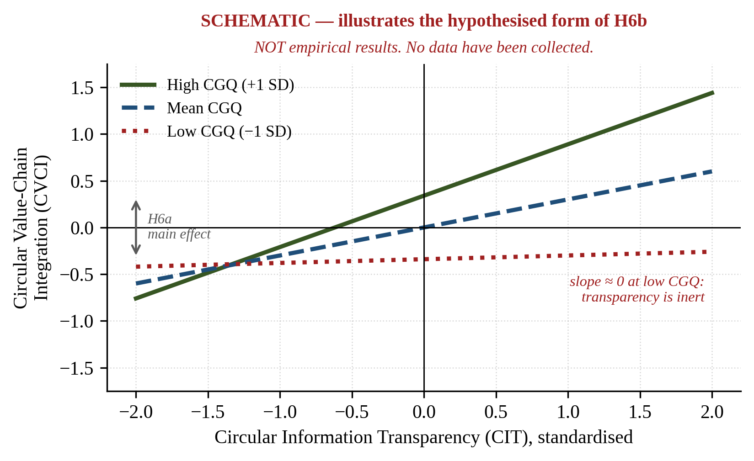
Figure 2. Predicted form of the focal moderation (H6b), schematic. Slopes diverge with governance quality and approach zero where it is weak. The figure illustrates the hypothesis only; it is not an empirical result. Source: Author(s)

4.2 Indirect and conditional effects
H7. Circular information transparency mediates the relationship between circular accounting capability and circular value-chain integration; complementary (partial) mediation is expected given H4.
H8. Circular value-chain integration mediates the relationship between transparency and circular value creation; indirect-only (full) mediation is expected given H5.
H9. Transparency and integration serially mediate the relationship between circular accounting capability and circular value creation. Because no direct path from capability to value creation is specified, the claim is clean: the effect of accounting on circular value creation is entirely indirect. Accounting does not create value; it makes value creation organisable. Because governance moderates a path inside the mediated chain that indirect effect is itself conditional, so an index of moderated mediation is required, and the conditional indirect effect is the study's central empirical quantity. Table II summarises all nine hypotheses, their type and expected sign, and the construct abbreviations used throughout.
Table II. Summary of hypotheses
No. | Relationship | Type | Expected sign | Role in the argument
H1 | CAC → CIT | Direct | + | Premise: measurement precedes visibility
H2 | CIT → CVCI | Direct | + | Premise: visibility enables joint action
H3 | CVCI → CVCP | Direct | + | Premise: joint action creates circular value
H4 | CAC → CVCI | Direct | + | Partial direct route
H5 | CIT → CVCP | Direct | ≈ 0 / ns | Falsification test
H6a | CGQ → CVCI | Direct | + | Required for the interaction
H6b | CIT × CGQ → CVCI | Interaction | + | Focal: the contribution
H7 | CAC → CIT → CVCI | Indirect | + | Mechanism, stage 1
H8 | CIT → CVCI → CVCP | Indirect | + | Mechanism, stage 2
H9 | CAC → CIT → CVCI → CVCP | Serial indirect | + | Full mechanism

4.3 Specification analysis: why this model and not the obvious alternatives
Three candidate specifications were developed and compared (Figure 3).
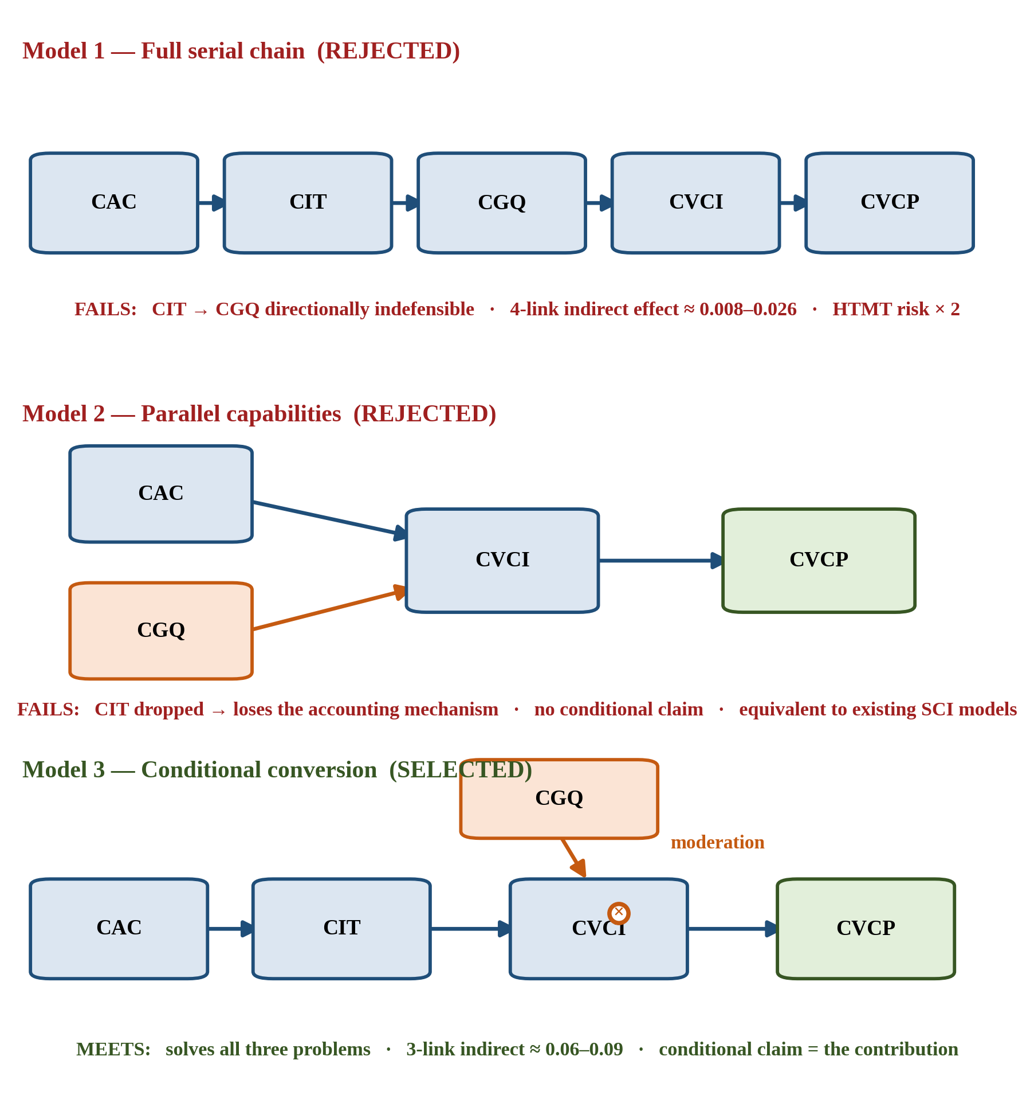
Figure 3. The three candidate specifications. Models 1 and 2 are rejected; Model 3 is adopted. The rejected models are the ones a reader would otherwise propose. Source: Author(s)
Alternative 1, the fully serial chain (accounting → transparency → governance → integration → value) is intuitively appealing, and rejected on three independent grounds. The path from transparency to governance is directionally indefensible in cross-section (3.3). The four-link indirect effect is statistically self-defeating: as products of standardised paths it is two to three-and-a-half times smaller than the three-link alternative at every value, being 0.063 against 0.125 where each link is 0.50 and 0.008 against 0.027 where each is 0.30, and falling below 0.03 once paths drop under 0.40, as Table III sets out, so across most of the plausible range the headline claim would rest on a quantity too small to discuss. And two adjacent construct pairs, accounting capability with transparency and governance with integration, are at high risk of discriminant-validity failure, a four-link chain of conceptually proximate constructs being a standard route to a measurement model that cannot be estimated as designed.
Table III. Attenuation of the serial indirect effect by chain length
Coefficient on each link | Three-link chain (adopted) | Four-link chain (rejected) | Ratio
0.50 | 0.125 | 0.063 | 2.0
0.45 | 0.091 | 0.041 | 2.2
0.40 | 0.064 | 0.026 | 2.5
0.35 | 0.043 | 0.015 | 2.9
0.30 | 0.027 | 0.008 | 3.4
Note. Products of standardised path coefficients. The three-link chain retains an interpretable effect across the whole range; the four-link chain does so only where every path is unusually strong, and becomes negligible below 0.40.
Alternative 2, parallel capabilities (accounting and governance both predicting integration, transparency omitted) would estimate cleanly but discards the paper's reason for existing. Removing transparency removes the accounting-specific mechanism, leaving a structure indistinguishable from established supply-chain integration models with circular labels applied; an additive bundle says nothing about how information becomes actionable.
The adopted model relocates governance from the causal chain to the conversion condition, resolving all three problems at once: the indefensible path is removed, the chain shortens to three links with an interpretable indirect effect, and governance measured as accountability structure rather than joint activity has a sharper boundary against integration. More importantly it converts the paper from describing a pathway to establishing a boundary condition, a claim that corrects an implicit consensus rather than confirming it.

4.4 Failure conditions
A theory earns its place by forbidding outcomes. Three are specified in advance. A null interaction alongside positive main effects would reduce the model to an additive bundle and the theoretical contribution would fail. A strong direct path from transparency to value creation surviving controls would favour a simpler information-economics account. A null or reversed path from accounting capability to transparency would make accounting a consequence rather than an antecedent of visibility, inverting the framework. Each will be reported whichever way it falls.

5. Research design

5.1 Constructs and measurement specification
Table IV. Construct definitions and measurement specification
Construct | Definition | Specification | Dimensions | Items
Circular Accounting Capability (CAC) | An actor's developed capacity to identify, quantify, cost and evaluate the physical and monetary consequences of resource flows, losses and recovery opportunities in its operations and exchanges | Reflective-formative (Type II) | Material and resource-flow measurement; loss and waste costing; recovery and circular investment evaluation | 9
Circular Information Transparency (CIT) | The extent to which information about resource flows, losses, recovery opportunities and the distribution of value along the chain is accessible, timely and intelligible to actors who need it to act | Reflective | n/a | 5
Circular Governance Quality (CGQ) | The extent to which relationships among chain actors embody clear allocation of responsibility for losses and recovery, joint monitoring and verification, participatory decision-making, and enforceable commitment | Reflective | n/a | 6
Circular Value-Chain Integration (CVCI) | The extent to which an actor and its partners coordinate operations, information and physical flows so as to retain, recover and redirect material that would otherwise leave the chain as waste | Reflective | n/a | 6
Circular Value Creation Performance (CVCP) | The extent to which an actor and its chain realise economic, environmental and social value from retaining, recovering and redirecting resources that would otherwise be lost | Reflective-formative (Type II) | Economic; environmental; social | 11

Circular accounting capability and circular value creation are specified as reflective-formative higher-order constructs because their dimensions are not interchangeable: an actor may record physical volumes meticulously while never costing a loss, and may capture economic value from by-product sales while distributing none socially. Treating either as a single reflective construct would assume an interchangeability that theory and the indicator literature contradict (Corona et al., 2019; Kristensen and Mosgaard, 2020), and higher-order reflective specification would invite the problems Lee and Cadogan (2013) identify. Specification follows Sarstedt et al. (2019), two-stage with redundancy analysis against global single-item measures.
Circular accounting capability is distinguished from four neighbouring constructs, testably rather than by assertion. Environmental management accounting takes the firm's environmental impact as its object and material flow cost accounting works within a process boundary; this construct takes the resource loop, spans exchange relationships and includes recovery valuation. Sustainability reporting is external, retrospective and applies to reporting entities; this is internal, prospective and applies to unincorporated enterprises. Eco-control is a control package; this is the calculative capacity that must exist before there is anything to control. Most fundamentally, conventional management accounting recognises purchased inputs and saleable outputs, whereas this construct recognises what the conventional system treats as nothing.

5.2 Empirical setting and unit of analysis
The proposed setting is a fragmented agri-food value chain, the Malta (Citrus sinensis) chain of the Indian Himalayan region, selected as a critical case rather than as the object of study. It exhibits the four scope conditions in unusually observable form: many dispersed small producers with no coordinating hierarchy; substantial recoverable material currently lost, with official national estimates placing harvest and post-harvest losses in fruits at 6.02–15.05 per cent and the processed share of fruit output at 4.5 per cent (Ministry of Food Processing Industries, 2025), aggregates for Indian fruit rather than for this chain, cited only to establish that the recoverable fraction is material; pronounced information asymmetry sustained by intermediary dependence; and wide variation in what actors measure. Crucially, governance quality varies widely within this single chain and regulatory environment, from informal spot transactions to formalised producer organisations, precisely the variance the focal moderation requires, and the variance that is compressed where circularity regulation supplies governance exogenously and near-uniformly.
The unit of analysis is the value-chain actor enterprise, including unincorporated enterprises; restricting it to incorporated entities would exclude most actors in any fragmented chain and render the scope condition unobservable. The key informant keeps or supervises records of quantities, costs and sales and participates in pricing and disposal decisions, confirmed by four screening items. Items are phrased as observable behaviours ("we write down how much fruit we reject or lose") rather than technical accounting knowledge: a smallholder who records rejected volumes and knows what they would have fetched is exercising circular accounting capability at low formality, and it is variance in that practice the model requires.

5.3 Sampling design
A composite sampling frame is assembled from horticulture, cooperative, market-licence and food-processing registers, institutional rosters, and grower-nominated referrals to unlicensed intermediaries. That last component is essential: informal intermediaries handle most volume but appear in no register, and excluding them would bias the sample toward the formal, better-governed segment where the predicted effects are strongest. Sampling is stratified purposive with disproportionate allocation, supplemented by chain-referral for the informal midstream; proportionate allocation would yield roughly eight processors, rendering the central recovery actors statistically invisible. The design is explicitly non-probability, so variable distributions are not generalisable, though structural relationships can still be estimated. The generalisability claim is theoretical, in that the mechanism travels, not statistical.
Allocation targets 520 valid responses: 180 non-affiliated producers and 120 producer-organisation members upstream, 80 aggregators, traders and commission agents at the information-asymmetry tier, 70 processors and common facility centres (the recovery actors, deliberately over-sampled), 40 downstream retailers and institutional buyers, and 30 chain support institutions, the last excluded from group analysis. These are design-stage planning parameters, not achieved counts, and are set out by stratum in Table V.
Table V. Planned sample composition
Stratum | Target valid responses | Share | Role in analysis
Producers, non-affiliated | 180 | 34.6% | Upstream; multi-group comparison
Producers, producer-organisation members | 120 | 23.1% | Upstream with collective governance
Aggregators, traders, commission agents | 80 | 15.4% | The information-asymmetry tier
Processors and common facility centres | 70 | 13.5% | Recovery actors; deliberately over-sampled
Retailers and institutional buyers | 40 | 7.7% | Downstream price-formation tier
Chain support institutions | 30 | 5.8% | Institutional context; excluded from group analysis
Total | 520 | 100%
Note. Allocation figures are design-stage planning parameters, not achieved counts.

5.4 Sample size determination
Sample size is derived rather than asserted. The ten-times rule is not applied: it would indicate about 100 responses, ignores effect size and power, and would leave the focal hypothesis undetectable. The binding quantity is the interaction, not the largest path. Interaction effects are characteristically the smallest estimates in a model, so planning against a medium main effect would under-power the central test, the most common sample-size error in moderation research.
The four derivations are set out in Table VI, and Figure 4 plots power against sample size across effect-size assumptions.
Table VI. Required sample size under four approaches
Approach | Basis | Requirement
A. A-priori power analysis | F-test for R² deviation from zero; 11 predictors on the focal endogenous construct; f² = 0.05; power = 0.90; α = 0.05 | 434
B. Inverse square root method | Kock and Hadaya (2018); smallest expected path β = 0.11; power = 0.80 | 511 (binding)
C. Measurement-model complexity | Covariance-based robustness check; ≈ 96 free parameters at a 5:1 ratio | 480
D. Multi-group analysis | Two groups each estimable at β ≈ 0.15–0.20 | 490–550
Adopted design target |  | 520
Note. Design stage. Minimum acceptable 350 (power 0.80, Approach A); recommended 450.
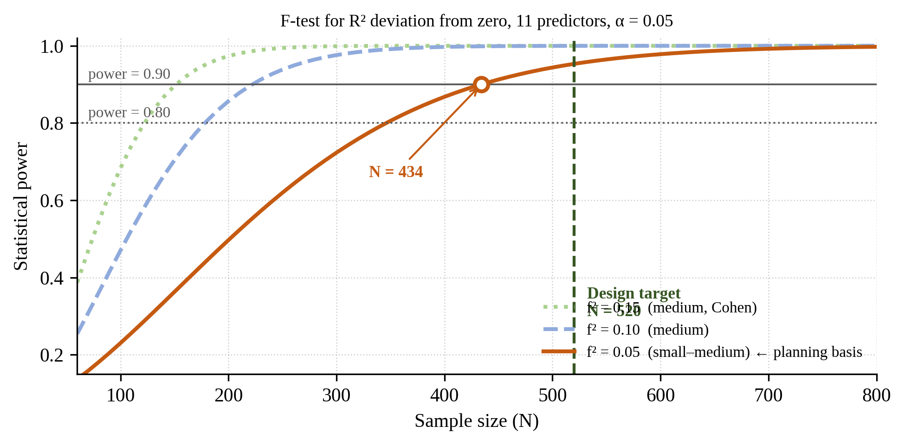
Figure 4. Statistical power against sample size, F-test for R² deviation from zero, eleven predictors, α = 0.05, computed at the design stage. At the target of 520 three group comparisons are viable, chain position, collective affiliation and enterprise size, while a producer-versus-processor comparison is not, since 70 processors would require β ≥ 0.30 to be detectable; it will therefore not be conducted, and the reason stated rather than the analysis quietly omitted.

5.5 Instrument development
Forty-six substantive items are administered on seven-point scales, consistent with the source instruments and preserving the variance interaction detection requires; a visual ladder card and enumerator administration mitigate cognitive load, with pre-specified conversion to five points if pilot discrimination is inadequate. Of the 46, 22 are adapted from validated scales, 11 adapt validated item structures to circular resource-flow content, 10 are newly developed and declared as such, and three constitute a validated marker. That roughly one item in five is new is neither concealable nor avoidable: no validated instrument exists for loss-recovery valuation, value-distribution transparency, responsibility allocation for losses, or social circular value, precisely the measurement gap the paper claims. The full instrument, with a source code against every item, is Table VI. A two-task expert study ran over three rounds with an eight-member panel. In task 1 all 46 items were rated for relevance, retention requiring an item-level index of at least 0.83 and a modified kappa of at least 0.74, with scale-level validity averaging at least 0.90 (Polit and Beck, 2006; Polit et al., 2007). The first threshold deserves a note: 0.78 is frequently quoted but applies to panels of nine to ten raters, whereas six to eight require 0.83, meaning at least seven of eight must judge an item relevant. Task 2 was a blind item-placement task following Anderson and Gerbing (1991) and Moore and Benbasat (1991), placing items against the five construct definitions shown without labels. It tests the principal measurement risk directly: that governance cannot be distinguished from integration, or accounting capability from transparency. Two rules were pre-specified so they could not be relaxed afterwards: items failing either placement criterion are revised and re-rated or dropped. And the consequential rule: if more than 20% of placements crossed either boundary, the corresponding hypothesis would be withdrawn. Rounds one and two administered both tasks in full, 368 ratings and 368 placements each; round three re-rated the revised items only. Returns were complete throughout. Results are in Table VII.

Table VII. Expert validation of the instrument, three rounds
Focal construct | Items | Content validity (S-CVI/Ave), R1 → R2 → R3 | Meets 0.90 | Placement hit rate, R1 → R2 | Meets 0.80
Circular accounting capability | 9 | 0.778 → 0.861 → 0.889 | No | 0.778 → 0.889 | Yes
Circular information transparency | 5 | 0.800 → 0.850 → 0.975 | Yes | 0.750 → 0.850 | Yes
Circular governance quality | 6 | 0.792 → 0.854 → 0.917 | Yes | 0.812 → 0.833 | Yes
Circular value-chain integration | 6 | 0.833 → 0.938 → 0.958 | Yes | 0.875 → 0.875 | Yes
Circular value creation performance | 11 | 0.784 → 0.886 → 0.920 | Yes | 0.818 → 0.898 | Yes
Focal constructs, overall | 37 | 0.794 → 0.878 → 0.926 | Yes | 0.818 → 0.883 | Yes
Whole instrument, incl. controls and marker | 46 | 0.799 → 0.864 → 0.908 | Yes | n/a | n/a
Boundary leakage, accounting ↔ transparency | n/a | n/a | n/a | 13.9% → 4.2%; 10.0% → 7.5% | Within 20%
Boundary leakage, governance ↔ integration | n/a | n/a | n/a | 6.2% → 6.2%; 2.1% → 2.1% | Within 20%

Note. S-CVI/Ave is the mean item-level content validity index; hit rate is the proportion of placements assigning an item to its intended construct. Boundary rows report leakage between the two critical pairs; above 20% the corresponding hypothesis is withdrawn. Items meeting the 0.83 item-level criterion rose from 20 to 31 to 43 of 46, and mean pairwise agreement from 0.657 to 0.752. Round three re-rated the twelve failing items with the panel held stable; the placement task was not repeated, so its column ends at round two. S-CVI/UA, the stricter universal-agreement statistic, reaches 0.326 whole and 0.405 focal (Table BIII). Every figure was independently recomputed from the raw ratings.
Round one drew on accounting, reporting, governance, auditing, environmental-management, supply-chain and business-ethics expertise. It did not establish content validity, and a deviation from the pre-registered composition is the probable cause, disclosed rather than concealed: the protocol required a circular-economy specialist and agri-food field expertise, and neither was present. Round two added exactly that expertise, a circular-economy academic and two agri-food practitioners, and improved every scale without reaching the criterion. Round three held the panel constant and changed only the items, revising and re-rating the twelve that had failed. All twelve passed (Table BII), and the scale-level criterion is now met: 0.908 whole instrument, 0.926 focal.
The sequence separates two explanations a single round would have conflated. Round two changed the raters and left the items alone, so its gain is attributable to composition; round three changed the items and left the raters alone, so its gain is attributable to revision. The seven items showing identical indices in both earlier rounds (CAC2, CGQ1, CGQ6, CVCI2, CIT3, IS1, MK3) were diagnosed as wording problems rather than panel artefacts; all seven moved once reworded, from 0.750 to between 0.875 and 1.000. The diagnosis was testable, and was tested.
Discriminant validity was established in round two: all five focal constructs met the placement criterion, including the two that failed in round one, and all four boundary checks passed. H6b is well founded on discriminant grounds, the boundary whose failure would have made the focal interaction a construct interacting with itself leaking 6.2% and 2.1% against a 20% tolerance.
Three qualifications carry forward. First, three of the fifteen failing items were not revised, namely IS2, IS3 and MK1, and retain round-two ratings of 0.750 with a modified kappa of 0.719, below both thresholds. None is focal: two belong to the institutional-support control and one to the marker. The marker is a special case: it is the validated colour-blue instrument, administered verbatim and chosen precisely because it is theoretically unrelated to every substantive construct (Miller and Simmering, 2023), so a low relevance rating is what qualifies it rather than a defect, and the remedy is to exclude it from the denominator rather than reword it, since rewording a published marker forfeits the warrant for using one. On the 43 items remaining, S-CVI/Ave is 0.913, so the criterion is met on all three denominators, 0.908, 0.913 and 0.926, and the conclusion does not turn on which is chosen. IS2 and IS3 are double-barrelled and should be revised before fielding. Second, circular accounting capability remains below 0.90 at construct level, at 0.889; it is the model's antecedent, which makes this the least convenient place for a shortfall, and it is reported rather than absorbed into the focal average. Third, the placement task was not repeated after twelve items were reworded, so for those twelve the discriminant evidence describes superseded wording. Given leakage well inside tolerance the conclusion is unlikely to reverse, but it has not been re-tested; a confirmatory check is the cheapest remaining improvement.
Dependent-variable items are framed as change over three seasons while predictors are current-state, giving temporal and format separation within one administration at no cost to response burden. A subsample supplies three objective indicators transcribed from records (loss ratio, by-product sale and value, realised price against the district modal price), permitting a convergent-validity check on the perceptual outcome measure. Panel composition is in Table BI; item-level results, the scoring script and the raw returns are listed in Table CI.

6. Analytical strategy
Estimation uses partial least squares structural equation modelling, with covariance-based estimation as a pre-specified robustness check. The choice is not justified by sample size: at 520 responses covariance-based estimation is feasible, as Approach C establishes. It rests on measurement specification, since two constructs are reflective-formative, which covariance-based estimation accommodates only through identification constraints that would distort the theorised structure; on capabilities being composites, and on a latent interaction inside a serial chain.
The critique of composite-based estimation is engaged directly rather than by citing advocates only. Concerns about parameter bias under common-factor conditions and the absent global fit test (McIntosh et al., 2014; Rönkkö et al., 2016) are met three ways: the constructs are theorised as composites, the condition under which composite estimation is appropriate rather than convenient (Hair, Sarstedt and Ringle, 2019; Guenther et al., 2023); the missing fit index is compensated by standardised root mean square residual, out-of-sample prediction and prediction-oriented comparison against the rejected specifications; and the model is re-estimated by covariance-based methods, with any divergence disclosed.
The protocol proceeds in eleven pre-registered steps, from data preparation under pre-specified cleaning rules through measurement assessment with declared escalation contingencies, second-stage construction of the formative higher-order constructs, method-bias assessment and structural estimation, to Johnson–Neyman analysis, conditional indirect effects, predictive assessment, multi-group analysis and an eleven-check robustness battery. Bootstrapping uses 10,000 subsamples with percentile and bias-corrected intervals.
Assessment criteria are pre-specified with the action to be taken if each is breached, following Hair, Sarstedt and Ringle (2019), Sarstedt et al. (2019) and Kock and Hadaya (2018), and are tabulated in Table VIII.
Table VIII. Pre-specified measurement and structural assessment criteria
Stage | Criterion | Threshold | Action if breached
Reflective measurement | Outer loading | ≥ 0.708 | Retain between 0.40 and 0.708 only where removal does not raise average variance extracted above threshold and content validity requires it
 | Reliability (ρ_A, ρ_c) | 0.70–0.95 | Below 0.70 investigate; above 0.95 check indicator redundancy
 | Average variance extracted | ≥ 0.50 | Apply pre-registered escalation to a two-dimensional specification
 | Discriminant validity (HTMT) | < 0.85 | Report confidence intervals; if the accounting–transparency or governance–integration pair breaches, the corresponding claim is withdrawn
Formative measurement | Indicator collinearity (VIF) | < 3 | Examine dimensional overlap
 | Outer weights and loadings | Weight significant, or loading ≥ 0.50 | Content validity takes precedence over statistical criteria
 | Redundancy analysis | Path to global measure ≥ 0.70 | Convergent validity not established; reported as a limitation
Structural model | Inner VIF | < 3 | Values of 3–5 reported and discussed
 | Interaction effect size | f² judged against interaction-specific benchmarks (0.005 / 0.01 / 0.025) | Cohen's main-effect benchmarks understate interactions and are not used
 | Predictive relevance | Q²predict > 0; PLS root mean square error below linear benchmark | Reported alongside cross-validated predictive ability test
Mediation | Indirect effect | Bootstrapped interval excluding zero | Significance of the indirect effect is the criterion; a significant total effect is not required
Note. Thresholds follow Hair, Sarstedt and Ringle (2019), Sarstedt et al. (2019) and Kock and Hadaya (2018). All result cells in the reporting templates remain empty until data are collected. Two are consequential enough to state here. If HTMT for the accounting–transparency or governance–integration pair reaches 0.85, the corresponding claim is withdrawn rather than defended. And interaction effect size is judged against interaction-specific benchmarks of 0.005, 0.01 and 0.025, because Cohen's main-effect benchmarks understate interactions and would make a real conditional effect look trivial. Where formative indicators conflict with statistical criteria, content validity takes precedence.
Two outputs deserve emphasis. The Johnson–Neyman point identifies the governance level at which the transparency–integration relationship ceases to be significant, delivering an actionable boundary rather than a directional claim. The index of moderated mediation establishes whether the pathway from measurement to circular value creation exists at low governance quality at all; the theoretical claim is that it does not.
Common method bias is addressed procedurally, through anonymity, the change-versus-level framing separation, a scripted break and neutral item framing, and statistically through full collinearity assessment, a validated marker and measured latent marker correction; Harman's single-factor test is deliberately not used. Endogeneity is addressed through eight theoretically justified controls, digital traceability capability and institutional support being the principal rival explanations, a Gaussian copula assessment, and estimation of the reversed model. Following Chenhall and Moers (2007), the design's limits are stated plainly: it establishes conditional association, not causation.

7. Expected contributions
Theoretical. Dynamic capabilities theory, including its application to accounting and circularity, locates capability and its returns inside the firm. Where the value-creating reconfiguration crosses organisational boundaries, returns are relationally contingent, depending on a governance arrangement the focal actor does not control. The contribution is not that capabilities need complementary assets, which Teece (2007) says, but identifying which asset substitutes for hierarchy under fragmentation, and a test in which its absence nullifies the capability's effect.
Accounting. Accounting is the sensing apparatus of circularity: a discarded fraction becomes an economic object only when quantified and valued. And accounting's effect on circular value creation is entirely indirect and conditional: no direct path is specified, and the analysis tests whether the indirect path exists where governance is weak. That is more precise than "accounting supports circularity", and it specifies when investment in circular measurement is worthwhile.
Governance and accountability. The literature repeatedly asserts that transparency requires verification, consequence or participation to matter. This paper specifies that assertion as a conditional relationship, quantifies the threshold at which it binds, and names the diagnostic core of fragmented circularity: resource loss is nobody's account.
Circular economy. Circular performance is predominantly measured as material efficiency. This paper specifies circular value creation as a formative higher-order construct spanning economic, environmental and social value, and examines whether the mechanism differs across them. Should economic and environmental value respond while social value does not, the finding speaks to who captures circular value, central to sustainability accounting and largely absent from circularity measurement.
Methodological and practical. The paper supplies a replicable instrument spanning an entire fragmented chain rather than one tier, with newly developed items identified and three rounds of validation reported in full, including where they still fall short. For policy the implication concerns sequencing. Measurement mandates and transparency requirements, from sustainability reporting directives to digital product passports, rest on the premise that visibility changes behaviour. If governance is the conversion mechanism, then where responsibility for loss is unallocated such requirements will generate compliance without circular value, and should be paired with responsibility allocation and enforcement capacity.
Why this matters beyond the empirical setting. Fragmentation is a property of circular chains generally, not of developing economies; 1 sets out the evidence. Where circularity regulation supplies governance exogenously and near-uniformly the conditional relationship is hard to observe for want of variance, so a mature disclosure regime is a poor place to test the premise on which its own instruments rest. The model applies unchanged to textile recovery, construction and demolition waste, and electronics chains, failing only where hierarchy performs the coordination, a boundary condition that is itself testable.

8. Limitations and future research
The model is specified but not estimated; the test requires primary data from a single harvest season. The cross-sectional design supports conditional association rather than causation, and a longitudinal panel across seasons is the principal priority for future work. Measurement is single-informant and largely perceptual; the objective-indicator subsample mitigates but does not eliminate this, and because enterprises able to produce records are those with higher accounting capability, that check is itself conditional. A dyadic design with matched producer–buyer pairs would be superior for the governance constructs but is not feasible where intermediary relationships are informal and often deliberately opaque, the condition under study. Sampling is non-probability, so variable distributions are not generalisable. Ten items are newly developed, and after three rounds of validation content validity meets the scale-level criterion with three qualifications carrying forward, as 5.5 reports: two control items and one marker item were never revised and remain below threshold; circular accounting capability, the model's antecedent, is the weakest focal scale at 0.889; and the placement task was not repeated after twelve items were reworded. The social dimension rests on the least developed indicator literature. Replication in a non-agricultural fragmented chain, and in a vertically integrated setting where the conditional effect should attenuate, would test the scope condition directly.

9. Conclusion
Circularity is often framed as a technological or behavioural problem. This paper argues it is substantially a calculative and accountability problem, and that the two are related in a testable way. Accounting is what makes a resource loop visible: until a discarded fraction is quantified and valued it is not an opportunity but an absence. Yet visibility is not self-executing. In a firm hierarchy converts information into action; in a fragmented chain there is no hierarchy, and what converts information into action is governance: responsibility for what is lost, monitoring of what was agreed, participation by those who share the gains, and enforceability of the commitments that justify investment.
The model makes that argument falsifiable. It predicts that the pathway from measurement through transparency to circular value creation exists only above a threshold of governance quality, and specifies the analysis identifying where that threshold lies. If the prediction fails, the account reduces to an additive capability bundle and should be abandoned; that condition is stated in advance. The discipline's contribution to circularity will not be exhausted by extending disclosure. What is measured must also be owed by someone to someone, with consequence. In fragmented value chains accounting produces the visibility circularity requires; governance determines whether that visibility does any work.

Declarations
The author(s) acknowledge the use of generative AI tools to enhance the linguistic quality and readability of this manuscript. These tools were employed solely to improve spelling, grammar, and overall clarity, based on the original content created by the author(s). The author(s) take full responsibility for the original content, interpretations, and conclusions presented in this work.
Data availability
The data that support the findings of this study are available on request from the corresponding author.

References
Adams, K.T., Osmani, M., Thorpe, T. and Thornback, J. (2017), "Circular economy in construction: current awareness, challenges and enablers", Proceedings of the Institution of Civil Engineers - Waste and Resource Management, Vol. 170, No. 1, pp. 15–24.
Anderson, J.C. and Gerbing, D.W. (1991), "Predicting the performance of measures in a confirmatory factor analysis with a pretest assessment of their substantive validities", Journal of Applied Psychology, Vol. 76 No. 5, pp. 732–740.
Aranda-Usón, A., Scarpellini, S. and Moneva, J.M. (2024), "Dynamic capabilities for a 'circular accounting' and material flows in a circular economy", Resources, Conservation and Recycling, Vol. 209, pp. 107756.
Aureli, S., Foschi, E. and Paletta, A. (2025), "Management accounting for a circular economy: current limits and avenue for a dialogic approach", Accounting, Auditing & Accountability Journal, Vol. 38, No. 9, pp. 291–319.
Bag, S., Wood, L.C., Xu, L., Dhamija, P. and Kayikci, Y. (2020), "Big data analytics as an operational excellence approach to enhance sustainable supply chain performance", Resources, Conservation and Recycling, Vol. 153, pp. 104559.
Barratt, M. and Oke, A. (2007), "Antecedents of supply chain visibility in retail supply chains: A resource‐based theory perspective", Journal of Operations Management, Vol. 25, No. 6, pp. 1217–1233.
Batista, L., Bourlakis, M., Smart, P. and Maull, R. (2018), "In search of a circular supply chain archetype – a content-analysis-based literature review", Production Planning & Control, Vol. 29, No. 6, pp. 438–451.
Bebbington, J. and Larrinaga, C. (2014), "Accounting and sustainable development: An exploration", Accounting, Organizations and Society, Vol. 39, No. 6, pp. 395–413.
Bocken, N.M.P., de Pauw, I., Bakker, C. and van der Grinten, B. (2016), "Product design and business model strategies for a circular economy", Journal of Industrial and Production Engineering, Vol. 33, No. 5, pp. 308–320.
Bressanelli, G., Perona, M. and Saccani, N. (2019), "Challenges in supply chain redesign for the Circular Economy: a literature review and a multiple case study", International Journal of Production Research, Vol. 57, No. 23, pp. 7395–7422.
Burritt, R.L. and Schaltegger, S. (2010), "Sustainability accounting and reporting: fad or trend?", Accounting, Auditing & Accountability Journal, Vol. 23, No. 7, pp. 829–846.
Cao, M. and Zhang, Q. (2011), "Supply chain collaboration: Impact on collaborative advantage and firm performance", Journal of Operations Management, Vol. 29, No. 3, pp. 163–180.
Chenhall, R.H. and Moers, F. (2007), "The Issue of Endogeneity within Theory-Based, Quantitative Management Accounting Research", European Accounting Review, Vol. 16, No. 1, pp. 173–196.
Christ, K.L. and Burritt, R. (2017), "Material flow cost accounting for food waste in the restaurant industry", British Food Journal, Vol. 119, No. 3, pp. 600–612.
Christ, K.L. and Burritt, R.L. (2015), "Material flow cost accounting: a review and agenda for future research", Journal of Cleaner Production, Vol. 108, pp. 1378–1389.
Corona, B., Shen, L., Reike, D., Rosales Carreón, J. and Worrell, E. (2019), "Towards sustainable development through the circular economy—A review and critical assessment on current circularity metrics", Resources, Conservation and Recycling, Vol. 151, pp. 104498.
Corvellec, H., Stowell, A.F. and Johansson, N. (2022), "Critiques of the circular economy", Journal of Industrial Ecology, Vol. 26, No. 2, pp. 421–432.
De Angelis, R., Howard, M. and Miemczyk, J. (2018), "Supply chain management and the circular economy: towards the circular supply chain", Production Planning & Control, Vol. 29, No. 6, pp. 425–437.
Eisenhardt, K.M. and Martin, J.A. (2000), "Dynamic capabilities: what are they?", Strategic Management Journal, Vol. 21, No. 10-11, pp. 1105–1121.
Farooque, M., Zhang, A. and Liu, Y. (2019a), "Barriers to circular food supply chains in China", Supply Chain Management: An International Journal, Vol. 24, No. 5, pp. 677–696.
Farooque, M., Zhang, A., Thürer, M., Qu, T. and Huisingh, D. (2019b), "Circular supply chain management: A definition and structured literature review", Journal of Cleaner Production, Vol. 228, pp. 882–900.
Ferreira, A., Moulang, C. and Hendro, B. (2010), "Environmental management accounting and innovation: an exploratory analysis", Accounting, Auditing & Accountability Journal, Vol. 23, No. 7, pp. 920–948.
Flynn, B.B., Huo, B. and Zhao, X. (2010), "The impact of supply chain integration on performance: A contingency and configuration approach", Journal of Operations Management, Vol. 28, No. 1, pp. 58–71.
Forliano, C., De Bernardi, P., Panero, M. and Kirchherr, J. (2026), "Technological capabilities, institutional context and circular economy adoption", Management Decision, pp. 1–32.
García-Granero, E.M., Piedra-Muñoz, L., Galdeano-Gómez, E. and Sorroche-del-Rey, Y. (2025), "A path towards sustainability through the circular economy phenom: indicators from the Spanish agri-food sector", Sustainability Accounting, Management and Policy Journal, Vol. 16, No. 7, pp. 28–61.
Geissdoerfer, M., Savaget, P., Bocken, N.M.P. and Hultink, E.J. (2017), "The Circular Economy – A new sustainability paradigm?", Journal of Cleaner Production, Vol. 143, pp. 757–768.
Gereffi, G., Humphrey, J. and Sturgeon, T. (2005), "The governance of global value chains", Review of International Political Economy, Vol. 12, No. 1, pp. 78–104.
Gualandris, J., Klassen, R.D., Vachon, S. and Kalchschmidt, M. (2015), "Sustainable evaluation and verification in supply chains: Aligning and leveraging accountability to stakeholders", Journal of Operations Management, Vol. 38, No. 1, pp. 1–13.
Guenther, P., Guenther, M., Ringle, C.M., Zaefarian, G. and Cartwright, S. (2023), "Improving PLS-SEM use for business marketing research", Industrial Marketing Management, Vol. 111, pp. 127–142.
Gunarathne, A.D.N., Lee, K. and Hitigala Kaluarachchilage, P.K. (2021), "Institutional pressures, environmental management strategy, and organizational performance: The role of environmental management accounting", Business Strategy and the Environment, Vol. 30, No. 2, pp. 825–839.
Gunarathne, N. and Lee, K.H. (2015), "Environmental Management Accounting (EMA) for environmental management and organizational change", Journal of Accounting & Organizational Change, Vol. 11, No. 3, pp. 362–383.
Gurung, R., Choubey, M. and Rai, R. (2024), "Economic impact of farmer producer organisation (FPO) membership: empirical evidence from India", International Journal of Social Economics, Vol. 51, No. 8, pp. 1015–1028.
Hair, J.F., Sarstedt, M. and Ringle, C.M. (2019), "Rethinking some of the rethinking of partial least squares", European Journal of Marketing, Vol. 53, No. 4, pp. 566–584.
Hart, J., Adams, K., Giesekam, J., Tingley, D.D. and Pomponi, F. (2019), "Barriers and drivers in a circular economy: the case of the built environment", Procedia CIRP, Vol. 80, pp. 619–624.
Henri, J.F. and Journeault, M. (2010), "Eco-control: The influence of management control systems on environmental and economic performance", Accounting, Organizations and Society, Vol. 35, No. 1, pp. 63–80.
Johnstone, L. (2024), "Leveraging digital data to facilitate circular control in the aftermarket – experiences from an international manufacturing firm", Sustainability Accounting, Management and Policy Journal, Vol. 15, No. 4, pp. 987–1014.
Kersten, C.C., Kerber, J.M.C., Silva, J.d.S., Bouzon, M. and Campos, L.M.d.S. (2024), "Traceability in the agri-food supply chain: a new perspective under the Circular Economy approach", Production, Vol. 34, e20240009.
Kirchherr, J., Piscicelli, L., Bour, R., Kostense-Smit, E., Muller, J., Huibrechtse-Truijens, A. and Hekkert, M. (2018), "Barriers to the Circular Economy: Evidence From the European Union (EU)", Ecological Economics, Vol. 150, pp. 264–272.
Kirchherr, J., Reike, D. and Hekkert, M. (2017), "Conceptualizing the circular economy: An analysis of 114 definitions", Resources, Conservation and Recycling, Vol. 127, pp. 221–232.
Kirchherr, J., Yang, N.H.N., Schulze-Spüntrup, F., Heerink, M.J. and Hartley, K. (2023), "Conceptualizing the Circular Economy (Revisited): An Analysis of 221 Definitions", Resources, Conservation and Recycling, Vol. 194, pp. 107001.
Kock, N. and Hadaya, P. (2018), "Minimum sample size estimation in PLS‐SEM: The inverse square root and gamma‐exponential methods", Information Systems Journal, Vol. 28, No. 1, pp. 227–261.
Kristensen, H.S. and Mosgaard, M.A. (2020), "A review of micro level indicators for a circular economy – moving away from the three dimensions of sustainability?", Journal of Cleaner Production, Vol. 243, pp. 118531.
Kristoffersen, E., Mikalef, P., Blomsma, F. and Li, J. (2021), "The effects of business analytics capability on circular economy implementation, resource orchestration capability, and firm performance", International Journal of Production Economics, Vol. 239, pp. 108205.
Lee, N. and Cadogan, J.W. (2013), "Problems with formative and higher-order reflective variables", Journal of Business Research, Vol. 66, No. 2, pp. 242–247.
Li, S., Rao, S.S., Ragu‐Nathan, T.S. and Ragu‐Nathan, B. (2005), "Development and validation of a measurement instrument for studying supply chain management practices", Journal of Operations Management, Vol. 23, No. 6, pp. 618–641.
Makarenko, I., Steiner, B. and Yuhai, K. (2024), "Toward a novel Sustainability Transparency Index for improved governance in agri-food value chains: A comparative study of Finnish and Ukrainian companies", Accounting and Financial Control, Vol. 5, No. 1, pp. 68–81.
Massari, G.F. and Giannoccaro, I. (2023), "Adopting GRI Standards for the Circular Economy strategies disclosure: the case of Italy", Sustainability Accounting, Management and Policy Journal, Vol. 14, No. 4, pp. 660–694.
McIntosh, C.N., Edwards, J.R. and Antonakis, J. (2014), "Reflections on Partial Least Squares Path Modeling", Organizational Research Methods, Vol. 17, No. 2, pp. 210–251.
Miller, B.K. and Simmering, M.J. (2023), "Attitude toward the color blue: an ideal marker variable", Organizational Research Methods, Vol. 26 No. 3, pp. 409–440.
Ministry of Food Processing Industries (2025), Processing and Supply Chain Infrastructure in Food Sector, Lok Sabha Starred Question No. 398, answered 27 March 2025, Government of India, New Delhi, available at: https://sansad.in/getFile/loksabhaquestions/annex/184/AS398_RJrv1D.pdf (accessed 7 August 2026). Reports the NABARD Consultancy Services loss study (2022) and the Ministry's commissioned study of processing levels (2021).
Moore, G.C. and Benbasat, I. (1991), "Development of an instrument to measure the perceptions of adopting an information technology innovation", Information Systems Research, Vol. 2 No. 3, pp. 192–222.
Opferkuch, K., Caeiro, S., Salomone, R. and Ramos, T.B. (2021), "Circular economy in corporate sustainability reporting: A review of organisational approaches", Business Strategy and the Environment, Vol. 30, No. 8, pp. 4015–4036.
Opferkuch, K., Caeiro, S., Salomone, R. and Ramos, T.B. (2022), "Circular economy disclosure in corporate sustainability reports: The case of European companies in sustainability rankings", Sustainable Production and Consumption, Vol. 32, pp. 436–456.
Osei, V., Asante-Darko, D. and Quayson, M. (2024), "Stakeholder Pressure, Circular Economy Practices, and Sustainability Performance: The Moderating Effect of Ecological Innovation Capabilities", Circular Economy and Sustainability, Vol. 4, No. 4, pp. 3139–3170.
Österberg, P. and Nilsson, J. (2009), "Members' perception of their participation in the governance of cooperatives: the key to trust and commitment in agricultural cooperatives", Agribusiness, Vol. 25, No. 2, pp. 181–197.
Polit, D.F. and Beck, C.T. (2006), "The content validity index: are you sure you know what's being reported?", Research in Nursing & Health, Vol. 29 No. 5, pp. 489–497.
Polit, D.F., Beck, C.T. and Owen, S.V. (2007), "Is the CVI an acceptable indicator of content validity? Appraisal and recommendations", Research in Nursing & Health, Vol. 30 No. 4, pp. 459–467.
Radu, C. and Lux, G. (2025), "Circular economy promotion and disclosure among Canadian municipalities", Sustainability Accounting, Management and Policy Journal, Vol. 16, No. 4, pp. 1016–1044.
Ratsimandresy, A. and Miemczyk, J. (2024), "Facilitating the circular economy: insights from novel supply network actors", Supply Chain Management: An International Journal, Vol. 29, No. 5, pp. 852–870.
Rönkkö, M., McIntosh, C.N., Antonakis, J. and Edwards, J.R. (2016), "Partial least squares path modeling: Time for some serious second thoughts", Journal of Operations Management, Vol. 47-48, No. 1, pp. 9–27.
Sarstedt, M., Hair, J.F., Cheah, J.H., Becker, J.M. and Ringle, C.M. (2019), "How to Specify, Estimate, and Validate Higher-Order Constructs in PLS-SEM", Australasian Marketing Journal, Vol. 27, No. 3, pp. 197–211.
Scarpellini, S., Kuba-Khoury, V. and Aranda-Usón, A. (2026), "Circular accounting practices for the Spanish waste sector: an approach from the stakeholders’ theoretical framework in a circular economy", Meditari Accountancy Research, Vol. 34, No. 2, pp. 499–525.
Scarpellini, S., Marín-Vinuesa, L.M., Aranda-Usón, A. and Portillo-Tarragona, P. (2020), "Dynamic capabilities and environmental accounting for the circular economy in businesses", Sustainability Accounting, Management and Policy Journal, Vol. 11, No. 7, pp. 1129–1158.
Sodhi, M.S. and Tang, C.S. (2019), "Research Opportunities in Supply Chain Transparency", Production and Operations Management, Vol. 28, No. 12, pp. 2946–2959.
Teece, D.J. (2007), "Explicating dynamic capabilities: the nature and microfoundations of (sustainable) enterprise performance", Strategic Management Journal, Vol. 28, No. 13, pp. 1319–1350.
Tong, X., Wang, T., Li, J. and Wang, X. (2024), "Extended producer responsibility to reconstruct the circular value chain", Circular Economy, Vol. 3, No. 1, pp. 100076.
Tran, T.T., Burritt, R.L., Herzig, C. and Christ, K.L. (2025), "Material flow cost accounting in Vietnam: a multi-level exploration", Accounting, Auditing & Accountability Journal, Vol. 38, No. 1, pp. 286–320.
Ubakivi-Hadachi, P. and Kall, K. (2026), "Fragmented Circularity: Power Asymmetries and Stakeholder Perspectives in the European Plastics Value Chain", Journal of Circular Economy, Vol. 4, No. 1, available online.
Velenturf, A.P.M. and Purnell, P. (2021), "Principles for a sustainable circular economy", Sustainable Production and Consumption, Vol. 27, pp. 1437–1457.
Vermunt, D.A., Negro, S.O., Verweij, P.A., Kuppens, D.V. and Hekkert, M.P. (2019), "Exploring barriers to implementing different circular business models", Journal of Cleaner Production, Vol. 222, pp. 891–902.
Williams, B.D., Roh, J., Tokar, T. and Swink, M. (2013), "Leveraging supply chain visibility for responsiveness: The moderating role of internal integration", Journal of Operations Management, Vol. 31, No. 7-8, pp. 543–554.
Zhu, Q., Sarkis, J. and Lai, K.h. (2008), "Confirmation of a measurement model for green supply chain management practices implementation", International Journal of Production Economics, Vol. 111, No. 2, pp. 261–2.

