Satisfaction as the Conduit: How User Engagement and Experience Create Brand Value in the Metaverse

Abstract
Purpose: This study investigates the drivers of brand success in the metaverse by empirically testing a configurational model connecting user engagement (UE), user experience (UX), and brand satisfaction (BSAT), grounded in Flow Theory and Self-Determination Theory (SDT).
Design/methodology/approach: A mixed-methods research design is employed. Partial least squares structural equation modelling (PLS-SEM) validates the measurement model, while fuzzy-set qualitative comparative analysis (fsQCA) addresses causal complexity. The study relies on data collected from 312 active metaverse users, a strategically important emerging market.
Findings: Stand-alone engagement or experience is insufficient for brand success. Rather, specific configurations particularly brand satisfaction situated alongside either user experience or user engagement are required for favorable outcomes. The fully triadic configuration (BSAT × UX × UE) yields the highest solution consistency, demonstrating equifinality in metaverse branding.
Practical implications: The configurational logic provides brand managers and strategists with actionable guidance for designing identity-affirming, community-embedded virtual experiences that sustain engagement and competitive differentiation in the metaverse.
Originality/value: This paper extends Flow Theory and SDT into co-creative, technology-mediated brand ecosystems. By utilizing fsQCA, it reveals the complex, equifinal pathways to brand success that traditional, linear engagement models often overlook.

Keywords: Metaverse; User engagement ;User experience ;Brand satisfaction ;Brand success; fsQCA

- Introduction:
The metaverse is an immersive virtual environment that utilizes augmented reality (AR) and virtual reality (VR) technologies, enabling users to interact with each other and virtual objects, as well as experiencing digital information in the real world (Arya et al., 2024a; Zallio and Clarkson, 2022). It's changing the way brands connect with consumers. The traditional marketing approach is replaced by digital experiences that provide tangible value (Arya et al., 2024a; Hennig-Thurau et al., 2023; Anderson et al., 2024).
The metaverse is not something that can be done via traditional digital means. It offers multisensory brand experiences that seamlessly connect physical and digital realms, linking individual interactions with broader social networks and requiring brands to adapt their strategies if they wish to remain competitive (Kopalle et al., 2024; Marvi et al., 2024; Bilgihan et al., 2024; Hwang and Seo, 2025). Academic literature on the integration of it into business strategy is still sparse (Eggenschwiler et al., 2024). Take Nike's Nikeland on Roblox; interactive mini-games and rewards pull users in, and it shows how virtual environments can redefine marketing (Kumar, 2024; Kozinets et al., 2023).
Branding here differs from website or app branding in four ways, and those differences are what push us toward a configurational approach. Environments are persistent, shared three-dimensional spaces. Users act through avatars, so identity and embodiment fuse with consumption. Interaction is socially synchronous, which creates co-presence with other people and with brands in real time. And value is frequently co-created. Brand outcomes emerge from combinations of these traits, not from any single attribute, so we adopt a configurational lens and ask which recipes of engagement, experience and satisfaction jointly produce brand success.
Emotional connection matters here. Emotional attachment correlates with stronger brand relationships (Bilgihan et al., 2024; Arya et al., 2022), and immersive, personalised interactions build satisfaction, trust and brand identification (Shamim et al., 2025; Vo et al., 2025).
Brands can also break past physical limits and reach global audiences, and personalisation strengthens both perceptions and satisfaction (Dwivedi et al., 2023; Chandra et al., 2022). From there, the study asks a central question: how do immersive, avatar-mediated interactions shape the configurations of user engagement, user experience and brand satisfaction that lead to brand success? Two sub-questions follow. Which combinations are sufficient for high brand success? And what role does brand satisfaction play in linking engagement and experience to success?
We make three contributions. First, instead of re-confirming that engagement, experience and satisfaction matter, the study specifies how immersive, avatar-based environments change their configuration, arguing that equifinality the existence of multiple sufficient pathways to success runs especially deep in the metaverse. Second, it brings Flow Theory and SDT together as complementary lenses that explain why immersive interactions sustain engagement and shape satisfaction. Third, through fsQCA, it pins down the specific combinations of engagement, experience and satisfaction associated with high brand success, and hands managers configurational guidance.

2. Literature Review:
2.1. Immersive Environment
Firms can improve metaverse experiences through three components: immersiveness, sociability and ecological faithfulness (Arya et al., 2024a). Immersiveness captures mental absorption and sensory engagement, often called "presence". It strengthens emotional engagement and connection, and through that, user satisfaction and brand trust (Shamim et al., 2025; Daassi et al., 2021; Bilgihan et al., 2024).
Sociability the quality of social interaction opens the door to collaboration, community building and emotional bonding, and social presence lifts enjoyment and advocacy (Hennig-Thurau et al., 2023; Osborne et al., 2024). Ecological faithfulness, the authenticity of virtual environments, builds trust among environmentally conscious consumers (Dwivedi et al., 2023).
Weaving together immersive storytelling, gamification and virtual product launches is a real growth avenue (Bilgihan et al., 2024; Blazquez, 2024; Lee and Shen, 2024). Such experiences can build loyalty (Rather et al., 2022), but a poorly executed design may trigger frustration, overstimulation or escapism, which is why psychologically safe, user-centred strategies matter (Lavoie et al., 2021; Duong et al., 2025).

2.2 Conceptualization of User Engagement in The Metaverse
No single definition has settled the matter, yet most accounts describe the metaverse as a three-dimensional virtual shared world powered by AR/VR, one that lets people move smoothly between physical and virtual domains for work, interaction and socialisation (Buhalis et al., 2023; Koohang et al., 2023; Kozinets et al., 2023).
Building on early engagement theory, O'Brien and Toms (2010) developed a validated, multifaceted engagement scale, while the Mobile User Engagement model explains engagement through motivation, perceived value and satisfaction (Soltani et al., 2024; Ilkan et al., 2023).
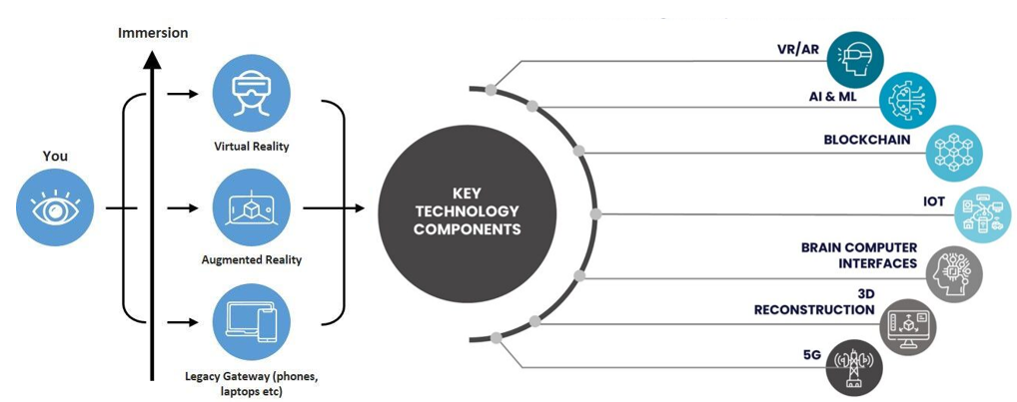
Figure 1. Depiction of Real and Virtual World Integration in the Metaverse. Source: Authors

2.3 Impact of User Behaviours on Brand Engagement in Virtual Environments
What users actually do buying NFTs, interacting socially, attending virtual events, creating content sits at the centre of brand engagement in immersive ecosystems. These behaviours shape perceptions, build emotional bonds and drive loyalty (Shamim et al., 2025; Bilgihan et al., 2024; Lee and Shen, 2024).
Branded NFTs open up digital self-expression, exclusivity and identity construction, and owning unique avatars, wearables and collectibles strengthens emotional attachment (Xie and Muralidharan, 2023; Simonetti et al., 2025). Scarcity and perceived investment value lift brand attitudes further, and social-comparison dynamics amplify the effect (Wang et al., 2024; Chang et al., 2024; Xie et al., 2024).
Social interaction reinforces engagement. Brand communities build trust, knowledge-sharing and purchase intention, and avatar-based interactivity deepens belonging and loyalty (Agnihotri et al., 2024; Kumar and Shankar, 2024; Payal et al., 2024).
Virtual events and gamified rewards build trust, satisfaction and loyalty, especially among Gen Z (Habachi et al., 2024), and participatory content creation deepens ownership and advocacy (Bilgihan et al., 2024; Xu et al., 2024).

2.4 Impact of user engagement and experience on brand success in virtual environments
User engagement and experience are major drivers of brand success. Wiertz and De Ruyter (2007) showed that contributions to firm-hosted online communities lift brand success, with knowledge-sharing doing much of the engagement work.
Brodie et al. (2011) cast engagement as active participation in brand experiences, and purchase intentions in virtual communities often serve social and self-identity needs, which frames engagement as a route to loyalty.

- Theoretical Foundation
3.1 Flow theory
The engagement in the metaverse can be read in a strong framework provided by Flow Theory (Csikszentmihalyi, 1990). Flow is a state of deep immersion and focused attention, characterized by high intrinsic motivation and enjoyment, and it's particularly important where engagement determines brand success. Recent studies extend it to virtual and augmented reality: Perceived enjoyment enhances flow and subsequently satisfaction and continued use in game-based metaverses (Hyeon and Lee, 2025).
Recent studies continue to link flow with virtual brand experiences. In the context of live streaming, authenticity, interactivity and entertainment enhance flow, with interactivity being the most influential ( Wu et al., 2024). The use of the metaverse in emerging markets is influenced by technological factors (Liang et al., 2024). In VR, flow increases subjective time (Rutrecht et al., 2021), and influences participative and sharing behaviours (Lo and Lai, 2023). To investigate the goals, immediate feedback, and challenge–skill balance, we constructed a survey that included flow elements and had participants report on their flow experience when interacting with the metaverse.

  - Self-Determination Theory (SDT)
Self-Determination Theory (SDT) suggests that when these three innate needs are satisfied, motivation and wellbeing are maximized: autonomy (volitional choice), competence (feeling effective) and relatedness (feeling connected) (Deci and Ryan, 2000). In digital environments, SDT describes how the intrinsic motivation to explore, master and connect drives engagement further.
The two theories go hand in hand. Flow is the moment-to-moment immersion that occurs when challenge–skill balance aligns, goals and feedback are clear, and autonomy facilitates exploration, competence fosters mastery, and relatedness sustains social interaction through avatars (Csikszentmihalyi, 1990); SDT offers an explanation of why people enter and remain in the state of flow. Together, they make up the immersion and need satisfaction that fall under engagement, satisfaction and loyalty.
3.3 Constructs and Hypotheses
Four constructs are in play. User engagement (UE) is the cognitive, emotional and behavioural involvement a user has with a brand during metaverse interactions. User experience (UX) is the perceived quality of that interaction immersion, usability, enjoyment and presence. Brand satisfaction (BSAT) is the user's overall evaluation of the brand from metaverse encounters. Brand success (BSUC) covers brand-relevant outcomes: continuance intention, purchase intention, advocacy and word of mouth. We treat the SDT needs and Flow dimensions as underlying psychological mechanisms, not as separately measured constructs.
Read together, Flow Theory and SDT imply that immersive, need-satisfying interactions raise engagement and experience, which then shape satisfaction and brand outcomes. We therefore expect higher user engagement to be positively associated with brand success (H1), and higher user experience quality to be positively associated with brand success (H2). Satisfaction sums up cumulative evaluations, so we expect brand satisfaction to mediate the engagement/experience-success relationships (H3). And in keeping with a configurational view, high brand success may arise from multiple sufficient configurations rather than any single necessary condition (P1).

4. Methodology
4.1 Fuzzy set Qualitative Comparative Analysis and its Application to the study
Jia et al (2022) provide a mixed method approach to the study of complex causal configurations in branding, namely Fuzzy-set Qualitative Comparative Analysis (fsQCA). It is located between exploratory and hypothesis-testing strategies, demonstrating that specific combinations of conditions (present or absent) together create an outcome, and it reveals equifinality (Schneider and Wagemann, 2012). It is a way to make a living in small-N research (Ragin, 2008).
It consists of six steps: case selection, identification of causal conditions, calibration of membership scores, construction of truth-table, logical minimisation, and consistency and coverage checks. This flow is described in Figure 2. Boolean minimisation is used to derive minimal sufficient combinations, revealing causal complexity that would not be found by single-variable effects.
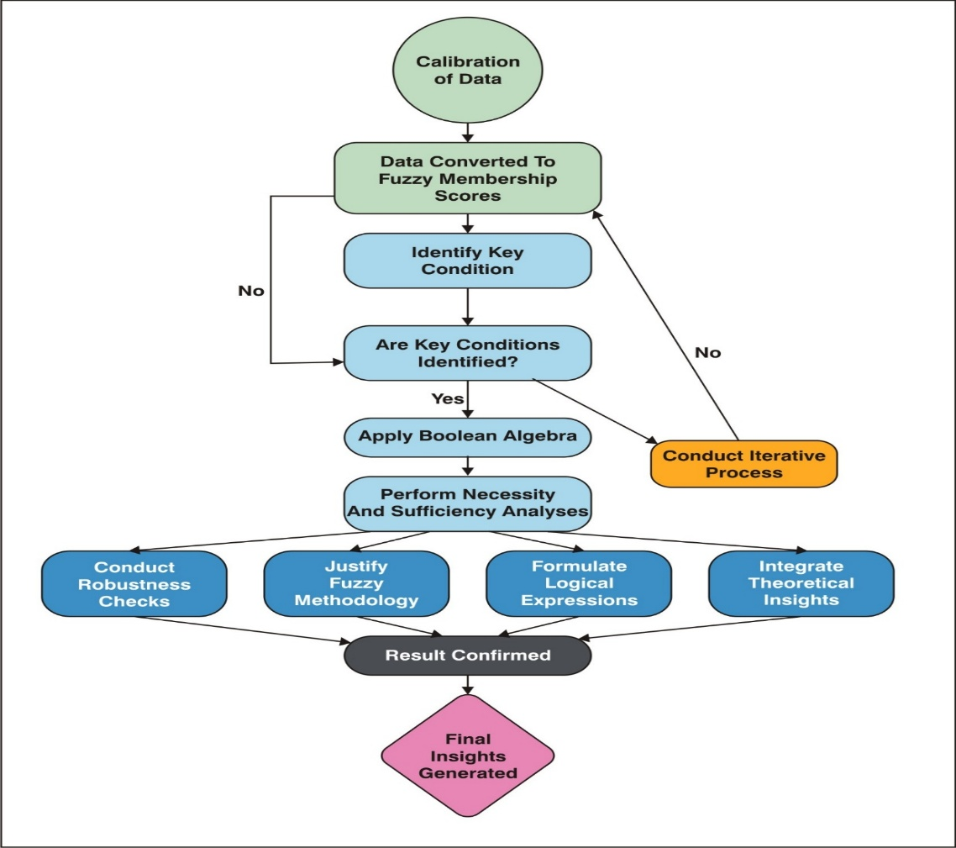
Figure 2. Flowchart illustrating the steps involved in the fuzzy set qualitative comparative analysis (FsQCA) methodology, from data calibration to the generation of final insights.

4.2 Identification and selection of variables
Variable selection followed a structured three-stage process. A literature review came first, pulling out consistently validated variables satisfaction, interaction frequency, perceived brand impact, emotional connection and personalisation as core indicators (Cadet and Chainay, 2020; Lu and Lau, 2025).
Second, interviews and focus groups gave a finer read on involvement, satisfaction drivers and brand-success perceptions, and the variables were refined accordingly. Third, surveys captured UE, UX, BSAT and BSUC (Table 2); immersiveness was measured via presence scales, sociability via social and co-presence measures, and ecological faithfulness via authenticity measures (Cadet and Chainay, 2020; Poeschl and Doering, 2015; Lu and Lau, 2025).
4.3 Measures
All constructs were measured on seven-point Likert scales anchored from 1 (strongly disagree) to 7 (strongly agree). The ten-item engagement and experience scales are adapted subsets. Appendix Table 1 lists the full measurement items alongside their adapted sources.

4.4 Platforms Studied and Metaverse Activities
We focused on three prominent platforms Roblox, Decentraland and The Sandbox chosen for their adoption, functionality and capacity to host brand interactions. Roblox, known for user-generated content and social gaming, hosts branded experiences such as Nike's Nikeland (Bilgihan et al., 2024). Decentraland, built on blockchain, lets users buy virtual land, trade NFTs and attend community events (Brouard, 2024).
The Sandbox supports voxel-based creation and monetisation, and brands such as Adidas use it (Brandes and Dölp, 2025). Across the platforms, four activity types were considered: trading digital assets, attending virtual events, avatar-based social interaction, and designing digital assets or experiences (Lee and Shen, 2024; Hennig-Thurau et al., 2023).

4.5 Data Collection
Data were collected using stratified random sampling. From a frame of adults (18+) active on at least one platform with prior brand-related metaverse experience, 600 eligible users were invited at random, stratified by primary activity (gaming, NFT trading, social interaction, content creation and virtual events). Of these, 312 provided complete, consenting responses a 52% response rate with balanced representation, measured on validated UE, UX, BSAT and BSUC scales.
India is a theoretically and empirically justified context. It's one of the world's fastest-growing metaverse markets (USD 2 billion in 2023, projected to grow at a robust CAGR through 2030), with a large, digitally native youth population (median age 28), rapid 5G expansion and high mobile-first penetration (Verma, 2024; Statista, 2025; Dwivedi et al., 2023). Indian consumers take readily to avatar-based self-expression and NFT ownership, which makes the setting especially relevant, and studying this underexplored, non-Western market widens the theoretical reach and generalisability of the findings (Payal et al., 2024).

5. Data Analysis and Results
5.1. Sample Profile
Descriptive analysis (IBM SPSS 25.0) profiled the 312 respondents (Table 1): 46% men (143) and 54% women (169), spread across age bands from 18 to 45, with the largest group aged 23-28 (24.04%).
On engagement, 60.58% used the metaverse frequently (several times a week); 45.19% took part in NFT trading, 52.56% in social interaction or content creation, and 41.35% in virtual events figures that point to how central these activities are to brand engagement, also reliability as present in table 2.

Table 1: Demographic and Metaverse Engagement Details of Respondents (N = 312)
Participants' Information | No. of Participants | % | Participants' Information | No. of Participants | %
Gender |  |  | Metaverse Engagement Frequency
Male | 143 | 46.00 | Daily | 52 | 16.67
Female | 169 | 54.00 | Several times a week | 98 | 31.41
 |  |  | Weekly | 73 | 23.38
Age (Years) |  |  | Monthly | 54 | 17.31
18–22 | 64 | 20.51 | Rarely | 35 | 11.21
23–28 | 75 | 24.04
29–34 | 60 | 19.23 | NFT Interaction
35–41 | 57 | 18.27 | Yes | 141 | 45.19
42–45 | 56 | 17.95 | No | 171 | 54.81
Marital Status |  |  | Virtual Event Participation
Single | 107 | 34.29 | Yes | 129 | 41.35
Married with children | 84 | 26.93 | No | 183 | 58.65
Married without children | 121 | 38.78 | Social Interaction/Content Creation
 |  |  | Yes | 164 | 52.56
Occupation |  |  | No | 148 | 47.44
Students | 88 | 28.21 | Monthly Family Income
Job | 102 | 32.69 | INR 30,000 or less | 57 | 18.40
Business | 122 | 39.10 | INR 30,001–50,000 | 80 | 25.64
 |  |  | INR 50,001–80,000 | 100 | 32.05
 |  |  | INR 80,001 and above | 75 | 23.91
Source: Authors

Table 2. Reliability Statistics
Factor Loadings
Factor | Indicator | Estimate | Cronbach’s Alpha | AVE | SE | Z | p
Brand Satisfaction | BSAT_1 | 0.705 | 0.841 | 0.514 | 0.0323 | 21.8 | <.001
 | BSAT_2 | 0.741 |  |  | 0.0337 | 22.0 | <.001
 | BSAT_3 | 0.721 |  |  | 0.0328 | 21.9 | <.001
 | BSAT_4 | 0.719 |  |  | 0.0335 | 21.5 | <.001
 | BSAT_5 | 0.699 |  |  | 0.0328 | 21.3 | <.001
User Engagement | UE_1 | 0.684 | 0.903 | 0.481 | 0.0322 | 21.3 | <.001
 | UE_2 | 0.696 |  |  | 0.0325 | 21.4 | <.001
 | UE_3 | 0.706 |  |  | 0.0325 | 21.7 | <.001
 | UE_4 | 0.684 |  |  | 0.0334 | 20.5 | <.001
 | UE_5 | 0.698 |  |  | 0.0327 | 21.3 | <.001
 | UE_6 | 0.705 |  |  | 0.0325 | 21.7 | <.001
 | UE_7 | 0.677 |  |  | 0.0323 | 20.9 | <.001
 | UE_8 | 0.707 |  |  | 0.0326 | 21.7 | <.001
 | UE_9 | 0.670 |  |  | 0.0311 | 21.5 | <.001
 | UE_10 | 0.706 |  |  | 0.0325 | 21.7 | <.001
User Experience | UX_1 | 0.690 | 0.902 | 0.481 | 0.0327 | 21.1 | <.001
 | UX_2 | 0.681 |  |  | 0.0319 | 21.3 | <.001
 | UX_3 | 0.714 |  |  | 0.0325 | 22.0 | <.001
 | UX_4 | 0.694 |  |  | 0.0326 | 21.3 | <.001
 | UX_5 | 0.678 |  |  | 0.0317 | 21.4 | <.001
 | UX_6 | 0.706 |  |  | 0.0328 | 21.5 | <.001
 | UX_7 | 0.687 |  |  | 0.0317 | 21.7 | <.001
 | UX_8 | 0.677 |  |  | 0.0320 | 21.1 | <.001
 | UX_9 | 0.703 |  |  | 0.0319 | 22.0 | <.001
 | UX_10 | 0.702 |  |  | 0.0321 | 21.9 | <.001
Brand Success | BSUC_1 | 0.661 | 0.765 | 0.448 | 0.0308 | 21.5 | <.001
 | BSUC_2 | 0.662 |  | 0.448 | 0.0314 | 21.1 | <.001
 | BSUC_3 | 0.673 |  | 0.448 | 0.0313 | 21.5 | <.001
 | BSUC_4 | 0.682 |  | 0.448 | 0.0317 | 21.5 | <.001

UE: User Engagement, UX: User Experience, BSAT: Brand Satisfaction, BSUC: Brand Success
Source: Authors

Table 2a. Heterotrait–Monotrait (HTMT) Ratio Matrix
Construct | BSAT | BSUC | UX | UE
Brand Satisfaction (BSAT)
Brand Success (BSUC) | 0.743
User Experience (UX) | 0.768 | 0.712
User Engagement (UE) | 0.756 | 0.729 | 0.814

Note: All HTMT values below 0.85 confirm discriminant validity. BSAT = Brand Satisfaction; BSUC = Brand Success; UX = User Experience; UE = User Engagement. Values derived from SmartPLS 4.1 bootstrapping procedure (5,000 subsamples). Source: Authors.
Figure 3 presents the Pearson correlation matrix (Jamovi), showing inter-item relationships across the BSAT, UE, UX and BSUC items on a colour gradient from strong positive to strong negative correlations, and so discriminant validity rests mainly on HTMT (Table 2a), with all ratios below 0.85.
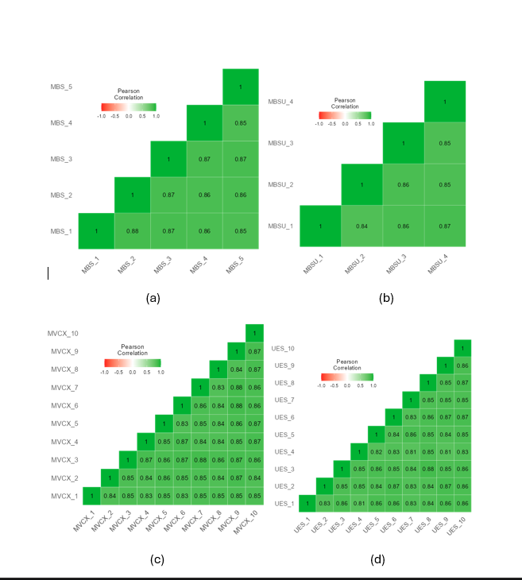
Figure 3. Correlation Heatmap Obtained using Jamovi Software.
Pearson correlation heatmaps for measurement items: (a) Brand Satisfaction (BSAT_1 to BSAT_5), (b) Brand Success (BSUC_1 to BSUC_4), (c) User Experience (UX_1 to UX_10), and (d) User Engagement (UE_1 to UE_10), illustrating positive inter-item correlations within each construct.
Source: Authors.

5.3. Data Analysis using FsQCA
5.3.1. Data Driven Results from FsQCA
To analyse UE, UX, BSAT and BSUC, raw responses were calibrated (Ragin, 2008) into fuzzy-set membership scores, each expressing how far a case belongs to a condition and to the outcome.
Calibration used three anchors: the 95th percentile for full membership (0.95), the 50th as the crossover point (0.50), and the 5th for full non-membership (0.05), which keeps scores between 0 and 1 (Ragin, 2008; Douglas et al., 2020). This shared scale lets us compare the calibrated UE, UX, BSAT and BSUC values (Table 3).

Table 3. Intermediate Solution
Model: BSUC = f (BSAT, UX, UE) | Raw coverage | Unique coverage | consistency
BSAT x UX | 0.208 | 0.036 | 0.650
BSAT x UE | 0.241 | 0.069 | 0.669
UX x UE | 0.219 | 0.046 | 0.600
User Experience (UX), User Engagement (UE), Brand Satisfaction (BSAT), and Brand Success (BSUC)
Note: solution coverage: 0.323827; solution consistency: 0.756327 Source: Authors

Table 3 gives the intermediate solution, modelling BSUC = f(BSAT, UX, UE). Raw coverage sits at roughly 20.84% for BSAT × UX, 24.15% for BSAT × UE and 21.90% for UX × UE; unique coverage is 3.59%, 6.90% and 4.65% respectively.
Consistency points to sufficiency (Table 4): 0.650 (BSAT × UX), 0.669 (BSAT × UE) and 0.600 (UX × UE). For the overall intermediate solution, coverage is 0.324 about 32% of the outcome and consistency is 0.756.
Figure 4 sets out the framework for brand success, mapping the proposed relationships among UX, UE, BSAT and BSUC in the metaverse.
In the model, UX, UE and BSAT are the antecedent conditions for BSUC. The subset–superset analysis asks which combinations are jointly sufficient for high brand success rather than estimating one directional path, which anchors the conceptual model in the empirical configurations.
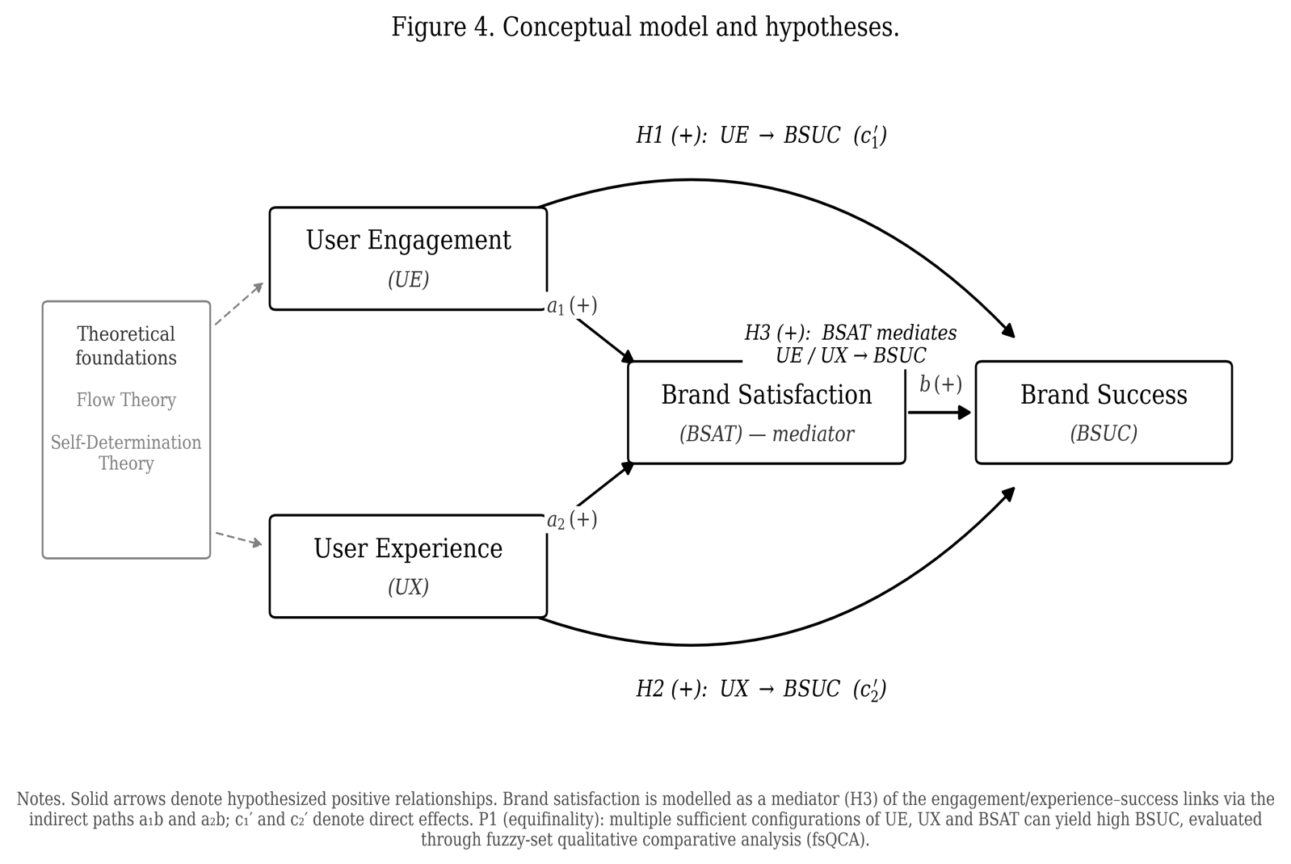
Figure 4. Conceptual model and hypotheses (H1–H3): user engagement (UE) and user experience (UX) as antecedents, brand satisfaction (BSAT) as mediator, and brand success (BSUC) as the outcome, framed by Flow Theory and Self-Determination Theory.
Source: Authors

Table 4. Subset/Superset Analysis
BSUC = f (BSAT, UX, UE) | Consistency | Raw Coverage | Combined
BSAT * UX * UE | 0.713 | 0.172 | 0.305
BSAT * UX | 0.650 | 0.208 | 0.246
UX * UE | 0.600 | 0.219 | 0.181
BSAT * UE | 0.669 | 0.241 | 0.295
UX | 0.362 | 0.349 | 0.084
BSAT | 0.410 | 0.368 | 0.086
UE | 0.373 | 0.349 | 0.084
User Experience (UX), User Engagement (UE), Brand Satisfaction (BSAT), and Brand Success (BSUC)
Source: Authors

Table 5. Configuration Analysis for High Brand Success (BSUC) in the Metaverse
Configuration | 1 | 2 | 3
Causal Conditions
BSAT (Brand Satisfaction) | ● | ●
UX (User Experience) | ● |  | ●
UE (User Engagement) |  | ● | ●
Performance Metrics
Raw Coverage | 0.208 | 0.241 | 0.218
Unique Coverage | 0.036 | 0.069 | 0.047
Consistency | 0.650 | 0.669 | 0.6
Overall Solution | Coverage: 0.324 | Consistency: 0.756
Note: Key: ● = Core condition present (essential for outcome), Blank = "Don't care" (condition irrelevant for configuration), User Experience (UX), User Engagement (UE), Brand Satisfaction (BSAT), and Brand Success (BSUC) (Outcome variable)

Table 6. Configuration Analysis for High Brand Success (BSUC) – Expanded Subset–Superset Configurations in the Metaverse
Configuration Type | Triple Path (BSAT+UX+UE) | Satisfaction + Experience | Experience + Engagement | Satisfaction + Engagement
Configuration | A | B | C | D
BSAT (Brand Satisfaction) | ● | ● | ● | ●
UX (User Experience) | ● | ● |  | ●
UE (User Engagement) | ● | ● | ●
Raw Coverage | 0.172 | 0.208 | 0.219 | 0.241
Consistency | 0.713 | 0.65 | 0.6 | 0.669
Combined Coverage | 0.305 | 0.246 | 0.181 | 0.295
Note: Key: ● = Core condition present (essential for outcome), Blank = "Don't care" (condition irrelevant for configuration), User Experience (UX), User Engagement (UE), Brand Satisfaction (BSAT), and Brand Success (BSUC) (Outcome variable)

Tables 5 and 6 make the equifinality plain: several distinct paths reach the same outcome (Ragin, 2008). No single factor BSAT, UX or UE is necessary on its own; it's their interaction that drives brand outcomes in immersive digital environments.
Table 5 gives three core configurations for high BSUC. Configuration 1 (BSAT + UX) shows brand success even without strong engagement, since satisfied users with positive immersive experiences form lasting relationships (Bilgihan et al., 2024). Configuration 2 (BSAT + UE) pairs satisfaction with active participation, lifting loyalty and advocacy (Hollebeek et al., 2022). Configuration 3 (UX + UE) shows that even without reported satisfaction, immersive interactive environments yield favourable outcomes, which supports Flow Theory (Csikszentmihalyi, 1990).
Table 6 widens the picture through subset–superset analysis. Configuration A, the "Triple Path" (BSAT, UX, UE), records the highest combined coverage (0.305): satisfied, engaged and immersed users push brand success to its peak, in step with service-dominant logic and value co-creation.
The other configurations show room to manoeuvre. B (BSAT + UX) and D (BSAT + UE) reaffirm satisfaction combined with either experience or engagement, so brands can tailor their strategies. C (UX + UE), despite lower consistency, backs immersive participatory experiences even without explicit satisfaction (Shin, 2019).
5.3.2. Necessity Analysis
The necessity analysis is a test that determines whether a condition is necessary or not, and a condition is necessary if its consistency is higher than 0.90 (Schneider and Wagemann, 2012). None managed to pass that hurdle: UE, UX and BSAT had single-condition consistency of 0.373, 0.362 and 0.410 respectively. Combinations are the key to high brand success, not any one essential condition, and that's why we go to the sufficiency analysis.

5.3.3. Sufficiency Analysis
The sufficiency analysis identifies which configurations are jointly sufficient. UE, UX and BSAT were entered into the truth table with consistency and frequency thresholds applied (Ragin, 2008; Schneider and Wagemann, 2012). As Tables 5 and 6 report, brand satisfaction turns up in every high-consistency sufficient path, while engagement and experience contribute in combination rather than in isolation.
The three sufficient configurations sit well with prior evidence. BSAT × UX records high coverage and consistency: satisfied users who enjoy well-designed experiences stay loyal and recommend the brand. BSAT × UE looks similarly favourable, consistent with engagement–loyalty links (Jeong and Kim, 2019) and social-media effects on customer equity (Ebrahim, 2020). UX × UE contributes at slightly lower consistency, which reflects how experience and engagement work together at the heart of brand success in immersive settings.
User engagement here is multifaceted asset trading, event attendance, social interaction, content creation and it reflects psychological, social and experiential motivations, which the UE and UX constructs capture rather than any platform-specific variables.

5.4 Structural Model and Hypothesis Evaluation
fsQCA tests sufficiency, not net linear effects, so the hypotheses are evaluated configurationally (Table 7). In line with the necessity result, user engagement (single-condition consistency 0.373) and user experience (0.362) aren't sufficient alone; they support brand success only in combination, which backs H1 and H2 within sufficient configurations. Brand satisfaction shows up in every high-consistency path the triadic BSAT × UX × UE (0.713), BSAT × UE (0.669) and BSAT × UX (0.650) and posts the highest single-condition consistency (0.410), a sign of the central, mediation-consistent role that supports H3. A formal bootstrap mediation test would make a useful complement.
Table 7. Hypothesis Evaluation Based on fsQCA Sufficiency Analysis. Source: Authors, from configurational results reported in Tables 5 and 6.

Hypothesis | Configurational evidence (fsQCA) | Key values | Outcome
H1: User engagement (UE) → brand success (BSUC) | UE not sufficient alone; sufficient in BSAT×UE and UX×UE | UE alone consistency 0.373; BSAT×UE 0.669; UX×UE 0.600 | Supported within configurations
H2: User experience (UX) → brand success (BSUC) | UX not sufficient alone; sufficient in BSAT×UX and triadic path | UX alone consistency 0.362; BSAT×UX 0.650; triadic 0.713 | Supported within configurations
H3: Brand satisfaction (BSAT) mediates UE/UX → BSUC | BSAT present in all high-consistency sufficient paths; highest single-condition consistency | Triadic 0.713; BSAT×UE 0.669; BSAT×UX 0.650; BSAT alone 0.410 | Supported (configurationally); SEM mediation test recommended
Overall solution | Three sufficient configurations (equifinality) | Solution coverage 0.324; solution consistency 0.756

6. Discussion
The fsQCA findings clarify how combinations of UE, UX and BSAT contribute to brand success in the metaverse, and they mark out the main pathways to favourable outcomes.
The result of the BSAT × UX configuration was a significant configuration (consistency 0.650, raw coverage 20.84%): satisfied users who feel that they have a high-quality immersive experience will become loyal and advocates, which is consistent with previous research on the relationship between satisfaction, experience and emotional connection (Thaichon et al., 2022; Bilgihan et al., 2024). Brands should prioritise seamless immersive experiences while facing up to ethical concerns such as data-privacy risks and excessive use.
The association of BSAT × UE was strong (consistency 0.669, coverage 24.15%): active participation with high satisfaction is associated with good outcomes, which is consistent with the engagement–equity links (Jeong and Kim, 2019). Brands need to promote gamified and co-creation activities that further engage the customer without compromising satisfaction.
Although not as consistent as UX (0.600, coverage 21.90%), UX × UE indicates that engagement is best achieved when the experience is of high quality even if it does not lead to high satisfaction, which aligns with the challenge–skill balance (Csikszentmihalyi, 1990; Shin, 2019).
Individual factors scored lower consistency than their combinations, which argues for holistic strategies: BSAT × UX × UE reached the highest consistency (0.713), reinforcing Flow Theory's premise that optimal engagement grows out of a balance between challenge and skill in immersive environments (Csikszentmihalyi, 1990).

7. Implications
7.1 Theoretical Contributions
This research brings SDT and Flow Theory together inside immersive, digitally mediated environments defined by persistent communities, avatar-based identity and interactive interfaces, and it clarifies how psychological needs and experiential states jointly shape engagement, satisfaction and brand outcomes. Earlier applications sat in traditional or gamified settings; metaverse interactions instead blend intrinsic motivation and experiential absorption in a distinctive way, which carries both theories into co-created domains.
Within SDT, autonomy, competence and relatedness take on distinctive forms here: autonomy through customisable avatars and digital-asset ownership, competence through skill-based challenges and achievement, and relatedness through persistent social interaction in branded communities (Bilgihan et al., 2024). We advance these as conceptual mechanisms behind engagement and experience, not as separately measured effects.
We extend Flow Theory by proposing that experiential immersion depends on matching task challenge to user skill, tuned by digital affordances and interaction design (Zhong and Hamouda, 2024); gamified missions and event-based interactions are the flow facilitators. In keeping with our findings, deep immersive engagement can yield favourable outcomes even when satisfaction isn't the dominant condition.
Taken together, the study moves marketing and psychological theory forward by suggesting that the confluence of need satisfaction and experiential immersion is associated with engagement, satisfaction and brand performance. It extends SDT and Flow Theory into co-created digital domains, and it keeps tested associations separate from theoretical interpretation.

7.2. Managerial Implications
User experience is a major determinant of both satisfaction and favourable outcomes, and it shows up again and again in the configurations associated with success. Crafting engaging, interactive and personalised metaverse experiences is therefore central to sustaining engagement and long-term brand success.
Brands should build immersive experiences tied to users' virtual identities. Personalisation customisable avatars, interactive environments lets users express who they are and strengthens presence, which reinforces the emotional bond. When a brand's virtual presence matches users' self-concept, connection grows; tailored experiences deepen engagement, loyalty and advocacy (Thaichon et al., 2022; Xie and Muralidharan, 2023).
Features that come up often NFT interoperability, smart contracts, rarity dynamics may strengthen exclusivity and trust, but we didn't measure them here, so we present them as future avenues rather than findings. The evidence speaks to combinations of engagement, experience and satisfaction, not to blockchain-specific mechanisms.
The results show synergy between satisfaction and engagement: pairing participation with high satisfaction strengthens equity and loyalty (Jeong and Kim, 2019). Managers should build gamified, co-creation and reward opportunities that deepen involvement, because a user's sense of ownership reinforces attachment and long-term loyalty.
User experience sits at the centre of both satisfaction and success. To stay competitive, brands have to make immersive experiences emotionally resonant, consistent and matched to users' values and identities (Jung and Pawlowski, 2014); functional or visually appealing assets no longer cut it. Brands that deliver high-quality interactive experiences build lasting engagement, loyalty and competitive advantage.

8. Limitations and Future Scope
The study carries several limitations. The sample of 312 active, experienced users guarantees expertise, but it may tilt results toward highly engaged participants and underrepresents casual or novice users, which limits generalisability; a more diverse, representative sampling frame is needed.
Inclusion and exclusion decisions may have missed relevant factors, and the lack of a control group limits causal attribution. fsQCA handles complex causal analysis well, yet its small-N, qualitative orientation trims robustness next to larger quantitative models and limits methodological triangulation.
The cross-sectional design can't track how engagement and experience change over time; longitudinal studies are needed to test whether engagement holds up. Ethical questions privacy, addiction, cyberbullying, exploitation stay underexplored, and future work should build safeguards for user well-being.
Several large technology firms have pulled back their metaverse investments, so we frame our contribution conservatively. The findings speak most directly to brands active on large, metaverse-like platforms game-based worlds such as Roblox and Fortnite, and social virtual reality and to the design of future immersive environments. We treat avatar-mediated branding as an evolving phenomenon whose psychological mechanisms engagement, experience and satisfaction are likely to persist across successive technological forms.

Funding: This research received no specific grant from any funding agency in the public, commercial, or not-for-profit sectors.
Conflicts of Interest: The authors declare no conflicts of interest.

Appendix Table 1. Measurement Items

The following items were administered to measure each construct, adapted to the metaverse branding context from the cited sources. All items used seven-point Likert scales anchored from 1 (strongly disagree) to 7 (strongly agree). Item codes correspond to the standardized loadings reported in Table 2.
Construct (source) | Code | Item wording (adapted)
User Engagement (UE) adapted from O’Brien and Toms (2010) | UE_1 | I lost track of myself in the brand’s metaverse experience.
 | UE_2 | The time I spent in the brand’s metaverse space slipped away.
 | UE_3 | I was absorbed in what I was doing in the brand’s metaverse space.
 | UE_4 | I felt involved in the brand’s metaverse activities.
 | UE_5 | The brand’s metaverse experience was fun.
 | UE_6 | I was motivated to keep interacting with the brand in the metaverse.
 | UE_7 | I would recommend the brand’s metaverse experience to others.
 | UE_8 | Interacting with the brand in the metaverse was worthwhile.
 | UE_9 | I felt interested in the brand’s metaverse activities.
 | UE_10 | I would return to the brand’s metaverse space.
User Experience (UX) adapted from O’Brien and Toms (2010); Basu et al. (2024); Cadet and Chainay (2020) | UX_1 | The brand’s metaverse environment was easy to use.
 | UX_2 | It was easy to navigate the brand’s metaverse space.
 | UX_3 | The brand’s metaverse environment was visually appealing.
 | UX_4 | The brand’s metaverse space was aesthetically pleasing.
 | UX_5 | I felt present in the brand’s metaverse environment.
 | UX_6 | The brand’s metaverse environment felt realistic.
 | UX_7 | The sensory quality (visuals and sound) of the experience was high.
 | UX_8 | The experience responded smoothly to my actions.
 | UX_9 | I felt immersed in the brand’s metaverse environment.
 | UX_10 | Overall, the brand’s metaverse experience was of high quality.
Brand Satisfaction (BSAT) adapted from Fornell et al. (1996) | BSAT_1 | Overall, I am satisfied with the brand’s presence in the metaverse.
 | BSAT_2 | The brand’s metaverse experience met my expectations.
 | BSAT_3 | The brand’s metaverse experience came close to my ideal.
 | BSAT_4 | I am pleased with my experience of the brand in the metaverse.
 | BSAT_5 | The brand’s metaverse offering was satisfactory.
Brand Success (BSUC) developed for this study, drawing on Mathwick et al. (2008) | BSUC_1 | This brand stands out from competitors in the metaverse.
 | BSUC_2 | I would choose this brand over others because of its metaverse presence.
 | BSUC_3 | I would speak positively about this brand to others.
 | BSUC_4 | The brand has a competitive advantage in the metaverse.
References
Agnihotri, D., Chaturvedi, P., Swarup, K., Mathur, A., Tripathi, V., and Singh, N. (2024). Does social presence drive customer brand engagement and purchase intention in the fashion retail metaverse? The moderating role of self-efficacy. Internet Research. https://doi.org/10.1108/intr-01-2024-0030
Anderson, K. C., Hansen, H., and Laverie, D. (2024). Technology has Agency too! Disentangling Technology's Causal and Structural Agency in a Service System. Journal of Macromarketing, 44(2), 510-533.
Arya, V., Paul, J., and Sethi, D. (2022). Like it or not! Brand communication on social networking sites triggers consumer‐based brand equity. International Journal of Consumer Studies, 46(4), 1381-1398.
Arya, V., Sambyal, R., Sharma, A., and Dwivedi, Y. K. (2024a). Brands are calling your AVATAR in Metaverse–A study to explore XR‐based gamification marketing activities and consumer‐based brand equity in virtual world. Journal of Consumer Behaviour, 23(2), 556-585.
Arya, V., Sethi, D., and Hollebeek, L. D. (2024b). Using augmented reality to strengthen consumer/brand relationships: the case of luxury brands. Journal of Consumer Behaviour. https://doi.org/10.1002/cb.2419
Basu, B., Kar, A. K., and Sen, S. (2024). Antecedents of user experience in the immersive Metaverse ecosystem: Insights from mining user reviews. Communications of the Association for Information Systems, 55(1), 13.
Bilgihan, A., Leong, A. M. W., Okumus, F., and Bai, J. (2024). Proposing a metaverse engagement model for brand development. Journal of Retailing and Consumer Services, 78, 103781.
Blazquez, M. (2024). The Metaverse and its potential for digital sustainability in fashion. Journal of Global Fashion Marketing, 15(3), 303-319.
Brandes, L., and Dölp, K. (2025). Non-Fungible Tokens (NFTs) as Digital Brand Extensions: Evidence on Financial Performance and Parent-Brand Spillovers. International Journal of Research in Marketing. https://doi.org/10.1016/j.ijresmar.2025.01.001
Brodie, R. J., Hollebeek, L. D., Jurić, B., and Ilić, A. (2011). Customer Engagement: Conceptual Domain, Fundamental Propositions, and Implications for Research. Journal of Service Research, 14(3), 252-271.
Brouard, M. (2024). Setting sail in a tokenized world: an exploration of the Bored Ape Yacht club and the co-created consumer experience. International Journal of Research in Marketing. https://doi.org/10.1016/j.ijresmar.2024.03.002
Buhalis, D., Leung, D., and Lin, M. (2023). Metaverse as a disruptive technology revolutionising tourism management and marketing. Tourism management, 97, 104724.
Cadet, L. B., and Chainay, H. (2020). Memory of virtual experiences: Role of immersion, emotion and sense of presence. International Journal of Human-Computer Studies, 144, 102506.
Chandra, S., Verma, S., Lim, W. M., Kumar, S., and Donthu, N. (2022). Personalization In Personalized Marketing: Trends and Ways Forward. Psychology and Marketing, 39(8), 1529-1562.
Chang, C. W., Lai, C. J., and Yen, C. C. (2024). Examining drivers of NFT purchase intention: The impact of perceived scarcity and risk. Acta Psychologica, 248, 104424.
Csikszentmihalyi, Mihaly. (1990). Flow: The Psychology of Optimal Experience. Journal of Leisure Research, 24(1), pp. 93–94
Daassi, M., and Debbabi, S. (2021). Intention to reuse AR-based apps: The combined role of the sense of immersion, product presence and perceived realism. Information and Management, 58(4), 103453.
Deci, E. L., and Ryan, R. M. (2000). The “What” and “Why” of Goal Pursuits: Human Needs and the Self-Determination of Behavior. Psychological Inquiry, 11(4), 227–268.
Douglas, E. J., Shepherd, D. A., and Prentice, C. (2020). Using fuzzy-set qualitative comparative analysis for a finer-grained understanding of entrepreneurship. Journal of Business Venturing, 35(1), 105970.
Duong, C. D., Ngo, T. V. N., Khuc, T. A., Tran, N. M., and Nguyen, T. P. T. (2025). Unraveling the dark side of ChatGPT: A moderated mediation model of technology anxiety and technostress. Information Technology and People, 38(4), 2015-2040.
Dwivedi, Y. K., Hughes, L., Wang, Y., Alalwan, A. A., Ahn, S. J., Balakrishnan, J., ... and Wirtz, J. (2023). Metaverse marketing: How the metaverse will shape the future of consumer research and practice. Psychology and Marketing, 40(4), 750-776.
Ebrahim, R. S. (2020). The role of trust in understanding the impact of social media marketing on brand equity and brand loyalty. Journal of Relationship Marketing, 19(4), 287-308.
Eggenschwiler, M., Linzmajer, M., Roggeveen, A. L., and Rudolph, T. (2024). Retailing in the metaverse: A framework of managerial considerations for success. Journal of Retailing and Consumer Services, 79, 103791.
Fan, X., Jiang, X., and Deng, N. (2022). Immersive technology: A meta-analysis of augmented/virtual reality applications and their impact on tourism experience. Tourism Management, 91, 104534.
Fornell, C., and Larcker, D. F. (1981). Evaluating Structural Equation Models with Unobservable Variables and Measurement Error. Journal of Marketing Research, 18(1), 39-50.
Fornell, Claes, Michael D. Johnson, Eugene W. Anderson, Jaesung Cha, and Barbara Everitt Bryant. "The American customer satisfaction index: nature, purpose, and findings." Journal of Marketing 60, no. 4 (1996): 7-18.
Habachi, S., Matute, J., and Palau-Saumell, R. (2024). Gamify, engage, build loyalty: exploring the benefits of gameful experience for branded sports apps. Journal of Product and Brand Management, 33(1), 57-75.
Hair, J. F., Risher, J. J., Sarstedt, M., and Ringle, C. M. (2019). When to use and how to report the results of PLS-SEM. European business review, 31(1), 2-24.
Hennig-Thurau, T., Aliman, D. N., Herting, A. M., Cziehso, G. P., Linder, M., and Kübler, R. V. (2023). Social interactions in the metaverse: Framework, initial evidence, and research roadmap. Journal of the Academy of Marketing Science, 51(4), 889-913.
Henseler, J., Ringle, C. M., & Sarstedt, M. (2015). A new criterion for assessing discriminant validity in variance-based structural equation modeling. Journal of the academy of marketing science, 43(1), 115-135.
Hsieh, J. K., and Tsao, W. C. (2019). Engaging Consumers with Branded Social Media: The Impact of Social Identification, Personal Identification, And Interactivity. Journal of Business Research, 96, 382-391.
Huang, Z., and Benyoucef, M. (2013). From E-Commerce to Social Commerce: A Close Look at Design Features. Electronic Commerce Research and Applications, 12(4), 246-259.
Hwang, I., and Seo, R. (2025). Organizational support for digital transformation in the metaverse: a contingent pathway from user experience to digitalization resistance. RandD Management, 55(2), 420-437.
Hyeon Jo, Jae Kwang Lee; Key Drivers of User Engagement in Game-Based Metaverses: Enjoyment, Escapism, Reward, and Spontaneity. PRESENCE: Virtual and Augmented Reality 2025; 34 219–241.
İlkan, Ş. P., Öztüren, A., Avcı, T., and Irani, F. (2023). Mobile application features effects on the application's engagement and intention for continuing use in tourism. Asia Pacific Journal of Tourism Research, 28(4), 386-400.
Jeong, E., and Kim, S. (2019). Exploring a theoretical framework for understanding the relationship between customer engagement and brand loyalty in social media marketing. Journal of Business Research, 95, 365-374.
Jia, R., Steelman, Z., and Jia, H. (2022). What makes one intrinsically interested in IT? An exploratory study on influences of autistic tendency and gender in the U.S. and India. MIS Quarterly, 45(3), 1603–1634.
Koohang, A., Nord, J. H., Ooi, K. B., Tan, G. W. H., Al-Emran, M., Aw, E. C. X., ... and Wong, L. W. (2023). Shaping the metaverse into reality: a holistic multidisciplinary understanding of opportunities, challenges, and avenues for future investigation. Journal of Computer Information Systems, 63(3), 735-765.
Kopalle, P. K., Gangwar, M., and Uppal, A. (2024). Commentary on “AI is Changing the World: For Better or for Worse?”. Journal of Macromarketing, 44(4), 886-891.
Kozinets, R. V. (2023). Immersive netnography: a novel method for service experience research in virtual reality, augmented reality and metaverse contexts. Journal of Service Management, 34(1), 100-125.
Kumar, A., and Shankar, A. (2024). Investigating the role of metaverse influencers’ attributes for the next generation of services. Journal of Services Marketing, 38(7), 816-838.
Kyriakou, T., de la Campa Crespo, M.Á., Panayiotou, A., Chrysanthou, Y., Charalambous, P. and Aristidou, A. (2024), Virtual Instrument Performances (VIP): A Comprehensive Review. Computer Graphics Forum, 43: e15065. https://doi.org/10.1111/cgf.15065
Lavoie, R., Main, K., King, C., and King, D. (2021). Virtual experience, real consequences: the potential negative emotional consequences of virtual reality gameplay. Virtual Reality, 25(1), 69-81.
Lee, C. T., and Shen, Y. C. (2024). Exploring determinants of non-fungible token creators’ engagement behaviors on metaverse-based NFT platforms: A multi-analytical SEM-IPMA method. Journal of Business Research, 185, 114920.
Li, Y., and Shang, H. (2023). How does e-government use affect citizens’ trust in government? Empirical evidence from China. Information and Management, 60(7), 103844.
Liang, Y., Zhang, X., Wang, H., and Liu, M. (2024). Users' Willingness To Adopt Metaverse Drawing on Flow Theory: An Empirical Study Using PLS-SEM and FsQCA. Heliyon, 10(13).
Lo, SY., Lai, CY. Investigating How Immersive Virtual Reality And Active Navigation Mediate The Experience of Virtual Concerts. Sci Rep 13, 8507 (2023).
Lu, Y., and Lau, S. K. (2025). Examining the ecological validity of VR experiments in soundscape and landscape research. Computers in Human Behavior, 162, 108462.
Lycett, M., and Radwan, O. (2019). Developing a quality of experience (QoE) model for web applications. Information Systems Journal, 29(1), 175-199.
Marvi, R., Zha, D., and Foroudi, P. (2024). Elevating B2B branding in a global context: integrating existing literature and proposing a forward-thinking conceptual framework. Industrial Marketing Management, 120, 247-272.
Mathwick, C., Wiertz, C., and De Ruyter, K. (2008). Social capital production in a virtual P3 community. Journal of consumer research, 34(6), 832-849.
Nunnally J. C., Bernstein I. H. (1994). Psychometric theory (3rd ed.). New York, NY: McGraw-Hill.
O'Brien, H. L., and Toms, E. G. (2010). The development and evaluation of a survey to measure user engagement. Journal of the American Society for Information Science and Technology, 61(1), 50-69.
Osborne, A. (2024). Design of Social Affordances for Meetings in Social Virtual Reality. UC Santa Cruz. Accessed on December 2024, available at: https://escholarship.org/uc/item/8h51c6s0
Payal, R., Sharma, N., and Dwivedi, Y. K. (2024). Unlocking the impact of brand engagement in the metaverse on Real-World purchase intentions: Analyzing Pre-Adoption behavior in a futuristic technology platform. Electronic Commerce Research and Applications, 65, 101381.
Podsakoff, P. M., MacKenzie, S. B., Lee, J. Y., & Podsakoff, N. P. (2003). Common method biases in behavioral research: a critical review of the literature and recommended remedies. Journal of applied psychology, 88(5), 879.
Poeschl, S., and Doering, N. (2015). Measuring co-presence and social presence in virtual environments–psychometric construction of a german scale for a fear of public speaking scenario. Annual Review of Cybertherapy and Telemedicine 2015, 58-63.
Ragin, C. C. (2008). Redesigning social inquiry: Fuzzy sets and beyond. University of Chicago Press, Chicago, IL, United States.
Rather, R. A., Hollebeek, L. D., Vo‐Thanh, T., Ramkissoon, H., Leppiman, A., and Smith, D. (2022). Shaping Customer Brand Loyalty During the Pandemic: The Role of Brand Credibility, Value Congruence, Experience, Identification, And Engagement. Journal of Consumer Behaviour, 21(5), 1175-1189.
Rutrecht, H., Wittmann, M., Khoshnoud, S., and Igarzábal, F. A. (2021). Time Speeds Up During Flow States: A Study in Virtual Reality with the Video Game Thumper. Timing and Time Perception, 9(4), 353-376.
Ryan, R. M., and Deci, E. L. (2000). Self-determination theory and the facilitation of intrinsic motivation, social development, and well-being. American Psychologist, 55 (1), 68–78.
Ryan, R. M., and Deci, E. L. (2017). Self-determination theory: Basic psychological needs in motivation, development, and wellness. Guilford Publishing.
Ryan, R. M., and Deci, E. L. (2024). Self-determination theory. In Encyclopedia of quality of life and well-being research (pp. 6229–6235). Cham: Springer International Publishing.
Scheider, S., Lauf, F., Möller, F., and Otto, B. (2023). A reference system architecture with data sovereignty for human-centric data ecosystems. Business and Information Systems Engineering, 65(5), 577-595.
Schneider, C. Q., and Wagemann, C. (2012). Set-theoretic methods for the social sciences: A guide to qualitative comparative analysis. Cambridge University Press, Cambridge, United Kingdom.
Shamim, N., Gupta, S., and Shin, M. M. (2025). Evaluating user engagement via metaverse environment through immersive experience for travel and tourism websites. International Journal of Contemporary Hospitality Management, 37(4), 1132-1174.
Shin, D. (2019). How does immersion work in augmented reality games? A user-centric view of immersion and engagement. Information, Communication and Society, 22(9), 1212-1229.
Simonetti, A., Bigne, E., and Navas, L. F. R. (2025). Consumer brand choice in the metaverse: Exploring personal and social factors. Technological Forecasting and Social Change, 213, 124033.
Soltani Nejad, N., Rastegar, R., and Jahanshahi, M. (2024). Tourist engagement with mobile apps of E-leisure: a combined model of self-determination theory and technology acceptance model. Tourism Recreation Research, 49(4), 714-725.
Statista. (2025). Metaverse India: Market forecast. Statista Market Insights. Retrieved March 21, 2026, from https://www.statista.com/outlook/amo/metaverse/india
Su, L., Monga, A. S. B., and Jiang, Y. (2021). How life-role transitions shape consumer responses to brand extensions. Journal of Marketing Research, 58(3), 579-594.
Takano, M., and Taka, F. (2022). Fancy avatar identification and behaviors in the virtual world: Preceding avatar customization and succeeding communication. Computers in Human Behavior Reports, 6, 100176.
Thaichon, P., Phau, I., and Weaven, S. (2022). Moving from multi-channel to Omni-channel retailing: Special issue introduction. Journal of Retailing and Consumer Services, 65, 102311.
Thorndike, R. M. (1995). Book Review : Psychometric Theory (3rd ed.) by Jum Nunnally and Ira Bernstein New York: McGraw-Hill, 1994, xxiv + 752 pp. Applied Psychological Measurement, 19(3), 303-305.
Verma, S. (2024). India metaverse market outlook to 2030 (Report No. KROD1819). Ken Research Private Limited. Retrieved March 21, 2026, from https://www.kenresearch.com/industry-reports/india-metaverse-market
Vo, T. H., Wei‐Han Tan, G., Pham, N. T., Truong, T. H. D., and Ooi, K. B. (2025). Promoting customer engagement and brand loyalty on social media: The role of virtual influencers. International Journal of Consumer Studies, 49(2), e70028.
Wang, X., Sung, B., and Phau, I. (2024). How rarity and exclusivity influence types of perceived value for luxury. Journal of Brand Management, 31(6), 576-592.
Wiertz, C., and De Ruyter, K. (2007). Beyond The Call of Duty: Why Customers Contribute to Firm-Hosted Commercial Online Communities. Organization Studies, 28(3), 347-376.
Wu, Y.-Y., Batool, H., and Yang, Y.-J. (2024). Relationship between the Characteristics of e-Commerce Live Streaming and Purchase Intentions: Moderating Effect of Hedonistic Shopping Value. Emerging Science Journal, 8(3), 1097–1117.
Xie, Q., Muralidharan, S., and Edwards, S. M. (2024). Who will buy the idea of non-fungible token (NFT) marketing? Understanding consumers’ psychological tendencies and value perceptions of branded NFTs. International Journal of Advertising, 43(6), 987-1015.
Xie, Q., Muralidharan, S., Edwards, S. M., and La Ferle, C. (2023). Unlocking the power of non-fungible token (NFT) marketing: How NFT perceptions foster brand loyalty and purchase intention among millennials and Gen-Z. Journal of Interactive Advertising, 23(4), 356-373.
Xu, S., Bauman, M. J., Ponting, S. S. A., Slevitch, L., Webster, C., and Kirillova, K. (2024). Neolocalism of craft brewery experience: Scale development and validation study. International Journal of Hospitality Management, 120, 103787.
Zallio, M., and Clarkson, P. J. (2022). Designing the metaverse: A study on inclusion, diversity, equity, accessibility and safety for digital immersive environments. Telematics and Informatics, 75, 101909.
Zhang, B., Peng, G., Liu, C., Zhang, Z. J., and Jasimuddin, S. M. (2022). Adaptation behaviour in using one-stop smart governance apps: an exploratory study between digital immigrants and digital natives. Electronic Markets, 32(4), 1971-1991.
Zhang, L., Anjum, M. A., and Wang, Y. (2024). The impact of trust-building mechanisms on purchase intention towards metaverse shopping: the moderating role of age. International Journal of Human–Computer Interaction, 40(12), 3185-3203.
Zhong, Z., and Hamouda, M. (2024). The impact of immersive and flow experiences on consumer participation in hyper‐connected shopping platforms: A metaverse perspective. Journal of Consumer Behaviour, 23(6), 2826-2845.

