Satisfaction as the Conduit: How User Engagement and Experience Create Brand Value in the Metaverse

Abstract
Purpose: This study investigates the drivers of brand success in the metaverse by empirically testing a configurational model connecting user engagement (UE), user experience (UX), and brand satisfaction (BSAT), grounded in Flow Theory and Self-Determination Theory (SDT).
Design/methodology/approach: A mixed-methods research design is employed. Partial least squares structural equation modelling (PLS-SEM) validates the measurement model, while fuzzy-set qualitative comparative analysis (fsQCA) addresses causal complexity. The study draws on data collected from 312 active metaverse users in India, a strategically important emerging market.
Findings: Stand-alone engagement or experience is insufficient for brand success. Rather, specific configurations—particularly brand satisfaction situated alongside either user experience or user engagement—are required for favourable outcomes. The fully triadic configuration (BSAT × UX × UE) yields the highest solution consistency, demonstrating equifinality in metaverse branding.
Practical implications: The configurational logic provides brand managers and strategists with actionable guidance for designing identity-affirming, community-embedded virtual experiences that sustain engagement and competitive differentiation in the metaverse.
Originality/value: This paper extends Flow Theory and SDT into co-creative, technology-mediated brand ecosystems. By using fsQCA, it reveals the complex, equifinal pathways to brand success that traditional, linear engagement models often overlook.

Keywords: Metaverse; User engagement; User experience; Brand satisfaction; Brand success; fsQCA

1. Introduction
The metaverse is an immersive virtual environment that uses augmented reality (AR) and virtual reality (VR) technologies, enabling users to interact with one another and with virtual objects while experiencing digital information in the real world (Arya et al., 2024a; Zallio and Clarkson, 2022). It is reshaping how brands connect with consumers, as traditional marketing gives way to digital experiences that deliver tangible value (Hennig-Thurau et al., 2023; Anderson et al., 2024).
Unlike conventional digital channels, it offers multisensory brand experiences that bridge physical and digital realms and link individual interactions with broader social networks, requiring brands to adapt if they are to remain competitive (Kopalle et al., 2024; Marvi et al., 2024; Bilgihan et al., 2024; Hwang and Seo, 2025). Yet scholarship on integrating the metaverse into business strategy remains sparse (Eggenschwiler et al., 2024). Nike’s Nikeland on Roblox, with its interactive mini-games and rewards, illustrates how virtual environments can redefine marketing (Kumar and Shankar, 2024; Kozinets, 2023).
Branding in this setting differs from website or app branding in four respects that motivate a configurational approach: environments are persistent, shared three-dimensional spaces; users act through avatars, so identity and embodiment fuse with consumption; interaction is socially synchronous, creating real-time co-presence with other users and with brands; and value is frequently co-created. Brand outcomes therefore emerge from combinations of these attributes rather than from any single one, which is why this study adopts a configurational lens and asks which recipes of engagement, experience and satisfaction jointly produce brand success.
Emotional connection is central in this setting. Emotional attachment correlates with stronger brand relationships (Bilgihan et al., 2024; Arya et al., 2022), and immersive, personalised interactions build satisfaction, trust and brand identification (Shamim et al., 2025; Vo et al., 2025). Brands can also transcend physical constraints to reach global audiences, with personalisation strengthening brand perceptions and satisfaction (Dwivedi et al., 2023; Chandra et al., 2022).
The study therefore asks how immersive, avatar-mediated interactions shape the configurations of user engagement, user experience and brand satisfaction that lead to brand success. Two sub-questions follow: which combinations are sufficient for high brand success, and what role does brand satisfaction play in linking engagement and experience to success?
The study makes three contributions. First, rather than re-confirming that engagement, experience and satisfaction matter, it specifies how immersive, avatar-based environments reconfigure them, arguing that equifinality—the existence of multiple sufficient pathways to success—is especially pronounced in the metaverse. Second, it brings Flow Theory and SDT together as complementary lenses that explain why immersive interactions sustain engagement and shape satisfaction. Third, through fsQCA it identifies the combinations of engagement, experience and satisfaction associated with high brand success, offering managers configurational guidance.

2. Literature review

2.1 Immersive environment
Firms can enhance metaverse experiences through three components: immersiveness, sociability and ecological faithfulness (Arya et al., 2024a). Immersiveness—the mental absorption and sensory engagement often termed presence—strengthens emotional engagement and, through it, user satisfaction and brand trust (Shamim et al., 2025; Daassi and Debbabi, 2021; Bilgihan et al., 2024). Sociability, the quality of social interaction, enables collaboration, community building and emotional bonding, with social presence lifting enjoyment and advocacy (Hennig-Thurau et al., 2023; Osborne, 2024), while ecological faithfulness, the authenticity of virtual environments, builds trust among environmentally conscious consumers (Dwivedi et al., 2023).
Immersive storytelling, gamification and virtual product launches represent a substantive growth avenue and can build loyalty (Bilgihan et al., 2024; Blazquez, 2024; Lee and Shen, 2024; Rather et al., 2022). Poorly executed design, by contrast, may trigger frustration, overstimulation or escapism, which is why psychologically safe, user-centred strategies matter (Lavoie et al., 2021; Duong et al., 2025).

2.2 Conceptualisation of user engagement in the metaverse
2.2 Conceptualization of User Engagement in The Metaverse
No single definition has settled the matter, yet most accounts describe the metaverse as a three-dimensional, shared virtual world powered by AR/VR that allows people to move seamlessly between physical and virtual domains for work, interaction and socialisation (Buhalis et al., 2023; Koohang et al., 2023; Kozinets, 2023). Figure 1 depicts this integration of real and virtual worlds.
Building on early engagement theory, O’Brien and Toms (2010) developed a validated, multifaceted engagement scale, while the mobile user engagement model explains engagement through motivation, perceived value and satisfaction (Soltani Nejad et al., 2024; İlkan et al., 2023).
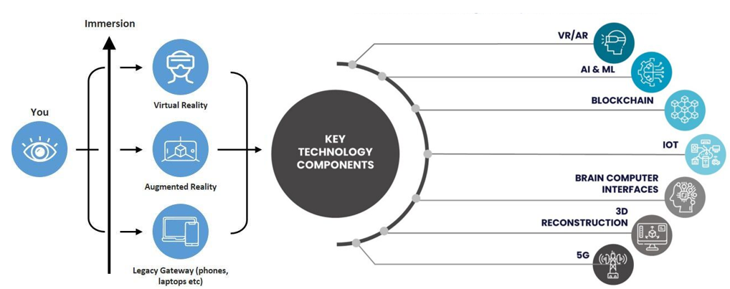
Figure 1. Depiction of real and virtual world integration in the metaverse. Source: Authors

2.3 Impact of user behaviours on brand engagement in virtual environments
User behaviours—purchasing NFTs, interacting socially, attending virtual events and creating content—sit at the centre of brand engagement in immersive ecosystems, shaping perceptions, building emotional bonds and driving loyalty (Shamim et al., 2025; Bilgihan et al., 2024; Lee and Shen, 2024).
Branded NFTs enable digital self-expression, exclusivity and identity construction, and owning unique avatars, wearables and collectibles strengthens emotional attachment (Xie et al., 2023; Simonetti et al., 2025). Scarcity and perceived investment value further lift brand attitudes, amplified by social-comparison dynamics (Wang et al., 2024; Chang et al., 2024; Xie et al., 2024).
Social interaction reinforces engagement: brand communities build trust, knowledge-sharing and purchase intention, and avatar-based interactivity deepens belonging and loyalty (Agnihotri et al., 2024; Kumar and Shankar, 2024; Payal et al., 2024).
Virtual events and gamified rewards build trust, satisfaction and loyalty, especially among Gen Z (Habachi et al., 2024), and participatory content creation deepens ownership and advocacy (Bilgihan et al., 2024; Xu et al., 2024).

2.4 Impact of user engagement and experience on brand success in virtual environments
User engagement and experience are major drivers of brand success. Wiertz and De Ruyter (2007) showed that contributions to firm-hosted online communities enhance brand success, with knowledge-sharing accounting for much of the engagement effect.
Brodie et al. (2011) conceptualise engagement as active participation in brand experiences, while purchase intentions in virtual communities often serve social and self-identity needs, framing engagement as a route to loyalty.

3. Theoretical foundation

3.1 Flow theory
Flow Theory (Csikszentmihalyi, 1990) offers a robust framework for interpreting engagement in the metaverse. Flow is a state of deep immersion and focused attention characterised by high intrinsic motivation and enjoyment, and it is particularly consequential where engagement determines brand success. Recent studies extend it to virtual and augmented reality: perceived enjoyment enhances flow and, in turn, satisfaction and continued use in game-based metaverses (Jo and Lee, 2025).
Evidence continues to link flow with virtual brand experiences. In live streaming, authenticity, interactivity and entertainment enhance flow, with interactivity the most influential (Wu et al., 2024), while metaverse adoption in emerging markets is shaped by technological factors (Liang et al., 2024). In VR, flow lengthens subjective time (Rutrecht et al., 2021) and influences participative and sharing behaviours (Lo and Lai, 2023). The survey therefore incorporated flow elements—clear goals, immediate feedback and challenge–skill balance—on which participants reported for their metaverse interactions.

3.2 Self-Determination Theory (SDT)
Self-Determination Theory (SDT) holds that motivation and well-being are maximised when three innate needs are satisfied: autonomy (volitional choice), competence (feeling effective) and relatedness (feeling connected) (Deci and Ryan, 2000; Ryan and Deci, 2017). In digital environments, the intrinsic motivation to explore, master and connect drives engagement further.
The two theories are complementary. Flow captures the moment-to-moment immersion that arises when challenge–skill balance aligns and goals and feedback are clear, while autonomy facilitates exploration, competence fosters mastery and relatedness sustains social interaction through avatars (Csikszentmihalyi, 1990); SDT explains why users enter and remain in flow. Together they constitute the immersion and need satisfaction underlying engagement, satisfaction and loyalty.

3.3 Constructs and hypotheses
Four constructs are examined. User engagement (UE) is the cognitive, emotional and behavioural involvement a user has with a brand during metaverse interactions. User experience (UX) is the perceived quality of that interaction—immersion, usability, enjoyment and presence. Brand satisfaction (BSAT) is the user’s overall evaluation of the brand arising from metaverse encounters. Brand success (BSUC) covers brand-relevant outcomes: continuance intention, purchase intention, advocacy and word of mouth. The SDT needs and flow dimensions are treated as underlying psychological mechanisms rather than as separately measured constructs.
Read together, Flow Theory and SDT imply that immersive, need-satisfying interactions raise engagement and experience, which in turn shape satisfaction and brand outcomes. Higher user engagement is therefore expected to be positively associated with brand success (H1), and higher user experience quality to be positively associated with brand success (H2). Because satisfaction summarises cumulative evaluations, brand satisfaction is expected to mediate the engagement/experience–success relationships (H3). Consistent with a configurational view, high brand success may arise from multiple sufficient configurations rather than from any single necessary condition (P1). Figure 2 summarises the resulting conceptual model.
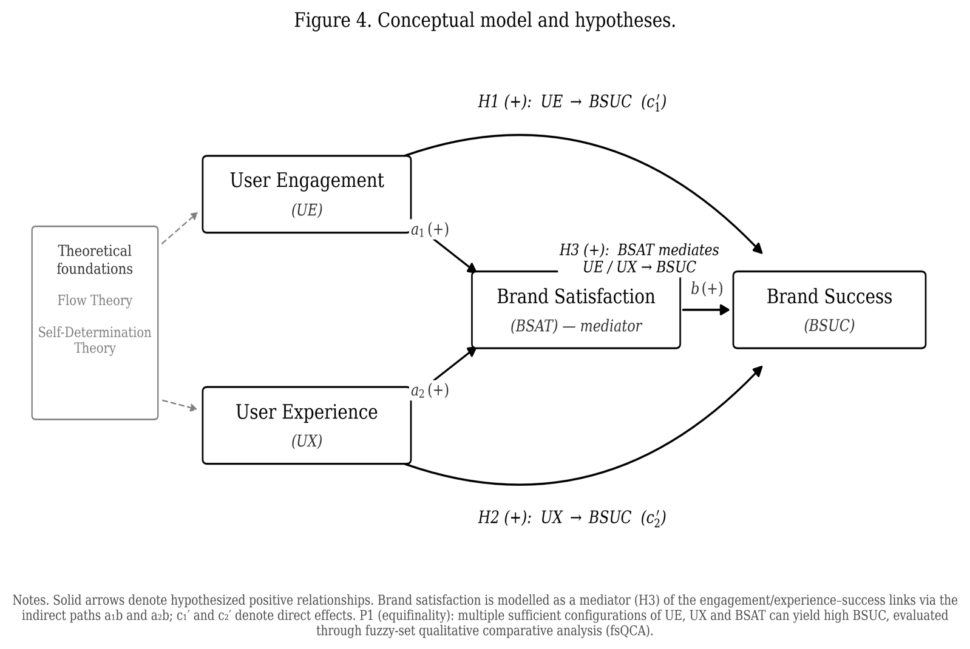
Figure 2. Conceptual model and hypotheses (H1–H3): user engagement (UE) and user experience (UX) as antecedents, brand satisfaction (BSAT) as mediator, and brand success (BSUC) as the outcome, framed by Flow Theory and Self-Determination Theory.
Source: Authors

4. Methodology

4.1 Fuzzy-set qualitative comparative analysis and its application to the study
Jia et al. (2022) advocate a mixed-method approach to studying complex causal configurations in branding: fuzzy-set qualitative comparative analysis (fsQCA). Positioned between exploratory and hypothesis-testing strategies, fsQCA demonstrates how combinations of conditions—present or absent—jointly produce an outcome and reveals equifinality (Schneider and Wagemann, 2012), and it remains viable in small-N research (Ragin, 2008).
The procedure comprises six steps, summarised in Figure 3: case selection, identification of causal conditions, calibration of membership scores, truth-table construction, logical minimisation, and consistency and coverage checks. Boolean minimisation derives minimal sufficient combinations, revealing causal complexity that single-variable effects would not detect.
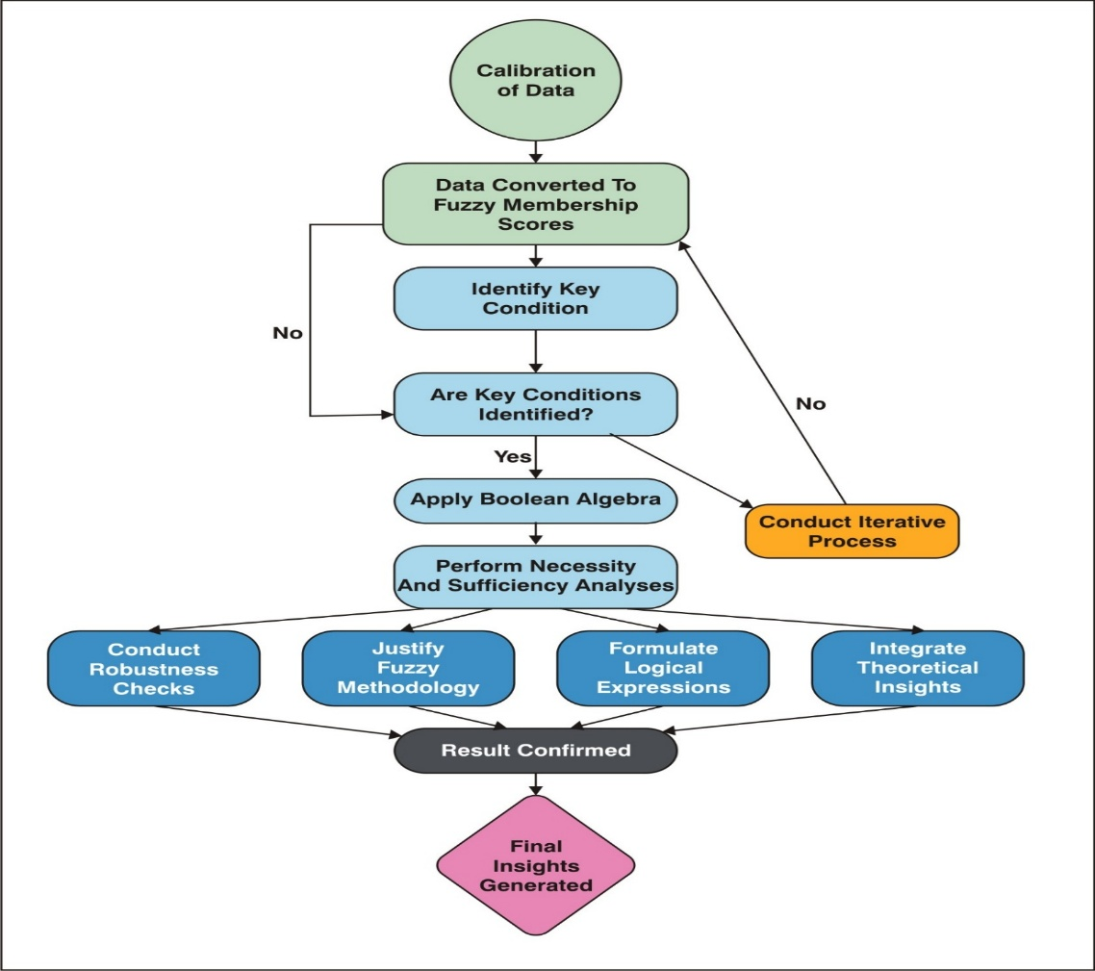
Figure 3. Flowchart illustrating the steps involved in the fuzzy-set qualitative comparative analysis (fsQCA) methodology, from data calibration to the generation of final insights.

4.2 Identification and selection of variables
Variable selection followed a structured three-stage process. First, a literature review identified consistently validated variables—satisfaction, interaction frequency, perceived brand impact, emotional connection and personalisation—as core indicators (Cadet and Chainay, 2020; Lu and Lau, 2025).
Second, interviews and focus groups provided a finer reading of involvement, satisfaction drivers and brand-success perceptions, and the variables were refined accordingly. Third, surveys captured UE, UX, BSAT and BSUC; immersiveness was measured via presence scales, sociability via social and co-presence measures, and ecological faithfulness via authenticity measures (Cadet and Chainay, 2020; Poeschl and Doering, 2015; Lu and Lau, 2025).

4.3 Measures
All constructs were measured on seven-point Likert scales anchored from 1 (strongly disagree) to 7 (strongly agree). User engagement was adapted from O’Brien and Toms (2010); user experience from O’Brien and Toms (2010), Basu et al. (2024) and Cadet and Chainay (2020); brand satisfaction from Fornell et al. (1996); and brand success was developed for this study drawing on Mathwick et al. (2008). The engagement and experience scales are ten-item adapted subsets, and full item wordings are available from the authors on request.

4.4 Platforms studied and metaverse activities
Three prominent platforms were studied—Roblox, Decentraland and The Sandbox—selected for their adoption, functionality and capacity to host brand interactions. Roblox, known for user-generated content and social gaming, hosts branded experiences such as Nike’s Nikeland (Bilgihan et al., 2024); Decentraland, built on blockchain, allows users to buy virtual land, trade NFTs and attend community events (Brouard, 2024); and The Sandbox supports voxel-based creation and monetisation, and is used by brands such as Adidas (Brandes and Dölp, 2025).
Across the platforms, four activity types were considered: trading digital assets, attending virtual events, avatar-based social interaction, and designing digital assets or experiences (Lee and Shen, 2024; Hennig-Thurau et al., 2023).

4.5 Data collection
Data were collected using stratified random sampling. From a frame of adults (18+) active on at least one platform with prior brand-related metaverse experience, 600 eligible users were invited at random, stratified by primary activity (gaming, NFT trading, social interaction, content creation and virtual events). Of these, 312 provided complete, consenting responses—a 52% response rate—with balanced representation across strata, measured on validated UE, UX, BSAT and BSUC scales.
India offers a theoretically and empirically justified context. It is one of the world’s fastest-growing metaverse markets (USD 2 billion in 2023, projected to grow at a robust CAGR through 2030), with a large, digitally native youth population (median age 28), rapid 5G expansion and high mobile-first penetration (Verma, 2024; Statista, 2025; Dwivedi et al., 2023). Indian consumers adopt avatar-based self-expression and NFT ownership readily, and studying this underexplored, non-Western market extends the theoretical reach and generalisability of the findings (Payal et al., 2024).

5. Data analysis and results

5.1 Sample profile
Table 1 profiles the 312 respondents (IBM SPSS 25.0). The sample is balanced by gender and spread across five age bands from 18 to 45 years, and most respondents report frequent metaverse use together with prior participation in NFT trading, social interaction or content creation, and virtual events—activities central to brand engagement.

Table 1. Demographic and metaverse engagement details of respondents (N = 312)
Participants' Information | No. of Participants | % | Participants' Information | No. of Participants | %
Gender |  |  | Metaverse Engagement Frequency
Male | 143 | 46.00 | Daily | 52 | 16.67
Female | 169 | 54.00 | Several times a week | 98 | 31.41
 |  |  | Weekly | 73 | 23.38
Age (Years) |  |  | Monthly | 54 | 17.31
18–22 | 64 | 20.51 | Rarely | 35 | 11.21
23–28 | 75 | 24.04
29–34 | 60 | 19.23 | NFT Interaction
35–41 | 57 | 18.27 | Yes | 141 | 45.19
42–45 | 56 | 17.95 | No | 171 | 54.81
Marital Status |  |  | Virtual Event Participation
Single | 107 | 34.29 | Yes | 129 | 41.35
Married with children | 84 | 26.93 | No | 183 | 58.65
Married without children | 121 | 38.78 | Social Interaction/Content Creation
 |  |  | Yes | 164 | 52.56
Occupation |  |  | No | 148 | 47.44
Students | 88 | 28.21 | Monthly Family Income
Job | 102 | 32.69 | INR 30,000 or less | 57 | 18.40
Business | 122 | 39.10 | INR 30,001–50,000 | 80 | 25.64
 |  |  | INR 50,001–80,000 | 100 | 32.05
 |  |  | INR 80,001 and above | 75 | 23.91
Source: Authors

5.2 Measurement model assessment
All standardised loadings were positive and significant (p < .001), and Cronbach’s alpha ranged from 0.765 to 0.903 across the four constructs, exceeding the conventional benchmark (Nunnally and Bernstein, 1994). Detailed measurement properties, including average variance extracted (Fornell and Larcker, 1981), are reported in Table 2 following the conventions of Hair et al. (2019). Discriminant validity was assessed using the heterotrait–monotrait (HTMT) ratio (Henseler et al., 2015) obtained from SmartPLS 4.1 bootstrapping with 5,000 subsamples: all ratios fell below the 0.85 criterion (BSAT–BSUC 0.743; UX–BSAT 0.768; UX–BSUC 0.712; UE–BSAT 0.756; UE–BSUC 0.729; UE–UX 0.814), confirming that the constructs are empirically distinct.

Table 2. Measurement model: item loadings, reliability and average variance extracted
Measurement properties
Factor | Indicator | Estimate | Cronbach’s Alpha | AVE | SE | Z | p
Brand Satisfaction | BSAT_1 | 0.705 | 0.841 | 0.514 | 0.0323 | 21.8 | <.001
 | BSAT_2 | 0.741 |  |  | 0.0337 | 22.0 | <.001
 | BSAT_3 | 0.721 |  |  | 0.0328 | 21.9 | <.001
 | BSAT_4 | 0.719 |  |  | 0.0335 | 21.5 | <.001
 | BSAT_5 | 0.699 |  |  | 0.0328 | 21.3 | <.001
User Engagement | UE_1 | 0.684 | 0.903 | 0.481 | 0.0322 | 21.3 | <.001
 | UE_2 | 0.696 |  |  | 0.0325 | 21.4 | <.001
 | UE_3 | 0.706 |  |  | 0.0325 | 21.7 | <.001
 | UE_4 | 0.684 |  |  | 0.0334 | 20.5 | <.001
 | UE_5 | 0.698 |  |  | 0.0327 | 21.3 | <.001
 | UE_6 | 0.705 |  |  | 0.0325 | 21.7 | <.001
 | UE_7 | 0.677 |  |  | 0.0323 | 20.9 | <.001
 | UE_8 | 0.707 |  |  | 0.0326 | 21.7 | <.001
 | UE_9 | 0.670 |  |  | 0.0311 | 21.5 | <.001
 | UE_10 | 0.706 |  |  | 0.0325 | 21.7 | <.001
User Experience | UX_1 | 0.690 | 0.902 | 0.481 | 0.0327 | 21.1 | <.001
 | UX_2 | 0.681 |  |  | 0.0319 | 21.3 | <.001
 | UX_3 | 0.714 |  |  | 0.0325 | 22.0 | <.001
 | UX_4 | 0.694 |  |  | 0.0326 | 21.3 | <.001
 | UX_5 | 0.678 |  |  | 0.0317 | 21.4 | <.001
 | UX_6 | 0.706 |  |  | 0.0328 | 21.5 | <.001
 | UX_7 | 0.687 |  |  | 0.0317 | 21.7 | <.001
 | UX_8 | 0.677 |  |  | 0.0320 | 21.1 | <.001
 | UX_9 | 0.703 |  |  | 0.0319 | 22.0 | <.001
 | UX_10 | 0.702 |  |  | 0.0321 | 21.9 | <.001
Brand Success | BSUC_1 | 0.661 | 0.765 | 0.448 | 0.0308 | 21.5 | <.001
 | BSUC_2 | 0.662 |  | 0.448 | 0.0314 | 21.1 | <.001
 | BSUC_3 | 0.673 |  | 0.448 | 0.0313 | 21.5 | <.001
 | BSUC_4 | 0.682 |  | 0.448 | 0.0317 | 21.5 | <.001

UE: User Engagement, UX: User Experience, BSAT: Brand Satisfaction, BSUC: Brand Success
Source: Authors

5.3 Data analysis using fsQCA

5.3.1 Data-driven results from fsQCA
To analyse UE, UX, BSAT and BSUC, raw responses were calibrated (Ragin, 2008) into fuzzy-set membership scores, each expressing the degree to which a case belongs to a condition and to the outcome.
Calibration used three anchors: the 95th percentile for full membership (0.95), the 50th as the crossover point (0.50) and the 5th for full non-membership (0.05), which constrains scores to the 0–1 interval (Ragin, 2008; Douglas et al., 2020). This shared scale permits direct comparison of the calibrated UE, UX, BSAT and BSUC values.

Table 3. Necessity and sufficiency analysis of conditions and configurations for high brand success (BSUC)
Condition / configuration | BSAT | UX | UE | Consistency | Raw coverage | Unique coverage | Combined coverage
BSAT × UX × UE (triadic path) | ● | ● | ● | 0.713 | 0.172 | - | 0.305
BSAT × UE | ● |  | ● | 0.669 | 0.241 | 0.069 | 0.295
BSAT × UX | ● | ● |  | 0.650 | 0.208 | 0.036 | 0.246
UX × UE |  | ● | ● | 0.600 | 0.219 | 0.046 | 0.181
BSAT (single condition) | ● |  |  | 0.410 | 0.368 | - | 0.086
UE (single condition) |  |  | ● | 0.373 | 0.349 | - | 0.084
UX (single condition) |  | ● |  | 0.362 | 0.349 | - | 0.084
User Experience (UX), User Engagement (UE), Brand Satisfaction (BSAT), and Brand Success (BSUC)
Note: Model BSUC = f (BSAT, UX, UE). ● = condition present in the configuration; blank = "don’t care" (condition irrelevant for that configuration). Unique coverage is reported for the three sufficient configurations of the intermediate solution. Overall solution coverage: 0.323827; overall solution consistency: 0.756327. A condition qualifies as necessary only where consistency exceeds 0.90. Source: Authors

Table 3 reports the intermediate solution for BSUC = f(BSAT, UX, UE). Three two-condition configurations—BSAT × UX, BSAT × UE and UX × UE—are each sufficient for high brand success and together account for approximately 32% of the outcome, at an overall solution consistency of 0.756.
In the model (Figure 2), UX, UE and BSAT act as the antecedent conditions for BSUC. The subset–superset analysis establishes which combinations are jointly sufficient for high brand success rather than estimating a single directional path, which anchors the conceptual model in the empirical configurations.

The configurational results demonstrate equifinality: several distinct paths lead to the same outcome (Ragin, 2008). No single factor—BSAT, UX or UE—is necessary in isolation; it is their interaction that drives brand outcomes in immersive digital environments.
Each sufficient path carries a distinct substantive meaning. BSAT × UX delivers brand success even without strong engagement, because satisfied users with positive immersive experiences form lasting relationships (Bilgihan et al., 2024). BSAT × UE combines satisfaction with active participation, lifting loyalty and advocacy. UX × UE indicates that immersive, interactive environments yield favourable outcomes even without reported satisfaction, which supports Flow Theory (Csikszentmihalyi, 1990).
The subset–superset analysis broadens this picture. The triadic path (BSAT × UX × UE) records the highest consistency and combined coverage: satisfied, engaged and immersed users raise brand success to its peak, consistent with service-dominant logic and value co-creation. The remaining paths afford strategic latitude, since satisfaction combined with either experience or engagement is sufficient, allowing brands to tailor strategies to their strengths, while UX × UE, despite lower consistency, supports immersive participatory experiences (Shin, 2019).

5.3.2 Necessity analysis
Necessity analysis establishes whether a condition must be present for the outcome to occur; a condition qualifies as necessary only if its consistency exceeds 0.90 (Schneider and Wagemann, 2012). As Table 3 shows, none of the single conditions approaches that threshold. High brand success therefore depends on combinations rather than on any individually essential condition, which motivates the sufficiency analysis.

5.3.3 Sufficiency analysis
The sufficiency analysis identifies the configurations that are jointly sufficient. UE, UX and BSAT were entered into the truth table with consistency and frequency thresholds applied (Ragin, 2008; Schneider and Wagemann, 2012). As Table 3 reports, brand satisfaction appears in every high-consistency sufficient path, whereas engagement and experience contribute in combination rather than in isolation—a pattern consistent with prior evidence on engagement–loyalty links (Jeong and Kim, 2019) and social-media effects on customer equity (Ebrahim, 2020).
User engagement in this setting is multifaceted—asset trading, event attendance, social interaction and content creation—and reflects psychological, social and experiential motivations that the UE and UX constructs capture rather than platform-specific variables.

5.4 Hypothesis evaluation
fsQCA tests sufficiency rather than net linear effects, so the hypotheses are evaluated configurationally against Table 3. Consistent with the necessity result, user engagement and user experience are not sufficient in isolation; they support brand success only in combination, which supports H1 and H2 within sufficient configurations. Brand satisfaction appears in every high-consistency path and records the highest single-condition consistency, indicating the central, mediation-consistent role posited in H3. The presence of three sufficient configurations rather than one necessary condition supports the equifinality proposition (P1). A formal bootstrap mediation test would provide a useful complement.

6. Discussion
The fsQCA findings clarify how combinations of UE, UX and BSAT contribute to brand success in the metaverse and delineate the principal pathways to favourable outcomes.
The BSAT × UX configuration is substantively important: satisfied users who perceive a high-quality immersive experience become loyal advocates, consistent with prior research linking satisfaction, experience and emotional connection (Thaichon et al., 2022; Bilgihan et al., 2024). Brands should therefore prioritise seamless immersive experiences while addressing ethical concerns such as data-privacy risks and excessive use.
BSAT × UE was similarly strong, echoing established engagement–equity links (Jeong and Kim, 2019): brands should promote gamified and co-creation activities that deepen engagement without compromising satisfaction. UX × UE, although less consistent, indicates that engagement is best achieved where experience quality is high, even when satisfaction is not reported, in line with the challenge–skill balance (Csikszentmihalyi, 1990; Shin, 2019).
Individual conditions recorded lower consistency than their combinations, which argues for holistic strategies: the triadic path achieved the highest consistency, reinforcing Flow Theory’s premise that optimal engagement arises from a balance between challenge and skill in immersive environments (Csikszentmihalyi, 1990).

7. Implications

7.1 Theoretical contributions
This research integrates SDT and Flow Theory within immersive, digitally mediated environments defined by persistent communities, avatar-based identity and interactive interfaces, clarifying how psychological needs and experiential states jointly shape engagement, satisfaction and brand outcomes. Earlier applications addressed traditional or gamified settings; metaverse interactions instead blend intrinsic motivation and experiential absorption in a distinctive way, which carries both theories into co-created domains.
Within SDT, autonomy, competence and relatedness assume distinctive forms: autonomy through customisable avatars and digital-asset ownership, competence through skill-based challenges, and relatedness through persistent social interaction in branded communities (Bilgihan et al., 2024). These are advanced as conceptual mechanisms underlying engagement and experience rather than as separately measured effects.
The study extends Flow Theory by proposing that experiential immersion depends on matching task challenge to user skill, tuned by digital affordances and interaction design (Zhong and Hamouda, 2024), with gamified missions and event-based interactions acting as flow facilitators. Deep immersive engagement can therefore yield favourable outcomes even when satisfaction is not the dominant condition.
Taken together, the confluence of need satisfaction and experiential immersion is associated with engagement, satisfaction and brand performance, extending SDT and Flow Theory into co-created digital domains while keeping tested associations distinct from theoretical interpretation.

7.2 Managerial implications
User experience recurs across the configurations associated with success, so designing engaging, interactive and personalised metaverse experiences is central to sustaining engagement and long-term brand success.
Brands should build immersive experiences tied to users’ virtual identities: customisable avatars and interactive environments allow users to express who they are and strengthen presence, reinforcing the emotional bond. Where a brand’s virtual presence matches users’ self-concept, tailored experiences deepen engagement, loyalty and advocacy (Thaichon et al., 2022; Xie et al., 2023).
Frequently discussed features—NFT interoperability, smart contracts and rarity dynamics—may strengthen exclusivity and trust, but they were not measured here and are therefore presented as future avenues rather than findings.
The results also indicate synergy between satisfaction and engagement (Jeong and Kim, 2019): managers should develop gamified, co-creation and reward opportunities that deepen involvement, because a user’s sense of ownership reinforces attachment and long-term loyalty.
Immersive offerings must accordingly be emotionally resonant, consistent and aligned with users’ values and identities; functional or visually appealing assets are no longer sufficient, and brands delivering high-quality interactive experiences build lasting engagement, loyalty and competitive advantage.

8. Limitations and future scope
The study carries several limitations. The sample of 312 active, experienced users ensures relevant expertise but may tilt results toward highly engaged participants and underrepresent casual or novice users, which limits generalisability; a more diverse, representative sampling frame is needed.
Inclusion and exclusion decisions may have omitted relevant factors, and the absence of a control group limits causal attribution. While fsQCA handles complex causal analysis well, its small-N, qualitative orientation reduces robustness relative to larger quantitative models and limits methodological triangulation.
The cross-sectional design cannot track how engagement and experience evolve; longitudinal studies are needed to establish whether engagement is sustained. Ethical questions—privacy, addiction, cyberbullying and exploitation—remain underexplored, and future work should develop safeguards for user well-being.
Several large technology firms have curtailed their metaverse investments, so the contribution is framed conservatively. The findings speak most directly to brands active on large, metaverse-like platforms—game-based worlds such as Roblox and Fortnite, and social virtual reality—and to the design of future immersive environments, since the psychological mechanisms of engagement, experience and satisfaction are likely to persist across successive technological forms.

Funding: This research received no specific grant from any funding agency in the public, commercial, or not-for-profit sectors.
Conflicts of Interest: The authors declare no conflicts of interest.

References
Agnihotri, D., Chaturvedi, P., Swarup, K., Mathur, A., Tripathi, V., and Singh, N. (2024). Does social presence drive customer brand engagement and purchase intention in the fashion retail metaverse? The moderating role of self-efficacy. Internet Research. https://doi.org/10.1108/intr-01-2024-0030
Anderson, K. C., Hansen, H., and Laverie, D. (2024). Technology has Agency too! Disentangling Technology's Causal and Structural Agency in a Service System. Journal of Macromarketing, 44(2), 510-533.
Arya, V., Paul, J., and Sethi, D. (2022). Like it or not! Brand communication on social networking sites triggers consumer‐based brand equity. International Journal of Consumer Studies, 46(4), 1381-1398.
Arya, V., Sambyal, R., Sharma, A., and Dwivedi, Y. K. (2024a). Brands are calling your AVATAR in Metaverse–A study to explore XR‐based gamification marketing activities and consumer‐based brand equity in virtual world. Journal of Consumer Behaviour, 23(2), 556-585.
Arya, V., Sethi, D., and Hollebeek, L. D. (2024b). Using augmented reality to strengthen consumer/brand relationships: the case of luxury brands. Journal of Consumer Behaviour. https://doi.org/10.1002/cb.2419
Basu, B., Kar, A. K., and Sen, S. (2024). Antecedents of user experience in the immersive Metaverse ecosystem: Insights from mining user reviews. Communications of the Association for Information Systems, 55(1), 13.
Bilgihan, A., Leong, A. M. W., Okumus, F., and Bai, J. (2024). Proposing a metaverse engagement model for brand development. Journal of Retailing and Consumer Services, 78, 103781.
Blazquez, M. (2024). The Metaverse and its potential for digital sustainability in fashion. Journal of Global Fashion Marketing, 15(3), 303-319.
Brandes, L., and Dölp, K. (2025). Non-Fungible Tokens (NFTs) as Digital Brand Extensions: Evidence on Financial Performance and Parent-Brand Spillovers. International Journal of Research in Marketing. https://doi.org/10.1016/j.ijresmar.2025.01.001
Brodie, R. J., Hollebeek, L. D., Jurić, B., and Ilić, A. (2011). Customer Engagement: Conceptual Domain, Fundamental Propositions, and Implications for Research. Journal of Service Research, 14(3), 252-271.
Brouard, M. (2024). Setting sail in a tokenized world: an exploration of the Bored Ape Yacht club and the co-created consumer experience. International Journal of Research in Marketing. https://doi.org/10.1016/j.ijresmar.2024.03.002
Buhalis, D., Leung, D., and Lin, M. (2023). Metaverse as a disruptive technology revolutionising tourism management and marketing. Tourism Management, 97, 104724.
Cadet, L. B., and Chainay, H. (2020). Memory of virtual experiences: Role of immersion, emotion and sense of presence. International Journal of Human-Computer Studies, 144, 102506.
Chandra, S., Verma, S., Lim, W. M., Kumar, S., and Donthu, N. (2022). Personalization In Personalized Marketing: Trends and Ways Forward. Psychology and Marketing, 39(8), 1529-1562.
Chang, C. W., Lai, C. J., and Yen, C. C. (2024). Examining drivers of NFT purchase intention: The impact of perceived scarcity and risk. Acta Psychologica, 248, 104424.
Csikszentmihalyi, M. (1990). Flow: The Psychology of Optimal Experience. Journal of Leisure Research, 24(1), 93–94.
Daassi, M., and Debbabi, S. (2021). Intention to reuse AR-based apps: The combined role of the sense of immersion, product presence and perceived realism. Information and Management, 58(4), 103453.
Deci, E. L., and Ryan, R. M. (2000). The “What” and “Why” of Goal Pursuits: Human Needs and the Self-Determination of Behavior. Psychological Inquiry, 11(4), 227–268.
Douglas, E. J., Shepherd, D. A., and Prentice, C. (2020). Using fuzzy-set qualitative comparative analysis for a finer-grained understanding of entrepreneurship. Journal of Business Venturing, 35(1), 105970.
Duong, C. D., Ngo, T. V. N., Khuc, T. A., Tran, N. M., and Nguyen, T. P. T. (2025). Unraveling the dark side of ChatGPT: A moderated mediation model of technology anxiety and technostress. Information Technology and People, 38(4), 2015-2040.
Dwivedi, Y. K., Hughes, L., Wang, Y., Alalwan, A. A., Ahn, S. J., Balakrishnan, J., ... and Wirtz, J. (2023). Metaverse marketing: How the metaverse will shape the future of consumer research and practice. Psychology and Marketing, 40(4), 750-776.
Ebrahim, R. S. (2020). The role of trust in understanding the impact of social media marketing on brand equity and brand loyalty. Journal of Relationship Marketing, 19(4), 287-308.
Eggenschwiler, M., Linzmajer, M., Roggeveen, A. L., and Rudolph, T. (2024). Retailing in the metaverse: A framework of managerial considerations for success. Journal of Retailing and Consumer Services, 79, 103791.
Fornell, C., Johnson, M. D., Anderson, E. W., Cha, J., and Bryant, B. E. (1996). The American customer satisfaction index: nature, purpose, and findings. Journal of Marketing, 60(4), 7-18.
Fornell, C., and Larcker, D. F. (1981). Evaluating Structural Equation Models with Unobservable Variables and Measurement Error. Journal of Marketing Research, 18(1), 39-50.
Habachi, S., Matute, J., and Palau-Saumell, R. (2024). Gamify, engage, build loyalty: exploring the benefits of gameful experience for branded sports apps. Journal of Product and Brand Management, 33(1), 57-75.
Hair, J. F., Risher, J. J., Sarstedt, M., and Ringle, C. M. (2019). When to use and how to report the results of PLS-SEM. European Business Review, 31(1), 2-24.
Hennig-Thurau, T., Aliman, D. N., Herting, A. M., Cziehso, G. P., Linder, M., and Kübler, R. V. (2023). Social interactions in the metaverse: Framework, initial evidence, and research roadmap. Journal of the Academy of Marketing Science, 51(4), 889-913.
Henseler, J., Ringle, C. M., and Sarstedt, M. (2015). A new criterion for assessing discriminant validity in variance-based structural equation modeling. Journal of the Academy of Marketing Science, 43(1), 115-135.
Hwang, I., and Seo, R. (2025). Organizational support for digital transformation in the metaverse: a contingent pathway from user experience to digitalization resistance. R&D Management, 55(2), 420-437.
İlkan, Ş. P., Öztüren, A., Avcı, T., and Irani, F. (2023). Mobile application features effects on the application's engagement and intention for continuing use in tourism. Asia Pacific Journal of Tourism Research, 28(4), 386-400.
Jeong, E., and Kim, S. (2019). Exploring a theoretical framework for understanding the relationship between customer engagement and brand loyalty in social media marketing. Journal of Business Research, 95, 365-374.
Jia, R., Steelman, Z., and Jia, H. (2022). What makes one intrinsically interested in IT? An exploratory study on influences of autistic tendency and gender in the U.S. and India. MIS Quarterly, 45(3), 1603–1634.
Jo, H., and Lee, J. K. (2025). Key drivers of user engagement in game-based metaverses: enjoyment, escapism, reward, and spontaneity. PRESENCE: Virtual and Augmented Reality, 34, 219–241.
Koohang, A., Nord, J. H., Ooi, K. B., Tan, G. W. H., Al-Emran, M., Aw, E. C. X., ... and Wong, L. W. (2023). Shaping the metaverse into reality: a holistic multidisciplinary understanding of opportunities, challenges, and avenues for future investigation. Journal of Computer Information Systems, 63(3), 735-765.
Kopalle, P. K., Gangwar, M., and Uppal, A. (2024). Commentary on “AI is Changing the World: For Better or for Worse?”. Journal of Macromarketing, 44(4), 886-891.
Kozinets, R. V. (2023). Immersive netnography: a novel method for service experience research in virtual reality, augmented reality and metaverse contexts. Journal of Service Management, 34(1), 100-125.
Kumar, A., and Shankar, A. (2024). Investigating the role of metaverse influencers’ attributes for the next generation of services. Journal of Services Marketing, 38(7), 816-838.
Lavoie, R., Main, K., King, C., and King, D. (2021). Virtual experience, real consequences: the potential negative emotional consequences of virtual reality gameplay. Virtual Reality, 25(1), 69-81.
Lee, C. T., and Shen, Y. C. (2024). Exploring determinants of non-fungible token creators’ engagement behaviors on metaverse-based NFT platforms: A multi-analytical SEM-IPMA method. Journal of Business Research, 185, 114920.
Liang, Y., Zhang, X., Wang, H., and Liu, M. (2024). Users' Willingness To Adopt Metaverse Drawing on Flow Theory: An Empirical Study Using PLS-SEM and FsQCA. Heliyon, 10(13).
Lo, S. Y., and Lai, C. Y. (2023). Investigating how immersive virtual reality and active navigation mediate the experience of virtual concerts. Scientific Reports, 13, 8507.
Lu, Y., and Lau, S. K. (2025). Examining the ecological validity of VR experiments in soundscape and landscape research. Computers in Human Behavior, 162, 108462.
Marvi, R., Zha, D., and Foroudi, P. (2024). Elevating B2B branding in a global context: integrating existing literature and proposing a forward-thinking conceptual framework. Industrial Marketing Management, 120, 247-272.
Mathwick, C., Wiertz, C., and De Ruyter, K. (2008). Social capital production in a virtual P3 community. Journal of Consumer Research, 34(6), 832-849.
Nunnally, J. C., and Bernstein, I. H. (1994). Psychometric theory (3rd ed.). New York, NY: McGraw-Hill.
O’Brien, H. L., and Toms, E. G. (2010). The development and evaluation of a survey to measure user engagement. Journal of the American Society for Information Science and Technology, 61(1), 50-69.
Osborne, A. (2024). Design of Social Affordances for Meetings in Social Virtual Reality. UC Santa Cruz. Accessed on December 2024, available at: https://escholarship.org/uc/item/8h51c6s0
Payal, R., Sharma, N., and Dwivedi, Y. K. (2024). Unlocking the impact of brand engagement in the metaverse on Real-World purchase intentions: Analyzing Pre-Adoption behavior in a futuristic technology platform. Electronic Commerce Research and Applications, 65, 101381.
Poeschl, S., and Doering, N. (2015). Measuring co-presence and social presence in virtual environments–psychometric construction of a german scale for a fear of public speaking scenario. Annual Review of Cybertherapy and Telemedicine 2015, 58-63.
Ragin, C. C. (2008). Redesigning social inquiry: Fuzzy sets and beyond. University of Chicago Press, Chicago, IL, United States.
Rather, R. A., Hollebeek, L. D., Vo‐Thanh, T., Ramkissoon, H., Leppiman, A., and Smith, D. (2022). Shaping Customer Brand Loyalty During the Pandemic: The Role of Brand Credibility, Value Congruence, Experience, Identification, And Engagement. Journal of Consumer Behaviour, 21(5), 1175-1189.
Rutrecht, H., Wittmann, M., Khoshnoud, S., and Igarzábal, F. A. (2021). Time Speeds Up During Flow States: A Study in Virtual Reality with the Video Game Thumper. Timing and Time Perception, 9(4), 353-376.
Ryan, R. M., and Deci, E. L. (2017). Self-determination theory: Basic psychological needs in motivation, development, and wellness. Guilford Publishing.
Schneider, C. Q., and Wagemann, C. (2012). Set-theoretic methods for the social sciences: A guide to qualitative comparative analysis. Cambridge University Press, Cambridge, United Kingdom.
Shamim, N., Gupta, S., and Shin, M. M. (2025). Evaluating user engagement via metaverse environment through immersive experience for travel and tourism websites. International Journal of Contemporary Hospitality Management, 37(4), 1132-1174.
Shin, D. (2019). How does immersion work in augmented reality games? A user-centric view of immersion and engagement. Information, Communication and Society, 22(9), 1212-1229.
Simonetti, A., Bigne, E., and Navas, L. F. R. (2025). Consumer brand choice in the metaverse: Exploring personal and social factors. Technological Forecasting and Social Change, 213, 124033.
Soltani Nejad, N., Rastegar, R., and Jahanshahi, M. (2024). Tourist engagement with mobile apps of E-leisure: a combined model of self-determination theory and technology acceptance model. Tourism Recreation Research, 49(4), 714-725.
Statista. (2025). Metaverse – India: Market forecast. Statista Market Insights. Retrieved March 21, 2026, from https://www.statista.com/outlook/amo/metaverse/indiahttps://www.statista.com/outlook/amo/metaverse/india
Thaichon, P., Phau, I., and Weaven, S. (2022). Moving from multi-channel to Omni-channel retailing: Special issue introduction. Journal of Retailing and Consumer Services, 65, 102311.
Verma, S. (2024). India metaverse market outlook to 2030 (Report No. KROD1819). Ken Research Private Limited. Retrieved March 21, 2026, from https://www.kenresearch.com/industry-reports/india-metaverse-market
Vo, T. H., Wei‐Han Tan, G., Pham, N. T., Truong, T. H. D., and Ooi, K. B. (2025). Promoting customer engagement and brand loyalty on social media: The role of virtual influencers. International Journal of Consumer Studies, 49(2), e70028.
Wang, X., Sung, B., and Phau, I. (2024). How rarity and exclusivity influence types of perceived value for luxury. Journal of Brand Management, 31(6), 576-592.
Wiertz, C., and De Ruyter, K. (2007). Beyond The Call of Duty: Why Customers Contribute to Firm-Hosted Commercial Online Communities. Organization Studies, 28(3), 347-376.
Wu, Y.-Y., Batool, H., and Yang, Y.-J. (2024). Relationship between the Characteristics of e-Commerce Live Streaming and Purchase Intentions: Moderating Effect of Hedonistic Shopping Value. Emerging Science Journal, 8(3), 1097–1117.
Xie, Q., Muralidharan, S., and Edwards, S. M. (2024). Who will buy the idea of non-fungible token (NFT) marketing? Understanding consumers’ psychological tendencies and value perceptions of branded NFTs. International Journal of Advertising, 43(6), 987-1015.
Xie, Q., Muralidharan, S., Edwards, S. M., and La Ferle, C. (2023). Unlocking the power of non-fungible token (NFT) marketing: How NFT perceptions foster brand loyalty and purchase intention among millennials and Gen-Z. Journal of Interactive Advertising, 23(4), 356-373.
Xu, S., Bauman, M. J., Ponting, S. S. A., Slevitch, L., Webster, C., and Kirillova, K. (2024). Neolocalism of craft brewery experience: Scale development and validation study. International Journal of Hospitality Management, 120, 103787.
Zallio, M., and Clarkson, P. J. (2022). Designing the metaverse: A study on inclusion, diversity, equity, accessibility and safety for digital immersive environments. Telematics and Informatics, 75, 101909.
Zhong, Z., and Hamouda, M. (2024). The impact of immersive and flow experiences on consumer participation in hyper‐connected shopping platforms: A metaverse perspective. Journal of Consumer Behaviour, 23(6), 2826-2845.

