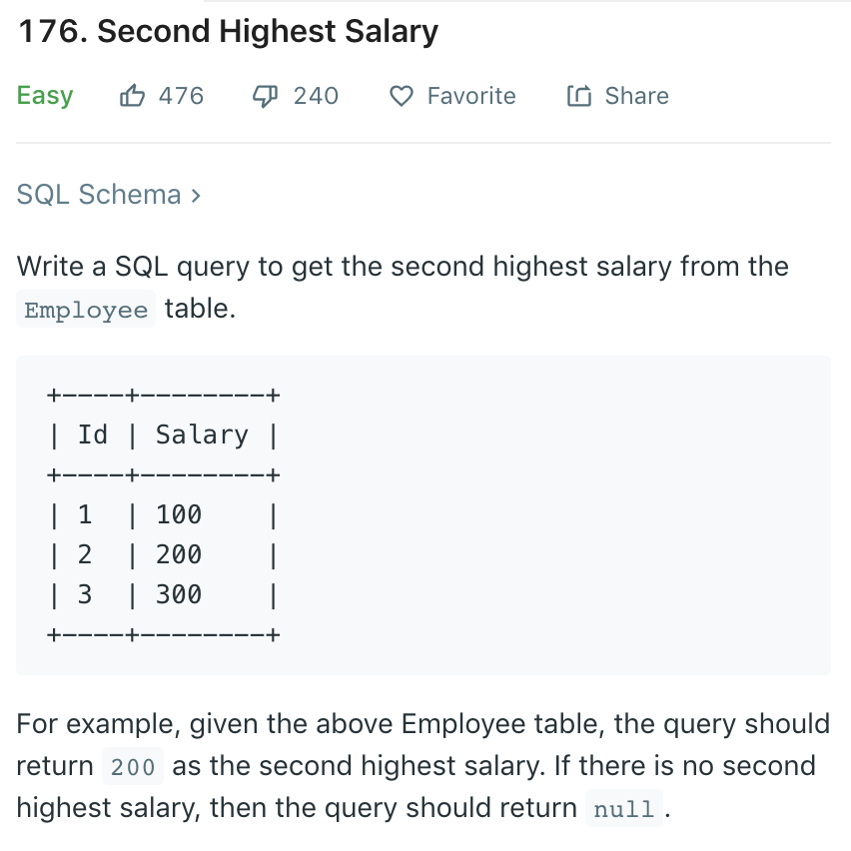

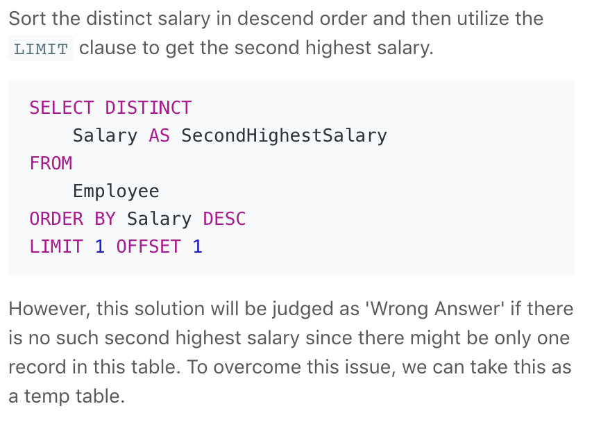

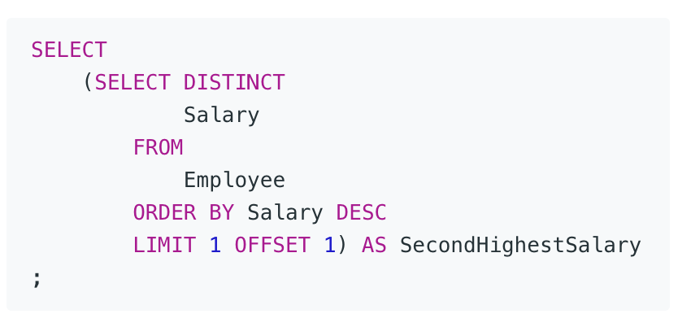

# Write your MySQL query statement below

SELECT MAX(Salary) as SecondHighestSalary

FROM Employee

WHERE Salary < (SELECT MAX(Salary) from Employee)