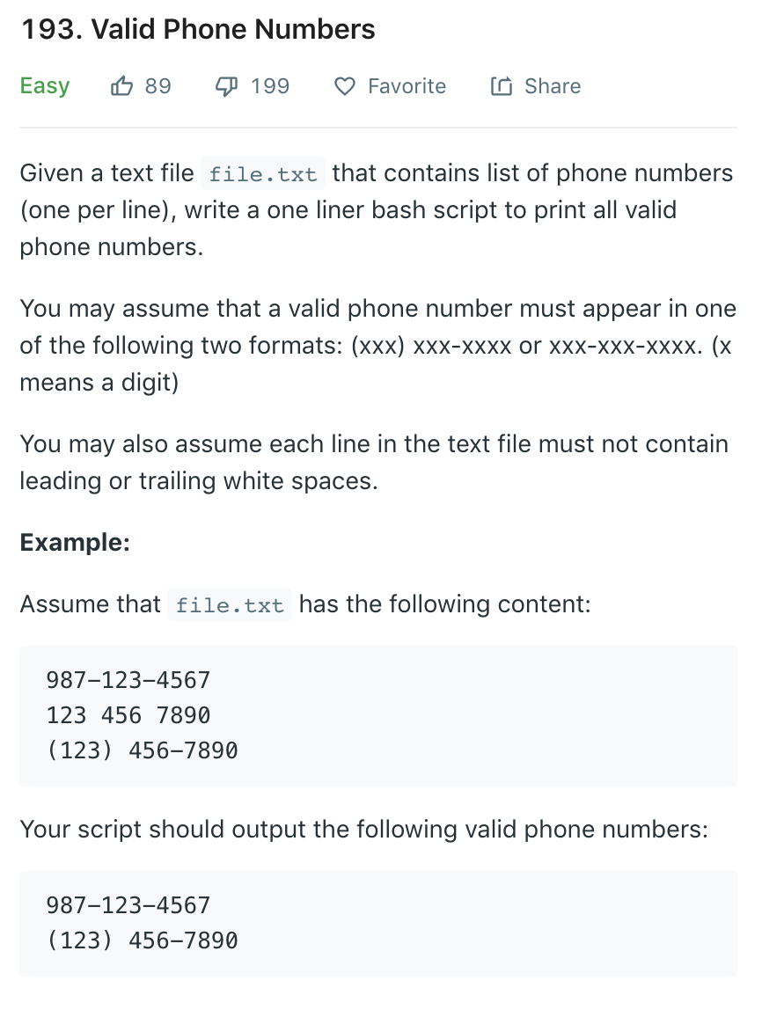

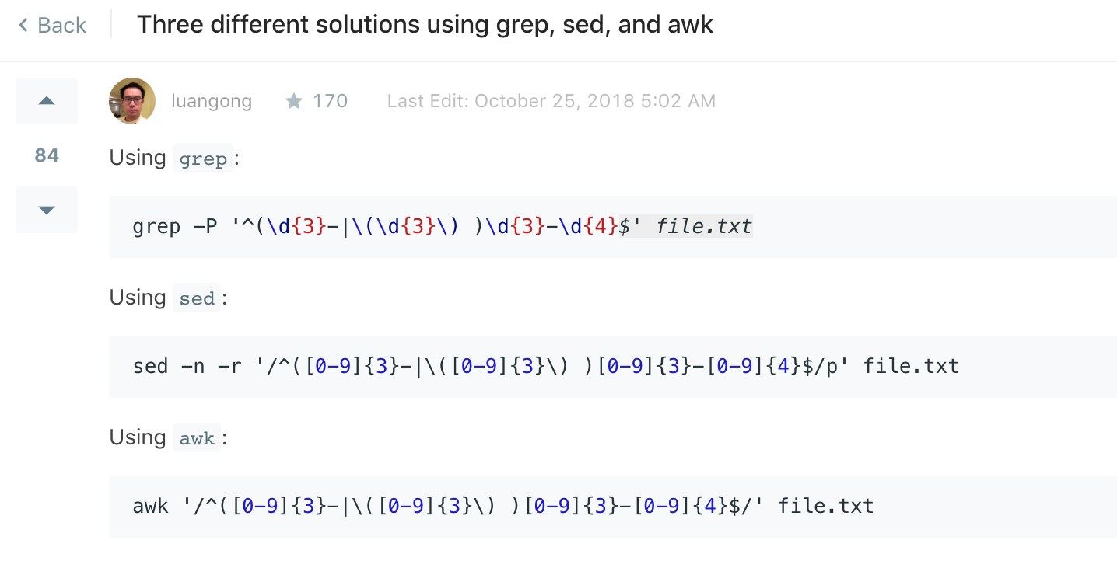

如何进行shell command 效率测试

<https://leetcode.com/problems/tenth-line/discuss/55544/Share-four-different-solutions>

**使用 time command 进行记时**

awk awk scripts

sed

head 命令