August Byrne

EECE 433

5/7/2021

Lab 3

Part 1:

1. arm_rfft_init_q31() with ifftFlagR = 0 and arm_rfft_q31()
2. arm_rfft_init_q31() with ifftFlagR = 1 and arm_rfft_q31()
3. fixed-point
4. //Left Channel

arm_rfft_q31(&arm_rfft_sR_q31_len128Left,&RxDMABuffer[LEFT_CH][BufferIndex].samples[0],&fftResultLeft[0]);

//Right Channel

arm_rfft_q31(&arm_rfft_sR_q31_len128Right,&RxDMABuffer[RIGHT_CH][BufferIndex].samples[0], &fftResultRight[0]);

1. //init Real FFT instance

arm_rfft_init_q31(&arm_rfft_sR_q31_len128Left,AUDIO_SAMPLES_PER_BLOCK, 0, 1);

arm_rfft_init_q31(&arm_rfft_sR_q31_len128Right,AUDIO_SAMPLES_PER_BLOCK, 0, 1);

1. 512 from line #define FFT_LENGTH
2. The FFT size and the samples per block are not the same
3. The FFT length is <= number of samples per block
4. Yes, from the line #define FREQ_BIN_SIZE SAMPLE_RATE_HZ/FFT_LENGTH
5. It can be a passthrough, and it can get take the fft of the data, and get the magnitude of the fft
6. arm_max_q31()

Part 2:

1. To verify that I set up the FFT successfully, I opened the global variables tab and looked to see if my values were correct. I set it to update while the target is running, and then checked to make sure that my calculated peakFreq was correct. Since it was the last calculation in the whole chain of FFT calculations, I knew that if I was getting reliable values from this, then my FFT calculations were correct.
2. My frequency resolution will be 93.75Hz (48000 Hz/512 samples). My peak frequency value was 1968Hz after sending in a frequency of 2kHz.

Part 3:

1. The carrier signal had a frequency of 20kHz, an amplitude of 1 (which worked for me), and a phase of 0. The message signal had a frequency of 2kHz, an amplitude of 1*my phones lowest output volume, and a phase of 0.
2. 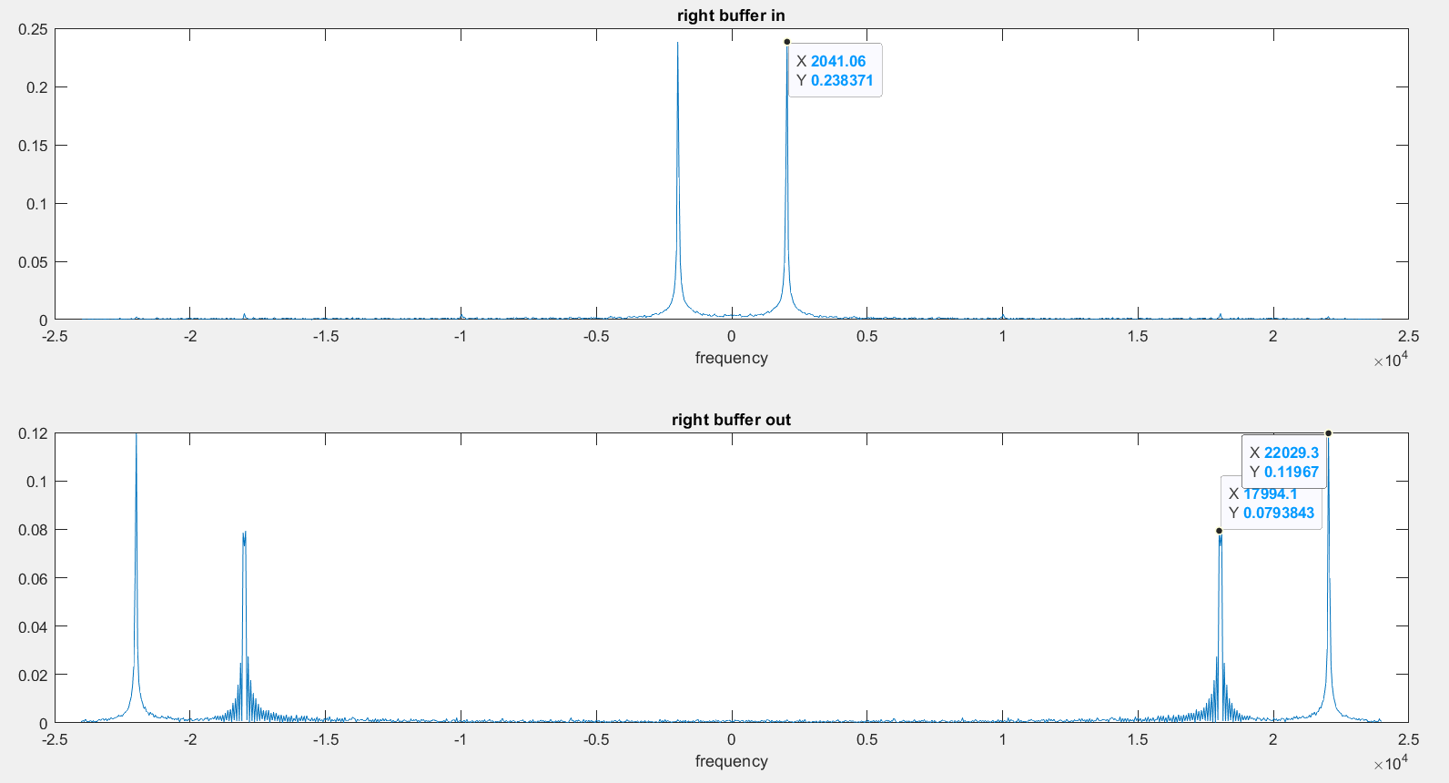
3. I verified the frequency spectrum by taking capturing the input and output buffers, and measuring their frequency domains in MATLAB to verify that the input was a 2kHz signal, and the output was the 2kHz signal modulated with a 20kHz carrier signal.