August Byrne

EECE 433

5/19/2021

Lab 5 Demo for 1.3

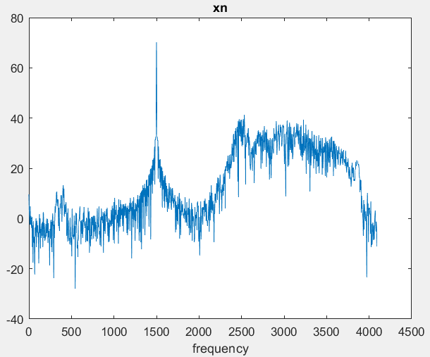

Xn (chirping with 1.5kHz noise)

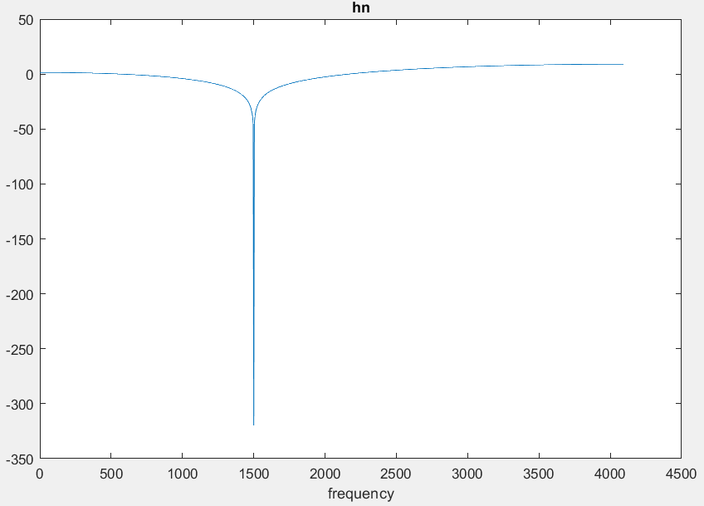

Hn (1st order Butterworth band stop filter designed in MATLAB using the butter function)

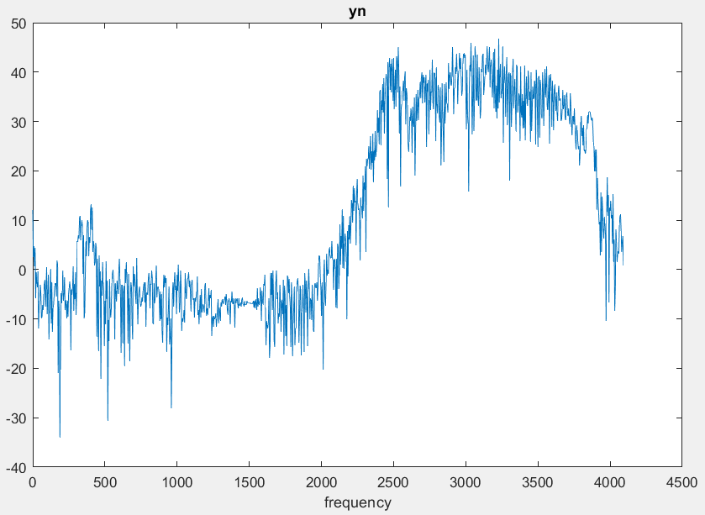

Yn (xn filtered with hn to remove the 1.5kHz noise)