August Byrne

EECE 433

6/11/2021

Lab 6

In this lab we learned about the usage of templates, cross-correlation, and edge detection in object tracking. We first used a template with ideal images to track a white ball at differing positions across multiple images. We then tried to do the same with a template of a heads silhouette on multiple real-world images of a person. We found that to successfully cross-correlate with these, we needed to use edge detection to remove everything from the image except the edges, which would then correctly correlate with the template.

Part 1:

|  |  |  |  |  |  |
| --- | --- | --- | --- | --- | --- |
| Test image | 1 | 2 | 3 | 4 | 5 |
| X | 28 | 52 | 112 | 172 | 232 |
| Y | 237 | 219 | 174 | 129 | 84 |
| R | 5 | 5 | 5 | 5 | 5 |

The tracking is accurate.



Image 1



Image 2



Image 3



Image 4

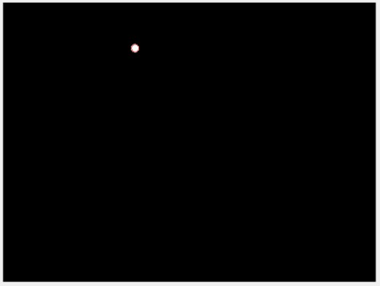

Image 5

Part 2:

1. a) In this part, the cross-correlation between the test images and the template is too even to give us any meaningful correlation between the two images. Many areas on the image have close correlation to the max correlation value. The two images are so dissimilar that the part of the image that cross-correlation finds is most like the template is the top right corner of the projector screen. This is not working as we want.

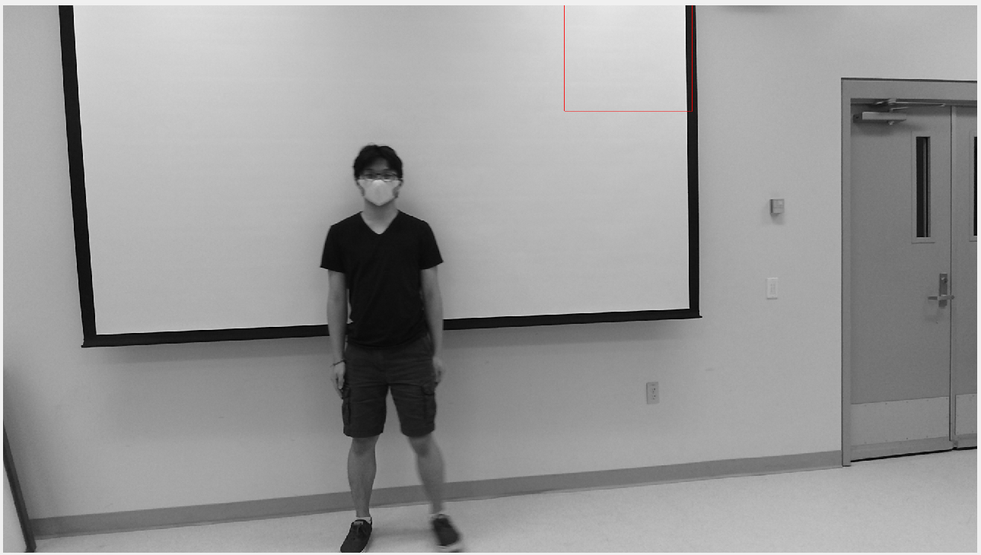

Example of part a being poorly correlated

b) In this case, the cross-correlation works correctly. There are very few locations that have comparable cross-correlation to the location with max correlation. After edge detection, we are left with an outline of a head (among outlines of everything else) which has a much stronger correlation with our template, since the template is an outline of a head.

|  |  |  |  |  |  |
| --- | --- | --- | --- | --- | --- |
| Test image | 1 | 2 | 3 | 4 | 5 |
| X | 457 | 494 | 545 | 580 | 630 |
| Y | 202 | 202 | 192 | 196 | 201 |

The testing is accurate. It correctly tracks his head.

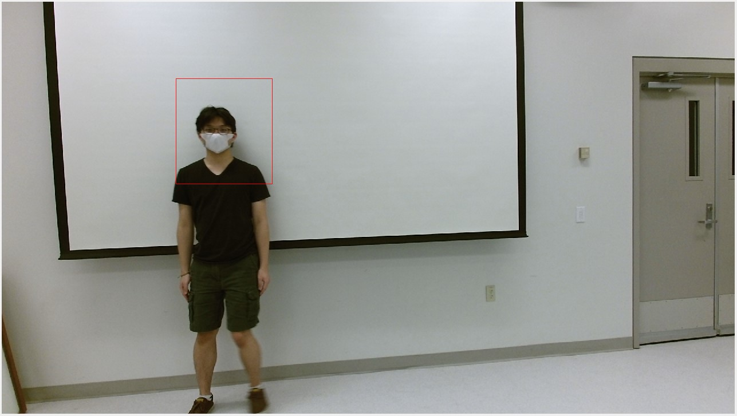

Image 1

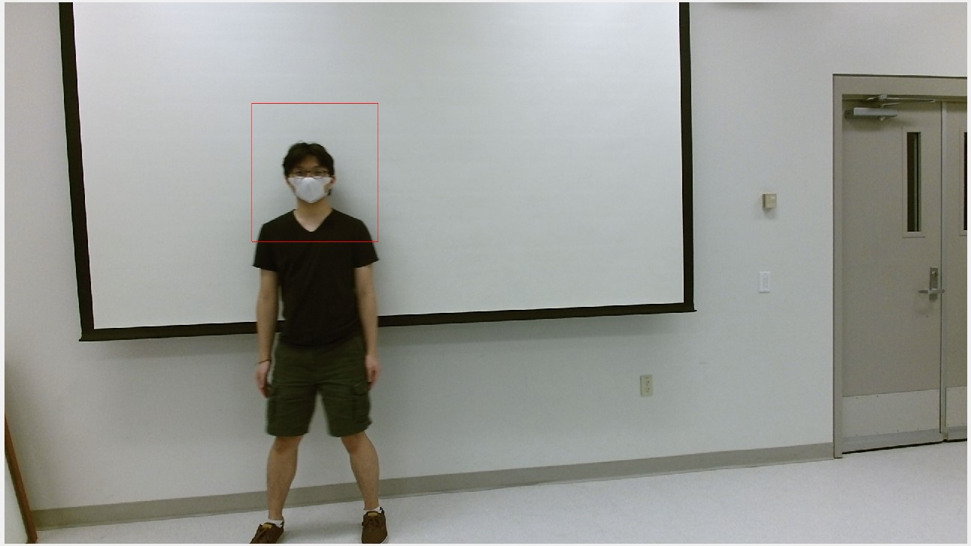

Image 2

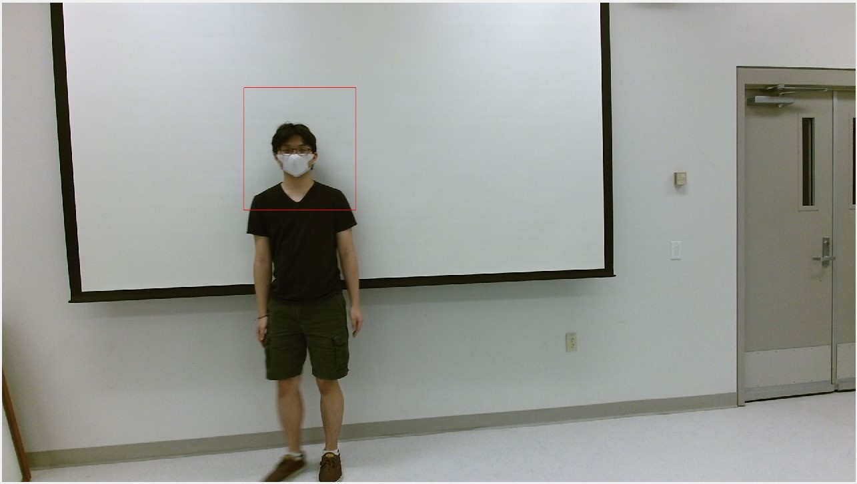

Image 3

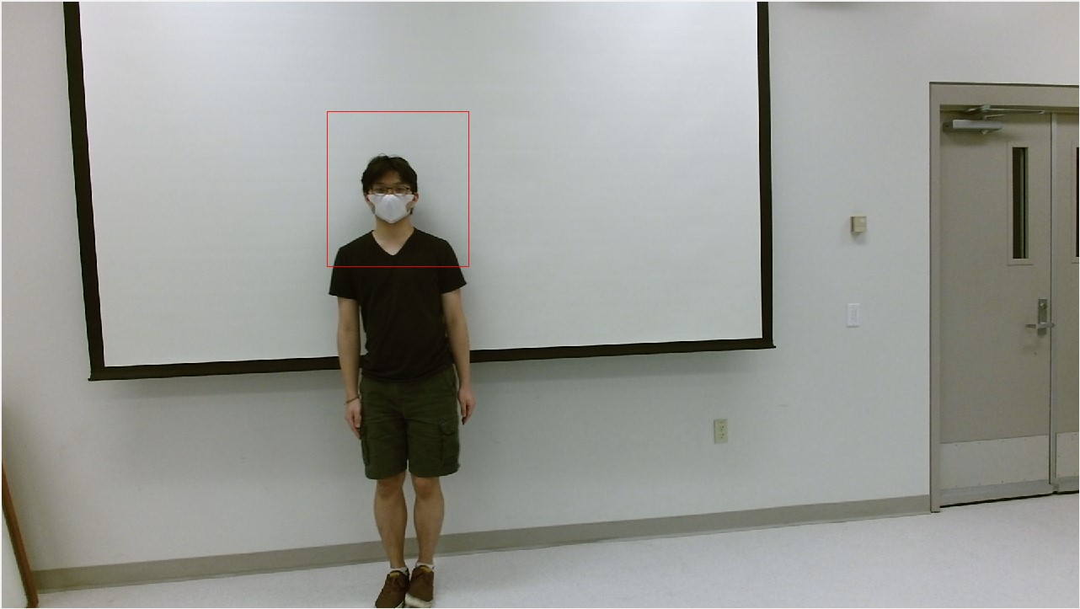

Image 4

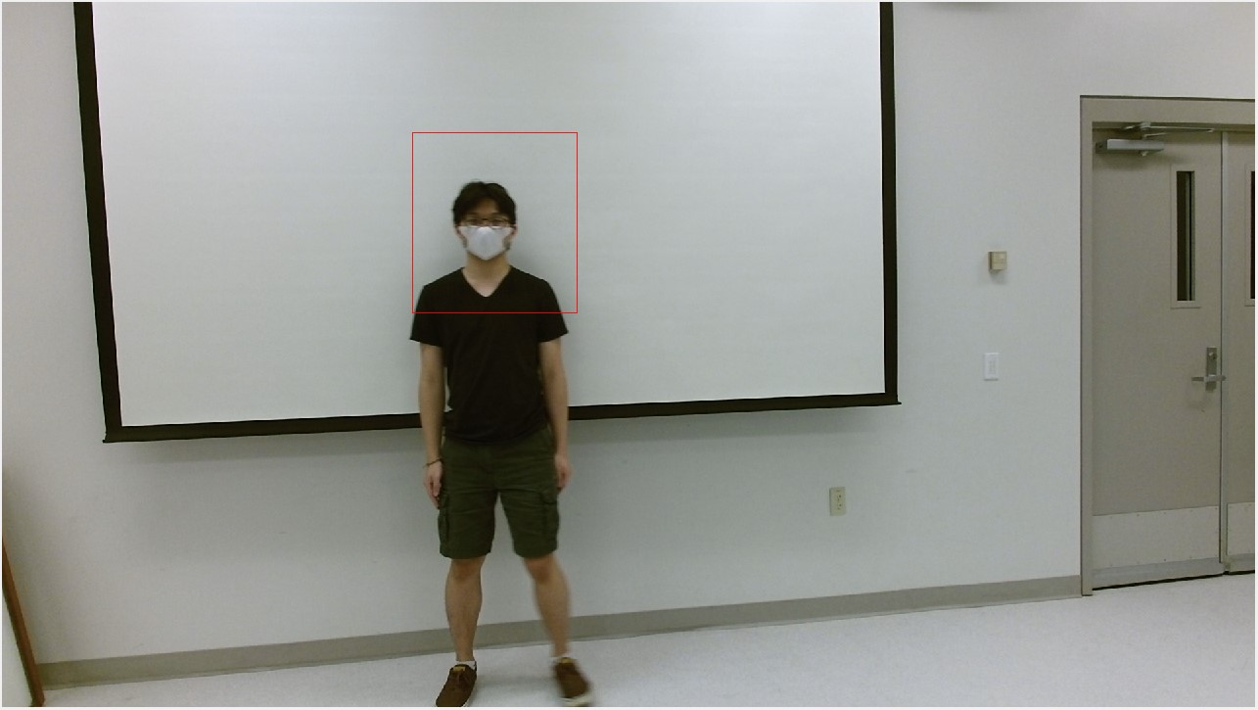

Image 5

In conclusion, if you know the shape of the object that you are trying to track, and this shape does not change much between frames, you can use a template and cross-correlation in conjunction with edge detection to track the object in images.