Norwegian Dictionary App Development Plan
Sep 28, 2026 · @August Yang
An offline Norwegian learner's dictionary for iPhone and iPad (iOS and iPadOS 18.0+) that covers Bokmål and Nynorsk side by side, finds any inflected form, and shows every definition and example in English and Simplified Chinese. Target App Store release: Feb 1, 2027.

App information
The app is a fast, fully offline lookup tool for people learning Norwegian, built on the two official dictionaries and translated ahead of time so no lookup ever waits on a network or an AI call.
Item | Plan
Working name | Slå opp ("look it up"); other candidates: Norsk ordbok – Norwegian Dictionary, NorskDict – Norwegian Dictionary
Platforms | iPhone and iPad, iOS 18.0+ and iPadOS 18.0+ (iPhone XS/XR and later, iPad 7th gen and later)
App Store category | Reference (secondary: Education)
Audience | Learners of Norwegian at A1–C1 who read English or Chinese, including students, immigrants and expats in Norway
App UI languages | English and Simplified Chinese at launch
Content languages | Norwegian (Bokmål and Nynorsk) definitions, English and Simplified Chinese translations
Size of content | 186,912 articles, about 590,000 searchable word forms, about 200,000 example sentences
Connectivity | Works entirely offline; no account, no server
Data collection | None planned (App Privacy: "Data Not Collected")
Description (App Store draft). Look up any Norwegian word, in any form. Type gikk, bøkene or augo and get the dictionary entry for gå, bok or auge, with Bokmål and Nynorsk shown side by side. Every definition and example sentence comes with English and Chinese translations, and everything works offline.
Positioning. No current app combines all four of: offline, both written standards, inflection lookup and Chinese.
App | Offline | Bokmål | Nynorsk | Inflection lookup | English | Chinese | Price
Ordboka | No | Yes | No | Yes | AI, online | AI, online | 50 free searches, then $3.99/month or $29.99/year
Farlex Norsk Ordbok | Yes | Yes | No | No | Partial | No | Free, $4.99 ad-free
Ordnett (Gyldendal) | Yes | Yes | Yes | Partial | Yes | Yes (separate dictionary) | Paid account required
This app | Yes | Yes | Yes | Yes, 590k forms | Yes | Yes | Open decision

Functionalities
Version 1 is search plus a complete entry view; study features and system integrations follow in 1.x releases.
Area | Feature | Release
Navigation | Tab bar with Search, Bookmarks, History and Settings on iPhone; the same four as a sidebar on iPad | v1
Search | Any inflected form finds its base word (gikk → gå, åt → ete, augo → auge), with the grammatical form shown ("past tense of gå") | v1
Search | Prefix search as you type (headwords starting with the query), results under 50 ms per keystroke | v1
Search | Similar headwords (Lignende oppslagsord): spelling within 1–2 edits, e.g. bøkker → bøkkar, lesse → lese | v1
Search | Bokmål ↔ Nynorsk variants surfaced together (ven / venn, kvit / hvit) | v1
Search | Accent- and letter-tolerant input: aa → å, oe → ø, ae → æ, fore → fôre | v1
Search | Reverse search from English or Chinese (glosses and definitions, full-text index) | v1
Results | Bokmål and Nynorsk results on two tabs: switch with a segmented control or by swiping left/right; the last-used tab is kept | v1
Entry | Bokmål/Nynorsk switched by tab or swipe on iPhone, side by side on iPad; homographs grouped (pleie "care for" and pleie "usually do") | v1
Entry | Numbered senses with sub-senses, examples and fixed expressions (idioms) | v1
Entry | Norwegian shown by default; small EN and 中文 toggles on the entry page show the English and Chinese translations; the toggle state is remembered for the next search | v1
Entry | Fixed expressions and inflection table as collapsible sections; whether each is expanded or collapsed is remembered for the next entry | v1
Entry | Full inflection table, the searched form highlighted, all accepted variants listed | v1
Entry | Tappable cross-references ("see: stilling") | v1
Entry | Pronunciation with Apple's built-in Norwegian voice (AVSpeechSynthesizer, nb-NO); Nynorsk uses the same voice | v1
Entry | "Machine-translated" label on translations, with a Report error button | v1
Personal | Bookmarks and search history, stored on device (SwiftData) | v1
Settings | Theme: a few background colour themes, plus Light, Dark or follow the system | v1
Personal | Word lists and flashcard review | 1.1
Personal | iCloud sync of bookmarks and lists (CloudKit) | 1.2
System | Home Screen widget: word of the day | 1.1
System | App Intents and Spotlight: look up a word from Siri or Spotlight | 1.2
System | Apple Intelligence explanations (Foundation Models, iOS 26+ devices only, hidden elsewhere) | Later
Content | More translation languages (e.g. Korean, Ukrainian, Arabic) from the same pipeline | Later

Data sources and licences
All bundled content can be used in a paid, offline app: the dictionaries allow commercial use and modification, and the translations are generated by us.
Source | Used for | Licence | Conditions the app must meet
Bokmålsordboka and Nynorskordboka (Språkrådet + University of Bergen), downloaded 2026-09-28 | Headwords, definitions, examples, idioms | Open licence from UiB and Språkrådet: any purpose incl. commercial, may modify and redistribute | Credit both owners; state that the content was changed; state clearly that UiB and Språkrådet are not responsible for the changes
Norsk ordbank (via the dictionaries' inflection data) | Inflection tables, form index | CC BY 4.0 | Attribution in the app and on the App Store page
English and Chinese translations | Glosses, definitions, examples | Our own output (Claude Sonnet 5); Anthropic's terms assign outputs to the user | Label as machine-translated, not produced by UiB or Språkrådet
Apple speech framework | Pronunciation | System framework, no licence cost | None beyond Apple's developer terms
What the app shows. An About → Sources screen with:
- "Dictionary content: Bokmålsordboka and Nynorskordboka, © Språkrådet and the University of Bergen, used under their open licence. Inflection data: Norsk ordbank (CC BY 4.0)."
- "The content has been restructured and English and Chinese translations have been added by machine. Språkrådet and the University of Bergen are not responsible for these changes."
- The dictionary data version (download date) and links to the licence pages.
What to avoid.
- Using "Bokmålsordboka", "Nynorskordboka", "ordbøkene" or their logos in the app name, icon or marketing in a way that suggests endorsement.
- Keeping the GitHub repository public, unless the published form carries the same credits and change notice.
- Adding Wiktionary text (CC BY-SA would require share-alike for the derived data) or NLLB output (non-commercial licence).
Before submission, email ord@uib.no to confirm the attribution wording; the full licence page was only readable in excerpt during research.

Architecture
The pipeline in the norskDict repo turns the UiB dumps into one read-only SQLite file; the app ships that file and never needs a network to look anything up.
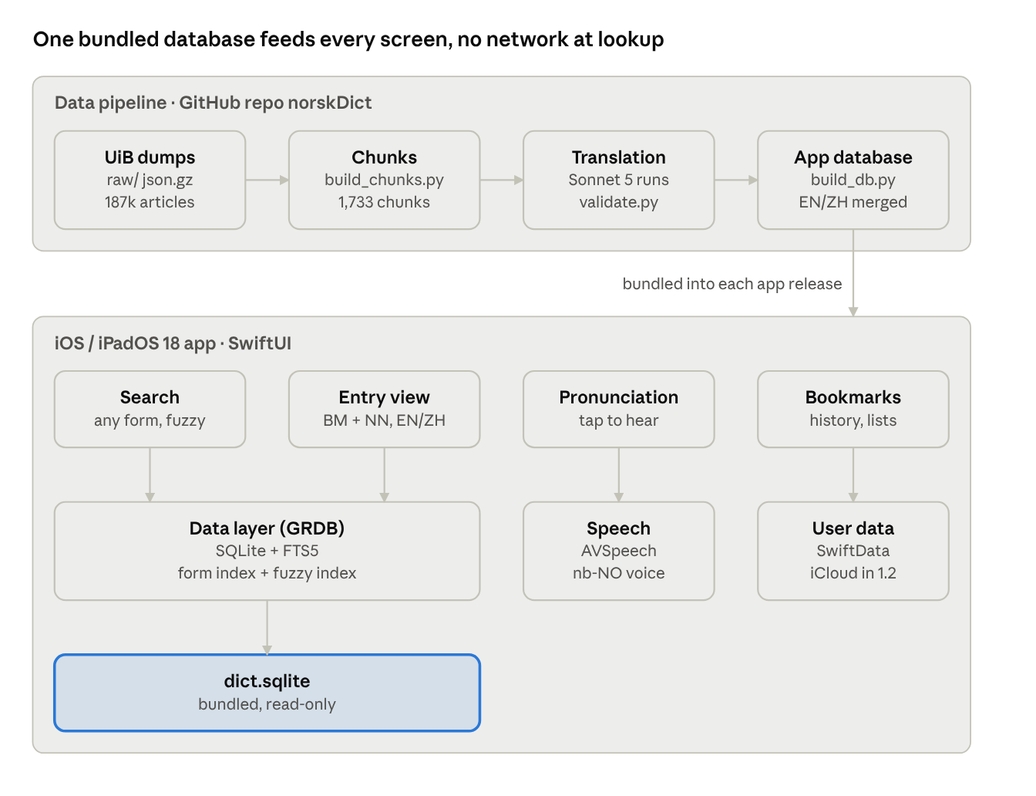
data pipeline and app components
Each app release bundles a fresh dict.sqlite; everything the user creates lives separately in SwiftData.
Layer | Choice | Reason
Language and UI | Swift 6, SwiftUI, deployment target iOS/iPadOS 18.0 | One codebase for iPhone and iPad; TabView on iPhone, NavigationSplitView sidebar on iPad
Dictionary data | SQLite through GRDB.swift (MIT), opened read-only | Fast indexed lookups, FTS5 full-text search
Form lookup | form(form_fold, article_id, tags) table, about 1.04M rows, indexed on the folded form | Sub-millisecond lookups measured in the prototype (0.01 ms each)
Similar headwords | Precomputed deletion index (SymSpell method) over about 190,000 headwords | Edit distance 1–2 in a few ms on device
Reverse search | FTS5 index over English and Chinese glosses and definitions | Lets users search friend or 朋友
User data | SwiftData: bookmarks, history, lists | Built in, CloudKit sync later
View preferences | @AppStorage (UserDefaults): EN/中文 toggles, last Bokmål/Nynorsk tab, expanded/collapsed state of fixed expressions and inflection, theme | Survives relaunch; read before the entry renders, so no flicker
Themes | A small set of colour tokens per theme (background, surface, text, accent), each with light and dark values | Dark mode and custom backgrounds from one set of views
Pronunciation | AVSpeechSynthesizer, voice nb-NO | Free, offline, no audio licensing
Data build | build_db.py in the repo merges chunks/ + out/ + inflections into dict.sqlite, stamped with the data date | Reproducible; a new UiB dump means rebuilding and shipping an app update
Size. Estimated text is about 50 MB (Norwegian 17 MB, English 18 MB, Chinese 15 MB) plus the form index, so about 120–150 MB installed and 40–50 MB compressed download.

Development plan
Seven phases take the app from data to App Store in about 18 weeks, with translation running in the background the whole time. Dates assume one developer working part-time; shift them if that changes.
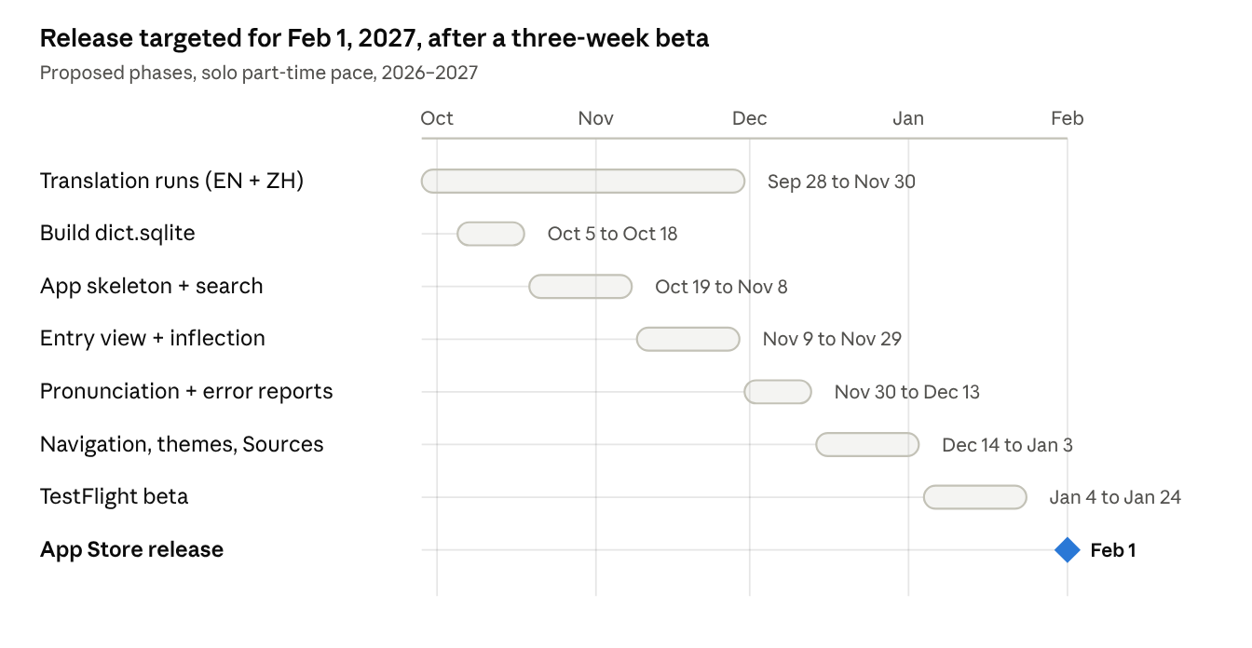
proposed phases to release
Phases 2–5 can start before translation finishes: the first 353 chunks (the ~15,000 most common words) arrive first, which is enough to build and test every screen.
Phase 1 · Data pipeline (translation runs in background)
- ☐ Translation runs reach chunk 353 (common words), then all 1,733 chunks; 40 done as of Sep 28
- ☐ Spot-check 100 random entries per 200 chunks, English and Chinese; log fixes as issues
- ☐ Write build_db.py: articles, senses, examples, idioms, forms, fuzzy index, FTS5, data-date stamp
- ☐ Group homograph articles and link Bokmål/Nynorsk pairs by headword
- ☐ Size check: dict.sqlite under 150 MB, compressed download under 60 MB
Phase 2 · App skeleton and search
- ☐ Xcode project, SwiftUI, deployment target 18.0, iPhone + iPad
- ☐ GRDB read-only connection to the bundled database
- ☐ Search screen: form lookup, prefix, similar headwords, EN/ZH reverse search, grouped results
- ☐ Input folding (aa → å, oe → ø, ae → æ) and diacritics
- ☐ Performance test: under 50 ms per keystroke on iPhone XS
Phase 3 · Entry view and inflection
- ☐ Results screen: Bokmål and Nynorsk tabs, switched by segmented control or swipe, last tab remembered
- ☐ Entry layout: Bokmål/Nynorsk tabs or swipe on iPhone, side by side on iPad
- ☐ Senses, sub-senses, examples; Norwegian by default with EN and 中文 toggles whose state is remembered
- ☐ Collapsible fixed expressions and inflection sections, expanded/collapsed state remembered
- ☐ Inflection table with the searched form highlighted
- ☐ Tappable cross-references and back navigation
Phase 4 · Pronunciation and error reports
- ☐ AVSpeechSynthesizer for headwords and examples (nb-NO voice)
- ☐ "Machine-translated" label and Report error (mail draft or form with article id)
Phase 5 · Navigation, bookmarks, themes, Sources
- ☐ Tab bar with Search, Bookmarks, History, Settings; the same as a sidebar on iPad
- ☐ SwiftData bookmarks and history
- ☐ iPad keyboard shortcuts (⌘F to search)
- ☐ Settings: themes (background colours + Light/Dark/System), UI language (English/中文), text size
- ☐ About → Sources screen with the licence credits and change notice
- ☐ Accessibility: Dynamic Type, VoiceOver labels, contrast checked in every theme
Phase 6 · TestFlight beta
- ☐ 20–30 testers: learners reading English and Chinese, at least one Nynorsk user
- ☐ Fix crashes and translation errors reported; freeze data version
Phase 7 · App Store release
- ☐ App Store listing in English and Chinese, screenshots for 6.9" iPhone and 13" iPad
- ☐ Privacy label "Data Not Collected", export compliance (no encryption beyond Apple's)
- ☐ Submit for review about one week before the target date

Testing and release
Test on the slowest devices iOS 18 supports: if search feels instant on an iPhone XS, it will everywhere.
Area | Target | How it is checked
Test devices | iPhone XS (oldest on iOS 18), a current iPhone, iPad 7th gen (oldest on iPadOS 18), an iPad Pro | Physical devices or simulators; TestFlight builds on both families
Search speed | Under 50 ms per keystroke, form lookup under 5 ms | XCTest performance tests on a list of 1,000 forms (irregular verbs, compounds, Nynorsk variants)
Launch time | Under 1 s to the search field, database opened lazily | Instruments, App Launch template
Data correctness | Every chunk passes validate.py; built database row counts match the source (186,912 articles) | Checks in build_db.py, run before every release
Translation quality | Spot-check 100 random entries per 200 chunks; fewer than 2 clear errors per 100 | Manual review in English and Chinese, errors logged as GitHub issues
Accessibility | Dynamic Type up to AX5, full VoiceOver labels, dark mode | Accessibility Inspector, manual pass
Offline | Every feature works in airplane mode | Manual test on device
App Store checklist.
- ☐ Apple Developer Program membership active
- ☐ Bundle ID, app name reserved, icon without UiB/Språkrådet marks
- ☐ Listing text and screenshots in English and Simplified Chinese
- ☐ Privacy nutrition label: Data Not Collected; privacy policy URL
- ☐ Age rating questionnaire (the dictionaries include vulgar words: expect 12+ or add a filter)
- ☐ Sources screen and App Store description carry the licence credits
- ☐ Pricing decided (see open decisions)

Risks and open decisions
The biggest risk is translation throughput and cost; everything else in the app is well understood.
Risk | Effect | Mitigation
Cloud credit runs out or is not applied to scheduled runs | Translation falls back to Pro limits and slows to weeks | Common words first (chunks 1–353); finish the long tail with a cheap batch API model (about $20–40 on Gemini Flash or Haiku)
Translation errors in idioms and culture-bound senses | Learners trust a wrong meaning | Spot checks, "machine-translated" label, Report error button, fixes in the next data release
UiB licence wording differs from the excerpt read | Attribution screen must change | Confirm with ord@uib.no before submission
Database larger than estimated | Slow download, App Store cellular prompt | Compress example text, drop unused columns, move Chinese or English to an optional download (Background Assets)
Norwegian speech voice missing or poor on some devices | No pronunciation | Detect the voice, hide the button, prompt to download the enhanced voice in Settings
Weekly UiB updates change article ids | Stale favourites | Store favourites by headword + dictionary as well as id
Open decisions.
- ☐ Final app name (working name Slå opp)
- ☐ Pricing: free, paid up front, or free with a one-time unlock (no running costs, so no subscription is needed)
- ☐ Whether v1 includes the English/Chinese reverse search or moves it to 1.1
- ☐ How often to ship data updates (every release, or quarterly)
- ☐ Norwegian as a third UI language
Sources.
- ordbøkene.no: open data and licence
- ord.uib.no: word lists and API
- Språkbanken: Norsk ordbank
- Ordboka on the App Store
- Claude API pricing
- GRDB.swift

