**Brief Introduction to the project**

For this project, a virtual zoo will be built up. In the zoo, there will be several types of animal archetypes with different behavioral logics. Observing how the animals will adapt in the entire environment is the highlight of this project.

**Solution**

The basic structure of the program can be defined as: 2 main class and the map level.

There are two parent classes. One is “Animal” and the other one is “Food”. Three classes can inherit from the “Animal” class, they are “Gatherer”, “Hunter”, and “Hider”. There is only one food in the game so I didn’t create the child class of the “Food” parent class. I just used the “Food” class.

For the “Animal”, there are some properties: Health, Speed, Attack, Sight range. Three child classes will have different settings according to their talents. Also, it has some basic functions like GetHealth()/SetHealth(), GetSpeed()/SetSpeed() and so on…

“Gatherer” has some important functions as listing below:

* Wandering(); this function is used for making the character wander in the map if nothing happened to it. The function has restricted the boundary so the character will not get out of the map.
* SpawnChild(); this function is used for spawning a new character depending on different conditions. In this case, it will depend on the happiness of the Gatherer character.
* GetHappiness(); this function is used for returning the current character’s happiness.
* SetRandomTarget(); this function is used for setting the random location within a certain boundary.
* DealDMG(); this function is used for dealing some damage to the target.

“Hunter” has some important functions as listing below:

* Wandering(); this function is used for making the character wander in the map if nothing happened to it. The function has restricted the boundary so the character will not get out of the map.
* SpawnChild(); this function is used for spawning a new character depending on different conditions.
* DealDMG(); this function is used for dealing some damage to the target.
* Chase(); this function is used for chasing the target.

“Hider” has some important functions as listing below:

* Wandering(); this function is used for making the character wander in the map if nothing happened to it. The function has restricted the boundary so the character will not get out of the map.
* SpawnChild(); this function is used for spawning a new character depending on different conditions.
* DealDMG(); this function is used for dealing some damage to the target.
* Flee(); this function is used for running away from the predator.

“Food” can only heal and add happiness to the consumer, who is the Gatherer.

The ways how I did to achieve the objectives required by the assignment are listed below:

1. Gatherer eats Food: Gatherer will firstly wander in the map. When it spots a food within the sight, it will use the state machine to execute the eat function. The food has a collision box. When a Gatherer is overlapping the food, the food will get destroyed and add health and happiness to the Gatherer.
2. Gatherer spawns: when a gatherer has enough happiness, it will use SpawnActor to spawn a new gatherer. In the meantime, it will clear the happiness to 0.
3. Gatherer attacks: Gatherer will attack Hunter when Hunter is very close to it. When a range is reached, they will both enter the Attack phase.
4. Hunter seeks out Gatherer and Hider: Hunter will firstly wander in the map. When it sees any other animal, it will enter chase state. If a close range is reached, it will enter the attack state. If the prey is dead, it will enter Eat state. In this Eat state, the prey will be destroyed in the meantime the Hunter will have Kills increased.
5. Kills is a counter for the number it kills. When it is reached 2, a new hunter will be spawned and set kills to 0.
6. Hider flee: when the hider is close to other animal including other hiders, it will try to flee away them. To flee, just get the location of the target and multiply by -1, to get the negative direction. However, when the distance is very close, they will fight to death.
7. There is a time tick in the class. When the time reaches 60s, it will spawn a new hider and set the time to 0.
8. How to count second in Tick(): in the tick function, as we all know, the time elapses according to the FPS. So it won’t be 1 second per DeltaTime. To do that, just make a var and let it incremented by the Deltatime. When the var reaches 1.0f or higher, that is the 1 second I am looking for. I used it for making the fight/battle look normal in speed and time. Remember to reset the timer.

**Methodology used in AI**

I used State Machine to help the agents to make decisions.

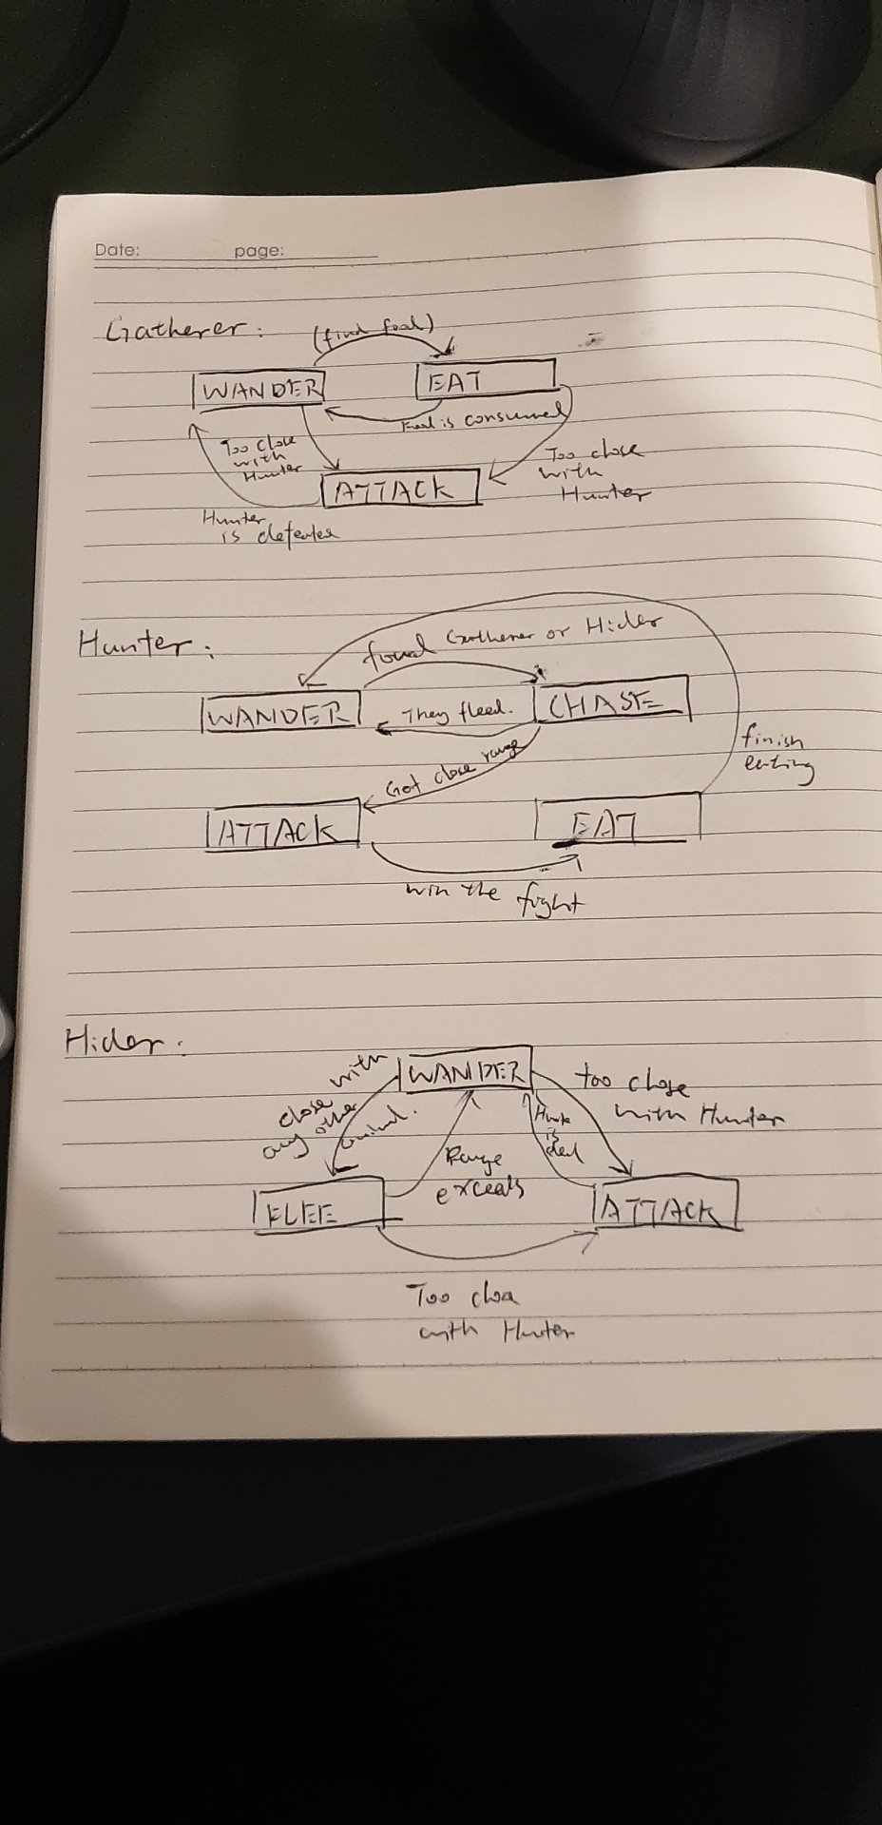

**Bugs and issues**

* The food is not generated randomly.
* No advanced AI tech.
* Game balance is not adjusted properly(the game functions are fine).
* No A* or any other navigation.
* No obstacle in the maps.
* Defense is not setup.
* Size is not setup.