# React: Film Releases

## Reading

[Thinking In React (20 mins)](https://facebook.github.io/react/docs/thinking-in-react.html)

## Practice

You task is to plan and build an application that displays a list of upcoming film titles, each one linking to their [imdb](https://www.imdb.com/" \t "_blank) page.

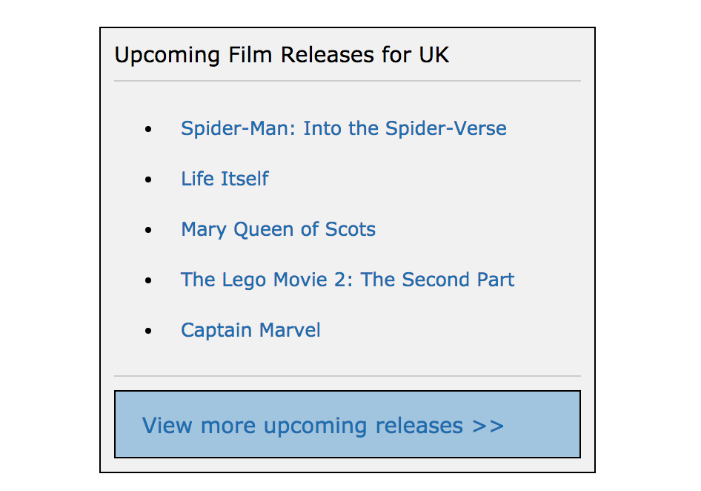 Screenshot of example result

* Draw out the UI on paper, breaking it down into components.
* Draw a component hierarchy diagram, noting down any state and props for each component.
* Implement the application in React.

Note: The ‘View more upcoming releases’ button can link to the imdb calendar page - <https://www.imdb.com/calendar/?region=gb>

### Data

You can use the following data to display in your application:

[

{

id: 1,

name: "Spider-Man: Into the Spider-Verse",

url: "https://www.imdb.com/title/tt4633694/?ref\_=rlm"

},

{

id: 2,

name: "Life Itself",

url: "https://www.imdb.com/title/tt5989218/?ref\_=rlm"

},

{

id: 3,

name: "Mary Queen of Scots",

url: "https://www.imdb.com/title/tt2328900/?ref\_=rlm"

},

{

id: 4,

name: "The Lego Movie 2: The Second Part", url: "https://www.imdb.com/title/tt3513498/?ref\_=rlm"

},

{

id: 5,

name: "Captain Marvel",

url: "https://www.imdb.com/title/tt4154664/?ref\_=rlm"

}

]