Auguste & Camille Colle with KU Leuven

Two brothers, an industrial engineer and a theoretical physicist sharing a passion for cycling and ice cream. They ride under the banner of KU Leuven where Auguste is employed. The KU Leuven has participated in the Sun Trip 2016. Camille cycled 3 months trough the USA in the summer of 2017 and picked up a passion for long distance touring.

Instutional partner

KU Leuven is an institution for research and education with international appeal. All programmes at this University are based on the innovative research of its scientists and professors. The Energy & Automation (E&A) research group is one of the 14 research groups of the faculty of industrial engineering at the KU Leuven Technology Campus Ghent. The group is part of the ESAT cluster Electrical Engineering

The research of E&A is situated in the field of electrical energy technology and industrial automation. Various research projects led to the development of expertise in autonomous hybrid energy systems, industrial datacom and security, PV metrology, industrial energy measurements and light electrical mobility.

https://www.kuleuven.be
Sponsors
Trident Trikes is located in beautiful Lincolnton NC- about 45 miles NW of Charlotte. It is a small company, but it strives to be the best in design, innovation, and value in the Recumbent Trike industry, at the same time giving the best in personal customer service.

http://tridenttrikes.com/

Heliostream
http://www.heliostream.be/


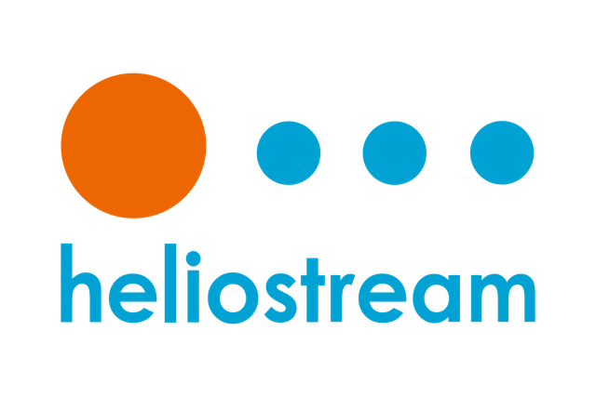

Solar bicycle
The Chameleon tandem trike from tridenttrikes is converted to an electric assisted trike and fitted with solar panels from SunPower. In the design process both efficiency and robustness are investigated in detail.

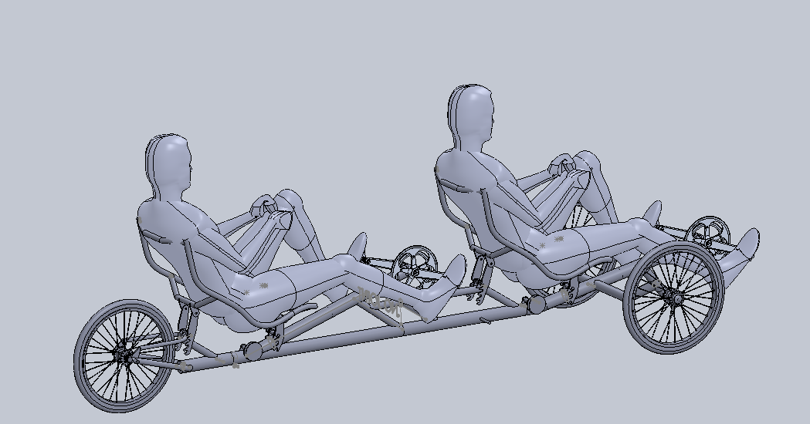

Some words of the adventurers

Auguste: Nowadays most people agree that renewable energy and energy efficiency are of major concern. This explains shifts in consumer goods and government regulations, for example the subsidizing of photo-voltaic installations or the banning of halogen spotlights from the European market. With this in mind, how can one explain that most people still believe a 1500 kilogram vehicle is the normal way to go for transporting a 80 kg person? It's intriguing how the automobile sector dominates the main idea on how to get from one place to another. For this (and many other reasons) I really like the Sun Trip initiative, putting Light Electric Vehicles on the radar by demonstrating how much is possible with so much less. I'm looking forward to meet our fellow enthusiasts, to share ideas and to experience for myself that the average amateur solar bicycle beats the average industrial alternative on energy efficiency.

Camille: In march 2017 I finished my PhD in theoretical nuclear physics and took a much needed vacation. I decided to ride across the USA on my bicycle. The experience was unforgettable and resulted in a strong passion for cycling and long distance touring. Not long after I returned from my 3 month cycling adventure I started dreaming about a next long distance tour. When the opportunity arose to participate in the SunTrip with my brother under the banner of the KU Leuven, where he works, I didn’t hesitate for a second. The foresight of cycling all the way to China greatly entices me and I am looking forward to embark on this epic adventure. Additionally I think renewable energy and sustainability should be among the top-priorities in a modern society and I am happy to help advocate this view by participating in the sun trip.

