Microalgae Metabolic Modeling with COBRApy
Light, CO2 and acetate growth, carbon storage, and flux maps
24 October 2026

Contents
Click any line to jump to that section.
- Overview
- The model at a glance
- Figure 1 – Flux maps: light vs dark
- Figure 2 – Growth and gas exchange in three modes
- Figure 3 – Light response curve
- Figure 4 – Growth vs starch and lipid
- How to run it yourself
- Limits and next steps
- Appendix A – Model code
- Appendix B – Simulation and figure code

1. Overview
This report builds a microalgae metabolic model in COBRApy, runs flux balance analysis (FBA) on it, and shows the results as pictures. The model is a compact Chlamydomonas-like core network: 27 reactions and 20 metabolites. All numbers and figures come from running the code in the appendices with COBRApy 0.32.1.
Main results:
Growth mode | Light (mmol photons/gDW/h) | Acetate uptake (mmol/gDW/h) | Growth rate (1/h) | O2 exchange | CO2 exchange
Autotrophic | 60 | 0 | 0.158 | +6.56 (released) | −6.01 (fixed)
Mixotrophic | 60 | 10 | 0.432 | +0.51 | +3.59
Heterotrophic (dark) | 0 | 10 | 0.255 | −6.87 (consumed) | +10.31
Mixotrophy grows fastest because light supplies ATP and NADPH while acetate supplies carbon. In the dark the cell breathes acetate: it consumes O2 and releases CO2, the reverse of photosynthesis.
Sign convention: exchange flux < 0 means uptake, > 0 means release. Fluxes are in mmol/gDW/h; growth is in 1/h.
Back to contents

2. The model at a glance
Pathway | Reaction(s) | What it does
Light reactions | LEF, CEF | 8 photons give 1 O2, 2 NADPH and 3 ATP (linear flow); cyclic flow gives extra ATP
Carbon fixation | CBB | Calvin–Benson cycle: 3 CO2 + 9 ATP + 6 NADPH → 1 triose phosphate (G3P)
Central carbon | GLYC, GNG, PDH | G3P ↔ pyruvate → acetyl-CoA
Acetate use | ACS, GLX, PEPCK | Acetate → acetyl-CoA; glyoxylate cycle makes C4 and C3 sugars from acetate
Respiration | TCA, RESP | Burns acetyl-CoA to CO2; NADH + O2 → ATP
Storage | STARCH_SYN, FAS | Starch from G3P; C16 fatty acid (lipid) from acetyl-CoA
Nitrogen | AAS | Pyruvate + NH4 → amino acids
Biomass | BIOMASS | 6 amino acid units + 4 G3P + 0.5 fatty acid + 40 ATP per gDW
Two rules keep it realistic: the Calvin cycle is switched off in the dark, and linear electron flow is capped at 9 mmol/gDW/h, so growth saturates in strong light.
Back to contents

3. Figure 1 – Flux maps: light vs dark
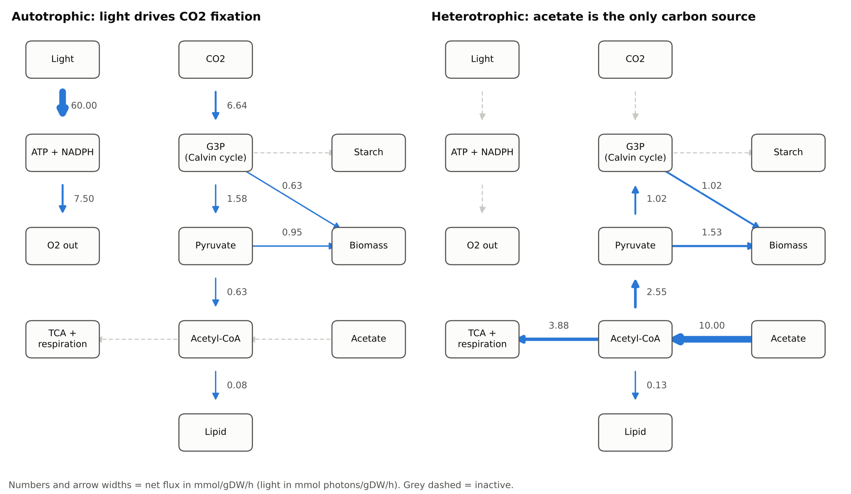
Figure 1. Flux maps of the microalgae model. Left: autotrophic growth on light and CO2. Right: heterotrophic growth on acetate in the dark. Arrow width and numbers show net flux (mmol/gDW/h).
How to read it: in the light (left), 60 photons drive 7.5 units of linear electron flow, releasing 7.5 O2 and fixing 6.64 CO2 into G3P. In the dark (right), the light and Calvin-cycle arrows go grey. Acetate (10.0) enters as acetyl-CoA; 3.88 is burned in the TCA cycle for energy and 2.55 is turned back into pyruvate and then G3P (gluconeogenesis) to build biomass.
Back to contents

4. Figure 2 – Growth and gas exchange in three modes
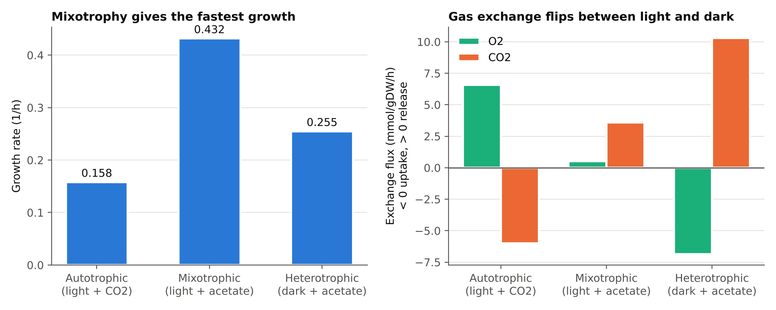
Figure 2. Left: growth rate in each mode. Right: O2 and CO2 exchange; positive = released, negative = taken up.
Mixotrophic growth (0.432 1/h) is slightly more than the autotrophic and heterotrophic rates added together (0.158 + 0.255 = 0.413), because light energy and acetate carbon each relieve the other’s limit. Gas exchange flips sign between light and dark.
Back to contents

5. Figure 3 – Light response curve
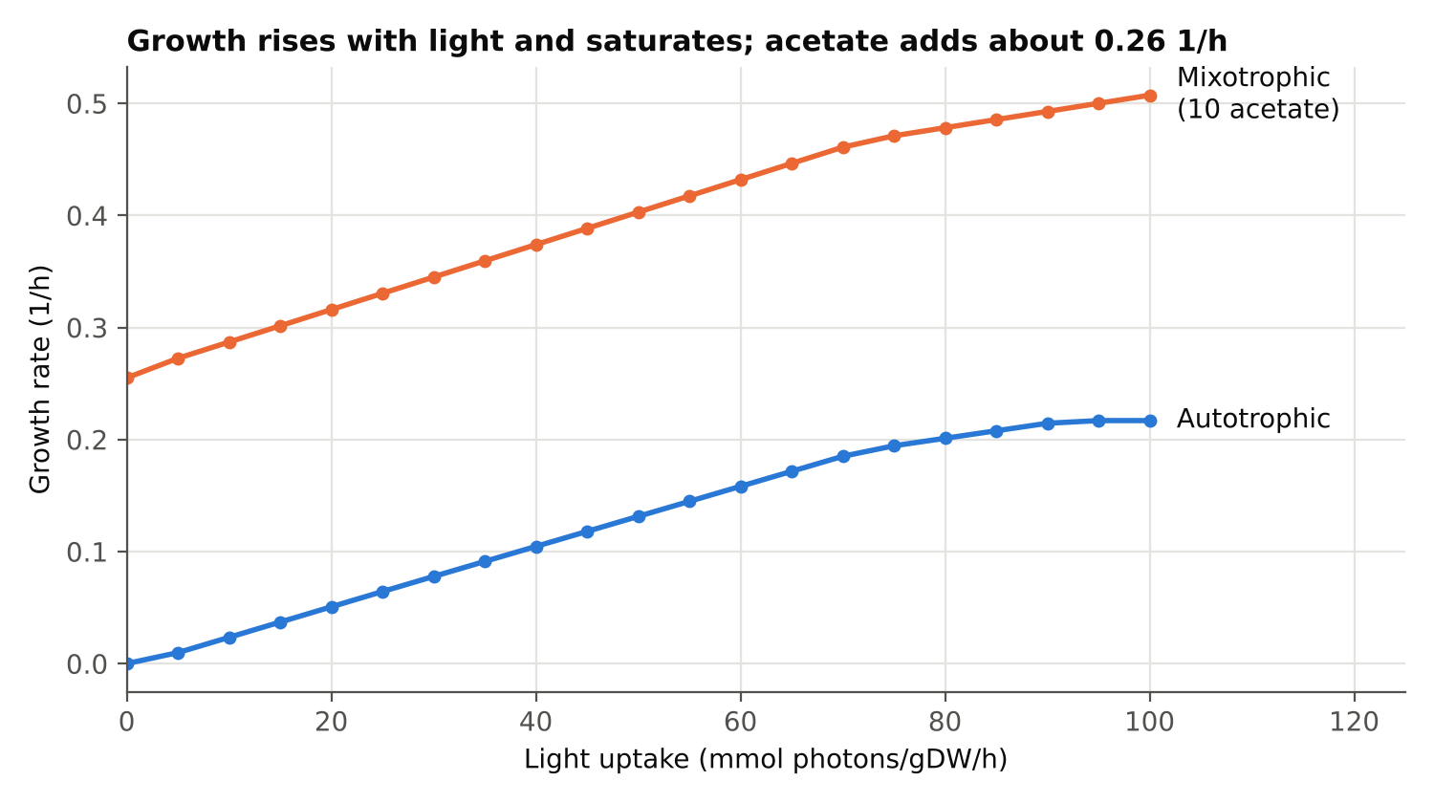
Figure 3. Growth rate against light uptake for autotrophic and mixotrophic cells.
Growth rises almost linearly with light, then flattens above about 70 mmol photons/gDW/h as the photosystems reach their capacity. Adding 10 mmol/gDW/h acetate lifts the whole curve by about 0.26–0.29 1/h.
Back to contents

6. Figure 4 – Growth vs starch and lipid
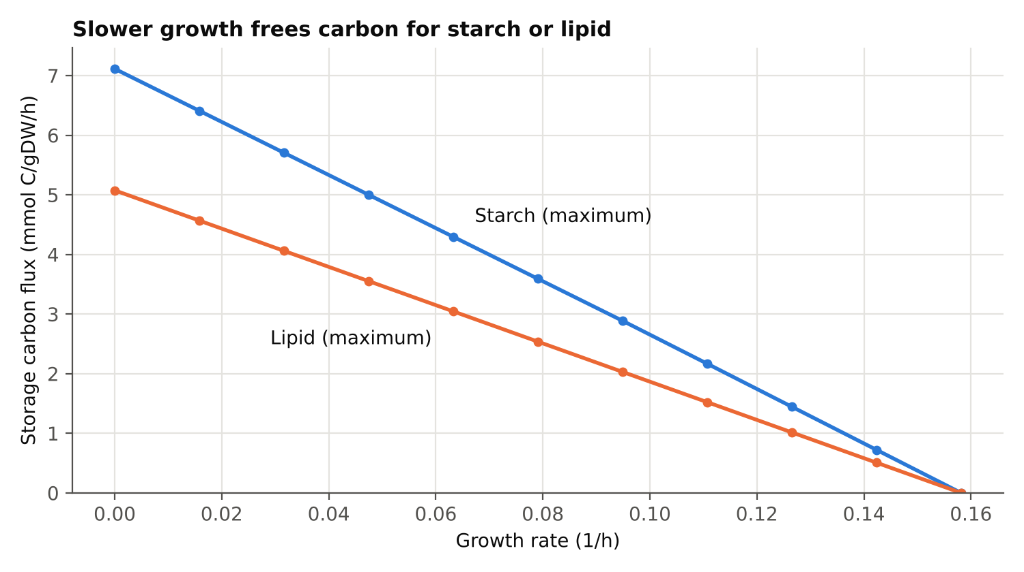
Figure 4. Maximum carbon that can go into starch or lipid at each growth rate (autotrophic, light 60).
This is a production envelope. When growth stops (for example under nitrogen starvation), up to 7.11 mmol C/gDW/h can go to starch or 5.08 mmol C/gDW/h to lipid. Lipid stores less carbon because fatty acid synthesis needs more ATP and NADPH per carbon. This is why algae accumulate starch first and lipid later when nitrogen runs out.
Back to contents

7. How to run it yourself
- Install COBRApy: pip install cobra matplotlib pandas
- Save the code in Appendix A as microalgae_cobrapy_model.py and Appendix B as microalgae_simulations.py in the same folder. (Both files are also supplied separately.)
- Run python microalgae_simulations.py.
- Open the new figures folder: it holds the four figures, CSV result tables, and the model as microalgae_core.xml (SBML).
To change conditions, edit set_mode(model, mode, light=..., acetate=...) or reaction bounds such as model.reactions.EX_nh4.lower_bound = -2 for nitrogen limitation.
Back to contents

8. Limits and next steps
- This is a teaching-scale model with lumped pathways and one compartment. Absolute numbers are illustrative, not predictions for a real strain.
- For research, load a curated genome-scale model of Chlamydomonas reinhardtii, such as iRC1080 or iCre1355, with cobra.io.read_sbml_model("iRC1080.xml"). The same analysis steps apply.
- Fit light and acetate uptake bounds to your own measurements before comparing with growth data.
- Useful next analyses: flux variability analysis (FVA), gene knockouts, and day–night cycles with starch as a carbon store.
Back to contents

Appendix A – Model code
"""
Microalgae core metabolic model in COBRApy
------------------------------------------
A compact, teaching-scale model of a green microalga (Chlamydomonas-like).
It lumps the main pathways so that flux balance analysis (FBA) can show
how the cell grows autotrophically, mixotrophically and heterotrophically,
and how it partitions carbon into starch and lipid.
Sign convention: exchange flux < 0 = uptake, > 0 = secretion.
Units: fluxes in mmol/gDW/h, light in mmol photons/gDW/h, growth in 1/h.
This is a simplified model; for research use a curated genome-scale
reconstruction such as iRC1080 (BiGG) or iCre1355.
Run: python microalgae_cobrapy_model.py
"""
from cobra import Model, Reaction, Metabolite
def build_model():
model = Model("microalgae_core")
# ------------------------------------------------------------ metabolites
def met(mid, name, formula=""):
return Metabolite(mid, name=name, formula=formula, compartment="c")
m = {
"photon": met("photon_c", "Photon"),
"co2": met("co2_c", "CO2", "CO2"),
"o2": met("o2_c", "O2", "O2"),
"h2o": met("h2o_c", "Water", "H2O"),
"nh4": met("nh4_c", "Ammonium", "NH4"),
"ac": met("ac_c", "Acetate", "C2H3O2"),
"atp": met("atp_c", "ATP"),
"adp": met("adp_c", "ADP"),
"nadph": met("nadph_c", "NADPH"),
"nadp": met("nadp_c", "NADP+"),
"nadh": met("nadh_c", "NADH"),
"nad": met("nad_c", "NAD+"),
"g3p": met("g3p_c", "Triose phosphate (C3)"),
"pyr": met("pyr_c", "Pyruvate (C3)"),
"accoa": met("accoa_c", "Acetyl-CoA (C2)"),
"oaa": met("oaa_c", "Oxaloacetate (C4)"),
"starch": met("starch_c", "Starch unit (C6)"),
"lipid": met("lipid_c", "Fatty acid, C16 (lipid)"),
"aa": met("aa_c", "Amino acid unit (C3N)"),
"biomass": met("biomass_c", "Biomass"),
}
def rxn(rid, name, stoich, lb=0.0, ub=1000.0, subsystem=""):
r = Reaction(rid, name=name, lower_bound=lb, upper_bound=ub, subsystem=subsystem)
r.add_metabolites({m[k]: v for k, v in stoich.items()})
return r
reactions = [
# ---------------------------------------------------- exchanges
rxn("EX_photon", "Light supply", {"photon": -1}, -100, 0, "Exchange"),
rxn("EX_co2", "CO2 exchange", {"co2": -1}, -1000, 1000, "Exchange"),
rxn("EX_o2", "O2 exchange", {"o2": -1}, -1000, 1000, "Exchange"),
rxn("EX_h2o", "Water exchange", {"h2o": -1}, -1000, 1000, "Exchange"),
rxn("EX_nh4", "Ammonium uptake", {"nh4": -1}, -10, 0, "Exchange"),
rxn("EX_ac", "Acetate uptake", {"ac": -1}, 0, 0, "Exchange"),
# ---------------------------------------------------- photosynthesis
# Linear electron flow: 8 photons -> 1 O2, 2 NADPH, 3 ATP
rxn("LEF", "Linear electron flow (PSII + PSI)",
{"photon": -8, "h2o": -2, "nadp": -2, "adp": -3,
"o2": 1, "nadph": 2, "atp": 3}, 0.0, 9.0, "Photosynthesis"),
# (upper bound 9 = photosystem capacity, so growth saturates in high light)
# Cyclic electron flow around PSI: extra ATP, no NADPH
rxn("CEF", "Cyclic electron flow (PSI)",
{"photon": -2, "adp": -1, "atp": 1}, subsystem="Photosynthesis"),
# Calvin-Benson cycle (lumped): 3 CO2 -> 1 triose phosphate
rxn("CBB", "Calvin-Benson cycle (RuBisCO)",
{"co2": -3, "atp": -9, "nadph": -6,
"g3p": 1, "adp": 9, "nadp": 6}, subsystem="Carbon fixation"),
# ---------------------------------------------------- central carbon
rxn("GLYC", "Glycolysis (G3P to pyruvate)",
{"g3p": -1, "adp": -1, "nad": -1, "pyr": 1, "atp": 1, "nadh": 1},
subsystem="Glycolysis"),
rxn("GNG", "Gluconeogenesis (pyruvate to G3P)",
{"pyr": -1, "atp": -2, "nadh": -1, "g3p": 1, "adp": 2, "nad": 1},
subsystem="Gluconeogenesis"),
rxn("PDH", "Pyruvate dehydrogenase",
{"pyr": -1, "nad": -1, "accoa": 1, "co2": 1, "nadh": 1},
subsystem="Central carbon"),
rxn("ACS", "Acetate activation (acetyl-CoA synthetase)",
{"ac": -1, "atp": -2, "accoa": 1, "adp": 2}, subsystem="Acetate assimilation"),
rxn("TCA", "TCA cycle (lumped)",
{"accoa": -1, "adp": -1, "nad": -4, "co2": 2, "atp": 1, "nadh": 4},
subsystem="TCA cycle"),
rxn("GLX", "Glyoxylate cycle (2 acetyl-CoA to OAA)",
{"accoa": -2, "nad": -1, "oaa": 1, "nadh": 1}, subsystem="Acetate assimilation"),
rxn("PEPCK", "PEP carboxykinase route (OAA to pyruvate)",
{"oaa": -1, "atp": -1, "pyr": 1, "co2": 1, "adp": 1}, subsystem="Gluconeogenesis"),
rxn("TH", "NADH to NADPH transhydrogenation",
{"nadh": -1, "nadp": -1, "nad": 1, "nadph": 1}, subsystem="Redox"),
# ---------------------------------------------------- respiration
rxn("RESP", "Mitochondrial respiration (oxidative phosphorylation)",
{"nadh": -1, "o2": -0.5, "adp": -2.5, "nad": 1, "atp": 2.5, "h2o": 1},
subsystem="Respiration"),
rxn("ATPM", "Non-growth ATP maintenance",
{"atp": -1, "adp": 1}, 1.0, 1000, "Maintenance"),
# ---------------------------------------------------- storage
rxn("STARCH_SYN", "Starch synthesis",
{"g3p": -2, "atp": -1, "starch": 1, "adp": 1}, subsystem="Storage"),
rxn("STARCH_DEG", "Starch degradation",
{"starch": -1, "g3p": 2}, subsystem="Storage"),
rxn("FAS", "Fatty acid synthesis (C16)",
{"accoa": -8, "atp": -7, "nadph": -14,
"lipid": 1, "adp": 7, "nadp": 14}, subsystem="Lipid synthesis"),
rxn("DM_starch", "Starch accumulation (storage sink)",
{"starch": -1}, subsystem="Storage"),
rxn("DM_lipid", "Lipid accumulation (storage sink)",
{"lipid": -1}, subsystem="Storage"),
# ---------------------------------------------------- nitrogen
rxn("AAS", "Amino acid synthesis (lumped)",
{"pyr": -1, "nh4": -1, "nadph": -1, "atp": -1,
"aa": 1, "nadp": 1, "adp": 1}, subsystem="Nitrogen assimilation"),
# ---------------------------------------------------- biomass
# Per gDW: 6 mmol amino acid units, 4 mmol triose (carbohydrate),
# 0.5 mmol C16 fatty acid, 40 mmol ATP for polymerization.
rxn("BIOMASS", "Biomass formation",
{"aa": -6, "g3p": -4, "lipid": -0.5, "atp": -40,
"adp": 40, "biomass": 1}, subsystem="Biomass"),
rxn("EX_biomass", "Biomass out", {"biomass": -1}, subsystem="Exchange"),
]
model.add_reactions(reactions)
model.objective = "BIOMASS"
return model
def set_mode(model, mode, light=60.0, acetate=10.0):
"""Set the growth mode: 'autotrophic', 'mixotrophic' or 'heterotrophic'."""
if mode == "autotrophic":
model.reactions.EX_photon.lower_bound = -light
model.reactions.EX_ac.lower_bound = 0
elif mode == "mixotrophic":
model.reactions.EX_photon.lower_bound = -light
model.reactions.EX_ac.lower_bound = -acetate
elif mode == "heterotrophic":
model.reactions.EX_photon.lower_bound = 0
model.reactions.EX_ac.lower_bound = -acetate
model.reactions.CBB.upper_bound = 0 # Calvin cycle is light-activated
else:
raise ValueError(mode)
if mode != "heterotrophic" and light == 0:
model.reactions.CBB.upper_bound = 0 # no light, no Calvin cycle
if __name__ == "__main__":
model = build_model()
print(f"{model.id}: {len(model.reactions)} reactions, "
f"{len(model.metabolites)} metabolites")
for mode in ["autotrophic", "mixotrophic", "heterotrophic"]:
with model:
set_mode(model, mode)
sol = model.optimize()
print(f"{mode:<14} growth = {sol.objective_value:.4f} 1/h "
f"O2 = {sol.fluxes['EX_o2']:+.2f} CO2 = {sol.fluxes['EX_co2']:+.2f}")
Back to contents

Appendix B – Simulation and figure code
"""
Simulations and figures for the microalgae core model.
Run after microalgae_cobrapy_model.py is in the same folder:
python microalgae_simulations.py
Writes figures (PNG) and results (CSV) to ./figures
"""
import os
import pandas as pd
import matplotlib
matplotlib.use("Agg")
import matplotlib.pyplot as plt
from matplotlib.patches import FancyBboxPatch, FancyArrowPatch
from cobra.flux_analysis import production_envelope, flux_variability_analysis
from cobra.io import write_sbml_model
from microalgae_cobrapy_model import build_model, set_mode
OUT = "figures"
os.makedirs(OUT, exist_ok=True)
BLUE, ORANGE, AQUA = "#2a78d6", "#eb6834", "#1baf7a"
INK, INK2, GRID, SURF = "#0b0b0b", "#52514e", "#e4e3df", "#fcfcfb"
plt.rcParams.update({
"font.family": "DejaVu Sans", "font.size": 10, "axes.edgecolor": INK2,
"axes.labelcolor": INK, "xtick.color": INK2, "ytick.color": INK2,
"axes.spines.top": False, "axes.spines.right": False,
"figure.facecolor": "white", "axes.facecolor": "white",
})
model = build_model()
write_sbml_model(model, os.path.join(OUT, "microalgae_core.xml"))
# ------------------------------------------------------------------ 1. modes
modes = ["autotrophic", "mixotrophic", "heterotrophic"]
rows, fluxes = [], {}
for mode in modes:
with model:
set_mode(model, mode)
sol = model.optimize()
fluxes[mode] = sol.fluxes.copy()
rows.append({
"mode": mode,
"growth_1_per_h": sol.objective_value,
"light_uptake": -sol.fluxes["EX_photon"],
"acetate_uptake": -sol.fluxes["EX_ac"],
"O2_exchange": sol.fluxes["EX_o2"],
"CO2_exchange": sol.fluxes["EX_co2"],
"RuBisCO_flux": sol.fluxes["CBB"] * 3,
"respiration_flux": sol.fluxes["RESP"],
})
modes_df = pd.DataFrame(rows)
modes_df.to_csv(os.path.join(OUT, "growth_modes.csv"), index=False)
pd.DataFrame(fluxes).to_csv(os.path.join(OUT, "flux_distributions.csv"))
print(modes_df.round(3).to_string(index=False))
labels = ["Autotrophic\n(light + CO2)", "Mixotrophic\n(light + acetate)", "Heterotrophic\n(dark + acetate)"]
fig, axes = plt.subplots(1, 2, figsize=(10, 4))
ax = axes[0]
bars = ax.bar(labels, modes_df["growth_1_per_h"], color=BLUE, width=0.55, edgecolor="white", linewidth=2)
for b, v in zip(bars, modes_df["growth_1_per_h"]):
ax.text(b.get_x() + b.get_width() / 2, v + 0.01, f"{v:.3f}", ha="center", color=INK, fontsize=10)
ax.set_ylabel("Growth rate (1/h)")
ax.set_title("Mixotrophy gives the fastest growth", loc="left", fontsize=11, color=INK, fontweight="bold")
ax.grid(axis="y", color=GRID); ax.set_axisbelow(True)
ax = axes[1]
x = range(3); w = 0.36
b1 = ax.bar([i - w / 2 for i in x], modes_df["O2_exchange"], w, color=AQUA, label="O2", edgecolor="white", linewidth=2)
b2 = ax.bar([i + w / 2 for i in x], modes_df["CO2_exchange"], w, color=ORANGE, label="CO2", edgecolor="white", linewidth=2)
ax.axhline(0, color=INK2, linewidth=1)
ax.set_xticks(list(x)); ax.set_xticklabels(labels)
ax.set_ylabel("Exchange flux (mmol/gDW/h)\n< 0 uptake, > 0 release")
ax.set_title("Gas exchange flips between light and dark", loc="left", fontsize=11, color=INK, fontweight="bold")
ax.legend(frameon=False, loc="upper left")
ax.grid(axis="y", color=GRID); ax.set_axisbelow(True)
fig.tight_layout()
fig.savefig(os.path.join(OUT, "fig2_growth_modes.png"), dpi=200)
plt.close(fig)
# ------------------------------------------------------------------ 2. light curve
lights = list(range(0, 101, 5))
curve = []
for L in lights:
row = {"light": L}
for mode in ["autotrophic", "mixotrophic"]:
with model:
set_mode(model, mode, light=L)
g = model.slim_optimize(error_value=0.0)
row[mode] = max(g, 0.0)
curve.append(row)
curve_df = pd.DataFrame(curve)
curve_df.to_csv(os.path.join(OUT, "light_response.csv"), index=False)
fig, ax = plt.subplots(figsize=(7.5, 4.2))
ax.plot(curve_df["light"], curve_df["autotrophic"], color=BLUE, linewidth=2, marker="o", markersize=4)
ax.plot(curve_df["light"], curve_df["mixotrophic"], color=ORANGE, linewidth=2, marker="o", markersize=4)
ax.text(101, curve_df["autotrophic"].iloc[-1], " Autotrophic", color=INK, va="center")
ax.text(101, curve_df["mixotrophic"].iloc[-1], " Mixotrophic\n (10 acetate)", color=INK, va="center")
ax.set_xlim(0, 125)
ax.set_xlabel("Light uptake (mmol photons/gDW/h)")
ax.set_ylabel("Growth rate (1/h)")
ax.set_title("Growth rises with light and saturates; acetate adds about 0.26 1/h", loc="left", fontsize=11, color=INK, fontweight="bold")
ax.grid(color=GRID); ax.set_axisbelow(True)
fig.tight_layout()
fig.savefig(os.path.join(OUT, "fig3_light_response.png"), dpi=200)
plt.close(fig)
# ------------------------------------------------------------------ 3. storage envelope
env_rows = []
with model:
set_mode(model, "autotrophic", light=60)
gmax = model.slim_optimize()
for frac in [i / 10 for i in range(11)]:
g = gmax * frac
with model:
model.reactions.BIOMASS.bounds = (g, g)
model.objective = "DM_lipid"
lip = model.slim_optimize(error_value=0.0)
model.objective = "DM_starch"
sta = model.slim_optimize(error_value=0.0)
env_rows.append({"growth": g, "lipid_C": lip * 16, "starch_C": sta * 6})
env_df = pd.DataFrame(env_rows)
env_df.to_csv(os.path.join(OUT, "storage_envelope.csv"), index=False)
fig, ax = plt.subplots(figsize=(7.5, 4.2))
ax.plot(env_df["growth"], env_df["starch_C"], color=BLUE, linewidth=2, marker="o", markersize=4)
ax.plot(env_df["growth"], env_df["lipid_C"], color=ORANGE, linewidth=2, marker="o", markersize=4)
ax.text(env_df["growth"].iloc[4] + 0.004, env_df["starch_C"].iloc[4] + 0.25, "Starch (maximum)", color=INK)
ax.text(env_df["growth"].iloc[4] - 0.004, env_df["lipid_C"].iloc[4] - 0.55, "Lipid (maximum)", color=INK, ha="right")
ax.set_xlabel("Growth rate (1/h)")
ax.set_ylabel("Storage carbon flux (mmol C/gDW/h)")
ax.set_title("Slower growth frees carbon for starch or lipid", loc="left", fontsize=11, color=INK, fontweight="bold")
ax.set_ylim(bottom=0)
ax.grid(color=GRID); ax.set_axisbelow(True)
fig.tight_layout()
fig.savefig(os.path.join(OUT, "fig4_storage_envelope.png"), dpi=200)
plt.close(fig)
# ------------------------------------------------------------------ 4. FVA
with model:
set_mode(model, "autotrophic", light=60)
fva = flux_variability_analysis(model, fraction_of_optimum=0.95)
fva.to_csv(os.path.join(OUT, "fva_autotrophic.csv"))
# ------------------------------------------------------------------ 5. flux map
NODES = {
"Light": (0.6, 8.6), "CO2": (3.6, 8.6),
"ATP + NADPH": (0.6, 6.6), "G3P\n(Calvin cycle)": (3.6, 6.6), "Starch": (6.6, 6.6),
"O2 out": (0.6, 4.6), "Pyruvate": (3.6, 4.6), "Biomass": (6.6, 4.6),
"TCA +\nrespiration": (0.6, 2.6), "Acetyl-CoA": (3.6, 2.6), "Acetate": (6.6, 2.6),
"Lipid": (3.6, 0.6),
}
# (from, to, net flux function); a negative value reverses the arrow
EDGES = [
("Light", "ATP + NADPH", lambda f: 8 * f["LEF"] + 2 * f["CEF"]),
("ATP + NADPH", "O2 out", lambda f: f["LEF"]),
("CO2", "G3P\n(Calvin cycle)", lambda f: 3 * f["CBB"]),
("G3P\n(Calvin cycle)", "Starch", lambda f: f["STARCH_SYN"]),
("G3P\n(Calvin cycle)", "Pyruvate", lambda f: f["GLYC"] - f["GNG"]),
("G3P\n(Calvin cycle)", "Biomass", lambda f: 4 * f["BIOMASS"]),
("Pyruvate", "Biomass", lambda f: f["AAS"]),
("Pyruvate", "Acetyl-CoA", lambda f: f["PDH"] - f["PEPCK"]),
("Acetate", "Acetyl-CoA", lambda f: f["ACS"]),
("Acetyl-CoA", "TCA +\nrespiration", lambda f: f["TCA"]),
("Acetyl-CoA", "Lipid", lambda f: f["FAS"]),
]
def draw_map(ax, fl, title):
ax.set_xlim(-0.4, 7.6); ax.set_ylim(-0.1, 9.3); ax.axis("off")
ax.set_title(title, loc="left", fontsize=11, color=INK, fontweight="bold")
vals = [fn(fl) for _, _, fn in EDGES]
vmax = max(abs(v) for v in vals) or 1
for (a, b, _), v in zip(EDGES, vals):
on = abs(v) > 1e-6
(x1, y1), (x2, y2) = NODES[a], NODES[b]
if v < -1e-6:
(x1, y1), (x2, y2) = (x2, y2), (x1, y1)
ax.add_patch(FancyArrowPatch(
(x1, y1), (x2, y2), arrowstyle="-|>", mutation_scale=13,
shrinkA=30, shrinkB=30, linewidth=1.2 + 5 * abs(v) / vmax if on else 1,
color=BLUE if on else "#c9c8c3", linestyle="-" if on else (0, (3, 3)), zorder=1))
if on:
mx, my = (x1 + x2) / 2, (y1 + y2) / 2
dx, dy = (0.42, 0) if abs(x2 - x1) < 0.1 else (0, 0.28)
ax.text(mx + dx, my + dy, f"{abs(v):.2f}", fontsize=8.5, color=INK2, ha="center", va="center",
bbox=dict(facecolor="white", edgecolor="none", pad=1), zorder=3)
for name, (x, y) in NODES.items():
ax.add_patch(FancyBboxPatch((x - 0.7, y - 0.38), 1.4, 0.76,
boxstyle="round,pad=0.02,rounding_size=0.12",
facecolor=SURF, edgecolor=INK2, linewidth=1, zorder=2))
ax.text(x, y, name, ha="center", va="center", fontsize=8.5, color=INK, zorder=3)
fig, axes = plt.subplots(1, 2, figsize=(11, 6.4))
draw_map(axes[0], fluxes["autotrophic"], "Autotrophic: light drives CO2 fixation")
draw_map(axes[1], fluxes["heterotrophic"], "Heterotrophic: acetate is the only carbon source")
fig.text(0.01, 0.012, "Numbers and arrow widths = net flux in mmol/gDW/h (light in mmol photons/gDW/h). Grey dashed = inactive.", fontsize=8.5, color=INK2)
fig.tight_layout(rect=(0, 0.035, 1, 1))
fig.savefig(os.path.join(OUT, "fig1_flux_maps.png"), dpi=200)
plt.close(fig)
print("Saved figures and CSV files to", OUT)
Back to contents

