Preliminary Design Analysis of Membrane Bioreactors
Application in Treatment Sequences for Modernization of Wastewater Treatment Plants

Process design model, engineering diagrams, scale-up technique, membrane fouling simulation and response-surface (DOE/JMP) optimisation
Including complete Python and JMP (JSL) source code
Reference case: 12,000 m³/d municipal plant · MLE-MBR retrofit
October 2026
Contents

Note: if the contents list appears empty, right-click it in Word and choose Update Field.

1. Introduction and scope
Many conventional activated sludge (CAS) plants must now meet tighter nitrogen and phosphorus limits, treat higher flows and produce effluent suitable for reuse, often without room to build new tanks. Inserting a membrane bioreactor (MBR) into the existing treatment sequence addresses all three: membranes replace the secondary clarifiers, which removes the settling limit on mixed-liquor concentration, so the same tank volume holds roughly two to three times more biomass and the effluent is free of suspended solids.
This report documents a complete preliminary-design model for such a modernization. It sizes the biological process (modified Ludzack-Ettinger configuration with simultaneous chemical phosphorus precipitation), the submerged hollow-fibre membrane system, process and membrane-scour aeration, and the plant's energy demand. It then simulates membrane fouling and cleaning over 240 days, checks whether the MBR fits the existing tanks, sets out a pilot-to-full-scale scale-up procedure, and uses a designed experiment with response-surface methodology to find the best compromise between energy, footprint, membrane area and fouling.
All calculations are performed by two Python programs (mbr_design.py and doe_runner.py) and one JMP script (MBR_RSM_analysis.jsl), reproduced in full in Appendices A to C. Every number and figure in this report is generated by that code, so the design can be repeated for another plant by changing the input data and re-running it.

1.1 Status of the numbers
The plant data used here are an illustrative reference case typical of a medium-strength municipal wastewater, not measurements from a specific site. Kinetic and design parameters are standard literature defaults (Metcalf & Eddy, 2014; Judd, 2011). Before detailed design, the influent characterisation, membrane vendor data and pilot-plant fouling results should replace these defaults.

2. Design basis
Table 1. Influent characteristics (after coarse screening, no primary settling)
Parameter | Value | Unit
Average dry-weather flow | 12,000 | m³/d
Max-month / max-day / peak-hour factors | 1.30 / 1.60 / 2.00 | –
BOD₅ | 280 | mg/L
COD | 600 | mg/L
bCOD / BOD₅ | 1.6 | –
TSS / VSS | 300 / 240 | mg/L
Non-biodegradable VSS fraction | 0.35 | –
TKN / NH₄-N | 60 / 40 | mg N/L
Total phosphorus | 9 | mg P/L
Alkalinity | 300 | mg CaCO₃/L
Winter / summer design temperature | 12 / 24 | °C
Table 2. Effluent targets and key design choices
Item | Value
NH₄-N / TN / TP | ≤ 1 / ≤ 10 / ≤ 0.5 mg/L
TSS, turbidity | < 1 mg/L, < 0.2 NTU (membrane barrier)
Nitrification safety factor on SRT | 1.5 (with 15 d aerobic SRT floor)
Bioreactor MLSS / RAS ratio | 9.0 g/L / 4Q (membrane tank → aerobic)
Aerobic DO / DO in nitrate recycle | 2.0 / 1.0 mg/L
Side-water depth / diffuser submergence | 5.5 m / 5.2 m
Fine screening ahead of membranes | ≤ 1 mm punched plate (hollow-fibre protection)
Phosphorus removal | FeCl₃ simultaneous precipitation, Fe:P = 1.8 mol/mol
Table 3. Activated sludge kinetic parameters at 20 °C (Metcalf & Eddy, 2014)
Parameter | Heterotrophs | Nitrifiers (AOB)
μmax (1/d) · θ | 6.0 · 1.07 | 0.90 · 1.072
Half-saturation K (mg/L) | Ks = 8 (bCOD) | Kn = 0.50 (NH₄-N); Ko = 0.50 (O₂)
Yield Y (g VSS/g) | 0.45 | 0.15
Decay b (1/d) · θ | 0.12 · 1.04 | 0.17 · 1.029
Cell debris fraction fd | 0.15 | –
SDNR (g NO₃-N/g VSS·d) · θ | 0.08 · 1.026 | –
Table 4. Membrane system design inputs (generic reinforced PVDF hollow fibre, 0.04–0.1 µm)
Parameter | Value
Module area / modules per cassette | 34.4 m² / 48 (1,651 m² per cassette)
Trains | 4
Gross flux at 20 °C: average / max-month / peak-hour | 25 / 30 / 40 L/m²·h
Filtration / relaxation cycle | 9 min / 1 min
Maintenance-clean downtime | 0.6 % of operating time
Clean-membrane permeability (20 °C) | 400 L/m²·h·bar
Specific scour air demand SAD_m | 0.25 Nm³/m²·h
Recovery-clean (CIP) trigger | TMP > 0.30 bar

3. Treatment sequence and process flow diagram
The modernized sequence is: coarse screen (6 mm) → aerated grit and grease removal → fine screen (≤ 1 mm) → anoxic zone → aerobic zone → submerged membrane tanks → permeate pumps → UV disinfection or reuse. Fine screening is essential because hair and fibres wrap around hollow fibres and are the most common cause of irreversible membrane damage.
Mixed liquor is returned from the membrane tanks to the aerobic zone at 4Q. This keeps the solids concentration at the membranes about 25 % higher than in the bioreactor, and sends the high-oxygen membrane-tank liquor to the aerobic zone rather than the anoxic zone, where it would suppress denitrification. A separate internal recycle carries nitrate from the aerobic to the anoxic zone. Waste sludge is drawn from the membrane tanks, where it is most concentrated.
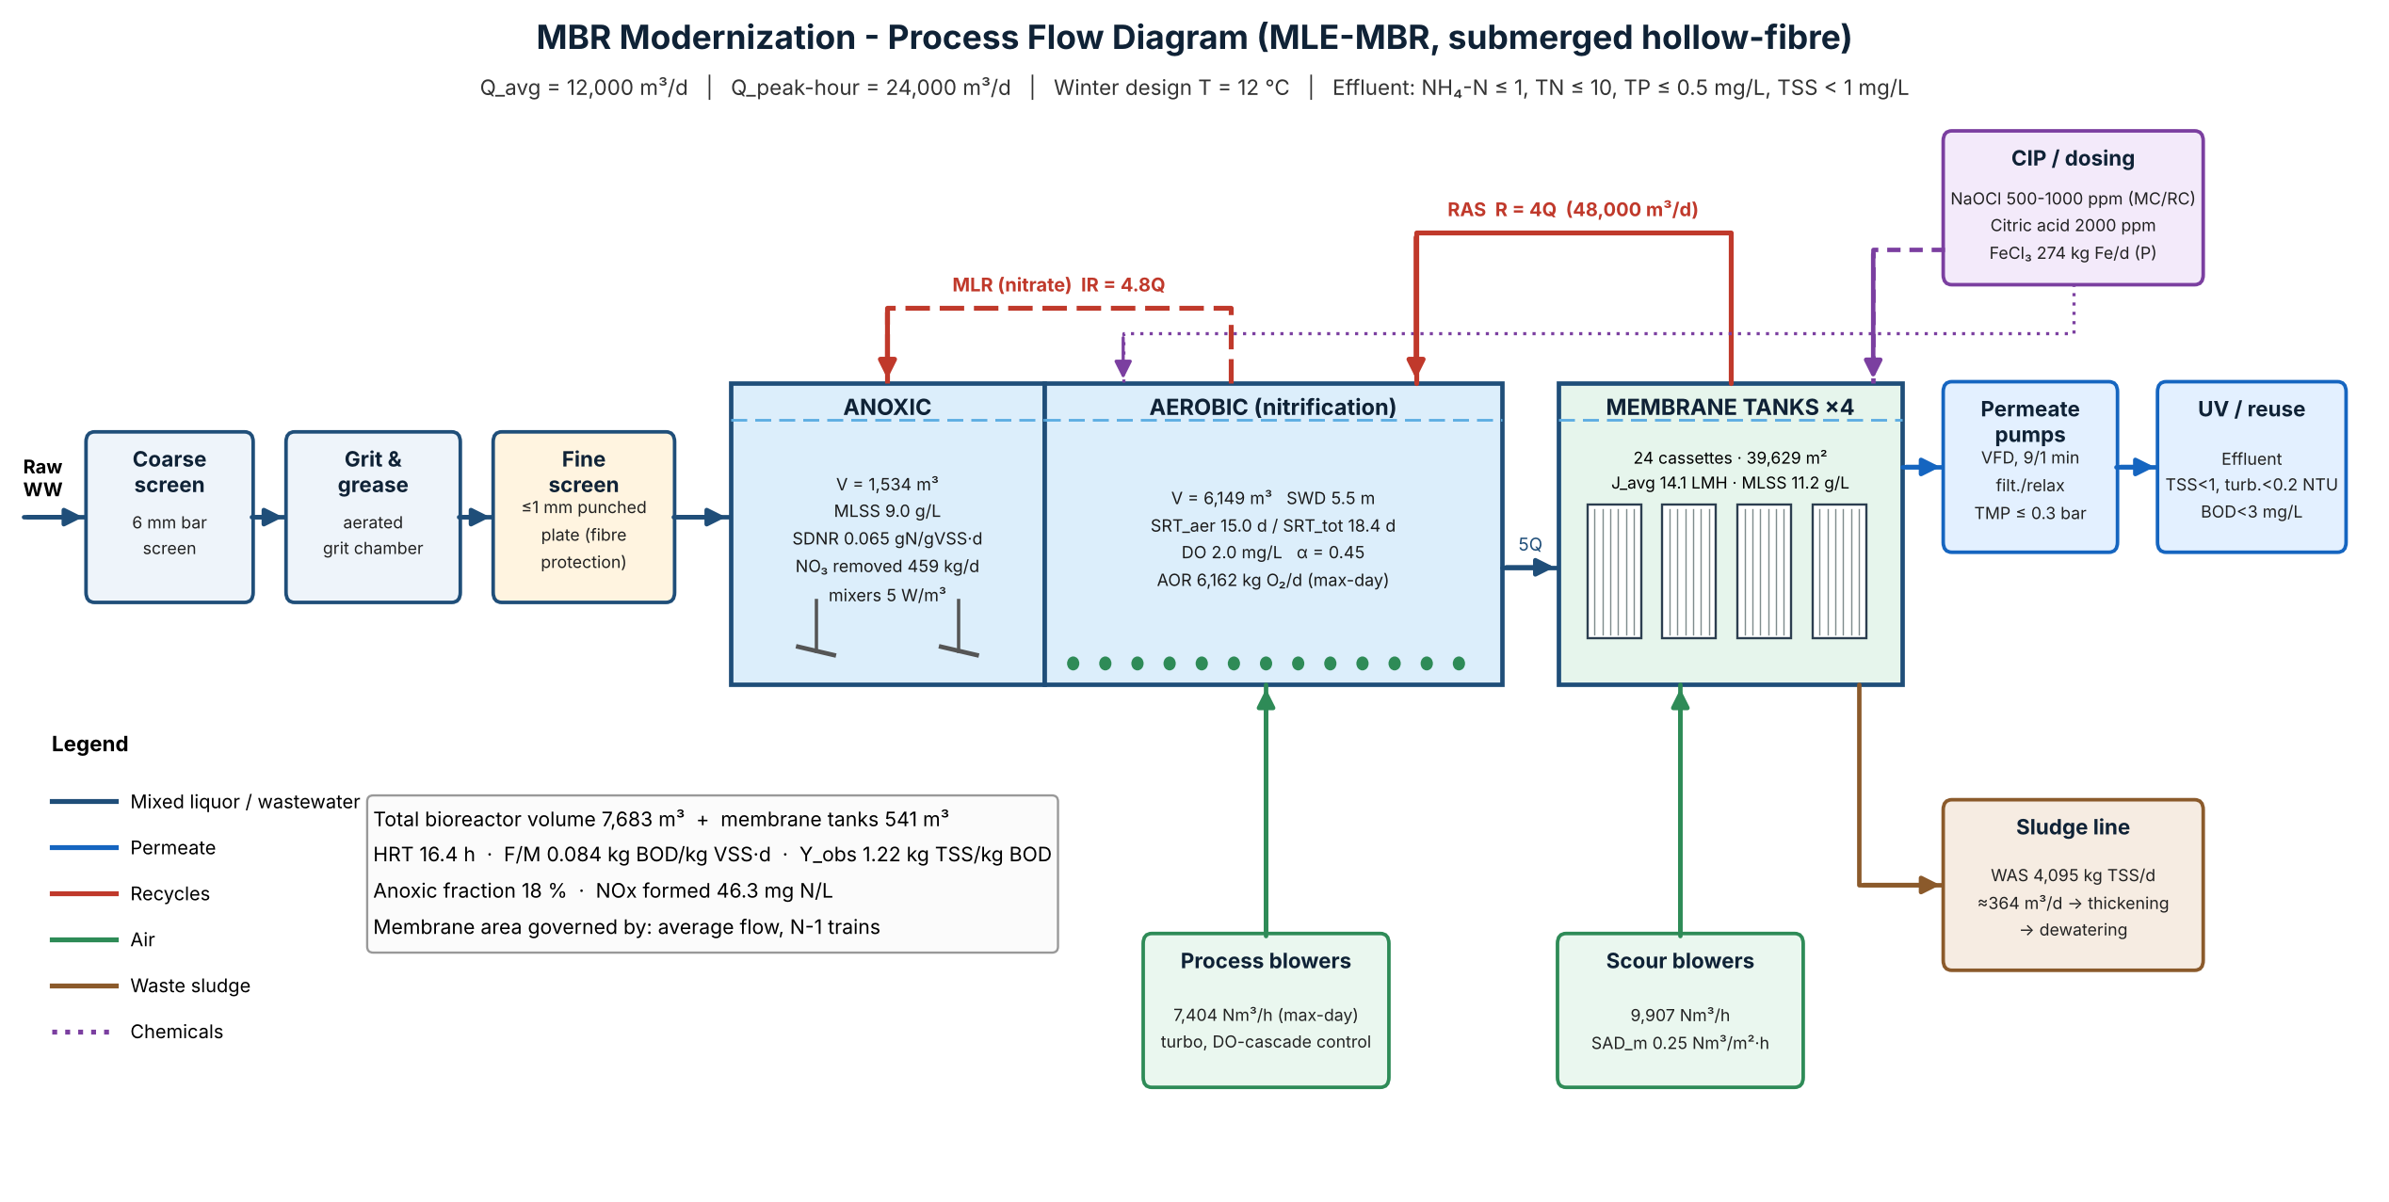
Figure 1. Process flow diagram with computed design values (generated by mbr_design.py)

4. Biological process design

4.1 Method
The minimum sludge age for nitrification is computed at the winter temperature from the net growth rate of the nitrifiers, and a safety factor is applied:
μA,T = μmax,A·θ^(T−20)·[N/(Kn+N)]·[DO/(Ko+DO)] ; SRTmin = 1/(μA,T − bA,T) (1)
The design aerobic SRT is the larger of 1.5 × SRTmin and 15 d. The effluent biodegradable COD and the biomass production follow the steady-state activated sludge model:
S = Ks(1 + bH·SRT) / [SRT(μmax,H − bH) − 1] (2)
PX,bio = Q·YH(S0−S)/(1+bH·SRT) + fd·bH·PX,H·SRT + Q·YA·NOx/(1+bA·SRT) (3)
Total solids production adds non-biodegradable VSS, inert inorganic solids and the ferric phosphate and hydroxide sludge. The total biomass inventory is PX,TSS × SRT; the part held in the membrane tanks is subtracted and the remainder sets the bioreactor volume at the design MLSS. The internal recycle ratio and the anoxic volume follow from the nitrate balance:
IR = NOx/NO3,e − 1 ; Vanox = (NO3,removed + DO recycled/2.86) / (SDNRT · XVSS) (4)
Because the anoxic fraction changes the total SRT, which changes sludge production and the nitrate load, equations 2 to 4 are solved iteratively until the anoxic fraction converges.

4.2 Results
Table 5. Biological process design results
Quantity | Value
Minimum nitrification SRT at 12 °C | 7.1 d
Design aerobic SRT / total SRT | 15.0 d / 18.4 d
Anoxic / aerobic / total bioreactor volume | 1,534 / 6,149 / 7,683 m³
Anoxic volume fraction | 18 %
MLSS bioreactor / membrane tank | 9.0 / 11.25 g/L
Hydraulic retention time (incl. membrane tanks) | 16.4 h
Food-to-microorganism ratio | 0.084 kg BOD/kg VSS·d
Sludge production (incl. chemical sludge) | 4,095 kg TSS/d (986 kg/d chemical)
Observed yield | 1.22 kg TSS/kg BOD
Nitrate formed / removed | 46.3 mg N/L / 459 kg N/d
Internal (nitrate) recycle ratio | 4.78 Q
FeCl₃ demand | 274 kg Fe/d
Residual alkalinity / supplement | 61 mg CaCO₃/L / 233 kg CaCO₃/d
Residual alkalinity falls below the usual 70–80 mg/L minimum for stable nitrification, mainly because ferric chloride consumes alkalinity, so a small lime, soda ash or magnesium hydroxide dose is included in the design.

5. Membrane system design

5.1 Method
Flux is corrected for water viscosity at the winter temperature and reduced by the time lost to relaxation and maintenance cleaning:
JT = J20 · μ20/μT ; Jnet = JT · tf/(tf + tr) · (1 − fMC) (5)
The required area is the largest of three cases: average flow with one train out of service for recovery cleaning, max-month flow at the sustained flux, and peak-hour flow at the short-term peak flux:
A = max{ Qavg / [Jnet,avg·(N−1)/N] , Qmm / Jnet,mm , Qph / Jnet,peak } (6)
The area is rounded up to whole cassettes per train. Scour air is the installed area multiplied by SAD_m, and the scour air per unit of permeate is SAD_p = SAD_m × 1000 / Jnet.

5.2 Results
Table 6. Membrane system design results
Quantity | Value
Viscosity correction at 12 °C / availability | × 0.814 / 89.5 %
Area: average N−1 / max-month / peak-hour | 36,603 / 29,740 / 34,315 m²
Governing case | average flow, N-1 trains
Installed | 4 trains × 6 cassettes = 24 cassettes (1,152 modules)
Installed membrane area | 39,629 m²
Operating gross flux at average flow | 14.1 L/m²·h
Scour air / SAD_p | 9,907 Nm³/h / 19.8 Nm³/m³
Membrane tank volume (all trains) and train size | 541 m³; each train 14.2 × 2.8 × 3.4 m
Packing density | 73 m²/m³
The operating flux of about 14 L/m²·h and SAD_p of about 20 Nm³/m³ are within the ranges reported for full-scale hollow-fibre MBRs (Judd, 2011).

6. Oxygen demand and aeration
The actual oxygen requirement combines carbon oxidation, nitrification and the credit returned by denitrification:
AOR = Q(S0 − S) − 1.42·PX,bio + 4.57·Q·NOx − 2.86·NO3,removed (7)
It is converted to standard (clean-water) conditions with the alpha factor, which falls steeply with MLSS (Krampe & Krauth, 2003), and with mid-depth oxygen saturation corrected for site elevation:
SOTR = AOR / [ α·F·(β·C*T,H − C)/C*20 · 1.024^(T−20) ] , α = exp(−0.08788·MLSS) (8)
Coarse-bubble scour air in the membrane tanks also transfers oxygen; this is credited before the fine-bubble process air is sized. Summer max-day governs blower capacity.
Table 7. Aeration results
Case | α | AOR (kg/d) | Scour O₂ credit (kg/d) | SOTR (kg/d) | Process air (Nm³/h)
winter | 0.45 | 4,929 | 619 | 11,351 | 5,512
summer | 0.45 | 4,929 | 534 | 11,907 | 5,783
summer max-day | 0.45 | 6,162 | 534 | 15,246 | 7,404
The alpha factor of 0.45 at 9 g/L means each kilogram of oxygen needs roughly twice the air it would at CAS concentrations. This is the main energy penalty of operating at high MLSS and is examined further in Sections 11 and 12.

7. Energy demand
Blower power uses the adiabatic compression equation (Metcalf & Eddy, 2014) with discharge pressure equal to diffuser submergence plus pipe and diffuser losses; pump power is ρgQH/η.
Pblower = w·R·T1 / (29.7·n·e) · [ (p2/p1)^0.283 − 1 ] (9)
Table 8. Average-day energy demand, full scale
Consumer | Power (kW) | Specific energy (kWh/m³)
Process aeration | 129 | 0.258
Membrane scour air | 138 | 0.276
Permeate pumping | 12 | 0.023
RAS pumping | 13 | 0.026
Nitrate recycle pumping | 9 | 0.017
Anoxic mixing | 8 | 0.015
Screens, CIP, miscellaneous | 20 | 0.040
TOTAL | 328 | 0.656
The total of 0.66 kWh/m³ is typical of a modern MBR. Membrane scour and process aeration together account for about 81 %, so they are the main targets for optimisation.

8. Membrane fouling and cleaning simulation
Membrane performance over 240 days is simulated hour by hour with the resistance-in-series model:
TMP = μ(T) · J · (Rm + Rres + Rirr + Rperm) (10)
dRres = k · (J/Jref)² · dV , k ∝ (0.25/SADm)^0.8 · (XMT/11.25)^0.5 (11)
Rm is the clean-membrane resistance. Residual fouling Rres builds with filtered volume and is 75 % removed by weekly maintenance cleans. A fraction becomes irreversible fouling Rirr, which only a recovery clean (CIP) removes; a smaller fraction becomes permanent fouling Rperm. The fouling rate rises with the square of flux (critical-flux behaviour), falls with more scour air and rises with mixed-liquor solids. Flow follows a diurnal pattern with six random storm events, temperature follows the seasons, and one train goes offline during each recovery clean.
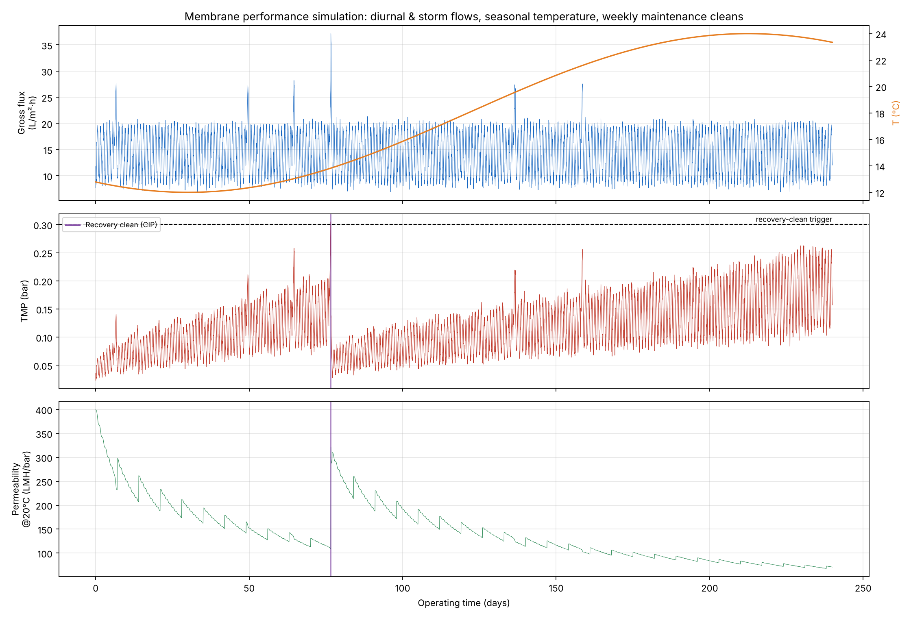
Figure 2. Simulated flux, temperature, TMP and temperature-corrected permeability over 240 days
In the reference design, TMP reaches the 0.30 bar trigger once, at day 77 in the cold period when water viscosity is highest, giving roughly 1.5 recovery cleans per year. Permeability drops from about 400 to about 100 L/m²·h·bar between cleans. Both are in line with full-scale experience. The fouling coefficients are calibration constants and should be fitted to pilot data.

9. Modernization (retrofit) check
The existing plant is assumed to have two aeration tanks of 4,000 m³ operating at 3.5 g/L MLSS, a concentration limited by the solids loading on its two 28 m secondary clarifiers. At the same SRT and nutrient targets, the treatment capacity of a fixed tank volume is proportional to the biomass it can hold:
Qmax = (Vexisting·XMLSS + VMT·XMT) / (PX,TSS per m³ · SRT) (12)
Table 9. Retrofit capacity comparison
Quantity | Existing CAS | MBR in same tanks
MLSS | 3.5 g/L | 9.0 g/L (11.25 in membrane tanks)
Capacity at SRT 18.4 d with N and P removal | 4,466 m³/d | 12,455 m³/d
Capacity gain | – | × 2.79
Bioreactor volume required for 12,000 m³/d | – | 7,683 of 8,000 m³ available
Secondary clarifiers | Required | Released: 4,926 m³, 1,232 m²
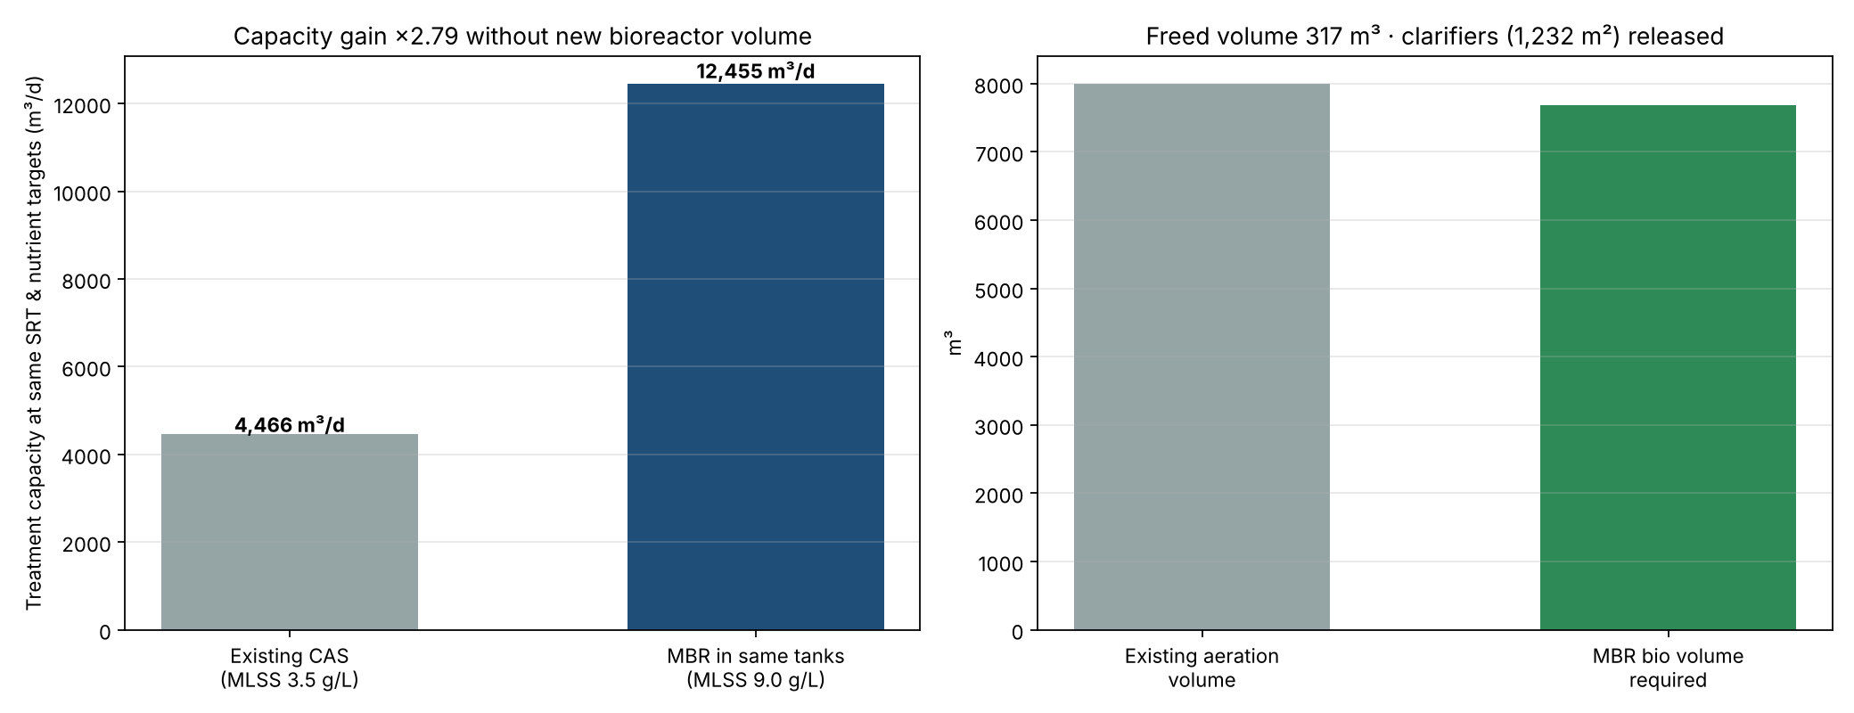
Figure 3. Capacity of the existing tanks as CAS and as MBR, and volume balance
The MBR fits within the existing aeration tanks while raising capacity from about 4,500 to 12,000 m³/d with full nitrogen removal. The released clarifiers can house the membrane tanks (about 160 m² footprint), flow equalisation or sludge storage.

10. Scale-up technique: pilot to full scale
Submerged membranes are scaled by numbering up identical modules rather than by enlarging them. A single pilot module is multiplied into a cassette (×48), a train (×6) and the plant (×4 trains), a total factor of 1,152. Because each module sees the same flux, scour air and mixed liquor, the filtration behaviour measured on the pilot transfers directly, provided the quantities that do change with size are corrected.
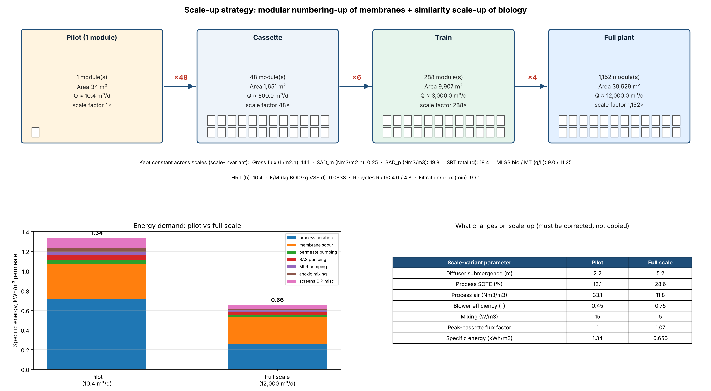
Figure 4. Modular scale-up hierarchy, energy at pilot and full scale, and scale-variant parameters
Table 10. Parameters held constant across scales (scale-invariant)
Parameter | Value | Why it must be held
Gross flux | 14.1 L/m²·h | Fouling rate depends on flux relative to critical flux
SAD_m / SAD_p | 0.25 Nm³/m²·h / 19.8 Nm³/m³ | Shear at the fibre surface controls cake build-up
SRT, MLSS, HRT, F/M | 18.4 d, 9.0 g/L, 16.4 h, 0.084 | Sludge properties (EPS, filterability, α) depend on them
Recycle ratios R / IR | 4.0 / 4.8 | Solids profile and nitrate removal
Filtration/relax cycle, cleaning protocol | 9/1 min; NaOCl, citric acid doses per m² | Fouling reversibility
Table 11. Parameters that change with scale and must be corrected (scale-variant)
Parameter | Pilot | Full scale | Consequence
Diffuser submergence | 2.2 m | 5.2 m | Oxygen transfer efficiency rises with depth
Process SOTE | 12.1 % | 28.6 % | Pilot needs ~2.8× more air per m³
Process air | 33.1 Nm³/m³ | 11.8 Nm³/m³ | Pilot energy overstates full scale
Blower efficiency | 0.45 | 0.75 | Small machines are inefficient
Mixing power | 15 W/m³ | 5 W/m³ | Small tanks need more mixing power
Peak-cassette flux factor | 1.00 | 1.07 | Uneven suction along long permeate headers
Specific energy | 1.34 kWh/m³ | 0.66 kWh/m³ | Pilot energy must not be used directly

10.1 Recommended scale-up procedure
- Run the pilot with the full-scale fine screen and the same membrane module, at the design flux, SAD_m, SRT and MLSS, for at least one full winter.
- Fit the fouling constants k, firr and the exponents in equation 11 to the measured TMP and permeability, including weekly maintenance cleans.
- Measure the alpha factor and oxygen uptake rate at pilot MLSS; use the measured alpha, not the pilot's air consumption, for full-scale blower sizing.
- Recalculate oxygen transfer, blower, pump and mixer power for full-scale depths and equipment (Table 11).
- Check permeate manifold head loss so that the most loaded cassette stays within about 5–7 % of the average flux, and add flux margin for that maldistribution.
- Check the design against peak-hour flow with all trains and average flow with one train in recovery cleaning (equation 6).

11. Design sensitivity
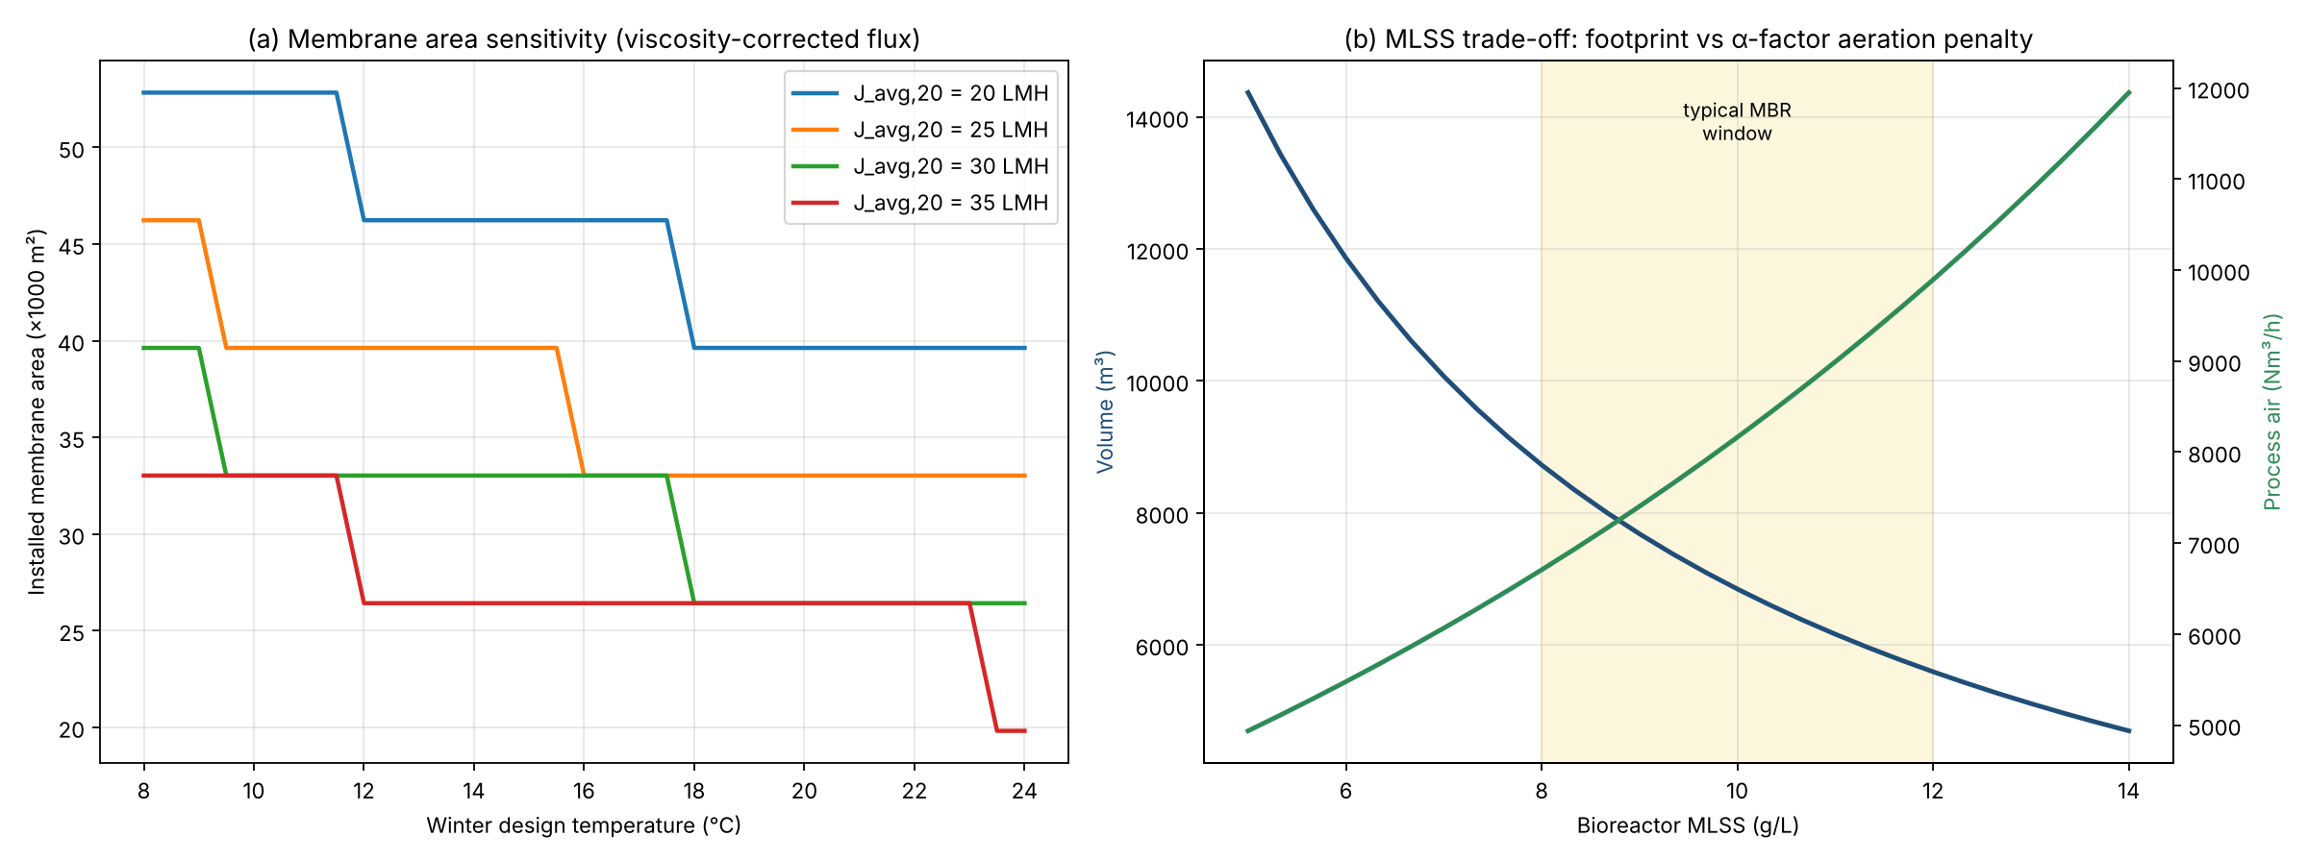
Figure 5. (a) Installed membrane area vs winter temperature and design flux; (b) bioreactor volume and process air vs MLSS
Panel (a) shows that a 4 °C colder design temperature adds roughly one cassette per train at any flux, because flux falls with water viscosity; the steps occur where an extra whole cassette is needed. Panel (b) shows the central MBR trade-off: raising MLSS shrinks the bioreactor but the falling alpha factor drives process air up. Between 8 and 12 g/L, the usual MBR operating window, the two effects roughly balance.

12. Design of experiments and response-surface optimisation

12.1 Experimental design
To optimise several design choices at once, the full model was run over a face-centred central composite design (CCD) in five factors: 32 factorial runs, 10 axial runs and 6 centre points, 48 runs in randomised order. This is the same design JMP builds under DOE › Classical › Response Surface Design. Winter temperature is included as a climate (noise) factor so that its effect is quantified, but it is locked at the 12 °C design value when optimising.
Table 12. DOE factors and levels
Factor | Low (−1) | Centre (0) | High (+1)
MLSS (g/L) | 7 | 9 | 11
Design flux at 20 °C (L/m²·h) | 20 | 25 | 30
SAD_m (Nm³/m²·h) | 0.15 | 0.25 | 0.35
Winter temperature (°C) | 10 | 13 | 16
Aerobic SRT floor (d) | 12 | 16 | 20

12.2 Response-surface models
A full quadratic model (intercept, 5 linear, 10 two-factor interaction and 5 squared terms) was fitted to each response by least squares, the same model JMP fits with the '& RS' effects in the script of Appendix C.
Table 13. Goodness of fit of the quadratic models
Response | R² | R² adjusted | RMSE
Energy (kWh/m³) | 0.9980 | 0.9964 | 0.0066
Footprint (m³) | 0.9996 | 0.9992 | 63
Required membrane area (m²) | 1.0000 | 1.0000 | 33
Mean TMP (bar) | 0.8957 | 0.8184 | 0.0067
Process air (Nm³/h) | 0.9998 | 0.9996 | 25
Sludge production (kg/d) | 0.9983 | 0.9971 | 4.9
Recovery cleans per year | 0.9339 | 0.8849 | 0.84
The engineering responses are fitted almost exactly. Mean TMP and the number of recovery cleans fit less well because the cleaning events make them jump in steps; their models are adequate for ranking factors but not for precise prediction.
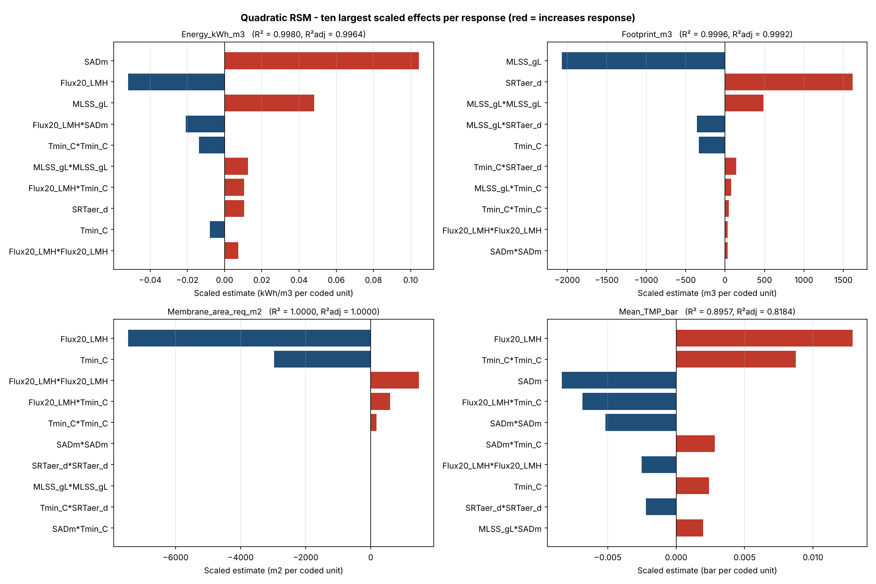
Figure 6. Ten largest scaled effects (coded coefficients) for each optimised response
Energy is driven mainly by scour air (SAD_m), then design flux (higher flux means less membrane and so less scour air), then MLSS through the alpha factor. Footprint depends on MLSS and SRT. Mean TMP rises with flux and falls with scour air, so flux and scour air pull energy and fouling in opposite directions.

12.3 Desirability optimisation
Energy, footprint, membrane area and mean TMP were each converted to a smaller-is-better Derringer desirability between their lowest and highest observed values, and the geometric mean D was maximised over the four controllable factors with temperature locked at 12 °C. The optimum (D = 0.61) was then re-run through the full model to check the prediction.
Table 14. Optimum factor settings
Factor | Optimum | Baseline design
MLSS (g/L) | 9.89 | 9.0
Design flux at 20 °C (L/m²·h) | 29.9 | 25.0
SAD_m (Nm³/m²·h) | 0.344 | 0.25
Winter temperature (°C, locked) | 12 | 12
Aerobic SRT floor (d) | 12.0 | 15.0
Table 15. Responses at the optimum: response-surface prediction, full-model check and baseline
Response | RSM prediction | Full model | Baseline
Energy (kWh/m³) | 0.716 | 0.704 | 0.656
Footprint (m³) | 6,537 | 6,312 | 8,224
Required membrane area (m²) | 30,580 | 30,610 | 36,600
Mean TMP (bar) | 0.114 | 0.115 | 0.119
Process air, max-day (Nm³/h) | 7,745 | 7,689 | 7,404
Sludge production (kg TSS/d) | 4,166 | 4,193 | 4,095
Recovery cleans per year | 1.7 | 3.0 | 1.5
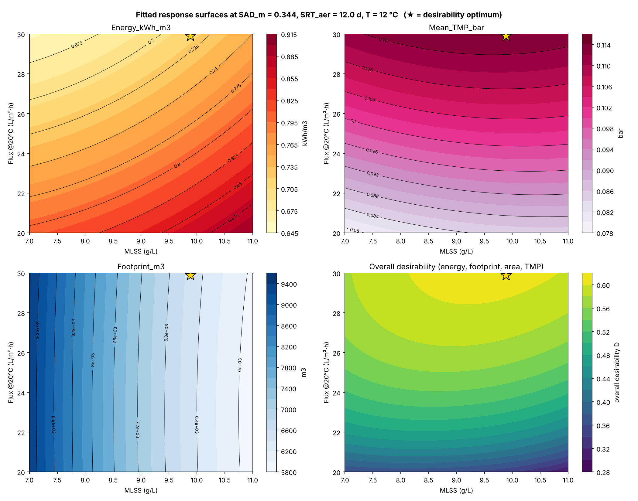
Figure 7. Fitted response surfaces versus MLSS and flux, with the overall desirability (★ = optimum)
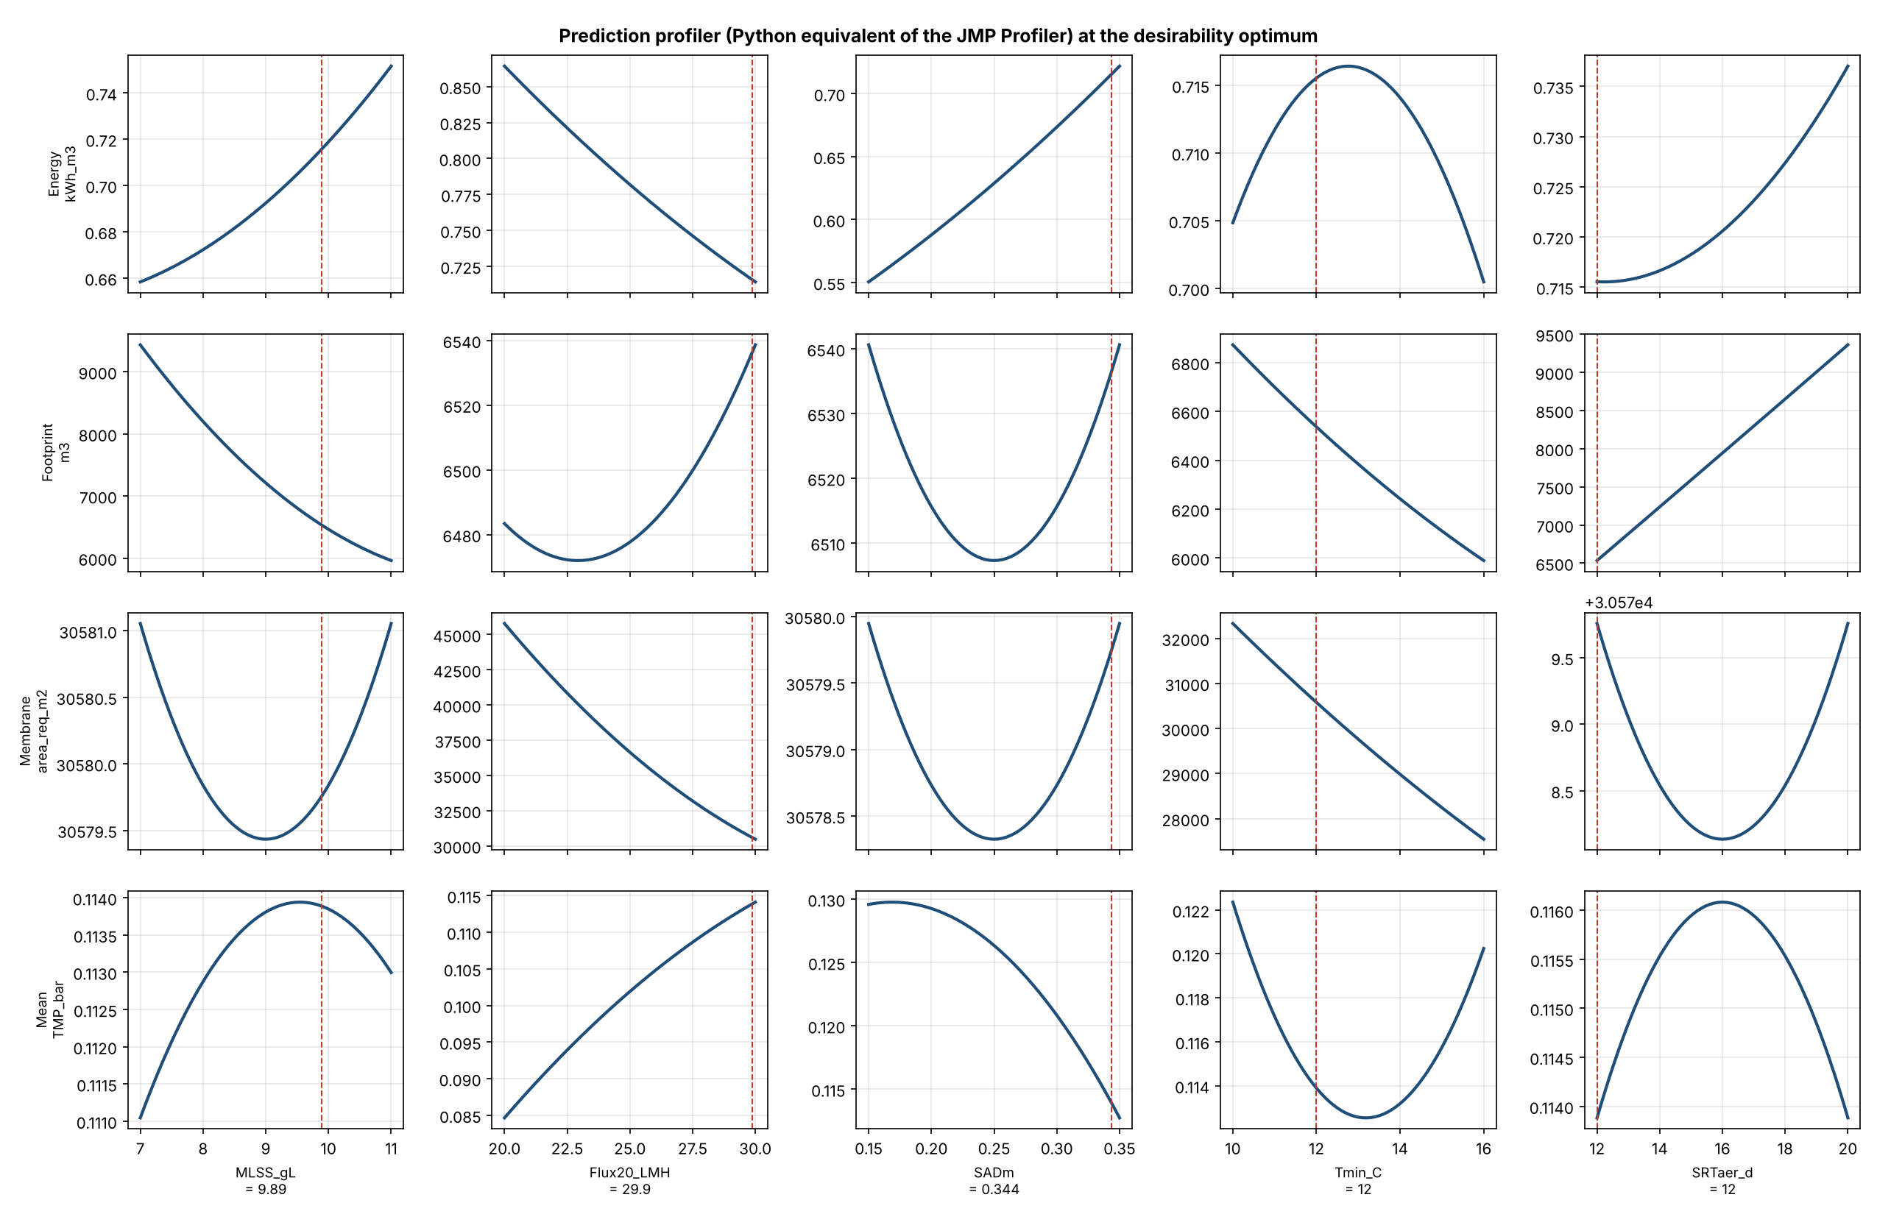
Figure 8. Prediction profiler at the optimum (equivalent of the JMP Profiler)
The optimum reduces bioreactor volume by about 23 % and membrane area by about 16 % for about 7 % more energy, trading scour air for a higher, still conservative flux. The full-model check agrees with the RSM prediction within 4 % for every engineering response. Two cautions apply: the optimiser chose the lowest allowed aerobic SRT (12 d), which leaves a small nitrification safety margin in cold weather, so 15 d or more is recommended for the final design; and the recovery-clean frequency at the optimum (about 3 per year) is higher than the model predicts, so it should be confirmed on the pilot.

13. Running the analysis in JMP
The response-surface analysis in Section 12 was computed in Python. The same analysis can be reproduced and explored interactively in JMP with the script in Appendix C:
- Place mbr_doe_runs.csv (Appendix D) and MBR_RSM_analysis.jsl in the same folder.
- Open MBR_RSM_analysis.jsl in JMP 16 or later and choose Run Script (Ctrl+R).
- The script sets factor coding and desirability limits, fits a full quadratic Standard Least Squares model for each of the seven responses and saves the prediction formulas.
- It opens the Prediction Profiler with temperature locked at 12 °C and runs Maximize Desirability, then a Contour Profiler with surface plots and a Graph Builder overview.
- The optimum and the fit statistics shown in JMP should match Tables 13 to 15.
The Python model itself can also run inside JMP 18 and later through File › New › Python Script, so the whole workflow can be kept in one tool if preferred.

14. Limitations and next steps
- Influent data are an illustrative reference case; a site sampling campaign (COD fractionation, TKN, alkalinity, temperature record) is needed.
- Steady-state design equations are used; a dynamic simulation (ASM1/ASM2d) should confirm effluent nitrogen under diurnal and storm loads.
- Fouling constants are literature-based calibration values and must be fitted to pilot TMP data.
- Membrane module dimensions and flux limits are generic; vendor data will change the cassette count and tank layout.
- Costs (capital, membrane replacement, chemicals, energy tariffs) are not yet included; adding net present value as a DOE response is a natural extension.

References
Judd, S. (2011). The MBR Book: Principles and Applications of Membrane Bioreactors for Water and Wastewater Treatment, 2nd ed. Butterworth-Heinemann, Oxford.
Krampe, J., Krauth, K. (2003). Oxygen transfer into activated sludge with high MLSS concentrations. Water Science and Technology 47(11), 297–303.
Metcalf & Eddy / AECOM (2014). Wastewater Engineering: Treatment and Resource Recovery, 5th ed. McGraw-Hill, New York.
Derringer, G., Suich, R. (1980). Simultaneous optimization of several response variables. Journal of Quality Technology 12(4), 214–219.

Appendix A. mbr_design.py: design model and diagrams
Python 3 with numpy and matplotlib. Run with: python mbr_design.py. Outputs are written to the folder mbr_outputs.
1 #!/usr/bin/env python3
2 """
3 =====================================================================================
4 MEMBRANE BIOREACTOR (MBR) - PRELIMINARY DESIGN, DIAGRAMS & SCALE-UP MODEL
5 Application: modernization of an existing conventional activated sludge (CAS) plant
6 by inserting an MLE-type MBR treatment sequence:
7 coarse screen -> grit/grease -> fine screen (<=1 mm) -> anoxic -> aerobic
8 -> submerged hollow-fibre membrane tank -> permeate -> UV
9 =====================================================================================
10 Methods / references used (standard design literature):
11 * Metcalf & Eddy (2014) Wastewater Engineering, 5th ed. - activated sludge kinetics,
12 biomass production, oxygen demand, MLE nitrogen removal, blower power.
13 * Judd, S. (2011) The MBR Book, 2nd ed. - flux, SAD_m / SAD_p, cleaning regimes,
14 specific energy demand benchmarks.
15 * Krampe & Krauth (2003) - alpha factor vs MLSS: alpha = exp(-0.08788 * MLSS[g/L]).
16 * Resistance-in-series filtration law: TMP = mu(T) * J * (Rm + Rres + Rirr).
17 All numbers are preliminary-design values; site data (influent characterisation,
18 vendor membrane data, pilot results) must replace defaults before detailed design.
19
20 Run: python mbr_design.py -> writes figures + report into ./mbr_outputs
21 Requires: numpy, matplotlib
22 =====================================================================================
23 """
24 from __future__ import annotations
25
26 import json
27 import math
28 import os
29 from dataclasses import dataclass, asdict, field
30
31 import numpy as np
32 import matplotlib
33
34 matplotlib.use("Agg")
35 import matplotlib.pyplot as plt
36 from matplotlib.patches import FancyBboxPatch, Rectangle, Circle
37
38 OUT = "mbr_outputs"
39 os.makedirs(OUT, exist_ok=True)
40
41 RHO_W = 998.0 # kg/m3
42 G = 9.81 # m/s2
43 P_ATM = 101.325 # kPa
44 O2_PER_NM3_AIR = 0.300 # kg O2 per Nm3 air (1.293 kg/Nm3 * 0.232)
45
46
47 # ----------------------------------------------------------------------------------
48 # 1. INPUT DATA
49 # ----------------------------------------------------------------------------------
50 @dataclass
51 class Influent:
52 """Raw municipal wastewater after coarse screening (no primary settling)."""
53 Q_avg: float = 12_000.0 # m3/d average dry-weather flow
54 pf_maxmonth: float = 1.30 # peaking factors
55 pf_maxday: float = 1.60
56 pf_peakhour: float = 2.00 # peak hour that membranes must pass (after EQ if any)
57 BOD: float = 280.0 # g/m3
58 COD: float = 600.0
59 bCOD_BOD: float = 1.60 # biodegradable COD / BOD5
60 TSS: float = 300.0
61 VSS: float = 240.0
62 nbVSS_frac: float = 0.35 # non-biodegradable fraction of VSS
63 TKN: float = 60.0 # g N/m3
64 NH4: float = 40.0
65 TP: float = 9.0 # g P/m3
66 Alk: float = 300.0 # g CaCO3/m3
67 T_min: float = 12.0 # degC, winter design (nitrification, flux)
68 T_max: float = 24.0 # degC, summer design (oxygen)
69
70
71 @dataclass
72 class DesignBasis:
73 NH4_eff: float = 1.0 # g/m3
74 TN_eff: float = 10.0
75 orgN_eff: float = 1.0
76 TP_eff: float = 0.5
77 DO_aer: float = 2.0 # g/m3 in aerobic zone
78 DO_mlr: float = 1.0 # DO carried with mixed-liquor recycle to anoxic
79 SF_nit: float = 1.5 # safety factor on nitrification SRT
80 SRT_aer_floor: float = 15.0 # d - MBR practice (sludge stability, fouling control)
81 X_bio: float = 9.0 # kg TSS/m3 in anoxic/aerobic tanks
82 R_ras: float = 4.0 # membrane tank -> aerobic recycle ratio (Q multiples)
83 swd_bio: float = 5.5 # m side water depth (existing CAS tanks)
84 sub_diffuser: float = 5.2 # m diffuser submergence
85 sote_per_m: float = 0.055 # fine-bubble clean-water SOTE per m submergence
86 fouling_F: float = 0.90 # diffuser fouling factor
87 beta: float = 0.95
88 elev_m: float = 120.0 # site elevation (Radnor-type site), m a.s.l.
89 Fe_P_molar: float = 1.8 # FeCl3 simultaneous precipitation
90 anox_mix_W_m3: float = 5.0 # submersible mixer power density
91
92
93 @dataclass
94 class Kinetics:
95 """Metcalf & Eddy (2014) Table 8-14 / 8-24 default values at 20 degC."""
96 mu_H: float = 6.0; th_muH: float = 1.07
97 Ks: float = 8.0
98 Y_H: float = 0.45
99 b_H: float = 0.12; th_bH: float = 1.04
100 fd: float = 0.15
101 mu_A: float = 0.90; th_muA: float = 1.072
102 Kn: float = 0.50
103 Ko_A: float = 0.50
104 Y_A: float = 0.15
105 b_A: float = 0.17; th_bA: float = 1.029
106 SDNR20: float = 0.08; th_SDNR: float = 1.026 # g NO3-N / g MLVSS.d
107 N_in_biomass: float = 0.12 # g N / g VSS
108 P_in_biomass: float = 0.015
109
110
111 @dataclass
112 class MembraneSpec:
113 """Generic reinforced PVDF hollow-fibre (0.04-0.1 um) submerged module data."""
114 module_area: float = 34.4 # m2 per module
115 modules_per_cassette: int = 48
116 cassette_L: float = 1.9 # m
117 cassette_W: float = 2.2
118 cassette_H: float = 2.6
119 J_avg20: float = 25.0 # L/m2.h gross design flux, 20 degC
120 J_mm20: float = 30.0 # L/m2.h sustained max-month flux, 20 degC
121 J_peak20: float = 40.0 # L/m2.h short-term peak flux, 20 degC
122 t_filt: float = 9.0 # min filtration
123 t_relax: float = 1.0 # min relaxation (air scour continues)
124 mc_downtime: float = 0.006 # fraction of time in maintenance cleaning
125 n_trains: int = 4
126 Lp_clean20: float = 400.0 # L/m2.h.bar clean-membrane permeability
127 SAD_m: float = 0.25 # Nm3 air / m2 membrane . h
128 mt_depth: float = 3.4 # m membrane tank water depth
129 scour_sub: float = 3.0 # m scour aerator submergence
130 scour_sote_per_m: float = 0.012 # coarse-bubble SOTE per m
131 TMP_max: float = 0.30 # bar - recovery-clean trigger
132
133
134 @dataclass
135 class ExistingCAS:
136 """Plant being modernised (illustrative)."""
137 n_aer_tanks: int = 2
138 V_aer_each: float = 4_000.0 # m3
139 X_cas: float = 3.5 # kg/m3 limited by secondary clarifier SLR
140 n_clarifiers: int = 2
141 clarifier_D: float = 28.0 # m
142 clarifier_swd: float = 4.0
143
144
145 # ----------------------------------------------------------------------------------
146 # 2. PROPERTY CORRELATIONS
147 # ----------------------------------------------------------------------------------
148 def water_viscosity(T: float) -> float:
149 """Dynamic viscosity of water, Pa.s (Vogel-type correlation)."""
150 return 2.414e-5 * 10 ** (247.8 / (T + 133.15))
151
152
153 def arr(k20: float, theta: float, T: float) -> float:
154 return k20 * theta ** (T - 20.0)
155
156
157 def do_saturation(T: float) -> float:
158 """Clean-water DO saturation at 1 atm, g/m3 (APHA polynomial)."""
159 return 14.652 - 0.41022 * T + 0.007991 * T**2 - 0.000077774 * T**3
160
161
162 def alpha_factor(mlss_gL: float) -> float:
163 """Krampe & Krauth (2003) - oxygen transfer alpha factor vs MLSS."""
164 return math.exp(-0.08788 * mlss_gL)
165
166
167 def pressure_at_elev(elev: float) -> float:
168 return P_ATM * (1 - 2.25577e-5 * elev) ** 5.25588 # kPa
169
170
171 # ----------------------------------------------------------------------------------
172 # 3. MEMBRANE SIZING
173 # ----------------------------------------------------------------------------------
174 def membrane_design(inf: Influent, m: MembraneSpec) -> dict:
175 mu_ratio = water_viscosity(20) / water_viscosity(inf.T_min) # flux temperature corr.
176 avail = m.t_filt / (m.t_filt + m.t_relax) * (1 - m.mc_downtime)
177
178 J_avg_T = m.J_avg20 * mu_ratio
179 J_peak_T = m.J_peak20 * mu_ratio
180 Jnet_avg = J_avg_T * avail
181 Jnet_peak = J_peak_T * avail
182
183 Q_avg_h = inf.Q_avg / 24.0 # m3/h
184 Q_mm_h = Q_avg_h * inf.pf_maxmonth
185 Q_ph_h = Q_avg_h * inf.pf_peakhour
186
187 Jnet_mm = m.J_mm20 * mu_ratio * avail
188 # Case A: average flow with one train offline for recovery cleaning (N-1)
189 A_avg = Q_avg_h * 1000 / Jnet_avg / ((m.n_trains - 1) / m.n_trains)
190 # Case B: max-month flow, all trains, sustained flux
191 A_mm = Q_mm_h * 1000 / Jnet_mm
192 # Case C: peak-hour flow, all trains online, short-term peak flux
193 A_ph = Q_ph_h * 1000 / Jnet_peak
194 cases = {"average flow, N-1 trains": A_avg, "max-month flow, sustained flux": A_mm,
195 "peak-hour flow, peak flux": A_ph}
196 governing = max(cases, key=cases.get)
197 A_req = cases[governing]
198
199 A_cas = m.module_area * m.modules_per_cassette
200 n_cas_train = math.ceil(A_req / A_cas / m.n_trains)
201 n_cas = n_cas_train * m.n_trains
202 A_inst = n_cas * A_cas
203
204 # Membrane tank geometry per train (0.3 m clearances)
205 L_train = n_cas_train * (m.cassette_L + 0.30) + 1.0
206 W_train = m.cassette_W + 2 * 0.30
207 V_train = L_train * W_train * m.mt_depth
208 V_mt = V_train * m.n_trains
209
210 air_scour = A_inst * m.SAD_m # Nm3/h
211 Jop_avg = Q_avg_h * 1000 / (A_inst * avail) # actual gross flux at Q_avg
212 SAD_p = air_scour / Q_avg_h # Nm3 air / m3 permeate
213 packing = A_inst / V_mt # m2/m3
214
215 return dict(mu_ratio=mu_ratio, availability=avail, J_avg_T=J_avg_T, J_peak_T=J_peak_T,
216 Jnet_avg=Jnet_avg, Jnet_peak=Jnet_peak, A_avg=A_avg, A_mm=A_mm, A_ph=A_ph, A_req=A_req,
217 governing=governing, A_cassette=A_cas, n_cas_train=n_cas_train, n_cassettes=n_cas,
218 n_modules=n_cas * m.modules_per_cassette, A_installed=A_inst,
219 L_train=L_train, W_train=W_train, V_mt=V_mt, air_scour_Nm3h=air_scour,
220 J_operating_avg=Jop_avg, SAD_p=SAD_p, packing_density=packing)
221
222
223 # ----------------------------------------------------------------------------------
224 # 4. BIOLOGICAL DESIGN (MLE configuration, iterative anoxic fraction)
225 # ----------------------------------------------------------------------------------
226 def nitrification_srt(k: Kinetics, d: DesignBasis, T: float) -> float:
227 mu = arr(k.mu_A, k.th_muA, T) * d.NH4_eff / (k.Kn + d.NH4_eff) * d.DO_aer / (k.Ko_A + d.DO_aer)
228 b = arr(k.b_A, k.th_bA, T)
229 return 1.0 / (mu - b)
230
231
232 def biological_design(inf: Influent, d: DesignBasis, k: Kinetics, mem: dict) -> dict:
233 T = inf.T_min
234 Q = inf.Q_avg
235 bCOD = inf.bCOD_BOD * inf.BOD
236 nbVSS = inf.nbVSS_frac * inf.VSS
237 iTSS = inf.TSS - inf.VSS
238
239 SRTmin = nitrification_srt(k, d, T)
240 SRT_aer = max(d.SF_nit * SRTmin, d.SRT_aer_floor)
241
242 muH, bH = arr(k.mu_H, k.th_muH, T), arr(k.b_H, k.th_bH, T)
243 muA, bA = arr(k.mu_A, k.th_muA, T), arr(k.b_A, k.th_bA, T)
244 X_mt = d.X_bio * (1 + d.R_ras) / d.R_ras # membrane-tank MLSS (mass balance)
245
246 f_anox, NOx = 0.20, 0.8 * inf.TKN
247 for _ in range(50):
248 SRT = SRT_aer / (1 - f_anox)
249 S = k.Ks * (1 + bH * SRT) / (SRT * (muH - bH) - 1) # effluent bCOD
250 Px_H = Q * k.Y_H * (bCOD - S) / (1 + bH * SRT) / 1000 # kg VSS/d
251 Px_D = k.fd * bH * Px_H * SRT
252 Px_A = Q * k.Y_A * NOx / (1 + bA * SRT) / 1000
253 Px_bio = Px_H + Px_D + Px_A
254 NOx = inf.TKN - d.NH4_eff - d.orgN_eff - k.N_in_biomass * Px_bio * 1000 / Q
255
256 # phosphorus: biological uptake + FeCl3 simultaneous precipitation
257 P_bio = k.P_in_biomass * Px_bio * 1000 / Q
258 P_chem = max(inf.TP - P_bio - d.TP_eff, 0)
259 Fe_kgd = Q * P_chem / 30.97 * d.Fe_P_molar * 55.85 / 1000
260 chem_sludge = Fe_kgd * 3.6 # FePO4 + Fe(OH)3
261
262 Px_VSS = Px_bio + Q * nbVSS / 1000
263 Px_TSS = Px_bio / 0.85 + Q * nbVSS / 1000 + Q * iTSS / 1000 + chem_sludge
264 M_total = Px_TSS * SRT # kg TSS inventory
265
266 # MLE nitrate balance
267 NO3_eff = d.TN_eff - d.NH4_eff - d.orgN_eff
268 IR = max(NOx / NO3_eff - 1.0, 0.0) # total recycle to anoxic
269 NO3_rem = Q * (NOx - NO3_eff) / 1000 # kg N/d
270 DO_eq = IR * Q * d.DO_mlr / 2.86 / 1000 # kg NO3-N eq/d
271 vss_frac = Px_VSS / Px_TSS
272 SDNR = arr(k.SDNR20, k.th_SDNR, T)
273 V_anox = (NO3_rem + DO_eq) / (SDNR * d.X_bio * vss_frac)
274
275 M_mt = mem["V_mt"] * X_mt
276 V_aer = max((M_total - M_mt) / d.X_bio - V_anox, 0.0)
277 f_new = V_anox * d.X_bio / M_total
278 if abs(f_new - f_anox) < 1e-6:
279 break
280 f_anox = 0.5 * f_anox + 0.5 * f_new
281
282 V_bio = V_anox + V_aer
283 HRT = (V_bio + mem["V_mt"]) / Q * 24
284 FM = Q * inf.BOD / 1000 / (M_total * vss_frac)
285 Y_obs = Px_TSS / (Q * (inf.BOD) / 1000)
286
287 # Alkalinity check
288 N_nit = NOx
289 alk_eff = inf.Alk - 7.14 * N_nit + 3.57 * (NOx - NO3_eff) - 2.0 * Fe_kgd * 1000 / Q
290 alk_add = max(80 - alk_eff, 0) * Q / 1000 # kg CaCO3/d
291
292 return dict(T_design=T, SRT_nit_min=SRTmin, SRT_aer=SRT_aer, SRT_total=SRT, S_eff_bCOD=S,
293 Px_H=Px_H, Px_D=Px_D, Px_A=Px_A, Px_bio=Px_bio, Px_VSS=Px_VSS, Px_TSS=Px_TSS,
294 chem_sludge=chem_sludge, Fe_kgd=Fe_kgd, NOx=NOx, NO3_eff=NO3_eff, IR=IR,
295 NO3_removed=NO3_rem, SDNR_T=SDNR, V_anox=V_anox, V_aer=V_aer, V_bio=V_bio,
296 f_anox=f_anox, X_mt=X_mt, M_total=M_total, HRT_h=HRT, FM=FM, Y_obs=Y_obs,
297 VSS_TSS=vss_frac, alk_eff=alk_eff, alk_add_kgd=alk_add)
298
299
300 # ----------------------------------------------------------------------------------
301 # 5. OXYGEN DEMAND & AERATION
302 # ----------------------------------------------------------------------------------
303 def oxygen_demand(inf: Influent, k: Kinetics, bio: dict) -> float:
304 """Average-day actual oxygen requirement AOR, kg O2/d (M&E Eq. 8-17 + denit credit)."""
305 bCOD = inf.bCOD_BOD * inf.BOD
306 Ro = (inf.Q_avg * (bCOD - bio["S_eff_bCOD"]) / 1000 - 1.42 * bio["Px_bio"]
307 + 4.57 * inf.Q_avg * bio["NOx"] / 1000 - 2.86 * bio["NO3_removed"])
308 return Ro
309
310
311 def aeration_design(inf: Influent, d: DesignBasis, m: MembraneSpec, bio: dict, mem: dict,
312 AOR_avg: float, sub: float | None = None, sote_per_m: float | None = None) -> dict:
313 sub = d.sub_diffuser if sub is None else sub
314 sote_pm = d.sote_per_m if sote_per_m is None else sote_per_m
315 Pb = pressure_at_elev(d.elev_m)
316 res = {}
317 for case, T, pf in (("winter", inf.T_min, 1.0), ("summer", inf.T_max, 1.0),
318 ("summer max-day", inf.T_max, 1.25)):
319 Cs20 = do_saturation(20)
320 CsT = do_saturation(T) * Pb / P_ATM
321 Pd = Pb + RHO_W * G * sub / 1000
322 CsTH = CsT * 0.5 * (Pd / Pb + 19.0 / 21.0) # mid-depth saturation
323 alpha = alpha_factor(d.X_bio)
324 AOR = AOR_avg * pf
325 # O2 delivered by membrane scour air (coarse bubble, in membrane tank)
326 alpha_mt = alpha_factor(bio["X_mt"])
327 sote_sc = m.scour_sote_per_m * m.scour_sub
328 CsTH_mt = CsT * 0.5 * ((Pb + RHO_W * G * m.scour_sub / 1000) / Pb + 19.0 / 21.0)
329 f_mt = alpha_mt * (d.beta * CsTH_mt - 4.0) / Cs20 * 1.024 ** (T - 20)
330 AOTR_scour = mem["air_scour_Nm3h"] * 24 * O2_PER_NM3_AIR * sote_sc * f_mt
331 AOR_proc = max(AOR - AOTR_scour, 0)
332 f_proc = alpha * d.fouling_F * (d.beta * CsTH - d.DO_aer) / Cs20 * 1.024 ** (T - 20)
333 SOTR = AOR_proc / f_proc
334 SOTE = sote_pm * sub
335 air = SOTR / (O2_PER_NM3_AIR * SOTE) / 24 # Nm3/h
336 res[case] = dict(T=T, alpha=alpha, AOR=AOR, AOTR_scour=AOTR_scour, SOTR=SOTR,
337 SOTE=SOTE, air_Nm3h=air, AOR_SOR=f_proc)
338 res["design_air_Nm3h"] = max(v["air_Nm3h"] for v in res.values() if isinstance(v, dict))
339 return res
340
341
342 def blower_kW(air_Nm3h: float, submergence: float, losses_kPa: float, eff: float,
343 T_in_C: float = 25.0, elev: float = 120.0) -> float:
344 """Adiabatic blower power, M&E Eq. 5-56 (SI)."""
345 w = air_Nm3h * 1.293 / 3600.0 # kg/s
346 p1 = pressure_at_elev(elev)
347 p2 = p1 + RHO_W * G * submergence / 1000 + losses_kPa
348 return w * 8.314 * (T_in_C + 273.15) / (29.7 * 0.283 * eff) * ((p2 / p1) ** 0.283 - 1)
349
350
351 def pump_kW(Q_m3d: float, H: float, eff: float) -> float:
352 return RHO_W * G * (Q_m3d / 86400) * H / eff / 1000
353
354
355 # ----------------------------------------------------------------------------------
356 # 6. ENERGY BALANCE (used for full scale and pilot scale)
357 # ----------------------------------------------------------------------------------
358 def energy_balance(Q: float, air_proc: float, air_scour: float, V_anox: float, R: float, IR: float,
359 sub_proc: float, sub_scour: float, blower_eff: float, pump_eff: float,
360 mix_W_m3: float, misc_kWh_m3: float = 0.04) -> dict:
361 kw = dict(
362 process_aeration=blower_kW(air_proc, sub_proc, 15.0, blower_eff),
363 membrane_scour=blower_kW(air_scour, sub_scour, 10.0, blower_eff),
364 permeate_pumping=pump_kW(Q, 6.0, pump_eff),
365 RAS_pumping=pump_kW(R * Q, 1.5, pump_eff * 0.9),
366 MLR_pumping=pump_kW(IR * Q, 0.8, pump_eff * 0.85),
367 anoxic_mixing=V_anox * mix_W_m3 / 1000,
368 screens_CIP_misc=misc_kWh_m3 * Q / 24,
369 )
370 kwh_m3 = {key: v * 24 / Q for key, v in kw.items()}
371 kwh_m3["TOTAL"] = sum(kwh_m3.values())
372 return dict(kW=kw, kWh_m3=kwh_m3)
373
374
375 # ----------------------------------------------------------------------------------
376 # 7. MEMBRANE FOULING / TMP SIMULATION (resistance in series, cleaning regime)
377 # ----------------------------------------------------------------------------------
378 def fouling_simulation(inf: Influent, m: MembraneSpec, mem: dict, days: int = 240, seed: int = 3,
379 X_mt: float = 11.25):
380 rng = np.random.default_rng(seed)
381 dt = 1.0 # h
382 n = int(days * 24 / dt)
383 t = np.arange(n) * dt / 24.0
384 T = 0.5 * (inf.T_min + inf.T_max) - 0.5 * (inf.T_max - inf.T_min) * np.cos(2 * np.pi * (t - 30) / 365)
385 hour = (np.arange(n) * dt) % 24
386 diurnal = 1 + 0.38 * np.sin(2 * np.pi * (hour - 9) / 24) + rng.normal(0, 0.05, n)
387 storms = np.zeros(n)
388 for d0 in rng.choice(np.arange(5, days - 2), size=6, replace=False): # wet-weather events
389 i0 = int(d0 * 24); storms[i0:i0 + 18] = 0.55
390 Qh = inf.Q_avg / 24 * np.clip(diurnal + storms, 0.4, inf.pf_peakhour)
391
392 Rm = 1 / (water_viscosity(20) * m.Lp_clean20 / 3.6e6 / 1e5)
393 J_ref = m.J_avg20 / 3.6e6
394 k_res, f_irr, f_irremov = 4.0e11, 0.42, 0.006 # m^-1 per (m3/m2), fractions
395 # fouling propensity falls with scour intensity and rises with mixed-liquor solids
396 # (empirical exponents in the range reported for HF MBRs; =1 at SAD_m 0.25, MLSS 11.25)
397 k_res *= (0.25 / m.SAD_m) ** 0.8 * (X_mt / 11.25) ** 0.5
398 Rres = Rirr = Rperm = 0.0
399 TMP = np.zeros(n); J = np.zeros(n); Lp = np.zeros(n); events = []
400 A_on = mem["A_installed"]
401 offline_until = -1
402 for i in range(n):
403 A = A_on * (m.n_trains - 1) / m.n_trains if i < offline_until else A_on
404 Jg = Qh[i] * 1000 / (A * mem["availability"]) / 3.6e6 # m/s gross
405 mu = water_viscosity(T[i])
406 dV = Jg * 3600 * dt # m3/m2 filtered
407 dR = k_res * (Jg / J_ref) ** 2 * dV
408 Rres += dR; Rirr += f_irr * dR; Rperm += f_irremov * dR
409 TMP[i] = mu * Jg * (Rm + Rres + Rirr + Rperm) / 1e5 # bar
410 J[i] = Jg * 3.6e6
411 Lp[i] = J[i] / TMP[i] * (water_viscosity(T[i]) / water_viscosity(20))
412 if i % (7 * 24) == 0 and i > 0: # weekly maintenance clean
413 Rres *= 0.25; events.append((t[i], "MC"))
414 if TMP[i] > m.TMP_max: # recovery clean (CIP)
415 Rres, Rirr = 0.0, Rirr * 0.08
416 offline_until = i + 12
417 events.append((t[i], "RC"))
418 return dict(t=t, T=T, J=J, TMP=TMP, Lp=Lp, events=events)
419
420
421 # ----------------------------------------------------------------------------------
422 # 8. RETROFIT (MODERNIZATION) CAPACITY CHECK
423 # ----------------------------------------------------------------------------------
424 def retrofit_check(inf: Influent, d: DesignBasis, bio: dict, mem: dict, cas: ExistingCAS,
425 m: MembraneSpec) -> dict:
426 V_exist = cas.n_aer_tanks * cas.V_aer_each
427 px_per_m3 = bio["Px_TSS"] / inf.Q_avg # kg TSS / m3 treated
428 Qmax_cas = V_exist * cas.X_cas / (px_per_m3 * bio["SRT_total"])
429 Qmax_mbr = (V_exist * d.X_bio + mem["V_mt"] * bio["X_mt"]) / (px_per_m3 * bio["SRT_total"])
430 clar_area = cas.n_clarifiers * math.pi * cas.clarifier_D**2 / 4
431 clar_vol = clar_area * cas.clarifier_swd
432 return dict(X_cas=cas.X_cas, X_mbr=d.X_bio, V_existing=V_exist, V_mbr_required=bio["V_bio"], fits=bio["V_bio"] <= V_exist,
433 Qmax_CAS=Qmax_cas, Qmax_MBR=Qmax_mbr, capacity_gain=Qmax_mbr / Qmax_cas,
434 freed_volume=V_exist - bio["V_bio"], clarifier_area_released=clar_area,
435 clarifier_volume_released=clar_vol,
436 MT_footprint=mem["L_train"] * mem["W_train"] * m.n_trains)
437
438
439 # ----------------------------------------------------------------------------------
440 # 9. SCALE-UP: pilot (1 module) -> cassette -> train -> full plant
441 # ----------------------------------------------------------------------------------
442 def scale_up(inf: Influent, d: DesignBasis, k: Kinetics, m: MembraneSpec, mem: dict,
443 bio: dict, aer: dict, AOR: float) -> dict:
444 """Modular 'numbering-up' of membranes + similarity-based scale-up of biology/aeration.
445 Scale-invariant (kept constant): flux, SAD_m, SRT, MLSS, HRT, F/M, R, IR, cleaning
446 protocol (chemical dose per m2), filtration/relax cycle, fibre packing.
447 Scale-variant (recomputed): diffuser submergence -> SOTE, blower/pump efficiency,
448 mixing power density, hydraulic distribution between cassettes, diurnal peaking."""
449 Q_full = inf.Q_avg
450 Q_pilot = m.module_area * mem["J_operating_avg"] * mem["availability"] * 24 / 1000
451 S = Q_full / Q_pilot
452
453 V_bio_p = bio["V_bio"] / S
454 V_anox_p = bio["V_anox"] / S
455 sub_pilot = 2.2
456 aer_p = aeration_design(inf, d, m, bio, {**mem, "air_scour_Nm3h": m.module_area * m.SAD_m},
457 AOR / S, sub=sub_pilot)
458 air_scour_p = m.module_area * m.SAD_m
459
460 E_full = energy_balance(Q_full, aer["design_air_Nm3h"] / 1.25 * 1.0, mem["air_scour_Nm3h"],
461 bio["V_anox"], d.R_ras, bio["IR"], d.sub_diffuser, m.scour_sub,
462 blower_eff=0.75, pump_eff=0.70, mix_W_m3=d.anox_mix_W_m3)
463 E_pilot = energy_balance(Q_pilot, aer_p["design_air_Nm3h"] / 1.25, air_scour_p,
464 V_anox_p, d.R_ras, bio["IR"], sub_pilot, 2.0,
465 blower_eff=0.45, pump_eff=0.40, mix_W_m3=15.0, misc_kWh_m3=0.10)
466
467 # Hydraulic maldistribution between cassettes at full scale (manifold headloss criterion)
468 # keep permeate manifold headloss < 10 % of TMP -> flux non-uniformity < ~5 %
469 n_c = mem["n_cas_train"]
470 maldist = 1 + 0.012 * n_c # empirical: peak-cassette flux factor
471
472 levels = [
473 ("Pilot\n(1 module)", 1, m.module_area, Q_pilot),
474 ("Cassette", m.modules_per_cassette, mem["A_cassette"], Q_pilot * m.modules_per_cassette),
475 ("Train", m.modules_per_cassette * n_c, mem["A_cassette"] * n_c,
476 Q_pilot * m.modules_per_cassette * n_c),
477 ("Full plant", mem["n_modules"], mem["A_installed"], Q_pilot * mem["n_modules"]),
478 ]
479 invariants = {
480 "Gross flux (L/m2.h)": mem["J_operating_avg"],
481 "SAD_m (Nm3/m2.h)": m.SAD_m,
482 "SAD_p (Nm3/m3)": mem["SAD_p"],
483 "SRT total (d)": bio["SRT_total"],
484 "MLSS bio / MT (g/L)": f'{d.X_bio:.1f} / {bio["X_mt"]:.2f}',
485 "HRT (h)": bio["HRT_h"],
486 "F/M (kg BOD/kg VSS.d)": bio["FM"],
487 "Recycles R / IR": f'{d.R_ras:.1f} / {bio["IR"]:.1f}',
488 "Filtration/relax (min)": f"{m.t_filt:.0f} / {m.t_relax:.0f}",
489 }
490 variants = {
491 "Diffuser submergence (m)": (sub_pilot, d.sub_diffuser),
492 "Process SOTE (%)": (aer_p["summer max-day"]["SOTE"] * 100, aer["summer max-day"]["SOTE"] * 100),
493 "Process air (Nm3/m3)": (aer_p["design_air_Nm3h"] / 1.25 * 24 / Q_pilot,
494 aer["design_air_Nm3h"] / 1.25 * 24 / Q_full),
495 "Blower efficiency (-)": (0.45, 0.75),
496 "Mixing (W/m3)": (15.0, d.anox_mix_W_m3),
497 "Peak-cassette flux factor": (1.0, maldist),
498 "Specific energy (kWh/m3)": (E_pilot["kWh_m3"]["TOTAL"], E_full["kWh_m3"]["TOTAL"]),
499 }
500 return dict(Q_pilot=Q_pilot, scale_factor=S, V_bio_pilot=V_bio_p, levels=levels,
501 invariants=invariants, variants=variants, E_full=E_full, E_pilot=E_pilot)
502
503
504 # ----------------------------------------------------------------------------------
505 # 10. DIAGRAMS
506 # ----------------------------------------------------------------------------------
507 C_TANK = "#dceefb"; C_EDGE = "#1f4e79"; C_AIR = "#2e8b57"; C_SLUDGE = "#8b5a2b"
508 C_REC = "#c0392b"; C_PERM = "#1565c0"; C_CHEM = "#7b3fa0"
509
510
511 def _box(ax, x, y, w, h, title, sub="", fc="#eef4fa", ec=C_EDGE, fs=9.5):
512 ax.add_patch(FancyBboxPatch((x, y), w, h, boxstyle="round,pad=0.02,rounding_size=0.12",
513 fc=fc, ec=ec, lw=1.6))
514 ax.text(x + w / 2, y + h - 0.15, title, ha="center", va="top", fontsize=fs, weight="bold",
515 color="#0f2236")
516 if sub:
517 ax.text(x + w / 2, y + (h - 0.45) / 2, sub, ha="center", va="center", fontsize=fs - 2,
518 color="#222", linespacing=1.35)
519
520
521 def _arrow(ax, pts, color=C_EDGE, lw=2.0, ls="-", head=True):
522 xs, ys = zip(*pts)
523 ax.plot(xs[:-1] + (xs[-1],), ys[:-1] + (ys[-1],), color=color, lw=lw, ls=ls,
524 solid_capstyle="round", zorder=1)
525 if head:
526 ax.annotate("", xy=pts[-1], xytext=pts[-2],
527 arrowprops=dict(arrowstyle="-|>", color=color, lw=lw, mutation_scale=16), zorder=2)
528
529
530 def _tank(ax, x, y, w, h, title, lines, fc=C_TANK):
531 ax.add_patch(Rectangle((x, y), w, h, fc=fc, ec=C_EDGE, lw=2.0))
532 ax.plot([x, x + w], [y + h * 0.88] * 2, color="#5dade2", lw=1.2, ls=(0, (6, 3)))
533 ax.text(x + w / 2, y + h - 0.12, title, ha="center", va="top", fontsize=10, weight="bold",
534 color="#0f2236")
535 ax.text(x + w / 2, y + h * 0.48, lines, ha="center", va="center", fontsize=7.6,
536 linespacing=1.35, color="#1b1b1b")
537
538
539 def draw_pfd(inf, d, m, mem, bio, aer, fname):
540 fig, ax = plt.subplots(figsize=(19, 9.5))
541 ax.set_xlim(0, 33); ax.set_ylim(0, 14); ax.axis("off")
542 Qa = inf.Q_avg
543
544 ax.text(16.5, 13.6, "MBR Modernization - Process Flow Diagram (MLE-MBR, submerged hollow-fibre)",
545 ha="center", fontsize=15, weight="bold", color="#0f2236")
546 ax.text(16.5, 13.05, f"Q_avg = {Qa:,.0f} m³/d | Q_peak-hour = {Qa*inf.pf_peakhour:,.0f} m³/d | "
547 f"Winter design T = {inf.T_min:.0f} °C | Effluent: NH₄-N ≤ {d.NH4_eff:.0f}, TN ≤ {d.TN_eff:.0f}, "
548 f"TP ≤ {d.TP_eff} mg/L, TSS < 1 mg/L", ha="center", fontsize=9.5, color="#333")
549
550 # Pretreatment
551 _arrow(ax, [(0.1, 8.0), (1.0, 8.0)]); ax.text(0.1, 8.25, "Raw\nWW", fontsize=8.5, weight="bold")
552 _box(ax, 1.0, 7.0, 2.3, 2.0, "Coarse\nscreen", "6 mm bar\nscreen")
553 _arrow(ax, [(3.3, 8.0), (3.8, 8.0)])
554 _box(ax, 3.8, 7.0, 2.4, 2.0, "Grit &\ngrease", "aerated\ngrit chamber")
555 _arrow(ax, [(6.2, 8.0), (6.7, 8.0)])
556 _box(ax, 6.7, 7.0, 2.5, 2.0, "Fine\nscreen", "≤1 mm punched\nplate (fibre\nprotection)", fc="#fff4e0")
557 _arrow(ax, [(9.2, 8.0), (10.0, 8.0)])
558
559 # Bioreactors
560 _tank(ax, 10.0, 6.0, 4.4, 3.6, "ANOXIC",
561 f"V = {bio['V_anox']:,.0f} m³\nMLSS {d.X_bio:.1f} g/L\nSDNR {bio['SDNR_T']:.3f} gN/gVSS·d\n"
562 f"NO₃ removed {bio['NO3_removed']:,.0f} kg/d\nmixers {d.anox_mix_W_m3:.0f} W/m³")
563 _tank(ax, 14.4, 6.0, 6.4, 3.6, "AEROBIC (nitrification)",
564 f"V = {bio['V_aer']:,.0f} m³ SWD {d.swd_bio} m\nSRT_aer {bio['SRT_aer']:.1f} d / SRT_tot {bio['SRT_total']:.1f} d\n"
565 f"DO {d.DO_aer} mg/L α = {aer['winter']['alpha']:.2f}\n"
566 f"AOR {aer['summer max-day']['AOR']:,.0f} kg O₂/d (max-day)")
567 for xx in np.arange(14.8, 20.6, 0.45): # fine-bubble diffusers
568 ax.add_patch(Circle((xx, 6.25), 0.07, color=C_AIR))
569 for xx in (11.2, 13.2): # mixers
570 ax.plot([xx, xx], [6.4, 7.0], color="#555", lw=1.5); ax.plot([xx - .25, xx + .25], [6.45, 6.35], color="#555", lw=2)
571
572 _arrow(ax, [(20.8, 7.4), (21.6, 7.4)])
573 ax.text(21.2, 7.6, f"{1+d.R_ras:.0f}Q", ha="center", fontsize=8, color=C_EDGE)
574
575 # Membrane tank
576 _tank(ax, 21.6, 6.0, 4.8, 3.6, f"MEMBRANE TANKS ×{m.n_trains}", "", fc="#e6f5ec")
577 for j in range(4):
578 x0 = 22.0 + j * 1.05
579 ax.add_patch(Rectangle((x0, 6.55), 0.75, 1.6, fc="white", ec="#2c3e50", lw=1))
580 for f in np.linspace(x0 + 0.1, x0 + 0.65, 6):
581 ax.plot([f, f], [6.6, 8.1], color="#7f8c8d", lw=0.6)
582 ax.text(24.0, 8.55, f"{mem['n_cassettes']} cassettes · {mem['A_installed']:,.0f} m²\n"
583 f"J_avg {mem['J_operating_avg']:.1f} LMH · MLSS {bio['X_mt']:.1f} g/L",
584 ha="center", va="center", fontsize=7.4, linespacing=1.3)
585
586 # Permeate
587 _arrow(ax, [(26.4, 8.6), (27.0, 8.6)], color=C_PERM)
588 _box(ax, 27.0, 7.6, 2.4, 2.0, "Permeate\npumps", f"VFD, {m.t_filt:.0f}/{m.t_relax:.0f} min\nfilt./relax\nTMP ≤ {m.TMP_max} bar", fc="#e3f0ff", ec=C_PERM)
589 _arrow(ax, [(29.4, 8.6), (30.0, 8.6)], color=C_PERM)
590 _box(ax, 30.0, 7.6, 2.6, 2.0, "UV / reuse", "Effluent\nTSS<1, turb.<0.2 NTU\nBOD<3 mg/L", fc="#e3f0ff", ec=C_PERM)
591
592 # RAS: membrane tank -> aerobic (above)
593 _arrow(ax, [(24.0, 9.6), (24.0, 11.4), (19.6, 11.4), (19.6, 9.6)], color=C_REC, lw=2.2)
594 ax.text(21.8, 11.6, f"RAS R = {d.R_ras:.0f}Q ({d.R_ras*Qa:,.0f} m³/d)", ha="center", fontsize=8.5, color=C_REC, weight="bold")
595 # MLR: aerobic -> anoxic
596 _arrow(ax, [(17.0, 9.6), (17.0, 10.5), (12.2, 10.5), (12.2, 9.6)], color=C_REC, lw=2.2, ls=(0, (5, 2)))
597 ax.text(14.6, 10.7, f"MLR (nitrate) IR = {bio['IR']:.1f}Q", ha="center", fontsize=8.5, color=C_REC, weight="bold")
598
599 # Blowers / air
600 _box(ax, 15.8, 1.2, 3.4, 1.8, "Process blowers", f"{aer['design_air_Nm3h']:,.0f} Nm³/h (max-day)\nturbo, DO-cascade control", fc="#eaf7ef", ec=C_AIR)
601 _arrow(ax, [(17.5, 3.0), (17.5, 6.0)], color=C_AIR)
602 _box(ax, 21.6, 1.2, 3.4, 1.8, "Scour blowers", f"{mem['air_scour_Nm3h']:,.0f} Nm³/h\nSAD_m {m.SAD_m} Nm³/m²·h", fc="#eaf7ef", ec=C_AIR)
603 _arrow(ax, [(23.3, 3.0), (23.3, 6.0)], color=C_AIR)
604
605 # WAS / sludge
606 _arrow(ax, [(25.8, 6.0), (25.8, 3.6), (27.0, 3.6)], color=C_SLUDGE)
607 _box(ax, 27.0, 2.6, 3.6, 2.0, "Sludge line", f"WAS {bio['Px_TSS']:,.0f} kg TSS/d\n"
608 f"≈{bio['Px_TSS']/bio['X_mt']:,.0f} m³/d → thickening\n→ dewatering", fc="#f6ece2", ec=C_SLUDGE)
609
610 # Chemicals
611 _box(ax, 27.0, 10.8, 3.6, 1.8, "CIP / dosing", "NaOCl 500-1000 ppm (MC/RC)\nCitric acid 2000 ppm\n"
612 f"FeCl₃ {bio['Fe_kgd']:,.0f} kg Fe/d (P)", fc="#f3eafa", ec=C_CHEM)
613 _arrow(ax, [(27.0, 11.2), (26.0, 11.2), (26.0, 9.6)], color=C_CHEM, ls=(0, (3, 2)))
614 _arrow(ax, [(28.8, 10.8), (28.8, 10.2), (15.5, 10.2), (15.5, 9.6)], color=C_CHEM, ls=(0, (1, 2)), lw=1.4)
615
616 # Legend
617 ly = 4.6
618 for i, (c, lab, ls) in enumerate([(C_EDGE, "Mixed liquor / wastewater", "-"), (C_PERM, "Permeate", "-"),
619 (C_REC, "Recycles", "-"), (C_AIR, "Air", "-"),
620 (C_SLUDGE, "Waste sludge", "-"), (C_CHEM, "Chemicals", ":")]):
621 ax.plot([0.5, 1.4], [ly - i * 0.55] * 2, color=c, lw=2.2, ls=ls)
622 ax.text(1.6, ly - i * 0.55, lab, va="center", fontsize=8.5)
623 ax.text(0.5, 5.2, "Legend", weight="bold", fontsize=9.5)
624
625 ax.text(5.0, 4.6, f"Total bioreactor volume {bio['V_bio']:,.0f} m³ + membrane tanks {mem['V_mt']:,.0f} m³\n"
626 f"HRT {bio['HRT_h']:.1f} h · F/M {bio['FM']:.3f} kg BOD/kg VSS·d · Y_obs {bio['Y_obs']:.2f} kg TSS/kg BOD\n"
627 f"Anoxic fraction {bio['f_anox']*100:.0f} % · NOx formed {bio['NOx']:.1f} mg N/L\n"
628 f"Membrane area governed by: {mem['governing']}",
629 fontsize=9, va="top", linespacing=1.5,
630 bbox=dict(boxstyle="round", fc="#fbfbfb", ec="#999"))
631 fig.savefig(fname, dpi=170, bbox_inches="tight"); plt.close(fig)
632
633
634 def draw_scaleup(sc, m, fname):
635 fig = plt.figure(figsize=(18, 10))
636 ax = fig.add_axes([0.02, 0.48, 0.96, 0.48]); ax.axis("off"); ax.set_xlim(0, 32); ax.set_ylim(0, 9)
637 ax.text(16, 8.6, "Scale-up strategy: modular numbering-up of membranes + similarity scale-up of biology",
638 ha="center", fontsize=14, weight="bold")
639 xs = [0.8, 8.8, 16.8, 24.8]
640 mults = [f"×{m.modules_per_cassette}", f"×{sc['levels'][2][1]//m.modules_per_cassette}",
641 f"×{sc['levels'][3][1]//sc['levels'][2][1]}"]
642 for i, ((lab, nmod, A, Q), x) in enumerate(zip(sc["levels"], xs)):
643 _box(ax, x, 2.6, 6.4, 5.2, lab.replace("\n", " "),
644 f"{nmod:,} module(s)\nArea {A:,.0f} m²\nQ ≈ {Q:,.1f} m³/d\n"
645 f"scale factor {Q/sc['Q_pilot']:,.0f}×", fc=["#fff4e0", "#eef4fa", "#e6f5ec", "#e3f0ff"][i], fs=12)
646 # small icon of modules
647 nshow = min(nmod, 24)
648 cols = 12
649 for j in range(nshow):
650 r, c = divmod(j, cols)
651 ax.add_patch(Rectangle((x + 0.45 + c * 0.47, 2.85 + r * 0.55), 0.35, 0.45, fc="white", ec="#555", lw=.6))
652 if i < 3:
653 _arrow(ax, [(x + 6.5, 5.2), (xs[i + 1] - 0.1, 5.2)], lw=2.5)
654 ax.text((x + 6.5 + xs[i + 1]) / 2, 5.5, mults[i], ha="center", fontsize=12, weight="bold", color=C_REC)
655 ax.text(16, 1.6, "Kept constant across scales (scale-invariant): " +
656 " · ".join(f"{k}: {v:.3g}" if isinstance(v, float) else f"{k}: {v}" for k, v in list(sc["invariants"].items())[:5]),
657 ha="center", fontsize=9)
658 ax.text(16, 0.9, " · ".join(f"{k}: {v:.3g}" if isinstance(v, float) else f"{k}: {v}" for k, v in list(sc["invariants"].items())[5:]),
659 ha="center", fontsize=9)
660
661 # Bottom left: energy breakdown pilot vs full
662 ax2 = fig.add_axes([0.06, 0.06, 0.42, 0.34])
663 keys = [k for k in sc["E_full"]["kWh_m3"] if k != "TOTAL"]
664 pil = [sc["E_pilot"]["kWh_m3"][k] for k in keys]; ful = [sc["E_full"]["kWh_m3"][k] for k in keys]
665 bottom_p = bottom_f = 0
666 cmap = plt.get_cmap("tab10")
667 for i, k in enumerate(keys):
668 ax2.bar(0, pil[i], bottom=bottom_p, color=cmap(i), width=0.55, label=k.replace("_", " "))
669 ax2.bar(1, ful[i], bottom=bottom_f, color=cmap(i), width=0.55)
670 bottom_p += pil[i]; bottom_f += ful[i]
671 ax2.set_xticks([0, 1]); ax2.set_xticklabels([f"Pilot\n({sc['Q_pilot']:.1f} m³/d)", f"Full scale\n({sc['Q_pilot']*sc['scale_factor']:,.0f} m³/d)"])
672 ax2.text(0, bottom_p + 0.03, f"{bottom_p:.2f}", ha="center", weight="bold")
673 ax2.text(1, bottom_f + 0.03, f"{bottom_f:.2f}", ha="center", weight="bold")
674 ax2.set_ylabel("Specific energy, kWh/m³ permeate"); ax2.set_title("Energy demand: pilot vs full scale")
675 ax2.legend(fontsize=7.5, loc="upper right"); ax2.grid(axis="y", alpha=.3)
676
677 # Bottom right: scale-variant parameter table
678 ax3 = fig.add_axes([0.54, 0.06, 0.43, 0.34]); ax3.axis("off")
679 rows = [[k, f"{v[0]:.3g}", f"{v[1]:.3g}"] for k, v in sc["variants"].items()]
680 tb = ax3.table(cellText=rows, colLabels=["Scale-variant parameter", "Pilot", "Full scale"],
681 loc="center", cellLoc="center", colWidths=[0.55, 0.2, 0.2])
682 tb.auto_set_font_size(False); tb.set_fontsize(9.5); tb.scale(1, 1.6)
683 for (r, c), cell in tb.get_celld().items():
684 if r == 0: cell.set_facecolor("#1f4e79"); cell.set_text_props(color="white", weight="bold")
685 ax3.set_title("What changes on scale-up (must be corrected, not copied)", fontsize=11)
686 fig.savefig(fname, dpi=160, bbox_inches="tight"); plt.close(fig)
687
688
689 def plot_fouling(sim, m, fname):
690 fig, axs = plt.subplots(3, 1, figsize=(14, 9.5), sharex=True)
691 t = sim["t"]
692 axs[0].plot(t, sim["J"], lw=0.4, color=C_PERM); axs[0].set_ylabel("Gross flux\n(L/m²·h)")
693 ax0b = axs[0].twinx(); ax0b.plot(t, sim["T"], color="#e67e22", lw=1.5); ax0b.set_ylabel("T (°C)", color="#e67e22")
694 axs[1].plot(t, sim["TMP"], lw=0.5, color="#c0392b"); axs[1].axhline(m.TMP_max, ls="--", color="k", lw=1)
695 axs[1].text(t[-1], m.TMP_max + 0.005, "recovery-clean trigger", ha="right", fontsize=8)
696 axs[1].set_ylabel("TMP (bar)")
697 axs[2].plot(t, sim["Lp"], lw=0.5, color=C_AIR); axs[2].set_ylabel("Permeability\n@20°C (LMH/bar)")
698 axs[2].set_xlabel("Operating time (days)")
699 for tt, ev in sim["events"]:
700 if ev == "RC":
701 for a in axs[1:]:
702 a.axvline(tt, color="#7b3fa0", lw=1.2, alpha=.7)
703 axs[1].plot([], [], color="#7b3fa0", label="Recovery clean (CIP)"); axs[1].legend(loc="upper left", fontsize=8)
704 axs[0].set_title("Membrane performance simulation: diurnal & storm flows, seasonal temperature, weekly maintenance cleans")
705 for a in axs: a.grid(alpha=.3)
706 fig.tight_layout(); fig.savefig(fname, dpi=160); plt.close(fig)
707
708
709 def plot_sensitivity(inf, d, k, m, fname):
710 fig, axs = plt.subplots(1, 2, figsize=(15, 5.6))
711 # (a) membrane area vs design temperature for several design fluxes
712 Ts = np.linspace(8, 24, 33)
713 for J in (20, 25, 30, 35):
714 A = []
715 for T in Ts:
716 i2 = Influent(**{**asdict(inf), "T_min": T}); m2 = MembraneSpec(**{**asdict(m), "J_avg20": J, "J_mm20": J * 1.2, "J_peak20": J * 1.6})
717 A.append(membrane_design(i2, m2)["A_installed"] / 1000)
718 axs[0].plot(Ts, A, lw=2, label=f"J_avg,20 = {J} LMH")
719 axs[0].set_xlabel("Winter design temperature (°C)"); axs[0].set_ylabel("Installed membrane area (×1000 m²)")
720 axs[0].set_title("(a) Membrane area sensitivity (viscosity-corrected flux)"); axs[0].legend(); axs[0].grid(alpha=.3)
721
722 # (b) MLSS optimisation: volume decreases, alpha penalty increases air
723 Xs = np.linspace(5, 14, 28); V, AIR = [], []
724 for X in Xs:
725 d2 = DesignBasis(**{**asdict(d), "X_bio": X})
726 mem = membrane_design(inf, m); bio = biological_design(inf, d2, k, mem)
727 aer = aeration_design(inf, d2, m, bio, mem, oxygen_demand(inf, k, bio))
728 V.append(bio["V_bio"]); AIR.append(aer["design_air_Nm3h"])
729 axs[1].plot(Xs, V, color=C_EDGE, lw=2.2, label="Bioreactor volume")
730 axs[1].set_xlabel("Bioreactor MLSS (g/L)"); axs[1].set_ylabel("Volume (m³)", color=C_EDGE)
731 b = axs[1].twinx(); b.plot(Xs, AIR, color=C_AIR, lw=2.2, label="Process air (max-day)")
732 b.set_ylabel("Process air (Nm³/h)", color=C_AIR)
733 axs[1].axvspan(8, 12, color="#f9e79f", alpha=.35); axs[1].text(10, max(V) * 0.95, "typical MBR\nwindow", ha="center", fontsize=9)
734 axs[1].set_title("(b) MLSS trade-off: footprint vs α-factor aeration penalty"); axs[1].grid(alpha=.3)
735 fig.tight_layout(); fig.savefig(fname, dpi=160); plt.close(fig)
736
737
738 def plot_retrofit(rf, fname):
739 fig, axs = plt.subplots(1, 2, figsize=(13, 5))
740 axs[0].bar([f"Existing CAS\n(MLSS {rf['X_cas']} g/L)", f"MBR in same tanks\n(MLSS {rf['X_mbr']} g/L)"], [rf["Qmax_CAS"], rf["Qmax_MBR"]],
741 color=["#95a5a6", C_EDGE], width=.55)
742 for i, v in enumerate([rf["Qmax_CAS"], rf["Qmax_MBR"]]):
743 axs[0].text(i, v * 1.01, f"{v:,.0f} m³/d", ha="center", weight="bold")
744 axs[0].set_ylabel("Treatment capacity at same SRT & nutrient targets (m³/d)")
745 axs[0].set_title(f"Capacity gain ×{rf['capacity_gain']:.2f} without new bioreactor volume")
746 axs[1].bar(["Existing aeration\nvolume", "MBR bio volume\nrequired"], [rf["V_existing"], rf["V_mbr_required"]],
747 color=["#95a5a6", C_AIR], width=.55)
748 axs[1].set_ylabel("m³"); axs[1].set_title(f"Freed volume {rf['freed_volume']:,.0f} m³ · clarifiers ({rf['clarifier_area_released']:,.0f} m²) released")
749 for a in axs: a.grid(axis="y", alpha=.3)
750 fig.tight_layout(); fig.savefig(fname, dpi=160); plt.close(fig)
751
752
753 # ----------------------------------------------------------------------------------
754 # 11. MAIN
755 # ----------------------------------------------------------------------------------
756 def main():
757 inf, d, k, m, cas = Influent(), DesignBasis(), Kinetics(), MembraneSpec(), ExistingCAS()
758
759 mem = membrane_design(inf, m)
760 bio = biological_design(inf, d, k, mem)
761 AOR = oxygen_demand(inf, k, bio)
762 aer = aeration_design(inf, d, m, bio, mem, AOR)
763 rf = retrofit_check(inf, d, bio, mem, cas, m)
764 sc = scale_up(inf, d, k, m, mem, bio, aer, AOR)
765 sim = fouling_simulation(inf, m, mem, X_mt=bio["X_mt"])
766
767 draw_pfd(inf, d, m, mem, bio, aer, f"{OUT}/01_process_flow_diagram.png")
768 draw_scaleup(sc, m, f"{OUT}/02_scale_up_strategy.png")
769 plot_fouling(sim, m, f"{OUT}/03_membrane_fouling_TMP.png")
770 plot_sensitivity(inf, d, k, m, f"{OUT}/04_design_sensitivity.png")
771 plot_retrofit(rf, f"{OUT}/05_retrofit_capacity.png")
772
773 n_rc = sum(1 for _, e in sim["events"] if e == "RC")
774 E = sc["E_full"]["kWh_m3"]
775 lines = [
776 "# MBR Preliminary Design Report (auto-generated by mbr_design.py)\n",
777 f"Design flow {inf.Q_avg:,.0f} m³/d avg, {inf.Q_avg*inf.pf_peakhour:,.0f} m³/d peak hour; winter {inf.T_min} °C.\n",
778 "## Biological process (MLE)",
779 f"- Min. nitrification SRT at {inf.T_min} °C: {bio['SRT_nit_min']:.1f} d → aerobic SRT {bio['SRT_aer']:.1f} d, total SRT {bio['SRT_total']:.1f} d",
780 f"- Anoxic {bio['V_anox']:,.0f} m³ + aerobic {bio['V_aer']:,.0f} m³ = {bio['V_bio']:,.0f} m³ (anoxic fraction {bio['f_anox']*100:.0f} %)",
781 f"- MLSS bio/membrane tank: {d.X_bio:.1f} / {bio['X_mt']:.2f} g/L; HRT {bio['HRT_h']:.1f} h; F/M {bio['FM']:.3f}",
782 f"- Sludge production {bio['Px_TSS']:,.0f} kg TSS/d (incl. {bio['chem_sludge']:,.0f} kg/d chemical); Y_obs {bio['Y_obs']:.2f} kg TSS/kg BOD",
783 f"- NOx formed {bio['NOx']:.1f} mg/L, internal recycle IR = {bio['IR']:.2f}Q, NO₃ removed {bio['NO3_removed']:,.0f} kg N/d",
784 f"- FeCl₃ for TP {d.TP_eff} mg/L: {bio['Fe_kgd']:,.0f} kg Fe/d; residual alkalinity {bio['alk_eff']:.0f} mg/L CaCO₃ (supplement {bio['alk_add_kgd']:,.0f} kg/d)",
785 "\n## Membranes",
786 f"- Flux viscosity correction at {inf.T_min} °C: ×{mem['mu_ratio']:.3f}; availability {mem['availability']*100:.1f} %",
787 f"- Area required: avg N-1 = {mem['A_avg']:,.0f} m², max-month = {mem['A_mm']:,.0f} m², peak-hour = {mem['A_ph']:,.0f} m² → governed by {mem['governing']}",
788 f"- Installed: {m.n_trains} trains × {mem['n_cas_train']} cassettes = {mem['n_cassettes']} cassettes, {mem['n_modules']:,} modules, {mem['A_installed']:,.0f} m²",
789 f"- Operating avg gross flux {mem['J_operating_avg']:.1f} LMH; SAD_m {m.SAD_m} → scour air {mem['air_scour_Nm3h']:,.0f} Nm³/h; SAD_p {mem['SAD_p']:.1f} Nm³/m³",
790 f"- Membrane tank volume {mem['V_mt']:,.0f} m³ (train {mem['L_train']:.1f} × {mem['W_train']:.1f} × {m.mt_depth} m); packing {mem['packing_density']:.0f} m²/m³",
791 f"- 240-day simulation: {n_rc} recovery cleans (TMP > {m.TMP_max} bar), weekly maintenance cleans",
792 "\n## Aeration",
793 *[f"- {c}: α={aer[c]['alpha']:.2f}, AOR {aer[c]['AOR']:,.0f} kg/d, scour-air O₂ credit {aer[c]['AOTR_scour']:,.0f} kg/d, "
794 f"SOTR {aer[c]['SOTR']:,.0f} kg/d, air {aer[c]['air_Nm3h']:,.0f} Nm³/h" for c in ("winter", "summer", "summer max-day")],
795 "\n## Energy (full scale, average day)",
796 *[f"- {k_}: {v:.3f} kWh/m³" for k_, v in E.items()],
797 "\n## Modernization (retrofit) check",
798 f"- Existing aeration volume {rf['V_existing']:,.0f} m³ vs MBR bio volume {rf['V_mbr_required']:,.0f} m³ → fits: {rf['fits']}",
799 f"- Capacity of existing tanks: CAS {rf['Qmax_CAS']:,.0f} m³/d → MBR {rf['Qmax_MBR']:,.0f} m³/d (×{rf['capacity_gain']:.2f})",
800 f"- Secondary clarifiers released ({rf['clarifier_volume_released']:,.0f} m³) → membrane tanks / EQ / sludge storage",
801 "\n## Scale-up (pilot → full)",
802 f"- Pilot = 1 module ({m.module_area} m²) treating {sc['Q_pilot']:.1f} m³/d; scale factor {sc['scale_factor']:,.0f}×",
803 *[f"- invariant · {k_}: {v:.3g}" if isinstance(v, float) else f"- invariant · {k_}: {v}" for k_, v in sc["invariants"].items()],
804 *[f"- variant · {k_}: pilot {v[0]:.3g} → full {v[1]:.3g}" for k_, v in sc["variants"].items()],
805 ]
806 with open(f"{OUT}/design_report.md", "w") as fh:
807 fh.write("\n".join(lines))
808 with open(f"{OUT}/design_results.json", "w") as fh:
809 json.dump(dict(membrane=mem, biology=bio, aeration=aer, retrofit=rf,
810 energy_full=sc["E_full"], energy_pilot=sc["E_pilot"]), fh, indent=2, default=str)
811 print("\n".join(lines))
812
813
814 if __name__ == "__main__":
815 main()
816

Appendix B. doe_runner.py: DOE, response surfaces and JSL generator
Requires mbr_design.py in the same folder. Run with: python doe_runner.py.
1 #!/usr/bin/env python3
2 """
3 =====================================================================================
4 DOE RUNNER for the MBR preliminary-design model (mbr_design.py)
5 -------------------------------------------------------------------------------------
6 1. Builds a face-centred Central Composite Design (CCD, alpha = 1) in 5 factors:
7 MLSS_gL bioreactor MLSS 7 - 11 g/L
8 Flux20_LMH gross design flux @20 degC 20 - 30 L/m2.h
9 SADm membrane scour air demand 0.15 - 0.35 Nm3/m2.h
10 Tmin_C winter design temperature 10 - 16 degC (noise / climate factor)
11 SRTaer_d aerobic SRT floor 12 - 20 d
12 32 factorial + 10 axial + 6 centre points = 48 runs, randomised run order
13 (identical structure to JMP: DOE > Classical > Response Surface Design > CCD-Uniform/Face).
14 2. Runs the full engineering model at every point (biology, membranes, aeration,
15 energy and the 240-day fouling simulation).
16 3. Writes mbr_doe_runs.csv -> open in JMP
17 MBR_RSM_analysis.jsl -> JMP script: RSM fits, profiler, desirability
18 4. Python cross-check of the same analysis (quadratic RSM by least squares, scaled
19 effects, contours, Derringer desirability optimum verified with the full model).
20 Run: python doe_runner.py
21 =====================================================================================
22 """
23 from __future__ import annotations
24
25 import csv
26 import itertools
27 import os
28 from dataclasses import asdict
29
30 import numpy as np
31 import matplotlib
32
33 matplotlib.use("Agg")
34 import matplotlib.pyplot as plt
35
36 import mbr_design as M
37
38 OUT = "mbr_outputs"
39 os.makedirs(OUT, exist_ok=True)
40
41 FACTORS = { # name: (low, high, unit, description)
42 "MLSS_gL": (7.0, 11.0, "g/L", "Bioreactor MLSS"),
43 "Flux20_LMH": (20.0, 30.0, "L/m2.h", "Gross design flux at 20 C"),
44 "SADm": (0.15, 0.35, "Nm3/m2.h", "Specific membrane scour air"),
45 "Tmin_C": (10.0, 16.0, "C", "Winter design temperature"),
46 "SRTaer_d": (12.0, 20.0, "d", "Aerobic SRT floor"),
47 }
48 FNAMES = list(FACTORS)
49 RESPONSES = { # name: (goal, unit, description)
50 "Energy_kWh_m3": ("min", "kWh/m3", "Specific energy demand"),
51 "Footprint_m3": ("min", "m3", "Bioreactor + membrane tank volume"),
52 "Membrane_area_req_m2": ("min", "m2", "Required membrane area"),
53 "Mean_TMP_bar": ("min", "bar", "Mean TMP over 240 d"),
54 "ProcessAir_Nm3h": ("none", "Nm3/h", "Process air, summer max-day"),
55 "Sludge_kgTSS_d": ("none", "kg/d", "Waste sludge production"),
56 "RC_per_year": ("none", "1/yr", "Recovery cleans per year"),
57 }
58 DESIRABILITY = ["Energy_kWh_m3", "Footprint_m3", "Membrane_area_req_m2", "Mean_TMP_bar"]
59 T_DESIGN = 12.0 # climate factor held at the site's winter design value when optimising
60
61
62 # ----------------------------------------------------------------------------------
63 def ccd_face_centred(k: int, n_center: int = 6) -> np.ndarray:
64 fact = np.array(list(itertools.product([-1, 1], repeat=k)), float)
65 axial = np.vstack([s * np.eye(k)[i] for i in range(k) for s in (-1, 1)])
66 return np.vstack([fact, axial, np.zeros((n_center, k))])
67
68
69 def decode(c: np.ndarray) -> dict:
70 return {f: (lo + hi) / 2 + c[i] * (hi - lo) / 2 for i, (f, (lo, hi, *_)) in enumerate(FACTORS.items())}
71
72
73 def encode(x: dict) -> np.ndarray:
74 return np.array([(x[f] - (lo + hi) / 2) / ((hi - lo) / 2) for f, (lo, hi, *_) in FACTORS.items()])
75
76
77 def run_model(x: dict, with_fouling: bool = True) -> dict:
78 inf = M.Influent(T_min=x["Tmin_C"])
79 d = M.DesignBasis(X_bio=x["MLSS_gL"], SRT_aer_floor=x["SRTaer_d"])
80 k = M.Kinetics()
81 J = x["Flux20_LMH"]
82 m = M.MembraneSpec(J_avg20=J, J_mm20=1.2 * J, J_peak20=1.6 * J, SAD_m=x["SADm"])
83 mem = M.membrane_design(inf, m)
84 bio = M.biological_design(inf, d, k, mem)
85 AOR = M.oxygen_demand(inf, k, bio)
86 aer = M.aeration_design(inf, d, m, bio, mem, AOR)
87 E = M.energy_balance(inf.Q_avg, aer["design_air_Nm3h"] / 1.25, mem["air_scour_Nm3h"], bio["V_anox"],
88 d.R_ras, bio["IR"], d.sub_diffuser, m.scour_sub, 0.75, 0.70, d.anox_mix_W_m3)
89 out = {
90 "Energy_kWh_m3": E["kWh_m3"]["TOTAL"],
91 "Footprint_m3": bio["V_bio"] + mem["V_mt"],
92 "Membrane_area_req_m2": mem["A_req"],
93 "ProcessAir_Nm3h": aer["design_air_Nm3h"],
94 "Sludge_kgTSS_d": bio["Px_TSS"],
95 }
96 if with_fouling:
97 sim = M.fouling_simulation(inf, m, mem, X_mt=bio["X_mt"])
98 n_rc = sum(1 for _, e in sim["events"] if e == "RC")
99 out["Mean_TMP_bar"] = float(sim["TMP"].mean())
100 out["RC_per_year"] = n_rc * 365 / 240
101 return out
102
103
104 # ----------------------------------------------------------------------------------
105 # Quadratic response-surface model (same model JMP fits with '& RS' effects)
106 # ----------------------------------------------------------------------------------
107 TERMS = (["Intercept"] + FNAMES + [f"{a}*{b}" for a, b in itertools.combinations(FNAMES, 2)]
108 + [f"{a}*{a}" for a in FNAMES])
109
110
111 def model_matrix(C: np.ndarray) -> np.ndarray:
112 cols = [np.ones(len(C))] + [C[:, i] for i in range(5)]
113 cols += [C[:, i] * C[:, j] for i, j in itertools.combinations(range(5), 2)]
114 cols += [C[:, i] ** 2 for i in range(5)]
115 return np.column_stack(cols)
116
117
118 def fit_rsm(C, y):
119 X = model_matrix(C)
120 beta, *_ = np.linalg.lstsq(X, y, rcond=None)
121 yhat = X @ beta
122 ss_res, ss_tot = np.sum((y - yhat) ** 2), np.sum((y - y.mean()) ** 2)
123 n, p = X.shape
124 r2 = 1 - ss_res / ss_tot
125 return dict(beta=beta, r2=r2, r2adj=1 - (1 - r2) * (n - 1) / (n - p), rmse=np.sqrt(ss_res / (n - p)))
126
127
128 def desirability_min(y, lo, hi):
129 return np.clip((hi - y) / (hi - lo), 0, 1)
130
131
132 # ----------------------------------------------------------------------------------
133 def write_jsl(limits: dict, fname: str):
134 eff_main = ", ".join(f":{f} & RS" for f in FNAMES)
135 eff_int = ", ".join(f":{a} * :{b}" for a, b in itertools.combinations(FNAMES, 2))
136 eff_quad = ", ".join(f":{f} * :{f}" for f in FNAMES)
137 coding = "\n".join(f'Column( dt, "{f}" ) << Set Property( "Coding", {{{lo}, {hi}}} );'
138 for f, (lo, hi, *_) in FACTORS.items())
139 units = "\n".join(f'Column( dt, "{n}" ) << Set Property( "Units", "{u}" );'
140 for n, (_, u, _d) in RESPONSES.items())
141 lims = "\n".join(
142 f'Column( dt, "{r}" ) << Set Property( "Response Limits", {{Goal( Minimize ), '
143 f'Lower( {lo:.6g}, 0.9819 ), Middle( {(lo+hi)/2:.6g}, 0.5 ), Upper( {hi:.6g}, 0.0183 ), Importance( 1 )}} );'
144 for r, (lo, hi) in limits.items())
145 ys = ", ".join(f'"{r}"' for r in RESPONSES)
146 pred_cols = ", ".join(f':Name( "Pred Formula {r}" )' for r in DESIRABILITY)
147 jsl = f"""// =====================================================================
148 // MBR_RSM_analysis.jsl
149 // Response-surface analysis of the MBR preliminary-design DOE
150 // (generated by doe_runner.py - 48-run face-centred CCD, 5 factors)
151 //
152 // HOW TO RUN: put this file and mbr_doe_runs.csv in the same folder,
153 // open this script in JMP (16 or later) and press Run Script (Ctrl+R).
154 // =====================================================================
155 Names Default To Here( 1 );
156
157 // ---- 1. Open the DOE table (same folder as script; otherwise ask) ----
158 dt = Try(
159 Open( "mbr_doe_runs.csv" ),
160 Open( Pick File( "Select mbr_doe_runs.csv", "", {{"CSV Files|csv", "All Files|*"}} ) )
161 );
162 dt << Set Name( "MBR DOE - face-centred CCD" );
163
164 // ---- 2. Factor coding (coefficients in coded -1..+1 units) ----------
165 {coding}
166
167 // ---- 3. Units and desirability limits (smaller-is-better) -----------
168 {units}
169 {lims}
170
171 // ---- 4. Quadratic response-surface model for every response ---------
172 ys = {{{ys}}};
173 fits = {{}};
174 For( i = 1, i <= N Items( ys ), i++,
175 f = Eval(
176 Substitute(
177 Expr(
178 dt << Fit Model(
179 Y( _Y_ ),
180 Effects( {eff_main},
181 {eff_int},
182 {eff_quad} ),
183 Personality( "Standard Least Squares" ),
184 Emphasis( "Effect Screening" ),
185 Run()
186 )
187 ),
188 Expr( _Y_ ), Parse( ":" || ys[i] )
189 )
190 );
191 f << Prediction Formula; // saves "Pred Formula <response>"
192 Insert Into( fits, f );
193 // carry desirability limits over to the saved formula column
194 lim = Column( dt, ys[i] ) << Get Property( "Response Limits" );
195 If( !Is Empty( lim ),
196 pc = Column( dt, "Pred Formula " || ys[i] );
197 Eval( Eval Expr( pc << Set Property( "Response Limits", Expr( lim ) ) ) );
198 );
199 );
200
201 // ---- 5. Prediction profiler + desirability optimisation -------------
202 // Winter temperature is a climate (noise) factor: locked at {T_DESIGN:g} C,
203 // the other four factors are optimised.
204 prof = dt << Profiler(
205 Y( {pred_cols} ),
206 Desirability Functions( 1 ),
207 Term Value( Tmin_C( {T_DESIGN:g}, Lock( 1 ), Show( 1 ) ) )
208 );
209 prof << Maximize Desirability;
210
211 // ---- 6. Contour profiler: energy vs fouling trade-off --------------
212 dt << Contour Profiler(
213 Y( :Name( "Pred Formula Energy_kWh_m3" ), :Name( "Pred Formula Mean_TMP_bar" ),
214 :Name( "Pred Formula Footprint_m3" ) ),
215 Surface Plot( 1 )
216 );
217
218 // ---- 7. Raw-data overview ------------------------------------------
219 dt << Graph Builder(
220 Size( 640, 420 ),
221 Variables( X( :MLSS_gL ), Y( :Energy_kWh_m3 ), Overlay( :SADm ) ),
222 Elements( Points( X, Y, Legend( 1 ) ), Smoother( X, Y, Legend( 2 ) ) )
223 );
224 """
225 with open(fname, "w") as fh:
226 fh.write(jsl)
227
228
229 # ----------------------------------------------------------------------------------
230 def main():
231 rng = np.random.default_rng(2026)
232 C = ccd_face_centred(5, n_center=6)
233 order = rng.permutation(len(C))
234 rows = []
235 for run_no, idx in enumerate(order, 1):
236 c = C[idx]
237 x = decode(c)
238 pattern = "".join("0" if v == 0 else ("+" if v > 0 else "-") for v in c)
239 if pattern == "00000":
240 pattern = "0"
241 elif np.count_nonzero(c) == 1:
242 pattern = "".join("A" if v > 0 else ("a" if v < 0 else "0") for v in c)
243 rows.append({"Run": run_no, "Pattern": pattern, **{f: round(x[f], 4) for f in FNAMES},
244 **run_model(x)})
245 print(f"run {run_no:2d}/{len(C)} {pattern:6s} E={rows[-1]['Energy_kWh_m3']:.3f} "
246 f"TMP={rows[-1]['Mean_TMP_bar']:.3f}")
247
248 with open(f"{OUT}/mbr_doe_runs.csv", "w", newline="") as fh:
249 w = csv.DictWriter(fh, fieldnames=list(rows[0]))
250 w.writeheader()
251 for r in rows:
252 w.writerow({k: (round(v, 5) if isinstance(v, float) else v) for k, v in r.items()})
253
254 Cc = np.array([encode(r) for r in rows])
255 Y = {r: np.array([row[r] for row in rows]) for r in RESPONSES}
256 limits = {r: (float(Y[r].min()), float(Y[r].max())) for r in DESIRABILITY}
257 write_jsl(limits, f"{OUT}/MBR_RSM_analysis.jsl")
258
259 # ---------------- Python cross-check of the JMP analysis -------------------
260 fits = {r: fit_rsm(Cc, Y[r]) for r in RESPONSES}
261
262 # (a) scaled effects (coded coefficients) - equivalent of JMP 'Scaled Estimates'
263 fig, axs = plt.subplots(2, 2, figsize=(15, 10))
264 for ax, r in zip(axs.flat, DESIRABILITY):
265 b = fits[r]["beta"][1:]
266 o = np.argsort(np.abs(b))[::-1][:10][::-1]
267 names = np.array(TERMS[1:])[o]
268 ax.barh(names, b[o], color=["#c0392b" if v > 0 else "#1f4e79" for v in b[o]])
269 ax.axvline(0, color="k", lw=.8)
270 ax.set_title(f"{r} (R² = {fits[r]['r2']:.4f}, R²adj = {fits[r]['r2adj']:.4f})", fontsize=10)
271 ax.set_xlabel(f"Scaled estimate ({RESPONSES[r][1]} per coded unit)")
272 ax.grid(axis="x", alpha=.3)
273 fig.suptitle("Quadratic RSM - ten largest scaled effects per response (red = increases response)",
274 weight="bold")
275 fig.tight_layout(); fig.savefig(f"{OUT}/06_doe_scaled_effects.png", dpi=150); plt.close(fig)
276
277 # (b) desirability optimum (Tmin locked at design value) on fitted surfaces
278 n = 200_000
279 S = rng.uniform(-1, 1, (n, 5))
280 S[:, FNAMES.index("Tmin_C")] = encode({**{f: (FACTORS[f][0] + FACTORS[f][1]) / 2 for f in FNAMES},
281 "Tmin_C": T_DESIGN})[FNAMES.index("Tmin_C")]
282 Xs = model_matrix(S)
283 D = np.ones(n)
284 for r in DESIRABILITY:
285 D *= desirability_min(Xs @ fits[r]["beta"], *limits[r])
286 D = D ** (1 / len(DESIRABILITY))
287 best = S[np.argmax(D)]
288 x_opt = decode(best)
289 pred = {r: float(model_matrix(best[None])[0] @ fits[r]["beta"]) for r in RESPONSES}
290 actual = run_model(x_opt)
291 base = run_model({f: v for f, v in zip(FNAMES, [9.0, 25.0, 0.25, 12.0, 15.0])})
292
293 # (c) contour plots of fitted surfaces vs MLSS & flux (SAD_m, SRT at optimum, T = 12)
294 g = np.linspace(-1, 1, 81)
295 G1, G2 = np.meshgrid(g, g)
296 grid = np.tile(best, (G1.size, 1))
297 grid[:, 0], grid[:, 1] = G1.ravel(), G2.ravel()
298 Xg = model_matrix(grid)
299 mx = FACTORS["MLSS_gL"][0] + (g + 1) / 2 * (FACTORS["MLSS_gL"][1] - FACTORS["MLSS_gL"][0])
300 fx = FACTORS["Flux20_LMH"][0] + (g + 1) / 2 * (FACTORS["Flux20_LMH"][1] - FACTORS["Flux20_LMH"][0])
301 fig, axs = plt.subplots(2, 2, figsize=(14, 11))
302 Dg = np.ones(G1.size)
303 for ax, r, cm in zip(axs.flat[:3], ["Energy_kWh_m3", "Mean_TMP_bar", "Footprint_m3"],
304 ["YlOrRd", "PuRd", "Blues"]):
305 Z = (Xg @ fits[r]["beta"]).reshape(G1.shape)
306 cf = ax.contourf(mx, fx, Z, 18, cmap=cm)
307 cs = ax.contour(mx, fx, Z, 9, colors="k", linewidths=.5); ax.clabel(cs, fontsize=7, fmt="%.3g")
308 fig.colorbar(cf, ax=ax, label=RESPONSES[r][1])
309 ax.plot(x_opt["MLSS_gL"], x_opt["Flux20_LMH"], "*", ms=18, mec="k", mfc="gold")
310 ax.set_title(r); ax.set_xlabel("MLSS (g/L)"); ax.set_ylabel("Flux @20°C (L/m²·h)")
311 for r in DESIRABILITY:
312 Dg *= desirability_min(Xg @ fits[r]["beta"], *limits[r])
313 Dg = (Dg ** (1 / len(DESIRABILITY))).reshape(G1.shape)
314 cf = axs[1, 1].contourf(mx, fx, Dg, 18, cmap="viridis")
315 fig.colorbar(cf, ax=axs[1, 1], label="overall desirability D")
316 axs[1, 1].plot(x_opt["MLSS_gL"], x_opt["Flux20_LMH"], "*", ms=18, mec="k", mfc="gold")
317 axs[1, 1].set_title("Overall desirability (energy, footprint, area, TMP)")
318 axs[1, 1].set_xlabel("MLSS (g/L)"); axs[1, 1].set_ylabel("Flux @20°C (L/m²·h)")
319 fig.suptitle(f"Fitted response surfaces at SAD_m = {x_opt['SADm']:.3f}, SRT_aer = {x_opt['SRTaer_d']:.1f} d, "
320 f"T = {T_DESIGN:g} °C (★ = desirability optimum)", weight="bold")
321 fig.tight_layout(); fig.savefig(f"{OUT}/07_rsm_contours.png", dpi=150); plt.close(fig)
322
323 # (d) prediction-profiler style traces around the optimum
324 fig, axs = plt.subplots(len(DESIRABILITY), 5, figsize=(17, 11), sharex="col")
325 for j, f in enumerate(FNAMES):
326 sweep = np.tile(best, (61, 1)); sweep[:, j] = np.linspace(-1, 1, 61)
327 xs = FACTORS[f][0] + (sweep[:, j] + 1) / 2 * (FACTORS[f][1] - FACTORS[f][0])
328 for i, r in enumerate(DESIRABILITY):
329 ax = axs[i, j]
330 ax.plot(xs, model_matrix(sweep) @ fits[r]["beta"], color="#1f4e79", lw=2)
331 ax.axvline(x_opt[f], color="#c0392b", ls="--", lw=1)
332 ax.grid(alpha=.3)
333 if j == 0: ax.set_ylabel(r.replace("_", "\n", 1), fontsize=9)
334 if i == len(DESIRABILITY) - 1: ax.set_xlabel(f"{f}\n= {x_opt[f]:.3g}", fontsize=9)
335 fig.suptitle("Prediction profiler (Python equivalent of the JMP Profiler) at the desirability optimum",
336 weight="bold")
337 fig.tight_layout(); fig.savefig(f"{OUT}/08_prediction_profiler.png", dpi=150); plt.close(fig)
338
339 # ---------------- summary -------------------------------------------------
340 lines = ["# DOE / response-surface results (Python cross-check of the JMP analysis)\n",
341 f"Design: face-centred CCD, 5 factors, {len(rows)} runs (32 factorial + 10 axial + 6 centre).\n",
342 "## Model fit (full quadratic, 21 terms)",
343 "| Response | R² | R² adj | RMSE |", "|---|---|---|---|"]
344 lines += [f"| {r} | {fits[r]['r2']:.4f} | {fits[r]['r2adj']:.4f} | {fits[r]['rmse']:.4g} |" for r in RESPONSES]
345 lines += ["\n## Desirability optimum (Tmin locked at 12 °C)",
346 f"Overall desirability D = {D.max():.3f}\n",
347 "| Factor | Optimum | Baseline design |", "|---|---|---|"]
348 lines += [f"| {f} | {x_opt[f]:.3g} | {v} |" for f, v in zip(FNAMES, [9.0, 25.0, 0.25, 12.0, 15.0])]
349 lines += ["\n| Response | RSM prediction | Full model at optimum | Baseline design |", "|---|---|---|---|"]
350 lines += [f"| {r} | {pred[r]:.4g} | {actual[r]:.4g} | {base[r]:.4g} |" for r in RESPONSES]
351 with open(f"{OUT}/doe_summary.md", "w") as fh:
352 fh.write("\n".join(lines))
353 print("\n".join(lines))
354
355
356 if __name__ == "__main__":
357 main()
358

Appendix C. MBR_RSM_analysis.jsl: JMP analysis script
Generated by doe_runner.py. Run in JMP 16 or later together with mbr_doe_runs.csv.
1 // =====================================================================
2 // MBR_RSM_analysis.jsl
3 // Response-surface analysis of the MBR preliminary-design DOE
4 // (generated by doe_runner.py - 48-run face-centred CCD, 5 factors)
5 //
6 // HOW TO RUN: put this file and mbr_doe_runs.csv in the same folder,
7 // open this script in JMP (16 or later) and press Run Script (Ctrl+R).
8 // =====================================================================
9 Names Default To Here( 1 );
10
11 // ---- 1. Open the DOE table (same folder as script; otherwise ask) ----
12 dt = Try(
13 Open( "mbr_doe_runs.csv" ),
14 Open( Pick File( "Select mbr_doe_runs.csv", "", {"CSV Files|csv", "All Files|*"} ) )
15 );
16 dt << Set Name( "MBR DOE - face-centred CCD" );
17
18 // ---- 2. Factor coding (coefficients in coded -1..+1 units) ----------
19 Column( dt, "MLSS_gL" ) << Set Property( "Coding", {7.0, 11.0} );
20 Column( dt, "Flux20_LMH" ) << Set Property( "Coding", {20.0, 30.0} );
21 Column( dt, "SADm" ) << Set Property( "Coding", {0.15, 0.35} );
22 Column( dt, "Tmin_C" ) << Set Property( "Coding", {10.0, 16.0} );
23 Column( dt, "SRTaer_d" ) << Set Property( "Coding", {12.0, 20.0} );
24
25 // ---- 3. Units and desirability limits (smaller-is-better) -----------
26 Column( dt, "Energy_kWh_m3" ) << Set Property( "Units", "kWh/m3" );
27 Column( dt, "Footprint_m3" ) << Set Property( "Units", "m3" );
28 Column( dt, "Membrane_area_req_m2" ) << Set Property( "Units", "m2" );
29 Column( dt, "Mean_TMP_bar" ) << Set Property( "Units", "bar" );
30 Column( dt, "ProcessAir_Nm3h" ) << Set Property( "Units", "Nm3/h" );
31 Column( dt, "Sludge_kgTSS_d" ) << Set Property( "Units", "kg/d" );
32 Column( dt, "RC_per_year" ) << Set Property( "Units", "1/yr" );
33 Column( dt, "Energy_kWh_m3" ) << Set Property( "Response Limits", {Goal( Minimize ), Lower( 0.481564, 0.9819 ), Middle( 0.710142, 0.5 ), Upper( 0.93872, 0.0183 ), Importance( 1 )} );
34 Column( dt, "Footprint_m3" ) << Set Property( "Response Limits", {Goal( Minimize ), Lower( 5457.27, 0.9819 ), Middle( 9478.24, 0.5 ), Upper( 13499.2, 0.0183 ), Importance( 1 )} );
35 Column( dt, "Membrane_area_req_m2" ) << Set Property( "Response Limits", {Goal( Minimize ), Lower( 27450.6, 0.9819 ), Middle( 37893.8, 0.5 ), Upper( 48337, 0.0183 ), Importance( 1 )} );
36 Column( dt, "Mean_TMP_bar" ) << Set Property( "Response Limits", {Goal( Minimize ), Lower( 0.0717862, 0.9819 ), Middle( 0.105542, 0.5 ), Upper( 0.139297, 0.0183 ), Importance( 1 )} );
37
38 // ---- 4. Quadratic response-surface model for every response ---------
39 ys = {"Energy_kWh_m3", "Footprint_m3", "Membrane_area_req_m2", "Mean_TMP_bar", "ProcessAir_Nm3h", "Sludge_kgTSS_d", "RC_per_year"};
40 fits = {};
41 For( i = 1, i <= N Items( ys ), i++,
42 f = Eval(
43 Substitute(
44 Expr(
45 dt << Fit Model(
46 Y( _Y_ ),
47 Effects( :MLSS_gL & RS, :Flux20_LMH & RS, :SADm & RS, :Tmin_C & RS, :SRTaer_d & RS,
48 :MLSS_gL * :Flux20_LMH, :MLSS_gL * :SADm, :MLSS_gL * :Tmin_C, :MLSS_gL * :SRTaer_d, :Flux20_LMH * :SADm, :Flux20_LMH * :Tmin_C, :Flux20_LMH * :SRTaer_d, :SADm * :Tmin_C, :SADm * :SRTaer_d, :Tmin_C * :SRTaer_d,
49 :MLSS_gL * :MLSS_gL, :Flux20_LMH * :Flux20_LMH, :SADm * :SADm, :Tmin_C * :Tmin_C, :SRTaer_d * :SRTaer_d ),
50 Personality( "Standard Least Squares" ),
51 Emphasis( "Effect Screening" ),
52 Run()
53 )
54 ),
55 Expr( _Y_ ), Parse( ":" || ys[i] )
56 )
57 );
58 f << Prediction Formula; // saves "Pred Formula <response>"
59 Insert Into( fits, f );
60 // carry desirability limits over to the saved formula column
61 lim = Column( dt, ys[i] ) << Get Property( "Response Limits" );
62 If( !Is Empty( lim ),
63 pc = Column( dt, "Pred Formula " || ys[i] );
64 Eval( Eval Expr( pc << Set Property( "Response Limits", Expr( lim ) ) ) );
65 );
66 );
67
68 // ---- 5. Prediction profiler + desirability optimisation -------------
69 // Winter temperature is a climate (noise) factor: locked at 12 C,
70 // the other four factors are optimised.
71 prof = dt << Profiler(
72 Y( :Name( "Pred Formula Energy_kWh_m3" ), :Name( "Pred Formula Footprint_m3" ), :Name( "Pred Formula Membrane_area_req_m2" ), :Name( "Pred Formula Mean_TMP_bar" ) ),
73 Desirability Functions( 1 ),
74 Term Value( Tmin_C( 12, Lock( 1 ), Show( 1 ) ) )
75 );
76 prof << Maximize Desirability;
77
78 // ---- 6. Contour profiler: energy vs fouling trade-off --------------
79 dt << Contour Profiler(
80 Y( :Name( "Pred Formula Energy_kWh_m3" ), :Name( "Pred Formula Mean_TMP_bar" ),
81 :Name( "Pred Formula Footprint_m3" ) ),
82 Surface Plot( 1 )
83 );
84
85 // ---- 7. Raw-data overview ------------------------------------------
86 dt << Graph Builder(
87 Size( 640, 420 ),
88 Variables( X( :MLSS_gL ), Y( :Energy_kWh_m3 ), Overlay( :SADm ) ),
89 Elements( Points( X, Y, Legend( 1 ) ), Smoother( X, Y, Legend( 2 ) ) )
90 );
91

Appendix D. DOE run table (mbr_doe_runs.csv)
Units: MLSS g/L; flux L/m²·h at 20 °C; SAD_m Nm³/m²·h; T °C; SRT d; energy kWh/m³; footprint m³; area m²; TMP bar (240-day mean); RC/yr recovery cleans per year. Process air and sludge production columns are in the CSV file. Pattern: 0 = centre point, a/A = axial low/high, −/+ = factorial levels.
Run | Pattern | MLSS | Flux | SAD_m | T | SRT | Energy | Footprint | Area | TMP | RC/yr
1 | 0 | 9 | 25 | 0.25 | 13 | 16 | 0.660 | 8,591 | 35,632 | 0.115 | 1.5
2 | 00a00 | 9 | 25 | 0.15 | 13 | 16 | 0.560 | 8,591 | 35,632 | 0.125 | 3.0
3 | +++-+ | 11 | 30 | 0.35 | 10 | 20 | 0.762 | 8,549 | 32,225 | 0.121 | 3.0
4 | 0000a | 9 | 25 | 0.25 | 13 | 12 | 0.647 | 6,871 | 35,632 | 0.115 | 1.5
5 | ---++ | 7 | 20 | 0.15 | 16 | 20 | 0.554 | 12,953 | 41,176 | 0.115 | 1.5
6 | +--+- | 11 | 20 | 0.15 | 16 | 12 | 0.629 | 5,457 | 41,176 | 0.108 | 3.0
7 | 0A000 | 9 | 30 | 0.25 | 13 | 16 | 0.618 | 8,612 | 29,693 | 0.129 | 3.0
8 | --++- | 7 | 20 | 0.35 | 16 | 12 | 0.768 | 8,665 | 41,176 | 0.100 | 0.0
9 | -++-- | 7 | 30 | 0.35 | 10 | 12 | 0.648 | 9,896 | 32,225 | 0.127 | 1.5
10 | -+--+ | 7 | 30 | 0.15 | 10 | 20 | 0.498 | 13,499 | 32,225 | 0.139 | 6.1
11 | --+-+ | 7 | 20 | 0.35 | 10 | 20 | 0.840 | 13,436 | 48,337 | 0.072 | 0.0
12 | 0000A | 9 | 25 | 0.25 | 13 | 20 | 0.670 | 10,253 | 35,632 | 0.115 | 1.5
13 | -+--- | 7 | 30 | 0.15 | 10 | 12 | 0.482 | 9,896 | 32,225 | 0.139 | 6.1
14 | ++--+ | 11 | 30 | 0.15 | 10 | 20 | 0.594 | 8,549 | 32,225 | 0.138 | 9.1
15 | +---+ | 11 | 20 | 0.15 | 10 | 20 | 0.669 | 8,486 | 48,337 | 0.100 | 1.5
16 | +---- | 11 | 20 | 0.15 | 10 | 12 | 0.648 | 6,193 | 48,337 | 0.100 | 1.5
17 | +--++ | 11 | 20 | 0.15 | 16 | 20 | 0.654 | 8,186 | 41,176 | 0.108 | 3.0
18 | -+-++ | 7 | 30 | 0.15 | 16 | 20 | 0.504 | 12,995 | 27,451 | 0.128 | 6.1
19 | 0 | 9 | 25 | 0.25 | 13 | 16 | 0.660 | 8,591 | 35,632 | 0.115 | 1.5
20 | 000a0 | 9 | 25 | 0.25 | 10 | 16 | 0.656 | 8,768 | 38,670 | 0.121 | 1.5
21 | -+-+- | 7 | 30 | 0.15 | 16 | 12 | 0.484 | 8,707 | 27,451 | 0.128 | 6.1
22 | A0000 | 11 | 25 | 0.25 | 13 | 16 | 0.714 | 7,005 | 35,632 | 0.126 | 1.5
23 | ---+- | 7 | 20 | 0.15 | 16 | 12 | 0.534 | 8,665 | 41,176 | 0.115 | 1.5
24 | ++++- | 11 | 30 | 0.35 | 16 | 12 | 0.746 | 5,499 | 27,451 | 0.110 | 3.0
25 | 0 | 9 | 25 | 0.25 | 13 | 16 | 0.660 | 8,591 | 35,632 | 0.115 | 1.5
26 | +-+-+ | 11 | 20 | 0.35 | 10 | 20 | 0.939 | 8,486 | 48,337 | 0.083 | 0.0
27 | +-++- | 11 | 20 | 0.35 | 16 | 12 | 0.864 | 5,457 | 41,176 | 0.117 | 0.0
28 | ----+ | 7 | 20 | 0.15 | 10 | 20 | 0.573 | 13,436 | 48,337 | 0.113 | 0.0
29 | ++-++ | 11 | 30 | 0.15 | 16 | 20 | 0.604 | 8,228 | 27,451 | 0.134 | 7.6
30 | ----- | 7 | 20 | 0.15 | 10 | 12 | 0.557 | 9,833 | 48,337 | 0.113 | 0.0
31 | a0000 | 7 | 25 | 0.25 | 13 | 16 | 0.617 | 11,084 | 35,632 | 0.106 | 1.5
32 | ++--- | 11 | 30 | 0.15 | 10 | 12 | 0.572 | 6,256 | 32,225 | 0.138 | 9.1
33 | +-+-- | 11 | 20 | 0.35 | 10 | 12 | 0.917 | 6,193 | 48,337 | 0.083 | 0.0
34 | -++-+ | 7 | 30 | 0.35 | 10 | 20 | 0.665 | 13,499 | 32,225 | 0.127 | 1.5
35 | 0a000 | 9 | 20 | 0.25 | 13 | 16 | 0.702 | 8,570 | 44,540 | 0.101 | 1.5
36 | -++++ | 7 | 30 | 0.35 | 16 | 20 | 0.671 | 12,995 | 27,451 | 0.116 | 1.5
37 | -+++- | 7 | 30 | 0.35 | 16 | 12 | 0.651 | 8,707 | 27,451 | 0.116 | 1.5
38 | +-+++ | 11 | 20 | 0.35 | 16 | 20 | 0.890 | 8,186 | 41,176 | 0.117 | 0.0
39 | 0 | 9 | 25 | 0.25 | 13 | 16 | 0.660 | 8,591 | 35,632 | 0.115 | 1.5
40 | +++-- | 11 | 30 | 0.35 | 10 | 12 | 0.741 | 6,256 | 32,225 | 0.121 | 3.0
41 | --+++ | 7 | 20 | 0.35 | 16 | 20 | 0.788 | 12,953 | 41,176 | 0.100 | 0.0
42 | ++-+- | 11 | 30 | 0.15 | 16 | 12 | 0.578 | 5,499 | 27,451 | 0.134 | 7.6
43 | +++++ | 11 | 30 | 0.35 | 16 | 20 | 0.772 | 8,228 | 27,451 | 0.110 | 3.0
44 | 00A00 | 9 | 25 | 0.35 | 13 | 16 | 0.761 | 8,591 | 35,632 | 0.100 | 1.5
45 | 0 | 9 | 25 | 0.25 | 13 | 16 | 0.660 | 8,591 | 35,632 | 0.115 | 1.5
46 | 000A0 | 9 | 25 | 0.25 | 16 | 16 | 0.623 | 8,441 | 32,941 | 0.131 | 6.1
47 | --+-- | 7 | 20 | 0.35 | 10 | 12 | 0.824 | 9,833 | 48,337 | 0.072 | 0.0
48 | 0 | 9 | 25 | 0.25 | 13 | 16 | 0.660 | 8,591 | 35,632 | 0.115 | 1.5

