**SBA2**

1. Write a program to reverse the String (use char[] or String built in method)

**package** com.ust.test;

**import** java.util.Scanner;

**public** **class** StringRev {

**public** **static** **void** main (String[] args) {

String str= "augustine", a="";

**char** ch;

System.***out***.println("word: "+str);

**for** (**int** i=0; i<str.length(); i++)

{

ch= str.charAt(i);

a= ch+a;

}

System.***out***.println("Reversed word: "+ a);

}

}

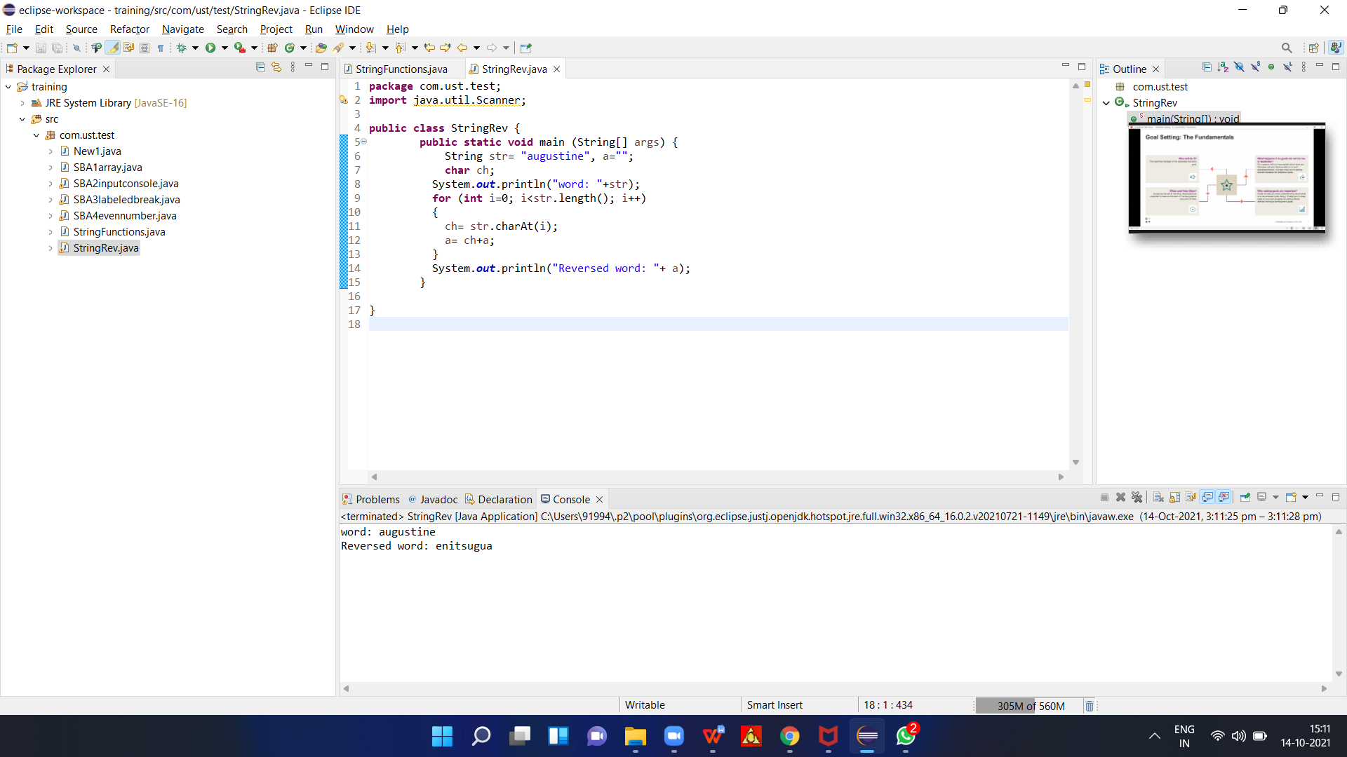

1. Write programs to depict the usage of contains(), length(), replace(), concat(), equals()

**package** com.ust.test;

**public** **class** StringFunctions {

**public** **static** **void** main(String[] args) {

String first = "Hello! Welcome ";

String second = "To Programming";

System.***out***.println("\nString: " + first);

System.***out***.println("\nString: " + second);

//LENGTGH

**int** length = first.length();

System.***out***.println("\nLength: " + length);

//conca

String joinedString = first.concat(second);

System.***out***.println("\nJoined String: " + joinedString);

//Equal

**boolean** result1 = first.equals(second);

System.***out***.println("\nIs Strings first and second are equal: " + result1);

//replace

System.***out***.println("\nreplaced");

System.***out***.println(first.replace('!', '.'));

}

}

