**SQL (Structured Query Language)**

SQL is Structured Query Language, which is a computer language for storing, manipulating and retrieving data stored in a relational database.

* Allows users to access data in the relational database management systems.
* Allows users to describe the data.
* Allows users to define the data in a database and manipulate that data.
* Allows to embed within other languages using SQL modules, libraries & pre-compilers.
* Allows users to create and drop databases and tables.
* Allows users to create view, stored procedure, functions in a database.
* Allows users to set permissions on tables, procedures and views.

RDBMS(Relational Database Management System)

* It is a database management system (DBMS) that is based on the relational model.
* TABLE: data in an RDBMS is stored in database objects which are called as tables.
* FIELDS:Every table is broken up into smaller entities called fields. The fields in the CUSTOMERS table consist of ID, NAME, AGE, ADDRESS and SALARY.
* ROW: A record is also called as a row of data is each individual entry that exists in a table.
* COLUMN:A column is a vertical entity in a table that contains all information associated with a specific field in a table.
* Schema:Schema diagram / ER diagram (Entity relationship).Schema is a blueprint.

SQL data types:

* int
* smallint
* tinyint
* float
* real
* date
* time
* datetime
* smalldatetime
* char
* varchar
* text
* image
* timestamp

Stored Procedures

These are nothing but functions/Methods which will hold verified SQL statements

SQL Commands

* CREATE DATABASE : creates a new database

Syntax:

CREATE DATABASE DatabaseName;

* DROP DATABASE: statement is used to drop an existing database in SQL schema.

Syntax:

DROP DATABASE DatabaseName;

* USE: statement is used to select any existing database in the SQL schema.

Syntax:

USE DatabaseName;

* CREATE TABLE - creates a new table

Syntax:

CREATE TABLE table_name(

column1 datatype,

column2 datatype,

column3 datatype,

.....

columnN datatype,

PRIMARY KEY( one or more columns )

);

* NOT NULL  − Ensures that a column cannot have NULL value.
* DEFAULT  − Provides a default value for a column when none is specified.
* UNIQUE  − Ensures that all values in a column are different.
* [PRIMARY Key](https://www.tutorialspoint.com/sql/sql-primary-key.htm)− Uniquely identifies each row/record in a database table.
* [FOREIGN Key](https://www.tutorialspoint.com/sql/sql-foreign-key.htm) − Uniquely identifies a row/record in any of the given database table.
* [CHECK](https://www.tutorialspoint.com/sql/sql-check.htm)  − The CHECK constraint ensures that all the values in a column satisfies certain conditions.
* [INDEX](https://www.tutorialspoint.com/sql/sql-index.htm) − Used to create and retrieve data from the database very quickly.
* DROP TABLE - deletes a table

Syntax:

DROP TABLE table_name;

* INSERT INTO - inserts new data into a database

Syntax:

INSERT INTO TABLE_NAME (column1, column2, column3,...columnN)

VALUES (value1, value2, value3,...valueN);

or

INSERT INTO TABLE_NAME VALUES (value1,value2,value3,...valueN);

* SELECT - extracts data from a database

Syntax:

SELECT column1, column2, columnN FROM table_name;

Select all

SELECT * FROM table_name;

* WHERE clause :

To specify a condition while fetching the data from a single table or by joining with multiple tables.

Syntax:Select with where

SELECT column1, column2, columnN

FROM table_name

WHERE [condition] ;

* UPDATE - updates data in a database

Syntax:

UPDATE table_name

SET column1 = value1, column2 = value2...., columnN = valueN

WHERE [condition];

* DELETE - delete the existing records from a table.

Syntax:

DELETE FROM table_name

WHERE [condition];

* ALTER TABLE

add, delete or modify columns in an existing table.

* add a New Column in an existing

ALTER TABLE table_name ADD column_name datatype;

* DROP COLUMN in an existing table

ALTER TABLE table_name DROP COLUMN column_name;

* change the DATA TYPE of a column in a table

ALTER TABLE table_name MODIFY COLUMN column_name datatype;

* add a NOT NULL constraint to a column in a table

ALTER TABLE table_name MODIFY column_name datatype NOT NULL;

* ADD UNIQUE CONSTRAINT to a table

ALTER TABLE table_name

ADD CONSTRAINT MyUniqueConstraint UNIQUE(column1,column2...);

* ADD CHECK CONSTRAINT to a table

ALTER TABLE table_name

ADD CONSTRAINT MyUniqueConstraint CHECK (CONDITION);

* ADD PRIMARY KEY constraint to a table

ALTER TABLE table_name

ADD CONSTRAINT MyPrimaryKey PRIMARY KEY (column1,column2...);

* DROP CONSTRAINT from a table

ALTER TABLE table_name

DROP CONSTRAINT MyUniqueConstraint;

* JOIN:

Joins clause is used to combine records from two or more tables in a database. A JOIN is a means for combining fields from two tables by using values common to each.

* [INNER JOIN](https://www.tutorialspoint.com/sql/sql-inner-joins.htm) − returns rows when there is a match in both tables.
* [LEFT JOIN](https://www.tutorialspoint.com/sql/sql-left-joins.htm) − returns all rows from the left table, even if there are no matches in the right table.
* [RIGHT JOIN](https://www.tutorialspoint.com/sql/sql-right-joins.htm) − returns all rows from the right table, even if there are no matches in the left table.
* [FULL JOIN](https://www.tutorialspoint.com/sql/sql-full-joins.htm) − returns rows when there is a match in one of the tables.
* [SELF JOIN](https://www.tutorialspoint.com/sql/sql-self-joins.htm) − is used to join a table to itself as if the table were two tables, temporarily renaming at least one table in the SQL statement.
* [CARTESIAN JOIN](https://www.tutorialspoint.com/sql/sql-cartesian-joins.htm) − returns the Cartesian product of the sets of records from the two or more joined tables.
* Order by

Used to sort the data in ascending or descending order, based on one or more columns. Some databases sort the query results in an ascending order by default.

Syntax:

SELECT column-list

FROM table_name

[WHERE condition]

[ORDER BY column1, column2, .. columnN] [ASC | DESC];

* Group by

Used in collaboration with the SELECT statement to arrange identical data into groups.

Syntax:

SELECT column1, column2

FROM table_name

WHERE [ conditions ]

GROUP BY column1, column2

ORDER BY column1, column2

* SQL View

View is a virtual table based on the result-set of an SQL statement.

Contains rows and columns.

Syntax:

Create view :

CREATE VIEW view_name AS

SELECT column1, column2.....

FROM table_name

WHERE [condition];

Update view:

UPDATE view_name

column= value

WHERE [condition];

Delete view:

DELETE FROM view_name

WHERE [condition];

* SQL Index

Indexes are used to retrieve data from the database more quickly than otherwise. The users cannot see the indexes, they are just used to speed up searches/queries.

Syntax:

Create index:

CREATE INDEX index_name ON table_name;

Single column:

CREATE INDEX index_name

ON table_name (column_name);

Unique :

CREATE UNIQUE INDEX index_name

on table_name (column_name);

compositive:

CREATE INDEX index_name

on table_name (column1, column2);

Drop Index:

DROP INDEX index_name;

* Subquery

A Subquery or Inner query or a Nested query is a query within another SQL query and embedded within the WHERE clause.

A subquery is used to return data that will be used in the main query as a condition to further restrict the data to be retrieved.

Subqueries can be used with the SELECT, INSERT, UPDATE, and DELETE statements along with the operators like =, <, >, >=, <=, IN, BETWEEN, etc.

Syntax:

Select:

SELECT column_name [, column_name ]

FROM table1 [, table2 ]

WHERE column_name OPERATOR

(SELECT column_name [, column_name ]

FROM table1 [, table2 ]

[WHERE])

Insert:

INSERT INTO table_name [ (column1 [, column2 ]) ]

SELECT [ *|column1 [, column2 ]

FROM table1 [, table2 ]

[ WHERE VALUE OPERATOR ]

Update:

UPDATE table

SET column_name = new_value

[ WHERE OPERATOR [ VALUE ]

(SELECT COLUMN_NAME

FROM TABLE_NAME)

[ WHERE) ]

Delete:

DELETE FROM TABLE_NAME

[ WHERE OPERATOR [ VALUE ]

(SELECT COLUMN_NAME

FROM TABLE_NAME)

[ WHERE) ]

**SQL QUERIES EXAMPLE**

SQL is Structured Query Language, which is a computer language for storing, manipulating and retrieving data stored in a relational database.

**Creating Database**

create database db1;

**Use Database**

use db1;

**creating Employee Table**

create table Employee (

Emp_ID int,

Emp_Name varchar(45),

Emp_Age int,

Emp_Dept varchar(45),

Dept_ID int,

Emp_Location varchar(45)

);

**Inserting Values to Employee Table**

insert into Employee(Emp_ID,Emp_Name,Emp_Age,Emp_Dept,Dept_ID,Emp_Location) values('101','jomin','22','IT','111','Bangalore');

insert into Employee(Emp_ID,Emp_Name,Emp_Age,Emp_Dept,Dept_ID,Emp_Location) values('102','kiran','23','Sales','111','Chennai');

insert into Employee(Emp_ID,Emp_Name,Emp_Age,Emp_Dept,Dept_ID,Emp_Location) values('103','swetha','30','HR','111','Hyderabad');

**creating Department Table**

create table Department (

Dept_ID int,

Dept_Name varchar(45),

Dept_Location varchar(45),

Project_ID int );

**Inserting values to Department Table**

insert into Department(Dept_ID,Dept_Name,Dept_Location,Project_ID) values('111','HR','Bangalore','11');

insert into Department(Dept_ID,Dept_Name,Dept_Location,Project_ID) values('112','IT','Chennai','12');

insert into Department(Dept_ID,Dept_Name,Dept_Location,Project_ID) values('113','Sales','Pune','15');

**creating Project Table**

create table Project (

ID_Project int,

Project_Name varchar(45),

Project_Location varchar(45),

Project_Strength int );

**Inserting values to Project Table**

insert into Project (ID_Project,Project_Name,Project_Location,Project_Strength) values('11','Health_care','Bangalore','5');

insert into Project (ID_Project,Project_Name,Project_Location,Project_Strength) values('12','Epay','Chennai','6');

insert into Project (ID_Project,Project_Name,Project_Location,Project_Strength) values('13','Stats','Hyderabad','3');

**select * from Employee;**

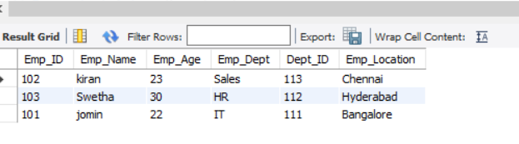

**select * from Department;**

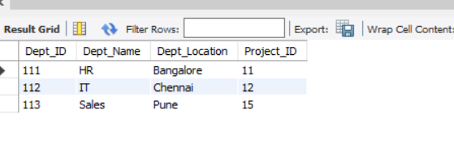

**select * from Project;**

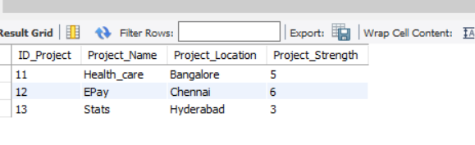

**alter table Employee add Salary double;**

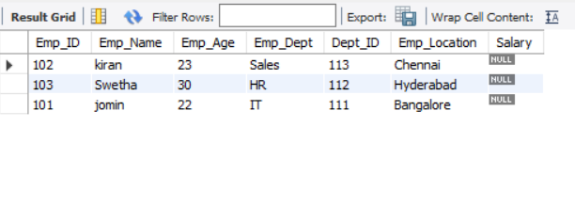

UPDATE Employee

SET Salary= '20000'

WHERE Emp_ID = 101;

UPDATE Employee

SET Salary= '10000'

WHERE Emp_ID = 102;

UPDATE Employee

SET Salary= '25000'

WHERE Emp_ID = 103;

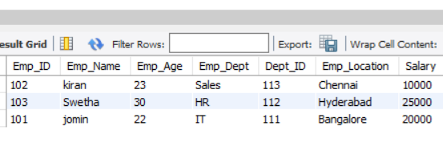

**select Emp_ID,Emp_Name from Employee where Emp_Age>21;**

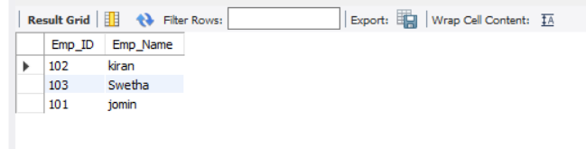

SELECT Emp_Name,Emp_Age

FROM Employee

ORDER BY Emp_Age desc;

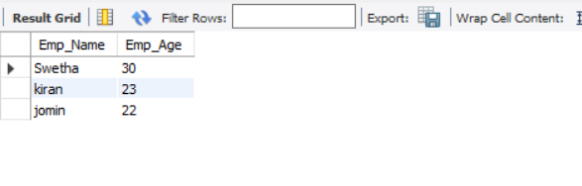

Inner Join

Select Employee.Emp_ID,Employee.Emp_Name,Department.Dept_Name,Department.Dept_Location

from Employee

inner join Department

on Employee.Dept_ID=Department.Dept_ID;

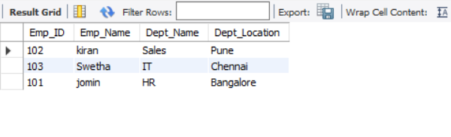

Left Join

select Employee.Emp_Name,Employee.Emp_Age,Project.Project_Name,Project.Project_Location

from Employee

left join Project

on Employee.Emp_Location=Project.Project_Location;

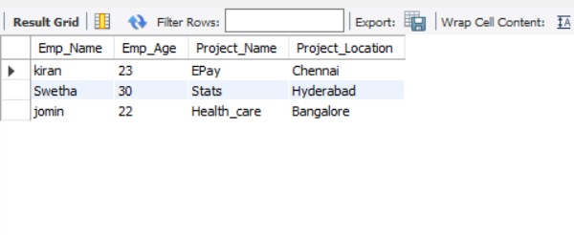

Right Join

select Employee.Emp_Name,Employee.Emp_Dept,Department.Dept_Name

from Employee

right join Department

on Employee.Emp_Location=Department.Dept_Location;

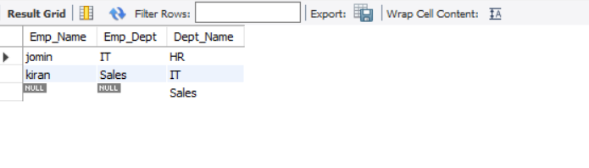

Cross Join

select * from Project cross join Department where Project_Strength>3;

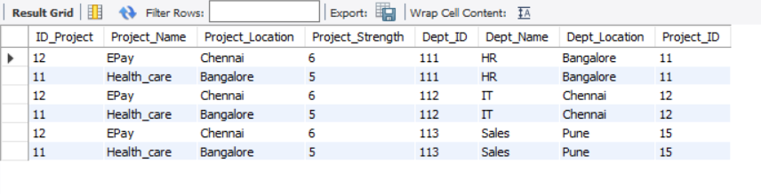

**Store Procedures**

CREATE DEFINER=`root`@`localhost` PROCEDURE `Update Salary`(in New_Salary double, in New_ID int)

BEGIN

update Employee set Salary=New_Salary where Emp_ID=New_ID;

END

call db1.`Update Salary`(45000, 103);

