**Game Booth for Exhibition Day**

Equipment for all booths: Background Canvas, monitor screens, cameras, speakers, Game Description stand

**Fun Games: James and Shu Luan**

|  |  |
| --- | --- |
| Game Name | Bounce Bounce Ping |
| Players | 1 vs 1 |
| Setting Up | Ping Pong balls with different color (orange and white), 9 cups and 3 tables. 3 tables in a row, put the 9 cups on the middle table. The two players stand at both side of the tables. |
| Playing Method | Firstly, each player will get different color of ping pong balls. Then, the players need to throws their own ping pong balls onto the first tables that located in front of them. After that, the ping pong balls will bounce into the empty cups those on the middle table. The player who successfully throw his ping pong ball into the cups and form a straight line with 3 ping pong balls, the player is the winner. If the player can win 3 round straightly, he will get an extra ticket for lucky draw. |

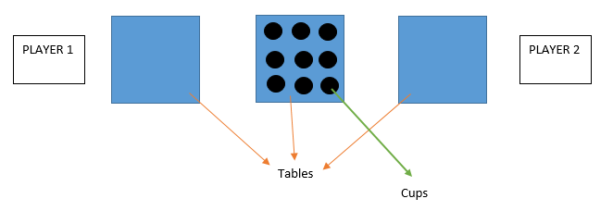

|  |  |
| --- | --- |
| Game Name | Balloon Pyramid |
| Players | 3-5 players |
| Setting Up | Balloons, 6 Paper Cups x Players, Tables |
| Playing Method | Contestant need to build a pyramid cups in one minutes without using their hands. The contestant cannot use their hand to build it need to replace it with balloon. They need to put the balloon in their mouth and blow it when the balloon is inside the cup to hold the cup up. Whoever the fastest complete a pyramid of cups as (the base with 3 cups, middle with 2 cups and 1 cup at the top.) is the winner. <https://www.youtube.com/watch?v=CKqQD7kUwwE> |

**Electronics and Electrical Games: Lance**

**Choose two!**

|  |  |
| --- | --- |
| Game Name | Speed Build |
| Players | 2 vs 2 |
| Setting Up | Arduino kits, Timer, Tables, 2 laptops |
| Playing Method | Selected Arduino items will be laid out on the table. compete with another team with 2 persons. Who can have the best and fastest build wins the game.  Reference: Army camp - Speed gun assembly |

|  |  |
| --- | --- |
| Game Name | Arena Junkyard |
| Players | 3v3 |
| Setting Up | Arena, 2 RC vehicle(base), 2 counters, boxes of junk items, 2 tables |
| Playing Method | Each team will assemble their body with the junk items provided. The RC vehicle will be pre-built. After the given time, both teams will compete their vehicles in the arena. The vehicle which is able to overturn, remove the most junk items from another vehicle, or most of all, remove the red ball in the center of the vehicle wins the game. |

|  |  |
| --- | --- |
| Game Name | Light Me Up (Colour edition) |
| Players | 2v2 |
| Setting Up | 2 long tables, 2 laptops, 2 Arduino, 2 RGB led, 2 led(normal), 2breadboard, transistors, resistors, batteries, long wires, cable cutter, manuals, timer |
| Playing Method | The incomplete circuitry of the Led is set up. Each team will require to complete the circuit and make the Led lights up. The challenge will be “complete the circuit with connecting components on breadboard, checking for faulty wires, writing Arduino codes, utillising transistors or output specified colours.” Whichever team completes the circuit in their own fastest time will be the winner.  Beginner: Arduino  Intermediate: Arduino + colour  Advance: Arduino + colour + transistors |

**Come and Go Games: Desmond**

|  |  |
| --- | --- |
| Game Name | Guess the Sentence |
| Players | All |
| Setting Up | Projector, Laptop |
| Playing Method | Every hour releases a character out of a sentence. Whoever guess the sentence correctly will win a chance for special lucky draw in the second day. |

|  |  |
| --- | --- |
| Game Name | Photo Contest |
| Players | All |
| Setting Up | Photo Booth, Banner / Bunting / Promote material etc. |
| Playing Method | Top 3 participants who catch the most interactive and interesting photos will win. #IEEEDigitalExpo2017 |

|  |  |
| --- | --- |
| Game Name | Facebook / Instagram Check-in |
| Players | All |
| Setting Up | - |
| Playing Method | Each day whoever check-in during the Digital Maker Expo will stand a chance to win prizes as well as obtaining a small gift #IEEEDigitalExpo2017 |

|  |  |
| --- | --- |
| Game Name | Match the Time |
| Players | All |
| Setting Up | Counting Timer, Laptop |
| Playing Method | Build a device that counting the time. Set the goal as 17 seconds. Whoever nearest 17 seconds but not exceed it will secure the top list of leaderboard. The winner of each day will win the prize. |