Text Mining and Sentiment Analysis

AUGUSTINE UGBEDA

2020 M11 4

TASK 1:

The task is to Scrape the GDP nominal rankings table provided by Statistics Times. <http://statisticstimes.com/economy/countries-by-projected-gdp.php>

## Running necessary libraries

library(rvest)

library(writexl)

##reading in the data and storing it in variable gdp

url <- read_html("http://statisticstimes.com/economy/countries-by-projected-gdp.php")

gdp <- url %>%  
 html_nodes("#table_id")%>%  
 html_table(fill = TRUE)  
  
gdp<- as.data.frame(gdp)  
View(gdp)

or

gdp <- url %>%  
 html_nodes("table")%>%  
 html_table(fill = TRUE)  
View(gdp[[2]])

##TO view the structure of the data

str(gdp)

## List of 2  
## $ :'data.frame': 2 obs. of 2 variables:  
## ..$ X1: chr [1:2] "Source" "Date"  
## ..$ X2: chr [1:2] "International Monetary Fund World Economic Outlook (October - 2020)" "06 Nov 2020"  
## $ :'data.frame': 197 obs. of 11 variables:  
## ..$ Country/Economy : chr [1:197] "Country/Economy" "Pakistan" "Venezuela" "Afghanistan" ...  
## ..$ GDP Nominal (billions of $) : chr [1:197] "2019" "276.114" "63.960" "18.876" ...  
## ..$ GDP Nominal (billions of $) : chr [1:197] "Rank" "45" "76" "116" ...  
## ..$ GDP Nominal (billions of $) : chr [1:197] "2020" "262.797" "48.610" "19.006" ...  
## ..$ GDP Nominal (billions of $) : chr [1:197] "Rank" "45" "86" "112" ...  
## ..$ GDP Nominal (billions of $) : chr [1:197] "share (%)" "0.313" "0.0580" "0.0227" ...  
## ..$ GDP PPP (billions of Int. $): chr [1:197] "2019" "1,065.373" "204.291" "81.880" ...  
## ..$ GDP PPP (billions of Int. $): chr [1:197] "Rank" "24" "69" "99" ...  
## ..$ GDP PPP (billions of Int. $): chr [1:197] "2020" "1,076.258" "155.383" "78.884" ...  
## ..$ GDP PPP (billions of Int. $): chr [1:197] "Rank" "23" "75" "97" ...  
## ..$ GDP PPP (billions of Int. $): chr [1:197] "share (%)" "0.827" "0.119" "0.0606" ...

## exporting the table to as excel file

writexl::write_xlsx(gdp,"C:\\Users\\augustine ugbeda\\Documents\\R\\GDP.xlsx")

## sample of the table

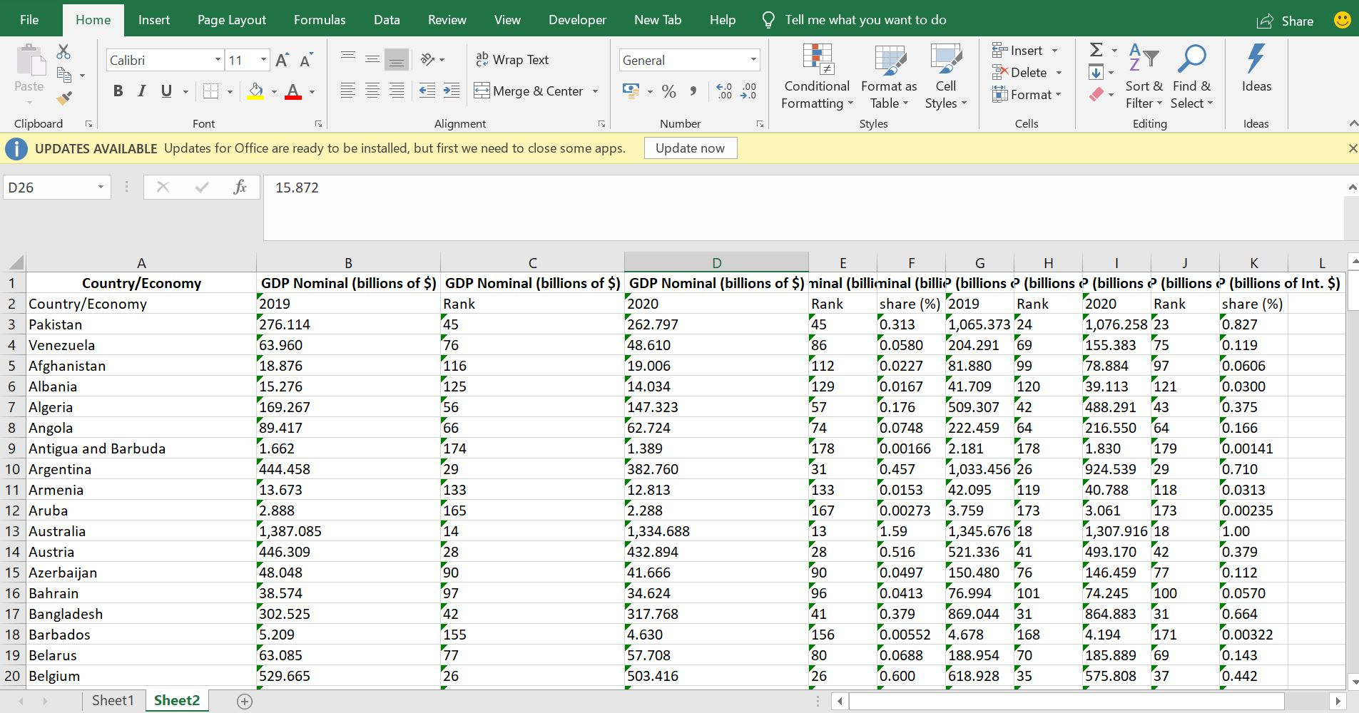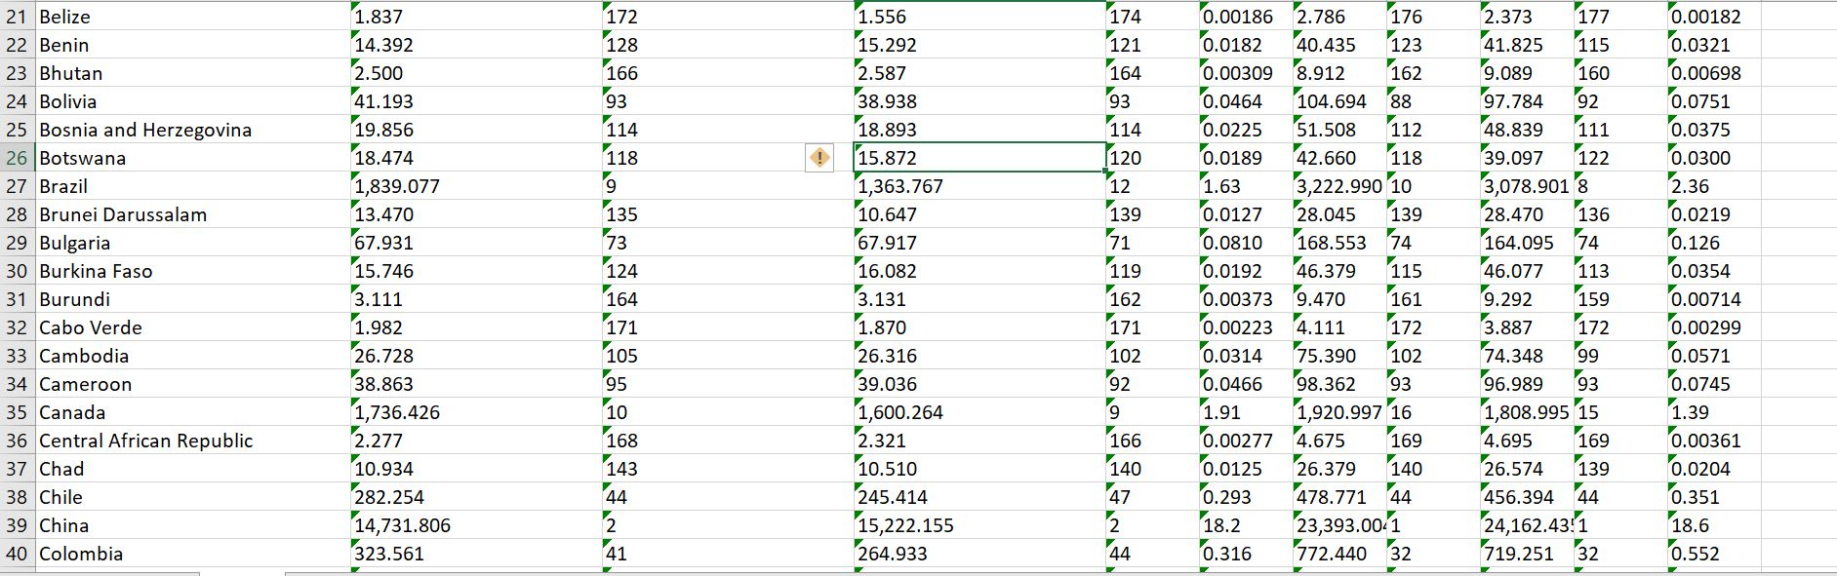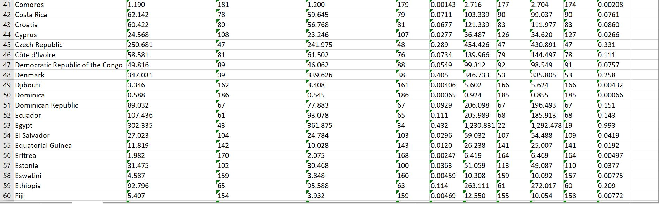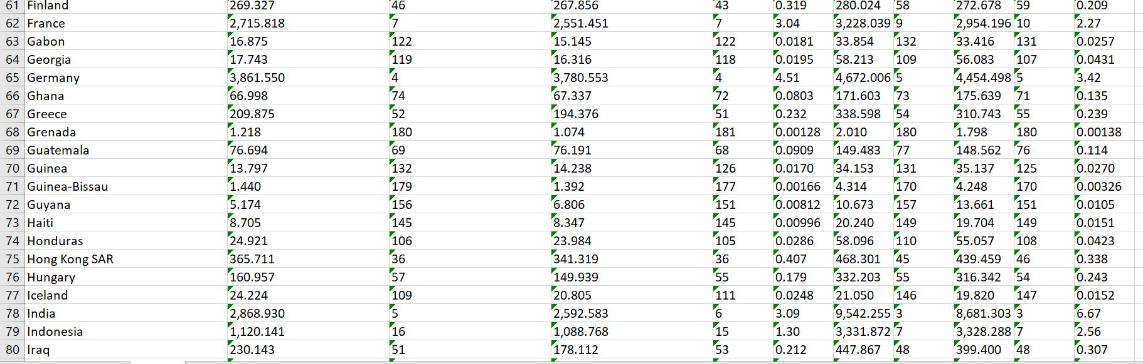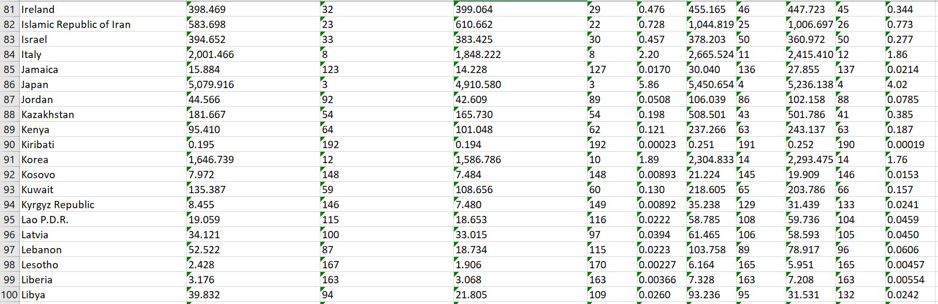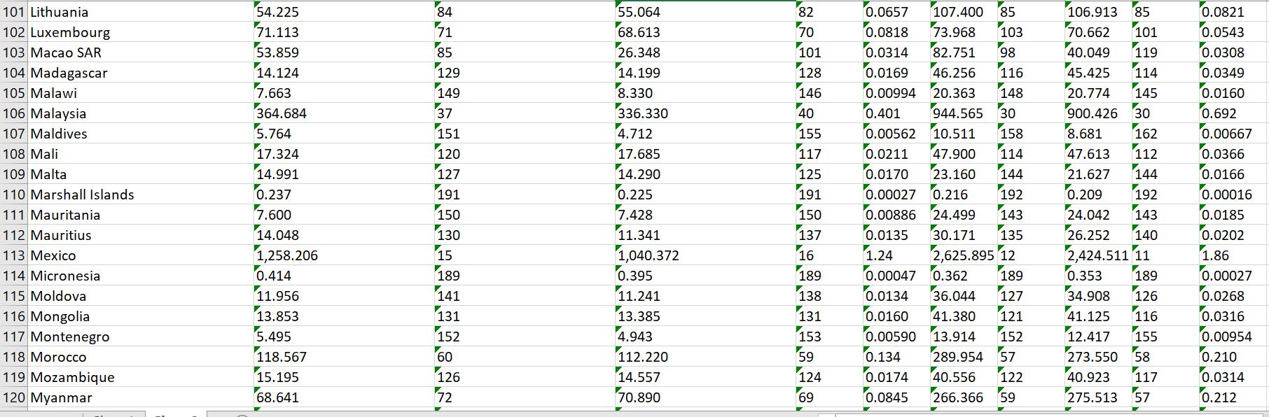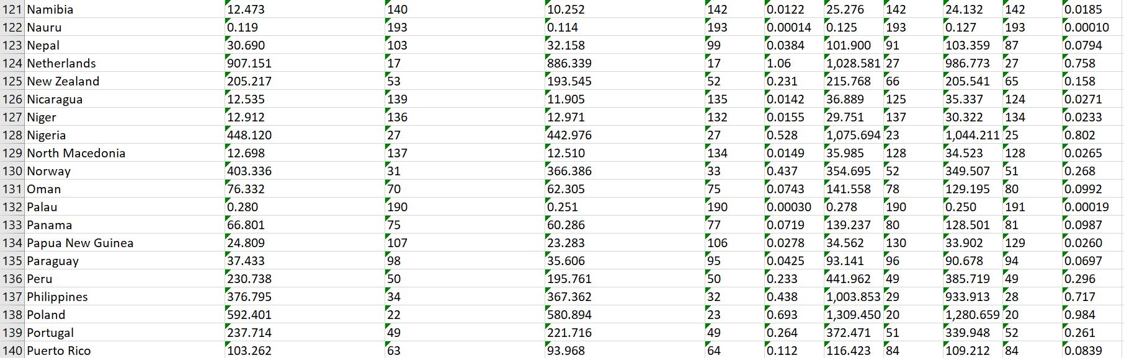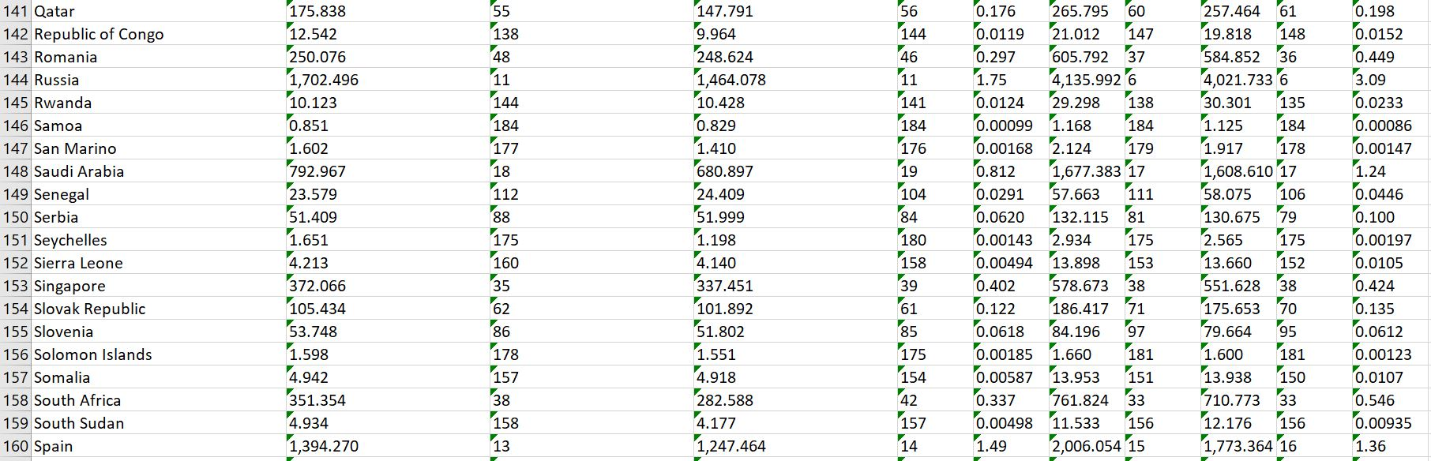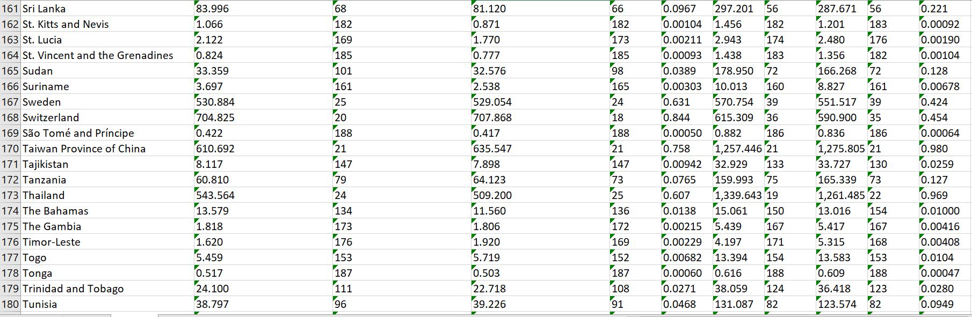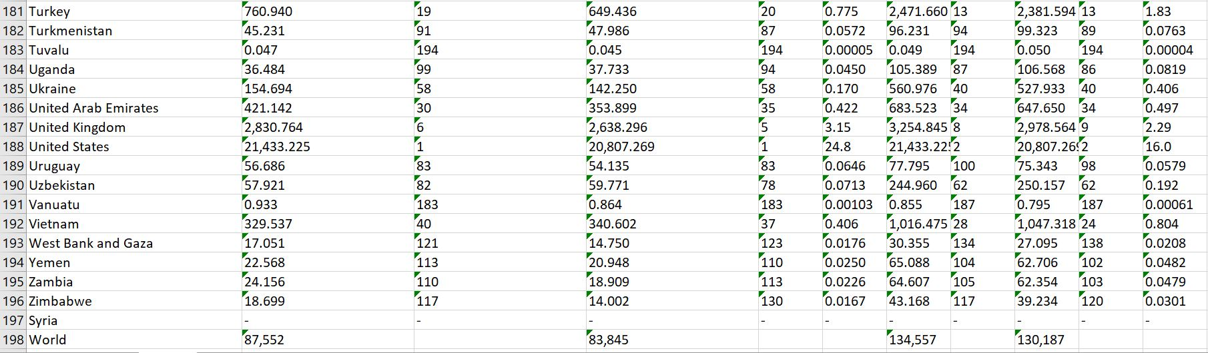

### 

### TASK 2:

### The task is to extract a sizeable amount of useful text from the main body content for the Wikipedia story on the EndSars Protest and run a sentiment analysis. <https://en.wikipedia.org/wiki/End_SARS>

## reading in the data

website <- read_html("https://en.wikipedia.org/wiki/End_SARS")  
 endsars <- html_nodes(website,"p")%>%  
 html_text()  
   
## storing it in the variable name “endsars2”

endsars2 <- website %>%  
 html_nodes("p") %>%  
 html_text()

## extracting the fourth to eighty second paragraphs  
start<- endsars2[4:82]  
start

## [1] "End SARS is a decentralised social movement, and series of mass protests against police brutality in Nigeria. The slogan calls for the disbanding of the Special Anti-Robbery Squad (SARS), a notorious unit of the Nigerian Police with a long record of abuses.[3][4] The protests which takes its name from the slogan started in 2017 as a Twitter campaign using the hashtag #ENDSARS to demand the disbanding of the unit by the Nigerian government.[5][6][7] After experiencing a revitalisation in October 2020 following more revelations of the abuses of the unit, mass demonstrations occurred throughout the major cities of Nigeria, accompanied by vociferous outrage on social media platforms. About 28 million tweets bearing the hashtag have been accumulated on Twitter alone.[8] Solidarity protests and demonstrations by Nigerians in diaspora and sympathizers occurred in many major cities of the world. The protests is notable for its patronage by a demographic that is made of entirely young Nigerians.[9][10] The movement has since expanded to include demands for good and acountable governance.\n"   
## [2] "Within a few days of renewed protests, on 11 October 2020, the Nigerian Police Force announced that it was dissolving the unit with immediate effect. The move was widely received as a triumph of the demonstrations.[11] However, it was noted in many quarters that similar announcements had been made in recent years to pacify the public without the unit actually being disbanded, and that the government had merely planned to reassign and review SARS officers to medical centres rather than disband the unit entirely.[12] Protests have continued accordingly, and the Nigerian government has maintained a pattern of violent repression including the killing of demonstrators.[13] There have been international demonstrations in solidarity with those happening in the country, and the movement has also grown increasingly critical of Muhammadu Buhari's government response to the protests.[14]"   
## [3] "SARS officers have been alleged to profile young Nigerians, mostly males, based on fashion choices, tattoos and hairstyles. They were also known to mount illegal road blocks, conduct unwarranted checks and searches, arrest and detain without warrant or trial, rape women, and extort young male Nigerians for driving exotic vehicles and using laptops and iPhones.[15] Nigerians have shared both stories and video evidence of how officers of SARS engaged in kidnapping, murder, theft, rape, torture, unlawful arrests, humiliation, unlawful detention, extrajudicial killings and extortion of Nigerian citizens. A large section of the victims of the abuses of SARS have been young male Nigerians.[16]"   
## [4] "The Special Anti-Robbery Squad (SARS) was a branch of the Nigeria Police Force under the State Criminal Investigation and Intelligence Department (SCIID). It was founded in late 1992 as one of the 14 units in the Force Criminal Investigation and Intelligence Department, which was established to detain, investigate, and prosecute people involved in crimes like armed robbery, kidnapping, and other violent crimes.[17] The squad was created as a masked police unit to perform undercover operations against violent crimes like armed robbery, car snatching, kidnapping, cattle rustling, and the bearing and use of illegal firearms.[18]"   
## [5] "SARS had been accused of several human rights violations, illegal \"stop and searches\", illegal arrests and detentions, extrajudicial killings, sexual harassment of women and brutalising of young male Nigerians. The human rights abuses were documented in trending videos on social media.[19]"   
## [6] "In 2017, Nigerian activists, youth and celebrities across the nation took to the streets in a peaceful protest to spread awareness of SARS brutality and extortions and to demand its disbanding. The protests also moved to social media using the hashtag #EndSARS.[20][21][22]"   
## [7] "A 2016 report by Amnesty International, indicted SARS maintaining that the squad was responsible for human rights abuses, cruelty, degrading treatment of Nigerians in their custody, and other widespread torture. Some of the human rights abuses by SARS include the shooting of their detainees in the leg, mock executions and threats of execution, hanging and physical assault.[23] A 2020 publication by the organisation documented 82 cases of abuses and extra judicial killings by SARS between January 2017 and May 2020.[24]"   
## [8] "Amnesty International accused the SARS officials of regularly detaining young male Nigerians illegally and extorting money from their relatives.[5] In 2016, a human rights activist, Segun Awosanya popularly known as Segalink started EndSARS campaign on Twitter prompting police authority to announce reform of the police unit but nothing was achieved at the time.[25] In 2018, Nigerian rapper Michael Ugochukwu Stephens professionally known Ruggedman joined the campaign to end police brutality by releasing a single titled, Is Police Your Friend?[26] In 2017, a petition signed by 10,195 people was submitted to Nigeria's National Assembly calling for a total disbandment of SARS.[27] A few Senators backed the call for total disbandment of the unit.[28] Consideration was given to reforming the force, rather than full disbandment due to the number of cases falling.[29][30]"   
## [9] "The campaigners moved from social media using the #EndSARS hashtag to organised, peaceful protests in Abuja, Lagos, Ibadan, Osun, Benin, Ughelli, Warri, Ilorin, Ogbomosho, Owerri, Jos, Kaduna, Calabar [31][21] and other Nigerian cities and states, threatening to continue if the government refused to disband the force.[32][33][34]"   
## [10] "Not only were there campaigners in Nigeria utilising the hashtag and having protests but they were also done in London and some parts of America recognising this situation as a global event. \n"   
## [11] "In response to the campaign, Nigeria Police Force Public Relations Officer Jimoh Moshood accused the campaigners of being \"criminals\".[35] Despite this, Inspector General of Nigeria Police Force Ibrahim K. Idris ordered the reform and reorganisation of SARS.[36]"   
## [12] "On Saturday 3 October 2020, a video showing a SARS police officer shooting a young Nigerian in front of Wetland Hotel, Ughelli, Delta State trended on the Internet. It was alleged that the police officers took away the young man's vehicle – a Lexus SUV.[37] The trending video caused public outcry on social media, especially on Twitter, with the #ENDSARS hashtag trending.[38]"   
## [13] "Just as the ENDSARS trend began on Twitter, on Monday 5 October 2020, another report surfaced of SARS officers killing a 20-year-old upcoming musician named Daniel Chibuike, popularly called Sleek in his neighbourhood.[39] Sleek was said to be sitting in front of a hotel with a friend when the SARS officers approached them, prompting them to flee. According to an eyewitness, the SARS men pursued the pair, shouting \"thief\", before shooting Sleek as they ran through a supermarket.[39] His friend was arrested.\n"   
## [14] "On Thursday 8 October 2020, nationwide protests on ENDSARS started after weeks of outrage and anger with videos and pictures showing police brutality, harassment and extortion in Nigeria. The protests were led predominantly by young Nigerians in different cities alongside many activists and celebrities.[40]Nigeria Police Force disrupted the protests in some cities, throwing teargas, using water cannons and shooting at unarmed peaceful protesters as seen in Abuja and Osun.[41] This led to the death of Jimoh Isiaq in Ogbomoso, Oyo State.[42][15][43][44][45] By Wednesday, 14 October 2020, the End SARS protests were still on-going with young people in different parts of Nigeria intensifying their calls for reforms and accountability in police operations.[46]"   
## [15] "On Sunday, 11 October 2020, the protestors made a list of five demands to be met by the Federal Government of Nigeria. The demands which were signed by 'A Nigerian Youth' demanded for the immediate release of all arrested during the protests as well as justice and compensation for all who died through police brutality in Nigeria. They also demanded that an independent body be set up within 10 days to investigate and prosecute all reports of police misconduct. The protestors also asked for the psychological evaluation and retraining of SARS operatives before they are deployed to any other police unit. Lastly, they asked for adequate increase in the salaries for officers of the Nigerian police.[47]"   
## [16] "In response to the public outcry on police brutality, the Inspector-General of Nigeria Police banned the FSARS, Special Tactical Squad (STS), Intelligence Response Team (IRT), Anti-Cultism Squad and other tactical units from mounting of roadblocks, checkpoints, stop-and-search and other routine and patrols. Similar bans had been announced multiple times over the previous four years, causing citizens of Nigeria to question whether the bans would actually be upheld. There were further reports of SARS officers involved in killings across the country.[48]"   
## [17] "As this was the fourth time that the Nigerian government had announced a similar ban on SARS activity,[49] protesters insisted that the notorious police unit be entirely disbanded and wide-ranging reform of the force to follow.[50]"   
## [18] "On Tuesday, 20 October 2020, the Central Bank of Nigeria and its Governor, Godwin Emefiele obtained an exparte motion to freeze the accounts of notable participants in the End SARS protest. In an exclusive report by Peoples Gazette, court documents showed that the Central Bank of Nigeria failed to give any justification for the freezing order. Twenty protesters with banking with Access Bank plc, Fidelity Bank Nigeria, First Bank of Nigeria, Guaranty Trust Bank, United Bank for Africa and Zenith Bank had all accounts linked to them placed under \"post no debit\".[51][52]"   
## [19] "Nigerian youths protested on EndSARS at the Lagos State Governor's House on Thursday 8 October and slept at the gate of the government house till Friday 9 October 2020 when the Deputy Governor addressed the protesters.[53] Among the Lagos State EndSARS Protesters were celebrities Falz, Runtown, Don Jazzy, Olu Jacobs, Eedris Abdulkareem and a host of others including several comedians and other media personalities.[54]"   
## [20] "On Friday, 9 October 2020, the Deputy Governor of Lagos State, Femi Hamzat addressed the protesters and acknowledged that police officers do not have the right to trample on the rights of law-abiding citizens based on their appearance or on items in their possession. He condemned police brutality and promised that the Lagos government will take action necessary to end it.[55][56] The deputy governor also stated that four years previously, he had been harassed by SARS police who were not in uniform.[57][58]"   
## [21] "The Lagos State House of Assembly held an emergency parliamentary sitting to deliberate the petition of the EndSARS protesters. The parliamentarians made a seven-point resolution, as follows: Nigeria's Senate and House of Assembly should probe FSARS, the Police Commissioner should protect protesters, molestation of youths should be stopped, institution of public inquiry on the extrajudicial killings by Senate President and the House of Representatives Speaker, proscription of SARS and its replacement by a new unit with a clear code of conduct, and sanction of illegalities.[59]"   
## [22] "Nigerian youths protested on EndSARS,[60] at the headquarters of Nigeria Police Force in Federal Capital Territory, Abuja and vow to camp at headquarters till Inspector-General of Police, Mohammed Adamu, addresses them.[61]"   
## [23] "While the protest continued on Saturday 10 October 2020, the Nigerian police started dispersing the youths with tear gas and water. The co-convener of Bring Back Our Girls, Aisha Yesufu, Rinu Oduala, popularly called @SavvyRinu on Twitter, and other protesters were reportedly manhandled by the Nigerian police.[62]"   
## [24] "The EndSARS protest in Ogbomosho, Oyo State turned violent as Nigerian police were alleged to have injured seven protesters and shot dead a young man known as Jimoh Isiaka during the protest, Traditional Rulers used the Nigerian Police to forcefully send back protesters. Jimoh Isiaka was taken to Bowen University Teaching Hospital for medical care and later died at the hospital. In response to the death of the protesters, the commissioner of police of Oyo State, Nwachukwu Enwonwu, denied the allegation that the police killed the protester. He said that the police used tear gas to prevent protesters from attacking and entering the police station. The governor of Oyo State, Seyi Makinde sent a condolence message on the demise of the protester and promised to investigate the incident.[63][64]"   
## [25] "On Sunday, 11 October 2020, Nigeria's Inspector-General of Police, Mohammed Adamu announced the \"dissolution\" of SARS. Many Nigerians within the movement criticised the announcement, however, pointing out that similar promises had been made in earlier years and that the government's plan was to reassign SARS officers to other police departments rather than eliminate them from the force entirely.[12] The protests continue despite the \"dissolution\" as many do not believe the pronouncement.[65]"   
## [26] "David Adeleke, a popular musician known as Davido joined a group of #EndSARS protesters in Abuja to call for the end police brutality and the notorious police unit in the city. The police started dispersing the protesters with tear gas, live bullets and water cannons.[66]"   
## [27] "Three more protestors were shot dead in Ogbomoso, Oyo State, following a killing the day before.[67]"   
## [28] "On Monday, 12 October 2020, the Governor of Lagos State Babajide Sanwo-Olu and the Minister of Police Affairs, Maigari Dingyadi, urged protestors to believe that SARS has been disbanded.[68] On Monday, 12 October 2020 the Rivers State Governor, Nyesom Wike announced that the End SARS protests are disallowed in Rivers State. He banned all forms of protests in Rivers State.[69] On Monday, 12 October 2020, the Governor of Oyo State, Seyi Makinde barred Police from engaging with the protestors in order to avert further casualties from the pandemic.[70]"   
## [29] "A bystander watching the protest was shot dead by members of the Nigeria Police Force in Surulere while leaving 4 injured and they also arrested and detained peaceful Protesters.[13] The protests in Lagos at Lekki-Epe Expressway toll gate, Murtala Mohammed International airport toll gate, Alausa, Ikorodu Road and Yaba caused heavy traffic gridlock and crippled businesses as young people continued to demand #EndSARS #SARSMustEnd.[71][72]"   
## [30] "Protests continued in Abuja as young people continued to march against police harassment, brutality and extortion. They blocked the Berger roundabout to draw attention to their demands. Earlier on in the day, the protestors had been challenged by Pro-SARS sympathizers who were marching in support of the Inspector General of Police Mohammed Adamu and the Nigerian President Muhammed Buhari under the aegis of Citizens Action for Good Governance.[73]"   
## [31] "Protesters in Oyo State with placards calling for the disbandment of SARS, an end to Police brutality extortion and extrajudicial killing demonstrated in front of University of Ibadan and Iwo Road in Ibadan.[74] The protests locked down Iwo Road making vehicular movement to be at a standstill.[75]"   
## [32] "On Tuesday, 13 October 2020, Ifeanyi Okowa the Governor of Delta State said that the #EndSARS protest is a result of failed leadership. The Governor also announced the constitution of a five-member Police Complaints Committee with two representatives from youth organisations.[76] The Governor had earlier appealed to the police to desist from harassing the protesters as people were free to express grievances in a democratic dispensation.[77] On Tuesday, 13 October 2020, the Public Relations Officer of the Nigerian Police Force, Frank Mba, announced the setting up of a Special Weapon and Tactics Team (SWAT) to replace SARS. The new outfit, which is expected to take off within the next 7 days, will undergo psychological and medical evaluation to determine their fitness.[60]"   
## [33] "The protest was taken to the National Assembly. Moving from Banex junction Abuja, protesters peacefully marched to the junction leading to the National Assembly around 2 p.m. where they were stopped by soldiers who violently resisted their movement and injured some protesters in the process.[78] ARISE TV news crew who were recording the fracas at the entry of the National Assembly were attacked. Ferdinard Duruoha was one of the crew members who were assaulted while Francis Ogbonna a cameraman with the same news outfit was attacked the previous day while covering the announcement of dissolution of SARS by the Inspector General of Police.[79]"   
## [34] "The Governor of Lagos State promised to set up a two hundred million naira (N200M) fund for residents of the State who have been victims of police brutality.[80] He met with President Muhammadu Buhari to present the demands of the protesters in Lagos State.[81] A video surfaced from this meeting showing the President chuckle as the Governor Sanwo-Olu talked about his state's compensation fund for victims. The President's actions met a lot of negative criticism from Nigerians.[82]"   
## [35] "According to a press release signed by spokesman of the president, Femi Adesina the Nigerian Government had agreed to the five demands of the End SARS protestors. The agreement was reached at a meeting organised by the Office of the Inspector General of Police and National Human Rights Commission (NHRC) was attended by stakeholders which include officials of Ministry of Police Affairs and Police Service Commission, representatives of Civil Society organisations and activists from the entertainment industry and #EndSARS movement.[83][84]"   
## [36] "The protests continued in Lagos. Young people carrying placards denouncing SARS and appealing for an end to police harassment, extortion and brutality blocked the Lagos-Ibadan expressway.[85]"   
## [37] "On Wednesday, 14 October 2020, protesters in Lagos were attacked with cutlasses, sticks and charms.[86] In Abuja, protesters were attacked by people with cutlasses and cudgels at Berger roundabout. Cars were destroyed and some of the protestors were injured.[87][88]"   
## [38] "On Thursday, 15 October 2020, the prohibition of demonstrations in the Federal Capital Territory Security Committee was announced. The decision was taken at a meeting which held on Wednesday, 14 October 2020 and which was chaired by FCT Minister, Malam Muhammad Bello. The announcement recognised the rights of citizens to gather and demonstrate however, it went on to point out that the EndSARS protests were unruly, caused discomfort to people, violated COVID-19 protocols and should be discontinued in view of the fact that Government had met the demands of the protesters.[89] Nigerians thought this absurd since there had been elections in Ondo and Edo along with massive rallies in preceding weeks.[90] Buhari's daughter had also had her wedding ceremony.[91] At the peak of the pandemic, Abba Kyari, late Chief of Staff to the President of Nigeria, was buried without adherence to COVID-19 guidelines.[92]"   
## [39] "People conveyed by Lagos state buses attacked protesters near the state secretariat in Alausa.[93]"   
## [40] "On Friday, 16 October 2020, the hacktivist group, Anonymous hacked the Twitter account of the National Broadcasting Commission and posted a message which stated \"We #Anonymous will continue supporting Nigerians\" in a support for the ongoing protests.[94]"   
## [41] "Thousands of protesters gathered at the Lekki toll gate and Alausa, Ikeja to hold a candlelight session for the various victims of SARS/police killings.[95][96]"   
## [42] "A day after the FCTA banned protests across the Capital territory amidst fear of a second wave of the COVID-19 outbreak due to the protests,[97] youths protesting against Police brutality and abuses moved their protest from City gate to airport road where they obstructed both incoming and outgoing commuters thereby causing a gridlock leaving thousands stranded.[98]"   
## [43] "Following violent escalations which included attacks by agitators against both protesters and police, the governor of Lagos state, Babajide Sanwo-Olu, declared a state-wide 24-hour curfew[99] effective 4:00 PM WAT on 20 October. During this time, images of some persons alleged to be working with the Lagos State government and the Lekki Concession Company removing cameras (later confirmed by the Lagos State Government to be laser cameras and not CCTV cameras as earlier publicized on social media[100]) at the toll gate circulated on End SARS on Twitter and street lights at the toll gate vicinity were turned off. A few hours later, it was reported that armed men of the Nigerian Army arrived at the scene of the protest and opened fire on peaceful and unarmed protesters, thereby resulting in a disputed number of deaths. A clip of the shooting videoed by a brave Nigerian youth, DJ Switch, trended on the Internet showing how live round of bullets were being shot at innocent protesters who crouched on the ground, holding hands together and singing the Nigerian National Antheem. There were also reports that at least 50 other people were injured. However, the Lagos State government later reported that the shooting resulted in up to 25 injured, and only 2 dead.[101] Despite the fact that the curfew was extended till 9:00 PM, soldiers of the Nigerian Army started shooting before 7:00 PM.[102][103][104][105][106][107]"  
## [44] "Following the killings on 20 October, video evidence showed that more shootings were still being carried out by the Nigerian Army and the Nigerian Police on the unarmed protesters. Some people also attacked and burnt buildings, vehicles, TV stations and raided the Oba of Lagos' palace.[108] The governor of Lagos had said that there were no casualties from the incident of the previous day but later tweeted that there had been reports of one casualty which negated the report sent in by various Twitter and Instagram users who had live recordings of the killings. While the protesters gathered again at the Lekki toll gate where the shooting took place on Tuesday 20 October, they were forced out by police.[108] While the protesters defied the curfew imposed by the Lagos state Governor, hoodlums burnt about 30 government buses at a bus station. Also burnt was Television Continental Station (TVC) linked to a former governor of the state, Bola Ahmed Tinubu, who is a national leader of the ruling All Progressives Congress (APC).[109][110]"   
## [45] "About seven people were reportedly killed within 24 hours since soldiers opened fire at protesters in Lagos. Authorities did not deny carrying out a crackdown, but refused to claim the deaths as of 21 October 2020. Brutality by the police forces made the protesters more angry intensifying the scale of the protests.[111]"   
## [46] "On Thursday, October 22, it was reported[112] that armed men began shooting at protesters in Oyigbo, Port Harcourt.[113][114] The attackers began breaking into homes, murdering those inside, and afterwards, torching down properties. It has been rumoured the shooters were Fulani herdsmen,[115] but there is no verification for this claim.\n"   
## [47] "On Saturday, 10 October 2020, the #EndSARS protest started from the Ekiugbo section of Ughelli, Delta State, went through the Ughelli Market, Ughelli Area Command and Isoko Road. The protests led to traffic gridlocks at the Ughelli-Patani section of the East-West Road. However, at Otovwodo Junction, fracas ensued as the peaceful protest assumed took another turn when hoodlums, motorcycle rider and others joined the youths. A police officer, Corporal Etaga Stanley of 'A' Division, Ughelli was disarmed, killed and his weapon and ammunition taken.[116][117]"   
## [48] "On Wednesday, 14 October 2020, young people in Effurun and Warri, Delta State joined in the protests.[118]"   
## [49] "On Saturday, 10 October 2020, hundreds of young people gathered at Ekwueme Square, Awka in the morning hours and peacefully matched past the Eke Awka market, and through the major streets of the town with placards.[119] SARS Awkuzu which is well known for human rights abuses is located in Anambra State.[120] The protests continued in Onitsha, the commercial nerve centre of Anambra State on Monday, 12 October, with protesters demanding that SARS be completely disbanded.[121]"   
## [50] "Protests continued in Awka on Wednesday, 14 October 2020 with protesters demanding for a total reform of the Nigerian Police Force.[122]"   
## [51] "On Friday, 16 October 2020, #EndSARS protesters including popular musicians and Anambra indigenes Phyno, Flavour, KCee, MasterKraft, marched from Awka, the state capital to Awkuzu town, where the dreaded SARS unit[123] is situated, calling for the total shutdown of the office.[124] The peaceful protesters were shot at by the officers of the supposedly dissolved SARS.[125][126]"   
## [52] "A similar protest was held simultaneously in Umuahia, capital of Abia State, by other youths in the state. They visited the police headquarters on Bende Road and Ab<U+1ECB>a State House of Assembly as well as the Abia Government House.[127]"   
## [53] "In Aba, the state's commercial nerve centre, youths took to the streets protesting police brutality on citizens.[128]"   
## [54] "In a statement on his Twitter handle, the governor said: \"I have taken note of the peaceful protests tagged #EndSARS and wish to assure Ab<U+1ECB>a youth and the general public that we will take up their concerns and ensure that your voices are heard at the right quarters.\"[127][129]"   
## [55] "On Monday, 12 October 2020, protesters in Osogbo, Osun State took to the streets of the capital town to protest against SARS with placards demanding that the squad be disbanded. The protests which took off from Olaiya junction and moved to the State House of Assembly caused traffic disruptions at the gate of government house, Osogbo as the protesters demanded that the Governor address them.[130][131]"   
## [56] "Aggrieved Nigerians in Port Harcourt, Rivers State, on Tuesday 13 2020, took to the streets of Port Harcourt, Rivers state capital, to protest against police brutality in defiance to the directive of the State Governor Ezenwo Nyesom Wike who had earlier issued a statement to the general public that all forms of protests have been banned throughout the State. The state governor, having observed this defiance by the protesters, joined them in solidarity, citing how Rivers State citizens had suffered so much police brutality carried out by members of SARS.[132][133]"   
## [57] "Fifteen #EndSARS protestors were arrested in Ogun State.[134] While others were released, three of the protesters; Adeniji Sodiq, Mutairu Faruq and Olatoye Joseph, who were arrested at the palace of the king of Owu on Friday, 9 October 2020 were charged for murder by the Police. After review of all evidence and as recommended by the Ogun State Attorney General, the Governor, Dapo Abiodun gave orders for their release as the charges against the protesters were withdrawn.[135] At Akute/Ajuwon/Agbole axis, Ogun State, Femi Kuti an Afrobeat musician, the son of late music icon Fela Kuti joined the protests and helped to stop many protesters from being arrested[136]"   
## [58] "On Tuesday, 13 October 2020, hundreds of protesters from different parts of Enugu State with placards denouncing and asking for the end to SARS, police brutality, extortion and harassment converged and moved from Okpara Square, Enugu to the Criminal Investigation Department where they submitted the five demands of the EndSARS protests. They were joined by musicians, Chinedu Izuchukwu Okoli known as Flavour, Chibuzor Nelson Azubuike, popularly known as Phyno and Zoro, a rapper. The protestors were later joined by the Deputy Governor of the State, Lolo Cecilia Ezeilo.[137][138]"   
## [59] "On Tuesday, 13 October 2020, hundreds of protesters in Abakiliki, capital of Ebonyi State took to the streets with placards demanding an end to police brutality and the prosecution of guilty officers.[139]"   
## [60] "The #EndSARS protest in Benin City turned violent on Friday, 16 October 2020 as the protesters that gathered at the Edo State House of Assembly got attacked with stones and bullets by a suspected thug who claimed that the protesters disturbed their daily businesses. Two protesters were killed and many were injured in the attack.[140]"   
## [61] "The protesters, in retaliation, took the fight back to where the thugs converged at the museum ground in King's Square (Ring Road) where they engaged in a brawl. The activities of the protesters left the Ring Road deserted due to fear of possible escalation of violence as motorists sought for alternative routes to their destination.[141]"   
## [62] "The Edo State governor, Godwin Obaseki, condemned the attack on the #EndSARS protesters in Benin City by unidentified hoodlums. He stated that a thorough investigation would be effected immediately to bring the culprits to justice.[142] In a statement, the governor commissioned the Edo State police command to come out fully and provide appropriate security to the protesters, as they were exercising their rights as concerned citizens of Nigeria.[142]"   
## [63] "According to him, \"I have just learnt that hoodlums have attacked #EndSARS protesters, who have conducted themselves peacefully in Benin City. I extend condolences to the victims of the attacks, including those who lost their lives and others who were injured by the thugs. It is disheartening that anyone would attack a peaceful assembly of young people who are expressing genuine concerns over police brutality and intimidation in their own country. I hereby call on the Edo State Police Command to get out on the streets and provide adequate security for the protesters and ensure that no one is harassed in the course of exercising their rights.\"[143]"   
## [64] "On 19 October 2020, news broke that \"hoodlums\" had stormed the correctional center in Edo state to free jailed inmates as part of the End SARS movement demands.[144][145]"   
## [65] "Jos, the capital of Plateau State saw youths in their number storm the city centre demanding the disbandment of the newly created Special Weapons and Tactics (SWAT) police unit by the Inspector General of Police (IG), Mohammed Adamu.[146]"   
## [66] "The protesters called on President Muhammadu Buhari and the Police Service Commission (PSC) to overhaul the entire Nigerian Police Force.[146]"   
## [67] "Displaying placards with various inscriptions such as #EndSARS; #EndSWAT; \"We don’t want SWAT\"; \"There’s no difference between SWAT and SARS\"; \"We want complete and total overhaul of all security apparatus in the country\", the youths stormed the Plateau State House of Assembly, The Plateau State Government House and other major streets in the city, calling on the state and federal government and the Nigerian Police Force to take action over the spate of extrajudicial killings by the operatives of the Nigerian Police. Placing it in context of the state, they called on the government to look into the general issues of insecurity in Plateau State among other neighbouring states.[147]"   
## [68] "On Tuesday 20 October 2020, while protest was going on, thugs hauled the Jos city biggest market, Terminus, where they burned cars, hauled shops and attacked unarmed #EndSARS protesters.[148][149]"   
## [69] "The on-going #EndSARS protests have been sustained by voluntary donations made by Nigerian citizens and the international community. There were voluntary donations of food items, water and professional services by lawyers and doctors for protesters.[150] Donations also came from local tech start-ups whose young male workers were constantly harassed by SARS and profiled as internet fraudsters because of laptops usually found in their possession.[151][152]"   
## [70] "International demonstrations were organised by the Nigerian diaspora in Europe, the Americas, Oceania, and elsewhere in Africa.[153][154][155] Many Nigerian and Nigerian diaspora celebrities gave supportive statements on social media and took part in protests, while demonstrators pledged to continue until the demands were met.[156][157][158]"   
## [71] "On Monday, 12 October 2020, Nigerians living in the Waterloo Region of Ontario organised a peaceful demonstration in support of the #EndSARs movement. The group gathered in the Waterloo Public Square chanting \"What do we want? End SARS!\"[159]"   
## [72] "On Friday, 23 October, Nigerians and German sympathizers organized a demonstration of several hundred participants in support of the #ENDSARS movement in Stuttgart.\n"   
## [73] "On Sunday, 11 October 2020, Nigerians in Dublin gathered in front of the Nigerian Embassy to show solidarity with the #EndSARS protests in Nigeria. They denounced police brutality and SARS.[160]"   
## [74] "On Sunday 11 October 2020, Ayodeji Ibrahim Balogun, a Nigerian singer known as Wizkid, Kelechi AFTV, Dr Dipo Awojide and many other Nigerians led a protest in support of the EndSARS protest at the Nigeria High Commission, Thai Square, London. It has been reported that Wizkid has called out the Nigerian president Muhammadu Buhari on Twitter over his silence on scrapping the notorious police unit.[161]"   
## [75] "On Saturday 17 October 2020, Nigerians and other supporters organised a peaceful demonstration in Moston, Manchester, UK, in support of the #EndSARs movement.[162]"   
## [76] "On Sunday, 11 October 2020, young Nigerians in New York converged at the Nigerian Consulate General in Midtown to protest against SARS. They shared their experiences with SARS while in Nigeria and asked that the outfit be totally disbanded so that young people can move freely without being profiled as criminals because of their dressing, accent or the type of vehicle they use.[163]"   
## [77] "On Sunday, 18 October 2020, Nigerians and other supporters organised a peaceful demonstration at Southfield in support of the #EndSARs movement.[164]"   
## [78] "On Wednesday, 22 October 2020, Nigerians, friends of Nigeria and Social Justice flooded the streets of Budapest in support of the #EndSARS protest in Nigeria. The Association of Nigerians in Hungary was led by Frederick Odorige the President, Precious Amaewhule, the Public Relations Officer, Felix Yellowee the Financial Secretary, Favour Opara, Fafore Adebowale and others. \nProtesters met in front of the Hungarian parliament by 10 a.m. and marched under Police escort to the Office of the European Union where they submitted a letter requesting EU visa travel ban on some Nigerian politicians and heads of the Police and Army responsible for the killing of peaceful protesters and attack on the rights of the Nigerian people who demanded an end to police brutality.\n"   
## [79] "They later moved from there to the Nigerian embassy where they were received by Ambassador Eniola Ajayi. Odorige addressed the protesters and the embassy staff on the embarrassment of Nigerians in diaspora due to the actions of the Nigerian government back home and the senseless killing of armless and law-abiding protesters by the Nigerian Army and Police. The protesters openly called for the resignation of President Muhammadu Buhari and the sack of the Inspector General of Police, Mohammed Adamu and the Chief of Army Staff, Tukur Yusuf Buratai. A letter was presented to the Ambassador who also addressed the protesters.\n"

SENTIMENT ANALYSIS

#install.packages("wordcloud") # word-cloud generator   
#install.packages("RColorBrewer") # color palettes  
#install.packages("syuzhet")   
#install.packages("ggplot2")   
#install.packages("sentimentr")  
#installed.packages("tidytext")   
#installed.packages(textdata)  
  
# Load  
  
library("wordcloud")# word-cloud generator

## Warning: package 'wordcloud' was built under R version 4.0.3

## Loading required package: RColorBrewer

library("RColorBrewer")# color palettes  
library("syuzhet") # for sentiment analysis

library("ggplot2") # for plotting graphs

library(tidyverse) # data manipulation & plotting

library(stringr) # text cleaning and regular expressions  
  
library(tidytext) # provides additional text mining functions

library(sentimentr)

library(textdata)

## putting the text in a tibble

text <- tibble(start)  
text

## # A tibble: 79 x 1  
## start   
## <chr>   
## 1 "End SARS is a decentralised social movement, and series of mass protests ag~  
## 2 "Within a few days of renewed protests, on 11 October 2020, the Nigerian Pol~  
## 3 "SARS officers have been alleged to profile young Nigerians, mostly males, b~  
## 4 "The Special Anti-Robbery Squad (SARS) was a branch of the Nigeria Police Fo~  
## 5 "SARS had been accused of several human rights violations, illegal \"stop an~  
## 6 "In 2017, Nigerian activists, youth and celebrities across the nation took t~  
## 7 "A 2016 report by Amnesty International, indicted SARS maintaining that the ~  
## 8 "Amnesty International accused the SARS officials of regularly detaining you~  
## 9 "The campaigners moved from social media using the #EndSARS hashtag to organ~  
## 10 "Not only were there campaigners in Nigeria utilising the hashtag and having~  
## # ... with 69 more rows

# get rid of any sneaky trailing spaces  
endsars_text <- trimws(start)  
# remove any dollar signs (they're special characters in R)  
endsars_text <- gsub("\\$", "", endsars_text)

## separate words

endsars_text <- tibble(text = start) %>% unnest_tokens(word, text)  
endsars_text

## # A tibble: 5,592 x 1  
## word   
## <chr>   
## 1 end   
## 2 sars   
## 3 is   
## 4 a   
## 5 decentralised  
## 6 social   
## 7 movement   
## 8 and   
## 9 series   
## 10 of   
## # ... with 5,582 more rows

## word count

endsars_text %>%  
 anti_join(stop_words) %>%  
 count(word, sort = TRUE)

## Joining, by = "word"

## # A tibble: 1,359 x 2  
## word n  
## <chr> <int>  
## 1 police 88  
## 2 protesters 65  
## 3 sars 52  
## 4 october 48  
## 5 2020 44  
## 6 nigerian 44  
## 7 protests 39  
## 8 endsars 35  
## 9 nigeria 26  
## 10 governor 25  
## # ... with 1,349 more rows

endsars_text %>%  
 anti_join(stop_words) %>%  
 count(word, sort = TRUE)

## Joining, by = "word"

## # A tibble: 1,359 x 2  
## word n  
## <chr> <int>  
## 1 police 88  
## 2 protesters 65  
## 3 sars 52  
## 4 october 48  
## 5 2020 44  
## 6 nigerian 44  
## 7 protests 39  
## 8 endsars 35  
## 9 nigeria 26  
## 10 governor 25  
## # ... with 1,349 more rows

## Get sentiment using “bing”

endsars_text %>%  
 inner_join(get_sentiments("bing")) %>% # pull out only sentiment words  
 count(sentiment) %>% # count the # of positive & negative words  
 spread(sentiment, n, fill = 0) %>% # made data wide rather than narrow  
 mutate(sentiment = positive - negative)

## Joining, by = "word"

## # A tibble: 1 x 3  
## negative positive sentiment  
## <dbl> <dbl> <dbl>  
## 1 247 87 -160

## Get sentiment using “nrc”

endsars_text %>%  
 inner_join(get_sentiments("nrc")) %>% # pull out only sentiment words  
 count(sentiment) %>% # count the # of positive & negative words  
 spread(sentiment, n, fill = 0) %>% # made data wide rather than narrow  
 mutate(sentiment = positive - negative)

## Joining, by = "word"

## # A tibble: 1 x 11  
## anger anticipation disgust fear joy negative positive sadness surprise  
## <dbl> <dbl> <dbl> <dbl> <dbl> <dbl> <dbl> <dbl> <dbl>  
## 1 156 103 57 288 75 235 335 88 75  
## # ... with 2 more variables: trust <dbl>, sentiment <dbl>

library(wordcloud)  
  
endsars_text %>%  
 anti_join(stop_words) %>%  
 count(word) %>%  
 with(wordcloud(word, n, max.words = 80))

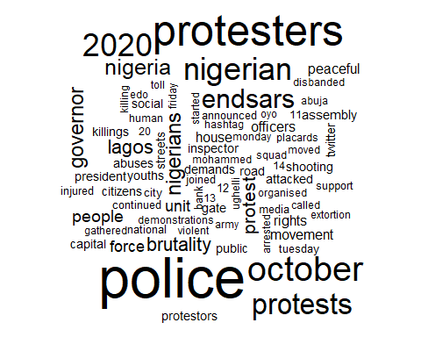

From the above word cloud, we can see that words like “police” , “protesters” , “October” appeared larger than others. this is because these are words that were frequently used as regards the #endsars protests

bing_endsars <- endsars_text %>%  
 inner_join(get_sentiments("bing")) %>%  
 count(word, sentiment, sort = TRUE) %>%  
 ungroup()

## Joining, by = "word"

bing_endsars

## # A tibble: 139 x 3  
## word sentiment n  
## <chr> <chr> <int>  
## 1 protests negative 39  
## 2 brutality negative 22  
## 3 protest negative 21  
## 4 peaceful positive 13  
## 5 abuses negative 9  
## 6 support positive 8  
## 7 extortion negative 6  
## 8 killing negative 6  
## 9 toll negative 6  
## 10 violent negative 6  
## # ... with 129 more rows

The above table shows words and their sentiments side by side and the number of times they appear. ”protests” and “brutality” are the highest ranked negative sentiment words

bing_endsars %>%  
 group_by(sentiment) %>%  
 top_n(10) %>%  
 ggplot(aes(reorder(word, n), n, fill = sentiment)) +  
 geom_bar(alpha = 0.8, stat = "identity", show.legend = FALSE) +  
 facet_wrap(~sentiment, scales = "free_y") +  
 labs(y = "Contribution to sentiment", x = NULL) +  
 coord_flip()

## Selecting by n

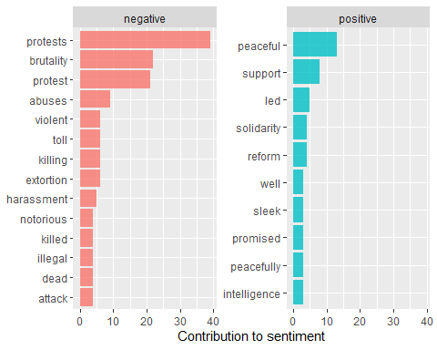

The above visualization shows contribution to sentiment and further separated to both negative and positive sentiments. ”protests” have the highest contribution to negative sentiment and overall sentiment followed by “brutality”. while “peaceful” has the highest contribution to positive sentiment

endsars_text %>%  
 right_join(get_sentiments("nrc")) %>%  
 filter(!is.na(sentiment)) %>%  
 count(sentiment, sort = TRUE)

## Joining, by = "word"

## # A tibble: 10 x 2  
## sentiment n  
## <chr> <int>  
## 1 negative 3458  
## 2 positive 2541  
## 3 fear 1692  
## 4 trust 1445  
## 5 anger 1340  
## 6 sadness 1226  
## 7 disgust 1081  
## 8 anticipation 903  
## 9 joy 736  
## 10 surprise 585

This table shows the number of words that have a certain sentiment .it shows that most words have a negative sentiment (3458).therefore we can conclude that there is a generall negative sentiment concerning the #endsars protests

nrc_endsars <- endsars_text %>%  
 inner_join(get_sentiments("nrc")) %>%  
 count(word, sentiment, sort = TRUE) %>%  
 ungroup()

## Joining, by = "word"

bing_endsars

## # A tibble: 139 x 3  
## word sentiment n  
## <chr> <chr> <int>  
## 1 protests negative 39  
## 2 brutality negative 22  
## 3 protest negative 21  
## 4 peaceful positive 13  
## 5 abuses negative 9  
## 6 support positive 8  
## 7 extortion negative 6  
## 8 killing negative 6  
## 9 toll negative 6  
## 10 violent negative 6  
## # ... with 129 more rows

nrc_endsars %>%  
 group_by(sentiment) %>%  
 top_n(10) %>%  
 ggplot(aes(reorder(word, n), n, fill = sentiment)) +  
 geom_bar(alpha = 0.8, stat = "identity", show.legend = FALSE) +  
 facet_wrap(~sentiment, scales = "free_y") +  
 labs(y = "Contribution to sentiment", x = NULL) +  
 coord_flip()

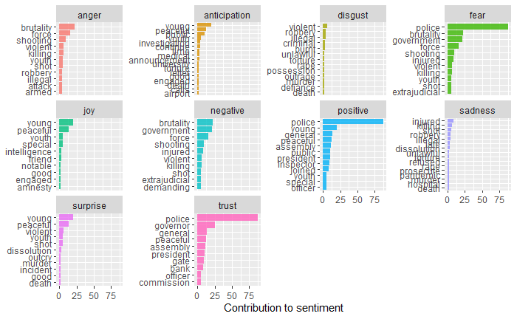

The above visualization shows the contribution of words to various types of sentiments. some words appear in more than one category e.g “police” which appears in fear ,positive and trust sentiments. generally ,there was little disgust about the protest as shown above .but there was also a lot of fear ,trust and positive feelings about the protests