PIP

Stakeholders

* **Communicators**: The communicators maintain communication with other stakeholders. They analyze and make documentation of the system. The Python Packaging Authority (PyPA) is the communicators of pip.
* **Developers**: PyPA developers and other contributors from Python Developers community.
* **Maintainers**: pip is based on core developers from PyPA and other contributors from Python Developers community. When the system is operational the PyPA takes care of it.

Development

The open source project pip is maintained by The Python Packaging Authority (PyPA), and is developed by Python core developer and other community hosted in GitHub. Any contributor can contribute in development of pip through GitHub.

In terms of software development Model-View-Controller (MVC) is a design pattern for software development and Python uses MVC architecture. The concept of MVC is, it split the full system into three interconnected segments, and that are a Model, View, and Controller. The Model part represents the domain, and domain is used for data storing and data retrieving. The View represents to the user and the Controller is used to make communication between the Model and The View.

However, to contribute in pip development the contributor needs to submit a Pull Request against the master branch in GitHub. The contributor must provide an explicit description about the tasks what he/she going to do. The task is tested locally first.

**Automated testing:** all kinds of pull requests and push to ‘master’ are tested in Travis, and Travis is based on .travis.yml file. Jenkins CI is used for certain versions of Python on centos and windows.

**Tests running:** to run the test an operating system needs to have subversion, git, bazaar, and mercurial. And Python requirements are a virtualenv, tox or pytest, scripttest, and mock.

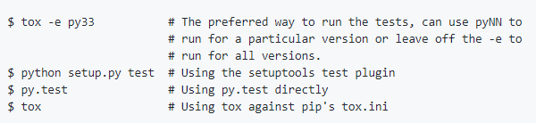

**Fig. Local testing system**

**Pip usage**

The Python Package Index (PyPI) is a repository of software for the Python. It is the host of different Python packages and their dependencies. At present there are 119685 packages on PyPI. Donald Stufft is a core developer of pip, and PyPI is solely developed and maintained by him.

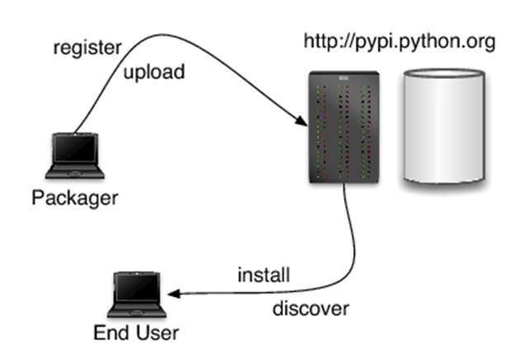

**Figure: Package management process in PyPI using pip**

Packager can register/upload their own work in PyPI using pip command and other users can browse existing projects. Source can be uploaded to an existing package. Pip uses PyPI as a default host for the packages and their dependencies.

Some important pip commands:

|  |  |
| --- | --- |
| Command | Action |
| Pip install | Install packages |
| Pip uninstall | Uninstall packages |
| Pip freeze | Output installed packages in requirements format |
| Pip list | List installed packages |
| Pip show | Show information about installed packages |
| Pip search | Search PyPI for packages |
| Pip zip | Zip individual packages |
| Pip unzip | Unzip individual packages |
| Pip bundle | Create pybundles |
| Pip help | Show help for commands |