In this document, we are to describe the flakiness in a test case of fullteaching, and how to fix/reduce it.

Test case:

|  |  |  |  |  |
| --- | --- | --- | --- | --- |
| **Number of executions** | **Memory** | **CPU** | **Screen resolution** | **Test output** |
| TC1 | 90MB | 1 core | 800x600 | FAILURE |
| TC2 | 90MB | 1 core | 1024x768 | FAILURE |
| TC3 | 90MB | 1 core | 2560x1024 | SUCCEED |
| TC4 | 240MB | 4 cores | 800x600 | FAILURE |
| TC5 | 240MB | 1 core | 2560x1024 | SUCCEED |
| TC6 | 240MB | 1 core | 1024x768 | FAILURE |

The same test case in 66.6% of executions fails (4 out of 6) and 33.3% succeed, then the tester may not rely on test outcomes. There is also difficult to know what issue triggers the flakiness. We execute the fault localization technique obtaining:

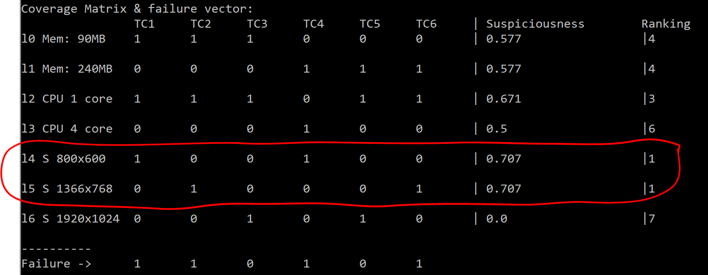

Root cause of flakiness: The test cases tend to be flaky in low screen resolutions. The test case tries to push a button in the fullteaching applications, but the button can be hidden inside of responsive menu depeding on screen resolutions:

|  |  |
| --- | --- |
|  |  |
|  | |

|  |  |
| --- | --- |
|  |  |
| Fig. 1. Screen resolution of 800x600 (unmaximized browser) | Fig. 2. Screen resolution of 1024x768 (unmaximized browser) |
|  | |
| Fig. 4. Screen resolution of 2560x1024 (unmaximized browser) | |

We can observe that the button COURSE appears in high resolution because there are enough window to place all butons. In lower resolution the tests cases fail when try to push the button COURSE because all buttons are hidden inside of resposive menu due a no enough window to place these buttons. However, we can observe that the test cases are executed in unmaximized browser. Executing the test cases in maximized browser can reduce the flakiness because the browser will have more space to place the button.

# Second execution: Test case in maximized browser

In order to fix or reduce the flakiness we have modified the test case to execute the functionality in maximized browser. We observed that the flakiness is reduced, but there still some flakiness. We executed again our fault localization technique:

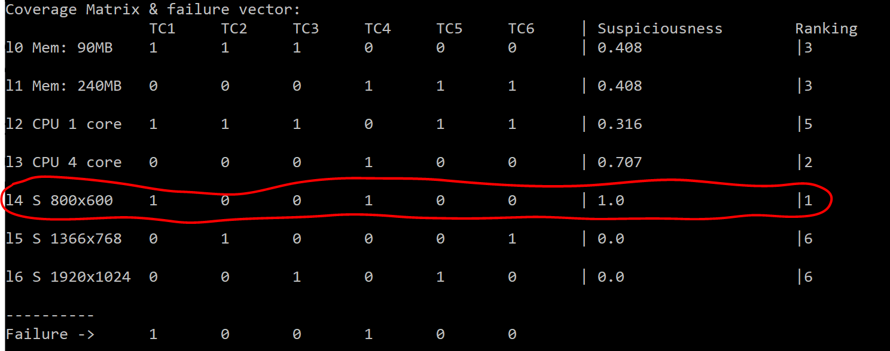

The root cause of flakiness is still the low resolutions (800x600). However, the test case stop to fail in 1366x768 resolution because the maximization of the window provides more space to place the buttons. However, in the 800x600 resolution there is no enough resolution an the button is still hidden in the resposive menu:

|  |  |
| --- | --- |
|  |  |
| Fig. 1. Screen resolution of 800x600 (maximized browser) | Fig. 2. Screen resolution of 1024x768 (maximized browser) |
|  | |
| Fig. 4. Screen resolution of 2560x1024 (maximized browser) | |
|  |  |
|  | |

The test case fails only in 33.3% of test executions (2 out of 6), and succeed in 66.6% of test executions. The tester coul still not rely on test ocutomes because the test case still fails in 800x600 resolution due the lack of space to place the buttons in the browser window. However, the space of the browser can be increased changing the browser resolution properties regardless of the screen resolution.

# Second execution: Test case in maximized browser with low browser resolution

In order to fix or reduce the flakiness we have modified the test case not only to execute the functionality in maximized browser, but also increasing programmatically the resolution of the browser window. After this change, we do not observe flakiness during the test execution:

|  |  |  |  |  |
| --- | --- | --- | --- | --- |
| **Number of executions** | **Memory** | **CPU** | **Screen resolution** | **Test output** |
| TC1 | 90MB | 1 core | 800x600 | FAIL |
| TC2 | 90MB | 1 core | 1024x768 | SUCCEED |
| TC3 | 90MB | 1 core | 2560x1024 | SUCCEED |
| TC4 | 240MB | 4 cores | 800x600 | FAIL |
| TC5 | 240MB | 1 core | 2560x1024 | SUCCEED |
| TC6 | 240MB | 1 core | 1024x768 | SUCCEED |

Now, the test case executed in 800x600 does not fail because the browser has enough space to place the COURSE button due the programmatically increasing of the resolution of the browser window:

|  |  |
| --- | --- |
| Fig. 1. Screen resolution of 800x600 (maximized browser and high browser resolution) | Fig. 2. Screen resolution of 1366x768 (maximized browser and high browser resolution) |
| Fig. 3. Screen resolution of 1920x1024 (maximized browser and high browser resolution) | |