**Selecting Multiple Columns**

When buying food, it is important to make sure it is fresh and not expired.  
You are given the following '**Products'** list:  
  
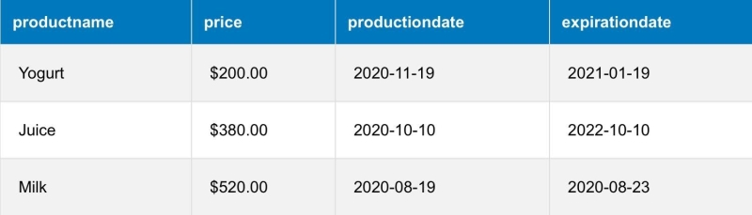Write a query to select the **ProductName**, **ProductionDate** and **ExpirationDate**.